IRONPULSE MANUFACTURING
Predictive Maintenance — Machine Failure Early-Warning System

The Bottom Line
We built a model that watches live sensor readings on every CNC machine and flags the ones at risk of failing — before they actually break down. On a test of 2,000 machines it never saw during training, it correctly caught 55 of 68 real failures, with only 10 false alarms. That means maintenance can plan a repair instead of reacting to a breakdown, for the large majority of failures.

Why This Matters
Machine failures are rare — about 3.4% of operating time — but each one causes unplanned downtime that is far more expensive than a planned inspection. A false alarm costs a technician a short inspection visit. A missed failure costs hours of unplanned downtime, rush repairs, and potential safety risk. The model is deliberately tuned to catch failures even at the cost of a few extra false alarms, because that trade-off saves the plant money.

What The Model Found: Top Risk Signals
Three signals matter most, and they line up with how these machines actually break:
- Rotational speed — unusually low speed under load is the single strongest early-warning sign.
- Mechanical power (a combination of torque and speed) — running outside the machine's normal power band signals overload.
- Tool wear combined with torque — a worn tool under high torque is when overstrain failures happen.
In plain terms: it's rarely one reading in isolation. It's a worn tool pushed too hard at the wrong speed. This matches what the maintenance team already sees on the floor.
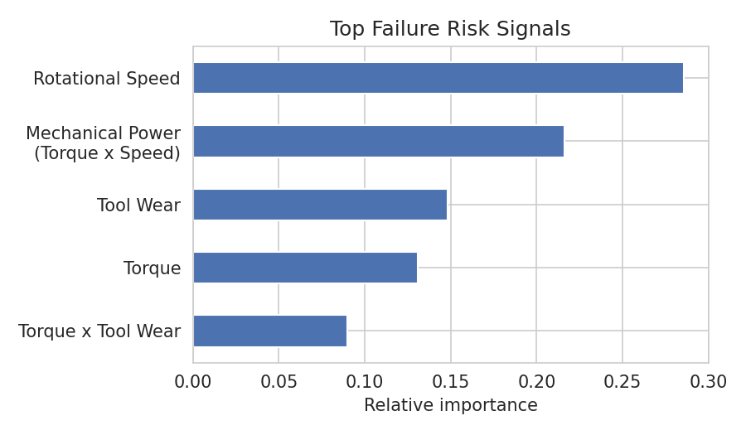

Model Results (Held-Out Test Set)
Metric | Result | What it means
Failures caught (Recall) | 81% | 55 of 68 real failures flagged in advance
Alert accuracy (Precision) | 85% | Most alerts are real, not noise
Missed failures | 13 | Slipped through — target for next iteration
False alarms | 10 | Out of ~1,932 healthy machines checked
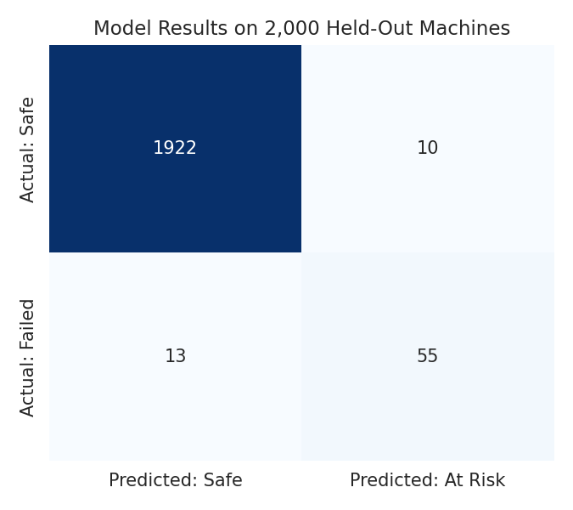

Recommended Actions for Next Quarter
- Pilot the model on a subset of the fleet: route its daily risk score into the maintenance dashboard as an advisory flag, not an automated shutdown — let the crew validate it against real outcomes for one quarter.
- Set a real-time monitoring threshold on the combination of tool wear and torque, not either alone — this is the strongest early-warning combination we found.
- Add a rotational-speed drop alert: sustained low speed under normal torque should trigger an inspection request, since it's the top single predictor.
- Track missed failures (the 13 we didn't catch) as a feedback loop — feed their sensor logs back into the next model refresh so the system improves quarter over quarter.

A Note on Confidence
This model is trained on 10,000 historical machine-hours, of which only 339 were failures. That's enough to build a genuinely useful early-warning signal, but not yet enough to reliably tell us which specific failure type to expect for every case — we recommend the pilot period above specifically to gather more labeled failure data and sharpen that second layer of the system.
Final Recommendation
Based on the current evaluation, the predictive maintenance model is recommended for pilot deployment as a decision-support system rather than a fully automated maintenance solution. It enables maintenance teams to identify high-risk machines early, schedule preventive maintenance, reduce unexpected downtime, lower repair costs, and improve equipment reliability. Regular retraining with newly collected production data is recommended.

