AUTO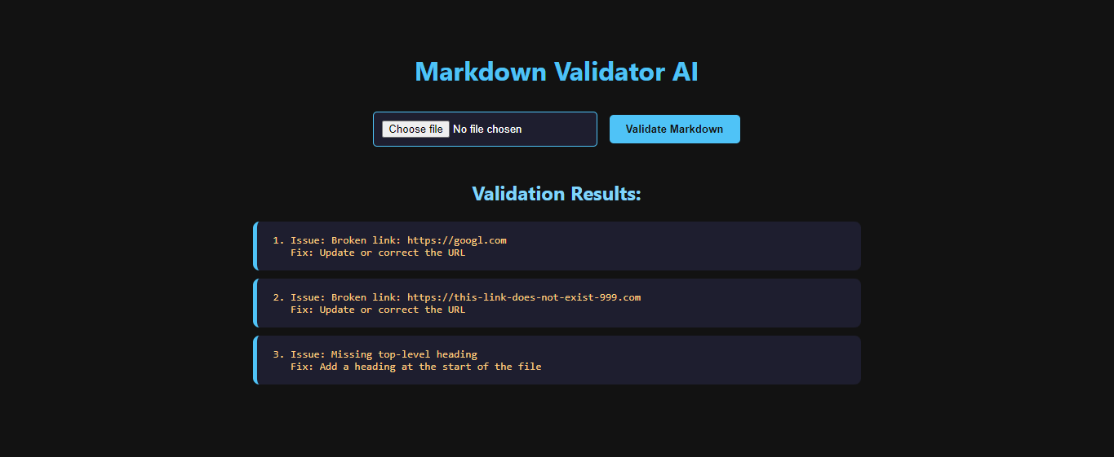MATED MARKDOWN VALIDATOR
(Using custom AI agent & Agno framework)
This project uses a custom AI agent built with the Agno framework to validate Markdown files by invoking a Python-based validation tool.

Slide 1: Title Slide
Title:
Automated Markdown Validator using AI Agent
Subtitle:
Offline Assignment – TalkSite Systems
Presented by:
Bharath Raja.V
Role:
Software Engineer – Assignment Presentation

Slide 2: Assignment Objective
Objective of the Assignment:
- Learn and apply an AI agent framework
- Build a local working demo
- Validate Markdown files automatically
- Identify issues and suggest fixes

Slide 3: Problem Statement
Problem Overview:
- Markdown files often contain formatting mistakes
- Broken links are difficult to detect manually
- Manual validation is time-consuming and error-prone
Need:
An automated and reliable system to validate Markdown files.

Slide 4: What is an AI Agent?
AI Agent Definition:
- An AI agent is an autonomous software component
- It understands a goal and decides the steps to achieve it
- It can invoke tools to complete specific tasks
In This Project:
The AI agent manages the validation workflow and delegates validation work to a tool.

Slide 5: AI Used & Framework
AI Used:
- Custom AI Agent designed specifically for this task
Framework Used:
- Agno – Python-based AI Agent Framework
Why Agno?
- Lightweight and easy to understand
- Supports agent and tool separation
- Suitable for local execution as required by the assignment

Slide 6: System Architecture
Architecture Overview:
- User uploads a Markdown file
- AI agent receives and processes the request
- Agent invokes the Python validation tool
- Tool returns validation results
- Agent presents results to the user
This architecture ensures clean separation of responsibilities.

Slide 7: Agent Workflow
Step-by-Step Agent Workflow:
- Agent receives the Markdown file from the user
- Agent identifies the goal as Markdown validation
- Agent decides to use the validation tool
- Agent invokes the Python validation tool
- Tool checks formatting and link issues
- Tool returns detected issues and fix suggestions
- Agent formats the results clearly
- Final output is displayed to the user

Slide 8: Technology Stack
Technologies Used:
- Python for core logic
- Agno for AI agent orchestration
- Flask for local web interface
- Regex and file parsing for validation
- Markdown files as input
All components run locally as required.

Slide 9: Local Demo Flow
Demo Execution Flow:
- Application is run locally
- User uploads a Markdown file
- Agent processes the file
- Validation results are displayed
This demonstrates real-time agent and tool interaction.

Slide 10: Output Details
Output Provided by the System:
- List of detected Markdown issues
- Clear explanation of each issue
- Suggested fix for every issue
The output is easy to understand and actionable.

Slide 11: Key Learnings
Key Learnings from This Project:
- Practical understanding of AI agents
- Importance of agent and tool separation
- Difference between AI reasoning and deterministic logic
- Writing clean, explainable, and testable code

Slide 12: Future Enhancements
Possible Future Improvements:
- Improved web-based user interface
- Support for additional Markdown rules
- Deployment on AWS EC2
- Support for validating multiple files
Output Screenshot:

