**Project Title:** Azure Storage – Working with Blob – Using Azure Portal.

**Project Description:** Create a Block Blob and try out the following tasks onto it.

Task – 1: Acquiring a Lease onto it.

Task – 2: Create a snap shot of it.

Task – 3: Providing a blob access to a given IP with specific SAS, for a

Given Date & Time duration.

**Acquire Lease:**

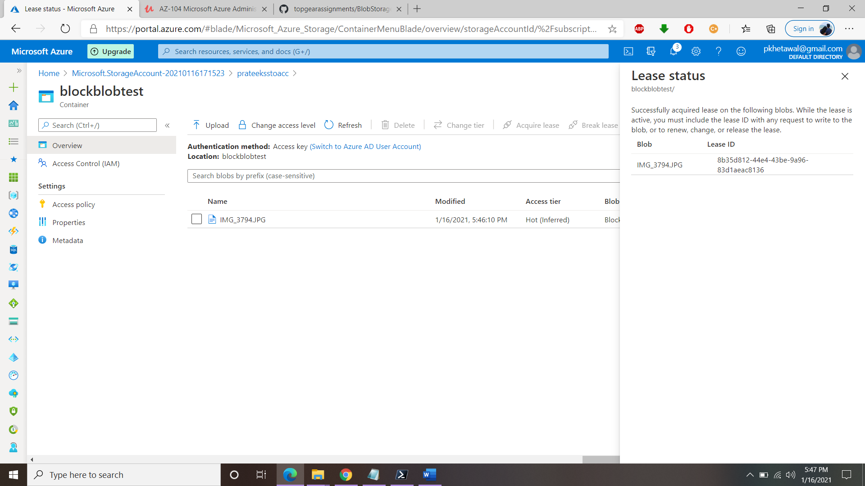

**Create Snaphot:**

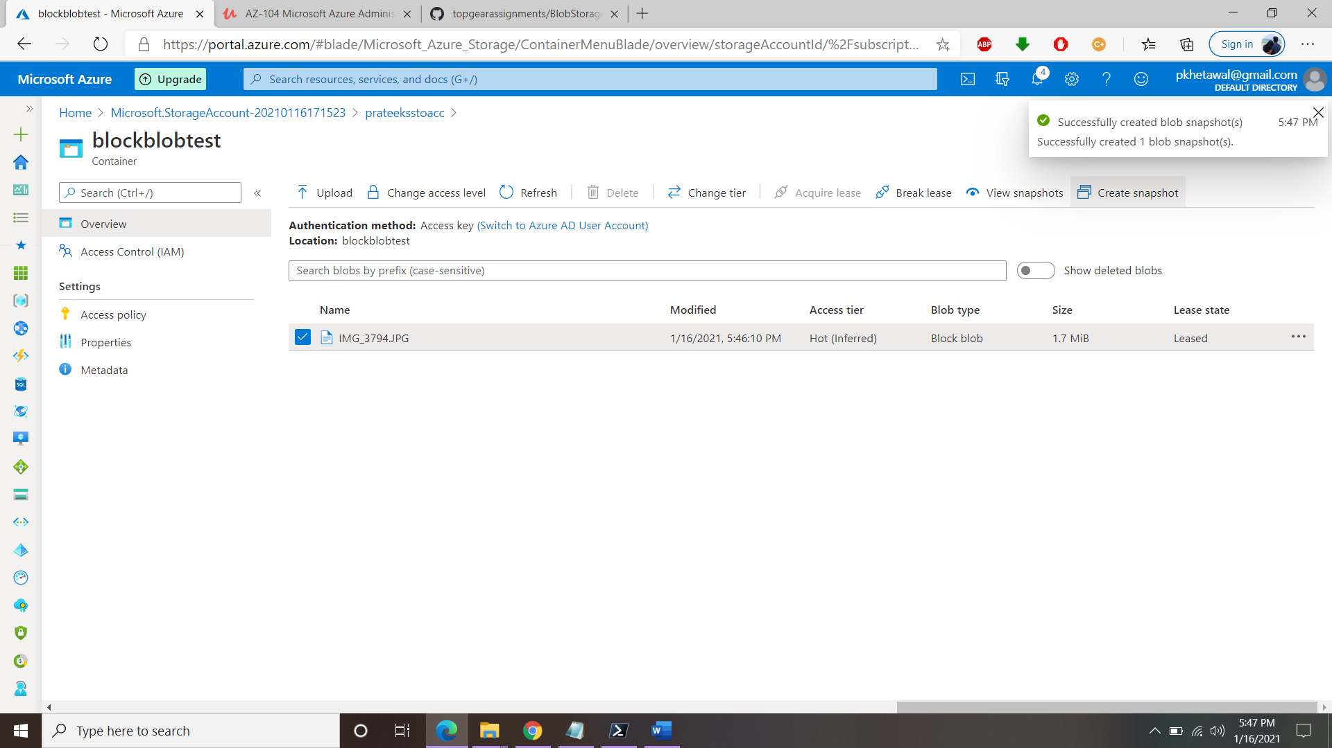

**Provide Blob Access:**

(Allow access from my machine’s IP) -

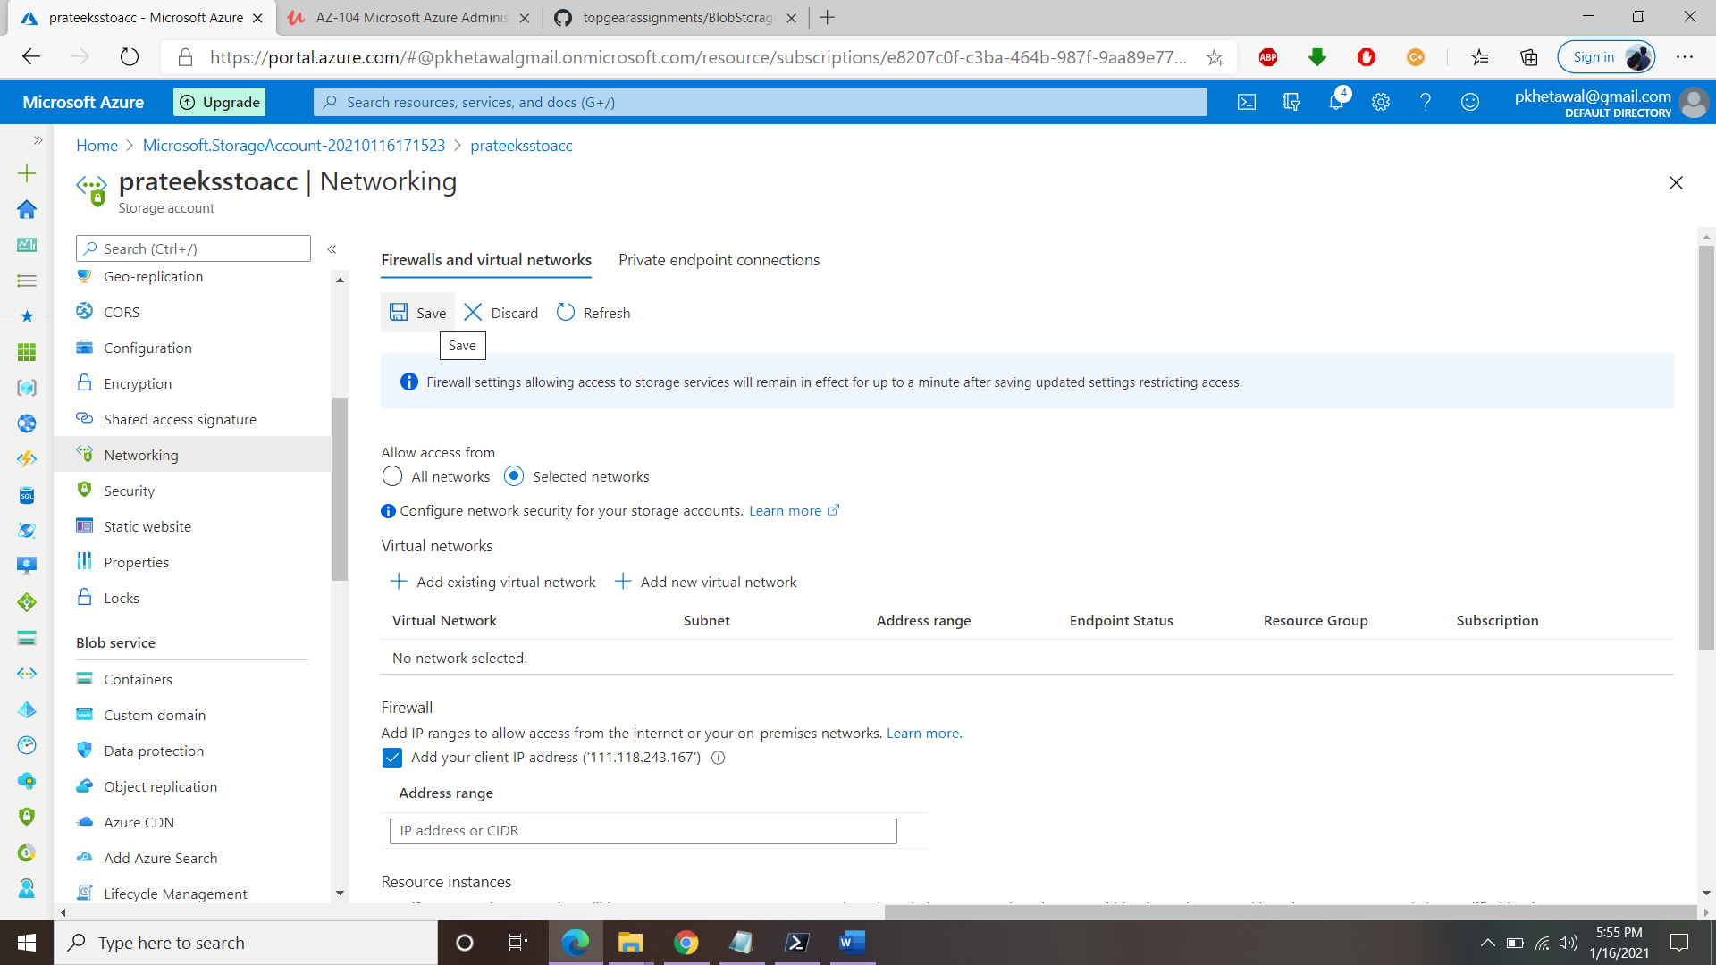

(Generate SAS URL for specific date range) –

