**Project Title:** Azure Storage – Working with Blob – Using PowerShell.

**Project Description:** Create a Block Blob and try out the following tasks onto it.

Task – 1: Acquiring a Lease onto it.

Task – 2: Create a snap shot of it.

Task – 3: Providing a blob access to a given IP with specific SAS, for a

Given Date & Time duration.

**Creation of storage account, blob container and upload file:**

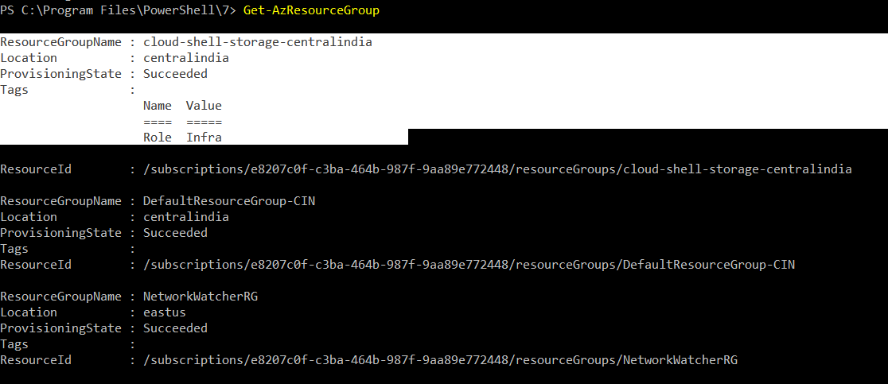

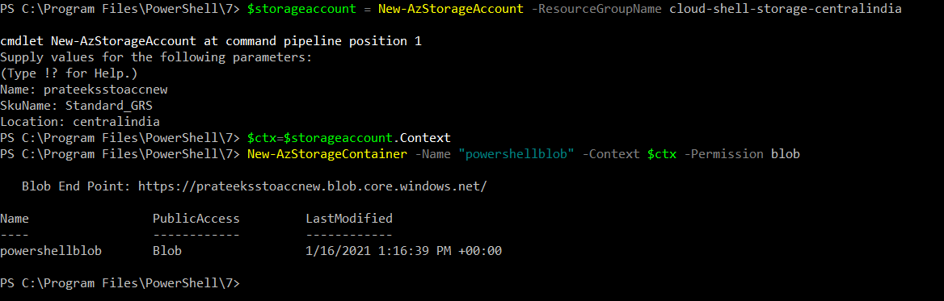

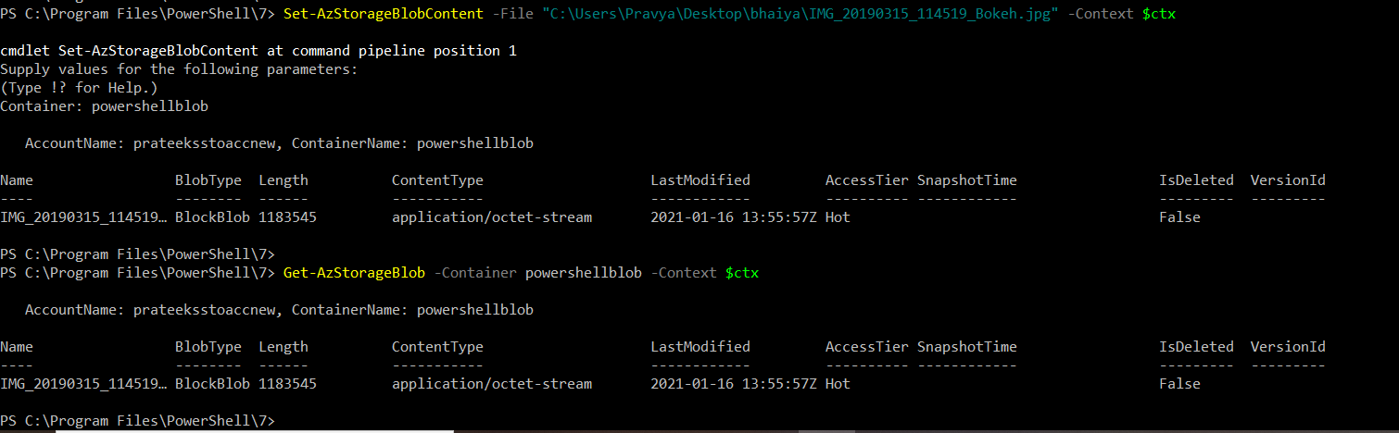

**Acquire Lease:**



**Create snapshot:**

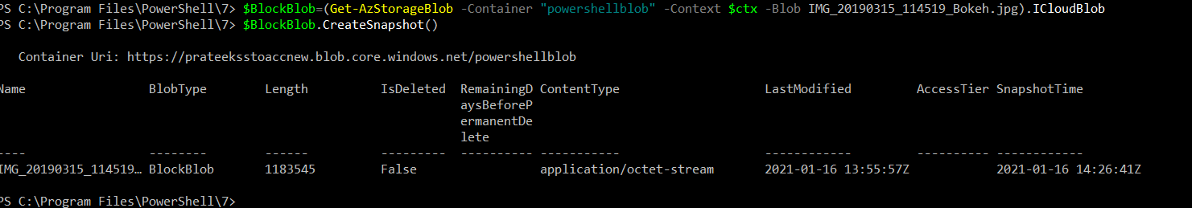

**Generate SAS URI, give specific IP access for a give date range:**

