1. Create an ASP.NET MVC Web Application to avail the “Blob Storage Facilities” of Azure Cloud.
   1. Design UI and Code for the following.
      1. User creating “Blob Container” by giving a name.
      2. Uploading Images onto “Blob Container” from the local machine.
      3. Listing of all the blobs from a “Blob Container”.
      4. Deletion of any given Blob.
      5. Viewing of any selected blob (Image).

------***------

**Blob Creation:**

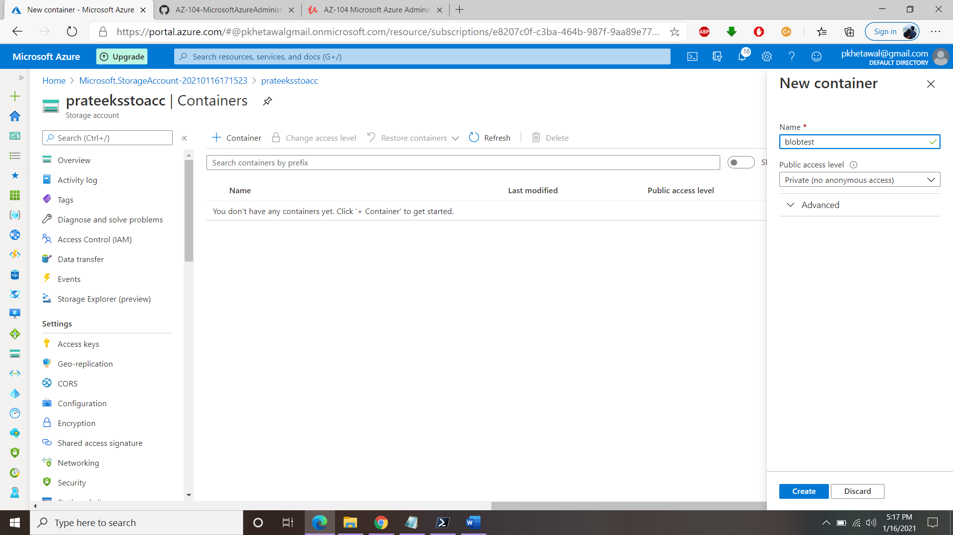

**Upload images:**

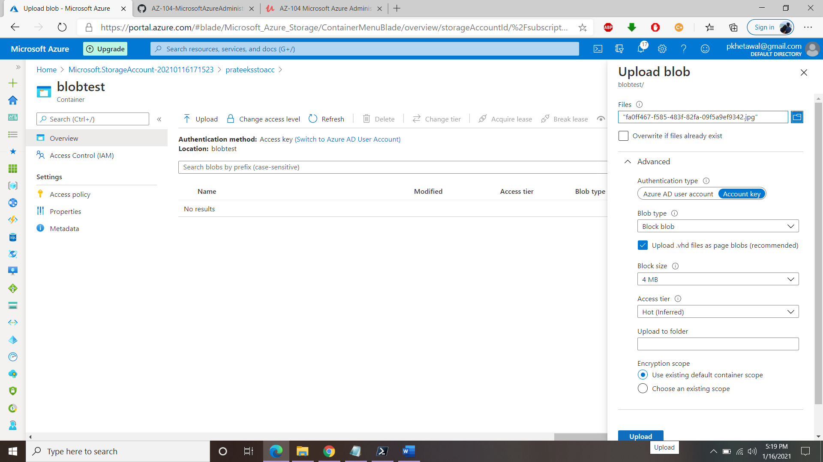

**Listing all Blobs:**

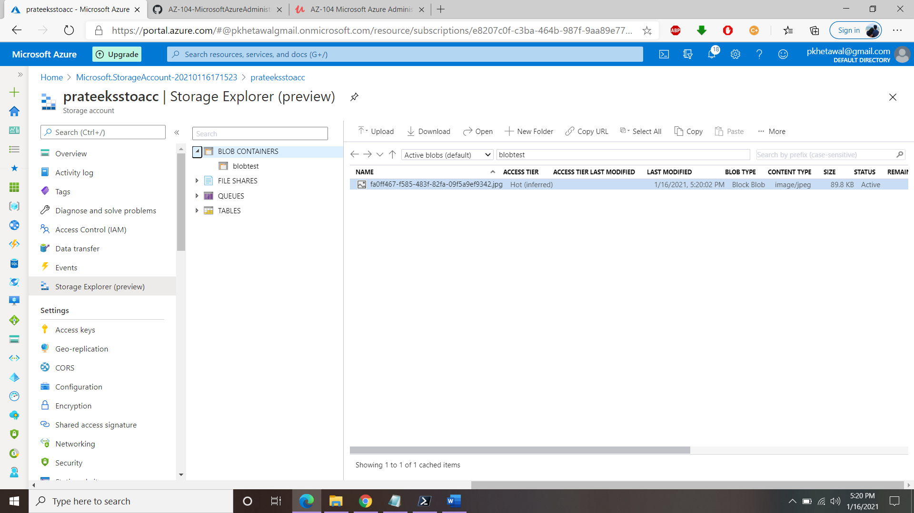

**Deletion of blob:**

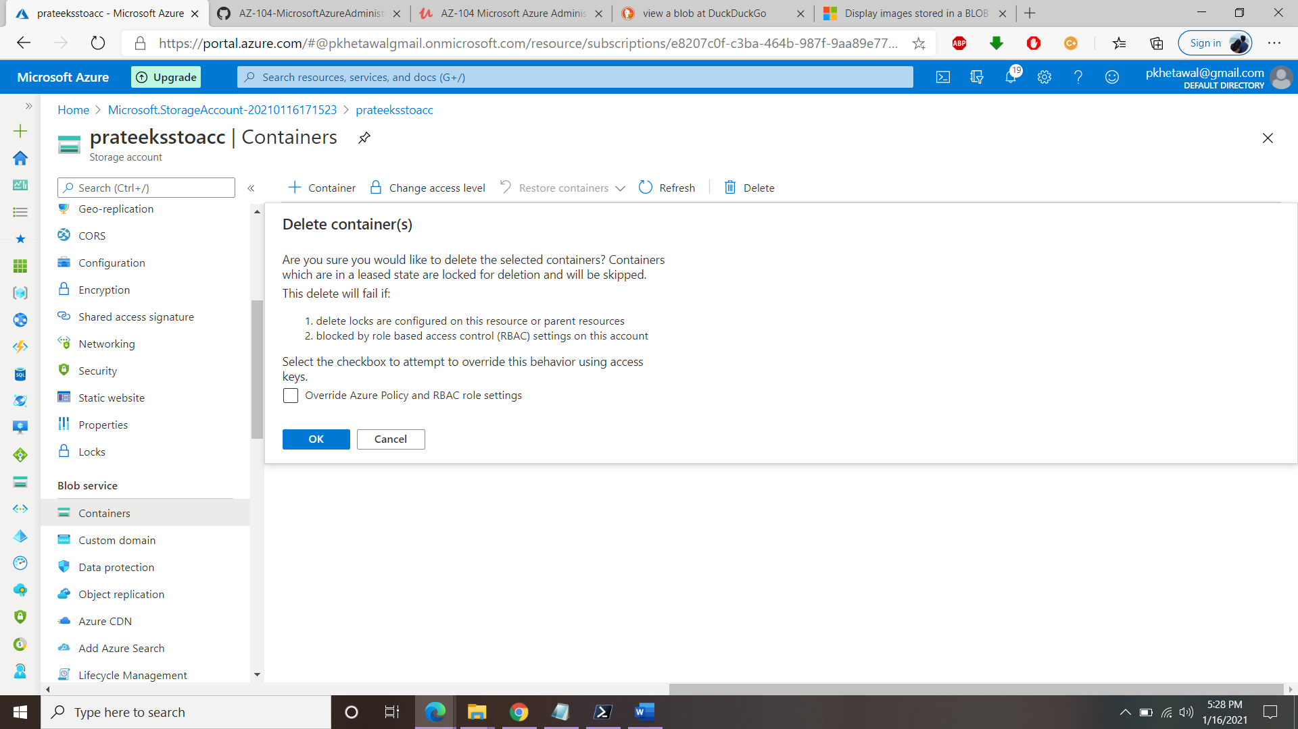

**Viewing the image in Blob:**

