**Project Title:** Dealing with VMs.

**Project Description:** Using the Azure Portal implement the following given tasks.

**Learning Objectives:** Creating VM, Windows Server 2016 OS, Opening required Ports, configuring it with IIS, attaching a Data disk to it, Capturing Generalized Image out of it & finally creating a new VM out of a Generalized Image.

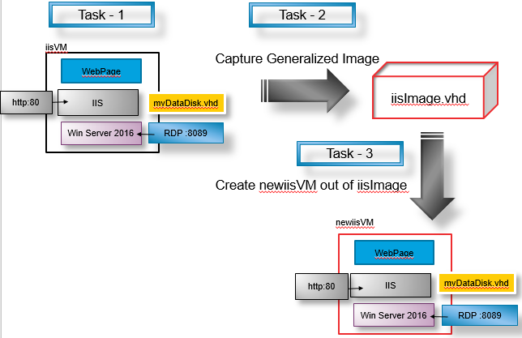

**Create Resource Group and VM**

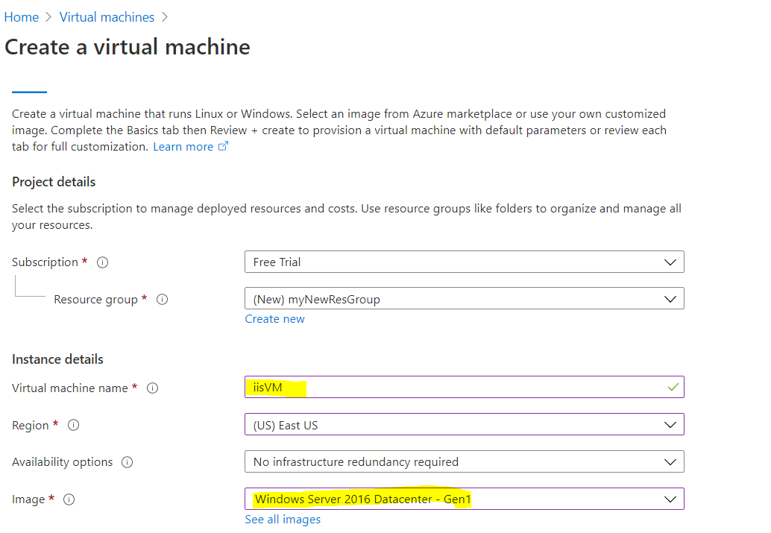

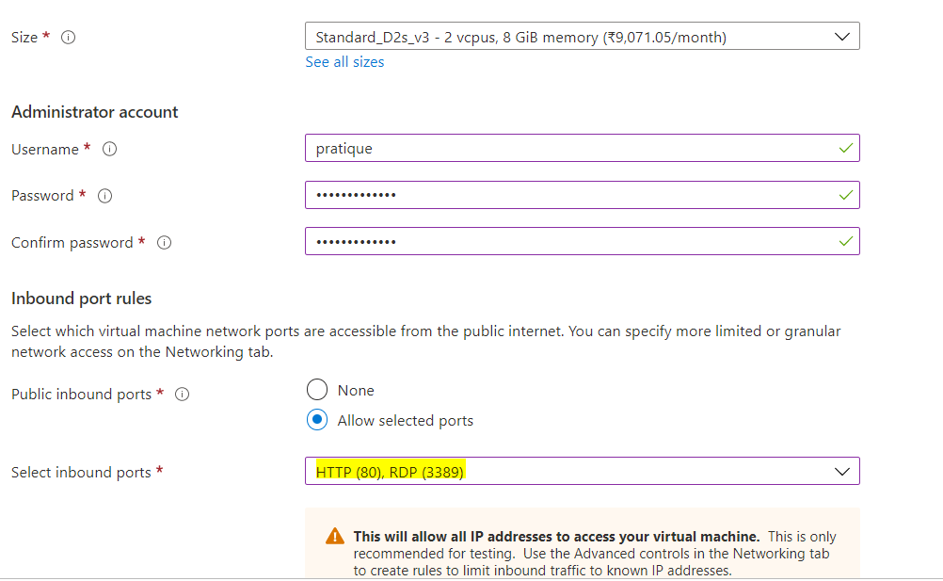

Click on “Review + Create” and after validation, hit “Create”

**Find out public IP of the VM and then validate RDP port by doing mstsc**

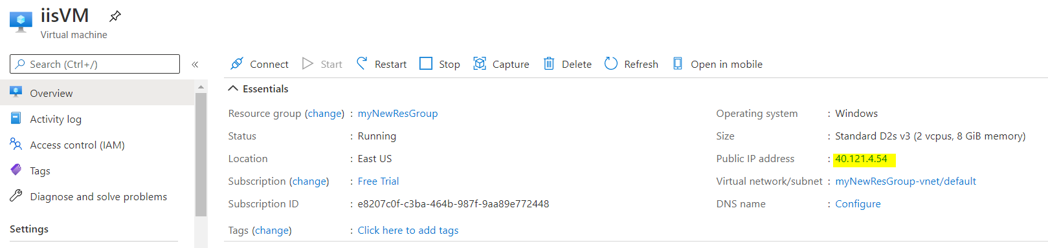

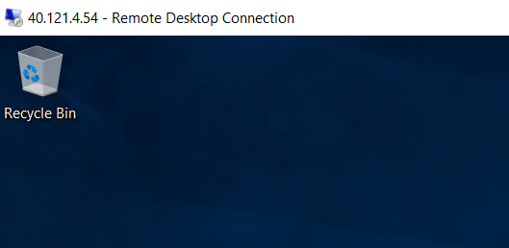

**Add IIS role to VM**

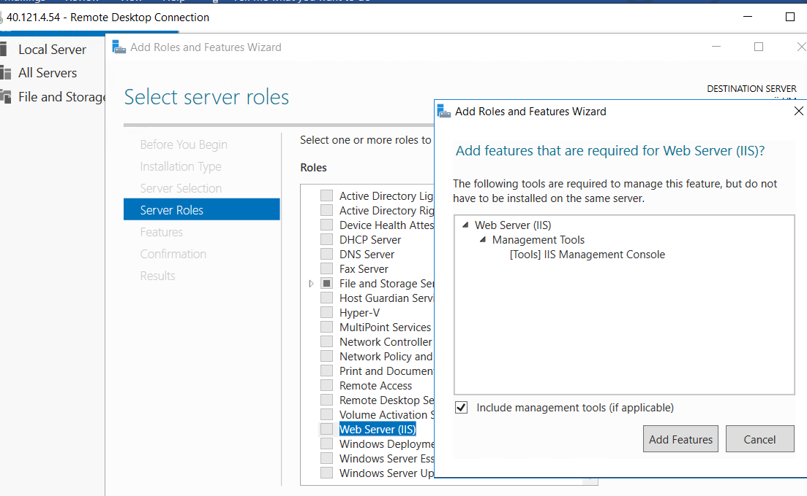

**Validate port 80 by launching the web portal via public IP**

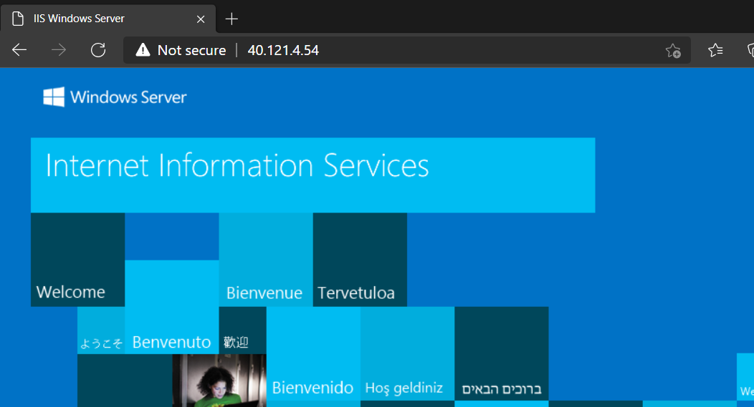

**Add managed disk**

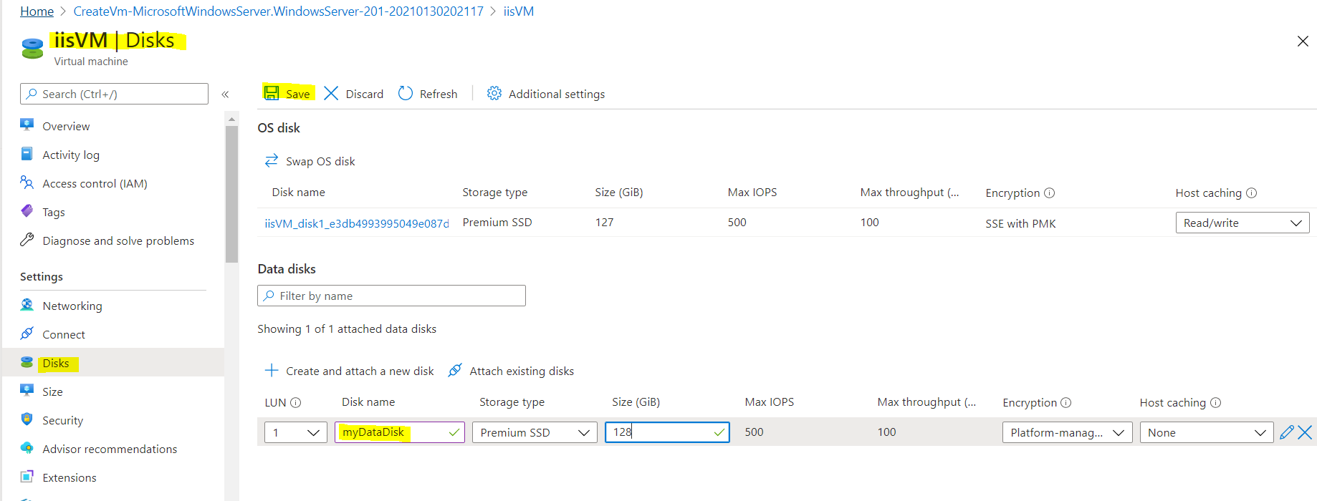

**Prepare the system for capturing image**

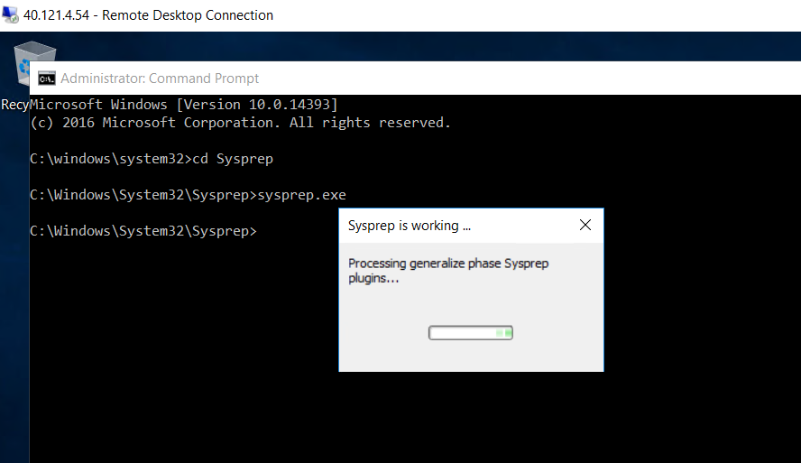

**Capture generalized image**

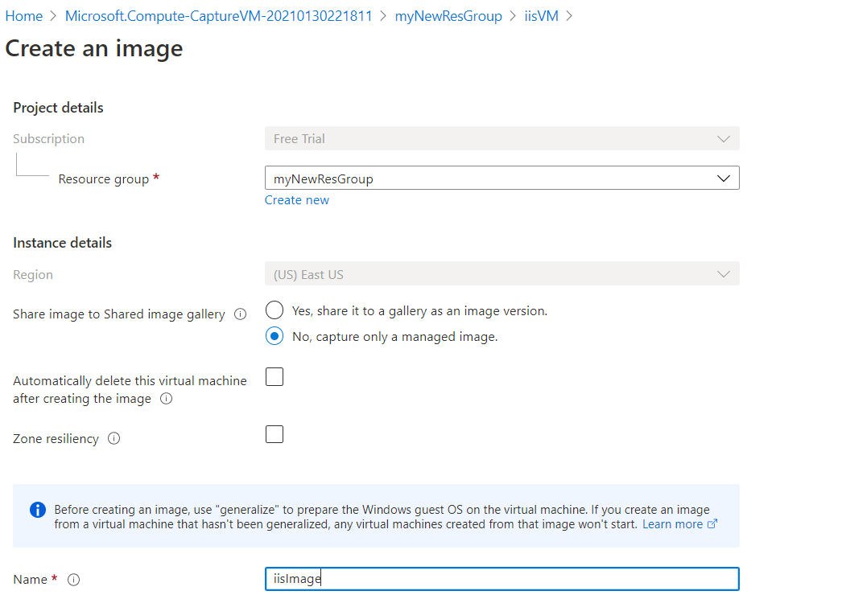

**Create VM from the image**

