**Project Title:** Dealing with VMs.

**Project Description:** Using the PowerShell script, implement the following given tasks.

**Learning Objectives:** Creating VM, Windows Server 2016 OS, Opening required Ports, configuring it with IIS, attaching a Data disk to it, Capturing Generalized Image out of it & finally creating a new VM out of a Generalized Image.

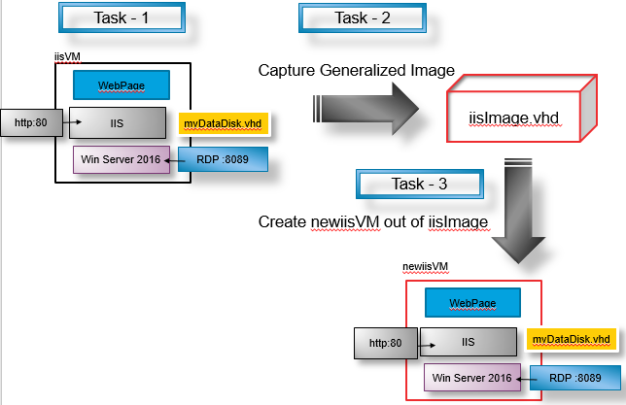

**Create Resource Group**

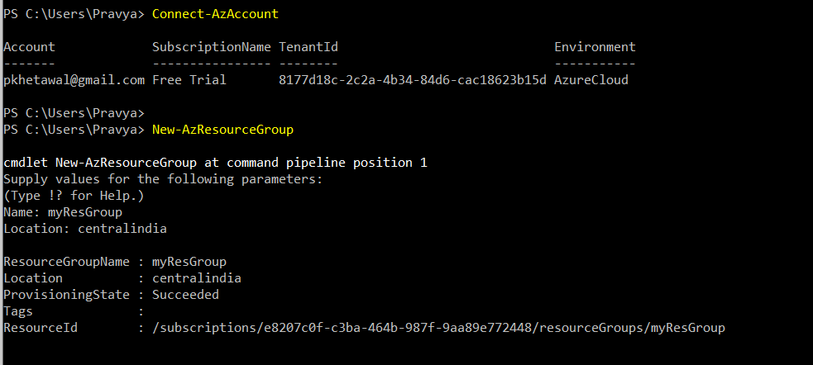

**Create VM and specify ports to be opened**

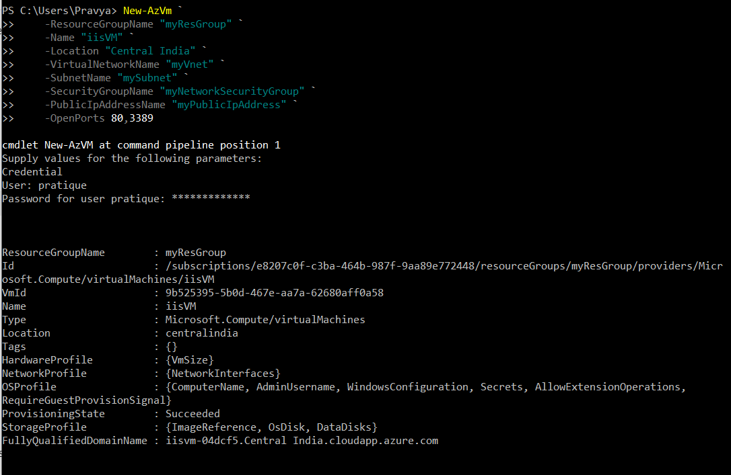

**Install Web server by browsing to the portal:**

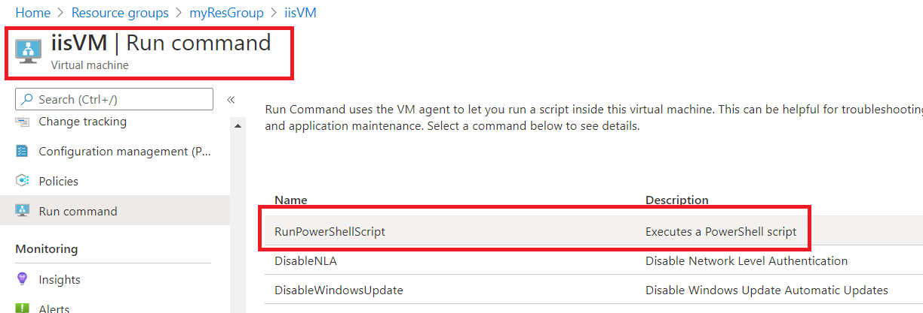

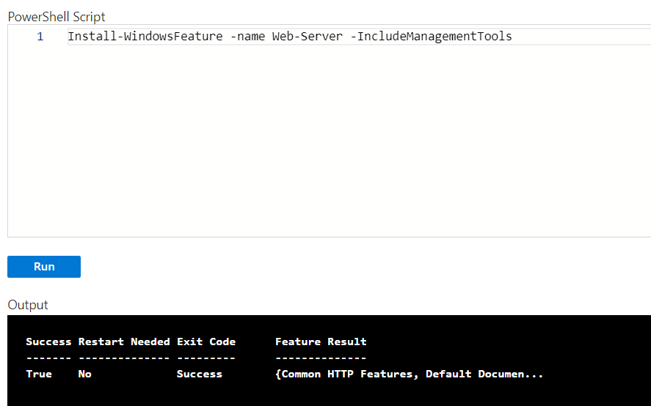

**Get the IP address of the VM:**

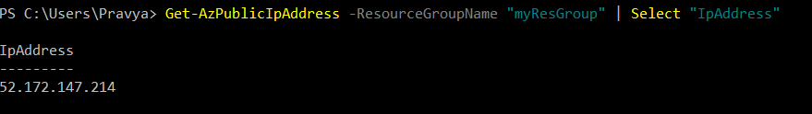

**Validate the enablement of IIS services**

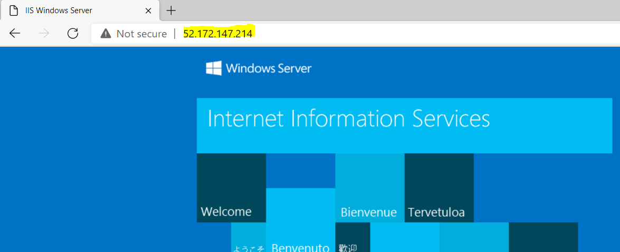

**Validate RDP protocol**

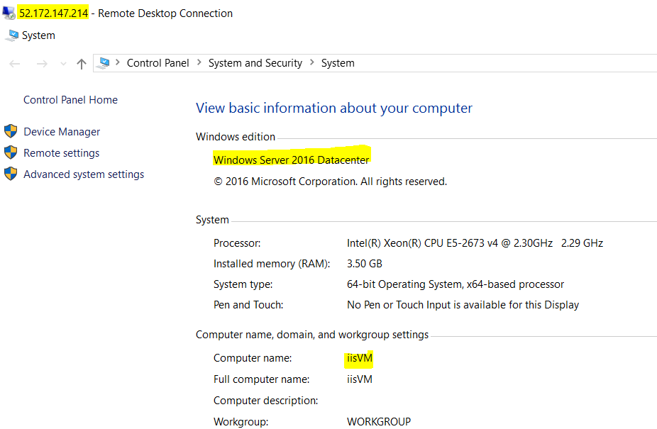

**Attach managed disk to VM**

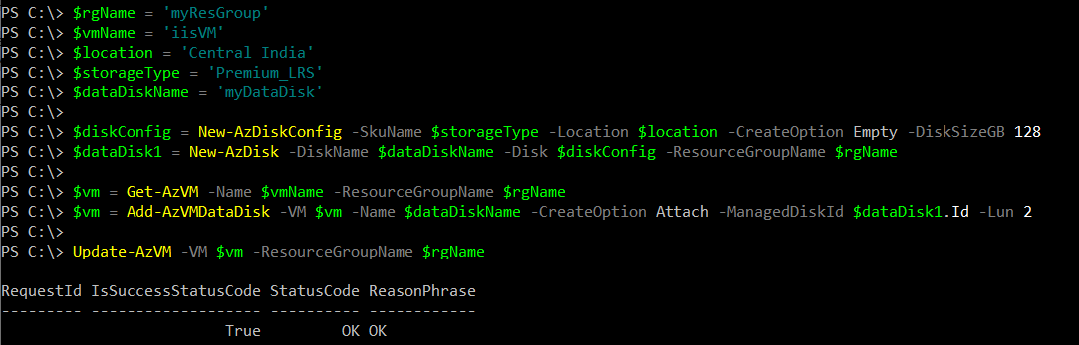

**Prepare the system for taking a clean image**

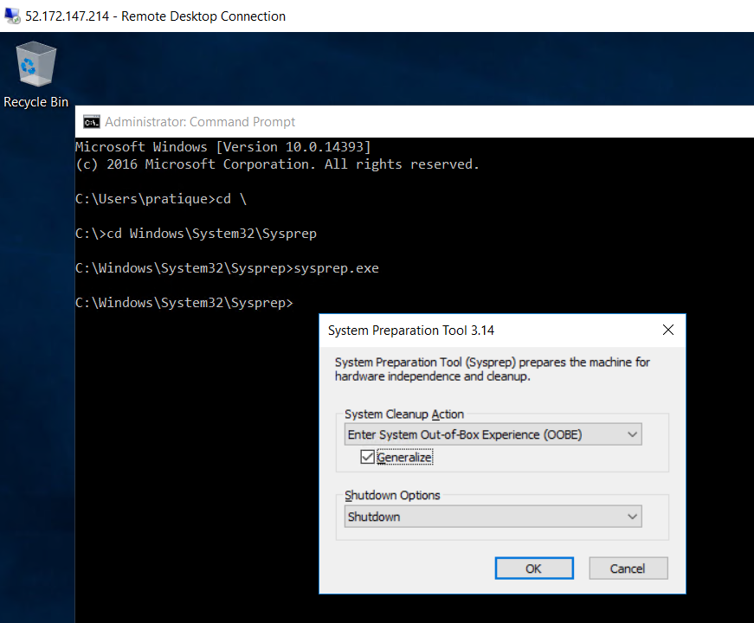

**Capture Generalized image**

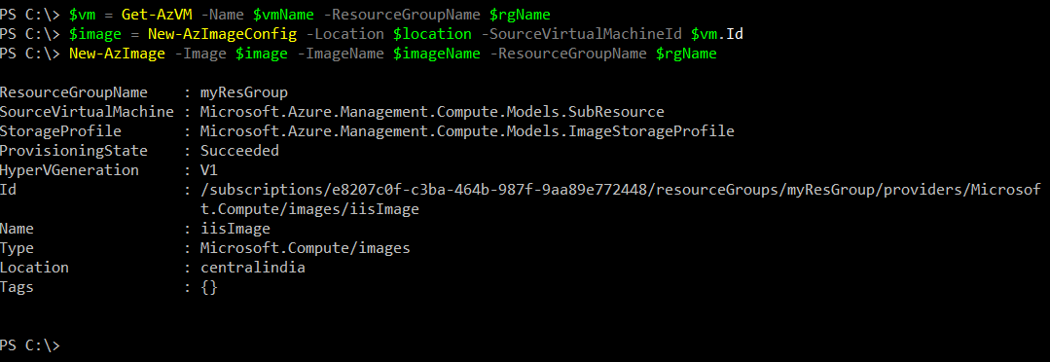

**Create VM from the image taken**

