For the following I am providing screenshots to showcase that I used MySQL to structure, query, and manage data efficiently while maintaining strong data integrity and security. This included applying relational database design principles and creating an ER model to define clear relationships between entities. I also performed full CRUD operations and used SQL JOINs and complex queries to extract meaningful insights and relationships across multiple data sets.
Task:
- Create a new database in MySQL to manage client and meeting data

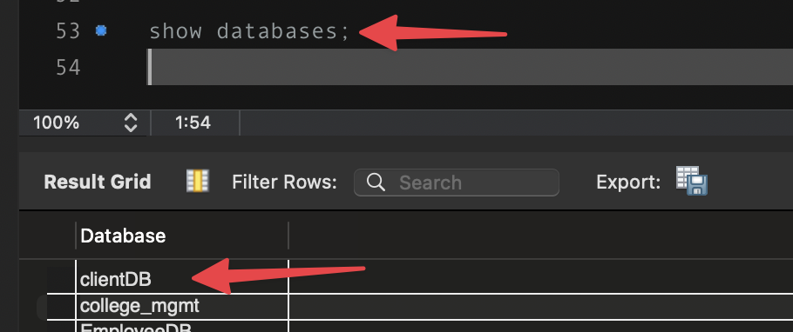

- Define a table for client details, including fields like ID, name, email, and password

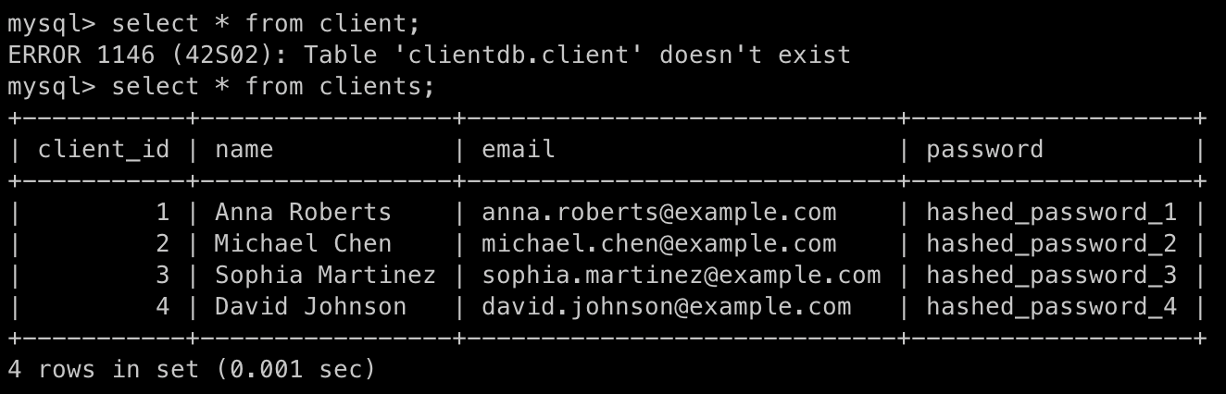

- Create a table for client meetings, with fields such as meeting topic, number of people, and date

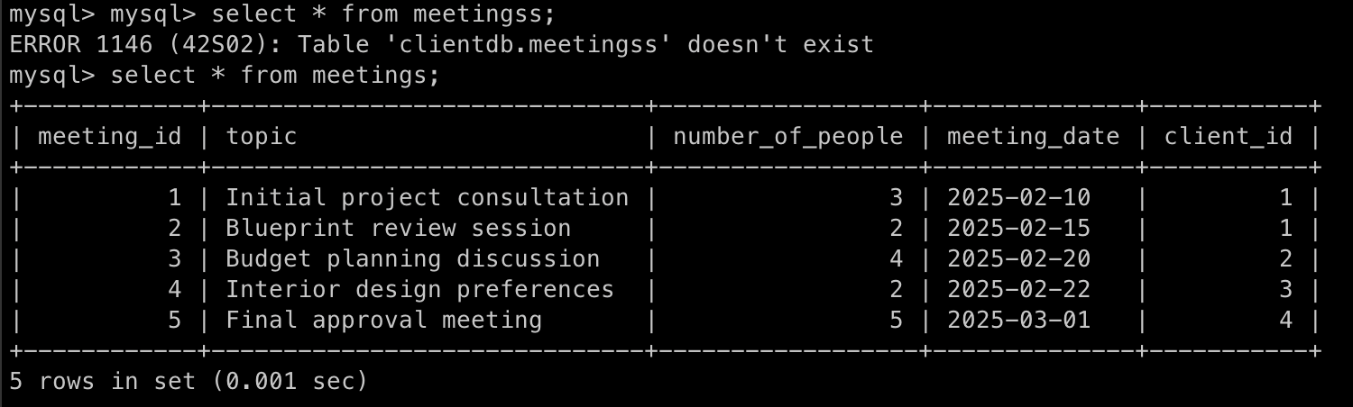

- Design an Entity-Relationship (ER) Diagram to model the client and meeting entities, their attributes, and the relationships between them

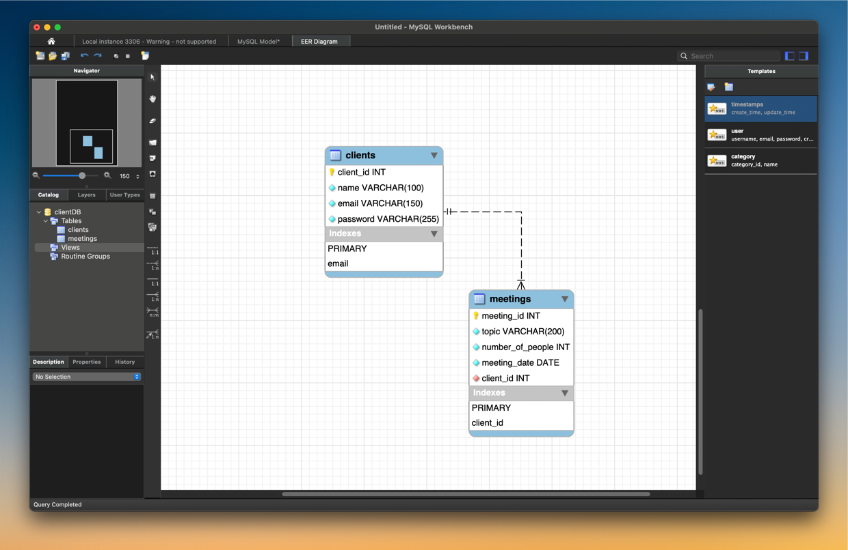

- Perform SQL operations, including data insertion, updates, deletions, and querying related records across tables

Insert client:
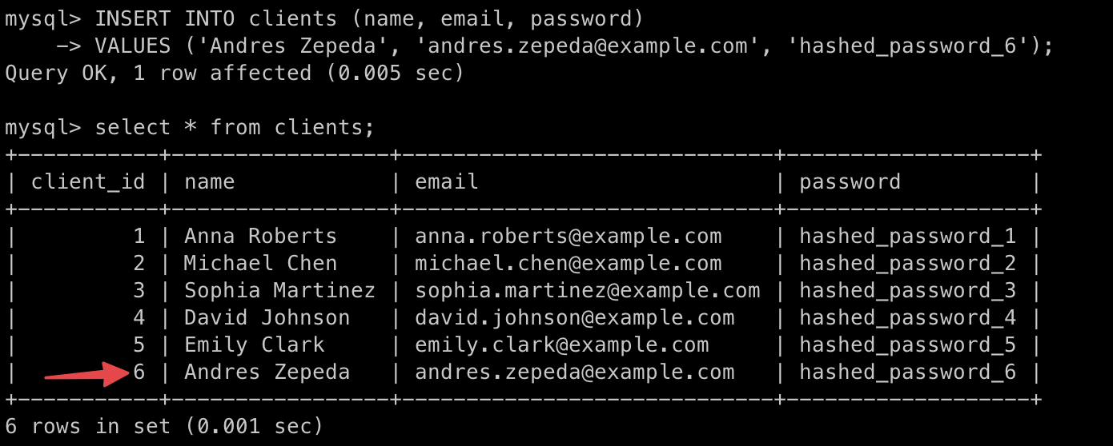

Insert Meeting:
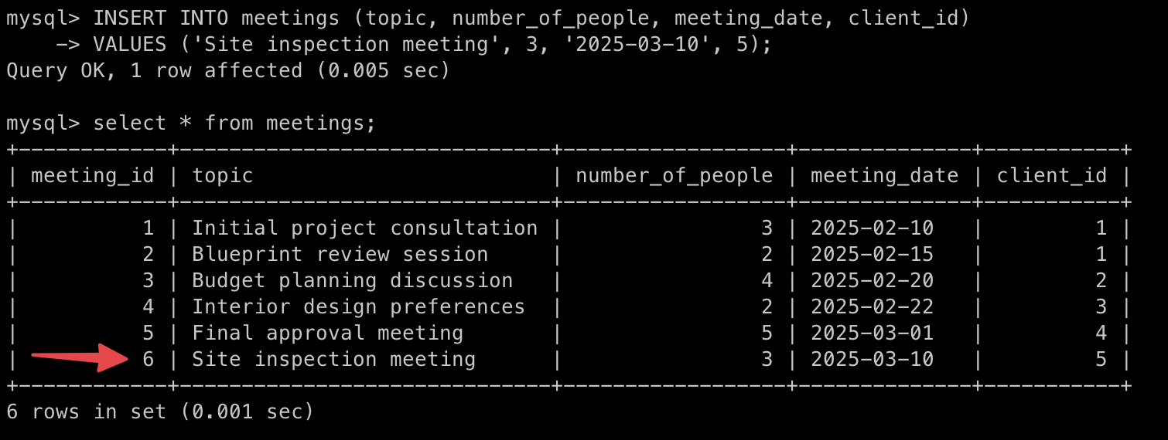

Update Client:
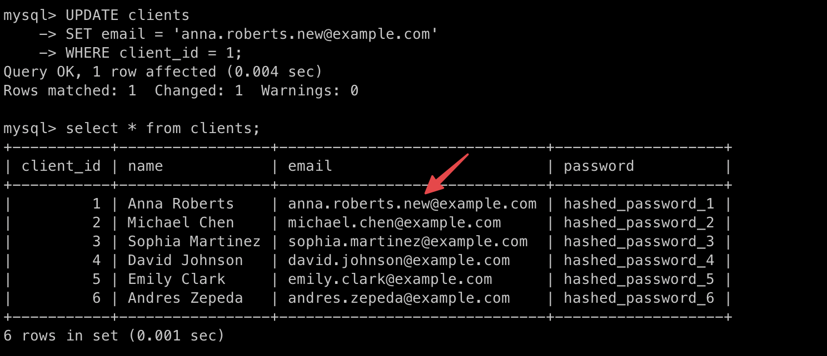

Update Meeting:
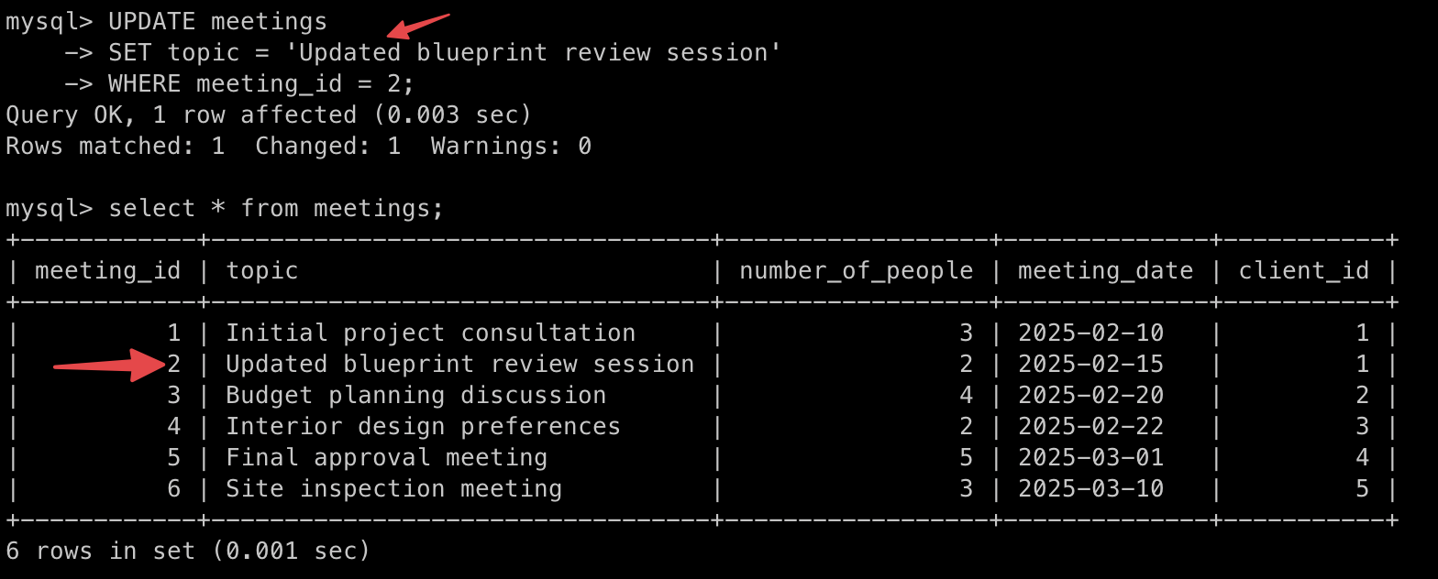

Delete Client:
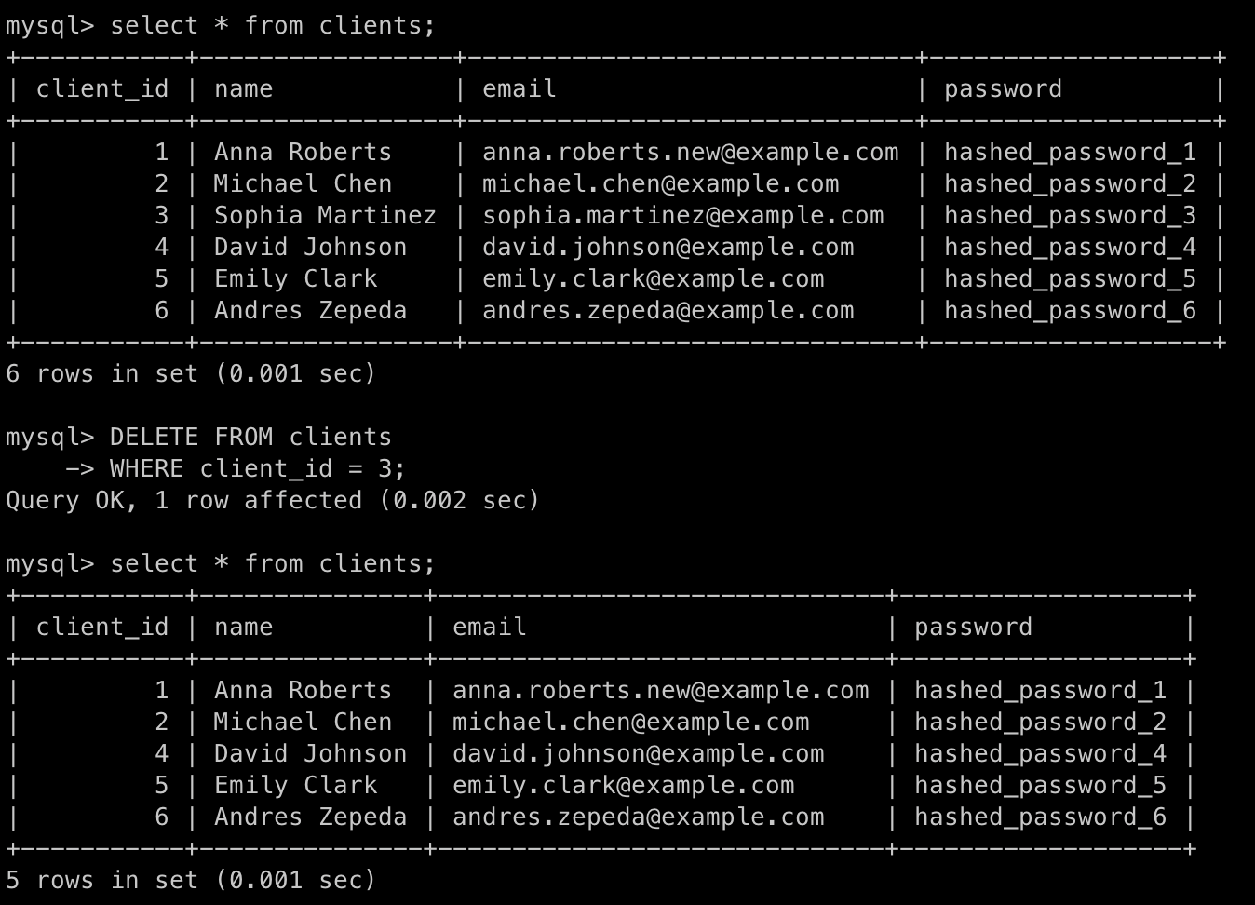

Delete Meeting:
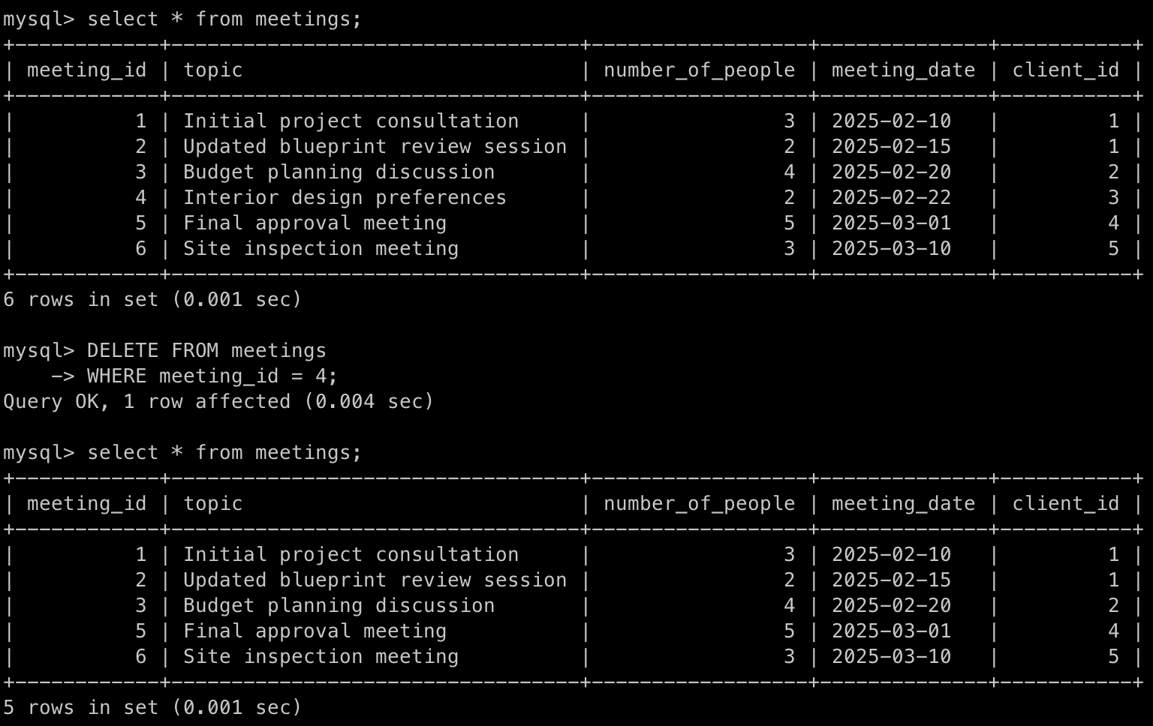

- Establish a relationship between the two tables using SQL JOINs

