**CYCLE 3**

1. Using TCP/IP sockets, write a client-server program to make client sending the file name and the server to send back the contents of the requested file if present.
2. **Server :**
3. A server has a bind() method which binds it to a specific IP and port so that it can listen to incoming requests on that IP and port. A server has a listen() method which puts the server into listening mode. This allows the server to listen to incoming connections. And last a server has an accept() and close() method. The accept method initiates a connection with the client and the close method closes the connection with the client.
4. First of all, we import socket which is necessary.
5. Then we made a socket object and reserved a port on our pc.
6. After that, we bound our server to the specified port. Passing an empty string means that the server can listen to incoming connections from other computers as well. If we would have passed 127.0.0.1 then it would have listened to only those calls made within the local computer.
7. After that we put the server into listening mode.5 here means that 5 connections are kept waiting if the server is busy and if a 6th socket tries to connect then the connection is refused.
8. At last, we make a while loop and start to accept all incoming connections and close those connections after a thank you message to all connected sockets.

closed by foreign host.

This output shows that our server is working.  
Now for the client-side:

* First of all, we make a socket object.
* Then we connect to localhost on port 12345 (the port on which our server runs) and lastly, we receive data from the server and close the connection.
* Now save this file as client.py and run it from the terminal after starting the server script.

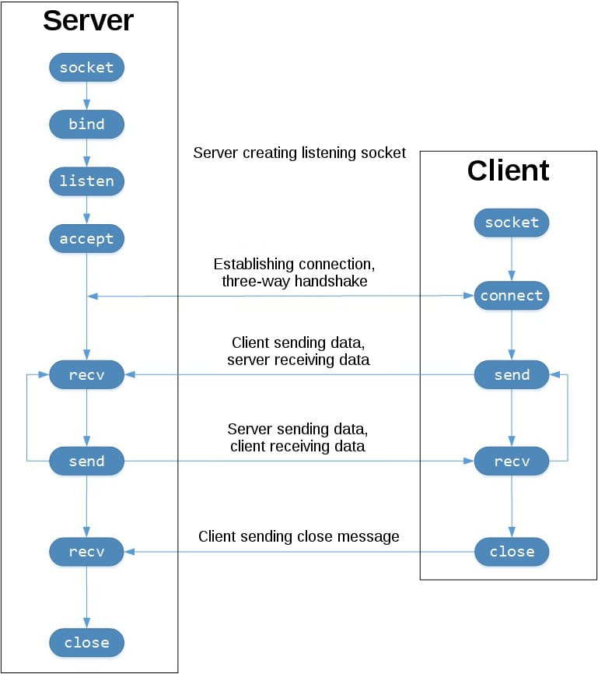

The arguments passed to socket() are constants used to specify the address family and socket type. AF_INET is the Internet address family for IPv4. SOCK_STREAM is the socket type for TCP, the protocol that will be used to transport messages in the network. The IP address 127.0.0.1 is the standard IPv4 address for the loopback interface, so only processes on the host will be able to connect to the server. port represents the TCP port number to accept connections on from clients. It should be an integer from 1 to 65535, as 0 is reserved.

The .bind() method is used to associate the socket with a specific network interface and port number

The listen() method has a backlog parameter. It specifies the number of unaccepted connections that the system will allow before refusing new connections. If your server receives a lot of connection requests simultaneously, increasing the backlog value may help by setting the maximum length of the queue for pending connections.

The accept() method blocks execution and waits for an incoming connection. When a client connects, it returns a new socket object representing the connection and a tuple holding the address of the client. The tuple will contain (host, port) for IPv4 connections

**SOLUTION:**

**ClientTCP.py**

from socket import *

serverName = '127.0.0.1'

serverPort = 12000

clientSocket = socket(AF_INET, SOCK_STREAM)

clientSocket.connect((serverName,serverPort))

sentence = input("\nEnter file name: ")

clientSocket.send(sentence.encode())

filecontents = clientSocket.recv(1024).decode()

print ('\nFrom Server:\n')

print(filecontents)

clientSocket.close()

**ServerTCP.py**

from socket import *

serverName="127.0.0.1"

serverPort = 12000

serverSocket = socket(AF_INET,SOCK_STREAM)

serverSocket.bind((serverName,serverPort))

serverSocket.listen(1)

while 1:

print ("The server is ready to receive")

connectionSocket, addr = serverSocket.accept()

sentence = connectionSocket.recv(1024).decode()

file=open(sentence,"r")

l=file.read(1024)

connectionSocket.send(l.encode())

print ('\nSent contents of ' + sentence)

file.close()

connectionSocket.close()

OUTPUT:

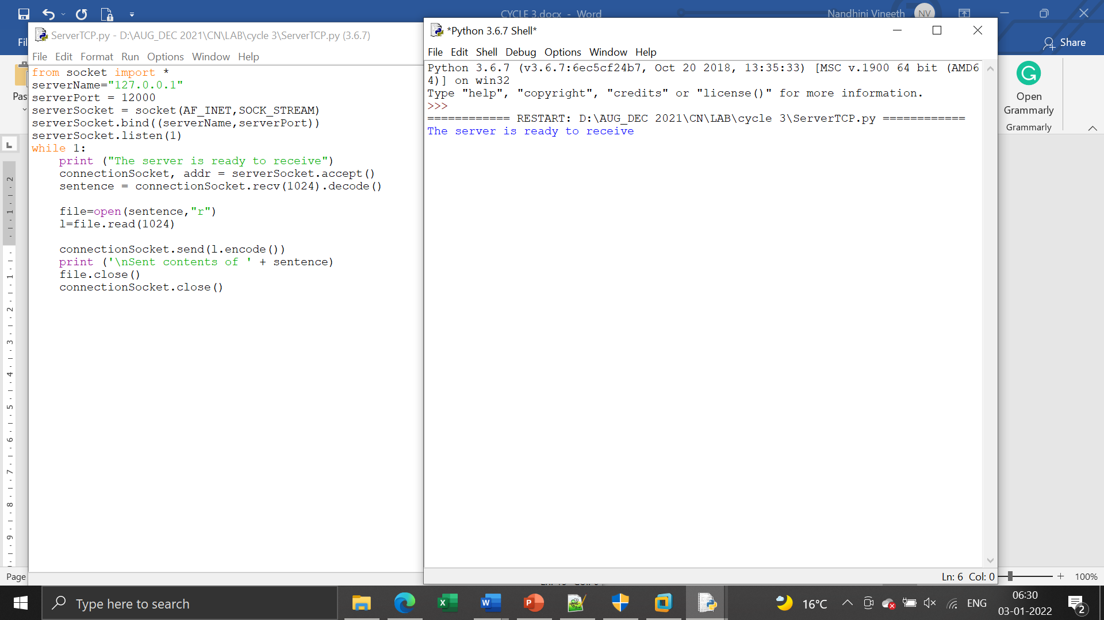

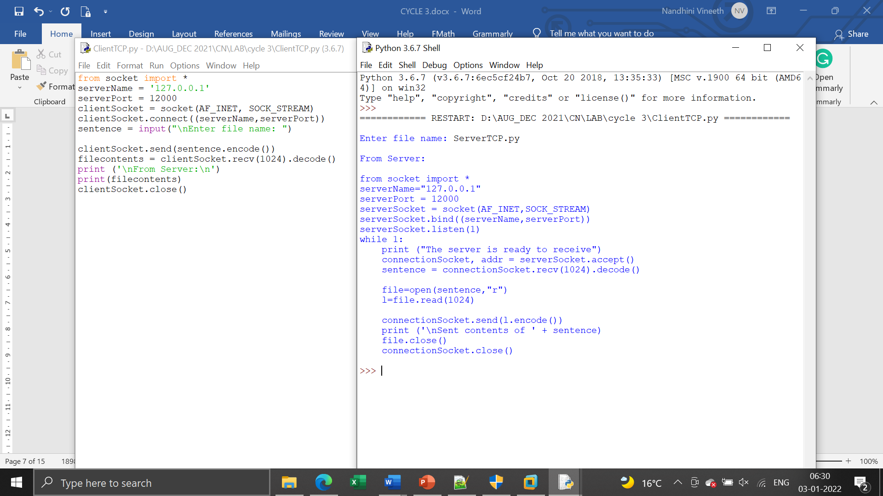

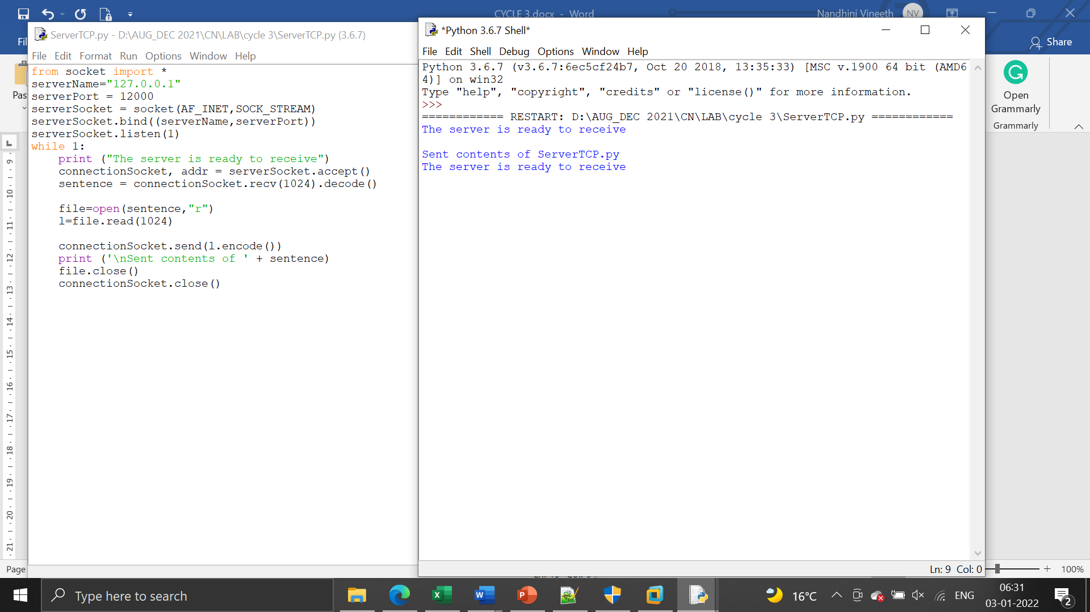

1. **Using UDP sockets, write a client-server program to make client sending the file name and the server to send back the contents of the requested file if present.**

**SOLUTION:**

**ClientUDP.py**

from socket import *

serverName = "127.0.0.1"

serverPort = 12000

clientSocket = socket(AF_INET, SOCK_DGRAM)

sentence = input("\nEnter file name: ")

clientSocket.sendto(bytes(sentence,"utf-8"),(serverName, serverPort))

filecontents,serverAddress = clientSocket.recvfrom(2048)

print ('\nReply from Server:\n')

print (filecontents.decode("utf-8"))

# for i in filecontents:

# print(str(i), end = '')

clientSocket.close()

clientSocket.close()

**ServerUDP.py**

from socket import *

serverPort = 12000

serverSocket = socket(AF_INET, SOCK_DGRAM)

serverSocket.bind(("127.0.0.1", serverPort))

print ("The server is ready to receive")

while 1:

sentence, clientAddress = serverSocket.recvfrom(2048)

sentence = sentence.decode("utf-8")

file=open(sentence,"r")

con=file.read(2048)

serverSocket.sendto(bytes(con,"utf-8"),clientAddress)

print ('\nSent contents of ', end = ' ')

print (sentence)

# for i in sentence:

# print (str(i), end = '')

file.close()

SOLUTION:

