How to configure RIP Routing Protocol in Routers
RIP-Routing Information Protocol
Routing Information Protocol is distance vector routing protocol.It knows only neighbors,
It doesn't know entire topology,Routing by rumors
It doesn't support classless network(CIDR),But Rip Version 2 supports CIDR and VLSM
It will update routing informations every 30 seconds(Periodic Updates)
It sends entire routing table to its neighbour
RIP- Routing Information Protocol
Administrative Distance-120
Maximum Hop count-15,16 is unreachable network
Metric - Hop count
Here we are going to see how to configure RIP in a simple topology,check connectivity between hosts
Step 1:Create a topology like i have added below
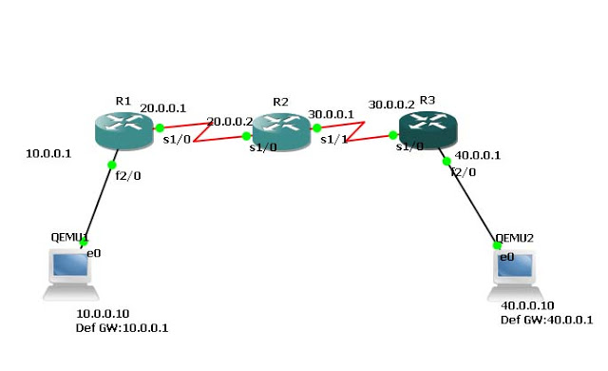
Step 2:Configure ip address for all interfaces and assign ip address,default gateway to hosts
In Router R1,
R1(config)#interface fastethernet 2/0
R1(config-if)#ip address 10.0.0.1 255.0.0.0
R1(config-if)#no shutdown
R1(config-if)#exit
R1(config)#interface serial 1/0
R1(config-if)#ip address 20.0.0.1 255.0.0.0
R1(config-if)#encapsulation ppp
R1(config-if)#clock rate 64000
R1(config-if)#no shutdown
R1(config-if)#exit
In Router R2,
R2(config)#interface serial 1/0
R2(config-if)#ip address 20.0.0.2 255.0.0.0
R2(config-if)#encapsulation ppp
R2(config-if)#no shutdown
R2(config-if)#exit
R2(config)#interface serial 1/1
R2(config-if)#ip address 30.0.0.1 255.0.0.0
R2(config-if)#encapsulation ppp
R2(config-if)#clock rate 64000
R2(config-if)#no shutdown
R2(config-if)#exit
In Router R3,
R3(config)#
R3(config)#interface serial 1/0
R3(config-if)#ip address 30.0.0.2 255.0.0.0
R3(config-if)#encapsulation ppp
R3(config-if)#no shutdown
R3(config-if)#exit
R3(config)#
R3(config)#interface fastethernet 2/0
R3(config-if)#ip address 40.0.0.1 255.0.0.0
R3(config-if)#no shutdown
R3(config-if)#exit
Step 3:Configure RIP to all routers by using command,
In Router R1,
R1(config)#router rip
R1(config-router)#network 10.0.0.0
R1(config-router)#network 20.0.0.0
R1(config-router)#exit
In Router R2,
R2(config)#router rip
R2(config-router)#network 20.0.0.0
R2(config-router)#network 30.0.0.0
R2(config-router)#exit
In Router R3,
R3(config)#router rip
R3(config-router)#network 30.0.0.0
R3(config-router)#network 40.0.0.0
R3(config-router)#exit
Step 4: Now check routing table of route R1.Router will have all network information in its routing table, router learned this route by using rip.
R1#show ip route
Codes: C - connected, S - static, R - RIP, M - mobile, B - BGP
D - EIGRP, EX - EIGRP external, O - OSPF, IA - OSPF inter area
N1 - OSPF NSSA external type 1, N2 - OSPF NSSA external type 2
E1 - OSPF external type 1, E2 - OSPF external type 2
i - IS-IS, L1 - IS-IS level-1, L2 - IS-IS level-2, ia - IS-IS inter area
* - candidate default, U - per-user static route, o - ODR
P - periodic downloaded static route
Gateway of last resort is not set
C 10.0.0.0/8 is directly connected, FastEthernet2/0
C 20.0.0.0/8 is directly connected, Serial1/0
R 40.0.0.0/8 [120/2] via 20.0.0.2, 00:00:02, Serial1/0
R 30.0.0.0/8 [120/1] via 20.0.0.2, 00:00:02, Serial1/0
Step 5:Now ping from host 10.0.0.10 to 40.0.0.10
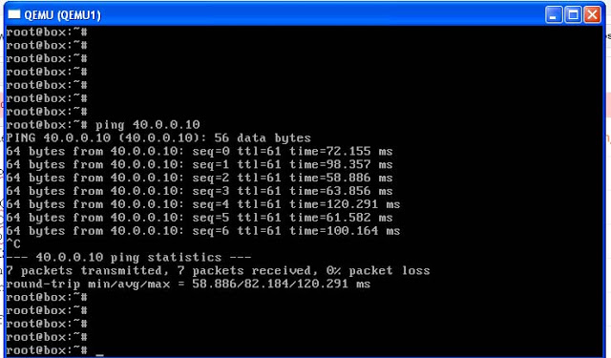

RIP Version 2
RIP- Routing Information Protocol
Administrative Distance-120
Maximum Hop count-15,16 is unreachable network
Metric - Hop count
Rip version 2 supports CIDR(Classless Ineternet Domain Routing)
To configure with rip version 2,just give this command,
R1(config)#router rip
R1(config-router)#version 2
R1(config-router)#network 10.0.0.0
R1(config-router)#network 20.0.0.0
R1(config-router)#exit

How to configure OSPF Routing Protocol and Connect Areas

OSPF-Open Short Path First,It is a Open Standard Routing Protocol
Link State Routing Protocol
Algorithm -Dijkistra,To find shortest path
Administrativ Distance-110
Metric- 10^8/Bandwidth
Incremental Update
Load Balancing Maximum 6 (Default 4)
It knows Network topology
Router ID-Initializes OSPF Process
Fast convergence
Timers
Hello-10
Dead-40
Wait-40
Retransmit-5
Step 1:Create topology like below i have given
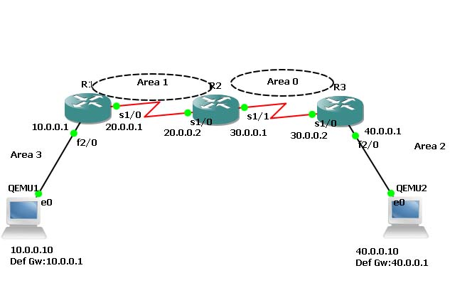 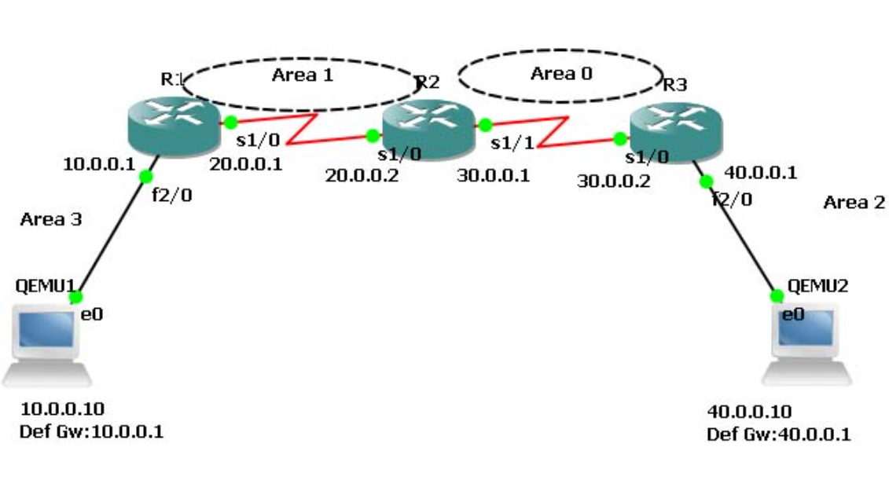
Step 2:Cofigure ip addres to all interfaces
In Router R1,
R1(config)#interface fastethernet 2/0
R1(config-if)#ip address 10.0.0.1 255.0.0.0
R1(config-if)#no shutdown
R1(config-if)#exit
R1(config)#interface serial 1/0
R1(config-if)#ip address 20.0.0.1 255.0.0.0
R1(config-if)#encapsulation ppp
R1(config-if)#clock rate 64000
R1(config-if)#no shutdown
R1(config-if)#exit
In Router R2,
R2(config)#interface serial 1/0
R2(config-if)#ip address 20.0.0.2 255.0.0.0
R2(config-if)#encapsulation ppp
R2(config-if)#no shutdown
R2(config-if)#exit
R2(config)#interface serial 1/1
R2(config-if)#ip address 30.0.0.1 255.0.0.0
R2(config-if)#encapsulation ppp
R2(config-if)#clock rate 64000
R2(config-if)#no shutdown
R2(config-if)#exit
In Router R3,
R3(config)#
R3(config)#interface serial 1/0
R3(config-if)#ip address 30.0.0.2 255.0.0.0
R3(config-if)#encapsulation ppp
R3(config-if)#no shutdown
R3(config-if)#exit
R3(config)#
R3(config)#interface fastethernet 2/0
R3(config-if)#ip address 40.0.0.1 255.0.0.0
R3(config-if)#no shutdown
R3(config-if)#exit
Step 3:Now,Enable ip routing by configuring ospf routing protocol in all routers,
In Router R1,
R1(config)#router ospf 1
R1(config-router)#router-id 1.1.1.1
R1(config-router)#network 10.0.0.0 0.255.255.255 area 3
R1(config-router)#network 20.0.0.0 0.255.255.255 area 1
R1(config-router)#exit
In Router R2,
R2(config)#router ospf 1
R2(config-router)#router-id 2.2.2.2
R2(config-router)#network 20.0.0.0 0.255.255.255 area 1
R2(config-router)#network 30.0.0.0 0.255.255.255 area 0
R2(config-router)#exit
In Router R3,
R3(config)#router ospf 1
R3(config-router)#router-id 3.3.3.3
R3(config-router)#network 30.0.0.0 0.255.255.255 area 0
R3(config-router)#network 40.0.0.0 0.255.255.255 area 2
R3(config-router)#exit
You have to configure router id when we configure ospf.It is used to identify the router
Step 4:Now check routing table of R1,
Router#show ip route
Codes: C - connected, S - static, R - RIP, M - mobile, B - BGP
D - EIGRP, EX - EIGRP external, O - OSPF, IA - OSPF inter area
N1 - OSPF NSSA external type 1, N2 - OSPF NSSA external type 2
E1 - OSPF external type 1, E2 - OSPF external type 2
i - IS-IS, L1 - IS-IS level-1, L2 - IS-IS level-2, ia - IS-IS inter area
* - candidate default, U - per-user static route, o - ODR
P - periodic downloaded static route
Gateway of last resort is not set
C 10.0.0.0/8 is directly connected, FastEthernet2/0
C 20.0.0.0/8 is directly connected, Serial1/0
O IA 40.0.0.0/8 [110/129] via 20.0.0.2, 00:04:23, Serial1/0
O IA 30.0.0.0/8 [110/128] via 20.0.0.2, 00:07:29, Serial1/0
Here,R2 knows Area 0.Network 20.0.0.0 connected to R2 from R1,So R1 learns networks through this network.
R3(config)#router ospf 1, Here, 1 is Process ID, it can be 1-65535.It initializes ospf process.
There must be one interface up to keep ospf process up. So its better to configure loopback address to routers. It is a virtual interface never goes down once we configured.
R1(config-if)#interface loopback 0
R1(config-if)#ip add 172.16.1.252 255.255.0.0
R1(config-if)#no shutdown
R2(config-if)#interface loopback 0
R2(config-if)#ip add 172.16.1.253 255.255.0.0
R2(config-if)#no shutdown
R3(config-if)#interface loopback 0
R3(config-if)#ip add 172.16.1.254 255.255.0.0
R3(config-if)#no shutdown
Step 5:Now ,Check Routing table of R3,
R3#show ip route
Codes: C - connected, S - static, R - RIP, M - mobile, B - BGP
D - EIGRP, EX - EIGRP external, O - OSPF, IA - OSPF inter area
N1 - OSPF NSSA external type 1, N2 - OSPF NSSA external type 2
E1 - OSPF external type 1, E2 - OSPF external type 2
i - IS-IS, L1 - IS-IS level-1, L2 - IS-IS level-2, ia - IS-IS inter area
* - candidate default, U - per-user static route, o - ODR
P - periodic downloaded static route
Gateway of last resort is not set
O IA 20.0.0.0/8 [110/128] via 30.0.0.1, 00:18:58, Serial1/0
C 40.0.0.0/8 is directly connected, FastEthernet2/0
C 30.0.0.0/8 is directly connected, Serial1/0
Here,R3 doesn't know about the area 3 so we have to create virtual link between R1 and R2
Step 6:Create virtual link between R1,R2,by this we create a virtual link to connect area 3 to area 0.
In Router R1,
R1(config)#router ospf 1
R1(config-router)#area 1 virtual-link 2.2.2.2
R1(config-router)#
*Feb 10 10:29:23.767: %OSPF-5-ADJCHG: Process 1, Nbr 2.2.2.2 on OSPF_VL0 from LOADING to FULL, Loadi
ng Done
In Rotuer R2,
*Feb 10 10:28:59.543: %OSPF-4-ERRRCV: Received invalid packet: mismatch area ID, from backbone area must be virtual-link but not found from 20.0.0.1, Serial1/0a
*Feb 10 10:29:09.535: %OSPF-4-ERRRCV: Received invalid packet: mismatch area ID, from backbone area must be virtual-link but not found from 20.0.0.1, Serial1/0.1.1
R2(config-router)#
R2(config-router)#area 1 virtual-link 1.1.1.1
R2(config-router)#exit
R2(config)#
*Feb 10 10:29:19.667: %OSPF-5-ADJCHG: Process 1, Nbr 1.1.1.1 on OSPF_VL0 from LOADING to FULL, Loadi
ng Done
Step 7:R2 and R3 get updates about Area 3 .Now,Check routing table of R3,
R3#show ip route
Codes: C - connected, S - static, R - RIP, M - mobile, B - BGP
D - EIGRP, EX - EIGRP external, O - OSPF, IA - OSPF inter area
N1 - OSPF NSSA external type 1, N2 - OSPF NSSA external type 2
E1 - OSPF external type 1, E2 - OSPF external type 2
i - IS-IS, L1 - IS-IS level-1, L2 - IS-IS level-2, ia - IS-IS inter area
* - candidate default, U - per-user static route, o - ODR
P - periodic downloaded static route
Gateway of last resort is not set
O IA 20.0.0.0/8 [110/128] via 30.0.0.1, 00:01:56, Serial1/0
C 40.0.0.0/8 is directly connected, FastEthernet2/0
O IA 10.0.0.0/8 [110/129] via 30.0.0.1, 00:01:56, Serial1/0
C 30.0.0.0/8 is directly connected, Serial1/0
Step 8:Check connectivity between host 10.0.0.10 to 40.0.0.10
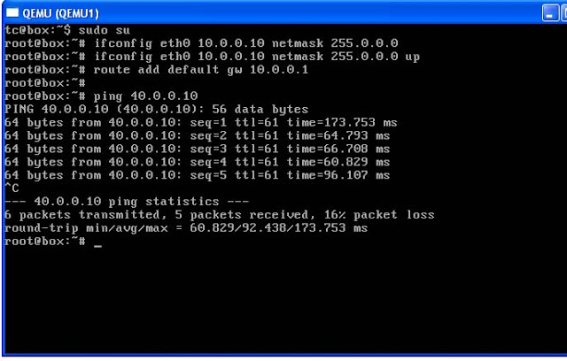

Trouble shooting
R3#show ip protocols
R3#show ip route ospf
R3#show ip ospf database
R3#show ip ospf interface

Router 1:
System Bootstrap, Version 12.1(3r)T2, RELEASE SOFTWARE (fc1)
Copyright (c) 2000 by cisco Systems, Inc.
PT 1001 (PTSC2005) processor (revision 0x200) with 60416K/5120K bytes of memory

Readonly ROMMON initialized

Self decompressing the image :
########################################################################## [OK]

Restricted Rights Legend

Use, duplication, or disclosure by the Government is
subject to restrictions as set forth in subparagraph
(c) of the Commercial Computer Software - Restricted
Rights clause at FAR sec. 52.227-19 and subparagraph
(c) (1) (ii) of the Rights in Technical Data and Computer
Software clause at DFARS sec. 252.227-7013.

cisco Systems, Inc.
170 West Tasman Drive
San Jose, California 95134-1706

Cisco Internetwork Operating System Software
IOS (tm) PT1000 Software (PT1000-I-M), Version 12.2(28), RELEASE SOFTWARE (fc5)
Technical Support: http://www.cisco.com/techsupport
Copyright (c) 1986-2005 by cisco Systems, Inc.
Compiled Wed 27-Apr-04 19:01 by miwang

PT 1001 (PTSC2005) processor (revision 0x200) with 60416K/5120K bytes of memory
.
Processor board ID PT0123 (0123)
PT2005 processor: part number 0, mask 01
Bridging software.
X.25 software, Version 3.0.0.
4 FastEthernet/IEEE 802.3 interface(s)
2 Low-speed serial(sync/async) network interface(s)
32K bytes of non-volatile configuration memory.
63488K bytes of ATA CompactFlash (Read/Write)

--- System Configuration Dialog ---

Continue with configuration dialog? [yes/no]: n

Press RETURN to get started!

Router>enable
Router#config t
Enter configuration commands, one per line. End with CNTL/Z.
Router(config)#interface fastethernet0/0
Router(config-if)#ip address 10.0.0.1 255.0.0.0
Router(config-if)#no shut

Router(config-if)#
%LINK-5-CHANGED: Interface FastEthernet0/0, changed state to up

%LINEPROTO-5-UPDOWN: Line protocol on Interface FastEthernet0/0, changed state to up

Router(config-if)#exit
Router(config)#interface serial2/0
Router(config-if)#ip address 20.0.0.1 255.0.0.0
Router(config-if)#encapsulation ppp
Router(config-if)#clock rate 64000
Router(config-if)#no shut

%LINK-5-CHANGED: Interface Serial2/0, changed state to down
Router(config-if)#exit
Router(config)#
%LINK-5-CHANGED: Interface Serial2/0, changed state to up

%LINEPROTO-5-UPDOWN: Line protocol on Interface Serial2/0, changed state to up

Router(config)#router ospf 1
Router(config-router)#router-id 1.1.1.1
Router(config-router)#network 10.0.0.0 0.255.255.255 area 3
Router(config-router)#network 20.0.0.0 0.255.255.255 area 1
Router(config-router)#exit
Router(config)#
00:19:37: %OSPF-5-ADJCHG: Process 1, Nbr 2.2.2.2 on Serial2/0 from LOADING to FULL, Loading Done

Router(config)#interface serial 2/0
Router(config-if)#interface loopback 0

Router(config-if)#
%LINK-5-CHANGED: Interface Loopback0, changed state to up

%LINEPROTO-5-UPDOWN: Line protocol on Interface Loopback0, changed state to up

Router(config-if)#ip address 172.16.1.252 255.255.0.0
Router(config-if)#no shut
Router(config-if)#exit
Router(config)#router ospf 1
Router(config-router)#area 1 virtual-link 2.2.2.2
00:29:27: %OSPF-4-ERRRCV: Received invalid packet: mismatch area ID, from backbone area must be virtual-link but not found from 20.0.0.1, Serial2/0

00:29:37: %OSPF-4-ERRRCV: Received invalid packet: mismatch area ID, from backbone area must be virtual-link but not found from 20.0.0.1, Serial2/0

00:29:47: %OSPF-4-ERRRCV: Received invalid packet: mismatch area ID, from backbone area must be virtual-link but not found from 20.0.0.1, Serial2/0

00:29:57: %OSPF-4-ERRRCV: Received invalid packet: mismatch area ID, from backbone area must be virtual-link but not found from 20.0.0.1, Serial2/0

00:30:07: %OSPF-4-ERRRCV: Received invalid packet: mismatch area ID, from backbone area must be virtual-link but not found from 20.0.0.1, Serial2/0

00:30:17: %OSPF-4-ERRRCV: Received invalid packet: mismatch area ID, from backbone area must be virtual-link but not found from 20.0.0.1, Serial2/0

00:30:27: %OSPF-4-ERRRCV: Received invalid packet: mismatch area ID, from backbone area must be virtual-link but not found from 20.0.0.1, Serial2/0

00:30:37: %OSPF-4-ERRRCV: Received invalid packet: mismatch area ID, from backbone area must be virtual-link but not found from 20.0.0.1, Serial2/0

00:30:47: %OSPF-4-ERRRCV: Received invalid packet: mismatch area ID, from backbone area must be virtual-link but not found from 20.0.0.1, Serial2/0

00:30:57: %OSPF-4-ERRRCV: Received invalid packet: mismatch area ID, from backbone area must be virtual-link but not found from 20.0.0.1, Serial2/0

00:31:07: %OSPF-4-ERRRCV: Received invalid packet: mismatch area ID, from backbone area must be virtual-link but not found from 20.0.0.1, Serial2/0

00:31:17: %OSPF-4-ERRRCV: Received invalid packet: mismatch area ID, from backbone area must be virtual-link but not found from 20.0.0.1, Serial2/0

00:31:27: %OSPF-4-ERRRCV: Received invalid packet: mismatch area ID, from backbone area must be virtual-link but not found from 20.0.0.1, Serial2/0

00:31:37: %OSPF-4-ERRRCV: Received invalid packet: mismatch area ID, from backbone area must be virtual-link but not found from 20.0.0.1, Serial2/0

00:31:47: %OSPF-4-ERRRCV: Received invalid packet: mismatch area ID, from backbone area must be virtual-link but not found from 20.0.0.1, Serial2/0

Router(config-router)#
Router(config-router)#exit
Router(config)#exit
Router#
%SYS-5-CONFIG_I: Configured from console by console

Router#show ip route
Codes: C - connected, S - static, I - IGRP, R - RIP, M - mobile, B - BGP
D - EIGRP, EX - EIGRP external, O - OSPF, IA - OSPF inter area
N1 - OSPF NSSA external type 1, N2 - OSPF NSSA external type 2
E1 - OSPF external type 1, E2 - OSPF external type 2, E - EGP
i - IS-IS, L1 - IS-IS level-1, L2 - IS-IS level-2, ia - IS-IS inter area
* - candidate default, U - per-user static route, o - ODR
P - periodic downloaded static route

Gateway of last resort is not set

C 10.0.0.0/8 is directly connected, FastEthernet0/0
20.0.0.0/8 is variably subnetted, 2 subnets, 2 masks
C 20.0.0.0/8 is directly connected, Serial2/0
C 20.0.0.2/32 is directly connected, Serial2/0
O IA 30.0.0.0/8 [110/128] via 20.0.0.2, 00:11:34, Serial2/0
O IA 40.0.0.0/8 [110/129] via 20.0.0.2, 00:09:51, Serial2/0
C 172.16.0.0/16 is directly connected, Loopback0
Router#
00:32:15: %OSPF-5-ADJCHG: Process 1, Nbr 2.2.2.2 on OSPF_VL0 from LOADING to FULL, Loading Done

Router 2:
System Bootstrap, Version 12.1(3r)T2, RELEASE SOFTWARE (fc1)
Copyright (c) 2000 by cisco Systems, Inc.
PT 1001 (PTSC2005) processor (revision 0x200) with 60416K/5120K bytes of memory

Readonly ROMMON initialized

Self decompressing the image :
########################################################################## [OK]

Restricted Rights Legend

Use, duplication, or disclosure by the Government is
subject to restrictions as set forth in subparagraph
(c) of the Commercial Computer Software - Restricted
Rights clause at FAR sec. 52.227-19 and subparagraph
(c) (1) (ii) of the Rights in Technical Data and Computer
Software clause at DFARS sec. 252.227-7013.

cisco Systems, Inc.
170 West Tasman Drive
San Jose, California 95134-1706

Cisco Internetwork Operating System Software
IOS (tm) PT1000 Software (PT1000-I-M), Version 12.2(28), RELEASE SOFTWARE (fc5)
Technical Support: http://www.cisco.com/techsupport
Copyright (c) 1986-2005 by cisco Systems, Inc.
Compiled Wed 27-Apr-04 19:01 by miwang

PT 1001 (PTSC2005) processor (revision 0x200) with 60416K/5120K bytes of memory
.
Processor board ID PT0123 (0123)
PT2005 processor: part number 0, mask 01
Bridging software.
X.25 software, Version 3.0.0.
4 FastEthernet/IEEE 802.3 interface(s)
2 Low-speed serial(sync/async) network interface(s)
32K bytes of non-volatile configuration memory.
63488K bytes of ATA CompactFlash (Read/Write)

--- System Configuration Dialog ---

Continue with configuration dialog? [yes/no]: n

Press RETURN to get started!

Router>enable
Router#config
Configuring from terminal, memory, or network [terminal]? t
Enter configuration commands, one per line. End with CNTL/Z.
Router(config)#interface serial2/0
Router(config-if)#ip address 20.0.0.2 255.0.0.0
Router(config-if)#encapsulation ppp
Router(config-if)#no shut

Router(config-if)#
%LINK-5-CHANGED: Interface Serial2/0, changed state to up

%LINEPROTO-5-UPDOWN: Line protocol on Interface Serial2/0, changed state to up

Router(config-if)#exit
Router(config)#interface serial3/0
Router(config-if)#ip address 30.0.0.1 255.0.0.0
Router(config-if)#encapsulation ppp
Router(config-if)#clock rate 64000
Router(config-if)#no shut

%LINK-5-CHANGED: Interface Serial3/0, changed state to down
Router(config-if)#exit
Router(config)#
%LINK-5-CHANGED: Interface Serial3/0, changed state to up

%LINEPROTO-5-UPDOWN: Line protocol on Interface Serial3/0, changed state to up

Router con0 is now available

Press RETURN to get started.

Router>enable
Router#config t
Enter configuration commands, one per line. End with CNTL/Z.
Router(config)#router ospf 1
Router(config-router)#router-id 2.2.2.2
Router(config-router)#network 20.0.0.0 0.255.255.255 area 1
Router(config-router)#network 20.0.0.0 0.255.255.255 area 1
00:19:33: %OSPF-5-ADJCHG: Process 1, Nbr 1.1.1.1 on Serial2/network 20.0.0.0 0.255.255.255 area 1
Router(config-router)#network 30.0.0.0 0.255.255.255 area 0
Router(config-router)#exit
Router(config)#
00:21:29: %OSPF-5-ADJCHG: Process 1, Nbr 3.3.3.3 on Serial3/0 from LOADING to FULL, Loading Done

Router(config)#interface serial2/0
Router(config-if)#interface loopback 0

Router(config-if)#
%LINK-5-CHANGED: Interface Loopback0, changed state to up

%LINEPROTO-5-UPDOWN: Line protocol on Interface Loopback0, changed state to up

Router(config-if)#ip address 172.16.1.253 255.255.0.0
Router(config-if)#no shutdown
Router(config-if)#exit
Router(config)#router ospf 1
Router(config-router)#area 1 virtual link 1.1.1.1
^
% Invalid input detected at '^' marker.
Router(config-router)#area 1 virtual-link 1.1.1.1
Router(config-router)#exit
Router(config)#
Router(config)#exit
Router#
%SYS-5-CONFIG_I: Configured from console by console

Router#show ip route
Codes: C - connected, S - static, I - IGRP, R - RIP, M - mobile, B - BGP
D - EIGRP, EX - EIGRP external, O - OSPF, IA - OSPF inter area
N1 - OSPF NSSA external type 1, N2 - OSPF NSSA external type 2
E1 - OSPF external type 1, E2 - OSPF external type 2, E - EGP
i - IS-IS, L1 - IS-IS level-1, L2 - IS-IS level-2, ia - IS-IS inter area
* - candidate default, U - per-user static route, o - ODR
P - periodic downloaded static route

Gateway of last resort is not set

20.0.0.0/8 is variably subnetted, 2 subnets, 2 masks
C 20.0.0.0/8 is directly connected, Serial2/0
C 20.0.0.1/32 is directly connected, Serial2/0
30.0.0.0/8 is variably subnetted, 2 subnets, 2 masks
C 30.0.0.0/8 is directly connected, Serial3/0
C 30.0.0.2/32 is directly connected, Serial3/0
O IA 40.0.0.0/8 [110/65] via 30.0.0.2, 00:07:59, Serial3/0
C 172.16.0.0/16 is directly connected, Loopback0
Router#show ip route
Codes: C - connected, S - static, I - IGRP, R - RIP, M - mobile, B - BGP
D - EIGRP, EX - EIGRP external, O - OSPF, IA - OSPF inter area
N1 - OSPF NSSA external type 1, N2 - OSPF NSSA external type 2
E1 - OSPF external type 1, E2 - OSPF external type 2, E - EGP
i - IS-IS, L1 - IS-IS level-1, L2 - IS-IS level-2, ia - IS-IS inter area
* - candidate default, U - per-user static route, o - ODR
P - periodic downloaded static route

Gateway of last resort is not set

20.0.0.0/8 is variably subnetted, 2 subnets, 2 masks
C 20.0.0.0/8 is directly connected, Serial2/0
C 20.0.0.1/32 is directly connected, Serial2/0
30.0.0.0/8 is variably subnetted, 2 subnets, 2 masks
C 30.0.0.0/8 is directly connected, Serial3/0
C 30.0.0.2/32 is directly connected, Serial3/0
O IA 40.0.0.0/8 [110/65] via 30.0.0.2, 00:10:06, Serial3/0
C 172.16.0.0/16 is directly connected, Loopback0
Router#
00:32:11: %OSPF-5-ADJCHG: Process 1, Nbr 1.1.1.1 on OSPF_VL0 from LOADING to FULL, Loading Done

Router#
Router#show ip route
Codes: C - connected, S - static, I - IGRP, R - RIP, M - mobile, B - BGP
D - EIGRP, EX - EIGRP external, O - OSPF, IA - OSPF inter area
N1 - OSPF NSSA external type 1, N2 - OSPF NSSA external type 2
E1 - OSPF external type 1, E2 - OSPF external type 2, E - EGP
i - IS-IS, L1 - IS-IS level-1, L2 - IS-IS level-2, ia - IS-IS inter area
* - candidate default, U - per-user static route, o - ODR
P - periodic downloaded static route

Gateway of last resort is not set

O IA 10.0.0.0/8 [110/65] via 20.0.0.1, 00:00:27, Serial2/0
20.0.0.0/8 is variably subnetted, 2 subnets, 2 masks
C 20.0.0.0/8 is directly connected, Serial2/0
C 20.0.0.1/32 is directly connected, Serial2/0
30.0.0.0/8 is variably subnetted, 2 subnets, 2 masks
C 30.0.0.0/8 is directly connected, Serial3/0
C 30.0.0.2/32 is directly connected, Serial3/0
O IA 40.0.0.0/8 [110/65] via 30.0.0.2, 00:10:46, Serial3/0
C 172.16.0.0/16 is directly connected, Loopback0

Router 3:
System Bootstrap, Version 12.1(3r)T2, RELEASE SOFTWARE (fc1)
Copyright (c) 2000 by cisco Systems, Inc.
PT 1001 (PTSC2005) processor (revision 0x200) with 60416K/5120K bytes of memory

Readonly ROMMON initialized

Self decompressing the image :
########################################################################## [OK]

Restricted Rights Legend

Use, duplication, or disclosure by the Government is
subject to restrictions as set forth in subparagraph
(c) of the Commercial Computer Software - Restricted
Rights clause at FAR sec. 52.227-19 and subparagraph
(c) (1) (ii) of the Rights in Technical Data and Computer
Software clause at DFARS sec. 252.227-7013.

cisco Systems, Inc.
170 West Tasman Drive
San Jose, California 95134-1706

Cisco Internetwork Operating System Software
IOS (tm) PT1000 Software (PT1000-I-M), Version 12.2(28), RELEASE SOFTWARE (fc5)
Technical Support: http://www.cisco.com/techsupport
Copyright (c) 1986-2005 by cisco Systems, Inc.
Compiled Wed 27-Apr-04 19:01 by miwang

PT 1001 (PTSC2005) processor (revision 0x200) with 60416K/5120K bytes of memory
.
Processor board ID PT0123 (0123)
PT2005 processor: part number 0, mask 01
Bridging software.
X.25 software, Version 3.0.0.
4 FastEthernet/IEEE 802.3 interface(s)
2 Low-speed serial(sync/async) network interface(s)
32K bytes of non-volatile configuration memory.
63488K bytes of ATA CompactFlash (Read/Write)

--- System Configuration Dialog ---

Continue with configuration dialog? [yes/no]: n

Press RETURN to get started!

Router>enable
Router#config t
Enter configuration commands, one per line. End with CNTL/Z.
Router(config)#interface serial2/0
Router(config-if)#ip addrss 30.0.0.2 255.0.0.0
^
% Invalid input detected at '^' marker.
Router(config-if)#ip address 30.0.0.2 255.0.0.0
Router(config-if)#encapsulation ppp
Router(config-if)#no shut

Router(config-if)#
%LINK-5-CHANGED: Interface Serial2/0, changed state to up

Router(config-if)#exit
Router(config)#
%LINEPROTO-5-UPDOWN: Line protocol on Interface Serial2/0, changed state to up

Router(config)#interface fastethernet0/0
Router(config-if)#ip address 40.0.0.1 255.0.0.0
Router(config-if)#no shut

Router(config-if)#
%LINK-5-CHANGED: Interface FastEthernet0/0, changed state to up

%LINEPROTO-5-UPDOWN: Line protocol on Interface FastEthernet0/0, changed state to up

Router(config-if)#exit
Router(config)#

Router con0 is now available

Press RETURN to get started.

Router>enable
Router#config t
Enter configuration commands, one per line. End with CNTL/Z.
Router(config)#router ospf 1
Router(config-router)#router-id 3.3.3.3
Router(config-router)#network 30.0.0.0 0.255.255.255 area 0
Router(config-router)#network 40.0.0.0 0.255.255.255 area 0
00:21:27: %OSPF-5-ADJCHG: Process 1, Nbr 2.2.2.2 on Serial2network 30.0.0.0 0.255.255.255 area 0
Router(config-router)#network 40.0.0.0 0.255.255.255 area 2
Router(config-router)#exit
Router(config)#interface serial 2/0
Router(config-if)#interface loopback 0

Router(config-if)#
%LINK-5-CHANGED: Interface Loopback0, changed state to up

%LINEPROTO-5-UPDOWN: Line protocol on Interface Loopback0, changed state to up

Router(config-if)#ip address 172.16.1.254 255.255.0.0
Router(config-if)#no shut
Router(config-if)#exit
Router(config)#exit
Router#
%SYS-5-CONFIG_I: Configured from console by console

Router#show ip route
Codes: C - connected, S - static, I - IGRP, R - RIP, M - mobile, B - BGP
D - EIGRP, EX - EIGRP external, O - OSPF, IA - OSPF inter area
N1 - OSPF NSSA external type 1, N2 - OSPF NSSA external type 2
E1 - OSPF external type 1, E2 - OSPF external type 2, E - EGP
i - IS-IS, L1 - IS-IS level-1, L2 - IS-IS level-2, ia - IS-IS inter area
* - candidate default, U - per-user static route, o - ODR
P - periodic downloaded static route

Gateway of last resort is not set

O IA 20.0.0.0/8 [110/128] via 30.0.0.1, 00:04:09, Serial2/0
30.0.0.0/8 is variably subnetted, 2 subnets, 2 masks
C 30.0.0.0/8 is directly connected, Serial2/0
C 30.0.0.1/32 is directly connected, Serial2/0
C 40.0.0.0/8 is directly connected, FastEthernet0/0
C 172.16.0.0/16 is directly connected, Loopback0
Router#show ip route
Codes: C - connected, S - static, I - IGRP, R - RIP, M - mobile, B - BGP
D - EIGRP, EX - EIGRP external, O - OSPF, IA - OSPF inter area
N1 - OSPF NSSA external type 1, N2 - OSPF NSSA external type 2
E1 - OSPF external type 1, E2 - OSPF external type 2, E - EGP
i - IS-IS, L1 - IS-IS level-1, L2 - IS-IS level-2, ia - IS-IS inter area
* - candidate default, U - per-user static route, o - ODR
P - periodic downloaded static route

Gateway of last resort is not set

O IA 10.0.0.0/8 [110/129] via 30.0.0.1, 00:00:20, Serial2/0
O IA 20.0.0.0/8 [110/128] via 30.0.0.1, 00:11:01, Serial2/0
30.0.0.0/8 is variably subnetted, 2 subnets, 2 masks
C 30.0.0.0/8 is directly connected, Serial2/0
C 30.0.0.1/32 is directly connected, Serial2/0
C 40.0.0.0/8 is directly connected, FastEthernet0/0
C 172.16.0.0/16 is directly connected, Loopback0

