Deployment Document — LavaRápido Vehicular
Vehicle wash management system · ADSO training project (SENA) Software implementation procedure on the production server.

Table of Contents
- General Information and Version Control
- Scope, Topology and Architecture
- Prerequisites and Preparation (Pre-deployment)
- Step-by-Step Deployment Procedure (Runbook)
- Verification, Testing and Evidence Plan (Smoke Tests)

1. General Information and Version Control

1.1 Deployment Fact Sheet

1.1.1 System identification and version (Release Tag)
Field | Value
System | LavaRápido Vehicular — bookings, payments and operations management for a car wash
Components | 6 backend microservices, API Gateway, web application, Android mobile app
Version (Release Tag) | As of 2026-11-04: v1.1.0 in api-gateway, security, operations, and notification; v1.1.1 in customer and booking; v1.1.2 in the web, infra, and the mobile app (the latter only with a corrected text, which reached the phones over the internet); and v1.1.3 in payment-service (merged into main on 2026-10-27, with tag and release on 2026-11-04; in production since 2026-11-04, 1.3.14). All are on main, protected in the 10 repositories (PR with one approval from another member and a green CI). Before: v1.0.0 (2026-10-23 in 8 repositories and 2026-10-24 in payment-service), v1.1.0 in all 10 and v1.1.1 in the web, the mobile app, payment-service, and infra on 2026-10-26 (1.3.12), and v1.1.1 in customer and booking and v1.1.2 in the web, payment-service, and infra on 2026-10-27 (1.3.13)
Deployed branch | main in the server's 9 repositories since 2026-10-26, payment-service included (since infra v1.1.1 it is no longer in DEVELOP_ONLY). Continuous deployment updates the server on every approved merge into main (4.3.4); the latest runs, of 2026-10-27, are in 1.3.13
Mobile app version | 1.1.1 (versionCode 6), APK published on 2026-10-26 at 22:39 + over-the-air updates (EAS Update); the latest, that of v1.1.2 on 2026-10-27 at 14:30 (1.3.13)
Repositories | lavarapido-infra, lavarapido-api-gateway, lavarapido-security-service, lavarapido-customer-service, lavarapido-booking-service, lavarapido-operation-service, lavarapido-notification-service, lavarapido-payment-service, Front-end-proyecto-web, LavadoVehicular-Movil
Public address | https://lavarapidovehicular.northcentralus.cloudapp.azure.com

1.1.2 Scheduled date, time and maintenance window
Field | Value
Initial deployment date | October 16, 2026
Maintenance window | 02:30 – 05:30 (Colombia time, UTC-5)
Actual duration | ~2 h 30 min (provisioning, image builds, HTTPS setup and testing)
User downtime | Not applicable: first deployment (no users in production yet)
Window for future updates | Outside the car wash's business hours (before 07:00 or after 18:00)
Latest update | 2026-10-27, through continuous deployment (1.3.13): at 01:03 (Colombia time) the web v1.1.2, and between 01:35 and 01:37 customer and booking v1.1.1 and payment-service and infra v1.1.2; every run that finished ended green, with the services healthy and the web and the API answering 200. At 14:30 the mobile app v1.1.2 reached the phones over the internet. Before, on 2026-10-26 at night: v1.1.0 and v1.1.1 and the first continuous deployment run (1.3.12). Before, on 2026-10-26 around 12:02 (Colombia time): booking-service, payment-service, and the web from develop, with payment at booking, booking migration 049 and seed 117 (1.3.11); services healthy and 0 errors. Before that, on 2026-10-24 at 17:12 UTC: notification-service only, with migration 048, which fixes reading pending_delivery (1.3.10). Before that, the same day around 15:10: the complete develop of the 10 repositories (fixes of October 23 and 24, 1.3.8 and 1.3.9), in two runs over SSH; 11 healthy containers, migrations 044, 045, and seed 113 (booking), 047 and seed 116 (notification), and 022 and 023 (payment) applied, and 0 errors in the logs. The previous update (2026-10-22) is in 1.3.7

1.1.3 Target environment (VPS / Staging / Production)
Field | Value
Environment | Academic production (also used as staging for the team's tests)
Provider | Microsoft Azure (Azure for Students subscription)
Type | Linux virtual machine (IaaS), equivalent to a VPS
Region | North Central US
Alternate environment | None: the Hostinger VPS was dropped on 2026-10-21 because the payment was not approved; production stays on Azure only

1.1.4 Roles and responsibilities matrix (DevOps, Tech Lead, QA, DBA)
Responsibilities according to the services each member maintains on GitHub (owner of each repository). The QA and DBA roles have no fixed person: the project leader assigns them and, meanwhile, they are covered as shown.
Role | Owner | Deployment responsibilities
DevOps | Brayan Cabrera | Server, Docker Compose, Caddy/HTTPS, deployment and update scripts
Tech Lead | Brayan Cabrera | Release approval, change review, team coordination
QA | No fixed person (assigned by Brayan Cabrera); meanwhile, each owner tests their part and DevOps runs section 5 | Smoke tests and functional validation per role (client, operator, administrator)
DBA | No fixed person (assigned by Brayan Cabrera); meanwhile, DevOps with the scripts of section 3.2 | Migrations, backups and database verification
booking-service and customer-service owner | Camilo Guilombo | Changes and verification of their services
payment-service and mobile app owner | Merari Urbano Quintero | Changes and verification of payments and the app

1.2 Document Version History
Version | Date | Author | Description
1.0 | 2026-10-16 | Brayan Cabrera | Initial version: deployment on Azure
1.1 | 2026-10-16 | Brayan Cabrera | Portainer CE installed, real evidence (5.4) and correction of Liquibase schemas and tables
1.2 | 2026-10-16 | Juan Camilo Guilombo | Table count corrected (57) and first administrator created with the environment variables
1.3 | 2026-10-19 | Juan Camilo Guilombo | Update of 2026-10-19 (migration 039 and app 1.1.0), SSH access with a personal key per member, deployment from GitHub Actions, continuous integration in the 10 repositories, and new terminal and web evidence
1.4 | 2026-10-20 | Development team | Topology diagram: customer-service also connects to RabbitMQ (it consumes security.user_registered to create the customer profile)
1.5 | 2026-10-21 | Brayan Cabrera | Verified automatic backups (3.2), security headers and CSP (2.2.3 and 5.2.4), health checks and capped logs in every container, SIMPLE recovery model, update of 2026-10-21 (1.3.6), code changes of 2026-10-21 pending deployment (1.3.7), and removal of the Hostinger VPS
1.6 | 2026-10-21 | Development team | Evening changes of 2026-10-21 in 1.3.7: confirmed bookings with an operator that nobody registered are no longer closed as "No-show" on their own and go to "To close", migrations 040 (operations) and 041 (notification), FOLLOW_UP_* variables, fix for null fields in notification-service events, and mobile app adjustments
1.8 | 2026-10-24 | Development team | Deployment of 2026-10-24 with develop (1.1.1, 1.1.2, and 1.3.9): two runs, health wait, :prev images, rollback.sh, and the protection that prevents downgrading; the web on port 8080 (2.2.3); new variables AUTH_RATE_LIMIT_*, TRUSTED_PROXIES, ROUTE_*_TIMEOUT, START_LATE_LIMIT, and INTERNAL_API_KEY and BOOKING_SERVICE_URL in customer-service (3.3.2); rollback with rollback.sh and restore with payment-migrate (3.2.4 and 3.4); continuous deployment merged into develop, without secrets (4.3.4); mobile OTA with cd.yml; CI of 2026-10-24 (4.3.3)
1.7 | 2026-10-23 | Development team | Version v1.0.0 in 8 repositories and what is pending for payment and mobile (1.1.1); deployment of 2026-10-22 (1.3.7); fixes of 2026-10-23 in develop for v1.1.0 (1.3.8); the variables the compose file already passes, FOLLOW_UP_LOOK_BACK_DAYS and ALLOWED_EMAIL_DOMAINS (3.3.2); a rollback that works (3.4); setup-server.sh from main (4.3.1); continuous deployment prepared and not yet tested live (4.3.4); QA and DBA owners (1.1.4). Includes the content of Merari Urbano's fix/A-06, fix/A-07, and fix/A-08 branches
1.9 | 2026-10-24 | Development team | notification-service update of 2026-10-24 at 17:12 UTC with migration 048 and its result (1.3.10); latest update (1.1.2)
1.10 | 2026-10-26 | Development team | Deployment of payment at booking on 2026-10-26 around 12:02 (Colombia time): booking-service, payment-service, and the web, with their checks (1.3.11); new booking-service variables and INTERNAL_API_KEY required in payment-service (3.3.2); latest update (1.1.2)
1.11 | 2026-10-26 | Development team | Versions v1.1.0 and v1.1.1, payment-service from main, first run of continuous deployment and of APK versionCode 6 with the over-the-air update, and SonarCloud fixes (1.3.12 and 4.3.4).
1.12 | 2026-10-27 | Development team | Versions v1.1.1 and v1.1.2 of 2026-10-27 and their automatic deployments (1.1.1, 1.1.2, and 1.3.13); 58 tables (2.1.4 and 5.4.5); continuous integration with 1,337 tests and payment's integration tests against SQL Server (4.3.3); two notes that no longer apply are removed from continuous deployment (4.3.4).
1.13 | 2026-10-27 | Development team | payment-service release v1.1.3 approved and pending publication, with what it requires in production (1.3.14).
1.14 | 2026-11-04 | Development team | payment-service v1.1.3: merged into main on 2026-10-27, with tag and release on 2026-11-04; the automatic deployment of 2026-10-27 did not run because the machine was off, and the release went into production on 2026-11-04, when it was turned on (1.1.1 and 1.3.14). Continuous integration with 1,348 tests (4.3.3).

1.3 Change Summary (Release Notes)

1.3.1 New features
Platform and deployment
- Full deployment with Docker Compose and a production file (docker-compose.prod.yml).
- Automatic HTTPS with Caddy and a Let's Encrypt certificate (automatic renewal).
- Creation of the first administrator when installing on an empty database (ADMIN_EMAIL / ADMIN_PASSWORD).
- Server installation script (setup-server.sh) and one-step update script (update-server.sh).
- Android app download from the web (button and QR code) at the fixed address /app/LavaRapidoVehicular.apk.
Notifications
- Push notifications in the mobile app (Expo + Firebase) implemented with the Command pattern.
- Delivery through channels (push and email) with failure isolation.
- Notices in the account's language (Spanish, English, French and Portuguese).
- Notice to administrators about upcoming bookings without an operator.
- New app version notice by push and in the inbox.
- The web bell refreshes by itself and shows a floating notice with new notifications.
Bookings and operations
- Automatic operator assignment when a booking is confirmed (RF-008).
- The client can choose the operator among the available ones (RF-010).
- The operator can only start the service from 15 minutes before the booking.
- Vehicle inspection report with phases, findings and photos, shared with the client.
- Daily summary and operator team metrics for the administrator.
Payments and accounts
- Payment history sorted and filterable by date and service (RF-015/016).
- Account lockout for 15 minutes after 5 failed login attempts (RF-004b).
- Business data editable by the administrator and profile address stored in the backend.
Mobile app
- New version notice and over-the-internet updates (EAS Update) without reinstalling.
- Icon with the project logo and the name "LavaRapidoVehicular".

1.3.2 Bug fixes
- An approved payment was shown as "under verification" on the payments screen (web and mobile).
- The deployed web received 403 on every call because of the services' CORS configuration.
- security-service did not start when an administrator already existed (query outside a transaction).
- The app's operator list did not show a newly created operator until logging out.
- A late 401 after logging out showed the "session expired" notice.
- The new APK announcement could not read the inter-service key because of file permissions.
- Pending reminders kept being sent after the service was started or finished.
- No operator is assigned to bookings whose time has already passed, and cancelled bookings are no longer listed as pending.
- The web requested a non-existent favicon.ico (404 error in the console) and used deprecated translation options (console warning).

1.3.3 Infrastructure and dependency changes
Change | Detail
Docker images | Java: eclipse-temurin:21-jdk (build) and 21-jre (runtime) · .NET: dotnet/sdk:8.0 and aspnet:8.0 · Web: node:22-alpine and nginx:1.27-alpine
Infrastructure services | mcr.microsoft.com/mssql/server:2022-latest (Express), rabbitmq:4-management, caddy:2-alpine, liquibase/liquibase:4.29
New migrations | 032 (business data), 033 (inspection report), 034 (login lockout), 035 (address), 036 (registration date), 037 (operator profile), 038 (new-version notice type), and 039 (acceptance of the legal documents, applied on 2026-10-19)
Web dependencies | qrcode 1.5.4
Mobile dependencies | expo-notifications, expo-device, expo-build-properties, expo-updates, expo-application
External services | Expo Push + Firebase Cloud Messaging (push), Gmail SMTP (email), EAS (app builds and updates)
Server operation (2026-10-20 and 21) | Automatic backups with verification (backup-db.sh, verify-backup.sh, restore-db.sh), database in the SIMPLE recovery model, health check every 30 s in the 11 containers, logs of each container capped at 3 files of 10 MB, and security headers with a CSP in Caddy

1.3.4 Breaking changes
- New mandatory variables on the server. Without them, Docker Compose does not start:
  - INTERNAL_API_KEY, PUBLIC_URL, RABBITMQ_USERNAME and RABBITMQ_PASSWORD;
  - RABBITMQ_* cannot be guest/guest.
- First administrator: the demo accounts (admin@gmail.com, etc.) only exist in development. In production the administrator is created with ADMIN_EMAIL / ADMIN_PASSWORD.
- Mobile app: the Android package changed to com.vehiclecarwash.app. Previous versions must be uninstalled once; later ones install on top.
- CORS: each service only accepts the origin defined in PUBLIC_URL.

1.3.5 Update of 2026-10-19
On 2026-10-19 at 03:20 (server time), update-server.sh was run. The develop changes up to October 17 and 18 were deployed:
- Database: migration 039, which stores the date and time each person accepts the Terms and the Data Processing Policy.
- Backend: the payment-service health check queries the database, payment-service handles the correlation identifier, the schedule error carries the reason (reason), two simultaneous requests no longer fail when creating the same operator, and a bay cannot be created in maintenance.
- Web: the payment screen selects by account, the profile option is called "Deactivate my account", Angular is on 21.2.25 and xlsx on 0.20.3, and there are layout fixes for phones.
- Mobile app: version 1.1.0 (versionCode 5), published on 2026-10-19 at 05:03, with the version shown in Settings.
The changes pushed afterwards are left for the next update: the error messages with spring.web.error in the Java services and the latest web and app fixes.

1.3.6 Update of 2026-10-21
On 2026-10-21 at 05:21 (server time), the images were rebuilt with the develop code of October 20 and the new lavarapido-infra infrastructure. A database backup was taken first.
- Infrastructure: verified automatic backups (3.2); database in the SIMPLE recovery model; health check every 30 seconds in the 11 containers, Caddy included (docker compose ps shows them healthy); logs capped at 3 files of 10 MB per container; security headers and a content security policy (CSP) in Caddy (5.2.4).
- Backend and web: the changes left pending on 2026-10-19 (error messages with spring.web.error and web fixes) and those of October 19 and 20: the role change of an account was removed, the example business data is cleared so the real business fills it in (booking-service seed 111), and the web opens the detail of each booking and notification.

1.3.7 Changes of 2026-10-21 (deployed on 2026-10-22)
They were in develop since 2026-10-21 and reached the server on 2026-10-22 with update-server.sh; seed 112 and migrations 040 and 041 were applied, and backups LavaRapido-20261022-081543.bak.gz and LavaRapido-20261022-173855.bak.gz were taken that day (the latter when operations-service was deployed again at 12:38):
- security-service and api-gateway: the token of a closed session (logout, disabled or deactivated account) stops working; the gateway confirms it with GET /api/v1/auth/session and keeps the answer 30 seconds per token.
- booking-service: every 5 minutes, a scheduled booking still unconfirmed one hour after its end is cancelled with the system reason EXPIRED ("Expired without confirmation"); seed 112 adds that reason, and booking-service applies it on startup. The internal route POST /internal/v1/bookings/{id}/no-show sets an expired confirmed booking to "No-show", only when operations-service asks for it (409 BOOKING_NOT_EXPIRED if it has not expired yet).
- operations-service: manual and automatic assignment use the same lock, and GET /api/v1/admin/assignments/unassigned gives the single count of bookings without an operator, now used by the web and the mobile app. Every 5 minutes, FollowUpJob sets to "No-show" a confirmed booking that never had an operator and ended more than an hour ago; one that had an operator and that nobody started or finished is never marked on its own: it goes to the administrator's "To close" list (GET /api/v1/admin/assignments/to-close and POST /api/v1/admin/assignments/{bookingId}/attended), with a single notice to the operator and the administrators. Migration 040 adds execution.service_execution.follow_up_notice_at.
- notification-service: OPERATOR_SERVICE_NOT_REGISTERED and ADMIN_SERVICE_NOT_REGISTERED notices (inbox and push, migration 041), and a null field in an event payload no longer sends the message to the dead-letter queue (DLQ).
- payment-service: receipts of at most 2 MB (RECEIPT_TOO_LARGE) and the cash account in the customer list only while it is active.
- Web: session in step across tabs, compressed receipt, QR magnifier, reports that count only completed bookings, the roles tab texts, and the "To close" card on the administrator's home.
- Mobile app: compressed receipt, QR magnifier, mandatory APK update screen, "To close" card, and count of unassigned bookings with the operations-service rule; the administrator's booking form saves the chosen operator and status, the customer's points bar is full when nothing is left to unlock and does not show "0% OFF", the operator sees "—" when there are no ratings, the roles tab says the 3 roles are fixed, and the new notices open the operator's services screen or the administrator's home. They add no native dependencies, so they arrive with npm run publish:update.
The new variables (SESSION_CHECK_*, BOOKING_EXPIRY_*, and FOLLOW_UP_*, nine in total, including FOLLOW_UP_LOOK_BACK_DAYS) have defaults, are commented out in .env.example and .env.production.example, and docker-compose.yml passes them to the containers since 2026-10-22 (commit 70b990c of lavarapido-infra): they are only written in .env.production to change their value. FOLLOW_UP_* needs INTERNAL_API_KEY, which is already in .env.production.

1.3.8 Version v1.0.0 and fixes of 2026-10-23 (deployed on 2026-10-24)
On 2026-10-23 develop was merged into main and tagged v1.0.0 in 8 repositories. payment-service and the mobile app do not have that version yet: payment's PR #2 is open, without review and with the SonarCloud quality gate failing on four false positives, and the app has no PR. That same day, after the tag, these fixes from the audit of 2026-10-22 entered develop and will ship in v1.1.0 (CI green in the 10 repositories):
- api-gateway: stops publishing /api/v1/operator/bookings/** (E-01).
- booking-service: the operator routes only accept operations-service with the internal key and apply the 15-minute rule (E-01); the administrator chooses the cancellation reason (A-20); a status change made by the administrator publishes an event for the customer (A-11); loyalty points are frozen on each booking line (A-09, migration 043).
- operations-service: sends the internal key to booking-service (E-01), stores the assignment notes (B-01, migration 042), and checks that the operator's account is still active when assigning and rescheduling (A-13, E-12).
- security-service: validates the allowed email domains on the server (ALLOWED_EMAIL_DOMAINS, gmail.com by default, A-01); a token that still carries a role the account no longer has stops working and its sessions are revoked (E-02); it no longer starts in the dev profile by default nor keeps demo passwords in the code (E-05).
- customer-service: rejects plates longer than 6 characters instead of cutting them (E-16).
- notification-service: notifies the customer when the administrator changes the status of their booking (A-11).
- payment-service: the percentage discount goes from 1 to 99 % and there is always an amount left to pay (E-07); removing the coupon cancels the redemption on the server (DELETE /api/v1/loyalty/redemptions/{bookingId}/{promotionId}) and only one promotion per booking is allowed (migration 021, E-08 and E-09); no default password for its isolated database (E-05).
- Web: E-07, E-08, and A-01 as above; reassigning the operator (A-02), notes when assigning (B-01), cancellation reason (A-20), real data in the operator's history and services (A-18), revenue by approval date and the "In service" status (A-17, A-19), message for a deactivated operator account (A-13), and tests for the guard, the interceptor, and several ViewModels (F-02).
- Mobile app: E-07, E-08, A-01, and A-13, and the first automated tests with jest-expo in the CI (F-01). They are JavaScript changes: they reach the installed APKs with npm run publish:update.
- lavarapido-infra: ALLOWED_EMAIL_DOMAINS and DEMO_ADMIN_PASSWORD, DEMO_OPERATOR_PASSWORD, and DEMO_CLIENT_PASSWORD (dev profile only) in the compose file and in .env.example, with no real passwords committed (E-05), and INTERNAL_API_KEY documented as required for the operator to start and finish services (E-01).
Before deploying them: INTERNAL_API_KEY is already in .env.production, so change E-01 needs nothing new; the demo accounts do not exist in production; and payment's migration 021 has the precondition onFail: CONTINUE: if the database already has a booking with two redeemed coupons, the unique index is not created and there is no warning, so it is worth checking the database before updating. It is also worth checking whether there are accounts with an email that is not @gmail.com (the web and the app no longer let them sign in) and plates longer than 6 characters in customer.customer_vehicle (customer-service can no longer read that vehicle). SEC-01, BIZ-01, BIZ-02, and OPS-01, still open that day, were fixed on 2026-10-24 (1.3.9). Since sign-in accepts any domain (A-01, 1.3.9), the query for accounts with another domain is no longer needed.

1.3.9 Fixes of 2026-10-24 (deployed that day)
On 2026-10-24, 128 fix branches of the 10 repositories were merged into develop (author brayan, no co-authors, --no-ff). Before pushing each repository, its branches were merged onto develop in a separate copy, the full suite was run, and it was checked that what was pushed was identical to what was tested. The develop CI was green in all 10 (1,192 tests). The main points:
- api-gateway: checks the session with any header scheme (SEC-01); 60 requests per minute per IP on /api/v1/auth/**, with 429 RATE_LIMITED and Retry-After, taking the client's real IP only from trusted proxies (SEC-04, SEC-11); 5 s to connect and 60 s to read on each route (SEC-16).
- security-service: mandatory consent when signing up (SEC-07); 5 attempts for the recovery code and the current password (423 TOO_MANY_ATTEMPTS, SEC-05, SEC-12); even timing for emails that do not exist (SEC-04); passwords of up to 72 bytes (SEC-11).
- booking-service: the customer only changes the date and time (BIZ-01); price greater than 0 (BIZ-04, migration 044); optimistic locking on the booking (BIZ-09, migration 045); schedule or bay changes that clash with bookings answer 409 (BIZ-10); /bookings/** routes only for customers (BIZ-12); the task that expired bookings was removed (B-07); seed 113 clears the sample data of the business (E-19).
- customer-service: does not allow removing a vehicle with active bookings (BIZ-08; it calls booking-service with BOOKING_SERVICE_URL and INTERNAL_API_KEY); /vehicles/** routes only for customers (BIZ-12); reads the long plates already stored (E-16).
- operations-service: starting and finishing do not leave the operator blocked (OPS-01, OPS-03, OPS-11); retries and the dead-letter queue operations-service.booking-confirmed.dlq (OPS-04; the old operations-service.events queue is drained and deleted on startup); a service can be started up to 4 hours after its end time (A-12, START_LATE_LIMIT); the operator sees the notes (B-01).
- notification-service: pending deliveries with retries (OPS-05, migration 047); the administrator's status changes cancel the reminders and NO_SHOW has its notice (A-11, seed 116); notice to the operator and the administrators when a booking is left without an operator (E-12).
- payment-service: the customer's amount and coupon (GET /loyalty/redemptions/{bookingId}, BIZ-02); 409 AMOUNT_CHANGED when approving an old amount (BIZ-01); percentage coupon with the current total (BIZ-05, migration 022); a single open payment and a unique reference (A-16, migration 023); the administrator's paged queue (E-10); cancelled-booking notice (BIZ-07); inactive cash for the administrator (C-04); SonarCloud green.
- Web: the server's amount and a coupon that survives a reload; fresh data without reloading (on entering, on returning to the tab, with each notification, and every 45 s on screens that wait for another person); the 216 error codes translated; read-only permission matrix (H-05); sign-in with any domain and sign-up only with gmail.com (A-01); the operator's notes and start window; nginx without root on port 8080 (H-19).
- Mobile app: the same as the web for the payment, the refresh (on returning to the screen and with each push), the errors, and the operator, plus the HTTPS URL in the production profile (MOV-08), the paged payment queue, and cd.yml to publish the over-the-air update (OTA) when it reaches main.
- lavarapido-infra: continuous deployment (4.3.4), :prev images and rollback.sh, image cleanup and backup retention, restore-db.sh with a lock and payment-migrate, the fix for the user of the backup cron, Caddy pointing to web:8080, the remote e2e battery (e2e.yml), and the protection that prevents downgrading (setup-server.sh, commit d5d6909).
How it was deployed (2026-10-24, around 15:10). Over SSH, in two consecutive runs:
- First run, with the scripts the server had: it pulled develop, backed up the database, rebuilt, and applied the migrations. Since those old scripts do not restart Caddy, the new web (which already listens on 8080) would have stayed behind a Caddy still pointing to web:80; that is why the second run was launched right away.
- Second run, with BRANCH=develop and the new scripts the first run brought: it kept the running version as :prev (8 images), restarted Caddy because the Caddyfile changed, waited up to 8 minutes for the 11 containers to be healthy, wrote backups/deployed-heads, and installed the @reboot task for boot-update.sh.
Result: 11 healthy containers; migrations and seeds 044, 045, 113, 047, 116, 022, and 023 applied; the operations-service.booking-confirmed queue and its .dlq created; 8 :prev images; 0 errors in the logs, and the web and API routes answering. Until v1.1.0 is released, every manual update is done with BRANCH=develop bash ~/lavarapido/lavarapido-infra/deploy/update-server.sh. When the machine is turned on, boot-update.sh pulls main by default and the protection stops it without touching anything (it is logged in backups/deploy.log): the server keeps what it had.
Before releasing v1.1.0, in the production database: look for the duplicate open payments that migration 023 rejected (rejection_reason LIKE 'Pago duplicado%') and count the COMPLETED bookings with open lines (they generate false "not started" notices, ACO-35). ACO-33 to ACO-40 remain open in the Corrective Actions document, Table 7, among them the web's unpaginated payment queue (ACO-33).

1.3.10 notification-service update of 2026-10-24 (17:12 UTC)
While testing production after the 15:10 deployment (1.3.9), notification-service turned out to be unable to read the new table notification.pending_delivery (migration 047): channel and language were VARCHAR, Hibernate reads them as NCHAR (use_nationalized_character_data: true), and the SQL Server driver does not support that conversion. Since the deployment, notification-service had sent no push notification or email at all (welcome, bookings, payments, and reminders); the inbox notices and the password-recovery email (sent by security-service) still worked. 2 deliveries were stuck: 1 push and 1 welcome email.
- Fix: migration 048-notification-pending-delivery-nvarchar.sql (commit 612417a, merged into develop as 3f99df4): channel NVARCHAR(10) NOT NULL and language NVARCHAR(5) NULL, with uq_pending_delivery_channel and ck_pending_delivery_channel re-created; MARK_RAN precondition and rollback. It was first tested in tempdb with the data kept, and the notification suite passed.
- Deployment: notification-service only, on 2026-10-24 at 17:12 UTC.
- Result: migration 048 applied; the 2 stuck deliveries went out at 17:13:50 (push) and 17:13:52 (email), and there have been no errors since. It is recorded as AC-87 in the Corrective Actions document.

1.3.11 Payment at booking: deployment of 2026-10-26 (around 12:02, Colombia time)
So that nobody blocks the schedule with bookings they do not intend to pay for (a question from the preparation of the final presentation and a recommendation of the instructor), the customer chooses how they will pay when booking: with cash they can have at most 1 active booking (409 CASH_BOOKING_LIMIT), and a booking with digital payment without a receipt is cancelled automatically after 30 minutes, or at the start time if that comes first, with the reason PAYMENT_TIMEOUT (AC-88 and AC-89 in the Corrective Actions document). What was deployed:
- booking-service (develop db156cb): paymentMode in POST /api/v1/bookings (400 INVALID_PAYMENT_MODE); paymentMode, paymentDeadline, and paymentReported in the booking views; migration 049-booking-payment-mode-deadline.sql (payment_mode NVARCHAR(10), payment_deadline, payment_reported_at, and the filtered index ix_booking_payment_pending; MARK_RAN precondition and rollback) and seed 117-seed-payment-timeout-cancellation-reason.sql (reason PAYMENT_TIMEOUT); queue booking.payment-events (with its .dlq) bound to carwash.events with payment.reported and payment.confirmed; the PaymentDeadlineJob task, which asks payment-service before cancelling. Global numbering after the change: structure max. 049 (next 050), seeds max. 117 (next 118); payment stays at 023.
- payment-service (develop d94cde5): payment.reported event when a payment with a receipt is reported, and the internal path GET /internal/v1/payments/bookings/{bookingId}/reported, which requires X-Internal-Key (401 without a key or with a wrong one). Until now payment did not validate any internal key.
- Web (develop 7f8aca5): step 4 "How will you pay?", deadline and cash label in the history, payment screen according to the mode, payment method in the administrator's detail, and the Terms and Conditions of 2026-10-26.
- lavarapido-infra (develop 0f949e5): the booking variables and payment's internal key in the compose file (3.3.2).
- Mobile app (develop acf4e6d): the same change, by OTA; it has not reached phones yet, because the OTA goes out when merged into main (v1.1.0) and the EXPO_TOKEN is missing.
How it was deployed. With BRANCH=develop and the server update script (update-server.sh, section 4.3.3), booking-service, payment-service, and the web were deployed, and migration 049 and seed 117 were applied when booking-service started. docker-compose.prod.yml now requires INTERNAL_API_KEY for payment-service; since it was already in .env.production for the other services, payment started healthy.
Checks:
- All services were healthy and there were 0 errors in the logs.
- The new columns of booking.booking are NVARCHAR and the PAYMENT_TIMEOUT reason exists.
- The booking.payment-events queue has a consumer.
- Payment's internal path answers 401 without a key and 200 reported:true with a key for a booking with an approved payment.
- 0 failures when publishing events.
- The team made a cash booking (#12) and a digital payment booking (#13, with its deadline at 13:06).
The live tests run earlier locally, with the two simulated failures, are in the Test document, section 3.4.

1.3.12 Versions v1.1.0 and v1.1.1 and first continuous deployment (2026-10-26, night, Colombia time)
- Versions. v1.1.0 in the 10 repositories (the mobile app got its first version) and v1.1.1 in the web, the mobile app, payment-service, and infra. v1.1.1 brings the Terms and Conditions with section 6 (bookings, cancellations, and provision of the service) in the third person and the new section 8 on the inspection report and the vehicle photographs, and the Data Policy with those photographs in the data collected, the purposes, and retention (sections 4, 5, and 12).
- payment-service from main. payment-service was removed from DEVELOP_ONLY in setup-server.sh (lavarapido-infra baeebad, included in v1.1.1): the server now pulls main in every repository.
- Continuous deployment. With the secrets created, merging the "Release v1.1.1" PR into main of lavarapido-infra launched the Desplegar en Azure workflow with automatic=true at 22:19, without logging in over SSH. The requests from the other repositories kept coming until 22:48; those that arrived while another one was running were cancelled and served by the next one. Every run that finished ended green: database backup, :prev, all services healthy ("Listo: todos los servicios están sanos"), and "Web y API responden 200". The 22:19 run still pulled payment-service from develop; since the 22:46 run it pulls it from main.
- Mobile app. Publishing v1.1.0 (13:13) failed because the EXPO_TOKEN secret was missing and nothing was published. With the secret created, APK versionCode 6 was published at 22:39 (/app/version.json) and the v1.1.1 run (22:41) compared the native fingerprint of the commit with the published APK's: since it matched ("La huella coincide: la actualización le llega al APK publicado"), it published the over-the-air update. If the fingerprint does not match, the workflow does not publish and asks for a new APK, so phones do not get an update they cannot use.
- SonarCloud. Fixes of 2026-10-26 in api-gateway (a real null access in the authentication path and comparing CIDR networks by content), security, operations, and notification (@Primary on the RabbitMQ publishers and the SMTP and Expo senders), the web, and the mobile app (stricter CI and quality warnings).

1.3.13 Versions v1.1.1 and v1.1.2 with continuous deployment (2026-10-27, Colombia time)
- Versions. v1.1.2 of the web (home and sign-in backgrounds in WebP); v1.1.1 of customer-service (vehicles by id are looked up with a single owners query) and of booking-service (400 VALIDATION_ERROR instead of 500 with a null or longer-than-10 list of services and with an invalid day in the opening hours, alternative times without those that clash with another booking of the same vehicle, and bookedBy only in the staff views); v1.1.2 of payment-service (the 17 integration tests run in the CI against SQL Server 2022) and of infra (the end-to-end tests send the payment mode when booking). The PRs to main of customer, booking, payment, and infra were approved by Brayan Patiño.
- Continuous deployment. Each merge asked the Desplegar en Azure workflow for a deployment, without logging in through SSH: the 01:03 run (the web) finished at 01:09 and the 01:35 and 01:36 runs (customer, booking, payment, and infra) finished at 01:36 and 01:37; a request that arrived while another was running was cancelled and the next one took care of it. Every run that finished ended green: database backup, :prev, «Listo: todos los servicios están sanos», and «Web y API responden 200». The server runs main.
- Mobile app. The merge of v1.1.2 (14:30), which only changes the note of the booking step in the four languages, ran cd.yml: the native fingerprint matched the one of APK versionCode 6 («La huella coincide: la actualización le llega al APK publicado») and the update was published over the internet, without a new APK.

1.3.14 payment-service v1.1.3: merged into main on 2026-10-27, tag and release on 2026-11-04
- What it brings (PR #15 and release PR #16, approved by Brayan Patiño). No passwords in the code: the end-to-end script reads DEMO_CLIENT_PASSWORD and DEMO_ADMIN_PASSWORD from the environment or lavarapido-infra/.env. The service does not start without DB_PASSWORD and, with MESSAGING_ENABLED=true against a remote RabbitMQ, not without RABBITMQ_USERNAME and RABBITMQ_PASSWORD either (guest only with a local RabbitMQ). .gitignore covers any .env.*. The local test database moves to SQL Server 2022 and LavaRapidoPaymentIT, like the CI, and the end-to-end script passes again (payment method when booking and a digital account). Tests: 275 in the CI (domain 142, application 61, API 47, and 25 in the infrastructure project, 12 of them against SQL Server).
- Production already meets those checks: docker-compose.prod.yml requires RABBITMQ_USERNAME and RABBITMQ_PASSWORD in .env.production and passes DB_PASSWORD to payment; /actuator/health still answers {"status":"UP"}. PR #16 was merged into main on 2026-10-27 at 17:28 (Colombia time) with a green CI, and its Pedir despliegue job started continuous deployment (lavarapido-infra run 40595202472), but the machine was off and nothing was deployed: the release installed itself when the machine was turned on, on 2026-11-04 (deploy/boot-update.sh, section 4.3.4). Those three variables should be confirmed in the server's .env.production first.
- Tag and release. The v1.1.3 tag (commit 1eba3d9, the merge of PR #16) and its GitHub release were published on 2026-11-04.
- Pending security item (ACO-25). payment-service's Git history still holds two old SQL Server passwords and the demo account ones; if any SQL Server one is used on the server, it must be changed.

2. Scope, Topology and Architecture

2.1 Components and Artifacts in Scope

2.1.1 Administration panel (Portainer CE)
Status: installed on 2026-10-16. Panel to view the containers' status, logs and resource usage and restart them. Deployment and updates are still done with the scripts (section 4.3).
Artifact | Image | Access
Portainer CE | portainer/portainer-ce:2.21.5 (~11 MB of RAM) | Only through an SSH tunnel (https://localhost:9443); listens on 127.0.0.1, not exposed to the internet
Environment | local (socket /var/run/docker.sock) | Stack lavarapido visible as Compose · Limited (created outside Portainer)

2.1.2 Web Frontend Layer (SPA / Nginx Web Server)
Artifact | Technology | Image / container
Web application | Angular 21 (SPA), i18n in 4 languages | lavarapido/web:local → lavarapido-web
Web server | nginx 1.27: serves the build and forwards /api to the gateway | inside lavarapido-web
Reverse proxy and HTTPS | Caddy 2 (Let's Encrypt) | lavarapido-caddy
Android mobile app | Expo / React Native, APK built with EAS | Served at /app/LavaRapidoVehicular.apk

2.1.3 Backend API Layer (Java Spring Boot / C# .NET Core)
Service | Technology | Internal port | Responsibility
api-gateway | Spring Cloud Gateway (Java 21) | 8080 | Single entry point for /api/v1
security-service | Spring Boot (Java 21) | 3001 | Accounts, login, JWT, roles, preferences
customer-service | Spring Boot (Java 21) | 3002 | Clients and vehicles
booking-service | Spring Boot (Java 21) | 3003 | Catalog, schedule, bookings
operations-service | Spring Boot (Java 21) | 3004 | Operators, assignment, execution, ratings, inspection
payment-service | ASP.NET Core 8 (C#) | 3005 | Payments, receipts, loyalty and promotions
notification-service | Spring Boot (Java 21) | 3006 | Inbox, email, push, reminders
rabbitmq | RabbitMQ 4 | 5672 | Events between services (exchange carwash.events)

2.1.4 Persistence Layer (SQL Server)
Artifact | Detail
Engine | Microsoft SQL Server 2022, Express edition (container lavarapido-sqlserver)
Database | LavaRapido: 9 schemas and 58 tables — security (11), customer (3), booking (10), catalog (3), execution (11), notification (7), payment (7), promotion (5), audit (1)
Migrations | Liquibase: the Java services apply them on startup; payment-service applies them with the payment-migrate container. Each service keeps its history in dbo.DATABASECHANGELOG_<SERVICE>
Persistent volumes | sqlserver-data (database), rabbitmq-data (queues), caddy-data (certificates)
Backups | ~/lavarapido/backups/ on the VM disk, outside Docker: the last 14 and the backup.log record (3.2)

2.2 Network and Infrastructure Architecture Diagram

2.2.1 VPS server topology
![Diagrama](C:/Users/JUAN CAMILO/Documents/PROYECTO FINAL_LAVADO VEICULAR/lavarapido-docs/_generador/work/mermaid/deployment_document_md-1.png)

2.2.2 Internal container network (Docker Bridge Network)
- All containers are on the bridge network lavarapido_default, created by Docker Compose.
- They call each other by service name: sqlserver, rabbitmq, security-service, api-gateway, web, etc. Docker's internal DNS is 127.0.0.11.
- The /internal/** routes (calls between services) are protected with the X-Internal-Key header (INTERNAL_API_KEY). The gateway does not publish them.
- No port of the internal network is published on the machine, except Caddy's.

2.2.3 Routing and Reverse Proxy with TLS/HTTPS certificates
Public route | Destination | Notes
https://<domain>/api/* | api-gateway:8080 | REST API v1 for the web and the app
https://<domain>/app/* | deploy/downloads folder | APK and version.json (no cache)
https://<domain>/* | web:8080 | Angular SPA (routes → index.html). Since 2026-10-24 the web runs nginx-unprivileged, without root, on port 8080; its health check also uses 8080
http://<domain>/* | 308 redirect to HTTPS | Automatic (Caddy)
- Certificate: Let's Encrypt, issued and renewed automatically by Caddy (expires on 2027-01-14 and is renewed before). It is stored in the caddy-data volume.
- Domain: Azure DNS label on the public IP: lavarapidovehicular.northcentralus.cloudapp.azure.com.
- Security headers: since 2026-10-20 Caddy adds HSTS, nosniff, X-Frame-Options, Referrer-Policy, and Permissions-Policy to every response, removes the Server header, and sends a content security policy (CSP) with the web (5.2.4).
- Configuration: lavarapido-infra/deploy/Caddyfile.

2.3 Environments, IP Addressing and Ports Matrix
Environment | Host | IP / URL | Use
Development | Each member's PC | localhost (web 4200, mobile 8081, gateway 8080) | Programming and local testing (Mailpit catches the emails)
Academic production | Azure VM vehiclecarwash-vm | Static IP 64.236.160.129 · https://lavarapidovehicular.northcentralus.cloudapp.azure.com | Presentation, team testing, installed app

Port | Service | Exposed to the internet?
22 | SSH (key only) | Yes (administration)
80 / 443 | Caddy | Yes
8080 | api-gateway | No (internal network only)
3001–3006 | Microservices | No
1433 | SQL Server | No
5672 / 15672 | RabbitMQ / panel | No
9443 | Portainer CE | No (only 127.0.0.1, through an SSH tunnel)

3. Prerequisites and Preparation (Pre-deployment)

3.1 Operating System and VPS Prerequisites Checklist

3.1.1 Available hardware resources (CPU, RAM, disk)
Resource | Minimum required | Available (Azure B2as_v2) | Measured in operation | ✓
CPU | 2 x86-64 vCPU (SQL Server does not run on ARM) | 2 AMD x64 vCPU | Peaks only while building images | ✅
RAM | 8 GB | 7.7 GB + 4 GB of swap | 3.3 GB used with the 12 containers, Portainer included (2026-10-19) | ✅
Disk | 30 GB | 64 GB standard SSD | 26 GB used of 61 GB (42%), mostly images and build cache (2026-10-19) | ✅
Operating system | Ubuntu 24.04 or 26.04 LTS | Ubuntu 24.04.4 LTS | — | ✅
Network | Ports 22, 80 and 443 open | Azure security group | Verified from the internet | ✅

3.1.2 Docker engine status and local socket
docker --version # Docker version 29.x
docker compose version # Docker Compose v5.x
sudo systemctl is-enabled docker # enabled → starts with the machine
sudo systemctl is-active docker # active
ls -l /var/run/docker.sock # local engine socket
deploy/setup-server.sh installs Docker (official get.docker.com script) if missing, enables it on boot and creates 4 GB of swap.

3.2 Backup Strategy and Execution
Status: automated since 2026-10-21. Backups, their check and restoring were tested in production (see 3.2.4).

3.2.1 Logical database backup (Dump / Snapshot)
deploy/backup-db.sh takes a full backup of LavaRapido (BACKUP DATABASE … WITH CHECKSUM), checks that it can be restored (RESTORE VERIFYONLY), copies it out of the container and compresses it with gzip, because SQL Server Express does not compress its backups. It is stored as ~/lavarapido/backups/LavaRapido-YYYYMMDD-HHMMSS.bak.gz, with 600 permissions, and the last 14 are kept.
When it runs | Triggered by
Before every update | update-server.sh (if the backup fails, nothing is updated)
5 minutes after the VM starts | azureuser crontab (@reboot)
Every day at 23:00 UTC (6 p.m. in Colombia), if the VM is on | azureuser crontab
Manually | bash ~/lavarapido/lavarapido-infra/deploy/backup-db.sh
The VM is started on demand; that is why, besides the daily job, a backup is taken at start-up and before updating. The database uses the SIMPLE recovery model (set by db-init): with full backups no transaction log backups are needed, and the log does not grow without limit.
Measured on 2026-10-21: the database takes 72 MB and the compressed backup 1.4 MB; it takes under 2 seconds.
Infrastructure-level complement: disk snapshot of the VM from the Azure portal (Disks → Create snapshot). Backups live on the VM's own disk: they protect against a human error or a bad migration, not against losing the VM. To keep a copy elsewhere, download them to a PC:
scp -i ~/.ssh/lavarapido_azure "azureuser@64.236.160.129:~/lavarapido/backups/*.bak.gz" .

3.2.2 Backup of Docker persistent volumes
mkdir -p ~/backups
for v in lavarapido_sqlserver-data lavarapido_rabbitmq-data lavarapido_caddy-data; do
sudo docker run --rm -v "$v":/data:ro -v ~/backups:/backup alpine \
tar czf "/backup/${v}_$(date +%F).tar.gz" -C /data .
done
For a consistent backup of sqlserver-data, the BACKUP DATABASE from 3.2.1 is preferred, because it can be done while the database is running.

3.2.3 Backup of Stack configurations and previous variables
cd ~/lavarapido/lavarapido-infra
cp .env.production ~/backups/env.production_$(date +%F) # contains secrets: chmod 600
chmod 600 ~/backups/env.production_*
git -C ~/lavarapido/lavarapido-infra rev-parse HEAD > ~/backups/infra-commit_$(date +%F).txt
The stack configuration (docker-compose.yml, docker-compose.prod.yml, deploy/Caddyfile) is versioned on GitHub (lavarapido-infra). To go back, a git checkout <commit> and a new up -d are enough.

3.2.4 Automatic check and restore
Automatic check. After every scheduled backup, deploy/verify-backup.sh runs: it restores the latest backup under another name (LavaRapido_verificacion), checks that it has the tables of the real database and can be read, and drops it. This proves every day that the backups work, without touching the real database.
Restore. It is never automatic: going back to a backup erases what happened afterwards, so a person always decides it. Since 2026-10-24 restore-db.sh takes the same lock as the deployment, requires a terminal, shows the backup's date and the steps before asking for confirmation, runs payment-migrate at the end, and never leaves the services stopped. The LavaRapido-pre-update-* backups that each update makes are kept separately (the last 10), besides the 14 regular ones. Open risk (ACO-37): the safety backup it makes before restoring applies the 14-file retention and could delete the file about to be restored if it is the oldest one; it is better to restore a recent backup or copy it to another folder first.
bash ~/lavarapido/lavarapido-infra/deploy/restore-db.sh <file.bak.gz> --as LavaRapido_prueba # inspect a backup without touching the database
bash ~/lavarapido/lavarapido-infra/deploy/restore-db.sh <file.bak.gz> # roll the database back to that backup
In the second case the script asks to type RESTAURAR, first backs up the current database, stops the 7 services, restores and starts them again (2 to 3 minutes of downtime). If the restore fails, the database stays open as it was and the services start again.
Log. Every backup, check and restore, including cancelled or failed ones, is written to ~/lavarapido/backups/backup.log:
2026-10-21 06:11:16 UTC | RESTAURACIÓN | CANCELADA | LavaRapido-20261021-061111.bak.gz -> LavaRapido | azureuser
2026-10-21 06:12:05 UTC | RESPALDO | OK | LavaRapido-20261021-061204.bak.gz (1.4M) | azureuser
2026-10-21 06:12:08 UTC | VERIFICACIÓN | OK | LavaRapido-20261021-061204.bak.gz: 69 tablas, 4 usuarios, 2 reservas | azureuser
Read it with tail -20 ~/lavarapido/backups/backup.log; only problems with grep FALLÓ ~/lavarapido/backups/backup.log.
Tests run in production (2026-10-21):
Test | Result
Manual backup and backup before updating | ✅ 1.4 MB, verified
Restore under another name and compare with the real database | ✅ Same records in users, bookings, payments, notifications and operators; 69 tables
Restore over the real database | ✅ Identical data; the 11 containers went back to healthy; database MULTI_USER / ONLINE / SIMPLE
Check with a deliberately corrupted backup | ✅ Detected and logged as FALLÓ, leaving no test database or temporary files
Cancelled restore | ✅ Logged as CANCELADA

3.3 Environment Variables and Secrets Management
- Secrets live only in ~/lavarapido/lavarapido-infra/.env.production (permissions 600), which is in .gitignore.
- The template without values is .env.production.example.
- Key generation: the keys were generated on the server with openssl rand -base64 48 and were never copied or displayed.
- First administrator: the owner wrote ADMIN_EMAIL and ADMIN_PASSWORD directly in .env.production on the server; security-service created the account at startup because there was no administrator yet (AdministratorBootstrapRunner). The password is not in any repository.

3.3.1 Database connection parameters
Variable | Description
DB_PASSWORD | sa password (8+ characters, uppercase, lowercase, number and symbol)
DB_NAME | LavaRapido
DB_USERNAME | sa (pending improvement: a user with limited permissions)
DB_URL (compose) | jdbc:sqlserver://sqlserver:1433;databaseName=LavaRapido;encrypt=true;trustServerCertificate=true

3.3.2 Token signing keys (JWT Secret Keys)
Variable | Description
JWT_SECRET | HS256 key shared by the services that validate tokens (≥ 32 bytes). Tokens last 1 hour
INTERNAL_API_KEY | Key for the /internal/** routes between services (X-Internal-Key header)
RABBITMQ_USERNAME / RABBITMQ_PASSWORD | Dedicated RabbitMQ user (not guest)
MAIL_USERNAME / MAIL_PASSWORD / MAIL_FROM | Gmail account with an app password
ADMIN_EMAIL / ADMIN_PASSWORD | First administrator (only used if the database has none)
PUBLIC_URL / SITE_ADDRESS | Public address (CORS, email links) and Caddy domain
PUSH_ENABLED / MESSAGING_ENABLED | true: push with Expo and events with RabbitMQ
The variables of 2026-10-21 are not required in .env.production: SESSION_CHECK_ENABLED, SESSION_CHECK_CACHE_TTL, and SESSION_CHECK_TIMEOUT (gateway session check: on, 30 s, and 3 s), BOOKING_EXPIRY_CHECK_ENABLED and BOOKING_EXPIRY_CHECK_INTERVAL (cancellation of scheduled bookings that expired without confirmation: on and every 5 minutes), BOOKING_EXPIRY_GRACE_MINUTES (60-minute grace, used by booking-service and operations-service), and FOLLOW_UP_ENABLED, FOLLOW_UP_INTERVAL, and FOLLOW_UP_LOOK_BACK_DAYS (follow-up of bookings that ended and nobody closed: on, every 5 minutes, and looking back 28 days, because the machine can stay off for weeks) keep their defaults if they are not written; docker-compose.yml does pass them to the containers, so they can be changed in .env.production. The same applies to ALLOWED_EMAIL_DOMAINS (email domains security-service accepts at sign-up, when creating users, and when changing the email, gmail.com by default; in production since 2026-10-24).
Variables of 2026-10-24, all with a default value in the service; the compose file does not pass them, so to change them they must be added to the service's environment block in docker-compose.yml:
Variable | Service | Default value | Purpose
AUTH_RATE_LIMIT_ENABLED, AUTH_RATE_LIMIT_REQUESTS, AUTH_RATE_LIMIT_WINDOW | api-gateway | true, 60, 1m | Request limit per IP on /api/v1/auth/** (429 RATE_LIMITED). If the gateway log shows every request coming from a 172.x IP, all users share the same bucket: check how X-Forwarded-For arrives
TRUSTED_PROXIES | api-gateway | Private and local networks (127.0.0.0/8, 10.0.0.0/8, 172.16.0.0/12, 192.168.0.0/16, ::1, fc00::/7) | Only the X-Forwarded-For coming from these networks (Caddy) is trusted
ROUTE_CONNECT_TIMEOUT, ROUTE_READ_TIMEOUT | api-gateway | 5s, 60s | Time to connect and to read the answer of each service; if exceeded, it answers 500
START_LATE_LIMIT | operations-service | PT4H | How long after the end time the operator can still start (409 SERVICE_TOO_LATE)
In addition, since 2026-10-24 customer-service receives BOOKING_SERVICE_URL (fixed in the compose file: http://booking-service:3003, the service root, without /api/v1) and INTERNAL_API_KEY (the same as the others; in production it is mandatory and, without it, the compose file does not start), to ask booking-service whether a vehicle has active bookings before removing it. Optional: BOOKING_SERVICE_TIMEOUT (3 s). In booking-service, BOOKING_EXPIRY_CHECK_ENABLED and BOOKING_EXPIRY_CHECK_INTERVAL no longer exist (the task was removed, B-07); the compose file still passes them with no effect (ACO-40). ADMIN_DOCUMENT and ADMIN_PHONE complete the ID number and mobile phone of the first administrator, next to ADMIN_EMAIL and ADMIN_PASSWORD. The DEMO_*_PASSWORD variables are not used in production: they only exist in the dev profile.
Variables of 2026-10-26 (payment at booking). The four booking-service variables have defaults, are commented out in .env.example, and the compose file already passes them to the container, so they can be changed in .env.production:
Variable | Service | Default value | Purpose
BOOKING_CASH_ACTIVE_LIMIT | booking-service | 1 | Maximum active cash bookings per customer (409 CASH_BOOKING_LIMIT)
BOOKING_PAYMENT_WINDOW | booking-service | 30m | Deadline to upload the receipt of a booking with digital payment (or the start time, if that comes first)
BOOKING_PAYMENT_EXPIRY_ENABLED | booking-service | true | Turns on PaymentDeadlineJob, which cancels overdue digital bookings with PAYMENT_TIMEOUT
BOOKING_PAYMENT_EXPIRY_INTERVAL | booking-service | 60s | How often that task runs
PAYMENT_SERVICE_URL | booking-service | http://payment-service:3005 (fixed in the compose file) | Root of payment-service for the internal query before cancelling
INTERNAL_API_KEY | booking-service and payment-service | No default | The same as the other services. Since 2026-10-26 payment-service also needs it: docker-compose.prod.yml requires it (the compose file does not start without it) and, without it, payment's internal path stays closed and booking cancels no booking for lack of payment

3.3.3 Memory and runtime limits (JVM -Xmx, ASPNETCORE_ENVIRONMENT)
Container | Limit (mem_limit) | Runtime
5 Java services + gateway | 512 MB each | java -XX:MaxRAMPercentage=75 → maximum heap ≈ 384 MB · prod profile (no Swagger)
payment-service | 384 MB | ASPNETCORE_ENVIRONMENT=Production
SQL Server | MSSQL_MEMORY_LIMIT_MB=1536 | MSSQL_PID=Express
web / caddy | 64 MB each | nginx / Caddy
All | restart: unless-stopped | They restart by themselves on failure and when the machine boots
All (since 2026-10-20) | Logs: 3 files of 10 MB (json-file) · health check every 30 s | The Java services get 150 s to start before failures count. Docker does not restart an unhealthy container by itself: the status shows in docker compose ps, Portainer, and update-server.sh

3.4 Communication Protocol and Maintenance Window
- Advance notice (24 h): the DevOps informs the team through the project group about the date, the window and the changes (release notes).
- Freeze: nothing is merged into the branch being deployed during the window. With continuous deployment (4.3.4) each merge into main deploys on its own and recreates containers for 1 or 2 minutes, so main is also frozen on the day of the presentation (2026-10-27).
- Start: "deployment started" is announced. update-server.sh backs up the database before updating (section 3.2).
- Execution: runbook in section 4.
- Verification: smoke tests in section 5. QA confirms each role.
- Closing: "deployment finished" is announced with the version and the evidence. If it fails, rollback. update-server.sh pulls the tip of each repository's branch again (it calls setup-server.sh), so a git checkout made by hand on the server is lost on the next update. Since 2026-10-24 setup-server.sh never downgrades: if what is deployed is not contained in the requested branch, it stops without touching anything (ALLOW_DOWNGRADE=1 allows it on purpose). Therefore:
  - On GitHub (the normal way): revert the change on the branch being deployed (git revert of the commit, or git revert -m 1 of the merge, in a fix/… branch with its PR) and deploy again: with continuous deployment, merging the revert into main is enough.
  - Emergency on the server: before rebuilding, update-server.sh keeps the running version as :prev on its own (if the last update failed, it does not overwrite it). To go back: ssh -t into the server and bash ~/lavarapido/lavarapido-infra/deploy/rollback.sh (all) or rollback.sh web (some). It shows the date of each service's previous version, asks to type VOLVER, waits if another update is running (same lock), recreates those containers without building, waits up to 8 minutes for them to be healthy, and logs it in backups/deploy.log. It does not touch the database or the repositories: then revert on GitHub. Open risk (ACO-37): rollback.sh uses the current compose file and Caddyfile; if a contract changed between the two versions (like the web's port 80 → 8080), going back may leave that service down, and update-server.sh run by hand does not take the lock.
  - Data: if the migration damaged data, restore the LavaRapido-pre-update-… backup taken before the update with restore-db.sh (section 3.2.4); it returns the whole database to that moment and, since 2026-10-24, runs payment-migrate at the end.
- Standard window: outside the car wash's business hours (before 07:00 or after 18:00, Colombia time).

4. Step-by-Step Deployment Procedure (Runbook)

4.1 Verification and Access to the Base Platform (Portainer CE)
Server access:
ssh -i ~/.ssh/lavarapido_azure azureuser@64.236.160.129
Access of each member with their own key: each person creates their key on their computer and only shares the public part (.pub). The private one is never sent or pushed to a repository.
ssh-keygen -t ed25519 -f $HOME\.ssh\lavarapido_azure # on the person's PC
Get-Content $HOME\.ssh\lavarapido_azure.pub # this line is the one to share
The DevOps owner adds it once, from the portal (vehiclecarwash-vm → Reset password → Reset SSH public key, user azureuser) or from the server with echo "<public key>" >> ~/.ssh/authorized_keys. As of 2026-10-19, the keys with access are the DevOps owner's, Juan Camilo's, and GitHub Actions' (restricted, see 4.3.3). To remove an access, delete its line from authorized_keys.
Portainer CE installation (done on 2026-10-16; listens only inside the server):
sudo docker volume create portainer_data
sudo docker run -d --name portainer --restart unless-stopped \
-p 127.0.0.1:9443:9443 \
-v /var/run/docker.sock:/var/run/docker.sock \
-v portainer_data:/data portainer/portainer-ce:2.21.5
Access from the administrator's PC (SSH tunnel, without opening ports):
ssh -i ~/.ssh/lavarapido_azure -L 9443:localhost:9443 azureuser@64.236.160.129
# then open https://localhost:9443 → user "admin"
- Password of the admin user: it was generated during installation and is on the server, in ~/portainer-admin-password (permissions 600). It is read with cat ~/portainer-admin-password and can be changed from Portainer (My account).
- local environment: registered on the Docker socket. lavarapido appears under Containers and Stacks.

4.2 Database Deployment and Migration

4.2.1 Running DDL/DML scripts or migration tools (Liquibase)
Migrations are automatic:
- The db-init container creates the LavaRapido database if it does not exist and sets it to the SIMPLE recovery model.
- The payment-migrate container (Liquibase 4.29) applies the payment-service changelogs (db/changelog/db.changelog-master.yaml) and exits.
- Each Java service applies its own changelogs on startup. Numbering is global: 001–041 plus the 1xx catalog seeds (040 of operations-service and 041 of notification-service are from 2026-10-21 and were applied on the server on 2026-10-22). In develop of 2026-10-23, 042 (operations-service, assignment notes) and 043 (booking-service, loyalty points per booking line) were added; they ship with v1.1.0 together with payment-service's 021 (one promotion per booking); the next free one is 044.
- Hibernate only validates that the model matches the tables (ddl-auto: validate); it never alters tables.
Production does not load test data: only catalogs (roles, services, statuses, schedule and business data).

4.2.2 Verification of schema, index and user integrity
P=$(grep '^DB_PASSWORD=' .env.production | cut -d= -f2-)
q(){ sudo docker exec -e SQLCMDPASSWORD="$P" lavarapido-sqlserver /opt/mssql-tools18/bin/sqlcmd \
-S localhost -U sa -C -d LavaRapido -Q "SET NOCOUNT ON; $1"; }
q "SELECT s.name AS esquema, COUNT(t.name) AS tablas FROM sys.schemas s JOIN sys.tables t ON t.schema_id=s.schema_id GROUP BY s.name"
for s in SECURITY CUSTOMER BOOKING OPERATIONS NOTIFICATION PAYMENT; do
q "SELECT '$s' AS servicio, COUNT(*) AS changesets, SUM(CASE WHEN EXECTYPE IN ('EXECUTED','MARK_RAN') THEN 1 ELSE 0 END) AS ok FROM DATABASECHANGELOG_$s"
done
q "SELECT COUNT(*) AS indices FROM sys.indexes WHERE object_id IN (SELECT object_id FROM sys.tables)"
q "SELECT u.username, r.code FROM security.app_user u JOIN security.user_role ur ON ur.user_id=u.user_id JOIN security.role r ON r.role_id=ur.role_id WHERE r.code='ADMIN'"
Expected result:
- the 9 schemas with their tables;
- in each service, ok equal to changesets (2026-10-16: 143 of 143; 2026-10-19: 144 of 144, with 039); since 2026-10-22, 040 also appears in DATABASECHANGELOG_OPERATIONS and 041 in DATABASECHANGELOG_NOTIFICATION;
- the initial administrator created (security log: First administrator created).

4.3 Application Stack Deployment and Orchestration

4.3.1 Loading the docker-compose.yml file in Portainer
The stack is defined with two files versioned in lavarapido-infra:
- docker-compose.yml: the base, the same as in development.
- docker-compose.prod.yml: overrides the production settings: no internal ports, prod profile, memory limits, Caddy, web and CORS.
Current deployment (CLI):
# 1. Download the 9 repositories (and prepare Docker and swap the first time)
curl -fsSL https://raw.githubusercontent.com/BrayanCABRERA123/lavarapido-infra/main/deploy/setup-server.sh -o setup-server.sh
bash setup-server.sh
The script is downloaded from main (version v1.0.0). In that version it clones and updates the develop branch of each repository (variable BRANCH). The one in develop (running on the server since 2026-10-24) clones main by default, except the repositories in DEVELOP_ONLY (today payment-service; since 2026-10-24 its main already has v1.0.0 with its whole develop, so it can be removed from the list), and never downgrades: if a repository already pulled has something the requested branch does not contain, it stops without touching it. Until v1.1.0 is released, use BRANCH=develop bash setup-server.sh.
With Portainer: Stacks → Add stack → Repository. The images are built from 9 sibling repositories, so the recommended flow is:
- build the images with the CLI (step 4.3.3);
- use Portainer to view, restart, check logs and resource usage of the containers of the lavarapido stack, which appears as a "limited" stack because it was created outside Portainer.

4.3.2 Injecting the Stack's environment variables
cd ~/lavarapido/lavarapido-infra
cp .env.production.example .env.production
chmod 600 .env.production
nano .env.production # fill in the values from section 3.3 (keys generated with openssl)
In Portainer, the same variables are loaded in Environment variables → Load variables from .env file.

4.3.3 Service deployment and container image updates
First deployment:
cd ~/lavarapido/lavarapido-infra
sudo docker compose -f docker-compose.yml -f docker-compose.prod.yml \
--env-file .env.production --profile app up -d --build
Later updates: first push the changes to GitHub and then (the script backs up the database before touching anything and, if the backup fails, does not update):
bash ~/lavarapido/lavarapido-infra/deploy/update-server.sh # everything
bash ~/lavarapido/lavarapido-infra/deploy/update-server.sh web # only the web
bash ~/lavarapido/lavarapido-infra/deploy/update-server.sh security-service notification-service
Until v1.1.0 is released, manual updates are prefixed with BRANCH=develop (BRANCH=develop bash …/update-server.sh); without it, the protection in setup-server.sh stops. If everything is healthy, the script deletes unused images (the current one and :prev are kept) and build cache older than 7 days.
From GitHub, without SSH: with the machine on, in the lavarapido-infra repository → Actions → Desplegar en Azure → Run workflow. The button exists since 2026-10-23, when deploy.yml reached main (the default branch) with version v1.0.0; in that version the workflow calls update-server.sh, which deploys develop. In Servicios, leave it empty to update everything or write the names (web payment-service). At the end, the workflow checks that the web and the API answer 200. It uses its own GitHub key (secret AZURE_SSH_KEY) that on the server can only run deploy/ci-deploy.sh, which validates the names and does not let two updates run at the same time. As of 2026-10-24 the workflow has never run (that day's deployment was done over SSH) and the repository has no secrets, so it would fail until AZURE_SSH_KEY is created and its line installed in the server's authorized_keys; meanwhile, the SSH option above is used.
Continuous integration: since 2026-10-19 the 10 repositories have .github/workflows/ci.yml, which runs on every push or pull request to develop and main, and the result appears as ✓ or ✗ next to each commit. As of 2026-10-27, the latest main run is green in all 10 (1,348 tests, including the 275 of payment-service v1.1.3, with its 12 integration tests against SQL Server):
Repository | What it checks
Java services and api-gateway | ./mvnw verify: builds and runs the tests (Java 21)
payment-service | dotnet build and dotnet test (.NET 8). Since 2026-10-27 the «Pruebas de integración» job runs the integration project (25 tests in v1.1.3, 12 of them against the database) on SQL Server 2022 with the Liquibase migrations, without skipping any
Front-end-proyecto-web | Production build and ng test
LavadoVehicular-Movil | tsc --noEmit and jest (jest-expo, 106 tests as of 2026-10-27). The APK is still built with EAS; cd.yml publishes the over-the-air update when it reaches main (4.3.4)
lavarapido-infra | Syntax and shellcheck of deploy/*.sh, docker compose config, actionlint of the workflows, and syntax of e2e/ and e2e/remote/. The remote battery is run by hand with e2e.yml (not yet run against the server)

4.3.4 Continuous deployment (active since 2026-10-26)
Continuous deployment has been merged into develop since 2026-10-24: lavarapido-infra (006b5b0) and the Pedir despliegue (request deployment) job in the 8 repositories deployed to Azure (web, api-gateway, security, customer, booking, operations, notification, and payment), plus cd.yml in the mobile app. It reached main with v1.1.0 and, with the secrets created, it ran on its own for the first time on the night of 2026-10-26 (section 1.3.12). This is how it works:
- When an approved PR enters main, the repository's ci.yml runs the CI and, if it passes, its Pedir despliegue job launches the Desplegar en Azure workflow of lavarapido-infra with automatic=true (secret DEPLOY_DISPATCH_TOKEN: a fine-grained token with access only to lavarapido-infra and Actions: Read and write permission). A merge into main of lavarapido-infra also deploys. The ✓ of Pedir despliegue only says the request arrived; the result is in Actions → Desplegar en Azure of lavarapido-infra.
- The workflow logs in over SSH (AZURE_SSH_KEY), backs up the database, pulls main of every repository (since infra v1.1.1 payment-service too, which used to stay on develop through DEVELOP_ONLY), and rebuilds what changed, first keeping the running version as :prev. If another update is already running, for example the one at machine startup, it waits up to 20 minutes and then updates. Then it waits up to 8 minutes for all containers to be healthy: if one does not start, the workflow ends red and says which. If the Caddyfile changed, it restarts Caddy. At the end it checks that the web and the API answer 200 and, if not, shows what the API answered.
- If the machine is off (neither SSH nor the site answers), the automatic workflow leaves a notice and does not fail; if the site answers but SSH does not, it ends red. When it is turned on, deploy/boot-update.sh (an @reboot task, installed on the server since 2026-10-24) pulls what is new in main and updates if something is not deployed, comparing with ~/lavarapido/backups/deployed-heads, which is only written when a complete update ends well. The result is in ~/lavarapido/backups/deploy.log.
- Mobile app (OTA): it is not deployed to Azure. Its cd.yml runs on each push to main (not for changes to .md or docs/ only) or by hand, but only publishes from main: it repeats the CI (tsc and jest), compares the native fingerprint of the code with that of the published APK and, if it matches, runs eas update --channel preview; if it changed, it fails asking for a new APK (eas build and publish:apk, still manual). It uses the EXPO_TOKEN secret.
How it was activated (AC-90 of the Corrective Actions document; the secrets exist since 2026-10-26):
Repository | Secret | Created by
lavarapido-infra | AZURE_SSH_KEY (and its restrict,command="bash …/deploy/ci-deploy.sh" line in the server's ~/.ssh/authorized_keys) | Brayan Patiño
web, api-gateway, security, operations, and notification | DEPLOY_DISPATCH_TOKEN | Brayan Patiño
customer and booking | DEPLOY_DISPATCH_TOKEN (the same token) | Juan Camilo Guilombo or someone with the Admin role
payment | DEPLOY_DISPATCH_TOKEN | Merari Urbano or someone with the Admin role
LavadoVehicular-Movil | EXPO_TOKEN (the project's Expo account) | Merari Urbano or someone with the Admin role
If DEPLOY_DISPATCH_TOKEN is missing, that repository's Pedir despliegue job ends red even if the CI passes. Order of the v1.1.0 release: first the web, the services, and payment (their deployment request fails with 422 while deploy.yml in infra's main does not accept automatic, with no harm) and lavarapido-infra last; then payment is removed from DEVELOP_ONLY. It is checked with crontab -l | grep boot-update and git -C ~/lavarapido/Front-end-proyecto-web branch --show-current (it must say main).
Publishing the mobile app, from the PC, in the app folder:
eas build -p android --profile preview # new APK (native changes)
npm run publish:apk -- "what changed" # publishes it in /app/ and notifies by push
npm run publish:update -- "what changed" # screen-only changes: over-the-internet update

4.4 Routing, Domain and SSL/TLS Certificate Configuration
- Domain: Azure → public IP vehiclecarwash-vm-ip → Configuration → DNS name label = lavarapidovehicular. The result is lavarapidovehicular.northcentralus.cloudapp.azure.com.
- Variables: .env.production:
- SITE_ADDRESS=lavarapidovehicular.northcentralus.cloudapp.azure.com
PUBLIC_URL=https://lavarapidovehicular.northcentralus.cloudapp.azure.com
- Apply: update-server.sh caddy security-service notification-service api-gateway. Caddy requests the certificate from Let's Encrypt through HTTP-01; port 80 must be open.
- Verify the certificate:
- echo | openssl s_client -connect lavarapidovehicular.northcentralus.cloudapp.azure.com:443 \
-servername lavarapidovehicular.northcentralus.cloudapp.azure.com 2>/dev/null | openssl x509 -noout -issuer -enddate
# issuer=C=US, O=Let's Encrypt · notAfter=Jan 14 2027
- Mobile app: EXPO_PUBLIC_API_URL in eas.json = https://lavarapidovehicular.northcentralus.cloudapp.azure.com/api/v1, and the APK is built.

5. Verification, Testing and Evidence Plan (Smoke Tests)

5.1 Service Verification Links and Endpoints Matrix

5.1.1 Access to the administration panel (Portainer)
Link | Expected | Status
https://localhost:9443 (through SSH tunnel) | Stack lavarapido: 11 containers running/healthy and 2 init containers in exited (0) | ✅ (see 5.4.1)
https://64.236.160.129:9443 (from the internet) | No connection | ✅ closed

5.1.2 Public web interface (Angular SPA)
Link | Expected | Result (2026-10-19)
https://<domain>/ | Home page with the "Download app" section | ✅ 200
https://<domain>/client, /admin | Angular routes (load index.html) | ✅ 200
http://<domain>/ | Redirect to HTTPS | ✅ 308
https://<domain>/app/version.json | Published app version | ✅ 200 (versionCode 5, version 1.1.0)
https://<domain>/app/LavaRapidoVehicular.apk | APK download (application/vnd.android.package-archive) | ✅ 200

5.1.3 Backend health endpoints (/actuator/health)
The health endpoints are not published to the internet: /actuator is not under /api. They are checked inside the server:
for s in security-service:3001 customer-service:3002 booking-service:3003 operations-service:3004 notification-service:3006 api-gateway:8080; do
sudo docker run --rm --network lavarapido_default curlimages/curl:8.10.1 -s "http://$s/actuator/health"; echo " ← $s"
done
sudo docker compose -f docker-compose.yml -f docker-compose.prod.yml --env-file .env.production --profile app ps
Expected: {"status":"UP"} in each Java service, and every container Up (healthy). db-init and payment-migrate must end in Exited (0).

5.1.4 Interactive API documentation (Swagger UI / OpenAPI)
- In production it is disabled on purpose (prod profile): the API structure is not exposed.
- It is consulted in development, with each service in the dev profile: http://localhost:3001/swagger-ui.html, and likewise for each port.
- The OpenAPI specification is versioned in vehicle-w-docs.

5.1.5 Direct TCP connectivity to the database engine
SQL Server does not have port 1433 published. Connectivity is tested from the internal network:
P=$(grep '^DB_PASSWORD=' .env.production | cut -d= -f2-)
sudo docker exec -e SQLCMDPASSWORD="$P" lavarapido-sqlserver /opt/mssql-tools18/bin/sqlcmd \
-S localhost -U sa -C -Q "SELECT @@VERSION, DB_NAME(DB_ID('LavaRapido'))"
nc -zv 64.236.160.129 1433 # from outside: must FAIL (port closed)

5.2 Functional Smoke Tests

5.2.1 Authentication flow and token issuance
Test | Expected | Result
POST /api/v1/auth/login with an empty body | 400 (validation) | ✅ 400
Login with invalid credentials | 401 INVALID_CREDENTIALS | ✅ 401
Login of the initial administrator from the web | JWT token with the ADMIN role and access to /admin | ✅
Request from a foreign origin (CORS) | 403 | ✅ 403
Internal route without key (/internal/...) | 401; unreachable from the internet | ✅ 401 / 405

5.2.2 Data read and query tests
Test | Result
GET /api/v1/catalog/services (public catalog) | ✅ 200 with the services
GET /api/v1/schedule/business-hours | ✅ 200
GET /api/v1/establishment | ✅ 200

5.2.3 Write and transactional persistence tests
Automated end-to-end test: lavarapido-infra/e2e/full-flow.test.js (npm run flow). It runs only locally, against the containers of docker compose --profile app (it reads the local .env and uses docker exec); the GitHub CI only checks its syntax (node --check) and does not run it against the server. It goes through the three roles via the gateway:
# | Step | Result
1 | The client books choosing an operator → automatic assignment → notices | ✅
2 | The client reports the payment with a receipt → it stays under review | ✅
3 | The administrator approves the payment → the client sees it approved and earns points | ✅
4 | The operator starts and finishes the service → notices to the client | ✅
5 | The client rates → the operator sees the rating | ✅
- When it ends: the test deletes everything it created and restores the client's points.
- Also verified in production:
  - real email delivery (recovery code through Gmail);
  - real push to the phone;
  - the push switch (off → inbox only; on → push).

5.2.4 Security headers check
Since 2026-10-20 Caddy adds the security headers to every response (web, API and downloads), and to the web a content security policy (CSP) that only allows the project's own code plus Google Fonts and the jsDelivr flags.
curl -s -I https://lavarapidovehicular.northcentralus.cloudapp.azure.com/ | grep -iE "strict|content-security|x-frame|x-content|referrer|permissions|server"
Test | Expected | Result (2026-10-20)
Headers on the web, /api and /app | HSTS, nosniff, X-Frame-Options: SAMEORIGIN, Referrer-Policy, Permissions-Policy; CSP on the web | ✅ No duplicated headers
Server header | Not present (it used to show nginx/1.27.5) | ✅
Web with the CSP on (home, login, sign-up, password recovery) | Loads fully: styles, fonts, flags, QR | ✅ 0 blocks and 0 console errors
Load an external script from the browser console (simulated attack) | The browser blocks it: Refused to load the script … Content Security Policy | ✅ Blocked

5.3 Log Inspection and Resource Monitoring

5.3.1 Review of startup traces without critical exceptions
C="sudo docker compose -f docker-compose.yml -f docker-compose.prod.yml --env-file .env.production --profile app"
$C logs --since 10m | grep -iE "ERROR|Exception|APPLICATION FAILED" | head
for s in security-service customer-service booking-service operations-service notification-service api-gateway; do
sudo docker logs lavarapido-$s 2>&1 | grep -oE "Started [A-Za-z]+ in [0-9.]+ seconds" | tail -1
done
sudo docker logs lavarapido-payment-service 2>&1 | grep "Now listening"
Expected:
- each service with its Started ... in N seconds;
- payment with Now listening on: http://0.0.0.0:3005;
- no APPLICATION FAILED TO START.

5.3.2 CPU and RAM usage monitoring in containers
sudo docker stats --no-stream --format "table {{.Name}}\t{{.CPUPerc}}\t{{.MemUsage}}"
free -h
Measurement on 2026-10-19, with the system idle and the machine just started:
Container | Memory
security-service | 311 MB / 512 MB
notification-service | 326 MB / 512 MB
operations-service | 327 MB / 512 MB
booking-service | 341 MB / 512 MB
customer-service | 292 MB / 512 MB
api-gateway | 176 MB / 512 MB
payment-service | 78 MB / 384 MB
sqlserver | 777 MB
rabbitmq | 148 MB
web / caddy | 12 MB / 60 MB
portainer | 61 MB
Machine total | 3.3 GB of 7.7 GB · swap unused

5.4 Visual Evidence Record (Screenshots)
The terminal and web screenshots were taken on 2026-10-19 on the production server, with the version deployed that day at 03:20; the terminal ones show the real output of the commands. The Portainer ones (5.4.1) are from 2026-10-16, because the panel requires logging in and only the DevOps owner uses it.

5.4.1 Screenshot of the Portainer panel with containers in Running state
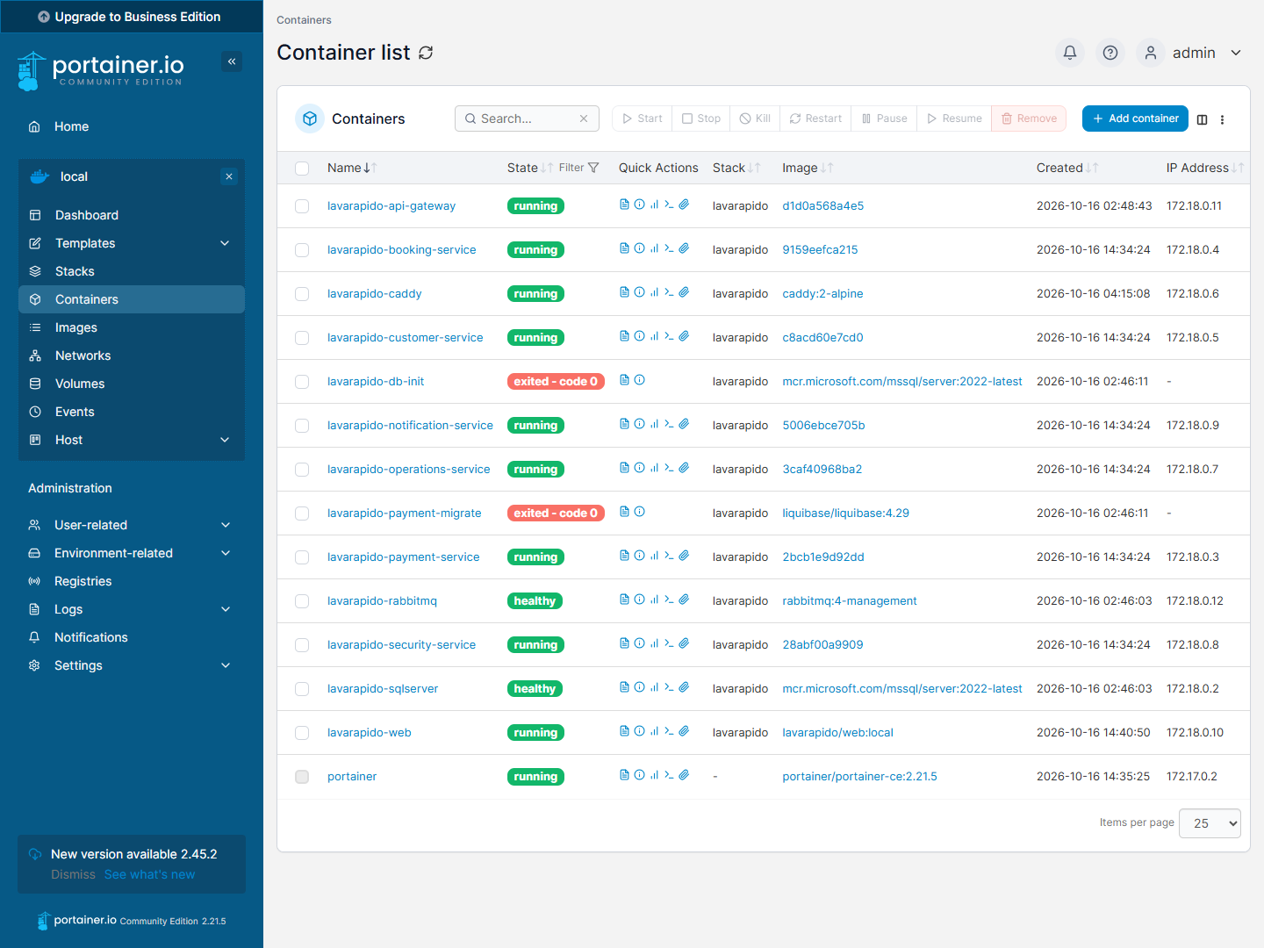
The 11 services in running / healthy*; db-init and payment-migrate end in* exited - code 0 because they run only once (create the database and apply the payment migrations).
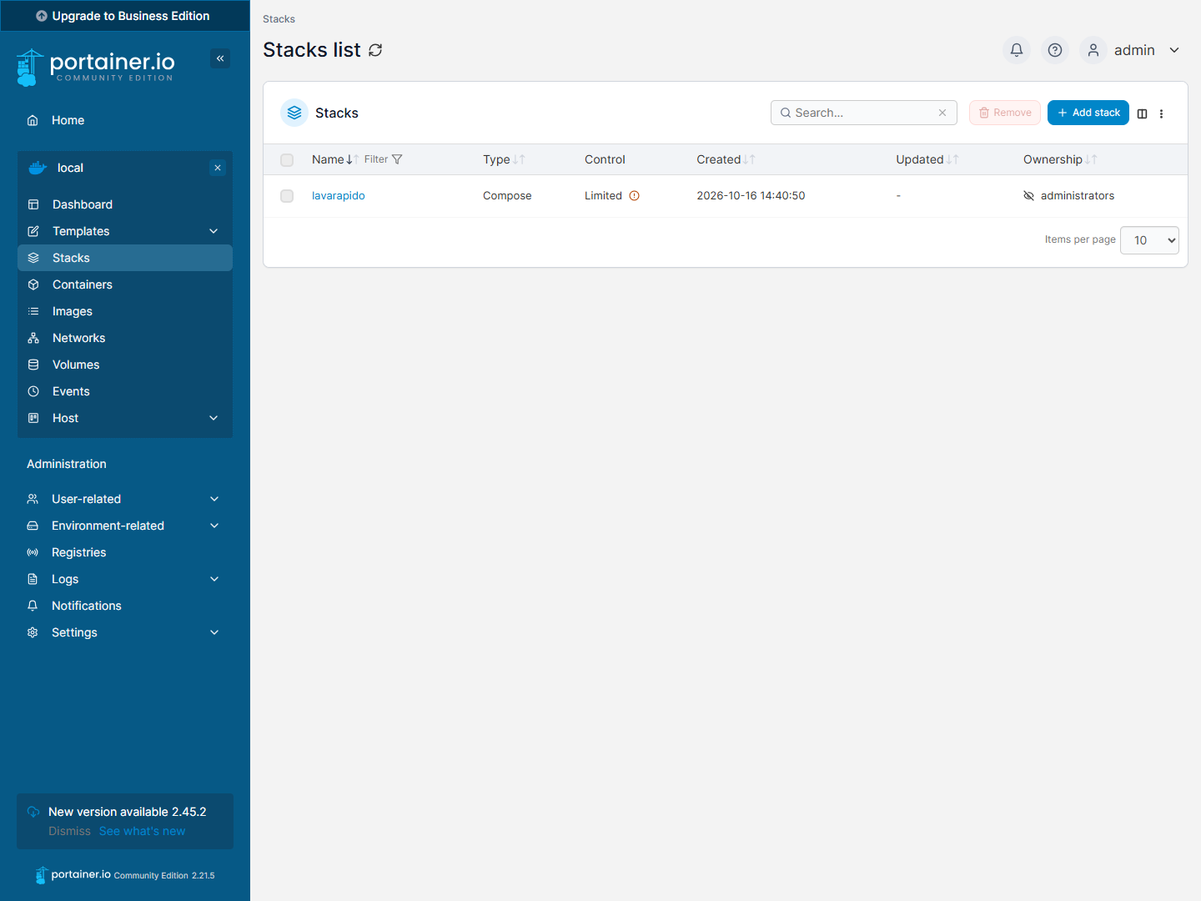
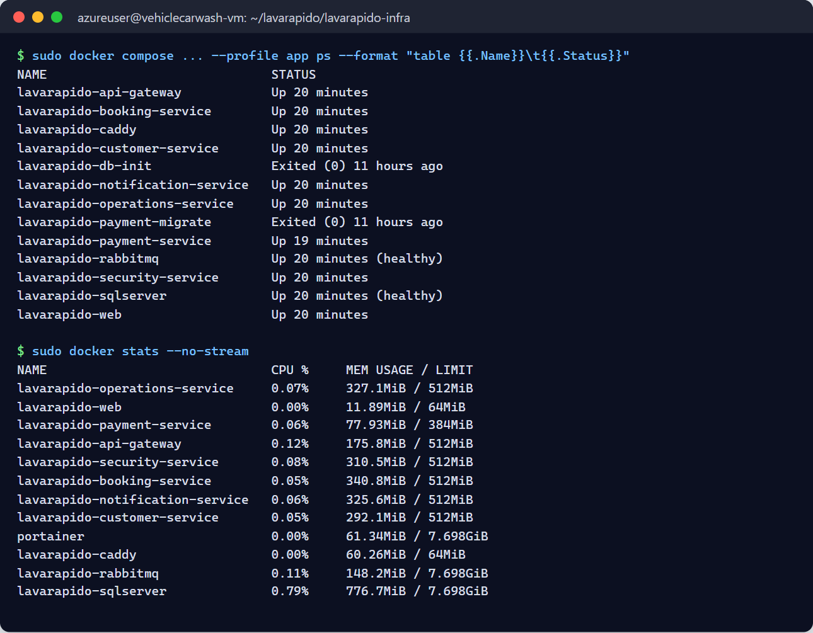
Status taken from the terminal on 2026-10-19: the 11 containers of the system Up (SQL Server and RabbitMQ healthy*), db-init and payment-migrate in* Exited (0), and the memory usage of each container.

5.4.2 Screenshot of the Backend services log viewer
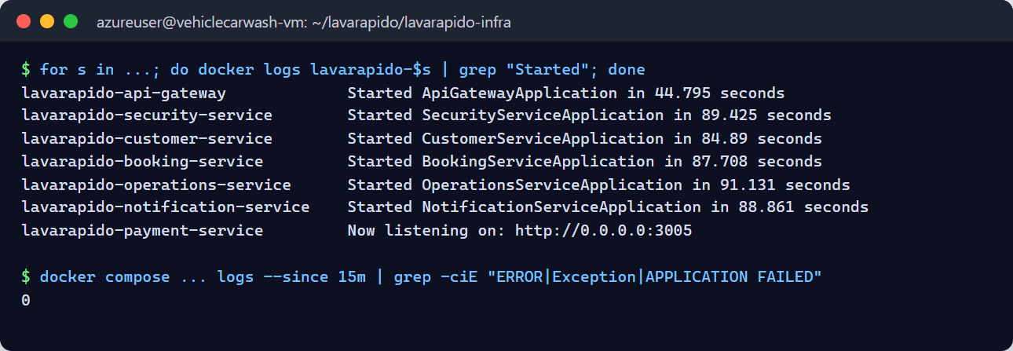
Each Java service shows Started … in N seconds (between 45 and 91 seconds with the machine just started) and payment Now listening on :3005*. There are 0 error traces in the last 15 minutes.*

5.4.3 Screenshot of the HTTP 200 response of the Health Checks
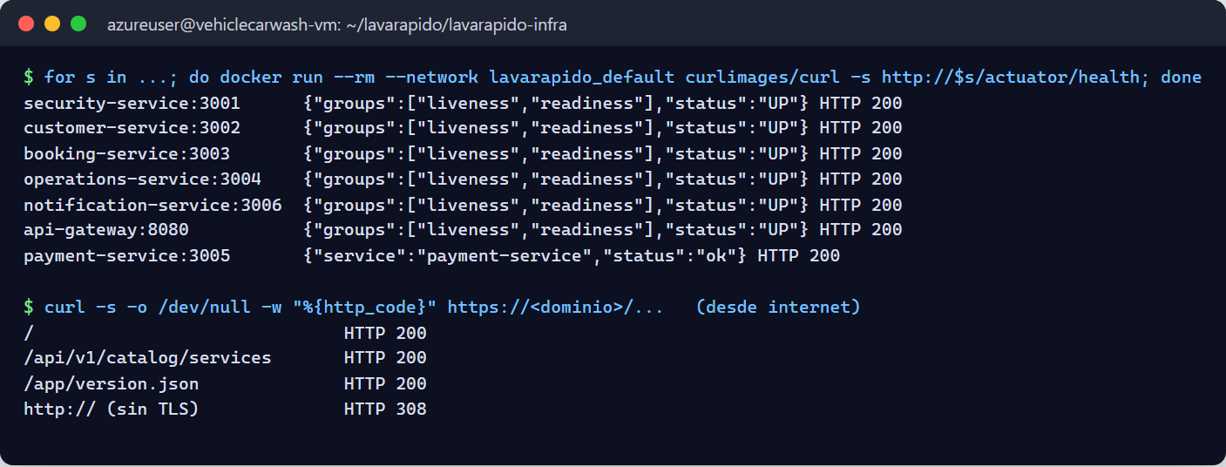
/actuator/health answers UP (HTTP 200) in the 6 Java services from the internal network, and payment-service answers ok. From the internet, the web, the API, and /app/version.json answer 200, and HTTP redirects to HTTPS with 308.

5.4.4 Screenshot of the web interface with a clean DevTools console
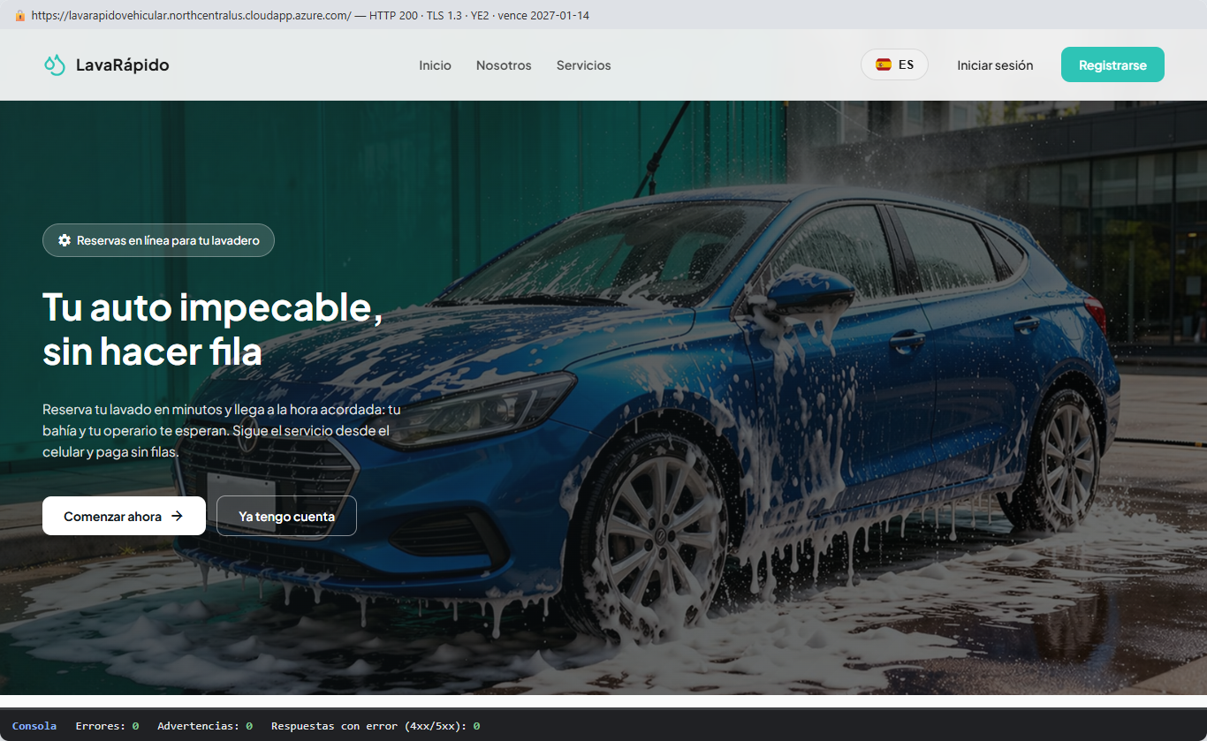
Home page in production over HTTPS (TLS 1.3, Let's Encrypt certificate valid until 2027-01-14). On load: 0 errors and 0 warnings in the console, and 0 error responses.

5.4.5 Screenshot of the successful migration record in the database
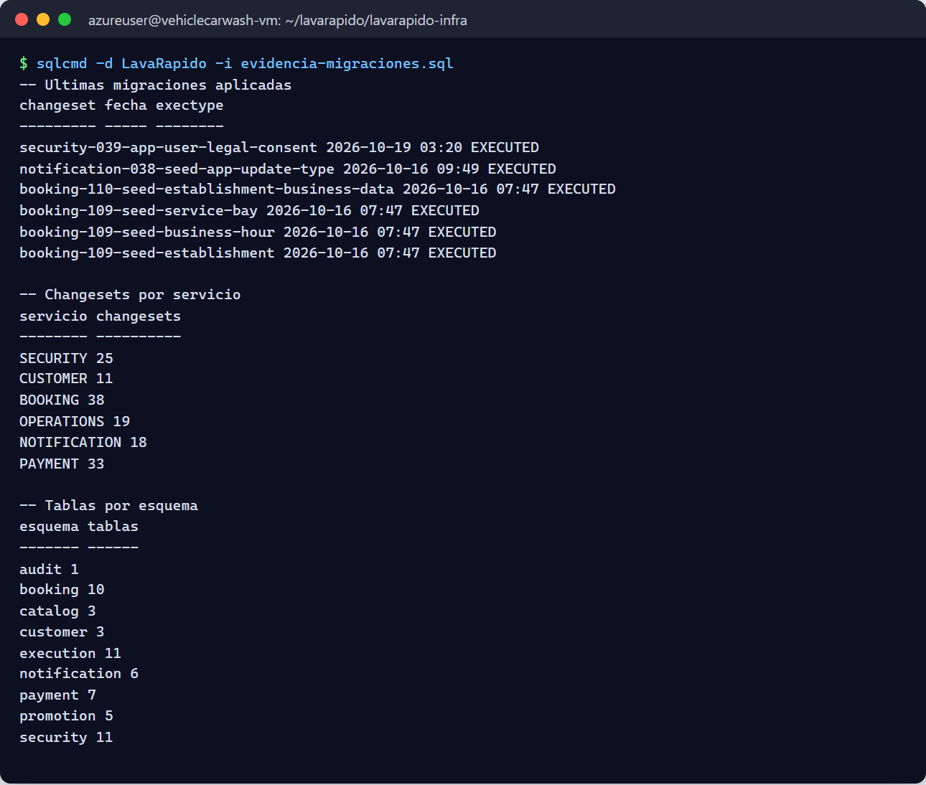
Migration 039 (acceptance of the legal documents) was applied on 2026-10-19; there are 144 EXECUTED changesets in the 6 histories and 57 tables in the 9 schemas. Since notification migration 047 (2026-10-24, pending_delivery) there are 58 tables.

Related documents:
- lavarapido-infra/DEPLOY.md: short deployment and update guide.
- lavarapido-infra/e2e/README.md: tests between services.
- vehicle-w-docs: architecture (ADR), OpenAPI and events.

