Installation Manual
Vehicle Washing Management System (Vehicle Washing)
Requirements, Configuration, Deployment With Docker, SQL Server Database, and Service Verification
Brayan Estiven Patiño Cabrera (Project Leader), Juan Camilo Guilombo Osorio (Frontend Leader), and Merari Urbano Quintero (Backend Leader)
Technologist in Software Analysis and Development (ADSO), Servicio Nacional de Aprendizaje (SENA), Training Center: Industria
Ficha 3145556
Instructor: Karol Daniela Correa
November 4, 2026
Manual Type: Installation Manual (Infrastructure and DevOps Staff) · Version 4.12

Version Control
Table 1 records the change history of this document. Each time the installation procedure changes (for example, because of a new version of a service or of a dependency), a row must be added with the version, the date, the description, and the person responsible.
Table 1
Version History of the Installation Manual
Version | Date | Description of the change | Responsible
2.0 | 2026-10-05 | Creation of the installation manual (in Spanish) from the project documentation, within version 2.0 of the manual set. | Development team
3.0 | 2026-10-07 | Translation into English, APA Style (7th ed.) formatting, and verification against the infrastructure repository and the code of the services. The placeholders were replaced with the real values: repositories, Compose services, ports, database name, environment variables, migrations per service, payment-service in .NET 8, health endpoints, and demonstration accounts. Corrected: migration strategy (one changelog per service applied at startup, not a single master changelog), absence of account lockout, and gateway behavior (it does not validate tokens). | Development team
3.1 | 2026-10-09 | Update against the code of October 9, 2026, and creation of the Spanish version (Manual_instalacion_LavadoVehicular_3145556_ES.md). Corrected: the operations repository is called lavarapido-operation-service and must be cloned with that name; real addresses of the four repositories that were pending; payment-service now runs in Docker with the app profile and the gateway container receives ROUTE_PAYMENT_URL; CORS origins include Expo web (8081); new changelogs (security 023, 026, and 030; booking 021, 022, and 024; notification 025, 027, 028, and 029; payment 017 to 020); 49 tables; 22 notification types; payment-service publishes events with MESSAGING_ENABLED; SPRING_PROFILES_ACTIVE added. | Development team
4.0 | 2026-10-16 | Review against the code of October 16, 2026. The figures changed from placeholders to real screenshots of the installation. Updated: 57 tables in the nine schemas (checked with the query in section 11.5), account lockout after failed attempts, the payment-service health endpoint that now checks the database, a reference to the Deployment Document for the Azure server and the APK, and Annex B items that were resolved. | Development team
4.1 | 2026-10-17 | Review against the code of October 17, 2026. Added the optional EXPO_PUBLIC_WEB_URL variable of the mobile app (section 10.5) and the native dependencies expo-image-picker and expo-image-manipulator, which require npm install and a new APK (section 13.2). | Development team
4.2 | 2026-10-19 | Continuous integration with GitHub Actions: the scope was updated and it was removed from Annex B. | Development team
4.3 | 2026-10-20 | Review against the code of October 20, 2026: the notification.notification_type catalog has 24 rows (migrations 031 and 038 added the alert for a booking without an operator and the new app version notice). | Development team
4.4 | 2026-10-21 | Review against the code of October 21, 2026: optional variables of the gateway session check and of the close of expired bookings (section 10.2), booking-service seeds 110 to 112 (section 11.2), cancellation reasons (Table 9), automatic backups of the public server (section 11.6), check of the token of a closed session (sections 16.3 and 16.4), and new errors (Table 14). | Development team
4.5 | 2026-10-21 | Change of the rule for bookings that end without being closed, reviewed by the team on the night of October 21: booking-service only cancels expired scheduled bookings and operations-service reviews the confirmed and started ones. Added the FOLLOW_UP_ENABLED and FOLLOW_UP_INTERVAL variables, BOOKING_EXPIRY_GRACE_MINUTES shared by booking-service and operations-service, and the services that use INTERNAL_API_KEY (section 10.2); changelogs 040 of operations-service and 041 of notification-service (section 11.2); 26 notification types (Table 9); check of the "To close" card (section 16.4); a new error (Table 14) and Annex B. | Development team
4.6 | 2026-10-23 | Review against develop of October 23, 2026 and version v1.0.0: branches and tags of each repository (8.1); variables the Compose file already passes, including FOLLOW_UP_LOOK_BACK_DAYS, ALLOWED_EMAIL_DOMAINS, DEMO_*_PASSWORD, ADMIN_DOCUMENT, and ADMIN_PHONE, and INTERNAL_API_KEY required for the operator (10.2); the global script lavarapido-6-services-sqlserver.sql is not versioned (11.3); the APK used to test push notifications is built with the EAS preview profile, because development does not exist (13.2); demonstration accounts through variables (15.1). Includes the content of Merari Urbano's fix/A-05 and fix/B-02 branches. | Development team
4.7 | 2026-10-24 | Review against develop of October 24, 2026, which runs on the public server since that day (8.1); new variables of the gateway (AUTH_RATE_LIMIT_*, TRUSTED_PROXIES, ROUTE_CONNECT_TIMEOUT, ROUTE_READ_TIMEOUT) and of operations-service (START_LATE_LIMIT), INTERNAL_API_KEY and BOOKING_SERVICE_URL in customer-service, and BOOKING_EXPIRY_CHECK_* with no effect (10.2); the published web listens on port 8080 (Annex B). | Development team
4.8 | 2026-10-26 | Payment at booking, reviewed against develop of October 26, 2026 and deployed to the public server that day: new booking-service variables (BOOKING_CASH_ACTIVE_LIMIT, BOOKING_PAYMENT_*, PAYMENT_SERVICE_URL) and INTERNAL_API_KEY also in payment-service (Table 7); booking-service migration 049 and seed 117 (Table 8); booking.payment-events queue and RABBITMQ_HOST=127.0.0.1 for payment-service outside Docker on Windows (12.5). | Development team
4.9 | 2026-10-26 | Versions v1.1.0 (10 repositories, including the first one of the mobile app) and v1.1.1 (web, mobile app, payment-service, and infra) of October 26, 2026, and recommended tag for an evaluation installation (8.1). | Development team
4.10 | 2026-10-27 | Versions v1.1.1 (customer and booking) and v1.1.2 (web, mobile app, payment-service, and infra) of October 27, 2026 and tags to use (8.1); 58 tables (11.1, 11.5, and checklist); operations-service.booking-confirmed queue in the RabbitMQ topology (12.5). | Development team
4.11 | 2026-10-27 | payment-service v1.1.3 (approved, pending publication): DB_PASSWORD required, RabbitMQ credentials required against a remote RabbitMQ, and local test database LavaRapidoPaymentIT with SQL Server 2022 (variables and payment section). | Development team
4.12 | 2026-11-04 | payment-service v1.1.3 merged into main on October 27 and tagged on November 4, 2026: tag to use when cloning (8.1) and payment's test projects (9.3). | Development team
Note. Dates are written in the ISO 8601 format (year-month-day). Prepared by the development team.

Table of Contents
- Version Control
- 4. Introduction
  - 4.1 Sources of This Document
  - 4.2 Scope
- 5. Objective
  - 5.1 General Objective
  - 5.2 Specific Objectives
- 6. Minimum Hardware Requirements
  - 6.1 Supported Operating Systems
  - 6.2 Network Ports
- 7. Required Software
  - 7.1 Checking the Installed Tools
- 8. Obtaining the Project
  - 8.1 Cloning the Repositories
  - 8.2 Expected Structure
- 9. Installing Dependencies
  - 9.1 Container Images
  - 9.2 Java Services
  - 9.3 payment-service (.NET 8)
  - 9.4 Web Application
  - 9.5 Mobile Application
- 10. Configuring Environment Variables
  - 10.1 Creating the .env File
  - 10.2 Variables of the .env File
  - 10.3 Generating Secrets
  - 10.4 Example of the .env File
  - 10.5 Configuring the Client Applications
- 11. Database Creation and Import
  - 11.1 Starting SQL Server and Creating the Database
  - 11.2 Migrations of Each Service
  - 11.3 Alternative Method: Global Script
  - 11.4 Database Accounts
  - 11.5 Verifying the Structure and the Initial Data
  - 11.6 Backup and Reset of the Local Database
- 12. Running the Backend
  - 12.1 Startup Order
  - 12.2 Option A: Services in Docker (Recommended)
  - 12.3 Option B: Java Services From a Terminal or the IDE
  - 12.4 payment-service (.NET 8) Outside Docker
  - 12.5 RabbitMQ and Mail
  - 12.6 Logs, Stopping, and Updating
- 13. Running the Frontend
  - 13.1 Web Application (Angular)
  - 13.2 Mobile Application (React Native With Expo)
  - 13.3 Static Mockups (Optional)
- 14. Accessing the System
  - 14.1 First Access to the Web Application
- 15. Test Users
  - 15.1 Demonstration Accounts
  - 15.2 Rules for Accounts
  - 15.3 Creating a Test Customer
  - 15.4 Operator and Administrator Accounts
- 16. Installation Verification
  - 16.1 Infrastructure and Database
  - 16.2 Messaging and Mail
  - 16.3 Services and Gateway
  - 16.4 Minimum Functional Flow
  - 16.5 Traces Verification
- 17. Common Errors and Solutions
- 18. Glossary
- References
- 19. Annexes
  - Annex A. Source of the Screenshots
  - Annex B. Information to Confirm Before Delivery
  - Annex C. Summary of Installation Commands
  - Annex D. Security Checklist Before Sharing the Environment
  - Annex E. Delivery Checklist
Note. Numbering starts at 4 because sections 1 to 3 are the cover, the version control, and the table of contents, which have no number in their title. It is kept this way so that the cross-references between documents by section number (for example, "Installation Manual, section 10") remain valid.

4. Introduction
The Vehicle Washing Management System (Vehicle Washing), internally called LavaRapido, is made up of a gateway (API Gateway), six backend microservices (five in Java 21 with Spring Boot 4 and one in C# with .NET 8), a Microsoft SQL Server 2022 database, a RabbitMQ message broker, a development mail server (Mailpit), and two clients: an Angular 21 web application and an Android application in React Native with Expo. This manual covers the local installation with Docker, which is the one the team uses to develop and test. The public server on Azure, which is turned on when it is needed to present the system, is set up with the scripts in the deploy folder of lavarapido-infra and is explained in the Deployment Document.
This manual explains how to prepare a machine, obtain the code, configure the environment variables, create the database, start each component in the correct order, and check that the system works. It is addressed to infrastructure and DevOps staff, or to anyone who must start the system on a local machine or a development server. It starts from the premise that an installation must be repeatable, automatable, and verifiable (Humble & Farley, 2010), and that the configuration that changes between environments must reside in the environment and not in the code (Wiggins, 2017).

4.1 Sources of This Document
The procedures were verified against the infrastructure repository (lavarapido-infra: docker-compose.yml, .env.example, and the team guide), the source code of the eleven repositories (develop branch as of October 21, 2026), and the project documentation updated on that same date (Vehicle Washing Development Team, 2026a, 2026b). The values that depend on each installation (passwords, keys, and addresses) are written between angle brackets, such as <SA_PASSWORD>; no placeholder must be copied literally into a terminal. The implementation of a release in its target environment (entry criteria, acceptance, training, and rollback) is described in the Implementation Procedure.

4.2 Scope
It covers: local installation with Docker of SQL Server, RabbitMQ, and Mailpit; the creation of the LavaRapido database and its migrations; the start of the six services and the gateway, in containers or from a terminal; the web and mobile applications; the first access, the test accounts, the verification, and the solution of common errors.
It does not cover: setting up the public server on Azure (Deployment Document), continuous integration (GitHub Actions; described in the Deployment Document), building and publishing the APK of the mobile application (Deployment Document), or the functional use of the system, which is explained in the User Manual and the Administrator Manual.

5. Objective

5.1 General Objective
To allow an infrastructure or DevOps person to install and start the Vehicle Washing Management System by following clear, complete, and verifiable instructions.

5.2 Specific Objectives
- Define the hardware, operating system, software, and network requirements to run the complete system.
- Describe how to obtain the code and install the backend, web, and mobile dependencies.
- Explain the configuration of the environment variables and the handling of secrets.
- Detail the creation of the database, the application of the migrations of each service, and the initial data.
- Indicate the startup order and the commands to start, stop, and review the logs of the components.
- Offer verification tests and a guide for solving frequent errors.

6. Minimum Hardware Requirements
The project documentation does not set hardware requirements. The values of Table 2 are recommendations of this manual, calculated to run SQL Server, RabbitMQ, Mailpit, the gateway, and the six services at the same time, plus the development tools. The only minimum with official support is that of SQL Server in a container, which requires at least 2 GB of RAM (Microsoft, n.d.).
Table 2
Recommended Hardware Requirements
Resource | Minimum | Recommended | Remark
Processor | 4 cores, 64-bit (x64) | 6 or 8 cores | The SQL Server image is for x64; on ARM processors it runs through emulation.
RAM | 8 GB | 16 GB | With 8 GB, assign at least 5 GB to Docker and close other applications.
Memory for Docker | 5 GB | 8 GB or more | SQL Server requires 2 GB; each Java service uses up to 75% of the memory of its container.
Free disk | 20 GB | 40 GB on SSD | Docker images, volumes, Maven, NuGet, and npm dependencies, and logs.
Network | Internet access | Stable broadband | Download of images and dependencies; for a physical phone, the same Wi-Fi network as the computer.
Note. Recommendations of this manual. The minimum of 2 GB of RAM for SQL Server is the one published by Microsoft (n.d.).

6.1 Supported Operating Systems
Table 3
Operating Systems and Additional Requirements
Operating system | Additional requirement
Windows 10 or 11 (64-bit) | Docker Desktop with WSL 2 and virtualization enabled in the BIOS or UEFI.
Ubuntu 22.04 LTS or later | Docker Engine 24 or later with the Docker Compose plugin (v2).
macOS | Docker Desktop; with Apple Silicon, enable x64 emulation (Rosetta) for SQL Server.
Note. Prepared by the authors from the team guide of the infrastructure repository.

6.2 Network Ports
Table 4 lists the ports that the system publishes on the host machine. They must be free before starting the installation.
Table 4
Ports Used by the System
Component | Port | Remark
SQL Server | 1433 | If a native SQL Server of Windows (service MSSQLSERVER) uses this port, stop it (section 17).
RabbitMQ (AMQP) | 5672 | Used by the services.
RabbitMQ (management console) | 15672 | Web interface.
Mailpit (SMTP) | 1025 | Receives the emails of the services.
Mailpit (web interface) | 8025 | Shows the captured emails.
API Gateway | 8080 | Single entry point of the web and mobile applications.
security-service | 3001 | Accounts, login, and roles.
customer-service | 3002 | Customers and vehicles.
booking-service | 3003 | Catalog, schedule, bays, and bookings.
operations-service | 3004 | Operators, assignment, execution, and ratings.
payment-service | 3005 | Payment accounts and payments (.NET).
notification-service | 3006 | Notifications, push, email, and reminders.
Web application (Angular) | 4200 | Development server.
Mobile application (Expo Metro) | 8081 | Development server.
Note. Values taken from docker-compose.yml, the configuration of each service, and the service catalog.

7. Required Software
Table 5 lists the tools. The versions come from the build files of each repository (pom.xml, Directory.Build.props, and package.json).
Table 5
Software Required for the Installation
Tool | Version | Use
Git | Recent | Obtain the repositories.
Docker Desktop or Docker Engine with Compose v2 | 24 or later | Run SQL Server, RabbitMQ, Mailpit, the migrations, and, optionally, the services.
JDK (Eclipse Temurin recommended) | 21 | Run the Java services outside Docker. Maven is not needed: each service includes the Maven Wrapper (mvnw).
.NET SDK | 8.0 | Build and run payment-service.
Node.js and npm | Node.js 20.19 or later (22 LTS recommended); npm 11 | Web application (Angular 21) and mobile application.
Angular CLI | 21 (optional; npx ng works without a global installation) | Development server and build of the web application.
Expo CLI and EAS CLI (through npx) | According to package.json (Expo SDK 57) | Run the mobile application and build versions with push notifications.
sqlcmd (optional) | Recent | Run verification queries from the host; it is also available inside the SQL Server container.
Graphical SQL client (optional) | SQL Server Management Studio or Azure Data Studio | Visual inspection of the database.
curl | Recent | Verification tests.
Android Studio or an Android phone (optional) | Recent | Emulator or device for the mobile application.
Note. The Liquibase CLI is not needed: the Java services apply their migrations when they start, and the payment-migrate container runs those of payment-service.

7.1 Checking the Installed Tools
Each command must print a version; if one fails, install the corresponding tool.
git --version
docker --version
docker compose version
java -version # must show 21
dotnet --version # must show 8.x
node -v
npm -v
curl --version
On Windows, docker info must show the Linux engine (WSL 2) and not the Windows containers engine.
Figure 1
Verification of Tool Versions
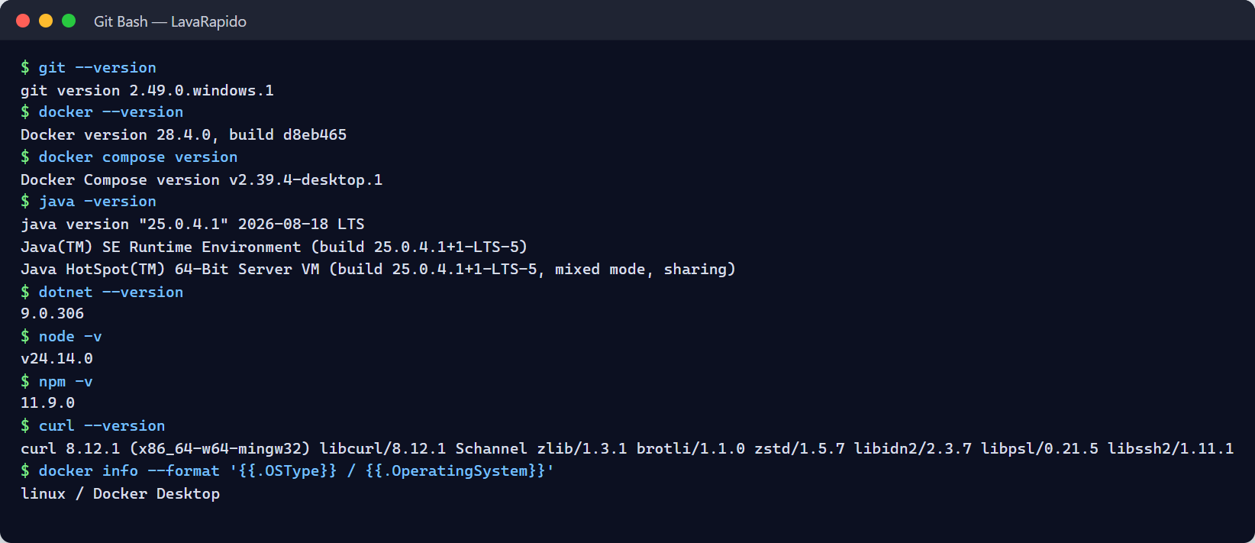

8. Obtaining the Project
The project is distributed in one repository per component. All the backend repositories must be cloned side by side in the same folder and without changing their names, because the services look for the shared configuration in ../lavarapido-infra/.env and docker-compose.yml builds them from ../<repository> (Table 6). Note that the operations repository is called lavarapido-operation-service (singular), although the service, its container, and its image are called operations-service: if it is cloned with another name, the Compose build fails.
Table 6
Project Repositories
Repository | Content | Address
lavarapido-infra | docker-compose.yml, .env.example, and team guide. | https://github.com/BrayanCABRERA123/lavarapido-infra
lavarapido-security-service | Accounts, login, roles, profile, and password recovery. | https://github.com/BrayanCABRERA123/lavarapido-security-service
lavarapido-customer-service | Customers and vehicles. | https://github.com/camiloguilombo12/lavarapido-customer-service
lavarapido-booking-service | Catalog, schedule, bays, and bookings. | https://github.com/camiloguilombo12/lavarapido-booking-service
lavarapido-operation-service | Operators, assignment, execution, and ratings (service operations-service). | https://github.com/BrayanCABRERA123/lavarapido-operation-service
lavarapido-payment-service | Payment accounts, payments, and receipts (.NET 8). | https://github.com/merari0322/lavarapido-payment-service
lavarapido-notification-service | Notifications, push, email, and reminders. | https://github.com/BrayanCABRERA123/lavarapido-notification-service
lavarapido-api-gateway | Gateway (Spring Cloud Gateway). | https://github.com/BrayanCABRERA123/lavarapido-api-gateway
Front-end-proyecto-web | Angular web application. | https://github.com/BrayanCABRERA123/Front-end-proyecto-web
LavadoVehicular-Movil | Android application (React Native with Expo). | https://github.com/merari0322/LavadoVehicular-Movil
vehicle-w-docs | Project documentation, ADRs, and OpenAPI contracts. | https://github.com/code-sena/vehicle-w-docs
Note. The addresses were taken from the Git remotes of the team copies on October 16, 2026.

8.1 Cloning the Repositories
The integration branch of the team is develop; the most recent version of every service is there, and main holds the delivered versions. On October 23, 2026 v1.0.0 was tagged in 8 repositories (web, api-gateway, security, customer, booking, operations, notification, and infra) and on the 24th in payment-service. On October 26, 2026 v1.1.0 shipped in the 10 repositories, including the mobile app, which had no version until then, and that same day v1.1.1 in the web, the mobile app, payment-service, and infra. On October 27, 2026 v1.1.1 shipped in customer-service and booking-service and v1.1.2 in the web, the mobile app, payment-service, and infra, and that same day payment-service v1.1.3 was merged into main; it was tagged on November 4, 2026. For an evaluation installation, use the most recent tag of each repository: v1.1.3 in payment-service; v1.1.2 in the web, the mobile app, and infra; v1.1.1 in customer-service and booking-service; and v1.1.0 in the API Gateway, security-service, operations-service, and notification-service. Each one is the tip of main, which is protected in the 10 repositories and is what the public server runs (payment-service v1.1.3 has been in production since November 4, 2026); develop has the latest work not yet released in a version.
mkdir Backend && cd Backend
git clone -b develop https://github.com/BrayanCABRERA123/lavarapido-infra.git
git clone -b develop https://github.com/BrayanCABRERA123/lavarapido-security-service.git
git clone -b develop https://github.com/camiloguilombo12/lavarapido-customer-service.git
git clone -b develop https://github.com/camiloguilombo12/lavarapido-booking-service.git
git clone -b develop https://github.com/BrayanCABRERA123/lavarapido-operation-service.git
git clone -b develop https://github.com/merari0322/lavarapido-payment-service.git
git clone -b develop https://github.com/BrayanCABRERA123/lavarapido-notification-service.git
git clone -b develop https://github.com/BrayanCABRERA123/lavarapido-api-gateway.git
cd ..
mkdir Frontend && cd Frontend
git clone -b develop https://github.com/BrayanCABRERA123/Front-end-proyecto-web.git
git clone -b develop https://github.com/merari0322/LavadoVehicular-Movil.git
To update a copy that already exists, run git checkout develop and git pull inside each repository.

8.2 Expected Structure
Project/
|-- Backend/
| |-- lavarapido-infra/ (docker-compose.yml + .env.example + .env)
| |-- lavarapido-security-service/
| |-- lavarapido-customer-service/
| |-- lavarapido-booking-service/
| |-- lavarapido-operation-service/ (singular: name expected by docker-compose.yml)
| |-- lavarapido-payment-service/
| |-- lavarapido-notification-service/
| `-- lavarapido-api-gateway/
`-- Frontend/
|-- Front-end-proyecto-web/ (Angular)
`-- LavadoVehicular-Movil/ (React Native / Expo)
Figure 2
Repositories Cloned in the Working Folder
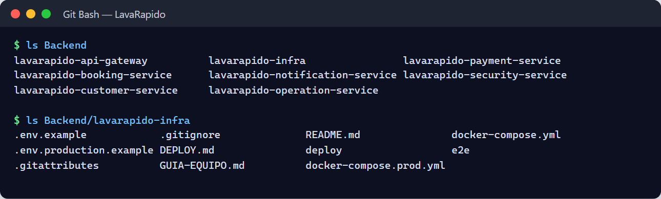

9. Installing Dependencies

9.1 Container Images
The local environment uses the images mcr.microsoft.com/mssql/server:2022-latest, rabbitmq:4-management, axllent/mailpit, and liquibase/liquibase:4.29; the images of the services are built from their Dockerfiles. From the infrastructure folder, validate the Compose file and download the base images:
cd Backend/lavarapido-infra
docker compose config --quiet && echo "Compose file is valid"
docker compose pull
The command docker compose config fails if DB_PASSWORD or JWT_SECRET are missing; in that case, complete the .env file first (section 10) and run it again.

9.2 Java Services
The Java services download their dependencies automatically: with Docker, during the build of the image; outside Docker, the first time mvnw runs (it can take several minutes). To download them in advance and run the unit tests of a service:
cd Backend/lavarapido-security-service
./mvnw -B test # Windows: .\mvnw.cmd -B test

9.3 payment-service (.NET 8)
cd Backend/lavarapido-payment-service
dotnet restore
dotnet test # domain, application, API, and integration tests (xUnit)

9.4 Web Application
cd Frontend/Front-end-proyecto-web
npm ci
The command npm ci installs exactly the versions of package-lock.json, which makes the installation repeatable. Known vulnerabilities are reviewed with npm audit.

9.5 Mobile Application
cd Frontend/LavadoVehicular-Movil
npm ci
Figure 3
Successful Installation of Dependencies
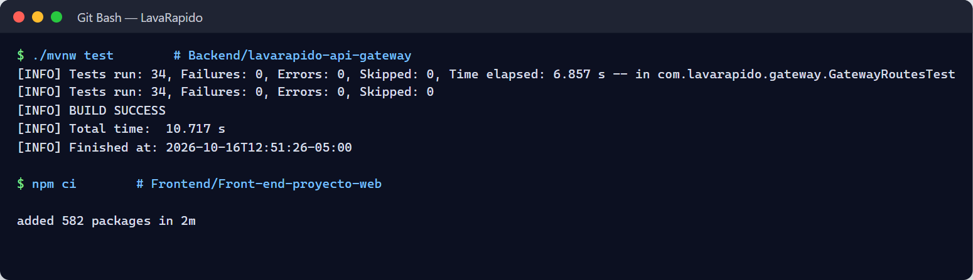

10. Configuring Environment Variables
The values that change between environments (connection data, secrets, mail, and switches) reside outside the code (Wiggins, 2017). All the services read the same file lavarapido-infra/.env: Docker Compose reads it automatically, the Java services import it with spring.config.import, and payment-service reads it with its EnvFile class. Real environment variables always take precedence over the file. The .env file is excluded from Git; the repository only contains .env.example.

10.1 Creating the .env File
cd Backend/lavarapido-infra
cp .env.example .env # PowerShell: Copy-Item .env.example .env
git check-ignore -v .env # must show the .gitignore rule that excludes it
If git check-ignore prints nothing, the file is not excluded and must not be filled with secrets until the .gitignore is corrected.

10.2 Variables of the .env File
Table 7
Main Environment Variables
Variable | Used by | Effect and local value
DB_PASSWORD | SQL Server and all services | Password of the sa account. Required; at least 8 characters with uppercase, lowercase, number, and symbol, or SQL Server does not start. With v1.1.3 payment-service does not start without it either.
DB_NAME | Infrastructure and services | Database name; LavaRapido.
DB_USERNAME | Services | sa in the local environment.
DB_URL | Java services run from the IDE | jdbc:sqlserver://localhost:1433;databaseName=LavaRapido;encrypt=true;trustServerCertificate=true
JWT_SECRET | All services | HS256 signing key shared by all services; at least 32 bytes. Required.
CORS_ALLOWED_ORIGINS | Services and gateway | Origins allowed to call from a browser: the web application and Expo web; http://localhost:4200,http://localhost:8081.
SPRING_PROFILES_ACTIVE | Java services in Docker | dev by default in the Compose file (Swagger and demonstration accounts); use another value, such as prod, in any shared environment. Since develop of October 23, 2026, security-service without this variable starts in prod (E-05).
DEMO_ADMIN_PASSWORD, DEMO_OPERATOR_PASSWORD, DEMO_CLIENT_PASSWORD | security-service (dev profile) | Passwords of the demonstration accounts admin@gmail.com, operador@gmail.com, and cliente@gmail.com (since develop of October 23, 2026, E-05). Empty: that account is not created. Each person chooses them in their .env; they are not in the code or in the documents.
ALLOWED_EMAIL_DOMAINS | security-service | Email domains allowed when signing up, creating users, and changing the email, comma separated; gmail.com by default (since develop of October 23, 2026, A-01). With another domain the server answers 400 EMAIL_DOMAIN_NOT_ALLOWED.
ADMIN_EMAIL, ADMIN_PASSWORD, ADMIN_DOCUMENT, ADMIN_PHONE | security-service (production) | First administrator, created only if the database has none; ADMIN_DOCUMENT and ADMIN_PHONE are their ID number and mobile phone (without them the profile keeps placeholder values). They go in .env.production and docker-compose.prod.yml passes them.
MAIL_ENABLED | security-service and notification-service | true sends emails; false writes the recovery code in the log of security-service.
MAIL_HOST, MAIL_PORT, MAIL_USERNAME, MAIL_PASSWORD, MAIL_FROM | security-service and notification-service | SMTP server. Locally Mailpit: localhost, 1025, any user and password. Gmail requires an app password.
MAIL_DOCKER_HOST | Services in Docker | SMTP host seen from the containers; mailpit by default.
MESSAGING_ENABLED | Java services and payment-service | true publishes and consumes RabbitMQ events; false (default) only writes them in the log. Without events, there are no notifications, payment notices, or point notices.
RABBITMQ_HOST, RABBITMQ_PORT, RABBITMQ_USERNAME, RABBITMQ_PASSWORD | Java services and payment-service | localhost, 5672, guest, guest in the local environment. With v1.1.3, if MESSAGING_ENABLED=true and RabbitMQ is not on localhost (Docker or server), payment-service does not start without a username and password: guest is only accepted with a local RabbitMQ.
PUSH_ENABLED, EXPO_ACCESS_TOKEN | notification-service | true sends push notifications through Expo; false only writes them in the log.
INTERNAL_API_KEY | security-service, customer-service, booking-service, operations-service, notification-service, and, since October 26, 2026, payment-service | Key of the internal routes; without it, booking, payment, and coupon notices and reminders are not sent by email, the notification switches of each user cannot be read, there is no automatic assignment, and operations-service cannot close as No-show the confirmed bookings that ended without an operator. Since develop of October 23, 2026 (E-01) it is also required for the operator to start and finish services: booking-service only accepts those routes from operations-service with this key. Since October 24, 2026 customer-service also uses it to ask booking-service whether a vehicle has active bookings before removing it: without it, removing a vehicle answers 503 BOOKING_SERVICE_UNAVAILABLE; in production the compose file does not start if it is missing. Since October 26, 2026 payment-service requires it on its internal path (GET /internal/v1/payments/bookings/{bookingId}/reported, header X-Internal-Key; 401 without a key or with a wrong one), and docker-compose.prod.yml does not start without it: without the key, booking-service cannot check whether an overdue digital booking already has a receipt, and it cancels no booking for lack of payment.
REMINDER_LEADS | notification-service | Advance of the reminders; 24h,1h by default.
BOOKING_ZONE, BOOKING_SLOT_MINUTES, BOOKING_MAX_DAYS_AHEAD | booking-service and operations-service | America/Bogota, 30, and 60 by default.
SESSION_CHECK_ENABLED, SESSION_CHECK_CACHE_TTL, SESSION_CHECK_TIMEOUT | api-gateway | Check of the token session (since October 21, 2026): true, 30s, and 3s by default. They are commented out in .env.example and the Compose file passes them to the container. Since October 24 the session is checked with any header scheme.
AUTH_RATE_LIMIT_ENABLED, AUTH_RATE_LIMIT_REQUESTS, AUTH_RATE_LIMIT_WINDOW | api-gateway | Request limit per IP on /api/v1/auth/* (since October 24, 2026): true, 60, and 1m by default; beyond it, it answers 429 RATE_LIMITED with Retry-After. They have a default value in the service and the compose file does not pass them: to change them, add them to the gateway's environment block.
TRUSTED_PROXIES | api-gateway | Networks from which the X-Forwarded-For header is trusted (by default the private and local ones: 127.0.0.0/8, 10.0.0.0/8, 172.16.0.0/12, 192.168.0.0/16, ::1, and fc00::/7). With Caddy in front, it does not need to be changed.
ROUTE_CONNECT_TIMEOUT, ROUTE_READ_TIMEOUT | api-gateway | Time to connect and to read the answer of each service (since October 24, 2026): 5s and 60s by default; if exceeded, the gateway answers 500.
BOOKING_EXPIRY_CHECK_ENABLED, BOOKING_EXPIRY_CHECK_INTERVAL | booking-service | No effect since October 24, 2026 (B-07): the task that cancelled expired scheduled bookings was removed, because every booking is created and rescheduled as confirmed. The Compose file still passes them; they can be deleted from .env.
BOOKING_EXPIRY_GRACE_MINUTES | booking-service and operations-service | Minutes after the end time before an expired booking is closed; 60 by default. Both services use it, so if it is changed it must have the same value in both; the Compose file passes it to both.
FOLLOW_UP_ENABLED, FOLLOW_UP_INTERVAL, FOLLOW_UP_LOOK_BACK_DAYS | operations-service | Review of the bookings that ended without being closed (since the night of October 21, 2026): a confirmed booking that never had an operator becomes No-show, and one that had an operator and nobody recorded stays in "To close". true, PT5M, and 28 (days it looks back, because the server can stay off for weeks) by default; needs INTERNAL_API_KEY. They go through the Compose file.
START_LATE_LIMIT | operations-service | How long after the end time the operator can start a service (since October 24, 2026): PT4H by default; afterwards it answers 409 SERVICE_TOO_LATE. It does not go through the compose file.
BOOKING_CASH_ACTIVE_LIMIT | booking-service | Maximum active cash bookings per customer (since October 26, 2026); 1 by default; beyond it, 409 CASH_BOOKING_LIMIT. Commented out in .env.example; the compose file passes it to the container.
BOOKING_PAYMENT_WINDOW | booking-service | Deadline to upload the receipt of a booking with digital payment (or the start time, if that comes first); 30m by default. To test the expiry locally without waiting, it can be lowered (for example, to 1m).
BOOKING_PAYMENT_EXPIRY_ENABLED, BOOKING_PAYMENT_EXPIRY_INTERVAL | booking-service | PaymentDeadlineJob, which cancels overdue digital bookings with PAYMENT_TIMEOUT after asking payment-service: true and 60s by default. They go through the compose file.
SECURITY_SERVICE_URL, CUSTOMER_SERVICE_URL, BOOKING_SERVICE_URL, PAYMENT_SERVICE_URL | Services that call others | Addresses of the services; they have defaults for the local environment. payment-service needs BOOKING_SERVICE_URL to read the total and to credit the points of a booking. Since October 24, 2026 customer-service also uses it, but with the service root (http://booking-service:3003 in Docker, http://localhost:3003 locally, without /api/v1), fixed in the compose file; optional, BOOKING_SERVICE_TIMEOUT (3 s). Since October 26, 2026 booking-service uses PAYMENT_SERVICE_URL (http://payment-service:3005 in Docker, fixed in the compose file; http://localhost:3005 by default locally) for the internal query to payment-service.
Note. Prepared by the authors from .env.example, docker-compose.yml, and the configuration files of the services.

10.3 Generating Secrets
The JWT secret, the sa password, and the internal key must be generated with a secure random source, not typed by hand:
openssl rand -base64 48 # JWT_SECRET
node -e "console.log(require('crypto').randomBytes(32).toString('base64url'))" # INTERNAL_API_KEY
The generated value is pasted in the .env file, never in a message, a shared document, or a repository.

10.4 Example of the .env File
The following fragment shows the structure; secrets are represented with asterisks.
DB_PASSWORD=********
DB_NAME=LavaRapido
DB_USERNAME=sa
DB_URL=jdbc:sqlserver://localhost:1433;databaseName=LavaRapido;encrypt=true;trustServerCertificate=true
JWT_SECRET=********
CORS_ALLOWED_ORIGINS=http://localhost:4200,http://localhost:8081
MAIL_ENABLED=true
MAIL_HOST=localhost
MAIL_PORT=1025
MAIL_USERNAME=dev
MAIL_PASSWORD=dev
MAIL_FROM=LavaRapido <no-reply@lavarapido.local>
MESSAGING_ENABLED=true
RABBITMQ_HOST=localhost
RABBITMQ_PORT=5672
RABBITMQ_USERNAME=guest
RABBITMQ_PASSWORD=guest
PUSH_ENABLED=false
INTERNAL_API_KEY=********

10.5 Configuring the Client Applications
- Web application. It calls the relative address /api/v1. In development, proxy.conf.json forwards every request that starts with /api to the gateway (http://localhost:8080), so no file has to be edited.
- Mobile application. Copy .env.example to .env.local and set EXPO_PUBLIC_API_URL. In the Android emulator use http://10.0.2.2:8080/api/v1 (the default value); on a physical phone, the IPv4 address of the computer on the same Wi-Fi network (for example, http://192.168.1.10:8080/api/v1); and for the web version of Expo, http://localhost:8080/api/v1. After changing it, restart Expo with npx expo start --clear. The optional EXPO_PUBLIC_WEB_URL variable sets the web address the app uses to build the public link of the inspection report; when it is not set, the same host as the gateway with port 4200 is used.
Figure 4
Configured .env File With Hidden Secrets
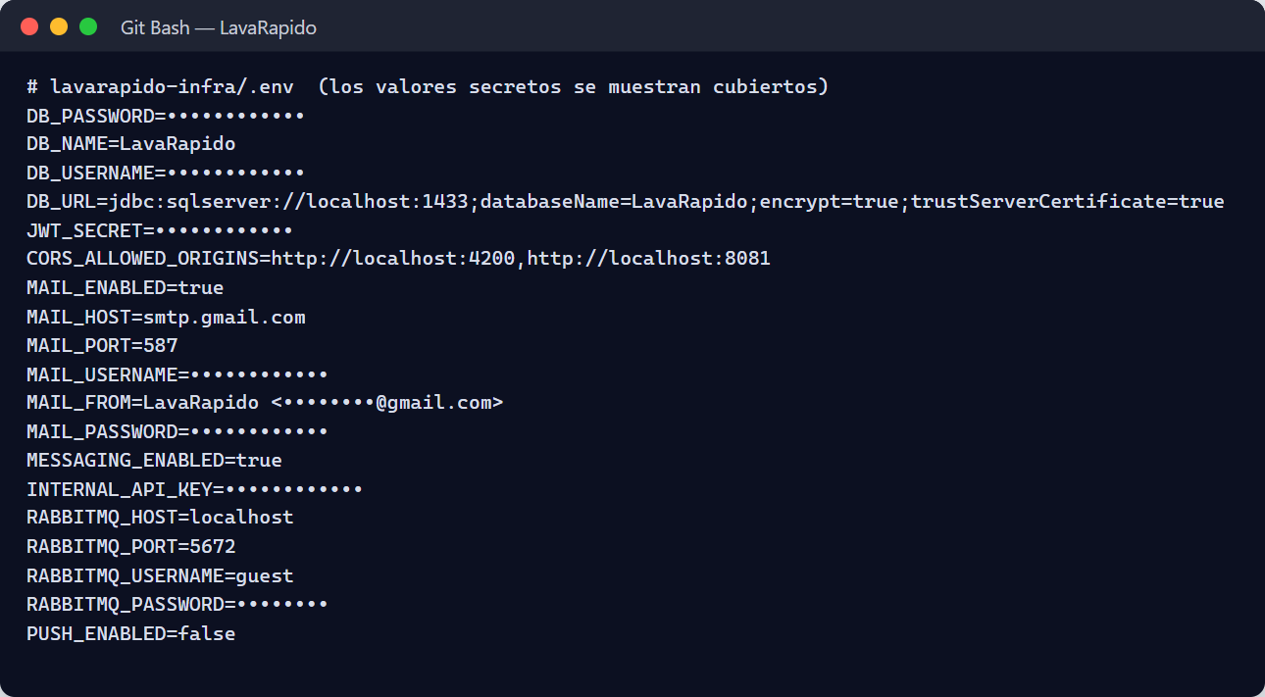
Note. Do not capture real values of secrets.

11. Database Creation and Import
The system uses a single SQL Server 2022 database called LavaRapido, divided into nine schemas: security, audit, customer, catalog, booking, execution, promotion, payment, and notification (58 tables). Each service owns its schemas and migrates only them with Liquibase, with its own control tables DATABASECHANGELOG_<SERVICE> (Vehicle Washing Development Team, 2026a).

11.1 Starting SQL Server and Creating the Database
cd Backend/lavarapido-infra
docker compose up -d
docker compose ps
This command starts, without the services:
- sqlserver (container lavarapido-sqlserver), with a health check and the volume sqlserver-data.
- db-init, which runs once and creates the LavaRapido database if it does not exist.
- payment-migrate, which runs once the Liquibase changelogs of payment-service (schemas payment and promotion).
- mailpit and rabbitmq (container lavarapido-rabbitmq, with a health check).
Wait until lavarapido-sqlserver and lavarapido-rabbitmq show the status healthy and db-init and payment-migrate end with exit code 0. If the SQL Server container stops after a few seconds, the usual causes are a weak DB_PASSWORD, insufficient memory, or port 1433 already in use (section 17).
Figure 5
Infrastructure Containers Running
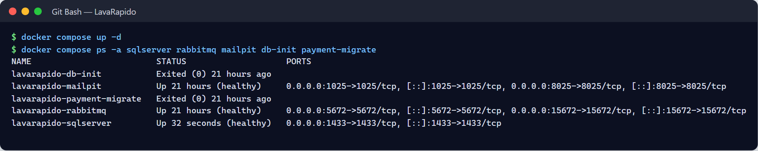

11.2 Migrations of Each Service
The Java services apply their migrations automatically when they start (spring.liquibase), and then Hibernate only validates that the entities match the tables. Therefore, the tables of the schemas security, audit, customer, catalog, booking, execution, and notification are created the first time each service starts (section 12). Table 8 shows the changelogs of the version of October 21, 2026.
Table 8
Changelogs of Each Service
Service | Changelogs | Control table
security-service | 001 schemas, 002 security and audit core, 003 user preference, 020 theme palettes, 023 custom role (created and dropped again by 026), 026 role permissions (permission catalog and default assignments), 030 notification switches of the user preference, 034 lockout after failed attempts, 035 person address, 036 account creation date, 039 acceptance of the legal documents; seed 101 roles. | DATABASECHANGELOG_SECURITY
customer-service | 004 customer schema, 014 customer user id, 015 vehicle model; seed 102 vehicle types. | DATABASECHANGELOG_CUSTOMER
booking-service | 005 catalog and booking schemas, 018 changes of ADR-010, 021 schedule history, 022 loyalty points of the catalog, 024 removal of the bay operator, 032 business data of the establishment; seeds 103 catalog, 104 statuses and reasons, 109 establishment, schedule, and four bays, 110 business data, 111 removal of the example business data so the real business fills it in, and 112 EXPIRED reason of the automatic close of expired bookings; since October 24, 2026, 044 price greater than 0, 045 optimistic locking of the booking, and seed 113 removal of the sample data of the site; since October 26, 2026, 049 payment mode and deadline of the booking (payment_mode, payment_deadline, payment_reported_at, and index ix_booking_payment_pending) and seed 117 PAYMENT_TIMEOUT reason. | DATABASECHANGELOG_BOOKING
operations-service | 007 execution schema, 033 inspection reports with phases, findings, and photos, 037 operator profile, 040 time of the service-not-recorded notice (follow_up_notice_at); seed 105 execution statuses. | DATABASECHANGELOG_OPERATIONS
notification-service | 010 notification schema, 016 device tokens, 017 processed events, 019 booking reminders, 025 promotion redeemed type, 027 staff notifications and booking tracking, 028 payment refunded type, 029 loyalty and inspection types, 031 unassigned booking alert, 038 new app version notice type, 041 service-not-recorded notice types for the operator and the administrator; seed 108 notification types. | DATABASECHANGELOG_NOTIFICATION
payment-service | db/changelog/changes/001 to 020 (own numbering; 017 package fields, 018 required points, 019 catalog verification, 020 points reversal and sequence), run by the payment-migrate container. | DATABASECHANGELOG_PAYMENT
Note. Source: migration strategy of the project documentation and the changelogs of the repositories.
Rules that must always be respected. Changesets are forward-only. A changeset that already ran is never edited: Liquibase calculates a checksum and refuses to continue if the content changed, which is an intentional protection. Every changeset has a precondition that marks it as run if the object already exists. The initial data uses fixed identifiers, and two of them are critical: booking_status_id = 5 (CANCELLED) is used by the constraint ck_booking_cancel and the trigger tr_booking_bay_overlap, and payment_status_id = 3 (APPROVED) by the index ux_payment_one_approved_per_booking.

11.3 Alternative Method: Global Script
As of October 23, 2026 the script lavarapido-6-services-sqlserver.sql is not versioned in any of the repositories (not in their history either), so this method cannot be followed: the database is created only with the Liquibase changelogs each service applies on startup (section 11.2). If the team publishes the script again, it is run on the empty database and, because every changeset has a precondition, Liquibase marks as run the objects that already exist:
sqlcmd -S localhost,1433 -U sa -P "<SA_PASSWORD>" -C -d LavaRapido -b -i lavarapido-6-services-sqlserver.sql
The recommended method is the one of section 11.2, because it leaves the history of each service in its control table.

11.4 Database Accounts
In the local environment all the services connect with the sa account (variable DB_USERNAME). The security policy of the project requires that each service use a login with rights only on its own schemas; it is a pending improvement that must be applied before any shared deployment. The generic procedure of SQL Server is:
CREATE LOGIN [booking_svc] WITH PASSWORD = '<STRONG_PASSWORD>', CHECK_POLICY = ON;
USE [LavaRapido];
CREATE USER [booking_svc] FOR LOGIN [booking_svc];
GRANT SELECT, INSERT, UPDATE, DELETE, EXECUTE ON SCHEMA::[catalog] TO [booking_svc];
GRANT SELECT, INSERT, UPDATE, DELETE, EXECUTE ON SCHEMA::[booking] TO [booking_svc];
Note. The migrations require rights to create objects (DDL); if the services stop using sa, the migrations must be run with a separate account.

11.5 Verifying the Structure and the Initial Data
The queries can be run from the host with sqlcmd or from inside the container:
docker compose exec sqlserver /opt/mssql-tools18/bin/sqlcmd -S localhost -U sa -P "$DB_PASSWORD" -C -d LavaRapido -Q "<QUERY>"
-- 1) Tables per schema (58 in total when all the services have started)
SELECT s.name AS schema_name, COUNT(*) AS tables
FROM sys.tables t JOIN sys.schemas s ON s.schema_id = t.schema_id
WHERE s.name IN ('security','audit','customer','catalog','booking',
'execution','promotion','payment','notification')
GROUP BY s.name ORDER BY s.name;
-- 2) Migration history of each service
SELECT name FROM sys.tables WHERE name LIKE 'DATABASECHANGELOG[_]%';
-- 3) Critical fixed identifiers
SELECT booking_status_id, code FROM booking.booking_status WHERE booking_status_id = 5;
SELECT payment_status_id, code FROM payment.payment_status WHERE payment_status_id = 3;
Table 9
Expected Results of the Initial Data
Table | Expected result
security.role | 3 rows: ADMIN, OPERATOR, and CLIENT.
customer.vehicle_type | 6 rows: CAR, SEDAN, SUV, PICKUP, TRUCK, and MOTO.
catalog.service | The services BASIC, PREMIUM, and FULL with prices for the six vehicle types.
booking.booking_status | 6 rows; identifier 5 corresponds to CANCELLED.
booking.cancellation_reason | 7 rows; EXPIRED (seed 112) is only used by the system and does not appear in the list of reasons.
booking.service_bay | 4 bays.
execution.execution_status | 5 rows: PENDING, IN_PROGRESS, PAUSED, COMPLETED, and WITH_ISSUE.
payment.payment_status | 5 rows; identifier 3 corresponds to APPROVED.
payment.payment_method_type | 4 rows: EFECTIVO, NEQUI, DAVIPLATA, and TRANSFERENCIA.
payment.loyalty_movement_type | 5 rows: EARNED, REDEEMED, EXPIRED, ADJUSTED, and REVERSED.
notification.notification_type | 26 rows.
security.permission | The permission catalog loaded by changelog 026.
Note. If a catalog table is empty, the service that owns it has not started yet or its seed changeset did not run.

11.6 Backup and Reset of the Local Database
Before applying changes in an environment with data that matters, back up the database (Administrator Manual, section 14):
docker compose exec sqlserver /opt/mssql-tools18/bin/sqlcmd -S localhost -U sa -P "$DB_PASSWORD" -C \
-Q "BACKUP DATABASE [LavaRapido] TO DISK = N'/var/opt/mssql/data/backup.bak' WITH INIT, CHECKSUM"
docker cp lavarapido-sqlserver:/var/opt/mssql/data/backup.bak ./backup.bak
On the public server backups are automatic: deploy/backup-db.sh backs up the database every day and before every update, deploy/verify-backup.sh checks each backup by restoring it under another name, and deploy/restore-db.sh restores one (Deployment Document, section 3.2).
To reset a disposable local environment, stop the containers and delete the volumes. This deletes all the data:
docker compose down -v

12. Running the Backend

12.1 Startup Order
The services do not depend on a strict order beyond the infrastructure, but the sequence of Table 10 avoids errors in the first start (for example, a booking that cannot validate the vehicle because customer-service is not ready).
Table 10
Startup Sequence of the Local Environment
Step | Component | Ready when
1 | SQL Server, RabbitMQ, and Mailpit (docker compose up -d) | sqlserver and rabbitmq are healthy; db-init and payment-migrate finished.
2 | security-service (3001) | The log shows "Started SecurityServiceApplication".
3 | customer-service (3002) | It responds on /actuator/health.
4 | booking-service (3003) | It responds on /actuator/health.
5 | operations-service (3004) | It responds on /actuator/health.
6 | payment-service (3005) | It responds on /actuator/health.
7 | notification-service (3006) | It responds on /actuator/health; it creates its queue if MESSAGING_ENABLED is true.
8 | api-gateway (8080) | It responds on /actuator/health.
Note. The first start of each Java service takes longer because it downloads dependencies and creates its tables.

12.2 Option A: Services in Docker (Recommended)
With the profile app, Docker Compose builds and starts the gateway and the six services (the five Java services and payment-service) in containers, after the infrastructure:
cd Backend/lavarapido-infra
docker compose --profile app up -d --build
docker compose ps
The --build option rebuilds the images from the current code; omit it to reuse images already built. Since October 8, 2026, payment-service has its own Dockerfile (build with the .NET 8 SDK, execution with the ASP.NET 8 runtime and an unprivileged user) and starts after payment-migrate ends successfully; the api-gateway container receives ROUTE_PAYMENT_URL: http://payment-service:3005, so the limitation TD-014 of version 3.0 no longer exists.
Figure 6
Environment Containers Running
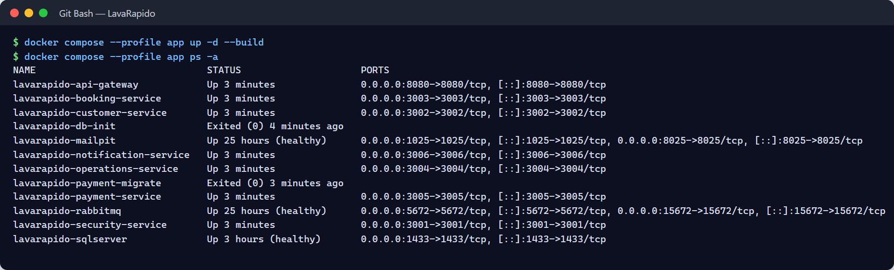

12.3 Option B: Java Services From a Terminal or the IDE
For development or debugging, keep only the infrastructure in Docker and run each service with the Maven Wrapper, one terminal per service. The services read ../lavarapido-infra/.env by themselves and use the dev profile by default, which enables Swagger and the demonstration accounts.
cd Backend/lavarapido-security-service
./mvnw spring-boot:run # Windows: .\mvnw.cmd spring-boot:run
Repeat the command in lavarapido-customer-service, lavarapido-booking-service, lavarapido-operation-service, lavarapido-notification-service, and lavarapido-api-gateway. Do not run the same service in Docker and on the host at the same time, because both would try to use the same port.

12.4 payment-service (.NET 8) Outside Docker
cd Backend/lavarapido-payment-service
dotnet run --project src/PaymentService.Api # http://localhost:3005
This option is for development or debugging; with Option A the service already runs in its container (stop it first with docker compose stop payment-service). The service reads lavarapido-infra/.env, listens on PAYMENT_PORT (3005 by default), and does not start without JWT_SECRET (since v1.1.3, not without DB_PASSWORD either). It never creates its tables: they are created by the payment-migrate container (section 11.1). The repository also has its own docker-compose.yml (since v1.1.3, SQL Server 2022 on port 1434 with the database LavaRapidoPaymentIT, the same as the CI "Pruebas de integración" job; its password is MSSQL_SA_PASSWORD in that repository's .env) only to test the migrations and the integration tests; it must not be used to run the system.

12.5 RabbitMQ and Mail
With MESSAGING_ENABLED=true, the services create the RabbitMQ topology when they start (payment-service only publishes: payment results, redeemed coupons, and points earned): the topic exchange carwash.events; the queues customer-service.events, notification-service.events, and operations-service.booking-confirmed (only booking.confirmed; it replaced the old operations-service.events, which operations-service empties and deletes at start-up); and their dead-letter queues (.dlq, through the carwash.events.dlx exchange), to which a message moves after three failed retries. Since October 26, 2026 booking-service also consumes: it creates the booking.payment-events queue (keys payment.reported and payment.confirmed) and its booking.payment-events.dlq. If payment-service runs outside Docker on Windows and does not connect to RabbitMQ, use RABBITMQ_HOST=127.0.0.1 instead of localhost: .NET may resolve localhost over IPv6 and Docker Desktop cuts the AMQP connection (finding of the test of October 26, 2026). With MESSAGING_ENABLED=false, the system works, but customer profiles are created on the first request of the customer and the notifications that depend on events are not generated.
With MAIL_ENABLED=true and Mailpit, the emails (welcome, recovery code, booking, payment, and coupon notices, inspection reports, and reminders) do not reach real inboxes: they are read at http://localhost:8025. With MAIL_ENABLED=false, the recovery code is written in the log of security-service.

12.6 Logs, Stopping, and Updating
docker compose logs -f security-service # follow a service's log
docker compose logs --since 10m booking-service # last 10 minutes
docker compose stop # stop without deleting data
docker compose start # resume
docker compose down # remove containers, keep volumes
docker compose --profile app up -d --build <service> # update a service after a change
The logs include the time, the level, the service name, and the correlation identifier. A log must never contain passwords, tokens, or receipt content; if they appear, it is a defect that must be reported.

13. Running the Frontend

13.1 Web Application (Angular)
cd Frontend/Front-end-proyecto-web
npm start # equivalent to: npx ng serve
The development server publishes the application at http://localhost:4200 and forwards /api to the gateway. The production build is generated with npm run build and leaves the static files in dist/; publishing them on a web server is outside the scope of this manual.
Figure 7
Web Application Running
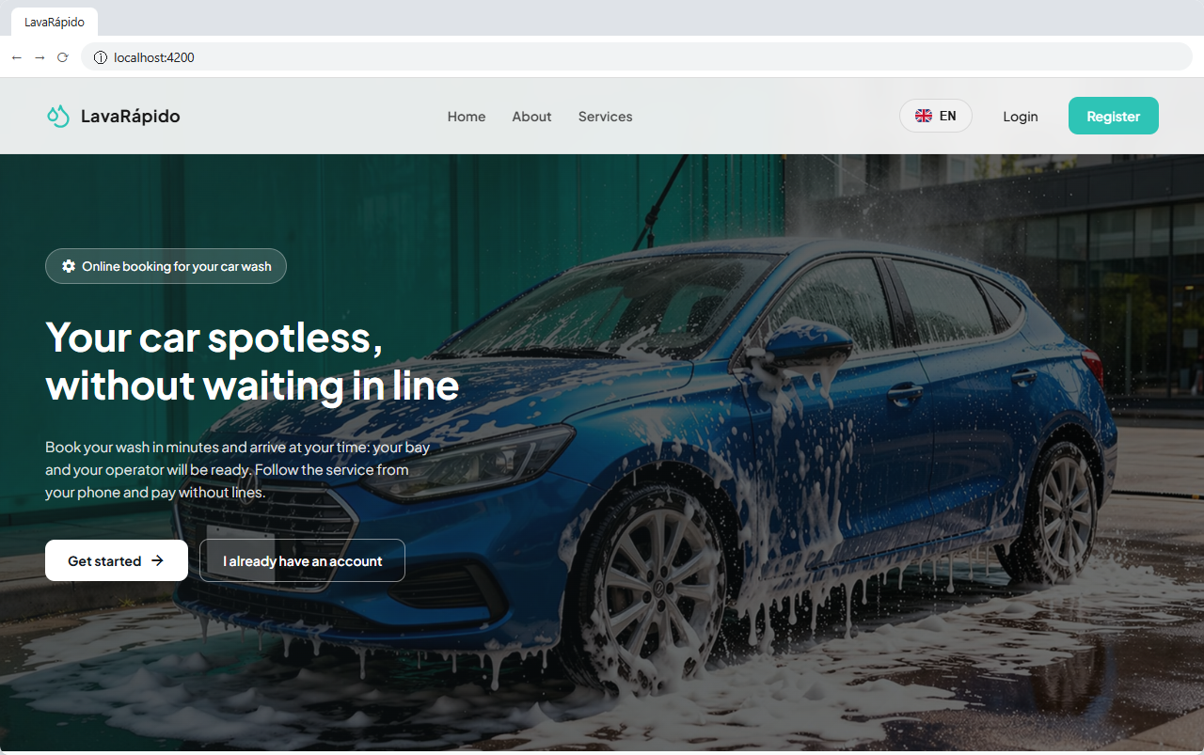

13.2 Mobile Application (React Native With Expo)
cd Frontend/LavadoVehicular-Movil
npx expo start # or: npm start
The command opens the Metro development server (port 8081) and shows a QR code. For a quick test, open the application in an Android emulator (key a) or on a phone with Expo Go on the same Wi-Fi network. Remember to configure EXPO_PUBLIC_API_URL (section 10.5).
New native dependencies. Since October 17, 2026, the app uses expo-image-picker (camera and gallery) and expo-image-manipulator (shrinking the photos) for the inspection report. After git pull, run npm install in Frontend/LavadoVehicular-Movil. Expo Go already includes these modules, but an APK built before that date does not: a new version must be built and published with EAS, as explained in the Deployment Document (section 4.3.3, "Publishing the mobile app"). The camera and photo permissions are declared in the expo-image-picker plugin inside app.json. The changes of October 21, 2026 (compressed receipt, QR magnifier, and mandatory APK update screen) add no native dependencies.
Push notifications. Expo Go does not receive remote push notifications. To test them, build the APK with the EAS preview profile (the only one defined in eas.json besides production; there is no development profile) and set PUSH_ENABLED=true in the backend:
npx eas-cli login
npx eas-cli build --profile preview --platform android
Figure 8
Expo Development Server
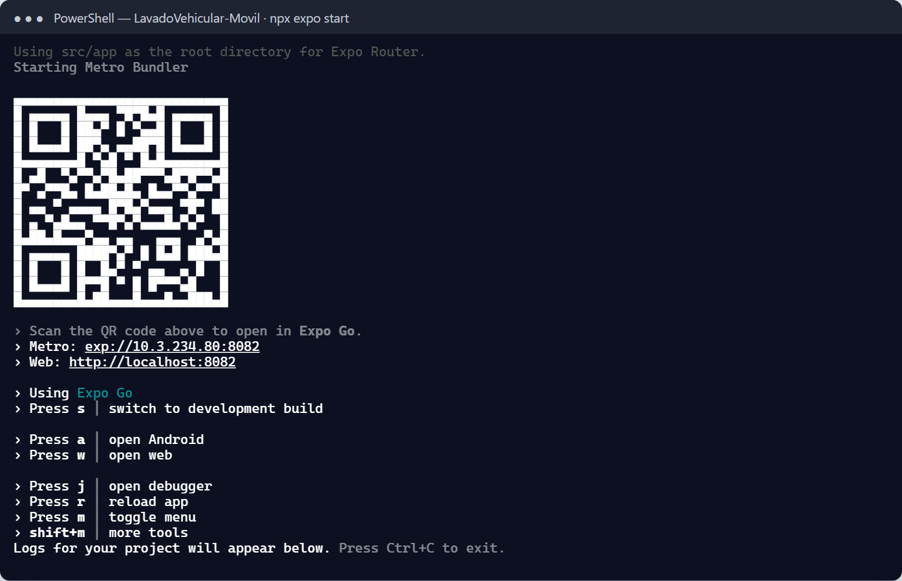

13.3 Static Mockups (Optional)
The documentation repository includes HTML mockups of the screens in 12-ux-ui/mockup. They are opened directly in the browser and do not require the backend; they must not be confused with the real application.

14. Accessing the System
Once all the components are started, people access the system through the web or mobile application, and the technical staff also uses the support interfaces of Table 11.
Table 11
Access Points of the Local Environment
Access | Address | Who uses it
Web application | http://localhost:4200 | Customers, operators, and administrators.
Mobile application | Expo Go or development build | Customers, operators, and administrators.
API Gateway | http://localhost:8080/api/v1 | Client applications and API tests.
Swagger of the Java services (profile dev) | http://localhost:3001/swagger-ui.html (3002, 3003, 3004, and 3006 equivalent) | Developers.
Swagger of payment-service (Development environment) | http://localhost:3005/swagger | Developers.
Mailpit | http://localhost:8025 | Technical staff: recovery codes and other emails.
RabbitMQ console | http://localhost:15672 | Technical staff: exchange, queues, and failed messages.
SQL Server | localhost,1433 | Technical staff: sqlcmd or a graphical client.
Note. Values taken from the configuration of the services and the team guide.

14.1 First Access to the Web Application
- Open an updated browser at http://localhost:4200.
- Check that the welcome screen shows the Login and Register buttons.
- Click Login (route /auth) and log in with a test account (section 15).
- Check that the system opens the home screen of the role: /client, /operator, or /admin.

15. Test Users

15.1 Demonstration Accounts
When security-service starts with the dev profile (the default one in local), it creates one demonstration account per role (administrator admin@gmail.com, operator operador@gmail.com, and customer cliente@gmail.com) if they do not exist. Since develop of October 23, 2026 (E-05) their passwords are not in the code or in any document: each person defines them in their lavarapido-infra/.env with DEMO_ADMIN_PASSWORD, DEMO_OPERATOR_PASSWORD, and DEMO_CLIENT_PASSWORD, and the account whose variable is empty is not created (team guide, lavarapido-infra/GUIA-EQUIPO.md, section 5). Accounts already created with the old passwords keep working until they are changed. Those accounts must never exist in a shared environment.

15.2 Rules for Accounts
Table 12
Rules for the Data of an Account
Data | Rule
Email | Must end in @gmail.com; no spaces. Each email admits a single account.
ID number | Between 5 and 20 digits; unique.
First and last names | Minimum 3 and 2 characters, respectively.
Phone | Colombian mobile number of 10 digits starting with 3.
Password | 8 to 72 characters, with at least one uppercase letter, one number, and one special character, without spaces.
Session | The token lasts one hour; after that, the person logs in again.
Failed attempts | Five failed attempts within 15 minutes lock the account for 15 minutes; resetting the password unlocks it.
Note. Source: validations of the registration form and the password policy of security-service.

15.3 Creating a Test Customer
- Open the web application and click Register.
- Fill in the form with test data and a test Gmail email; accept the legal documents.
- Click Register and then Go to login.
- With MAIL_ENABLED=true and MESSAGING_ENABLED=true, open Mailpit (http://localhost:8025) and check that the welcome email arrived.
- Log in and check that the customer dashboard (/client) opens.

15.4 Operator and Administrator Accounts
Operator and administrator accounts are created by an administrator from Management > Users > Create user or Operators > New operator, with a temporary password (Administrator Manual, section 9.3). The first administrator of an environment without the dev profile is created with the procedure of section 8.4 of the Administrator Manual.

16. Installation Verification
The verification is done in layers: infrastructure, database, messaging, services, and functional flow (Table 13).
Table 13
Installation Checklist
No. | Check | Expected result
1 | Containers | sqlserver and rabbitmq healthy; mailpit and the services running.
2 | Database | The 58 tables in the nine schemas (section 11.5).
3 | Initial data | The results of Table 9.
4 | RabbitMQ | Exchange carwash.events and the queues of customer and notification (with messaging active).
5 | Mailpit | Web interface available.
6 | Health of each service | /actuator/health responds {"status":"UP"} in ports 3001 to 3006 and 8080.
7 | Protected route without a token | Error 401 returned by the service.
8 | Web application | The welcome screen and the login are displayed.
9 | Registration and login | An account is created and the customer dashboard opens.
10 | Password recovery | The code arrives in Mailpit and allows changing the password.
11 | Booking flow | A vehicle is registered and a booking is created.
12 | Assignment and execution | The administrator assigns an operator, who starts and finishes the service.
13 | Payment | The customer reports a payment and the administrator approves it.
14 | Persistence | The data remains after restarting the containers.
Note. Prepared by the authors from the integration checks of the project documentation.

16.1 Infrastructure and Database
docker compose ps
docker compose exec sqlserver /opt/mssql-tools18/bin/sqlcmd -S localhost -U sa -P "$DB_PASSWORD" -C -Q "SELECT @@VERSION"
Then run the queries of section 11.5. If the results do not match, do not continue with the following tests.

16.2 Messaging and Mail
curl -s -u guest:guest http://localhost:15672/api/exchanges/%2F/carwash.events
docker compose exec rabbitmq rabbitmqctl list_queues name messages
curl -s -o /dev/null -w "%{http_code}\n" http://localhost:8025/
The first command returns the data of the exchange (type topic); the second, the queues with their messages (the .dlq queues must be at zero); and the third, the code 200 of Mailpit. Replace guest:guest with the RabbitMQ credentials of the .env file if they were changed.

16.3 Services and Gateway
for port in 3001 3002 3003 3004 3005 3006 8080; do
echo "$port: $(curl -s http://localhost:$port/actuator/health)"
done
curl -i http://localhost:8080/api/v1/bookings/me
Each health endpoint must answer {"status":"UP"}. The last command calls a protected route without a token through the gateway: it must return 401. The gateway does not check the token signature (ADR-006): a request without a token goes straight through and booking-service rejects it. Since October 21, 2026 the gateway does cut the token of a closed session: after signing out, repeating the call with the same token (-H "Authorization: Bearer <TOKEN>") returns 401 from the gateway, without reaching the service. Every service, including payment-service, checks the database in its health endpoint: if SQL Server does not answer, it replies DOWN with code 503.
Figure 9
Response of the Health Endpoints
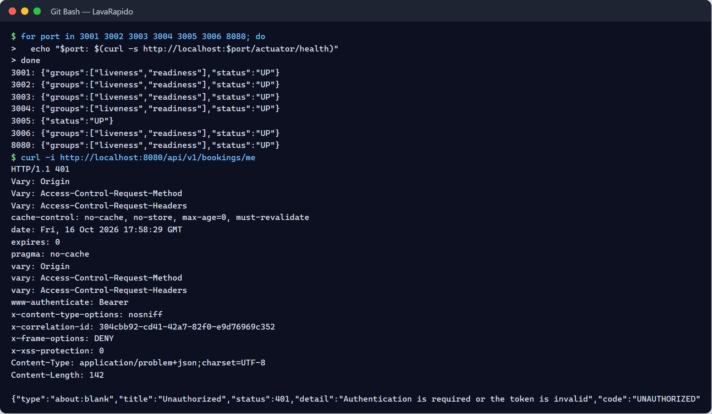

16.4 Minimum Functional Flow
- Register a test customer and check the welcome email in Mailpit.
- Test password recovery: request the code, read it in Mailpit, and change the password.
- Log in as the customer, register a vehicle, and create a booking; a free slot is confirmed immediately.
- Log in as the administrator and assign an operator to the booking (Bookings > Assign).
- Log in as the operator on the day of the booking, start the service, and finish it.
- As the customer, report a payment with a test receipt; as the administrator, approve it in Payments.
- With messaging active, check that the customer received the notifications of the booking, the assignment, and the approved payment, the email in Mailpit, and the points in the dashboard.
- Sign out and repeat a call with the same token: the gateway answers 401.
- Optional: as administrator, create a test booking for a time that ends soon, with an operator, and do not start it. A few minutes after its end time it must appear in the To close card of the administrator's home, with the notice "Servicio sin registrar" (service not recorded); clicking Attended makes it Completed.
- Restart the containers (docker compose restart) and check that the data remains.

16.5 Traces Verification
The audit table audit.audit_log exists but is not populated in the current version (Administrator Manual, section 16). After the tests of section 16.4, verify instead that the sessions were recorded:
SELECT TOP (5) u.username, s.started_at, s.revoked_at
FROM security.user_session s JOIN security.app_user u ON u.user_id = s.user_id
ORDER BY s.started_at DESC;
Figure 10
Session Records
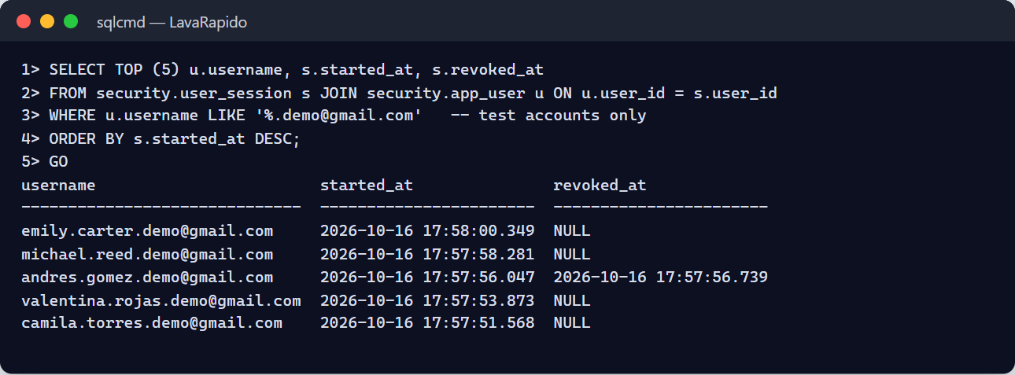

17. Common Errors and Solutions
The first step in any error is to consult the log of the affected service with docker compose logs --tail 100 <service> or the terminal where it runs (Table 14).
Table 14
Frequent Errors, Probable Causes, and Solutions
Error or symptom | Probable cause | Solution
Login failed for user 'sa' | A native SQL Server of Windows answers on port 1433, or the password differs from the one used when the volume was created. | Stop the Windows service MSSQLSERVER; use the original password or recreate the volume (docker compose down -v) in a disposable environment.
A port is in use (address already in use) | Another process uses the port. | Find it (netstat -ano on Windows, lsof -i :PORT on Linux or macOS) and stop it.
The SQL Server container stops | Weak DB_PASSWORD or less than 2 GB of memory. | Use a strong password and assign more memory to Docker.
docker compose config fails | DB_PASSWORD or JWT_SECRET missing in .env. | Complete the .env file (section 10).
A Java service does not start: "JWT secret" or database errors | The .env file is not in ../lavarapido-infra/ or the folder was renamed. | Keep the repositories side by side with their original names.
UnsupportedClassVersionError | JDK earlier than 21. | Install JDK 21 and check java -version.
payment-service does not start | JWT_SECRET missing, or .NET 8 SDK not installed. | Complete the .env file; install the .NET 8 SDK.
Invalid object name 'payment.payment' | The payment migrations did not run. | Run docker compose up -d again and check that payment-migrate ended with code 0.
docker compose build fails: path ../lavarapido-operation-service not found | The operations repository was cloned with another name (for example, lavarapido-operations-service). | Rename the folder to lavarapido-operation-service or clone it again with that name.
Payment screens fail and the other screens work | The payment-service container is not running, or payment-migrate did not end with code 0. | Check docker compose ps and docker compose logs payment-service payment-migrate.
Liquibase: checksum mismatch | A changeset that already ran was edited. | Revert the change and write a new changeset; in a disposable environment, recreate the database.
Liquibase: waiting for changelog lock | A previous start was interrupted. | Make sure no other instance is running and delete the row of the corresponding DATABASECHANGELOGLOCK_ table.
401 on every request | Expired token or different JWT_SECRET among services. | Log in again; check that all the services read the same .env file.
401 right after signing out in another tab or device | The session was closed and the gateway cuts its token. | Log in again.
Requests take about 3 more seconds and the gateway log says No se pudo confirmar la sesión | security-service does not answer; the gateway lets the request through after waiting for it. | Start security-service and check its health.
503 CUSTOMER_SERVICE_UNAVAILABLE or BOOKING_SERVICE_UNAVAILABLE | The service called is down. | Start customer-service or booking-service.
"Your customer profile is not ready yet" | The customer profile has not been created (event not consumed). | Wait and retry; with MESSAGING_ENABLED=true check the customer-service queue.
Emails do not arrive in Mailpit | MAIL_ENABLED=false or wrong host or port. | MAIL_HOST=localhost and MAIL_PORT=1025 on the host; MAIL_DOCKER_HOST=mailpit in Docker.
Booking emails and reminders do not arrive | INTERNAL_API_KEY empty. | Generate the key and restart security-service and notification-service.
Bookings that ended do not appear in "To close", or those without an operator do not become No-show | FOLLOW_UP_ENABLED=false, INTERNAL_API_KEY empty, or booking-service down. | Check the operations-service log (Could not follow up finished bookings or was not closed as not attended) and the internal key.
Notifications do not arrive | MESSAGING_ENABLED=false or messages in a dead-letter queue. | Enable messaging and review the queues.
CORS error in the browser | The origin is not allowed. | CORS_ALLOWED_ORIGINS=http://localhost:4200,http://localhost:8081 (add the real origin if it is different) and restart the services.
Blank screen or 404 on /api in the web application | The gateway is not running on port 8080. | Start the gateway and check proxy.conf.json.
The mobile app does not reach the backend | localhost used from the phone, or different network. | Use 10.0.2.2 in the emulator or the IPv4 address of the computer on the same network.
npm ERESOLVE or build failures | Node.js version not supported by Angular 21. | Use Node.js 22 LTS and reinstall with npm ci.
Docker consumes all the memory on Windows | WSL 2 without a memory limit. | Limit the memory in .wslconfig and assign at least 5 GB to Docker.
Shifted booking times | Wrong time zone; the system stores UTC. | Check BOOKING_ZONE=America/Bogota.
Note. Prepared by the authors from the infrastructure repository, the runbooks of the services, and the technical backlog.

18. Glossary
Table 15
Glossary of Installation Terms
Term | Definition
API Gateway | Single entry point that routes the requests to the services; it does not check the token signature, but since October 21, 2026 it cuts the tokens of closed sessions.
Changelog | Liquibase file that describes the changes of the database.
Changeset | Unit of change of a changelog, identified by its id and author.
Compose profile | Group of services of Docker Compose that starts only when it is requested (--profile app).
Container | Isolated process that runs an application with its dependencies.
CORS | Browser mechanism that restricts requests between different origins.
Dead-letter queue (DLQ) | Queue where messages that failed after retries are kept.
Exchange | RabbitMQ element that receives messages and routes them to queues.
Health endpoint | Route (/actuator/health) that indicates whether a service is working.
Image | Read-only template from which a container is created.
JDK | Java development kit; the project uses version 21.
Liquibase | Tool for versioning and migrating the database schema.
Mailpit | Development mail server that captures emails without sending them.
Maven Wrapper | Script (mvnw) that downloads and runs the correct version of Maven.
Volume | Persistent Docker storage that survives the recreation of a container.
WSL 2 | Windows Subsystem for Linux used by Docker Desktop.
Note. Prepared by the authors from the project documentation.

References
Humble, J., & Farley, D. (2010). Continuous delivery: Reliable software releases through build, test, and deployment automation. Addison-Wesley.
Microsoft. (n.d.). Microsoft SQL Server - Ubuntu based images [Container image]. Docker Hub. Retrieved October 7, 2026, from https://hub.docker.com/r/microsoft/mssql-server
Servicio Nacional de Aprendizaje. (2026). Guía para elaborar manuales de software: Manual de usuario, manual técnico, manual de instalación y manual de administrador [Guide for writing software manuals: User manual, technical manual, installation manual, and administrator manual] [Unpublished instructional material]. Technologist in Software Analysis and Development program.
Vehicle Washing Development Team. (2026a). Vehicle washing management system: Project documentation (vehicle-w-docs) [Unpublished project documentation]. GitHub. https://github.com/code-sena/vehicle-w-docs
Vehicle Washing Development Team. (2026b). lavarapido-infra (develop branch) [Computer software]. GitHub. https://github.com/BrayanCABRERA123/lavarapido-infra
Wiggins, A. (2017). The twelve-factor app: III. Config. https://12factor.net/config

19. Annexes

Annex A. Source of the Screenshots
The figures in this manual were taken on October 16, 2026, on a Windows 11 computer with Docker Desktop, following the steps of the manual. The terminal screenshots show the real output of the commands, and the browser screenshot shows the web application running at http://localhost:4200. They contain no real passwords, secrets, or personal data: the values of the .env file are never shown.

Annex B. Information to Confirm Before Delivery
Table 16
Information Pending Confirmation
Topic | What is missing | Section
One database login per service | The services use sa. | 11.4
Variables of October 21, 2026 | Resolved on October 22, 2026: the nine of them (SESSION_CHECK_*, BOOKING_EXPIRY_*, and FOLLOW_UP_*) are in .env.example and docker-compose.yml (action ACO-14, closed). | 10.2
Variables of October 24, 2026 | AUTH_RATE_LIMIT_*, TRUSTED_PROXIES, ROUTE_*_TIMEOUT, and START_LATE_LIMIT have a default value but are not yet in .env.example or the compose file (ACO-40). | 10.2
Published web | Since October 24, 2026 the web image runs nginx without root on port 8080 (formerly 80); Caddy points to web:8080. Nothing changes locally: ng serve stays on 4200. | 9
Global database script | lavarapido-6-services-sqlserver.sql is not versioned; the database is only created with Liquibase. | 11.3
Note. Prepared by the authors from the verification of the repositories and the technical backlog.

Annex C. Summary of Installation Commands
# 1. Get the project (repositories side by side; see section 8.1)
git clone -b develop https://github.com/BrayanCABRERA123/lavarapido-infra.git
# 2. Configure the environment
cd lavarapido-infra && cp .env.example .env # set DB_PASSWORD, JWT_SECRET, INTERNAL_API_KEY
# 3. Infrastructure, database, and payment migrations
docker compose up -d && docker compose ps
# 4. Services (Java and payment-service) and gateway in Docker
docker compose --profile app up -d --build
# 5. Clients
cd ../../Frontend/Front-end-proyecto-web && npm ci && npm start
cd ../LavadoVehicular-Movil && npm ci && npx expo start
# 6. Verification
curl -s http://localhost:8080/actuator/health

Annex D. Security Checklist Before Sharing the Environment
Table 17
Environment Security Controls
Control | Met
The .env file is not versioned and has restricted permissions | Yes / No
JWT_SECRET has at least 32 bytes and is not a shared example | Yes / No
The passwords of sa and RabbitMQ and the INTERNAL_API_KEY were changed | Yes / No
The services do not use the sa account to connect | Yes / No
Only the gateway and the web application are exposed outside the machine | Yes / No
Mailpit, the RabbitMQ console, SQL Server, and ports 3001 to 3006 are not accessible from outside | Yes / No
The security service does not run with the dev profile (no demonstration accounts) | Yes / No
HTTPS with TLS 1.2 or later is used if the environment leaves the local machine | Yes / No
Logs do not contain passwords, tokens, or receipts | Yes / No
Note. Prepared by the authors from the security policy of the project.

Annex E. Delivery Checklist
Table 18
Installation Manual Checklist
Criterion | Met
Complete title page and version | Yes / No
Table of contents with updated pages | Yes / No
Objective and scope explained | Yes / No
The commands match the real infrastructure repository | Yes / No
The repository folders keep their original names (including lavarapido-operation-service) | Yes / No
All figures are real screenshots of the installation | Yes / No
Steps verified on a clean installation | Yes / No
No credentials, keys, or sensitive data | Yes / No
Exported to PDF with the name Manual_instalacion_LavadoVehicular_3145556.pdf | Yes / No
Note. Adapted from the checklist of the guide for writing software manuals (SENA, 2026).

