PORTFOLIO RESEARCH DESIGN PAPER

Langfuse for
Graph-RAG Operations
  - A Traceable Evaluation Blueprint
for Sentinel RAG Ops
Observability architecture, trace contracts, evaluation methodology,
and privacy-aware operational evidence
Harsh Chaudhary
1 September 2026

Abstract
Graph-and-vector RAG systems can fail at ingestion, retrieval, context assembly, model invocation, or evaluation while still producing plausible outputs. This paper proposes a Langfuse-based observability and evaluation architecture for Sentinel RAG Ops, a LightRAG-derived document knowledge application. It defines trace boundaries, typed observations, safe metadata, an offline-to-online evaluation loop, operational metrics, release gates, and privacy controls. The work is a design study: it contributes a testable protocol and implementation roadmap, but reports no fabricated Langfuse traces or benchmark gains.
TRACE / EVALUATE / DIAGNOSE / GOVERN
Paper status: independent portfolio research design; proposed Langfuse integration; not peer-reviewed.
01 / RESEARCH DESIGN

Research framing

Problem statement
A RAG system can return a plausible answer even when retrieval was weak, context was truncated, a model call was throttled, or the answer was not supported by the selected evidence. Application uptime alone does not expose these failures. Sentinel RAG Ops already makes document status and graph state visible, but it does not yet provide a unified record of each retrieval and generation decision.
This paper proposes a Langfuse-based observability and evaluation layer for Sentinel RAG Ops. The design treats an ingestion job or user query as a trace, important pipeline steps as typed observations, and quality judgments as scores. It is a research design and implementation blueprint, not a report of a completed Langfuse deployment.

Research questions
- RQ1. Which trace structure makes graph-and-vector RAG failures attributable to ingestion, retrieval, context assembly, or generation?
- RQ2. Which offline and online measures provide useful evidence of retrieval quality, answer grounding, latency, cost, and reliability?
- RQ3. How can telemetry remain diagnostically useful without copying private document content into an observability store by default?

Contribution and scope
The contribution is a system-specific trace contract, evaluation protocol, release-gate strategy, and privacy boundary grounded in the existing Sentinel architecture and current Langfuse concepts. It does not introduce a new RAG algorithm, reproduce the LightRAG benchmark, or claim that observability alone improves answer quality.
Claim boundary: the existing project has historical evidence for one successful document workflow. All Langfuse traces, dashboards, experiments, and target metrics described here are proposed work.
02 / RESEARCH DESIGN

Foundations and system context
Retrieval-augmented generation combines model-based generation with information selected from an external collection [1]. LightRAG extends this pattern with graph structures, entity and relationship extraction, and dual-level retrieval [2]. Sentinel RAG Ops packages that engine behind a FastAPI service and a document, graph, and retrieval interface.

Why observability is a separate engineering layer
An application log records events, but a RAG trace preserves causality across the user request, retrieval operation, selected context, model call, and result. Langfuse organizes individual observations into traces and can group traces into sessions [3]. Its typed observations include retriever, embedding, generation, evaluator, span, and event records [4].
Layer | Existing Sentinel responsibility | Proposed Langfuse evidence
Ingestion | Parse, chunk, extract, persist | Stage duration, status, counts, error class
Retrieval | Graph and vector evidence selection | Mode, top-k, source IDs, scores, latency
Generation | Keywords, extraction, final answer | Model, prompt version, usage, latency, error
Evaluation | Not yet systematic | Dataset run, deterministic checks, judge and human scores
Operations | Status UI and local logs | Versioned dashboards, release comparisons, alerts

Design principle
Stable semantic names should describe pipeline roles rather than model brands. Langfuse guidance notes that evaluators, dashboards, saved views, and experiments depend on consistent trace structure and meaningful inputs and outputs [5]. Model identifiers, retrieval mode, storage workspace, and software release belong in attributes rather than observation names.
Operational observability answers what happened and where. Evaluation asks whether the result was good enough. The two should share trace IDs but remain conceptually distinct.
03 / RESEARCH DESIGN

Proposed observability architecture
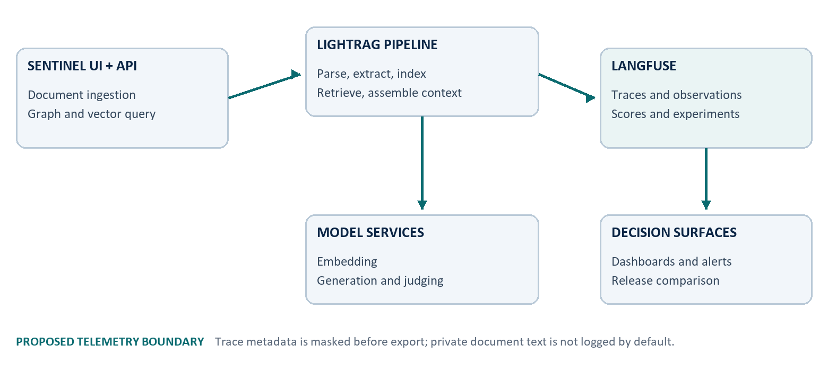
Figure 1. Proposed telemetry architecture. Langfuse is an observability and evaluation plane beside the existing RAG path; it is not in the answer-critical path.

Placement and failure isolation
Instrumentation should surround existing LightRAG boundaries instead of replacing them. The application starts a root trace when an ingestion job or query begins. Child observations record parsing, embedding, graph extraction, retrieval, context assembly, generation, and evaluation. Telemetry export must be buffered and fail open: an unavailable observability backend should not block a document job or user answer.

Identity and correlation
Field | Proposed value | Reason
trace name | rag.ingest or rag.query | Stable workload grouping
session ID | Conversation or batch identifier | Multi-turn and multi-document analysis
user ID | Pseudonymous internal identifier | Abuse, cost, and cohort analysis
release | Application build identifier | Regression comparison
tags | environment, route, experiment | Known-at-start segmentation
metadata | workspace hash, mode, top-k | Run-specific diagnostic context

Langfuse is built on OpenTelemetry and can coexist with other telemetry destinations [3]. That makes a later infrastructure correlation path possible without forcing infrastructure-level spans into every LLM trace. Only observations needed to explain the RAG decision should be retained.
04 / RESEARCH DESIGN

Trace specification

One trace per unit of work
The root observation should show the reviewable input and output: document metadata and terminal status for ingestion, or user question and final answer for a query. Each model invocation remains a separate generation observation so token use, latency, and failures are attributable [5].
Trace | Child observation | Type | Minimum safe attributes
rag.ingest | parse_document | span | format, bytes, parser, status
rag.ingest | chunk_document | span | chunk policy, count, truncation
rag.ingest | embed_chunks | embedding | model, dimensions, batch size, usage
rag.ingest | extract_graph | generation | model, prompt version, entity and edge counts
rag.query | retrieve_context | retriever | mode, top-k, source hashes, retrieval scores
rag.query | assemble_context | span | selected count, context tokens, truncation
rag.query | generate_answer | generation | model, prompt version, usage, finish reason
rag.query | evaluate_answer | evaluator | metric version, score, rationale class

Naming and error taxonomy
Observation names remain stable across providers. Errors are normalized into parser_error, provider_auth, model_unavailable, rate_limited, storage_error, retrieval_empty, context_overflow, generation_error, and telemetry_error. Raw provider messages may be retained only after credential and content scrubbing.
trace=rag.query > retrieve_context[retriever] > assemble_context[span] > generate_answer[generation] > evaluate_answer[evaluator]
Do not log full source chunks by default. Log source hashes, counts, score summaries, token totals, and a controlled redacted preview only when a research workspace explicitly allows it.
05 / RESEARCH DESIGN

Evaluation methodology
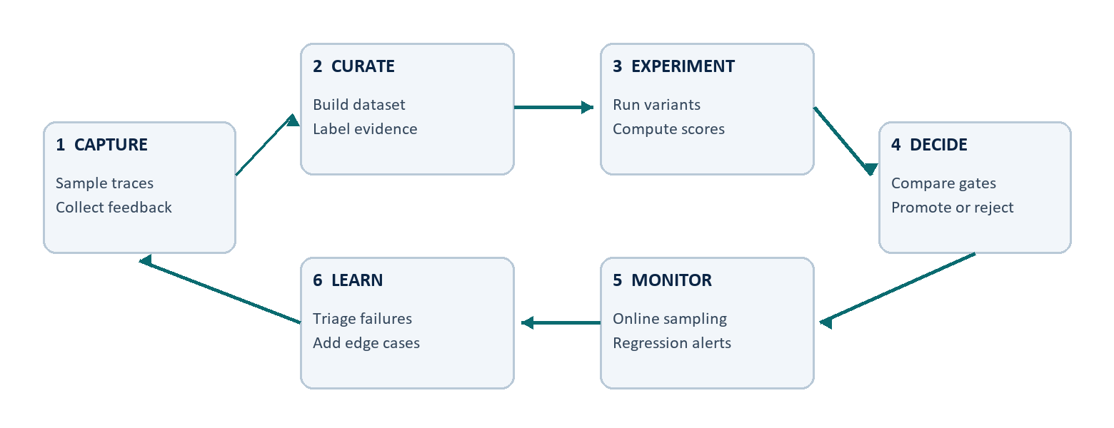
Figure 2. Proposed continuous evaluation loop. Production failures become curated test cases; offline experiments inform release decisions; online monitoring checks generalization.

Offline and online evidence
Langfuse datasets and experiment runs can compare the same test items across prompt, model, retriever, and code variants; resulting judgments are stored as scores [6]. Online scores can then sample real traces and feed discovered edge cases back into the offline dataset. This closes the loop without treating production traffic as ground truth.
Dimension | Primary measure | Evidence required
Retrieval | Recall@k, MRR@k, context precision | Expected source or graded relevant passages
Grounding | Faithfulness / citation support | Answer claims aligned to retrieved evidence
Usefulness | Answer relevance and task success | Expected answer, rubric, or reviewer label
Efficiency | p50 and p95 latency, tokens, cost | Timestamp and generation usage attributes
Reliability | Success rate by normalized error class | Terminal trace status and release

RAGAS separates context relevance, faithfulness, and answer relevance, illustrating why a single end-to-end score is insufficient [7]. Automated judges are useful for coverage but should be calibrated against human-reviewed samples and deterministic checks.
06 / RESEARCH DESIGN

Experimental protocol

Dataset construction
Begin with a public, versioned corpus rather than private resumes. Create questions across direct facts, multi-hop relationships, summaries, unanswerable requests, contradictory sources, and prompt-injection attempts. Each item stores the question, expected source IDs, optional reference answer, task class, and difficulty. Split items into development and held-out evaluation sets before tuning.

Controlled comparisons
Factor | Candidate levels | Control rule
Retrieval mode | naive, local, global, hybrid, mix | Same corpus, embedding space, model, and top-k
Context budget | small, medium, large | Same retrieval output and answer prompt
Prompt version | baseline and candidate | Same model, temperature, and evidence
Generation model | baseline and candidate | Same prompt, context, and decoding policy

Analysis plan
Run each deterministic configuration over the identical held-out items. Report per-item results, bootstrap confidence intervals, and paired differences rather than only averages. Segment by question class and inspect failures before selecting a winner. If model sampling is enabled, repeat runs and report variance.
- Gate A. No material regression in faithfulness or expected-source retrieval on the held-out set.
- Gate B. Latency and cost remain within a budget established from the baseline and user experience target.
- Gate C. Security cases do not expose hidden instructions, secrets, or unsupported source content.
Thresholds are deliberately not fabricated here. They should be fixed after a pilot, before the final comparison is run.
07 / RESEARCH DESIGN

Metrics, dashboards, and diagnosis
Langfuse metrics can aggregate quality scores, cost, latency, volume, tokens, and release dimensions [8]. A useful dashboard begins with decisions and failure modes, not every available field.
Question | Dashboard slice | Diagnostic action
Are answers becoming less grounded? | Faithfulness by release and retrieval mode | Inspect low-score traces and source selection
Why did latency move? | p50/p95 by observation and model | Separate retrieval, queue, and generation time
Where is cost concentrated? | Tokens and cost by route, model, workspace | Check context size, retries, and prompt changes
What fails in production? | Error rate by normalized class and release | Route to parser, provider, storage, or retrieval owner
Does a candidate generalize? | Offline run vs sampled online score distribution | Compare class coverage and drift

Alert design
Alerts should combine a meaningful threshold, minimum sample size, and time window. A single bad trace is a debugging case; a sustained rate change may be an incident. Separate availability alerts from quality monitors so a provider outage is not misclassified as an answer-quality regression.

Trace-to-action examples
- Empty retrieval. Verify document completion, workspace identity, index version, mode, and top-k before changing the answer prompt.
- High cost. Compare context token growth, repeated model calls, retries, and prompt version at observation level.
- Low faithfulness. Inspect whether evidence was irrelevant, context was truncated, or generation ignored relevant passages.
A dashboard is not evidence of improvement. A release decision requires comparable runs, preserved configurations, and inspectable failures.
08 / RESEARCH DESIGN

Privacy, security, and governance

Telemetry is another data destination
Sentinel can run locally while model calls and observability export leave the device. A trace may contain user questions, retrieved passages, prompts, answers, identifiers, and provider errors. Those fields can be as sensitive as the original document. Self-hosting changes operational control but does not remove the need for minimization, access control, backups, and retention policy.

Proposed controls
- Minimize. Default to hashes, counts, model metadata, durations, and normalized errors; omit full chunks and prompts where they are not required.
- Mask before export. Redact credentials, email addresses, phone numbers, document paths, and configured sensitive patterns on the client side.
- Separate environments. Use distinct Langfuse projects or environments for development, evaluation, and production; never mix public benchmark data with private workspaces.
- Restrict and expire. Apply least-privilege access, retention limits, deletion procedures, and key rotation appropriate to the deployment.
- Audit. Sample traces for leakage, missing redaction, label quality, and evaluator drift before expanding capture.
Langfuse documents client-side masking as the option that prevents sensitive data from leaving the application and describes server-side ingestion masking as an additional self-hosted control [9]. For this project, client-side masking is the required first boundary.

Threat-aware evaluation
The dataset should include malicious or misleading document instructions, cross-workspace retrieval attempts, secret-like strings, and unanswerable questions. Pass criteria must inspect both the final answer and the trace payload: a safe answer paired with leaked telemetry is still a failure.
Never store real API keys or private document text merely to make a trace look complete. Diagnostic value must be earned field by field.
09 / RESEARCH DESIGN

Implementation roadmap

Phase 1 - trace without changing behavior
Add the Langfuse SDK behind a disabled-by-default configuration flag. Instrument one query and one ingestion path with stable names, terminal status, timing, and safe metadata. Flush telemetry asynchronously and confirm that export failure does not affect application results.

Phase 2 - establish evaluation evidence
Create a small public dataset with expected source IDs and reviewer rubrics. Run the current configuration as the named baseline. Add deterministic retrieval and citation checks first, then calibrate model-based scores against a human-reviewed subset.

Phase 3 - operationalize decisions
Add release and prompt version attributes, dashboards for latency, cost, quality, and errors, and a documented promotion checklist. Sample online traces and route failures into the dataset rather than continuously editing metrics to match observed behavior.
Risk | Early signal | Mitigation
Trace volume or cost grows | Unexpected span count or ingestion lag | Filter infrastructure noise; sample noncritical traces
Sensitive content appears | Audit finds raw PII or source text | Block export, strengthen client masking, delete affected data
Evaluator drift | Human agreement falls by class | Version judge prompts; recalibrate and retain human review
Instrumentation changes behavior | Latency or failure rate rises when enabled | Buffer export, time-box flush, fail open

Acceptance evidence
Completion requires trace examples for both success and failure, a privacy audit, a reproducible dataset run, baseline and candidate configurations, a short error analysis, and a release decision that cites measured tradeoffs. Screenshots alone are not sufficient.
10 / RESEARCH DESIGN

Limitations and conclusion

Limitations
This design has not been executed against a live Langfuse instance. It therefore cannot report trace overhead, ingestion reliability, evaluator agreement, retrieval improvements, cost, or dashboard usefulness. Langfuse features and SDK contracts may change; implementation should follow the version installed at that time. Model-based evaluation can be biased, nondeterministic, and sensitive to the judge prompt. Human review remains necessary for calibration and high-risk cases.
The protocol also does not prove that the proposed metrics capture every user need. Recall@k requires meaningful relevance labels, faithfulness does not guarantee completeness, and a low-latency answer can still be wrong. Aggregate scores can hide rare but important failures, especially privacy breaches and cross-workspace retrieval.

Conclusion
A credible RAG operations layer must connect each answer to the retrieval, context, model, version, and evaluation evidence that produced it. Langfuse provides a compatible trace, score, dataset, experiment, and metrics model for that work. The proposed design keeps the answer path owned by Sentinel and LightRAG while adding an inspectable evidence plane beside it.
The next milestone is intentionally small: instrument one public-data query path, verify privacy-safe trace structure, create a baseline dataset run, and publish measured results as a later empirical report. Until then, this paper is a transparent research blueprint rather than a performance claim.
Portfolio summary: designed a privacy-aware observability and evaluation architecture for a graph-and-vector RAG system, including trace contracts, experiment methodology, operational metrics, and release evidence.
11 / RESEARCH DESIGN

References and evidence status
[1] Lewis, P. et al. (2020). Retrieval-Augmented Generation for Knowledge-Intensive NLP Tasks. NeurIPS 2020.
https://arxiv.org/abs/2005.11401
[2] Guo, Z., Xia, L., Yu, Y., Ao, T. and Huang, C. (2024; revised 2025). LightRAG: Simple and Fast Retrieval-Augmented Generation.
https://arxiv.org/abs/2410.05779
[3] Langfuse. Observability data model: observations, traces, sessions, attributes, and OpenTelemetry. Accessed 1 September 2026.
https://langfuse.com/docs/observability/data-model
[4] Langfuse. Observation types. Accessed 1 September 2026.
https://langfuse.com/docs/observability/features/observation-types
[5] Langfuse. What does a good trace look like? Accessed 1 September 2026.
https://langfuse.com/docs/observability/best-practices
[6] Langfuse. Evaluation core concepts. Accessed 1 September 2026.
https://langfuse.com/docs/evaluation/core-concepts
[7] Es, S., James, J., Espinosa-Anke, L. and Schockaert, S. (2024). RAGAS: Automated Evaluation of Retrieval Augmented Generation. EACL 2024 Demo.
https://arxiv.org/abs/2309.15217
[8] Langfuse. Metrics overview. Accessed 1 September 2026.
https://langfuse.com/docs/metrics/overview
[9] Langfuse. Data masking for self-hosted deployments. Accessed 1 September 2026.
https://langfuse.com/self-hosting/security/data-masking

Project evidence status
Existing evidence: Sentinel RAG Ops architecture and one historical functional workflow documented in the companion technical case study. Proposed evidence: every Langfuse trace, score, dataset run, dashboard, alert, and promotion gate in this paper. No Langfuse credentials, telemetry, screenshots, or invented benchmark results are included.

Attribution and paper status
Author and project owner: Harsh Chaudhary. Prepared with AI-assisted research and document production. This is an independent portfolio research design paper, not a peer-reviewed publication. Core graph-RAG functionality is attributed to LightRAG and its contributors; Langfuse capabilities are attributed to its documentation.

