Metoo-Movement-Tweet-Analysis

Your Name (First M. Last)

Name of School or Institution

Course Number and Name *(for student papers)*

Instructor *(for student papers)*

Date *(for student papers)*

# Author Note *(for professional papers)*

# Abstract

Many women accused Harvey Weinstein, a producer, of sexual harassment in October 2017. Their experiences inspired additional women to report sexual harassment claims against other well-known individuals, including politicians, actors, and producers. Due to the widespread adoption of the hashtag, these incidents are known collectively as the "#MeToo movement."

On social media sites like Twitter and Facebook, use the hashtag "#metoo." Because it has given previously unheard women's voices more prominence than those of traditionally prominent men, the movement is frequently referred to as "empowering." In this study, we look at how sentiment, power, and agency dynamics play out in the online media's reporting on these events. We describe a contextual emotional analysis using a corpus of online media articles about the #MeToo movement..

NLP(Natural Language Processing) was used to determine the Quality of the Tweet,whether it has hatred in the tweet or not.

Topic modelling for Social Media Microblogging App using #MeToo Hashtag Data

## Brief Introduction

Tarana Burke founded the #MeToo movement in 2006, with the goal of instilling hope and solidarity among women who have experienced sexual harassment.have been sexually assaulted (Ohlheiser 2018). Following the wave of sexual harassment allegations against producer Harvey Weinstein in October 2017, actress Alyssa Milano posted a tweet with the hashtag #MeToo and encouraged others to do the same. Her message sparked a nationwide movement, drawing attention to the prevalence of sexual harassment and encouraging women to share their experiences.Tarana Burke has stated that the movement's primary goal is "empowerment through empathy."

On social media sites like Twitter and Facebook, use the hashtag "#metoo." Because it has given previously unheard women's voices more prominence than those of traditionally prominent men, the movement is frequently referred to as "empowering." In this study, we look at how sentiment, power, and agency dynamics play out in the online media's reporting on these events. We describe a contextual emotional analysis using a corpus of online media articles about the #MeToo movement..

### 

### Brief Related Works

Anjalie Field et al in their paper Contextual Affective Analysis:mentioned that NLP's contributions (Bamman 2015). However, most approaches (Iyyer et al. 2016; Chambers and Jurafsky 2009; Bamman, O'Connor, and Smith 2013; Card et al. 2016) rely on unsupervised models, which can capture high-level patterns but are difficult to interpret and do not target specific dimensions.To tackle this problem they used Contextual Affective Analysis:which was effective for binary format of output and could not predict the hate speech correctly.

**Detailed Discussion on Implemented Algorithm**

The algorithm used in our model relies on Natural language processing (NLP) , the technique used is known as Sentiment analysis which is the process of detecting positive or negative sentiment in text. It’s often used by businesses to detect sentiment in social data, gauge brand reputation, and understand customers.A basic task in sentiment analysis is classifying the polarity of a given text at the document, sentence, or feature/aspect level—whether the expressed opinion in a document, a sentence or an entity feature/aspect is positive, negative, or neutral. Advanced, "beyond polarity" sentiment classification looks, for instance, at emotional states such as enjoyment, anger, disgust, sadness, fear, and surprise.Existing approaches to sentiment analysis can be grouped into three main categories: knowledge-based techniques, statistical methods, and hybrid approaches.

# Results

The algorithm implemented upon the given dataset classifies the tweets (Total Tweets: 393135)

Into two groups has hatred and has no hatred. The tweets after being classified are tabulated below.

**Sentiments**

**Has Hatred 4206**

**Has No Hatred 34158**

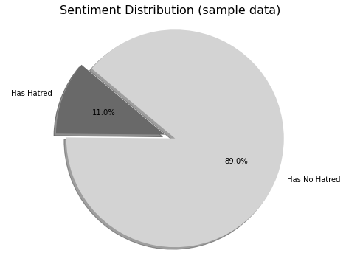

## 

**Keywords in Tweets with Hatred**

--------------------------------------------------------------------------------------------

['https', 'rt', 'made', 'co', 'metoomvmt', 'magazine', 'person', 'year', 'time', 'movement']

**Keywords in Tweets with no Hatred**

--------------------------------------------------

['rt', 'https', 'co', 'mika', 'msnbc', 'movement']

## 

# 

**Result 2:**

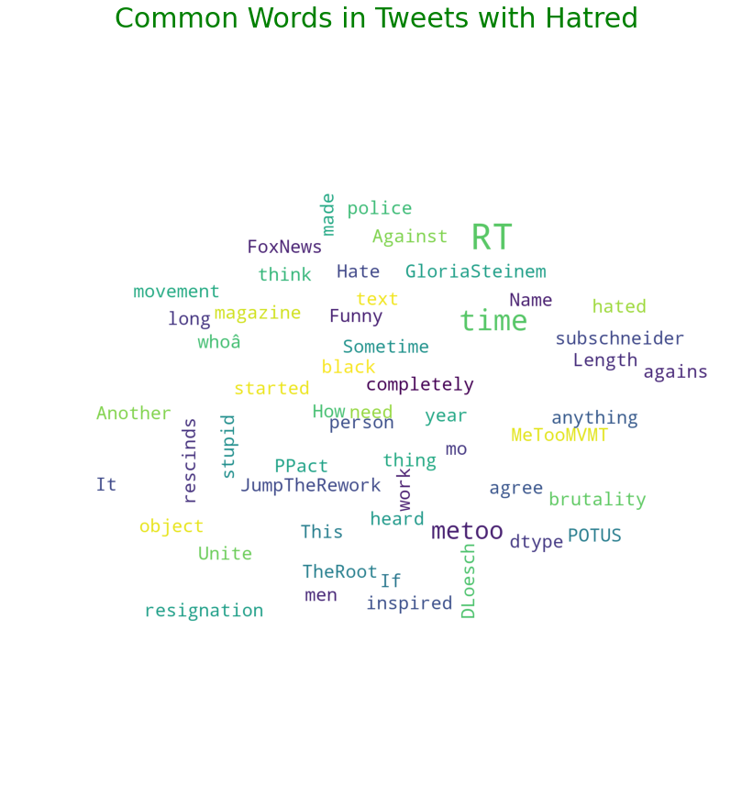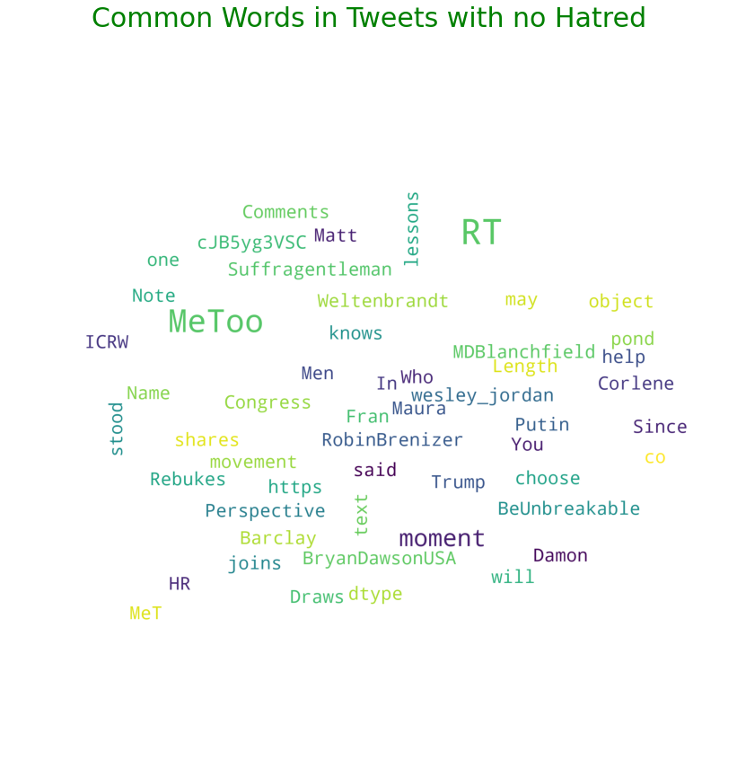

# 

# Conclusion

Our approach is a general framework that can be adapted to other corpora and research questions because we focus specifically on power, agency, and sentiment in media coverage of the #MeToo movement. Our examination of media coverage of the #MeToo movement addresses questions such as "Who is portrayed as sympathetic?" and "Who is portrayed as powerful?" We show that, while this movement has empowered women by encouraging them to share their stories, this empowerment does not always translate into event coverage in online media. While women are among the most sympathetic entities in media reports, traditionally powerful men remain among the most powerful. We also demonstrate the importance of journalists and third-party entities commenting on events without being directly involved.

# 

# References

Prabhakaran, V., and Rambow, O. 2017. Dialog structure through the lens of gender, gender environment, and power. Dialogue & Discourse

Rho, E. H. R.; Mark, G.; and Mazmanian, M. 2018. Fostering civil discourse online: Linguistic behavior in comments of #MeToo articles across political perspectives. In CSCW.

Rashkin, H.; Singh, S.; and Choi, Y. 2016. Connotation frames: A data-driven investigation. In ACL.

Weiss, B. 2018. Aziz Ansari is guilty. Of not being a mind reader. The New York Times.

Way, K. 2018. I went on a date with Aziz Ansari. It turned into the worst night of my life. Babe.net.