MarketLink | TECHWIZZ 7 | 2026  End-to-End Web Solutions

PROJECT REPORT
Bringing local farmers markets online with pre-orders, live maps and an AI assistant.
Cash on pickup · English & Urdu · Theme: eGreen Basket
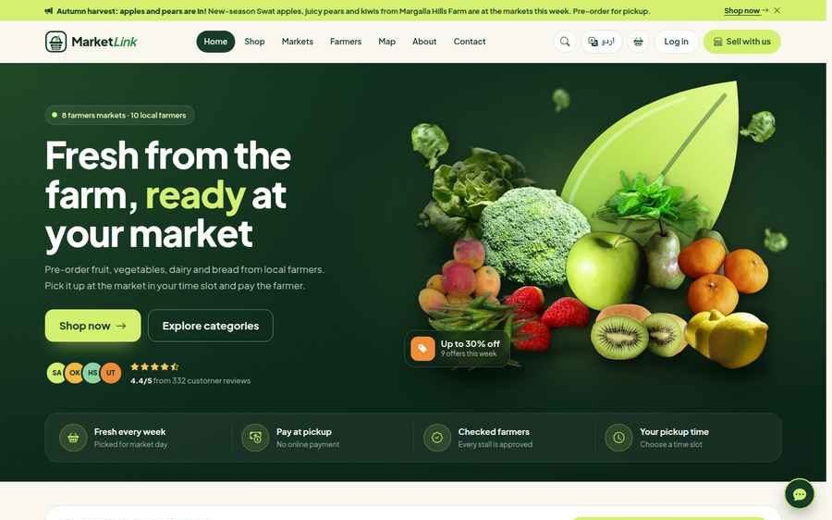

CREATED BY | MENTOR | CENTRE | ISSUED
Team Omniverse | Sir Sufyan | Aptech Learning Centre, F.B. Area, Karachi | September 2026

TABLE OF
Contents
01 | Introduction  Problem definition, the solution, team, objectives, scope | 3
02 | Project overview  Users, key features, screens, what was delivered, roles | 5
03 | Design specifications  Approach, stack, architecture, business rules, API, security | 8
04 | Database design  ER diagram, collections, database scripts | 13
05 | Flowcharts & data flow  DFD level 0 and 1, pre-order flow, order lifecycle, workflows | 16
06 | Testing & test data  Test cases with data, suites, results, defects fixed | 24
07 | The product in pictures  Portals, customer journey, unique features, reports | 28
08 | Challenges & lessons  What was hard and what we learned | 32
09 | Conclusion & next steps  Outcome and where MarketLink goes next | 34
A–E | Appendices  Installation, traceability, credentials, assumptions, demo data | 35
LIST OF FIGURES
Figure 1 | High-level system architecture | 9
Figure 2 | Entity relationship diagram of the core collections | 14
Figure 3 | Data flow diagram, level 0 (context) | 16
Figure 4 | Data flow diagram, level 1 | 17
Figure 5 | Pre-order and pickup slot flow | 18
Figure 6 | Order status lifecycle | 19
Figure 7 | Farmer registration and approval | 20
Figure 8 | How a farmer handles a pre-order | 21
Figure 9 | Receipt confirmation and review | 22
Figure 10 | How the assistant answers a question | 23

S E C T I O N  01  Introduction  Weekend farmers markets in Pakistani cities still run entirely in person. MarketLink puts them online without changing how people pay: order ahead, collect at the stall, pay the farmer in cash. | 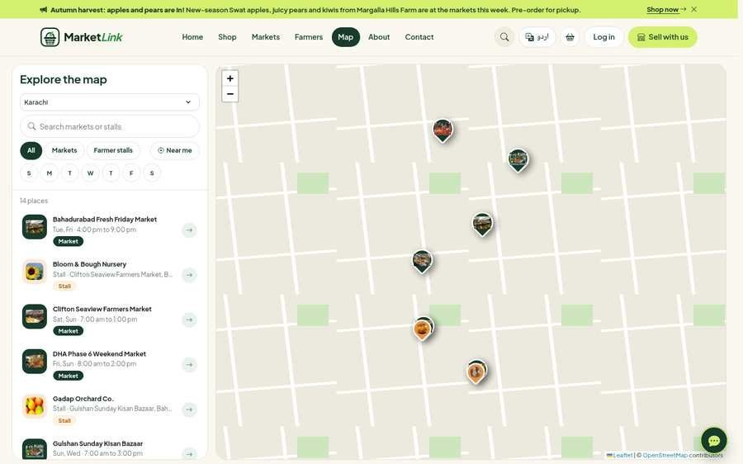

1.1 Problem definition
WHAT GOES WRONG EVERY WEEKEND
Farmers markets in urban Pakistani cities, such as the weekend stalls in Clifton, DHA or F-9 Park, have no online presence. Every week the same problems repeat for shoppers, farmers and organisers:
01  No visibility before the market  Customers travel without knowing which farmers are coming, what they bring, the prices, or what is already sold out. | 02  Produce goes to waste  Farmers guess how much to harvest. Too much spoils unsold; too little means lost sales.
03  Early-morning sell-outs  Popular produce such as Sindhri mangoes is gone early, and families who arrive later go home empty-handed. | 04  No market management  There is no central place for opening hours, stall maps, verified reviews or complaints.

1.2 The MarketLink solution
THEME: EGREEN BASKET
MarketLink connects local growers with city shoppers. Shoppers find markets on an interactive map, check stock by weight, reserve produce with a pre-order for a pickup time slot, and pay the farmer in cash at pickup. There are no delivery fees and no online payment step.
- Farmers publish their weekly stock, prices, offers and pickup windows.
- Customers reserve real stock with a pre-order and collect it at a time slot they choose.
- Administrators approve farmers, manage markets and categories, moderate content and read the platform reports.

“ | Live stock that updates as orders come in, protection against clashing pickup slots, a full English and Urdu interface, and an assistant that answers in Roman Urdu.  KEY DELIVERABLE

1.3 Team & mentor
WHO BUILT WHAT
MEMBER | ROLE | OWNED
Muhammad Saad | Team lead & Backend | Node.js REST API, security, JWT sign-in, e-mail services
Ghulam Mustafa | Frontend & UI/UX | React app, SCSS design system, animations
Fahad Musa | Database & QA lead | MongoDB schema, indexes, seed data, testing
Muhammad Hamza | Maps & AI | Leaflet maps, Roman Urdu chatbot, documentation
Sir Sufyan | Project mentor & advisor | Technical guidance and architecture review

1.4 Project objectives
FIVE THINGS MARKETLINK HAD TO DO
- Let customers browse markets, farmers and products by location, day, category and price, with a map and directions to the pickup point.
- Let customers pre-order against the farmer's real stock for a pickup slot, then track, change or cancel the order before the farmer's cut-off time.
- Give farmers a simple dashboard for products and weekly stock, offers, pickup windows, pre-orders, sales insights and replies to reviews.
- Give the administrator control over users, markets, categories, content, announcements and reports.
- Work well on phones, in English and Urdu, with secure, role-based access.

1.5 Scope
IN, OUT, AND HOW SUCCESS WAS MEASURED
IN SCOPE | OUT OF SCOPE (SRS 1.5)
Customer, farmer and admin areas with role-based access | Online payment (payment is made at pickup)
Markets, farmers, products, categories and cities | Delivery or courier logistics (pickup only)
Pre-orders with pickup slots and cut-off times | Checking farmer identity, licences or organic certificates
Reviews, ratings, favourites and restock reminders | Native mobile apps (the website is responsive instead)
Maps (OpenStreetMap), directions, notifications and e-mail
AI assistant in English, Urdu and Roman Urdu

SUCCESS MEASURE | RESULT AT HAND-IN
Every requirement of SRS 1.6 has a page or screen | Yes: listed one by one, with verification, in Appendix B
Business rules enforced by the server, not only the screens | Stock, cut-off, slot capacity, pickup clash and role checks are covered by automated tests (Section 6.2)
Works on phones and computers in English and Urdu | Checked at 18 screen widths (320 to 1920 px) in both languages
Ready to run with demo data | One folder with the built app, packages, sample data and documents

S E C T I O N  02  Project overview  One platform, three kinds of user. Each role gets its own portal, and every page works on phones, tablets and computers in English and Urdu. | 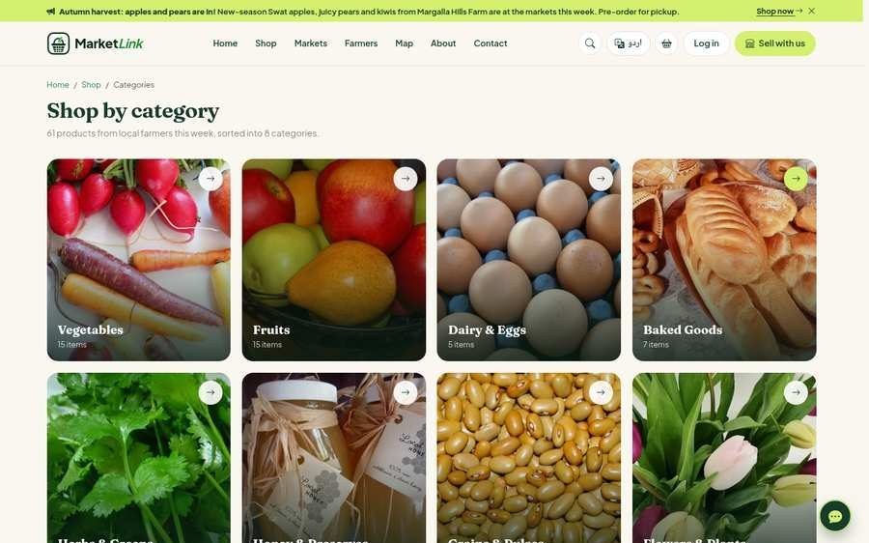

2.1 Who uses MarketLink
FOUR ROLES
ROLE | WHAT THEY DO ON MARKETLINK
Guest | Browses markets, farmers and products, uses the map and the assistant, and can check out without signing up first: an account is created and the password is e-mailed.
Customer | Browses markets on the map, shops by weight (250 g, 500 g, 1 kg …), pre-orders for a pickup slot, pays cash at the stall, writes reviews, keeps favourites and family sharing, and reports "I did not receive it" problems.
Farmer | Runs a stall page, manages Products & Pricing, accepts or declines orders, marks orders ready, replies to reviews, and gives a reason when they cannot attend a market.
Administrator | Approves farmers, manages markets and categories, decides pickup problems, tracks market attendance, and runs 17 platform reports with CSV export and print.

2.2 Key features
TEN THINGS WORTH SHOWING THE JUDGES
M  Live market map  Leaflet and OpenStreetMap show every market with directions and opening days. | P  Pre-order & pickup slots  Customers choose a pickup window; a customer cannot book pickups at two markets at the same time.
G  Buy by weight  Farmers sell kg or litre products in smaller steps with a minimum and a maximum per order. | C  Price comparison  The product page shows the same produce at other stalls first, e.g. "Rs 30 less per kg".
U  English & Urdu  Full right-to-left Urdu pages and a "Write in Urdu" helper next to every Urdu box. | A  Roman Urdu assistant  A chatbot answers shopper questions in English, Urdu and Roman Urdu from live data.
R  Reports & analytics  All 17 platform reports on one page, with CSV download, print and saved copies. | !  Pickup problem handling  Customer, farmer and admin each have a flow to resolve an order that was not received.
D  Market-day check-in  Farmers check in or say why they cannot come; customers see a live "at the market today" badge. | S  Weekly stock template  A recurring template refills the stall each market day, and low-stock alerts warn the farmer.

2.3 Screens at a glance
THE FIRST PAGES A SHOPPER SEES, THEN THE BUYING JOURNEY
A Landing page | B Market map | C Categories
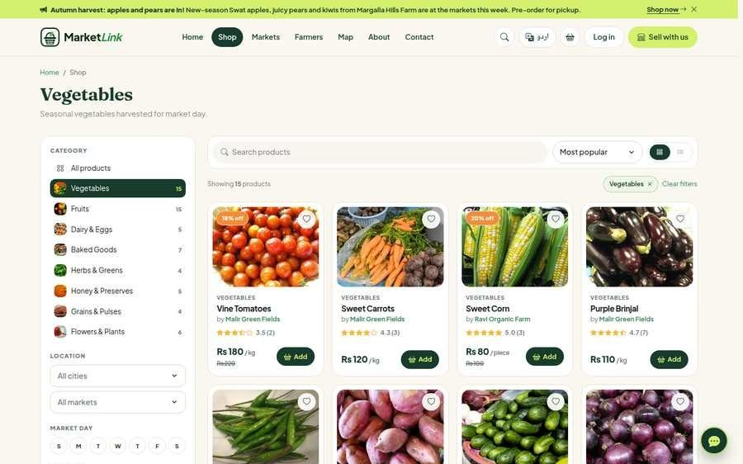  D Shop & filters | 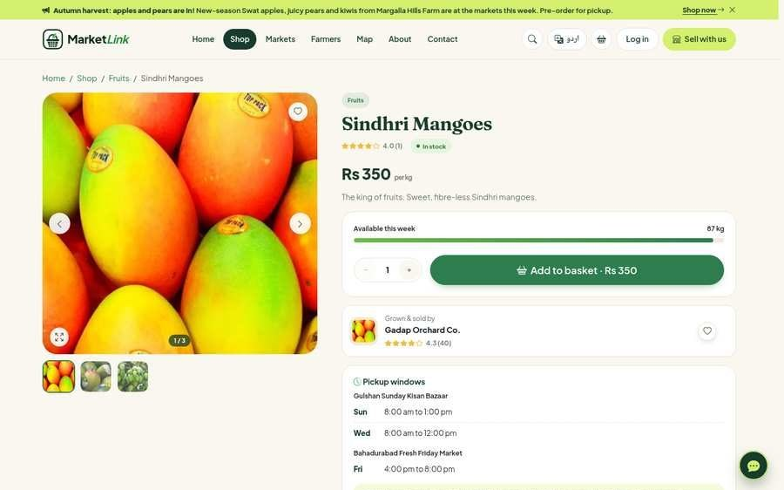  E Product & weight | 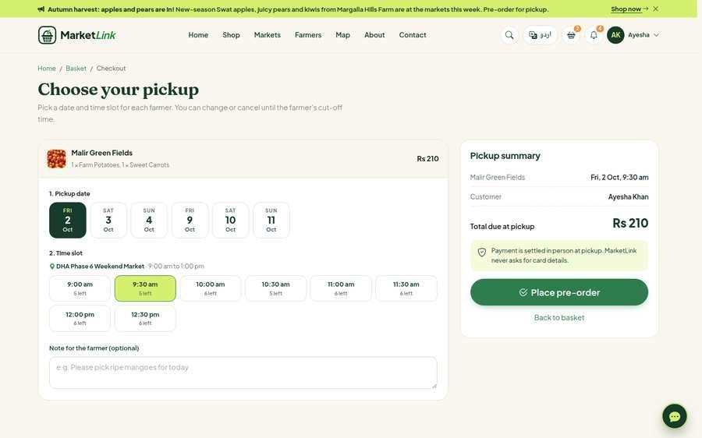  F Checkout & slot

2.4 What was delivered
THE HAND-IN PACKAGE
77  PAGES | 148  API ENDPOINTS | 20  COLLECTIONS | 1,122  AUTOMATED CHECKS

DELIVERABLE | DETAILS
The MarketLink website | 77 pages in three areas (public and customer, farmer, admin), in English and Urdu
REST API | 148 endpoints under /api with input checks, role checks and rate limits
Database | MongoDB with 20 collections, a schema script with validation rules and indexes, and sample data
Demo data | The seed script creates 21 users, 8 markets, 62 products, 435 pre-orders, 341 reviews and more (Appendix E)
Documentation | This report, the test plan and test report, the README files, and design notes in the documentation folder
Automated tests | 410 API checks, 712 browser checks and page sweeps at 18 screen widths in both languages
Ready-to-run package | One folder with the built app, the server packages, screenshots of every page and the reports

2.5 Roles & permissions
CHECKED ON THE SERVER FOR EVERY REQUEST
Without a login the API answers 401; with the wrong role it answers 403.
CAPABILITY | GUEST | CUSTOMER | FARMER | ADMIN
Browse markets, farmers, products and the map | ✓ | ✓ | ✓ | ✓
Use the AI assistant | ✓ | ✓ | ✓ | ✓
Check out (guests get an account by e-mail) | ✓ | ✓ | – | –
Track, change and cancel own orders before the cut-off | – | ✓ | – | –
Favourites, family sharing, reviews, restock reminders | – | ✓ | – | –
Manage products, weekly stock, offers and pickup windows | – | – | ✓ | –
Accept, decline, mark ready and complete pre-orders | – | – | ✓ | –
Reply to reviews; check in on the market day | – | – | ✓ | –
Approve or suspend farmers; activate or deactivate customers | – | – | – | ✓
Manage markets, cities and categories | – | – | – | ✓
Moderation queue, announcements, offer banner, FAQs | – | – | – | ✓
Place an order for a customer; decide pickup problems | – | – | – | ✓
17 reports, farmer rankings, CSV export and print | – | – | – | ✓

2.6 Project activities
SEVEN STAGES, BUILT IN SHORT ROUNDS
STAGE | WHAT WE DID
1. Study and planning | Read the SRS, listed every requirement, chose the MERN stack, drew the architecture, data flow and flowcharts, designed the database
2. Foundations | Set up the server and the React app, accounts and login for every role, the database models and the demo data
3. Customer features | Markets and map, farmers, products with filters and search, basket, checkout with pickup slots, orders, favourites, reviews
4. Farmer features | Registration wizard and approval, products and weekly stock, inventory, offers, pickup windows, market day, pre-orders, sales insights
5. Admin features | Dashboard, user management, markets and cities, categories, moderation, announcements, banner, messages, reports and rankings
6. Extras | Urdu with right-to-left layout, the AI assistant, restock reminders, receipt confirmation, notifications, e-mail, SEO
7. Testing and polish | API and browser tests, responsive sweeps, alignment checks, defect fixes, screenshots, documentation

S E C T I O N
03

Design specifications
MarketLink is a MERN application (MongoDB, Express, React, Node.js) built in short rounds: each round shipped working features, was tested, and fed the next one.

3.1 Approach
HOW THE WORK WAS RUN
- Requirement checklist. Every line of SRS section 1.6 became a row in a checklist (Appendix B) with the page or screen that meets it, checked again after every round.
- Short rounds. Plan a small set of features, build them, test them, review them, then move on, so problems were found early.
- Test first for the important rules. Stock reservation, cut-off times, pickup slots and role checks are enforced on the server and covered by automated tests.
- Real data from day one. The demo data covers every situation: a farmer waiting for approval, a suspended farmer, sold-out products, orders in every status.
- AI as an assistant. Claude Code helped with coding and testing; every decision and check stayed with the team (Appendix D).

3.2 Technology stack
WHAT WE USED, AND WHY
LAYER | TECHNOLOGY | WHY WE CHOSE IT
Frontend | React 19, Vite, React Router 7, Bootstrap 5 with a custom SCSS theme, Bootstrap Icons, Recharts, DataTables, Leaflet, intl-tel-input | Fast pages, responsive design system, right-to-left Urdu support, charts and tables for the dashboards
Backend API | Node.js 20+, Express 5, Mongoose, JWT, bcrypt, Helmet, Nodemailer, an hourly scheduler | REST controllers, role checks on every route, input cleaning, e-mail and background jobs
Database | MongoDB (Community Server or Atlas), Mongoose | 20 collections with validation rules and map (geo) indexes
Maps & AI | Leaflet, OpenStreetMap, OSRM routes, Google Maps links; rule-based assistant, optional Claude for text | Market maps and directions without a paid key; Roman Urdu chatbot
Caching | Redis (optional) | Used when configured; in-memory cache otherwise
Testing | Playwright (Chromium), Node.js API scripts, ESLint | Full journeys, responsive sweeps and API checks after every round

3.3 System architecture
THREE TIERS AND FOUR OUTSIDE SERVICES
The browser runs the React app, the Express server exposes a REST API and serves the built app, and MongoDB stores the data. Map tiles, routes and e-mail come from outside services.
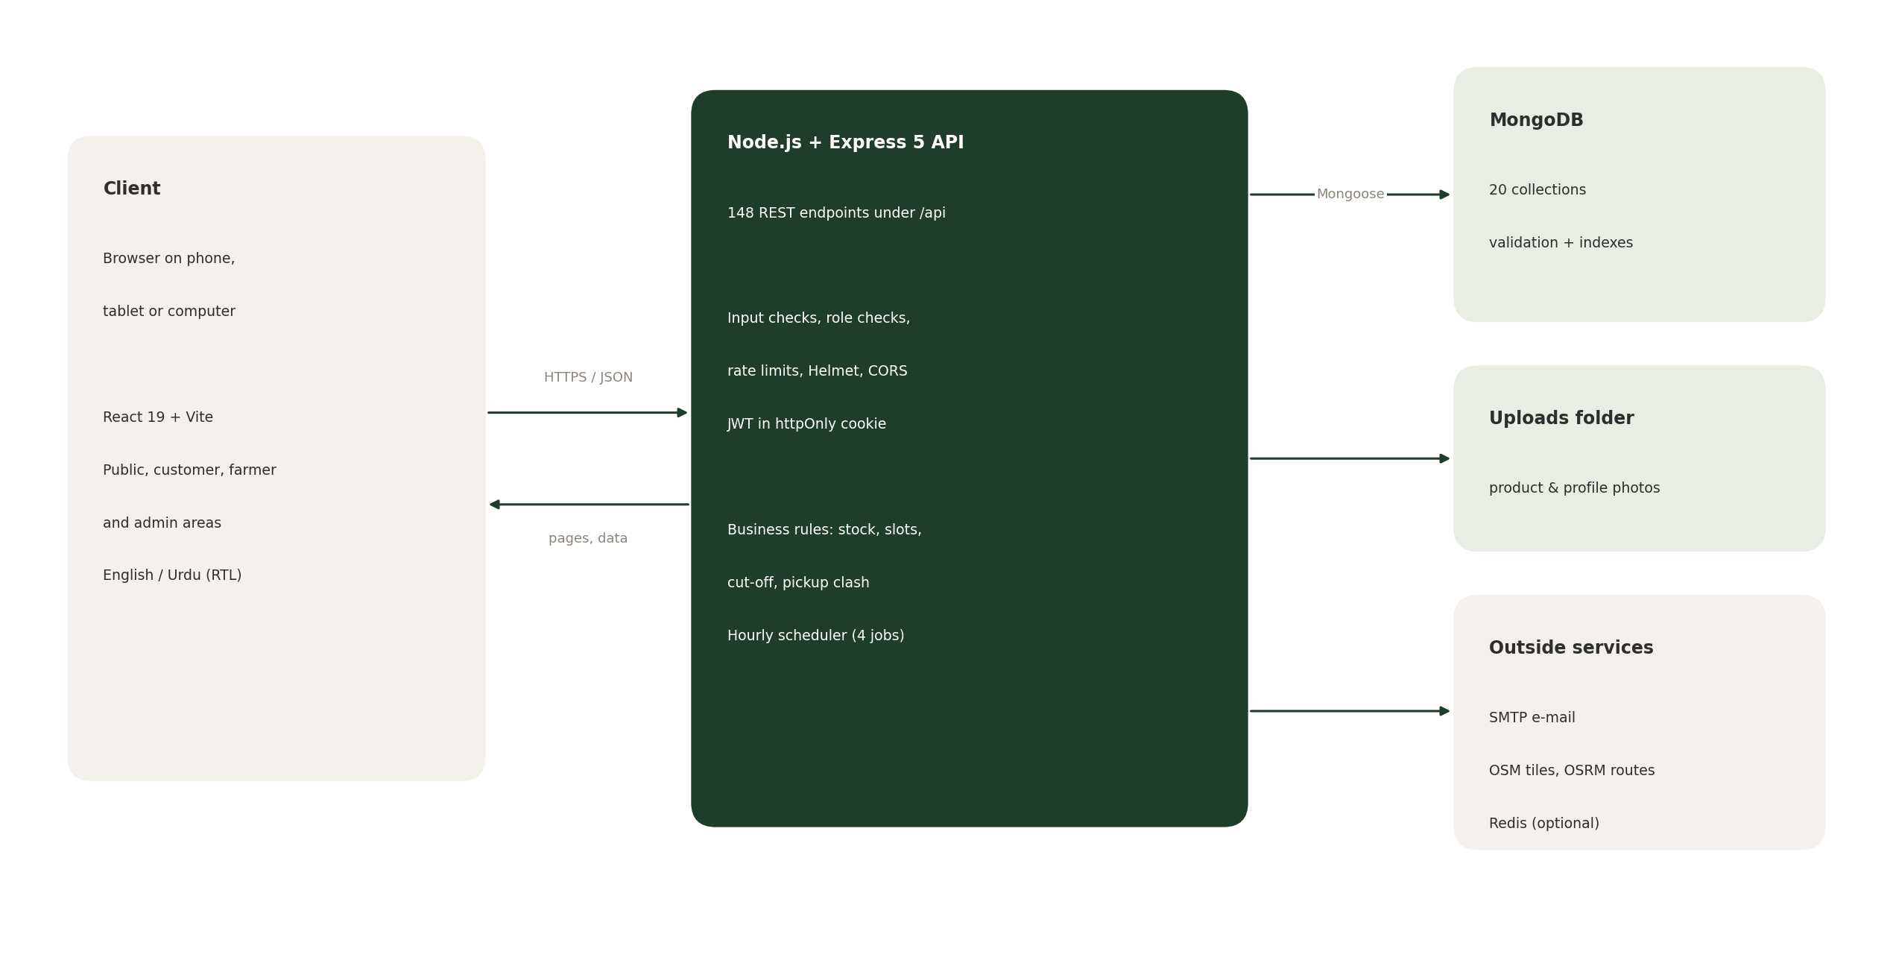
Figure 1 High-level system architecture
LAYER | WHAT IT DOES
Presentation | The React app: public pages, the customer area, the farmer portal and the admin dashboard, in English and Urdu
Application | The Express API: input checks on every request, role checks on every protected route, rate limits on login, chat and AI features
Security | Passwords hashed with bcrypt, the login token in an httpOnly cookie, Helmet security headers, CORS, file-type checks on uploads
Data | MongoDB through Mongoose, with validation rules and indexes on every collection
Services | E-mail (SMTP), the hourly scheduler (weekly stock template, low-stock alerts, "market open today" notices, offers that end on their last day), maps and routes

3.4 Business rules enforced on the server
THE RULES THAT MAKE PRE-ORDERING TRUSTWORTHY
RULE | HOW IT WORKS
Stock reservation | Each item is reserved with one atomic database update that fails when the stock is not enough; the order is created only after the reservation. If one farmer's part of a checkout fails, every earlier reservation is released and the earlier orders are removed.
Pickup slot validation | The date must match one of the farmer's pickup windows, must not be a closed date, the slot must be free (capacity per slot) and the time must be before the farmer's cut-off.
No pickup clash | Pickups on the same day at different markets must start at least 60 minutes apart. Pickups at the same market may share a time. The check covers the checkout and the customer's other open orders.
Checkout limits | At most 10 farmers in one checkout; note field limited to 500 characters; one order per farmer is created.
Order numbers | Human-friendly and unique, in the form ML-YYMMDD-XXXX.
Modify an order | Only while the order is placed or accepted and before the cut-off. Old stock is released and the new amount reserved; if that fails the original reservation is restored.
Cancel an order | Stock returns to the farmer, the movement is logged, and both the farmer and the customer are notified.
Receipt confirmation | After completion the customer answers "Did you receive your order?" (30 days). "No" opens a pickup problem and tells the farmer and admins; repeated reports reopen it.
Guest checkout | Name, e-mail, phone, address and the Terms are required. If the e-mail already has an account the customer is asked to log in instead.
Restock reminders | One request per product and e-mail address; refused for products that are in stock.

3.5 REST API overview
148 ENDPOINTS UNDER /API, GROUPED BY WHO MAY CALL THEM
ROUTE GROUP | PURPOSE | ACCESS
/auth | Register, login, logout, forgot and reset password, quick account for guest checkout, profile | Public / logged in
/markets, /farmers, /products, /categories, /cities, /map, /search | Catalogue, stalls, map data and live search | Public
/orders, /customer | Pre-orders, receipts, reorder, family orders, dashboard, favourites, household | Customer
/reviews, /notifications, /flags | Reviews, bell menu and notifications, reports of inappropriate content | Logged in
/farmer | Products, weekly stock, offers, inventory, pickup windows, market day, orders, insights | Approved farmer
/admin | Farmers, customers, markets, cities, categories, moderation, banner, reports, rankings, pickup problems | Admin
/assistant, /ai | Chat assistant and text helpers ("Write with AI", Urdu writer) | Rate limited
/newsletter, /contact, /faqs, /banners, /announcements, /credits | Newsletter, contact form, FAQs, offer banner, seasonal notices, photo credits | Public

3.6 Security & data protection
EIGHT MEASURES
MEASURE | HOW IT IS DONE
Passwords | Hashed with bcrypt; reset links are one-time and valid for 30 minutes
Sessions | JSON Web Token stored in an httpOnly cookie, so page scripts cannot read it
Role checks | Middleware checks the role on every protected route; farmers are also locked until the admin approves them
Rate limits | Failed logins: 20 per 15 minutes; sign-up and contact forms: 40 per 15 minutes; chat and AI helpers: 30 per minute
Headers and CORS | Helmet security headers and a CORS policy; compressed responses
Uploads | File-type and size checks on every image upload; files are stored in the uploads folder
Input and data rules | Input cleaning on every request, protection against NoSQL injection, MongoDB validation rules and unique indexes
Consent | The Terms & Conditions checkbox is required on both sign-up forms and the accepted version is stored

3.7 Notifications, e-mail & background jobs
WHO HEARS ABOUT WHAT
Every important event creates an in-app notification (the bell menu) and, where it matters, a branded HTML e-mail sent with Nodemailer. Without SMTP settings the e-mails are printed in the server window, so the demo works with no setup.
EVENT | WHO IS TOLD | HOW
Pre-order placed (with pickup details and directions link) | Customer and farmer | In-app + e-mail
Accepted, ready, declined, completed | Customer | In-app + e-mail
Order changed or cancelled by the customer | Farmer (and customer for cancel) | In-app
Low stock or sold out | Farmer | In-app + e-mail
Product back in stock ("Remind me") | Customers and guests who asked | In-app + e-mail
Farmer cannot come to the market | Customers with a pickup that day | In-app + e-mail (once)
Not received / not received again | Farmer and admins | In-app (+ e-mail when repeated)
Markets open today; new farmer approved | Customers of that city or saved markets | In-app

An hourly scheduler runs four jobs: it refills the weekly stock template, ends offers after their last day and puts the usual price back, sends the "market open today" notice an hour before the first market opens, and raises the low-stock alerts.

3.8 Urdu interface & AI assistant
LANGUAGE AS A FEATURE
Urdu. The whole site can be switched to Urdu with a right-to-left layout, the Noto Nastaliq Urdu font, Urdu product names, FAQs, terms and server messages. A script scans every text in the app and reports missing translations (0 missing at hand-in). Farmers and the admin get a "Write in Urdu" helper next to every Urdu box.
Assistant. A rule-based assistant answers from live data in English, Urdu and Roman Urdu, remembers follow-up questions, and keeps a saved chat history for signed-in users. Text helpers such as "Write with AI" use Claude when an API key is set and a built-in writer otherwise.
QUESTION | LANGUAGE | ANSWER
which farmer is highly rated | English | The top-rated farmer with review count, and a top-5 list
tamatar kahan milega | Roman Urdu | Tomatoes with price, farmer and pickup days
sab se sasti sabzi | Roman Urdu | The five cheapest vegetables in stock
any offers this week? | English | Products on offer with the percent off
markets open now | English | Markets open now, or the ones opening later today
is Malir Green Fields at the market today? | English | Whether the farmer is there now, later, has left or is away
password bhool gaya | Roman Urdu | How to reset the password, with a link
سب سے اچھی ریٹنگ والا کسان کون ہے؟ | Urdu | The top-rated farmer, answered in Urdu

3.9 User interface design
LOOK, FEEL AND ACCESS
- Look and feel. Dark green on a cream background, white cards and real photos of produce, markets and farmers. Fraunces for headings, Plus Jakarta Sans for text and Noto Nastaliq Urdu for Urdu.
- Home page. A banner with the headline, "Shop now" and "Explore categories", then sections that alternate between dark green and cream: categories, the offer banner, top picks, a video tour, top-rated farmers, markets and map, the farm-to-table story, customer reviews, why choose us and the FAQ.
- Phones. A bottom navigation bar on every page, dialogs that open as bottom sheets, filters that slide in from the side, tables that turn into cards.
- Accessibility. Keyboard access to every control, visible focus, alt text on every image, reduced motion respected, colour contrast checked.

3.10 Search & answer-engine optimisation
BE FOUND BY PEOPLE AND AI ASSISTANTS
- Why it matters. Farmers and shoppers find markets through search engines and, more and more, through AI assistants. A React page that only fills itself in the browser is empty to crawlers that do not run JavaScript, so MarketLink prepares the facts on the server.
- Page facts in the HTML. For every public page the server adds the title, description, canonical link, Open Graph and Twitter tags and a short plain-text summary (market timings, farmer stock, prices) before the page is sent. Private pages such as the account, farmer and admin areas are marked noindex.
- Structured data. JSON-LD describes the site and its content in a form search engines understand: WebSite, Organization, LocalBusiness and Place for markets and stalls, Product with Offer and AggregateRating, FAQPage with Question, and BreadcrumbList.
- Sitemap and robots. sitemap.xml is built live from the database, so new markets, farmers and products appear on their own, each with English and Urdu (hreflang) versions. robots.txt opens the public pages and closes the private ones.
- Answer engines (AEO). llms.txt and llms-full.txt describe the whole site in Markdown for AI assistants, robots.txt names the well-known AI crawlers, and pages start with a short answer-first summary. The FAQ pages use question-and-answer markup so an assistant can quote them. A script (npm run seo-files) writes a static copy of these files, and the r7api test checks them.

S E C T I O N
04

Database design
MongoDB stores the data in 20 collections. Relations are stored as references, except the order items and the pickup windows, which live inside their order or farmer document.

4.1 Entity relationship diagram
THE TEN CORE COLLECTIONS
Each card is a collection. PK marks the primary key, FK a reference to another collection, and [ ] an array stored inside the document. The labels on the lines give the cardinality: one user places many orders, one order has at most one review.
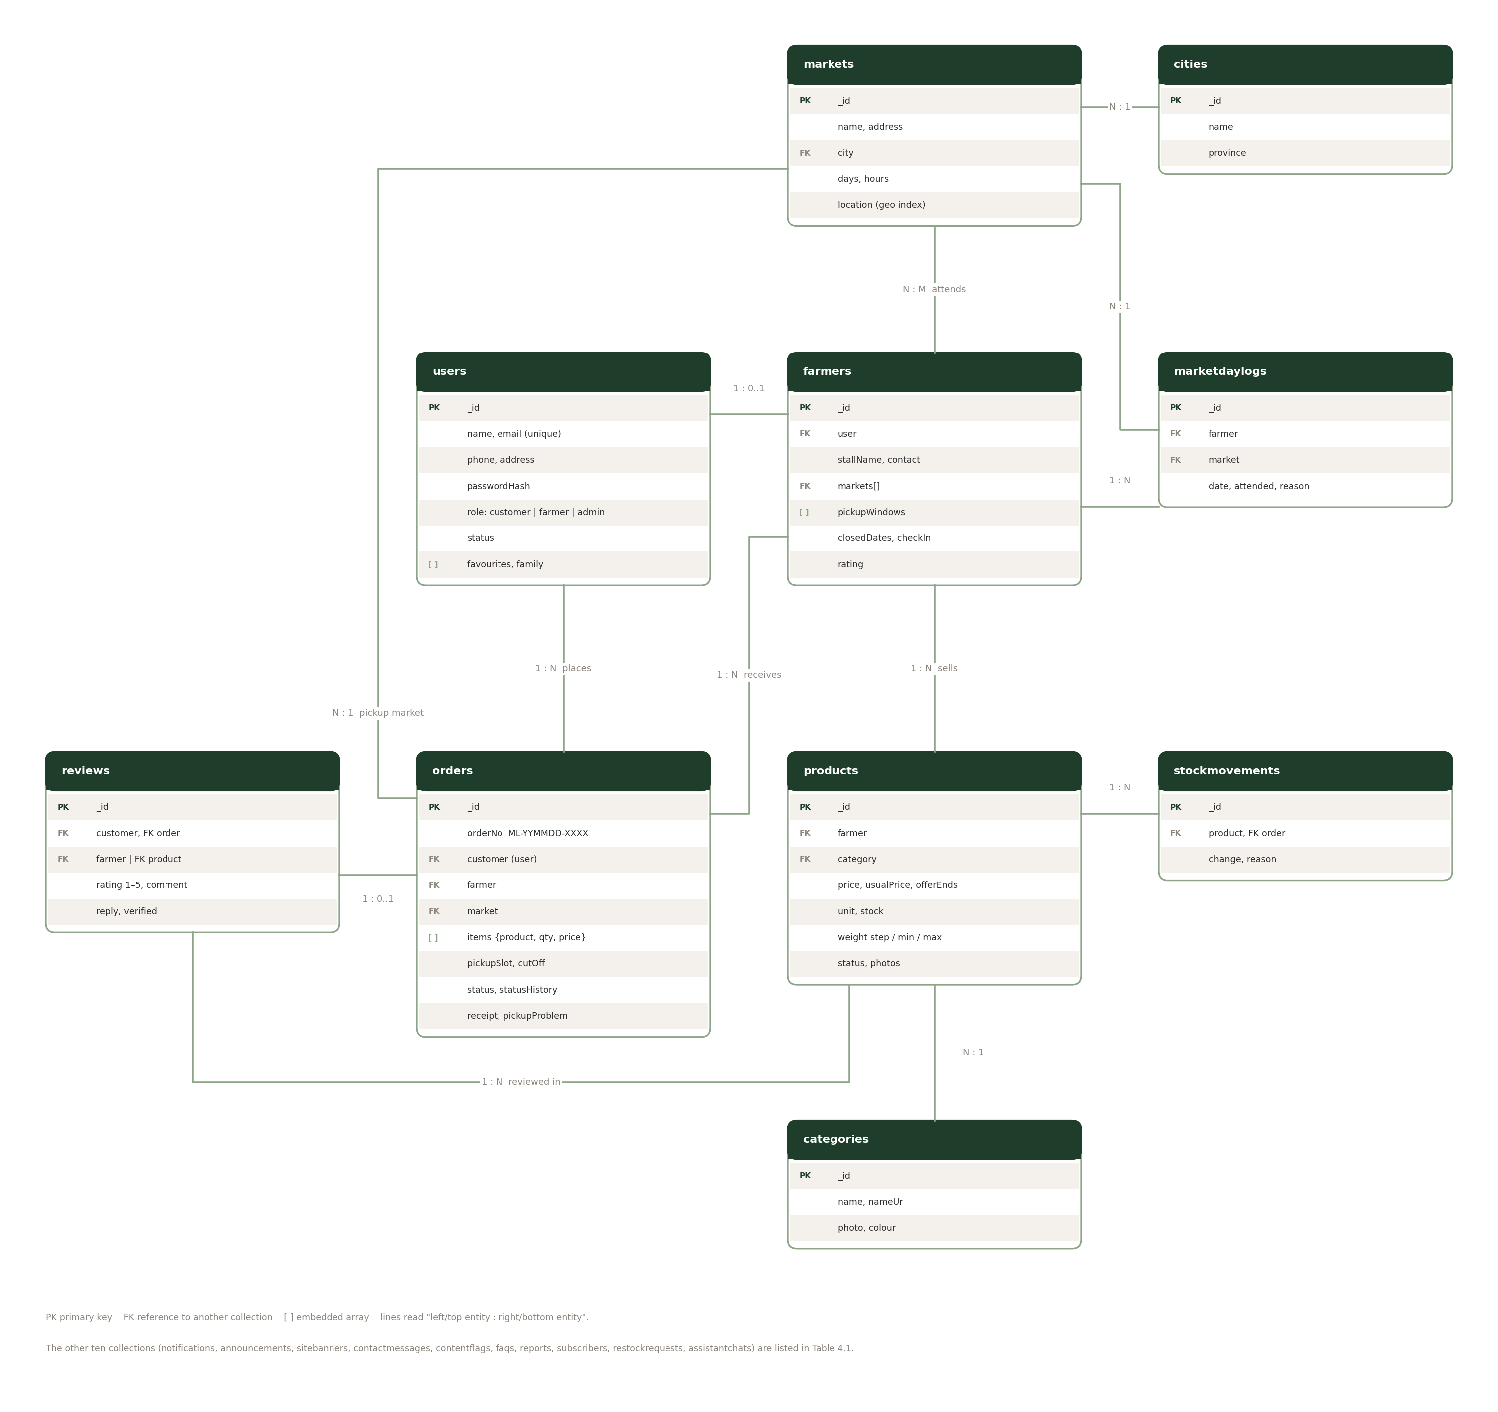

Figure 2 Entity relationship diagram of the core collections
ALL 20 COLLECTIONS
COLLECTION | WHAT IT STORES
users | Every login: customers, farmers and administrators (role, status, favourites, family)
farmers | The stall profile of a farmer: markets, days, pickup windows, closed dates, today's check-in, rating
markets | Farmers markets with address, days, hours and map position
cities | The list of cities for markets and farmers
categories | Product categories with an Urdu name, photo and colour
products | A farmer's product: price, usual price and last day of an offer, unit, stock, how it is bought (by weight, smallest and largest amount), status, photos, SEO fields
orders | Pre-orders with items, pickup slot, status history, receipt answer and pickup problem
marketdaylogs | One line per farmer and market day: came, or could not come and why
reviews | Ratings and comments for farmers and products, with the farmer's reply
stockmovements | The history of every stock change (orders, restocks, template, corrections)
notifications | In-app messages for each user
restockrequests | "Remind me when it is back" requests (unique per product and e-mail)
announcements | Platform notices, optionally for a season
sitebanners | The home page offer banner the admin edits
contactmessages | Contact form messages with their topic
contentflags | Reports of inappropriate content for the moderation queue
faqs | Questions and answers in English and Urdu
reports | Saved platform reports
subscribers | Newsletter subscribers
assistantchats | Chat history and memory of signed-in users

4.2 Database scripts
MONGODB INSTEAD OF .SQL
WHY THERE IS NO .SQL FILE
MongoDB does not use SQL. The project ships a mongosh schema script that creates the collections with validation rules and indexes, the demo data as JSON files for MongoDB Compass or mongoimport, and a seed command that fills a fresh database with the same data. The ReadMe says the same.

S E C T I O N
05

Flowcharts & data flow
The diagrams show the system in plain steps: who sends what, where it is stored, and what happens to a pre-order from the basket to the review.

5.1 Data flow diagram, level 0
THE CONTEXT: WHO TALKS TO MARKETLINK
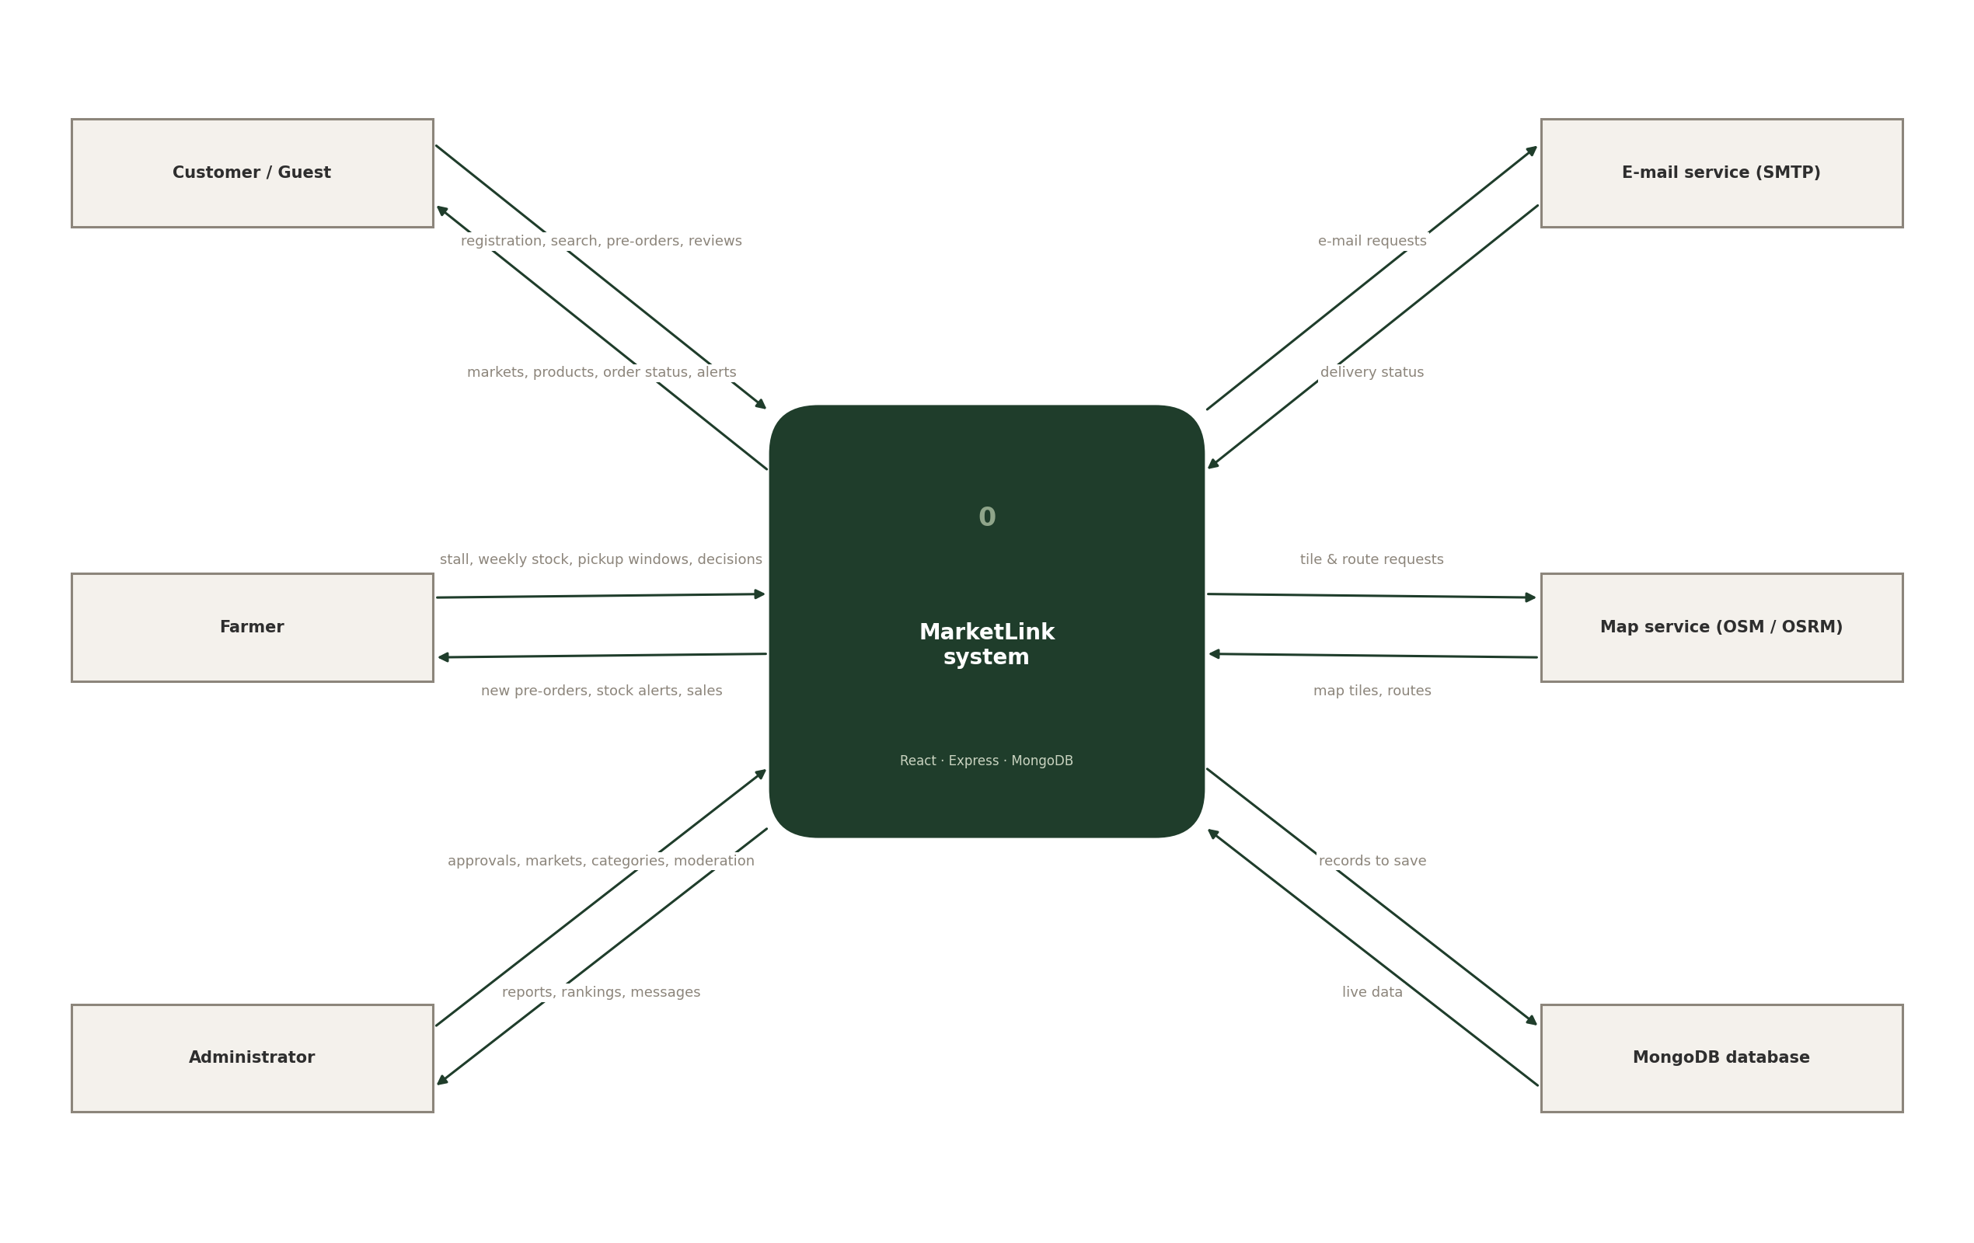
Figure 3 Data flow diagram, level 0 (context)
WHO | SENDS TO MARKETLINK | RECEIVES FROM MARKETLINK
Guest visitor | Searches, browsing, a guest pre-order | Markets, farmers, products and the map
Customer | Registration, pre-orders, reviews, receipt answers | Order status, notifications, recommendations
Farmer | Stall details, weekly stock, pickup windows, order decisions | New pre-orders, alerts, sales reports
Administrator | Approvals, markets, categories, moderation, the offer banner | Platform reports, rankings, messages
E-mail, map, database | Requests for e-mails, map tiles and routes; data to save | Delivered e-mails, tiles and routes, live data

5.2 Data flow diagram, level 1
EIGHT PROCESSES AND SIX DATA STORES
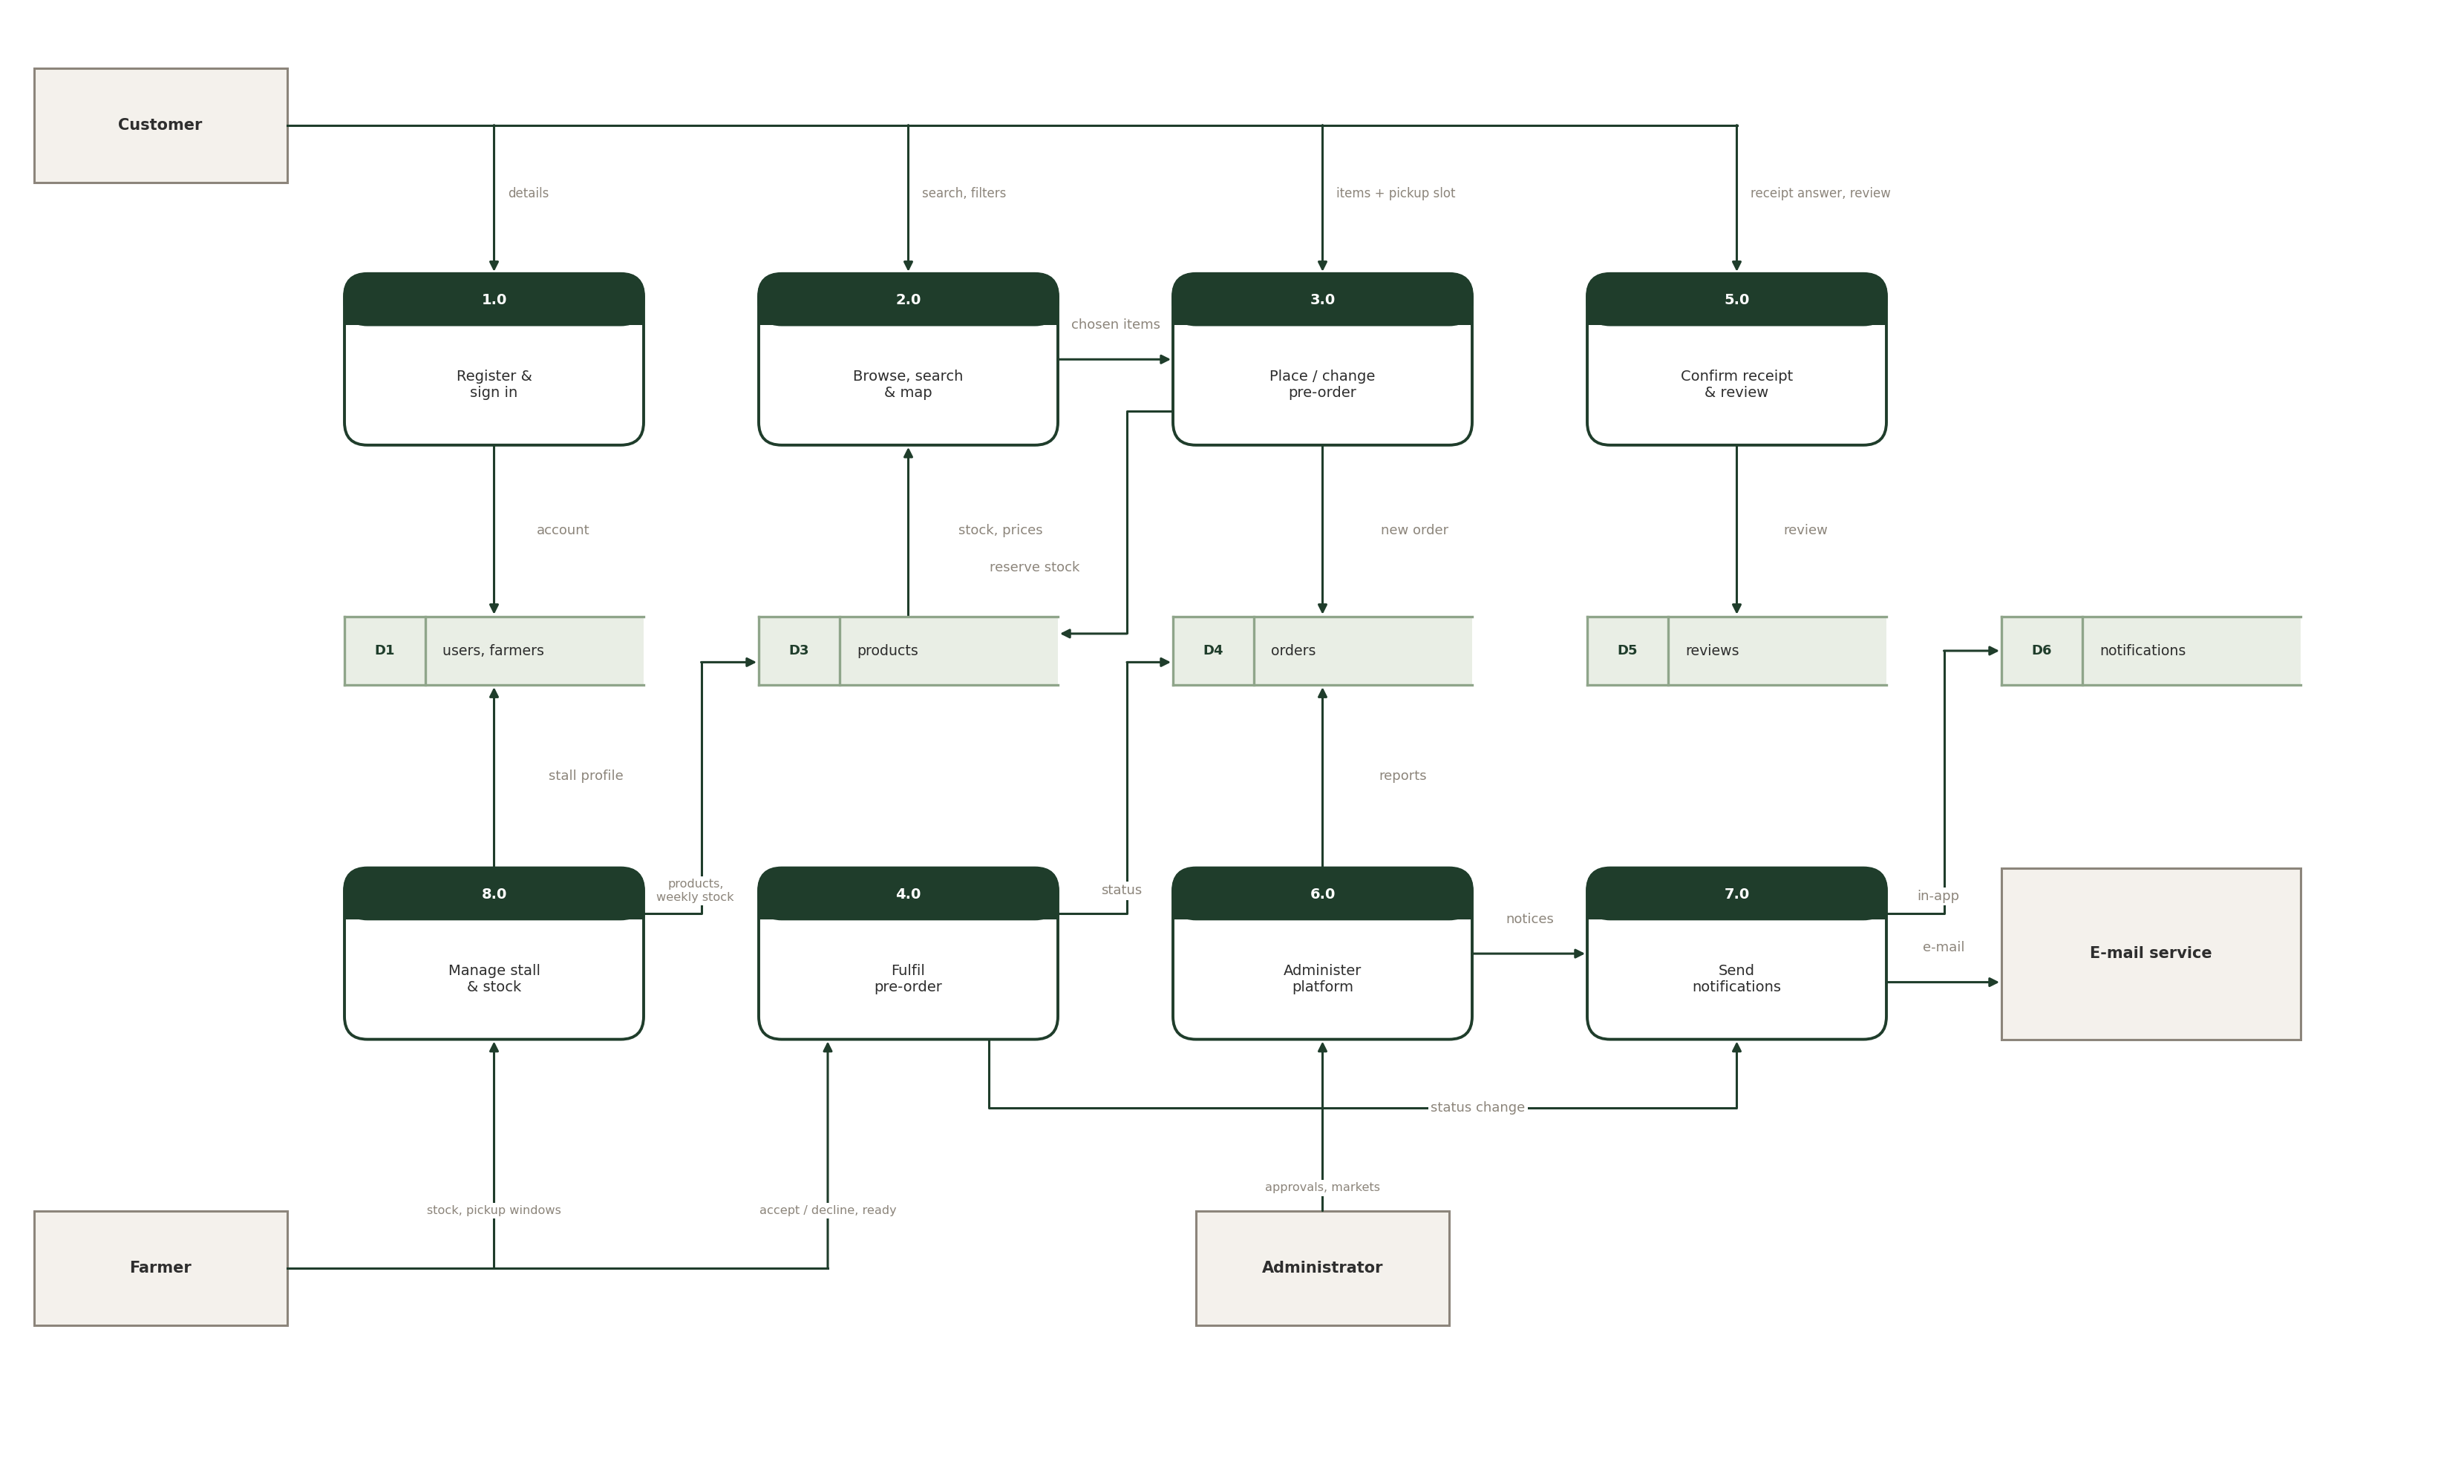
Figure 4 Data flow diagram, level 1
PROCESS | READS | WRITES
1.0 Register & sign in | Registration details | D1 users
2.0 Browse, search & map | D3 products, market and farmer data | —
3.0 Place / change pre-order | Chosen items and pickup slot | D3 stock reservation, D4 orders
4.0 Fulfil pre-order | Farmer decisions | D4 order status
5.0 Confirm receipt & review | Receipt answer, rating, comment | D5 reviews
6.0 Administer platform | D4 for reports | Approvals, markets, categories
7.0 Send notifications | Events from 4.0 and 6.0 | D6 notifications, e-mail
8.0 Manage stall & stock | Stock, pickup windows | D1 stall profile, D3 products

5.3 Pre-order & pickup slot flow
FROM BROWSING TO A RESERVED SLOT
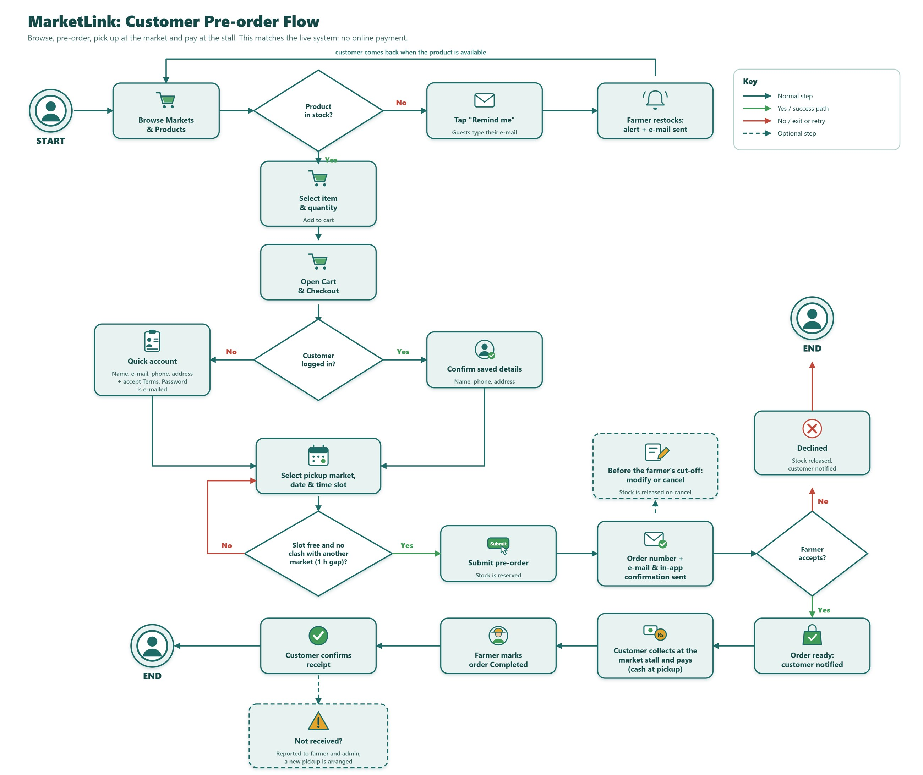
Figure 5 Pre-order and pickup slot flow
STEP | WHAT HAPPENS IN THE SYSTEM
Out of stock | The product shows "Remind me". Guests type an e-mail address; when the farmer restocks, a notification and an e-mail go out.
Checkout | Logged-in customers confirm their saved details. Guests get a quick account (name, e-mail, phone, address, Terms accepted) and the password is e-mailed.
Pickup slot | A slot is offered only if it is inside the farmer's pickup window, has free capacity and is before the cut-off. Two markets on the same day must be at least an hour apart.
Submit | Stock is reserved at once, the order number is created and a confirmation goes out by e-mail and in the app. Until the cut-off the order can be changed or cancelled.
After the order | The farmer accepts or declines, marks it ready, the customer collects and pays cash, the farmer marks it completed and the customer confirms receipt.

5.4 Order status lifecycle
SIX STATES
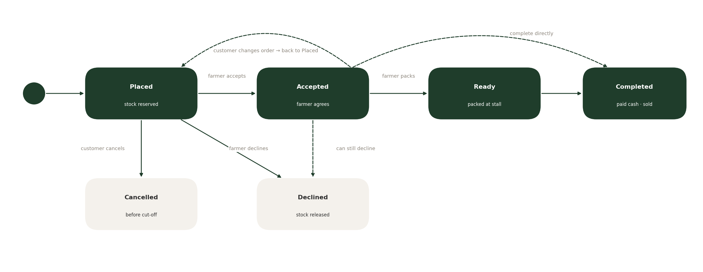
Figure 6 Order status lifecycle
STATUS | MEANING | WHO MOVES IT | STOCK
Placed | The customer sent the pre-order; the farmer has not answered yet | Customer | Reserved
Accepted | The farmer agrees to fulfil the order | Farmer | Reserved
Ready | Items are packed and waiting at the stall | Farmer | Reserved
Completed | The customer collected the order and paid in cash | Farmer | Sold
Declined | The farmer cannot fulfil the order (also after accepting) | Farmer | Released
Cancelled | The customer cancelled before the cut-off | Customer | Released
DASHED PATHS
A farmer can decline an order that was already accepted, and can complete an accepted order directly when nothing needs packing. Any change the customer makes to a placed or accepted order puts it back to Placed so the farmer has to accept it again.

5.5 Farmer registration and approval
A NEW STALL STAYS LOCKED UNTIL APPROVED
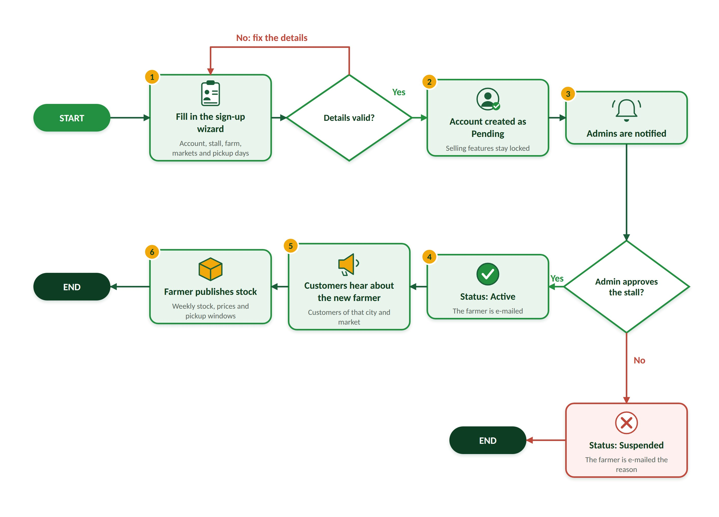
Figure 7 Farmer registration and approval
STEP | WHAT HAPPENS
1 | The farmer fills in the sign-up wizard: account, stall, farm details, markets and pickup days. Invalid details send the farmer back.
2 | The account is created with status Pending; selling features stay locked.
3 | All administrators are notified and review the stall.
4 | Approve: status becomes Active and the farmer is e-mailed. Not approved: status becomes Suspended with the reason.
5 | Customers of that city and market hear about the new farmer.
6 | The farmer publishes weekly stock, prices and pickup windows.

5.6 How a farmer handles a pre-order
DECIDE, PACK, COMPLETE
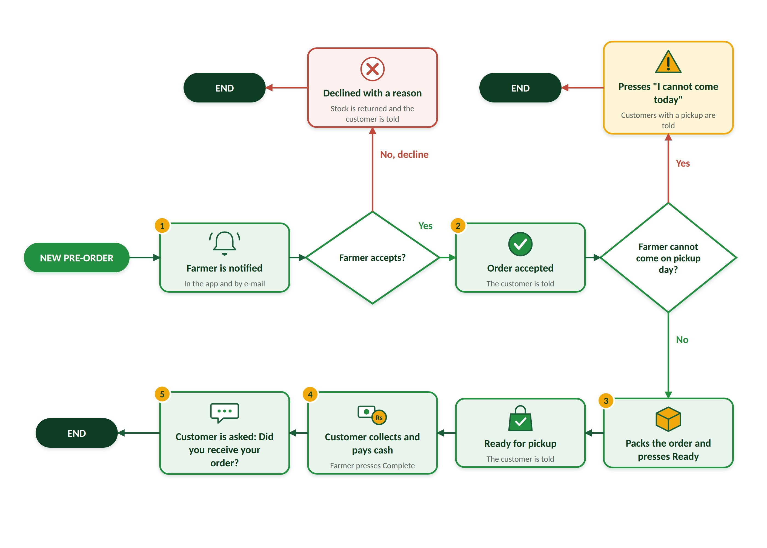
Figure 8 How a farmer handles a pre-order
STEP | WHAT HAPPENS
1 | The farmer is notified in the app and by e-mail when a pre-order arrives.
2 | Accept: the customer is told. Decline: the farmer gives a reason, the stock is returned and the customer is told.
3 | If the farmer cannot come on the pickup day, "I cannot come today" tells every customer with a pickup that day.
4 | Otherwise the farmer packs the order and presses Ready; the customer is told.
5 | The customer collects and pays cash; the farmer presses Complete.
6 | The customer is asked "Did you receive your order?" (Figure 9).

5.7 Receipt confirmation and review
ONLY CONFIRMED PICKUPS CAN BE REVIEWED
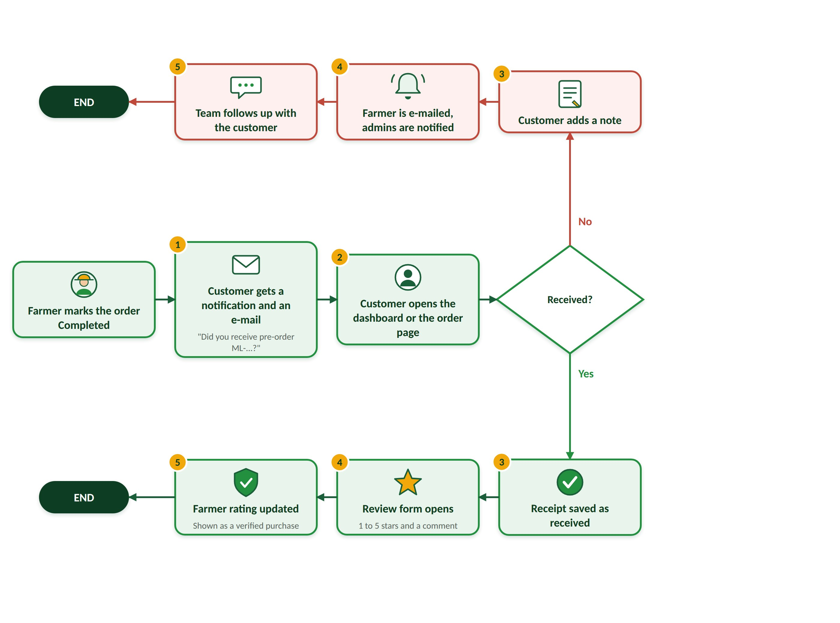
Figure 9 Receipt confirmation and review
STEP | WHAT HAPPENS
1 | The customer receives a notification and an e-mail asking "Did you receive pre-order ML-…?".
2 | The customer opens the dashboard or the order page and answers.
3 | Yes: the receipt is saved as received. No: the customer adds a note.
4 | Yes: the review form opens (1 to 5 stars and a comment). No: the farmer is e-mailed and the admins are notified.
5 | Yes: the farmer rating is updated and the review is shown as a verified purchase. No: the team follows up.

5.8 How the assistant answers a question
KEYWORDS, MEMORY, LIVE DATA
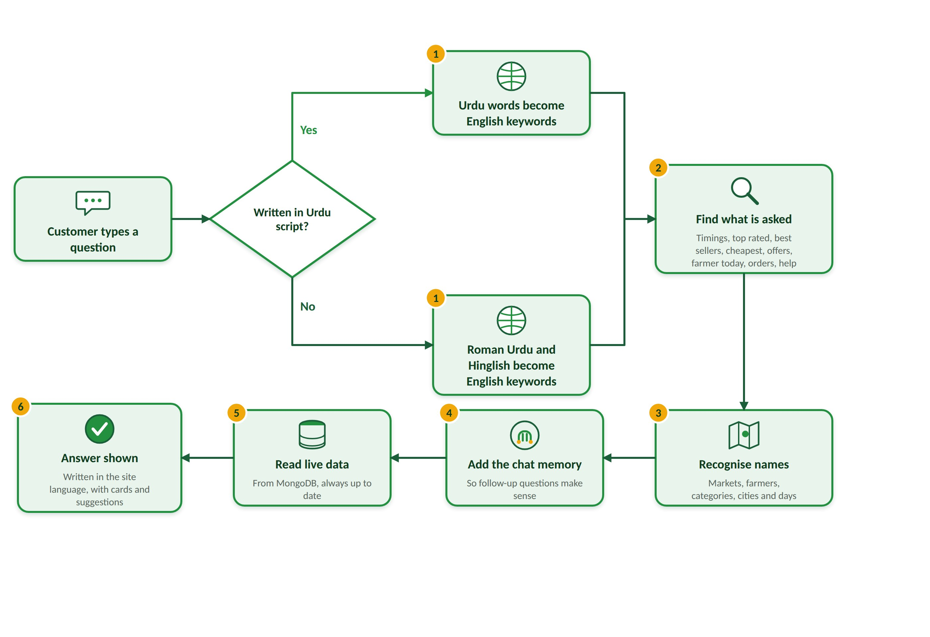
Figure 10 How the assistant answers a question
STEP | WHAT HAPPENS
1 | Detects Urdu script or Roman Urdu / English and turns the words into English keywords.
2 | Works out what is asked: timings, top rated, best sellers, cheapest, offers, is a farmer at the market today, order status or help.
3 | Recognises the markets, farmers, categories, cities and days named in the question.
4 | Adds what the chat is about from memory, so follow-up questions make sense.
5 | Reads live data from MongoDB, so answers are always current.
6 | Writes the answer in the site language, with cards and suggestions.

S E C T I O N
06

Testing & test data
Thirteen build rounds took MarketLink from a basic catalogue to a complete market platform, with every round checked by automated tests before the next began.

410  API TESTS | 712  BROWSER CHECKS | 18  SCREEN WIDTHS | 100%  PASS RATE

6.1 Test data used in the project
INPUTS, EXPECTED RESULTS AND OUTCOMES FOR THE KEY RULES
All tests run on the demo database created by the seed script (Appendix E), which is reset before every suite. The cases below use that data.
ID | SCENARIO | TEST DATA | EXPECTED | SUITE | RESULT
TC-01 | Two customers want the last kilo | Product stock 1 kg; two orders of 1 kg sent one after the other | First reserved, second refused: not enough stock | smoke | Pass
TC-02 | Pickup clash | Same Sunday: Clifton 10:00 and DHA Phase 6 10:30 | Refused with the 60-minute message | r12clash | Pass
TC-03 | Same market, same time | Two farmers, both at Clifton, both 10:00 | Accepted | r12clash | Pass
TC-04 | Change after cut-off | Placed order whose farmer cut-off has passed | Change refused | audit3 | Pass
TC-05 | Full slot | Slot at its capacity; one more order for it | Refused: slot full | audit3 | Pass
TC-06 | Closed date | Pickup on a date the farmer marked closed | Refused | smoke2 | Pass
TC-07 | Pending farmer lists a product | Farmer account with status Pending | 403, product not created | audit3 | Pass
TC-08 | Wrong role | Customer calls an /admin route; no login on /orders | 403; 401 | smoke | Pass
TC-09 | Guest with an existing e-mail | Guest checkout using a registered e-mail | Asked to log in | r5api | Pass
TC-10 | Buying by weight | Chillies: step 250 g, min 250 g, max 2 kg; orders of 500 g and 100 g | 500 g accepted, 100 g refused | r13api | Pass
TC-11 | Too many farmers | Basket with items from 11 farmers | Refused: at most 10 per checkout | smoke | Pass
TC-12 | Remind me when in stock | Restock request on a product with stock | Refused | r10test | Pass

6.2 Round-by-round delivery
WHAT EACH ROUND ADDED
ROUND | WHAT WAS ADDED | CHECKS
1–2 | Foundations: server and React app, accounts and login for every role, database models, demo data; core customer, farmer and admin features | smoke, audit3, apitools, api4, e2e
3 | Footer, profile photo upload, admin shell, placing an order for a customer, CSV export | Footer, avatar, admin UI
4 | Password eye button, shared page shells, verified reviews, product gallery, inventory, sales insights, moderation, phone layouts | 112 browser
5 | One login page for all roles, search inside dropdowns, quick view, basket sidebar, checkout without an account | 45 browser + 25 API
6 | Home banner, video tour, review wall, newsletter, seasonal announcements, DataTables everywhere | 59 browser + 44 API
7 | Real product photos, banner pictures, amount dialog, empty basket, FAQs, SEO on every page | 73 browser + 63 API
8 | Basket speed, review wall, Urdu on every page, guest pre-order in Urdu, assistant memory | 39 browser + 65 API
9 | Banner and toasts, category photos, offers, FAQ accordion, filter sidebar | 60 browser
10 | Assistant in three languages, offer banner, photo credits, restock reminders, receipt question, "away today", farmer rankings, live search | 88 browser
11 | Farmer offers with a last day, market-day check-in, new home banner, 320 px phones | 136 browser
12 | Pickup problems, absence reasons and attendance report, unsaved-changes warnings, "Write in Urdu", reports page, clash message | 76 browser + 5 API
13 | Buying by weight, the same produce at other stalls, checkout items list, final polish and documents | 24 browser + 20 API

6.3 Testing results
SUITES AND TOTALS
API SUITE | WHAT IT COVERS | CHECKS | PASSED
smoke | Accounts, markets, farmers, products, basket rules, pre-orders, reviews, favourites, family, role checks | 69 | 69
smoke2 | Filters, search, closed dates, reviews, maps data | 23 | 23
audit3 | SRS checklist: registration fields, near me, cut-off, slot capacity, suspend / approve | 32 | 32
apitools | Admin tools: cities, markets, categories, accounts, place order, tables | 33 | 33
api4 | Inventory, low-stock alerts, sales insights, moderation, reports | 31 | 31
r5api | Single login, guest checkout, verified reviews, SEO heads | 25 | 25
r6api | Announcements by season, newsletter, FAQs, product SEO fields | 44 | 44
r7api | FAQs admin, structured data, llms.txt, robots, sitemap | 63 | 63
r8api | Urdu content in the API, server messages in Urdu, assistant memory | 65 | 65
r12clash | No pickups at two markets at the same time | 5 | 5
r13api | Buying by weight, the same produce at other stalls | 20 | 20
Total |  | 410 | 410

BROWSER & STATIC | WHAT IT COVERS | RESULT
r4test – r9test | Shells, reviews, gallery, inventory, banner, basket, FAQs, Urdu on every page | 388 passed
r10test | Assistant in 3 languages, offer banner, credits, reminders, receipt, away today, rankings | 88 passed
r11test | Farmer offers, market day, new home banner, 320 px phones, Urdu | 136 passed
r12test, r12unsaved, r12clashui | Pickup problems, attendance, unsaved-changes warnings, Write in Urdu, clash message | 76 passed
r13ui | Price comparison, buying rules, weight in basket and checkout | 24 passed
resp8 (EN and UR) | Every page at 18 widths, 320 to 1920 px | 567 page views each, no problems
dtsweep, align, emojiscan, sw | Every DataTable, alignment, no sideways scrolling at 360 / 390 / 768 / 1024 px | No problems
Static checks | ESLint on server and client; production build; missing Urdu translations | 0 errors, 0 missing

6.4 Defects found and fixed
TWENTY REAL PROBLEMS THE TESTS CAUGHT
# | DEFECT | FOUND BY | FIX
1 | Saved phone number blanked the customer profile | Test r10 | Phone box uses the typed number until its rules load
2 | Receipt pop-up covered the dashboard for every test user | Regression | Expected for the demo customer; r10 checks it
3 | Basket side panel shook when it opened | Manual | Page keeps space for the scroll bar
4 | Notification menu went off the left edge on phones | Responsive | Full-width menu under the bell on phones
5 | Assistant read "mera naam kya hai" as a new name | Assistant test | Roman Urdu phrase for "what's my name" added
6 | "Top rated fruits in Karachi" matched a farmer named Karachi… | Assistant test | A city name alone no longer picks a farmer
7 | Map tiles blocked (HTTP 403) | Manual | Correct referrer policy and a second tile server
8 | Home banner did not change by itself | Manual | Autoplay timer fixed
9 | Inventory page failed on an older database | API test | Query rewritten for the stored data
10 | 992–1199 px: account menu pushed 69 px off screen | Responsive | Links show from 1200 px; sidebar below that
11 | Markets page on phones: buttons ran off the edge | Responsive | Buttons wrap onto a second line
12 | Urdu top bar at 768 px was 6 px too wide | Responsive | Smaller padding in Urdu
13 | Offer banner label style changed the "% off" tag | Test r9 | Banner label has its own class
14 | Toast title after guest checkout stayed English on Urdu site | Test r8 | Urdu text added
15 | Approved farmers could not say they could not come | Customer report | "Your market day" card on the dashboard
16 | Offer button made stock table actions too wide on phones | Test r11 | Only the tag icon shows on phones
17 | 320 px: signed-in top bar about 30 px too wide | Responsive | Smaller buttons, gaps and logo below 375 px
18 | 320 px: Add / Remind me stuck out of the card | Responsive | Price may wrap; label hides
19 | Assistant missed Roman Urdu "how" questions | Test r11 | Plain "how" and Urdu phrasing lead to help
20 | "I cannot come today" wrapped on a 390 px phone | Alignment | Slightly smaller font on phones

S E C T I O N  07  The product in pictures  Every screen below comes from the final build with the demo data loaded. | 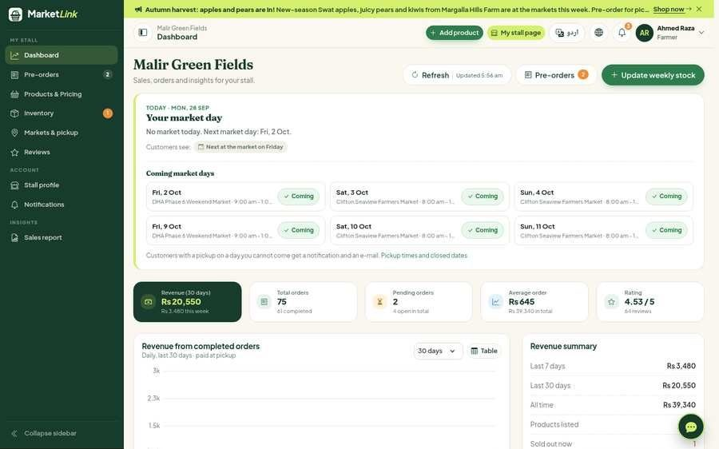

7.1 Farmer portal
STOCK, PRICES, STALL
A Farmer dashboard | 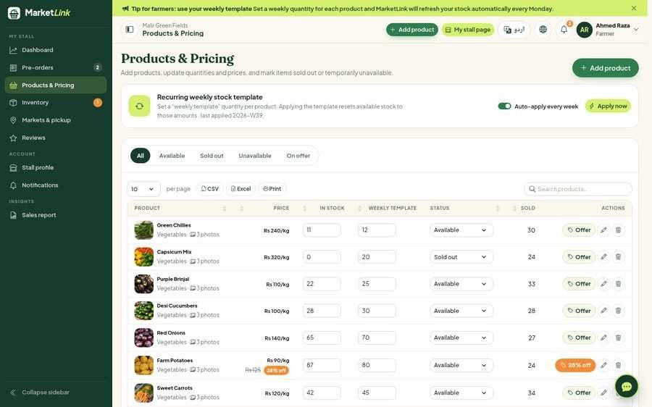  B Products & pricing | 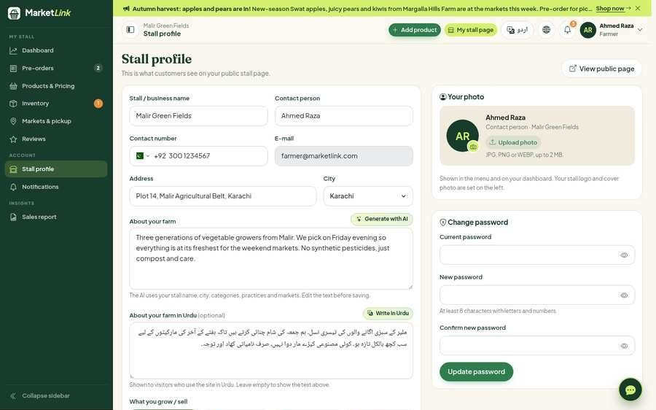  C Stall profile

7.2 Admin control centre
OVERSIGHT AND REPORTS
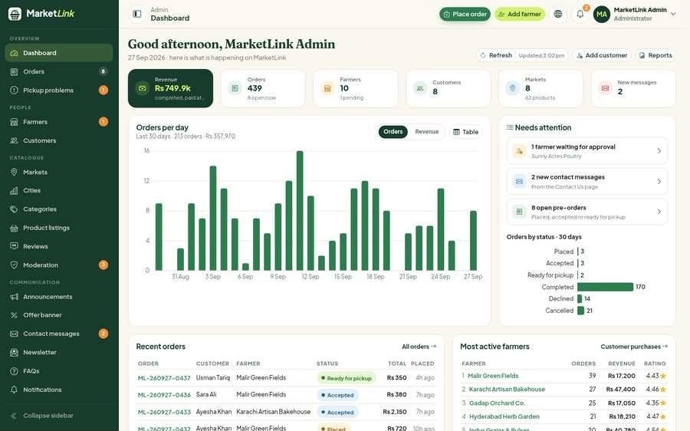  A Admin overview | 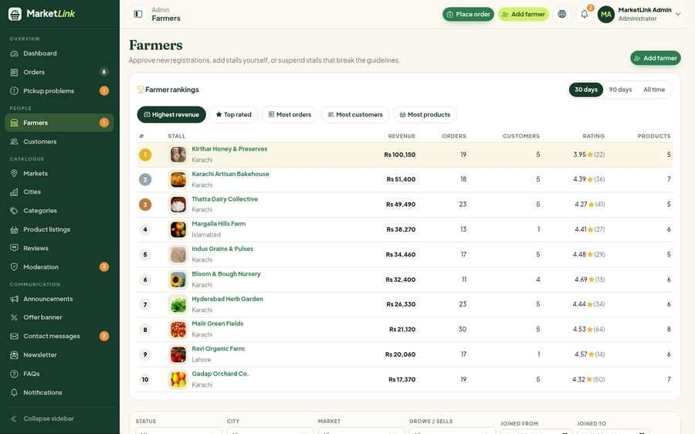  B Farmers table + CSV | 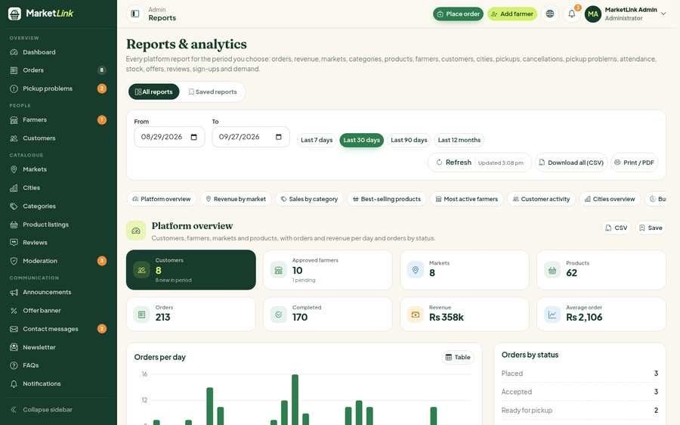  C Reports & analytics

7.3 Urdu & AI assistant
RIGHT-TO-LEFT AND ROMAN URDU
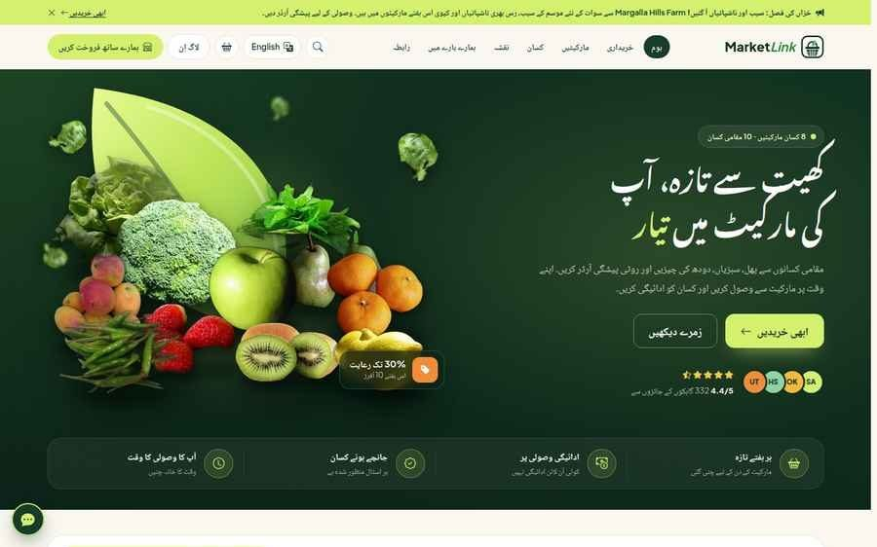  A Full Urdu page | 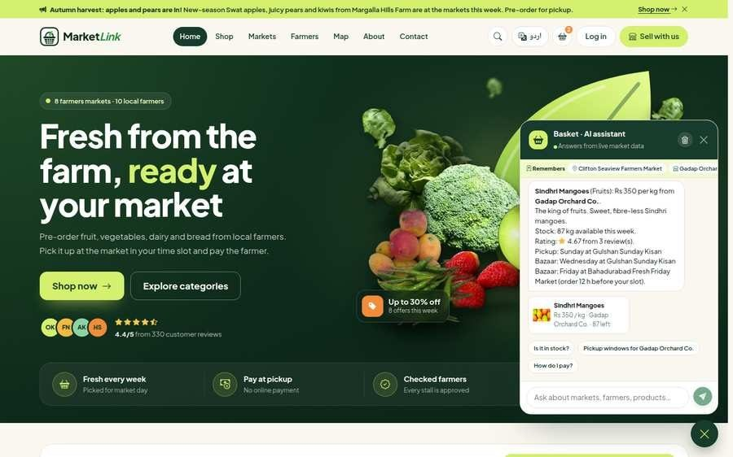  B Assistant in Roman Urdu

7.4 The customer journey
FROM THE DASHBOARD TO THE RECEIPT QUESTION
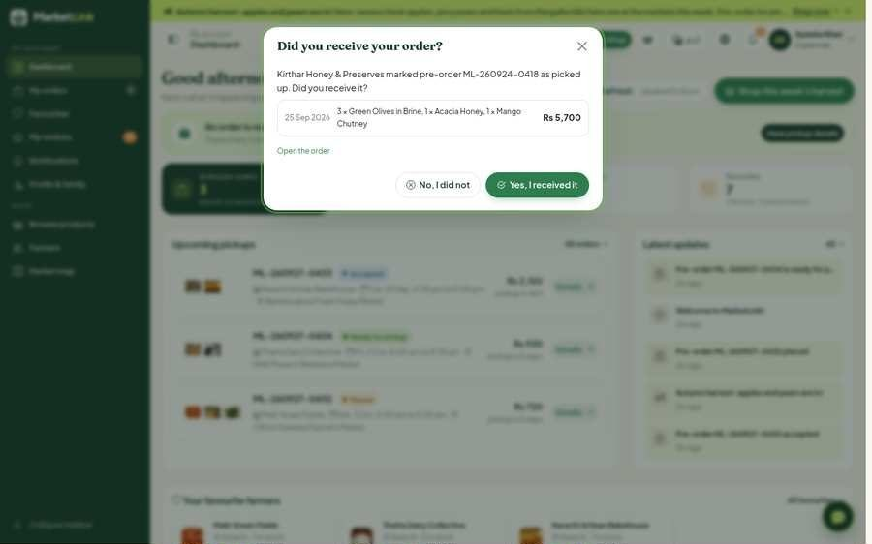  A Customer dashboard | 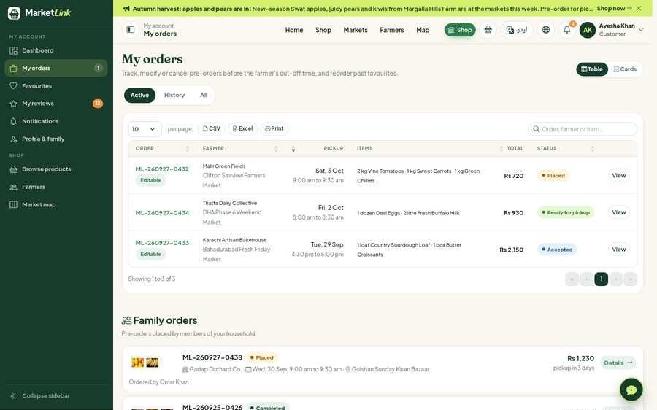  B My orders | 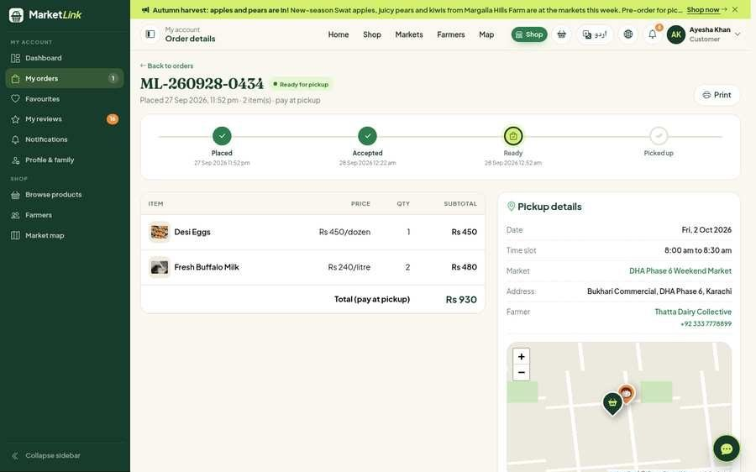  C Order with pickup details
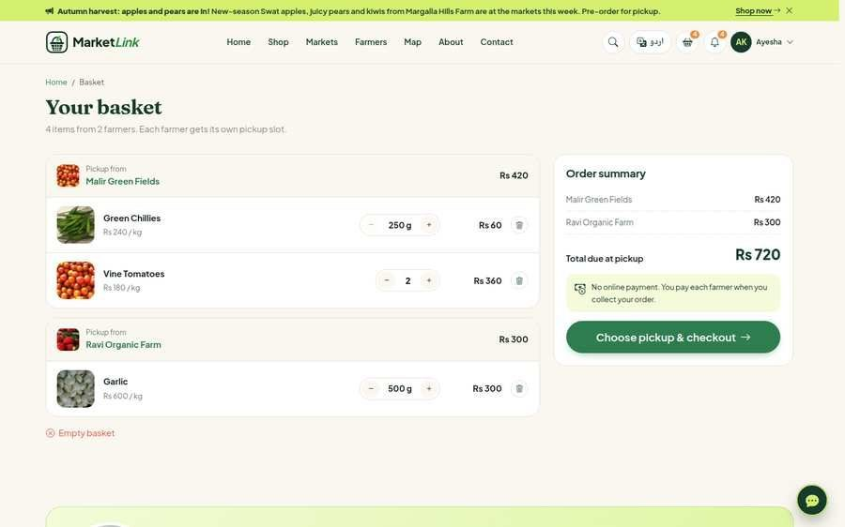  D Buying by weight | 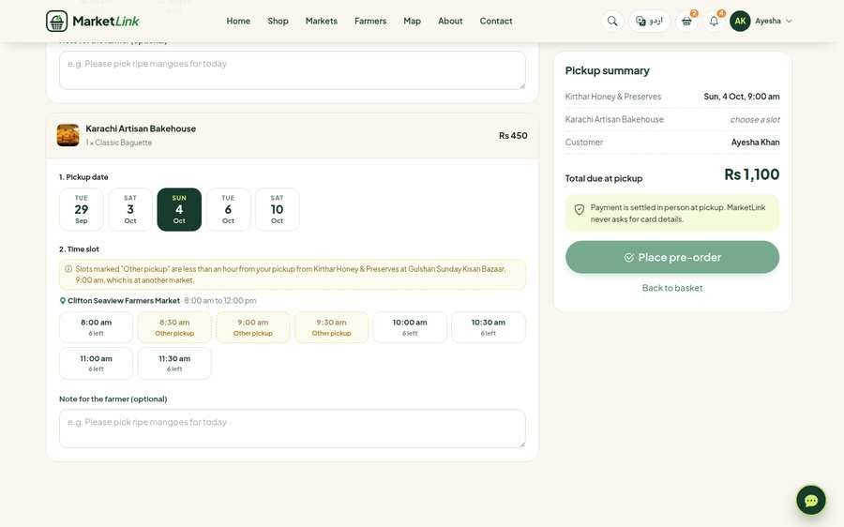  E Pickup clash message | 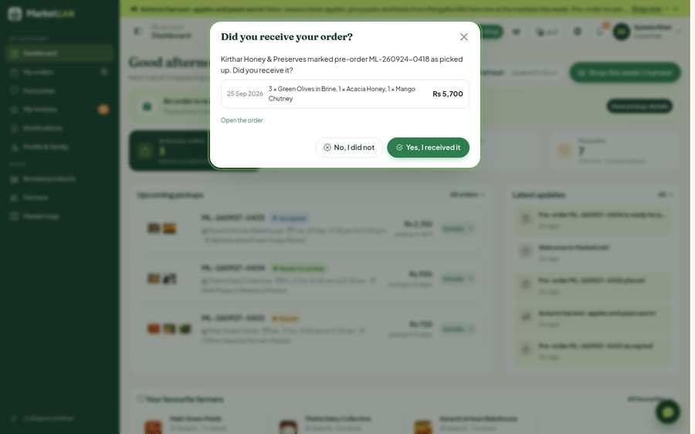  F Receipt question

7.5 Farmer and admin workflows
THE BAD DAYS, HANDLED
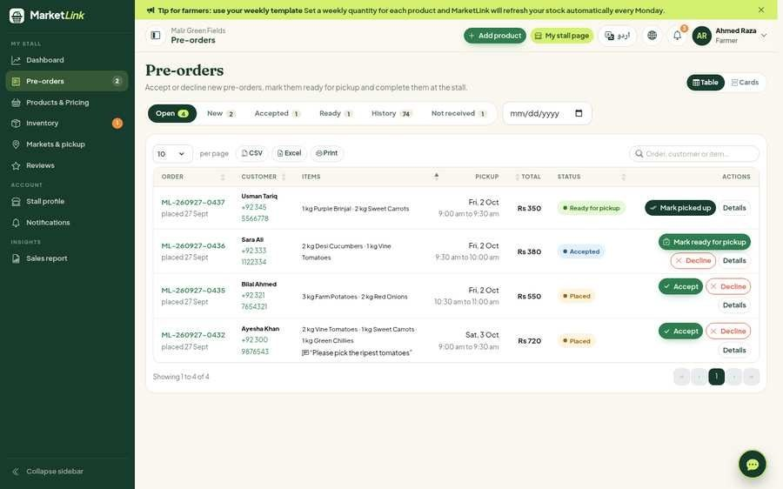  A Farmer pre-orders | 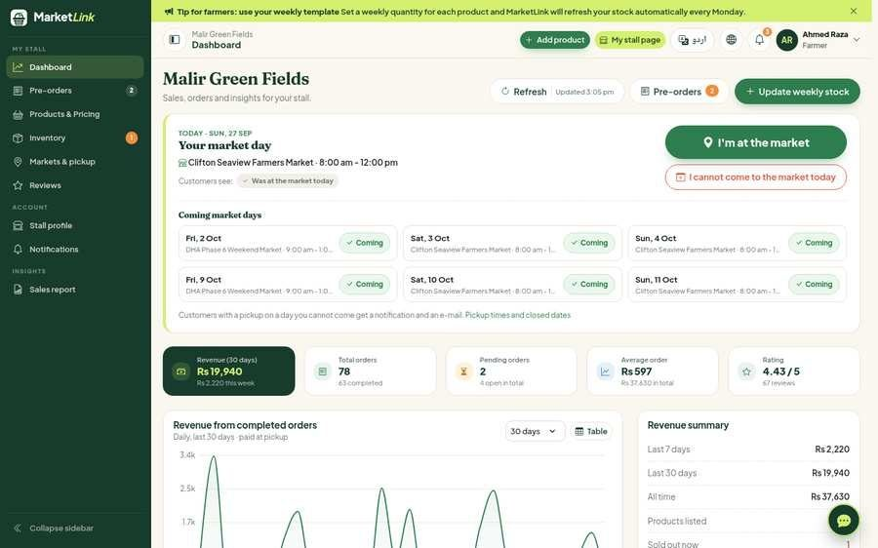  B Market-day check-in | 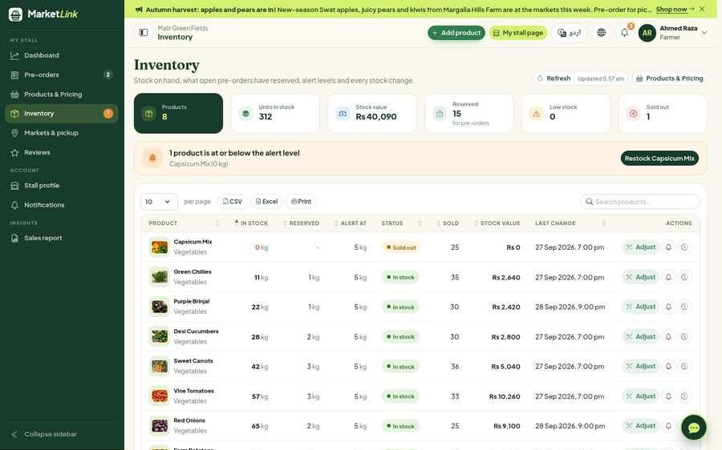  C Inventory & history
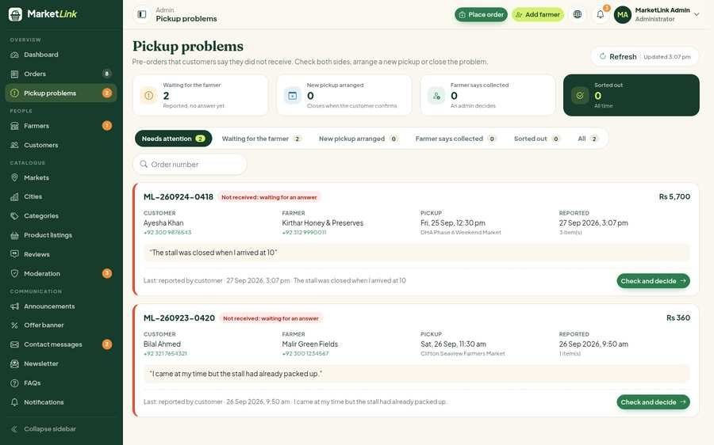  D Pickup problems | 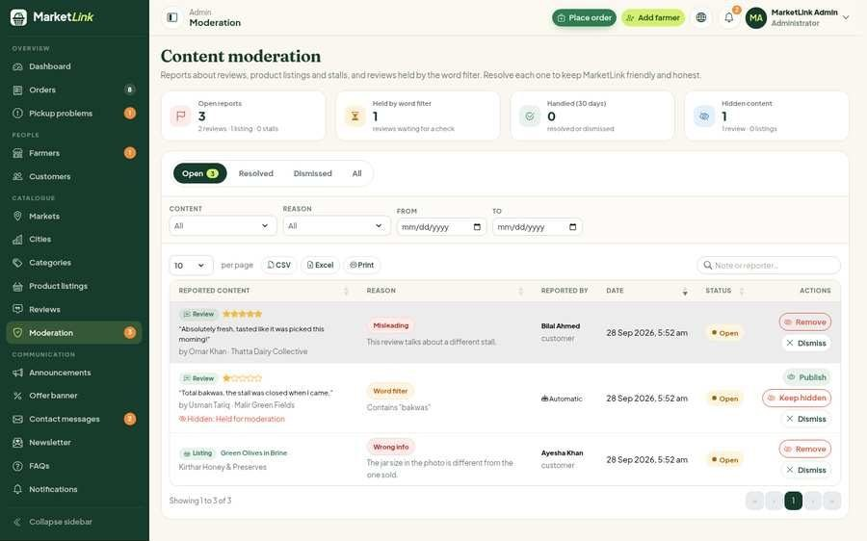  E Moderation queue | 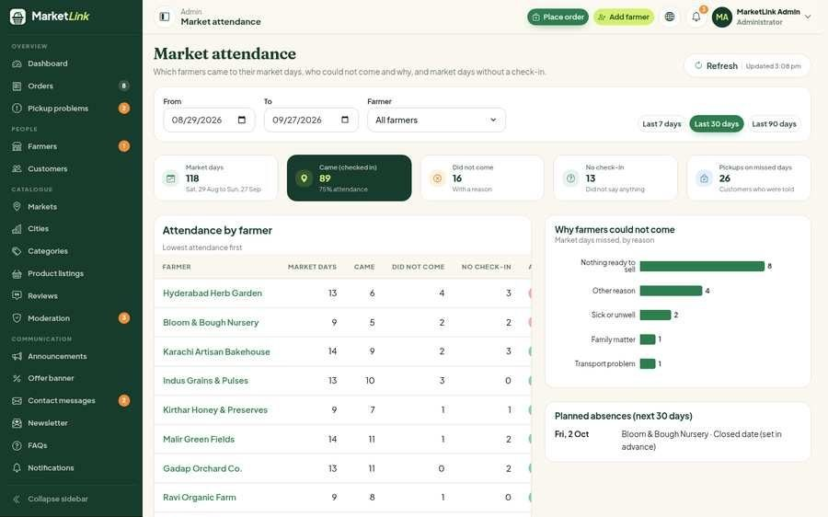  F Market attendance

7.6 Unique features that solve real problems
TWELVE PROBLEMS, TWELVE ANSWERS
# | REAL-WORLD PROBLEM | WHAT MARKETLINK DOES ABOUT IT
1 | "Is the farmer even coming today?" | The farmer checks in on the market day; a live "at the market today" badge shows, and customers with an order are told when the farmer cannot come
2 | Wasted trips when produce sells out early | Pre-orders reserve real stock the moment the order is placed
3 | Two pickups at the same time in different places | Checkout refuses them and asks for at least an hour between
4 | "I went, and my order was not there" | The customer reports it; the farmer answers; the admin verifies and decides
5 | Buying chillies or ginger by the kilo is too much | The customer picks 250 g, 500 g or 1 kg within the farmer's limits
6 | Same produce, different prices at several stalls | The product page shows "Rs 30 less per kg" or "Rs 20 more per kg"
7 | Farmers forget to update stock every week | A weekly template refills the stall; low-stock alerts warn the farmer
8 | Customers miss the product they wanted | "Remind me" e-mails the customer (or a guest) when it is back
9 | Reviews that nobody trusts | Only customers who confirmed a pickup can review; verified badge; farmers reply
10 | Many customers do not read English well | The whole site in Urdu, "Write in Urdu" for farmers, an assistant that understands Roman Urdu
11 | Market organisers have no numbers | Seventeen reports, farmer rankings and a market attendance report
12 | New customers give up at the sign-up form | Guest checkout: the account is created and the password e-mailed

7.7 Reports & analytics
SEVENTEEN REPORTS ON ONE PAGE
Each report has a date range, a chart, a table, CSV / Excel / print export and saved copies. Farmers get their own printable sales-insights report.
01 | Orders summary | 10 | Busiest pickup days and times
02 | Revenue by market | 11 | Cancelled and declined orders
03 | Most active farmers | 12 | Pickup problems (not received)
04 | Sales by category | 13 | Farmer market attendance
05 | Customer activity | 14 | Offers and discounts
06 | Inventory and low stock | 15 | Farmer sign-ups and approvals
07 | Cities overview | 16 | Customer demand (remind me)
08 | Reviews and moderation | 17 | Newsletter, messages and sign-ups
09 | Best-selling products

S E C T I O N
08

Challenges & lessons
The hardest parts were not the pages themselves but the real-world rules around them: time, weight, language and trust between strangers.

CHALLENGE | HOW WE SOLVED IT | WHAT WE LEARNED
Two customers reserving the last kilo | Stock is decreased with one atomic database operation that fails when the stock is not enough; the order is created only after that | Business rules belong on the server and in the database
Clashing pickups | The server compares every new pickup with the customer's other slots and refuses two markets at the same time | Think about what happens between farmers, not only inside one order
Selling by weight | Farmers set the smallest step, a minimum and a maximum; quantities are rounded to three places; every screen shows "250 g" or "1.5 kg" | Amounts, money and rounding need one shared set of helpers
Urdu right-to-left | Direction-aware styles, an Urdu font, a translation file checked by a script, and "Write in Urdu" | Plan for both directions from the start
Orders not received | Cash on pickup needs a fair way to settle disputes: the customer reports, the farmer answers, the admin decides | Real markets need features for the bad days too
Farmers who cannot come | A market-day check-in, "I cannot come" with a reason, customer notices and an attendance report | Tell people early when plans change
Maps without a paid key | OpenStreetMap tiles with a fallback server, OSRM for routes, Google Maps links for directions | Free services work well when you handle their limits
Photos we may use | Open Images Dataset (CC BY 2.0) with a credits page; larger banners made with a super-resolution model | Licences and credits are part of the work
E-mail at the demo | Three modes: console (default), a free test inbox, or real SMTP | Make the default work with no setup
Lost edits | Save and Cancel highlight, and dialogs warn about unsaved changes | Protect the user's work
Speed without extra setup | Redis is used when configured; memory otherwise | Optional parts need a safe fallback
Testing a large app quickly | Suites reseed the database and run in a real browser at many widths | Automated tests find phone-width problems nobody checks by hand

Lessons learned
FOUR WE WILL KEEP
1  Design for the real market  Rules such as cut-off times and pickup windows mattered more than extra screens. | 2  Test every round  Automated API and browser tests let us change a lot each round without breaking earlier work.
3  Language is a feature  Right-to-left Urdu had to be planned into the design system, not added at the end. | 4  Plan for missing services  Optional parts like Redis and SMTP need a safe fallback so the app still runs anywhere.

S E C T I O N
09

Conclusion & next steps
MarketLink delivers a complete end-to-end web solution for local farmers markets in Pakistan.

By combining online pre-orders with cash on pickup, live stock, full Urdu support and an AI assistant, MarketLink helps farmers plan their harvest and sell more of it, and gives city families a reliable way to get fresh produce. The application was built as a MERN multi-tier system, tested with more than a thousand automated checks, and is delivered as a ready-to-run package with demo data and documentation.
3  PORTALS | 20  COLLECTIONS | 17  REPORTS | 13  ROUNDS

Next steps
WHERE MARKETLINK GOES NEXT
→  Mobile app  A mobile app for farmers to update stock straight from the market, built on the same API. | →  SMS & WhatsApp reminders  Pickup reminders for customers without regular e-mail access.
→  More cities and languages  Add markets in more cities and invite their farmers; add Sindhi and Pashto. | →  Optional online payment  A deposit option for large pre-orders while keeping cash on pickup.
→  Delivery through a partner  For customers who cannot come to the market. | →  Farmer verification badges  Identity, organic or food-safety certificates checked by the admin.

S E C T I O N
A

Installation
Requirements: Node.js 20 or newer, and MongoDB (Community Server on the computer, or a free MongoDB Atlas cluster). Command-line details and all settings are in the README.md files.

A.1 Run it on a computer
SEVEN STEPS
- Open a terminal in the MarketLink folder.
- Install all packages with the install command listed in the ReadMe.
- Copy the example settings file in the server folder and fill in the MongoDB connection address and a long random secret for sign-in tokens.
- (Optional) Create the collections and indexes by running the schema script with mongosh.
- Load the demo data with the seed command. This deletes any existing MarketLink data.
- Start the app in development mode and open it in the browser at localhost port 5173.
- Or build it and start one server, then open localhost port 5000.

E-mail. Without SMTP settings the e-mails are printed in the server window. To send real e-mails, add the SMTP details to the settings file and run the mail test command.
Urdu. Press the Urdu button in the top bar, or add ?lang=ur to any page address.
S E C T I O N
B

Requirement traceability
Every requirement of SRS sections 1.6 and 1.7, where it lives in MarketLink, and how it was checked.

CUSTOMER
ID | SRS REQUIREMENT | WHERE IN MARKETLINK | VERIFIED BY
C-01 | Registration with name, contact number, e-mail, address | /register, /login; phone box with country flag | audit3 (fields)
C-02 | Favourite farmers and products | Heart buttons; Account → Favourites | smoke
C-03 | Family account sharing (optional) | Account → Profile → Family | smoke
C-04 | Browse markets by location and day; farmers at each | /markets (open today first), market page | audit3 (near me)
C-05 | Farmer profile: stall, location, days, weekly stock | /farmers/<name> | smoke
C-06 | Map with markers and directions | /map, market and farmer pages (OSM, OSRM, Google Maps link) | smoke2 (map data)
C-07 | Categories and filters: price, category, market, day | /products filters, /categories | smoke2
C-08 | Product details: price, unit, quantity, farmer | /products/<name> | smoke
C-09 | Basket and pre-order against stock | Basket, /checkout | smoke, TC-01
C-10 | Pickup date and slot | /checkout slot picker | audit3, r12clash, TC-02–06
C-11 | Order status; cancel or modify before cut-off | Account → Orders → order page | audit3, TC-04
C-12 | Order history and reorder | Account → Orders, "Order again" | e2e journeys
C-13 | Favourites and restock alerts | "Remind me" on sold-out products | r10test, TC-12
C-14 | Saved markets, route-friendly pickup details | Favourites → Saved markets; order page directions | Manual walkthrough
C-15 | AI assistant (optional) | Chat button on every page | r8api, r10test
C-16 | Reviews after completion; visible before ordering | Receipt question, review form, product and farmer pages | r5api (verified)
FARMER
ID | SRS REQUIREMENT | WHERE IN MARKETLINK | VERIFIED BY
F-01 | Registration: stall, contact, number, e-mail, address | /register/farmer wizard | audit3
F-02 | Profile: markets, days, pickup windows, map pin | Farmer → Profile, Pickup | smoke2 (closed dates)
F-03 | Add / edit / view / delete products | Farmer → Products & Pricing | smoke
F-04 | Recurring weekly stock template | Farmer → Inventory; hourly job | Manual walkthrough
F-05 | Mark sold out / unavailable | Farmer → Inventory | api4
F-06 | Accept, decline, mark ready | Farmer → Orders | e2e journeys
F-07 | Cut-off times and pickup slots | Farmer → Pickup | audit3, TC-04/05
F-08 | Sales history, best sellers, orders, revenue | Farmer → Dashboard, Sales | api4 (insights)
F-09 | Reply to reviews | Farmer → Reviews; own stall page | r4test
ADMINISTRATOR
ID | SRS REQUIREMENT | WHERE IN MARKETLINK | VERIFIED BY
A-01 | Admin login and dashboard with totals | /admin | apitools
A-02 | Approve / suspend farmers | Admin → Farmers | audit3, TC-07
A-03 | Activate / deactivate customers | Admin → Customers | apitools
A-04 | Manage markets with map position | Admin → Markets | apitools
A-05 | Remove inappropriate listings / reviews | Admin → Moderation, Products, Reviews | api4
A-06 | Reports: orders, revenue by market, active farmers | Admin → Reports, rankings | api4, r12test
A-07 | Categories and announcements | Admin → Categories, Announcements | apitools, r6api
OTHER FUNCTIONAL
ID | SRS REQUIREMENT | WHERE IN MARKETLINK | VERIFIED BY
O-01 | Role-based access | Role check on every protected request | smoke, TC-08
O-02 | Search, sort, filter with map results | Shop, farmers, markets, map pages | smoke2
O-03 | Responsive design | Every page, phone bottom bar | resp8 (18 widths)
O-04 | E-mail / in-app notifications | Bell menu, Notifications page, e-mails | e2e journeys
O-05 | About Us | /about | resp8
O-06 | Contact Us with map | /contact | r10test (topics)
NON-FUNCTIONAL (SRS 1.7)
REQUIREMENT | HOW IT IS MET | VERIFIED BY
Compatibility | Standard HTML, CSS and JavaScript for current Chrome, Edge, Firefox and Safari | Chromium automated; others Manual walkthrough
Responsive design | 18 widths from 320 to 1920 px; bottom bar and bottom-sheet dialogs on phones | resp8
Security | Hashed passwords, httpOnly cookies, server role checks, rate limits, upload checks | smoke, TC-08
Performance | Server-side paging, compression, lazy-loaded pages, sized images, optional Redis | Manual walkthrough
Usability | Toasts for every action, button spinners, empty states, unsaved-changes warnings | r12unsaved
Accessibility | Keyboard access, visible focus, alt text, reduced motion, contrast | Manual walkthrough
Languages | English and Urdu on every public, customer and farmer page | r8api, translation scan
Search and answer engines | Titles and descriptions per page, page facts in the HTML, structured data (JSON-LD), sitemap, robots.txt, llms.txt for AI assistants, English and Urdu alternates | r7api

S E C T I O N
C

User credentials
Demo accounts for every role and every account state, created by the seed script.

ROLE | STATE | NAME | LOGIN E-MAIL | PASSWORD
Administrator | Active | MarketLink Admin | admin@marketlink.com | Admin@123
Customer | Active | Ayesha Khan | customer@marketlink.com | Customer@123
Customer | Deactivated | Kashif Javed | inactive.customer@marketlink.com | Customer@123
Farmer | Approved | Malir Green Fields | farmer@marketlink.com | Farmer@123
Farmer | Waiting for approval | Sunny Acres Poultry | pending.farmer@marketlink.com | Farmer@123
Farmer | Suspended | Old Town Goat Dairy | suspended.farmer@marketlink.com | Farmer@123

NOTE FOR JUDGES
A deactivated customer and a suspended farmer cannot sign in; the waiting farmer can sign in but cannot sell until approved. These accounts are included so the locked states can be seen.

SUBMISSION CHECKLIST (SRS 1.9)
ITEM | WHERE
Zip of the consolidated project | Submission folder
README.md files with assumptions | Submission folder; Appendix D
Database scripts (mongosh + JSON) and the .sql note | database folder; Section 4.2
Demo video (.mp4) covering every functional requirement | Submission folder
Installation instructions | Appendix A
User credentials | Appendix C
Test data used in the project | Section 6.1
Problem definition, design specifications, diagrams | Sections 1, 3, 4, 5

S E C T I O N
D

Assumptions, limits & AI tools
What we assumed where the SRS was silent, what the system does not do yet, and which AI tools were used.

D.1 Assumptions
ALSO LISTED IN THE README
- Payment is made in person at pickup; there is no payment gateway (SRS 1.5). Pickup only; no delivery.
- Farmer identity and organic or food-safety claims are not verified; tags such as "Pesticide-free" are the farmer's own description.
- All markets use one time zone (Asia/Karachi by default) for pickup slots, cut-off times and "today".
- The market-day check-in is the farmer's own word; the location is not checked.
- An offer with a last day ends after that day; the hourly job puts the usual price back.
- A customer needs at least one hour between pickups at different markets on the same day.
- Products priced per kg or per litre can be sold by weight when the farmer allows it; the smallest amount is also the step.
- "Not received" is the customer's word; the farmer can answer and the admin decides.
- Public pages and reports may be cached for up to a minute; every change empties the cache.
- The e-mail address is the login name.
- The project uses MongoDB, so the database is delivered as a mongosh script and JSON sample data instead of .sql files.
- OpenStreetMap is used instead of the paid Google Maps API; Google Maps links are offered for directions.
- Stock photos come from the Open Images Dataset under CC BY 2.0; photographers are listed on the Photo credits page.

D.2 Known limitations
HONEST EDGES
- Tests ran in Chromium only; Firefox and Safari were not tested automatically.
- Real e-mail delivery depends on the SMTP settings; the tests use a local SMTP server.
- Maps need an internet connection for the tiles; directions use the free OSRM service.
- The assistant is rule-based; very unusual questions get a polite "I couldn't find an answer" with suggestions.

D.3 AI tools used
REQUIRED BY THE SRS
TOOL | WHAT IT WAS USED FOR
Claude Code (Anthropic) | Coding assistant during development and testing
Canva | Logo design
EDSR super-resolution model (OpenCV) | Enlarging the 1024 px banner photos to 1920 px for large screens

S E C T I O N
E

Demo data
Created by the seed script and used for every test in Section 6.

DATA | RECORDS | DETAILS
Users | 21 | 1 administrator; 12 farmers (10 approved, 1 waiting, 1 suspended); 8 customers (7 active, 1 deactivated)
Cities | 9 | Karachi, Lahore, Islamabad, Rawalpindi, Hyderabad, Faisalabad, Multan, Peshawar, Quetta
Markets | 8 | 6 in Karachi, 1 in Lahore, 1 in Islamabad
Categories | 8 | Vegetables, Fruits, Dairy & Eggs, Baked Goods, Herbs & Greens, Honey & Preserves, Grains & Pulses, Flowers & Plants
Products | 62 | 60 in stock, 2 sold out; 8 on offer; some sold by weight; prices Rs 50 to Rs 3,200
Pre-orders | 435 | Completed, cancelled, declined and upcoming orders (placed, accepted, ready)
Reviews | 341 | 188 farmer reviews and 153 product reviews, most with a verified purchase
Stock movements | 81 | Restocks, weekly template runs, corrections and order reservations
MARKETS IN THE DEMO DATA
MARKET | CITY | DAYS | HOURS
Clifton Seaview Farmers Market | Karachi | Sunday, Saturday | 07:00–13:00
DHA Phase 6 Weekend Market | Karachi | Sunday, Friday | 08:00–14:00
Gulshan Sunday Kisan Bazaar | Karachi | Sunday, Wednesday | 07:00–15:00
North Nazimabad Evening Green Market | Karachi | Wednesday, Saturday | 16:00–21:00
Bahadurabad Fresh Friday Market | Karachi | Tuesday, Friday | 16:00–21:00
Saddar Heritage Farmers Market | Karachi | Monday, Thursday, Saturday | 06:00–12:00
Model Town Kisan Market | Lahore | Sunday, Thursday | 07:00–13:00
F-9 Park Weekend Market | Islamabad | Sunday, Saturday | 08:00–14:00

