Document Scanner + OCR Pipeline
A Computer Vision Project Report
Course: CSE3010 – Computer Vision
Assignment: Build Your Own Project (VITyarthi)
Institution: VIT Bhopal University, School of Computing Science and Engineering
Submitted by: Sharanya
[Registration Number: __________]

1. Introduction
Photographs of physical documents taken with a phone camera are almost never perfectly aligned: they are skewed, perspective-distorted, and unevenly lit. This project builds a command-line pipeline that takes such a photo and produces a clean, flattened, high-contrast scan, then extracts the document's text via Optical Character Recognition (OCR). The pipeline is organized into three independent, testable modules that map directly onto the image-processing and geometric-transform concepts covered in the CSE3010 syllabus: image formation and enhancement, homography-based perspective correction, and feature/contour-based boundary detection.

2. Problem Statement
There is a need for a lightweight, GUI-free tool that converts a raw photo of a document into (a) a flattened, readable scan and (b) accurate, structured machine-readable text — without relying on a phone app or cloud service. This project addresses that need with a fully local, scriptable pipeline runnable from a terminal.

3. Functional Requirements
The system implements three major functional modules, as required by the assignment brief:
- Module 1 – Document Detection & Perspective Correction: locates the document boundary in the input photo (Canny edge detection + contour approximation) and applies a homography-based perspective warp to produce a top-down view.
- Module 2 – Image Enhancement & Binarization: converts the warped image to grayscale, applies CLAHE contrast equalization and denoising, then adaptive thresholding to produce a clean, scanner-quality black-and-white page.
- Module 3 – OCR Text Extraction & Structured Output: runs Tesseract OCR on the enhanced image and emits both plain text and a structured JSON file containing per-word text, confidence score, and bounding box.
Input/output structure: the CLI accepts a single image path (--input) and an output directory (--output-dir); it writes the intermediate warped image, the enhanced/binarized image, the extracted text file, and a structured JSON result.
Workflow: read image → detect & warp → enhance & binarize → OCR extract → write outputs → print summary. See the Process Flow diagram in Section 6.

4. Non-Functional Requirements
Requirement | How it is addressed
Performance | Image is resized before contour search (fixed 800px height) to bound processing cost; full pipeline runs in well under a second for typical inputs.
Reliability | A DocumentNotFoundError fallback path uses the full frame if no 4-point contour is found, so the pipeline degrades gracefully instead of crashing.
Usability | Single CLI entry point with argparse, clear --help text, sensible defaults, and a printed run summary (word count, confidence, elapsed time).
Maintainability | Each module (detector, enhancer, OCR) is a separate file with a narrow, documented public API, so any module can be modified or swapped independently.
Error handling | Every module validates its inputs (empty/invalid images) and raises specific exceptions; main.py catches and logs these without a raw stack trace reaching the user.
Logging / monitoring | Centralized logging (utils.setup_logging) writes timestamped, leveled logs to both the console and scanner.log.
Resource efficiency | Uses OpenCV's headless build (no GUI dependencies) and releases all intermediate arrays automatically via Python's garbage collector; no persistent state between runs.

5. System Architecture
The CLI (main.py) orchestrates three independent modules, each with a single responsibility, plus a shared utilities module for logging and I/O helpers.
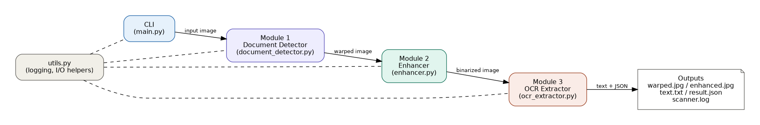
Figure 1: System architecture — module responsibilities and data handed between them.

6. Design Diagrams

6.1 Process Flow / Workflow Diagram
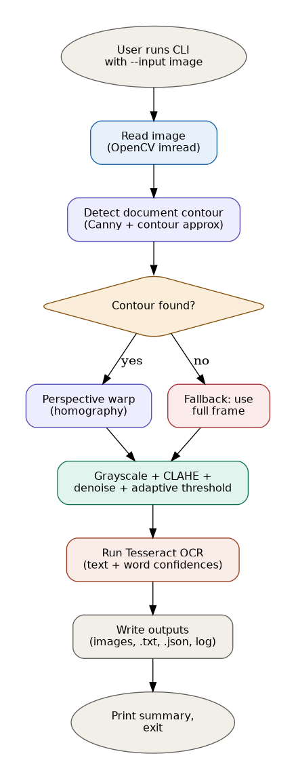
Figure 2: End-to-end processing workflow, including the contour-not-found fallback path.

6.2 Use Case Diagram
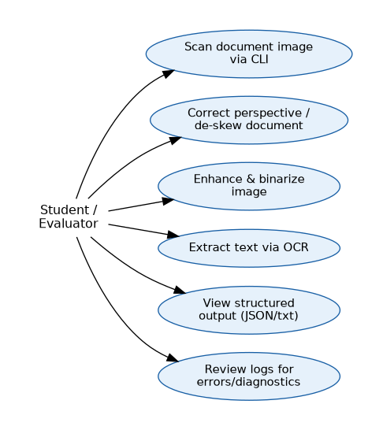
Figure 3: Use cases available to the student/evaluator running the CLI.

6.3 Class / Component Diagram
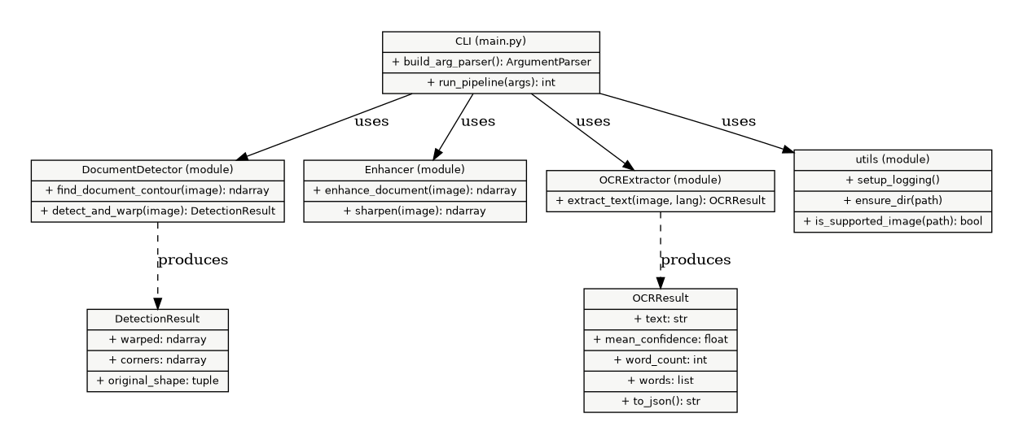
Figure 4: Module-level components, their public methods, and the data classes they produce.

6.4 Sequence Diagram
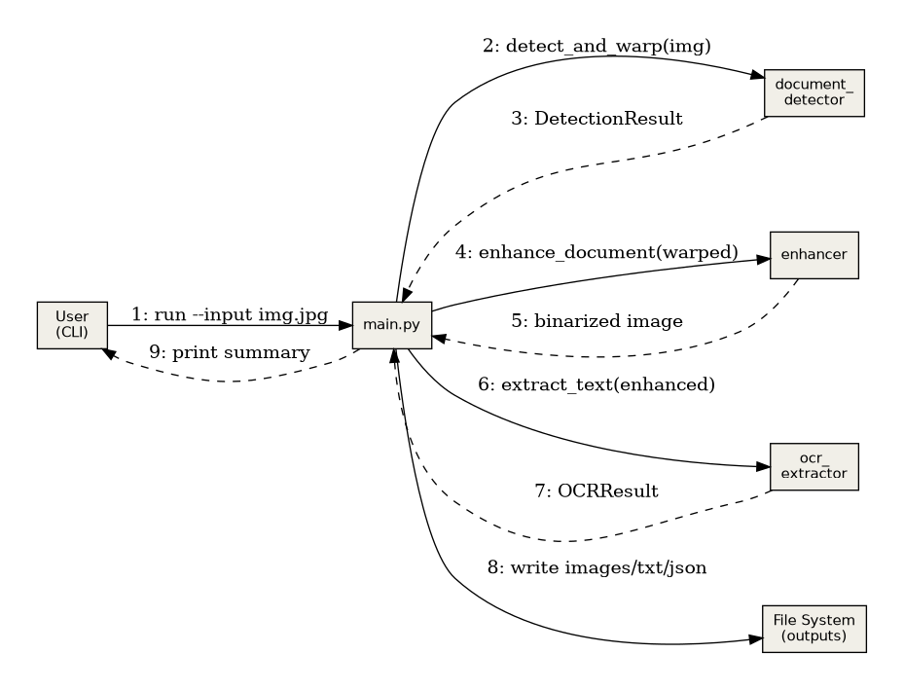
Figure 5: Call sequence for a single CLI invocation, from input image to written outputs.

6.5 Database / Storage Design
Not applicable — this project is a stateless, file-in/file-out CLI pipeline and does not use a database. Outputs are written directly to the filesystem as image, text, and JSON files (see Section 3).

7. Design Decisions & Rationale
- Three separate modules instead of one script: keeps each concept (geometry, image processing, OCR) independently testable and replaceable — e.g. Module 3 could be swapped for a cloud OCR API without touching Modules 1–2.
- Fallback-to-full-frame on failed detection: chosen over hard-failing so the pipeline is robust to photos where the document fills the whole frame or has low-contrast edges.
- Adaptive thresholding over a global threshold: documents photographed under uneven lighting have local brightness gradients that a single global threshold cannot handle well.
- JSON structured output alongside plain text: enables downstream automation (e.g. filtering by confidence, locating specific words) rather than only a human-readable transcript.
- CLI-only (argparse), no GUI: satisfies the assignment's command-line-executable requirement and keeps the tool scriptable/automatable.

8. Implementation Details
Language & libraries: Python 3, OpenCV (opencv-python-headless) for all image processing and geometric transforms, NumPy for array operations, and pytesseract as a thin wrapper around the Tesseract OCR engine.

8.1 Module 1 — document_detector.py
Resizes the input for fast contour search, applies Gaussian blur + Canny edge detection, finds the largest contours, and keeps the first one that approximates to a 4-point polygon (cv2.approxPolyDP). Corners are ordered (top-left, top-right, bottom-right, bottom-left) and a perspective transform matrix is computed with cv2.getPerspectiveTransform, then applied with cv2.warpPerspective.

8.2 Module 2 — enhancer.py
Converts to grayscale, optionally applies CLAHE (contrast-limited adaptive histogram equalization) to correct uneven lighting, denoises with cv2.fastNlMeansDenoising, and binarizes with cv2.adaptiveThreshold (Gaussian-weighted, block size 25).

8.3 Module 3 — ocr_extractor.py
Calls pytesseract.image_to_string for the plain-text transcript and pytesseract.image_to_data for per-word bounding boxes and confidence scores, aggregating them into an OCRResult dataclass with a to_json() serializer.

8.4 CLI — main.py
Wires the three modules together behind an argparse interface, writes all intermediate and final artifacts to the chosen output directory, and prints a run summary.

9. Screenshots / Results
The pipeline was validated on a synthetically generated test document (a skewed page with printed text on a dark background, generated in tests/test_pipeline.py) to provide a deterministic, reproducible demonstration.
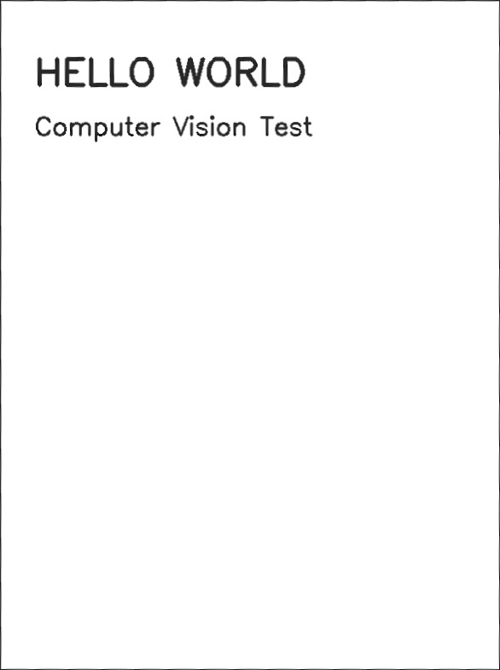
Figure 6: Module 1 output — perspective-corrected, de-skewed document.
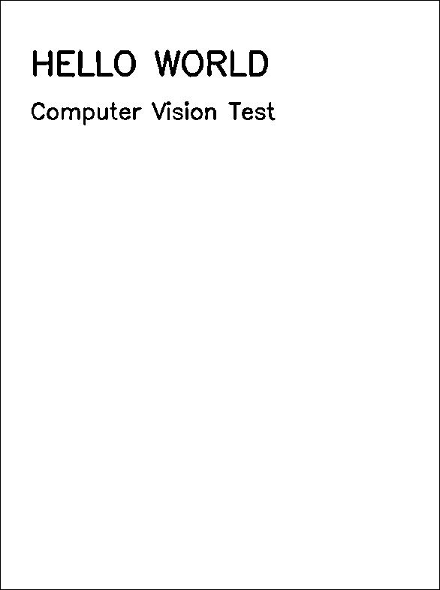
Figure 7: Module 2 output — enhanced, binarized scan ready for OCR.
Module 3 (OCR) output on this sample:
{
"text": "HELLO WORLD\n\nComputer Vision Test",
"mean_confidence": 96.0,
"word_count": 5,
"words": [ { "text": "HELLO", "confidence": 96.0, "bbox": {...} }, ... ]
}
Run summary printed by the CLI:
Words extracted: 5
Mean OCR confidence: 96.0%
Time elapsed: 0.59s

10. Testing Approach
Automated unit tests (tests/test_pipeline.py, run via pytest) cover all three modules:
- Document Detector: verifies a valid DetectionResult is returned for a normal image, that an empty image raises DocumentNotFoundError, and that a blank/featureless image correctly falls back to using the full frame.
- Enhancer: verifies output is strictly binary (0/255 pixel values only) and that an empty image raises ValueError.
- OCR Extractor: verifies text is extracted from a synthetic page, mean_confidence is a float, an empty image raises ValueError, and JSON serialization includes expected fields.
All 8 tests pass. Synthetic test images are generated on the fly (no external fixture files needed), keeping the test suite fully self-contained and deterministic. The pipeline was additionally validated end-to-end via the CLI itself (Section 9).

11. Challenges Faced
- Robust corner ordering: perspective warps break if the four detected corners aren't consistently ordered (TL/TR/BR/BL); solved using the sum/difference-of-coordinates trick.
- Handling failed contour detection gracefully: rather than letting the pipeline crash on low-contrast or edge-filling images, a full-frame fallback path was added and unit-tested explicitly.
- Uneven lighting in photographed documents: a plain global threshold produced patchy results; switching to adaptive Gaussian thresholding (with CLAHE beforehand) fixed this.
- Deterministic testing without real photos: building a synthetic-document generator (skewed page + printed text) so tests don't depend on external image fixtures or manual photography.

12. Learnings & Key Takeaways
- Practical experience applying homography/perspective-transform theory (Module 2 of the syllabus) to a real image, not just synthetic point sets.
- Adaptive, locally-aware image processing (CLAHE, adaptive thresholding) matters far more than global operations once inputs come from uncontrolled, real-world conditions like phone photography.
- Designing for graceful degradation (fallback paths, input validation) is as important as the 'happy path' algorithm for a tool meant to be run by someone else.
- A clean module boundary (detector → enhancer → OCR) made independent unit testing straightforward and would make it easy to later swap any one stage (e.g. a different OCR engine) without touching the rest.

13. Future Enhancements
- Multi-page / batch processing: accept a directory of images or a PDF and process all pages in one run.
- Automatic rotation correction: detect and correct 90°/180° rotated documents in addition to perspective skew.
- Layout-aware OCR: group extracted words into lines/paragraphs/table cells instead of a flat word list.
- Configurable OCR backend: abstract Module 3 behind an interface so a cloud OCR API can be swapped in for higher accuracy on handwriting.

14. References
- R. Szeliski, Computer Vision: Algorithms and Applications, Springer-Verlag London Limited, 2011.
- R. Hartley and A. Zisserman, Multiple View Geometry in Computer Vision, 2nd Edition, Cambridge University Press, 2004.
- OpenCV Documentation: https://docs.opencv.org/
- Tesseract OCR / pytesseract Documentation: https://github.com/tesseract-ocr/tesseract , https://github.com/madmaze/pytesseract
- CSE3010 Computer Vision course syllabus, VIT Bhopal.

