**DisasterAid**

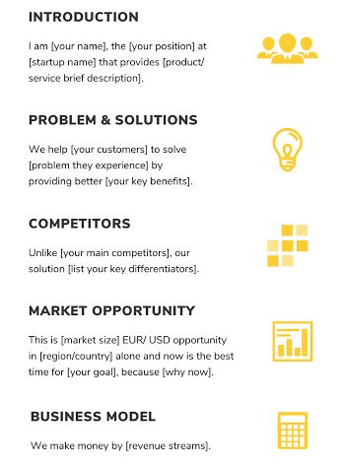 **Introduction**  
My name is Shehriyar Ali. I am working on a project called DisasterAid with my teammate Shamas Alam. We will be using API technology for the project. The idea was his and he is handling the API part. We are both working on the frontend and backend together.

**Problem And Solution**  
During disasters most people do not know where to get the right info. We want to fix that by building a simple site that gives alerts on time, shows daily weather, and helps people find help.

**Competitors**  
Most apps only do one thing. Our website brings everything in one place. Disaster alerts, weather updates, and a relief finder. We will also have some helpful blogs and a contact page.

**Market Opportunity**  
Disasters are getting more common so people need tools to stay ready. This is the right time to build something like DisasterAid that is free and easy to use.

**Business Model**  
The main features will stay free. In the future we might add extra features, work with relief groups, or allow safe sponsored content to support the platform.