Practical No-2

Aim-Computation of GCD Using Euclid's Algorithm in Python

Theory
The GCD of two integers is the largest positive integer that divides both numbers exactly.

Euclid's algorithm is based on the rule:
gcd(a, b) = gcd(b, a mod b)


b = 0
a % b
b
b

We repeatedly replace
a
by
and
by
until .

At that point:

gcd(a, b) = a

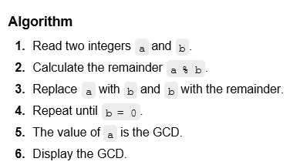

Step-by-step Solution
Find:

Using Euclid's algorithm:

Therefore,

Next:

Therefore,

Next:

gcd(48, 18)

48 = 18 × 2 + 12

gcd(48, 18) = gcd(18, 12)

18 = 12 × 1 + 6

gcd(18, 12) = gcd(12, 6)

12 = 6 × 2 + 0

Since the remainder is 0, the last non-zero remainder is 6. Therefore,
gcd(48, 18) = 6

Final Answer: GCD = 6

