Submitting Report
2-Month
Advanced Threat Detection & Incident Response

Name: Hemanth BandiEmail Id: hemanthbandi0963@gmail.com

Contents
- Abstract ………………………………………………………………. 3
- Introduction ………………………………………………………........3
  - Purpose ……………………………………………………………..3
  - Background …………………………………………………………3
  - Project Scope ………………………………………………………..3
  - Definitions, Acronyms, and Abbreviations ……………………........4
- Overall Description …………………………………………………….5
  - Product Perspective ……………………………………………........5
  - Product Functions …………………………………………………...5
  - User Characteristics …………………………………………………5
  - Constraints …………………………………………………………..5
  - Assumptions and Dependencies …………………………………….5
- Specific Requirements ………………………………………………….5
  - Functional Requirements ……………………………………………6
  - Non-Functional Requirements ………………………………………6
  - External Interface Requirements ……………………………………6
- Literature Survey ……………………………………………………….6
- Working ………………………………………………………………...7
  - Aim ………………………………………………………………….7
  - Proposed System …………………………………………………….7
  - Methodology …………………………………………………………7
  - Workflow …………………………………………………………….8
- Software Requirements ………………………………………………….8
- Results ……………………………………………………………….......8
- Future work ……………………………………………………………….9
- Conclusion………………………………………………………………….9
- References………………………………………………………………….10

1. Abstract
This project aims to develop an intelligent phishing detection system using machine learning algorithms. By leveraging a large dataset of website features, the model is trained to differentiate between phishing and legitimate websites. The project combines multiple components including data preprocessing, model training, web integration, and prevention strategies. In addition, it offers insights into phishing detection techniques, real-time analysis, and future enhancements.

2. Introduction
2.1 Purpose
This Software Requirements Specification (SRS) defines the functional and non-functional requirements of the phishing website detection and prevention system using machine learning. The system is built to assist users and organizations in protecting against phishing threats.

2.2 Background
Phishing is a deceptive practice where attackers impersonate legitimate entities to steal sensitive data such as usernames, passwords, and credit card numbers. These attacks are commonly conducted through fake websites. Machine learning models trained on website attributes can be a powerful defense mechanism against phishing.

2.3 Project Scope
The system allows users to input URL-based features and predict whether the site is phishing or legitimate. It also provides feature importance visualization, detection reports, and integrates prevention tips. The backend is developed using Python and Flask, with models trained using scikit-learn.

2.4 Definitions, Acronyms, and Abbreviations
URL: Uniform Resource Locator
ML: Machine Learning
HTTPS: Hypertext Transfer Protocol Secure
GBC: Gradient Boosting Classifier
RF: Random Forest
SRS: Software Requirements Specification
GUI: Graphical User Interface
CSV: Comma-Separated Values
API: Application Programming Interface

3. Overall Description
3.1 Product Perspective
The product is an independent system that integrates ML with a user interface. It takes features from users, processes them using a trained model, and returns the classification result.

3.2 Product Functions
Input feature form
Predict phishing/legitimate status
Display result and confidence score
Visualize feature importance
Offer preventive measures

3.3 User Characteristics
Casual users with basic internet knowledge
Cybersecurity professionals
Developers integrating API services

3.4 Constraints
Requires pre-processed features
Model must be updated periodically
Accuracy depends on data quality

3.5 Assumptions and Dependencies
Reliable internet access
Updated Python environment and packages
Compatibility with modern browsers

4. Specific Requirements
4.1 Functional Requirements
Feature-based input collection
ML model prediction
Display detailed classification result
Downloadable report generation
Model accuracy evaluation

4.2 Non-Functional Requirements
Secure data processing
Responsive UI
Real-time response (< 1 second)
Easy deployment and maintenance

4.3 External Interface Requirements
HTML/CSS/JS for frontend
Flask-based backend API
Model serialization with Pickle

- Literature Survey
Research has shown the effectiveness of ML algorithms such as Logistic Regression, Random Forest, and Gradient Boosting in detecting phishing websites. Studies emphasize the significance of URL structure, HTTPS presence, domain registration, and external resources in determining a site's legitimacy.

6. Working
6.1 Aim
To develop a machine learning-based phishing detection and prevention system that enhances online safety.

6.2 Proposed System
A web-based solution that allows real-time phishing detection using a trained ML model. The system displays predictions and educates users on prevention.

6.3 Methodology
Data Collection: Kaggle dataset with labeled phishing/legitimate websites
Preprocessing: Cleaning, feature selection
Model Training: GBC and RF with evaluation
Deployment: Flask web application
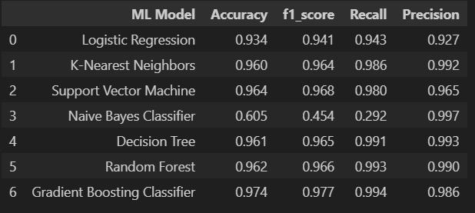

6.4 Workflow
Input website features
Model makes prediction
Result and confidence score shown
Visualization of top features
Tips for phishing prevention displayed

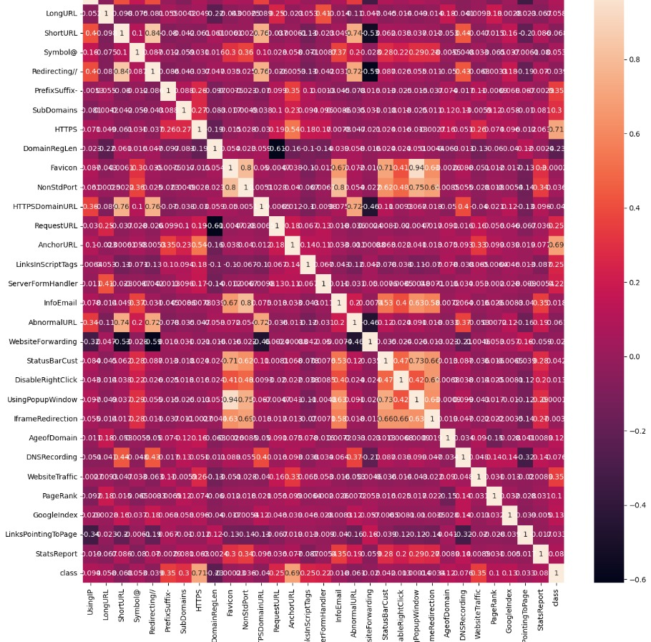

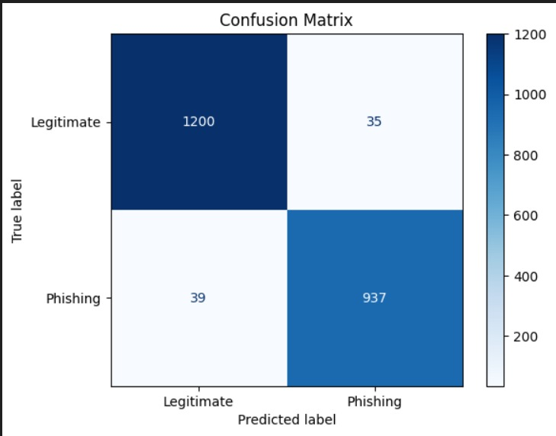

7. Software Requirements
Python 3.8+
Libraries: pandas, sklearn, seaborn, Flask, matplotlib
IDE: Jupyter Notebook, VSCode
OS: Windows/Linux
Web browser

8. Results
Achieved model accuracy > 95%
F1-score and confusion matrix indicate strong performance
HTTPS, Prefix/Suffix, SubDomains, and WebsiteTraffic identified as major features
Real-time predictions demonstrated successfully

9. Prevention Techniques
Avoid clicking on unknown links
Check for HTTPS and domain validity
Use anti-phishing toolbars and extensions
Verify email authenticity before clicking links
Regularly update browsers and antivirus software

10. Detection Strategies
Heuristic-based detection: Identify suspicious patterns
Blacklist-based detection: Known phishing URLs
Machine Learning-based detection: Feature extraction + prediction
Hybrid detection: Combines multiple methods for robustness

11. Future Work
Browser extension for live phishing detection
Deep learning models for better accuracy
Real-time URL scraping and feature extraction
Expand dataset to include multilingual websites
Add modules for email, QR code, and smishing detection

12. Conclusion
The project successfully builds a reliable phishing detection system leveraging machine learning. The results show high accuracy and usability. With added prevention strategies and feature visualization, the system can contribute to a safer internet environment.

13. References
1.https://www.researchgate.net/publication/329716781_Study_on_Phishing_Attacks.
2. Lee, C. (2024). Behavioral Threat Detection. IEEE.
3. https://ieeexplore.ieee.org/document/9396693
4. Smith, J. (2023). AI in Cybersecurity.

