ANKUR (917)
KESHAV (975)

IT PRACTICAL

JAVA

1. Implement a Bank Account having Instance variables: Account Number, Balance and
having methods:
float Deposit (float x)
float withdraw (float x)
int get account no ()
float get balance ()
tax deduction ()
Then implement class Bank having an array list of accounts of type BankAccount.
Implement following methods:
AddAccount in Bank
Get Total balance in Bank
Get account number with max. and min. balance
Find an account given a bank account no.
Count no. of accounts having atleast specific balance

Main.java
package Account;
import java .util.Scanner;
public class Main {
public static void main(String[] args) {
int ch;
Account bk=new Account(2000);
Scanner sc=new Scanner(System.in);
System.out.println("1.Existing account");
System.out.println("2.Bank ");
ch=sc.nextInt();
if(ch==1){
bk.createexist();
}else
{
bk.menu();
}
}
}

Account.java

package Account;
import java.util.ArrayList;
import java.util.Random;
import java.util.Scanner;
public class Account {

Random no=new Random();
private int acc;
private int bal;
private String name;
private ArrayList<Account> accounts=new ArrayList<Account>();

Account(int x){
acc=x;
bal=0;

accounts.add(new Account("ankur",acc));
acc++;
accounts.add(new Account("keshav",acc));
acc++;
}
Account(String name,int acc){
this.name=name;
this.acc=acc;
bal=0;
}

public void createexist(){

int ch;
do{
System.out.println("--- Menu ---");
System.out.println("1.Get Balance");
System.out.println("2.Withdraw from bank");
System.out.println("3.Deposit in Account");
System.out.println("4.Go to bank menu");
System.out.println("Enter Your Choice:");
//System.out.println("");
Scanner sc = new Scanner(System.in);
ch = sc.nextInt();

switch(ch)
{
case 1:
this.getBal();
break;
case 2:
this.withdrawl();
break;
case 3:
this.deposit();
break;
case 4: menu();
default:
System.out.println("Wrong Choice");

}

}while(ch!=9);

}

public void menu(){
int ch;
do{
System.out.println("--- Menu ---");
System.out.println("1.Create New Account");
System.out.println("2.Show Total Bank Balance");
System.out.println("3.Show Max and Min Account Balance Holders");
System.out.println("4.Check for Given Balance");
System.out.println("5.Check for Given Account");
System.out.println("6.check existing account");
System.out.println("7.Exit");
System.out.println("Enter Your Choice:");
//System.out.println("");
Scanner sc = new Scanner(System.in);
ch = sc.nextInt();

switch(ch)
{

case 1:
this.createAccount();
break;
case 2:
this.showBankBal();
break;
case 3:
this.maxMin();
break;
case 4:
this.checkBal();
break;
case 5:
this.checkAccount();
break;
case 6:
this.createexist();
break;
case 7:
System.exit(0);
default:
System.out.println("Wrong Choice");
}
}while(ch!=9);
}

public void getBal(){
System.out.println("Enter Your Account Number : ");
Scanner inp=new Scanner(System.in);
int ac=inp.nextInt();
int f=1;
for (int i = 0; i < accounts.size(); i++) {
if(ac==accounts.get(i).acc){
f=0;
System.out.println("Your Account Balance is : " + accounts.get(i).bal);
break;
}
else{
f=1;
}
}
if(f==1){
System.out.println("Account not found");
}
}

public void withdrawl(){
System.out.println("Enter Your Account Number : ");
Scanner inp=new Scanner(System.in);
int ac=inp.nextInt();
int f=1;
for (int i = 0; i < accounts.size(); i++) {
if(ac==accounts.get(i).acc){
int ac1=i;
f=0;
System.out.println("Enter withdrawl amount : ");
int withdraw=inp.nextInt();
if(withdraw>accounts.get(i).bal){
System.out.println("Insufficient Balance");
}
else if(withdraw<=0){
System.out.println("Wrong withdrawl amount");
}
else{
accounts.get(ac1).bal-=withdraw;
System.out.println("Your Updated Balance is : "+ accounts.get(ac1).bal);
}
break;
}
else{
f=1;
}
}
if(f==1){
System.out.println("Account not found");
}

}

public void deposit(){
System.out.println("Enter Your Account Number : ");
Scanner inp=new Scanner(System.in);
int ac=inp.nextInt();
int f=1;
for (int i = 0; i < accounts.size(); i++) {
if(ac==accounts.get(i).acc){
f=0;
int ac1=i;
System.out.println("Enter the amount to be deposited : ");
int deposit=inp.nextInt();
if(deposit<=0){
System.out.println("Wrong deposit amount");
}
else if(deposit>10000){
int a=tax_red(deposit);
accounts.get(ac1).bal+=a;
System.out.println("Your Updated Balance is : "+ accounts.get(ac1).bal);
}
else{
accounts.get(ac1).bal+=deposit;
System.out.println("Your Updated Balance is : "+ accounts.get(ac1).bal);
}
break;
}
else{
f=1;
}
}
if(f==1){
System.out.println("Account not found");
}

}

public int tax_red(int d){
int x=(int)(d-(.02*d));
//this.bal+=x;
return x;
}

void createAccount() {
System.out.println("Enter Your name");
Scanner sc = new Scanner(System.in);
String name=sc.nextLine();
this.acc++;
accounts.add(new Account(name,this.acc));
System.out.println("Welcome " +name+" Your Account is successfully created with acc no : " + this.acc);
}

private void showBankBal() {
int total=0;
for (int i = 0; i < accounts.size(); i++) {
//System.out.println(accounts.get(i).bal);
total+=accounts.get(i).bal;
}
System.out.println("Total Amount in bank : "+total);
}

private void maxMin() {
int minValue=accounts.get(0).bal;
for(int i=1;i<accounts.size();i++){
if(accounts.get(i).bal < minValue){
minValue = accounts.get(i).bal;
}
}
int maxValue=accounts.get(0).bal;
for(int i=1;i<accounts.size();i++){
if(accounts.get(i).bal > maxValue){
maxValue = accounts.get(i).bal;
}
}
System.out.println("Min Balance in Bank : "+minValue);
System.out.println("Max Balance in Bank : "+maxValue);
}
private void checkBal() {
System.out.println("Enter the amount to be checked..?");
Scanner sc=new Scanner(System.in);
int b=sc.nextInt();
int count=0;
for(int i=1;i<accounts.size();i++){
if(accounts.get(i).bal >= b){
count++;
}
}
System.out.println("Total accounts with balance greater than or equal to "+b+" are : "+count);
}

private void checkAccount() {
System.out.println("Enter Your Account Number : ");
Scanner inp=new Scanner(System.in);
int ac=inp.nextInt();
int f=1;
for (int i = 0; i < accounts.size(); i++) {
if(ac==accounts.get(i).acc){
f=0;
System.out.println("Your account was found with Account Balance : " + accounts.get(i).bal);
break;
}
else{
f=1;
}
}
if(f==1){
System.out.println("Account not found");
}
}

}

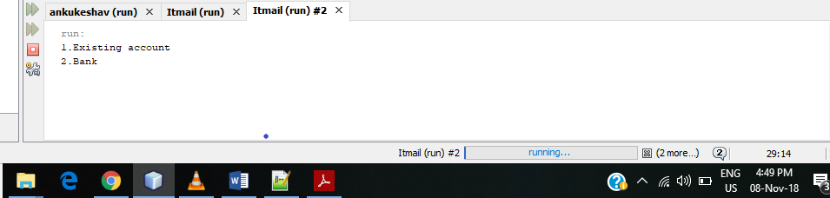

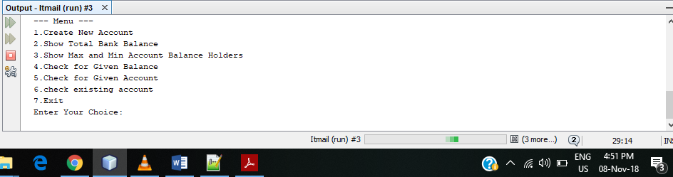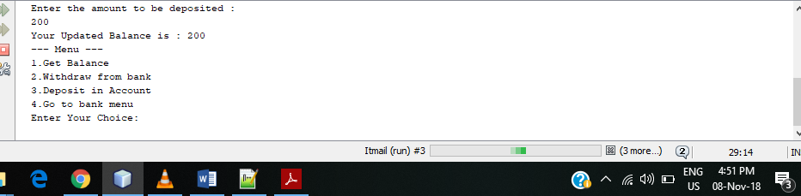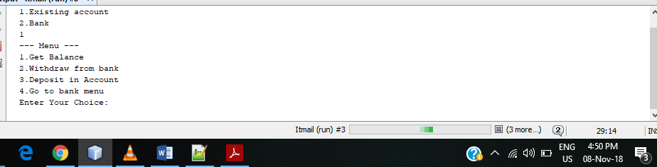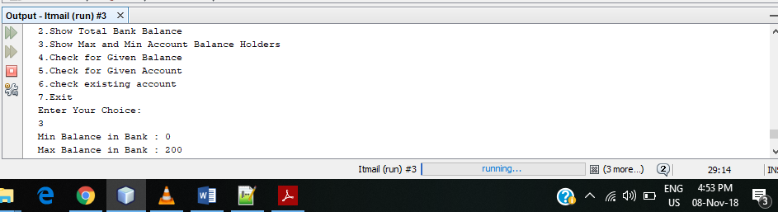

2. Implement an Abstract Class Stack with methods push, pop, display for two classes: StaticStack and DyanamicStack. StaticStack uses one dimensional integer array to store numbers and DyanamicStack uses an integer ArrayList to store.

Stack.java
abstract class Stack
{
int top;

Stack()
{
this.top = -1;
}

abstract void push(int paramInt);

abstract int pop();

abstract void display();
}

DynamicStack.java

import java.io.PrintStream;
import java.util.ArrayList;

class dynamicStack
extends Stack
{
ArrayList<Integer> arr;

dynamicStack()
{
this.arr = new ArrayList();
}

void push(int paramInt)
{
this.arr.add(++this.top, Integer.valueOf(paramInt));
}

int pop()
{
if (this.top == -1) {
return -1;
}
return ((Integer)this.arr.remove(this.top--)).intValue();
}

void display()
{
System.out.print("The Stack is : ");
for (int i = 0; i < this.arr.size(); i++) {
System.out.print(this.arr.get(i) + " ");
}
System.out.println();
}
}

StaticStack.java
/*
* To change this license header, choose License Headers in Project Properties.
* To change this template file, choose Tools | Templates
* and open the template in the editor.
*/

/**
*
* @author hhhty
*/

import java.io.PrintStream;

class staticStack
extends Stack
{
int[] arr;
int size;

staticStack(int paramInt)
{
this.size = paramInt;
this.arr = new int[this.size];
}

void push(int paramInt)
{
if (this.top == this.size - 1) {
System.out.println("overflow");
} else {
this.arr[(++this.top)] = paramInt;
}
}

int pop()
{
if (this.top == -1) {
return -1;
}
return this.arr[(this.top--)];
}

void display()
{
System.out.print("The Stack is : ");
for (int i = 0; i <= this.top; i++) {
System.out.print(this.arr[i] + " ");
}
System.out.println();
}
}

Main1.java
import java.io.PrintStream;
import java.util.Scanner;

class main1
{
public static void main(String[] paramArrayOfString)
{
Scanner localScanner = new Scanner(System.in);
System.out.println("Enter");
System.out.println("1.staticStack");
System.out.println("2.dynamicStack");
System.out.println("3.Exit");
int m = localScanner.nextInt();
switch (m)
{
case 1:
System.out.println("Enter array size");
int i3 = localScanner.nextInt();
staticStack localstaticStack = new staticStack(i3);
System.out.println("Enter");
System.out.println("1.Push");
System.out.println("2.Pop");
System.out.println("3.Display");
int i4;
do
{
System.out.println("Enter your choice");
int i = localScanner.nextInt();
switch (i)
{
case 1:
System.out.println("Enter a number to be pushed into the stack");
int j = localScanner.nextInt();
localstaticStack.push(j);
break;
case 2:
int k = localstaticStack.pop();
if (k == -1) {
System.out.println("Underflow");
} else {
System.out.println("Number popped =" + k);
}
break;
case 3:
localstaticStack.display();
}
System.out.println("Enter 0 if you want to continue");
i4 = localScanner.nextInt();
} while (i4 == 0);
break;
case 2:
dynamicStack localdynamicStack = new dynamicStack();
System.out.println("Enter");
System.out.println("1.Push");
System.out.println("2.Pop");
System.out.println("3.Display");
for (;;)
{
System.out.println("Enter your choice");
int n = localScanner.nextInt();
switch (n)
{
case 1:
System.out.println("Enter a number to be pushed into the stack");
int i1 = localScanner.nextInt();
localdynamicStack.push(i1);
break;
case 2:
int i2 = localdynamicStack.pop();
if (i2 == -1) {
System.out.println("Underflow");
} else {
System.out.println("Number popped =" + i2);
}
break;
case 3:
localdynamicStack.display();
}
System.out.println("Enter 0 if you want to continue");
int i5 = localScanner.nextInt();
if (i5 != 0) {
break;
}
}
}
}
}

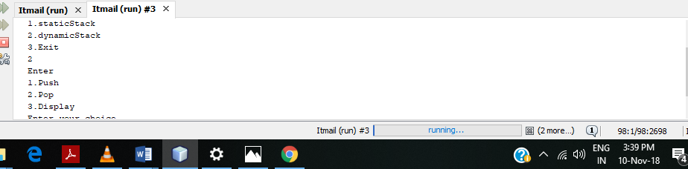
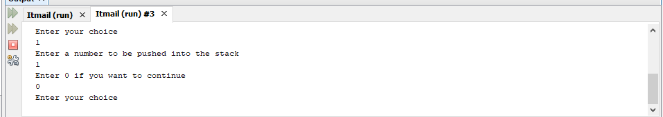

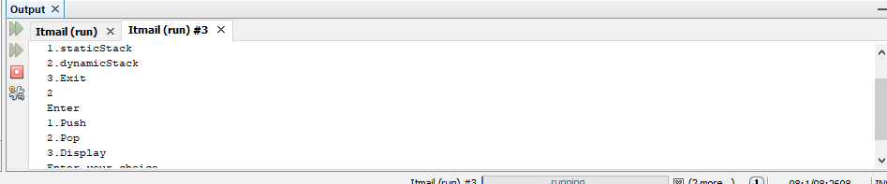

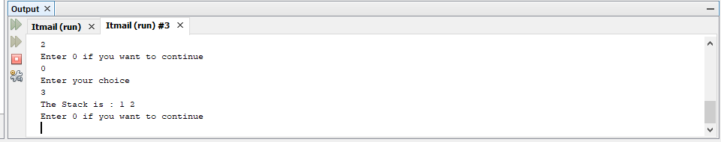

JavaBeans
1. Implement Student JavaBean using Serializability Interface.

Stu.java
package Account;
public class Stu {
public static void main (String args[]){
StudentBean s=new StudentBean();
s.setName("Ankurkeshav");
s.setRoll(7);
s.setCourse("CS");
System.out.println(s.getName());
System.out.println(s.getRoll());
System.out.println(s.getCourse());
}
}

StudentBean.java
package Account;
public class StudentBean implements java.io.Serializable {
String name;
int roll;
String course;
StudentBean(){}
public String getName()
{
return name;
}
public int getRoll()
{
return roll;

}
public String getCourse()
{
return course;
}
public void setName(String name){
this.name=name;
}
public void setCourse(String course){
this.course=course;
}
public void setRoll(int roll){
this.roll=roll;
}
}

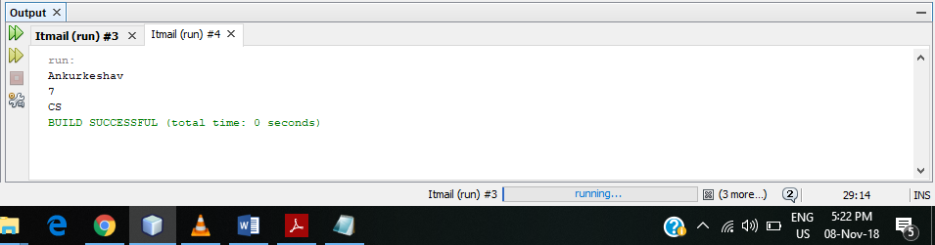

2. Implement Employee JavaBean using Serializability Interface.
EmployeeBean.java
public class EmployeeBean {
String name;
int id;
String dept;
EmployeeBean(){}
public String getName()
{
return name;
}
public int getId()
{
return id;

}
public String getDept()
{
return dept;
}
public void setName(String name){
this.name=name;
}
public void setDept(String dept){
this.dept=dept;
}
public void setId(int id){
this.id=id;
}

}

Em.java
package Account;

public class em {
public static void main (String args[]){
EmployeeBean s=new EmployeeBean();
s.setName("ankurkeshav");
s.setId(7);
s.setDept("CS");
System.out.println(s.getName());
System.out.println(s.getId());
System.out.println(s.getDept());
}

}
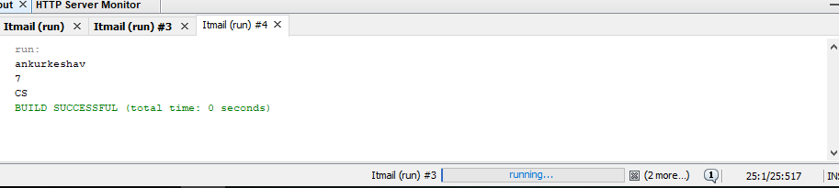

JDBC
1. Create Student and Results Database and perform the following using JDBC programs
a. Find total number of students
b. Print average marks for each subject input by user.
c. Find the name of student getting highest marks.
d. Find no of students getting first, second and third division.
e. Find subject wise toppers
f. Find the average marks
g. Find the student getting second highest marks.
Jdbc.java
package Account;

import java.io.BufferedReader;
import java.io.InputStreamReader;
import java.sql.DriverManager;
import java.sql.*;
import java.util.Scanner;
public static void main(String[] args) {
ResultSet rs;
try{
int c1=0;
int c2=0;
int c3=0;
int c4=0;
Class.forName("com.mysql.jdbc.Driver");
Connection con =DriverManager.getConnection("jdbc:mysql://localhost:3306/ak","root","12345");
Statement stmt= con.createStatement();
do{
System.out.println("MENU");
System.out.println("1.FIND TOTAL STUDENTS");
System.out.println("2.Each subject avergae marks");
System.out.println("3.STUDENT NAME WITH HIGHEST MARKS");
System.out.println("4.NO OF STUDENTS GETTING FIRST SECOND AND THIRD DIVISION");
System.out.println("5.SUBJECT WISE TOPEERS");
System.out.println("6.AVERGAE MARKS");
System.out.println("7.STUDENT GETTING SECOND HIGHEST MARKS");

int ch;
String sub;
BufferedReader br = new BufferedReader(new InputStreamReader(System.in));
Scanner sc = new Scanner(System.in);
ch=sc.nextInt();

switch(ch){
case 1: rs= stmt.executeQuery("select count(*) total from student");
rs.next();
int tota =rs.getInt("total");
System.out.println(tota);
break;
case 2:
System.out.println("Enter the subject");
sub=sc.next();
String sql="select AVG(marks) as abg from result where subject='"+sub+"'";
rs=stmt.executeQuery(sql);
rs.next();
int s=rs.getInt("abg");
System.out.println(s);
break;
case 3:
System.out.println("");
rs = stmt.executeQuery("Select max(marks),s.name as name from student s,result r where s.rollno=r.rollno");
rs.next();
String n=rs.getString("name");
System.out.println("The student with highest marks is "+" "+n);
break;
case 4:
rs=stmt.executeQuery("select rollno,(SUM(marks)/300)*100 AS 'DIV' from result GROUP BY rollno");
while(rs.next()){
if(rs.getInt("div")>90){
c1++;
}
else if(rs.getInt("div")<90&&rs.getInt("div")>60){
c2++;
}
else if(rs.getInt("div")<60&&rs.getInt("div")>33){
c3++;
}
else{
c4++;
}
}
System.out.println(+c1);
System.out.println(+c2);
System.out.println(+c3);
System.out.println(+c4);
break;

case 5:
rs=stmt.executeQuery("select s.name as 'name',r.subject as 'sub',max(r.marks) from student s,result r where r.rollno=s.rollno group by subject");
while(rs.next()){
System.out.println("max marks in "+rs.getString("sub")+"is of "+rs.getString("name"));

}
break;
case 6:
rs=stmt.executeQuery("select s.name as 'name',avg(r.marks) as 'avg' from student s, result r where s.rollno=r.rollno group by r.rollno");
while(rs.next()){
System.out.println("Average marks of "+rs.getString("name")+"are"+rs.getInt("avg"));
}

case 7:rs=stmt.executeQuery("SELECT S.NAME,SUM(R.MARKS)) AS 'TOTA' FROM STUDENT S RESULT R WHERE R.ROLLNO=S.ROLLNO GROUP BY R.ROLLNO ORDER BY TOTA ");
System.out.println(" second topeer"+rs.getString("name"));

break;
}

System.out.println("Do u want to continue y\n");
String s= br.readLine();
if(s.startsWith("n")){
System.exit(0);
}
} while(true);

}
catch(Exception e){
System.out.println(e);
// TODO code application logic here
}

}

}
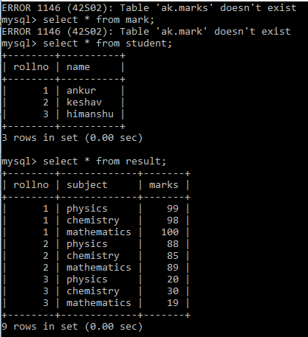

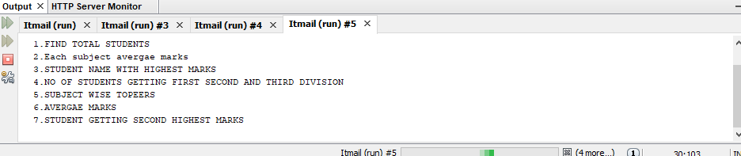

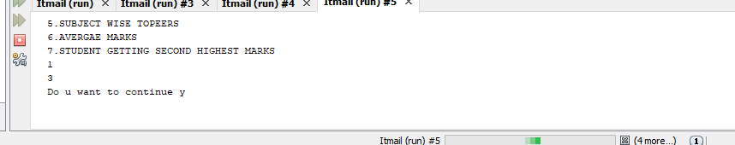

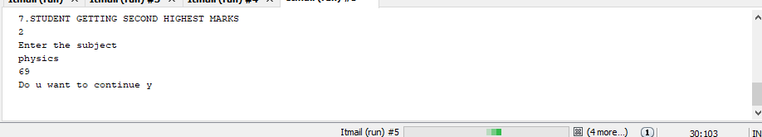

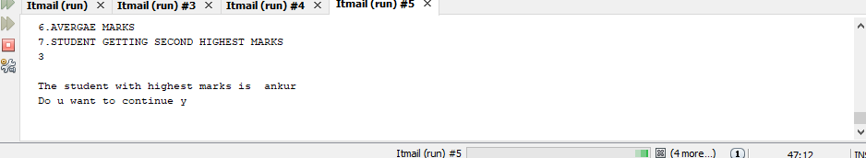

2. Create a procedure in MySQL to count the number of Rows in table 'Student'. Use CallableStatement to call this method from Java code.

Procedure.java

import java.sql.CallableStatement;
import java.sql.Connection;
import java.sql.DriverManager;
import java.sql.Statement;

public class procedure {

public static void main(String args[]){

try{
Class.forName("com.mysql.jdbc.Driver");
Connection con =DriverManager.getConnection("jdbc:mysql://localhost:3306/ak","root","keshav");
CallableStatement cstmt= con.prepareCall("{call gettotal(?)}");
cstmt.registerOutParameter(1,java.sql.Types.NUMERIC);
cstmt.execute();
int tot=cstmt.getInt(1);
System.out.println("total number of students "+" "+tot);
}

catch(Exception e){
System.out.println(e);
}
}
}

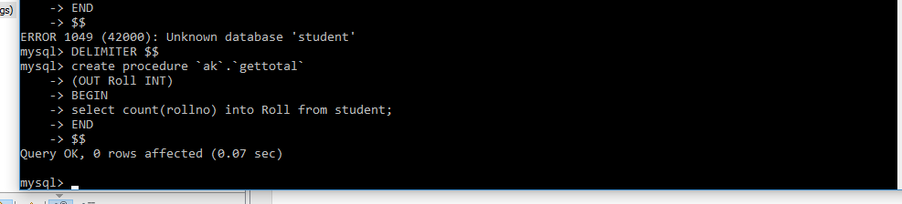

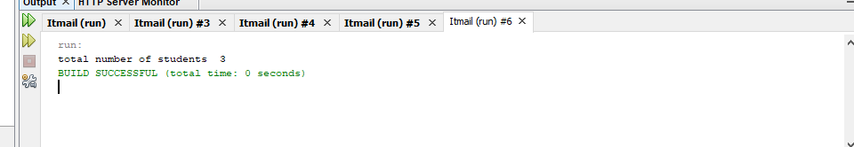

JavaScript
1. Create a student registration form. Create functions to perform the following checks:
a. Roll number is a 7 digit numeric value
b. Name should be an alphabetical value (String)
c. DOB entered in dd/mm/yy format and should be display in words (e.g. Saturday, January 01, 2000)
d. Check on non-empty fields

regex.html
<!DOCTYPE html>
<html>
<head>
<title>Regular expression</title>
<meta charset="UTF-8">
<meta name="viewport" content="width=device-width, initial-scale=1.0">
</head>
<body>
<div>
<form action="">
Name: <input type="text" id="name"/><br>
Roll no: <input type="number" id="roll"/><br>
DOB: <input type="date" id="dob"/><br>
<input type="button" value="Submit" onclick="validate()"/>
</form>
<p id="text"></p>
</div>
<script>
function validate(){
var name=document.getElementById("name").value;
var roll=document.getElementById("roll").value;
var dob=document.getElementById("dob").value;
var p=document.getElementById("text");
var regAlpha=/^[A-Za-z]{1,}$/;
var regNum=/^[0-9]{7}$/;
if(!name==""&&!roll==""&&!dob==""){
if(regAlpha.test(name)){
alert("Name Validated..!");
}
else{
alert("Name Not Validated..!");
}
if(regNum.test(roll)){
alert("Roll Validated..!");
}
else{
alert("Roll Not Validated..!");
}
p.innerHTML=new Date(dob);
}
else{
p.innerHTML="All fields are required";
}
}
</script>
</body>
</html>

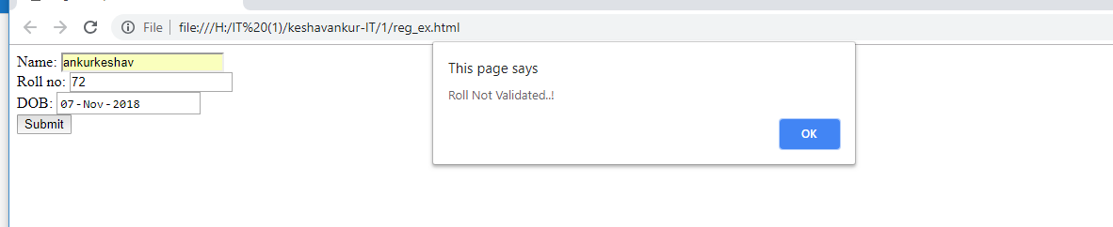
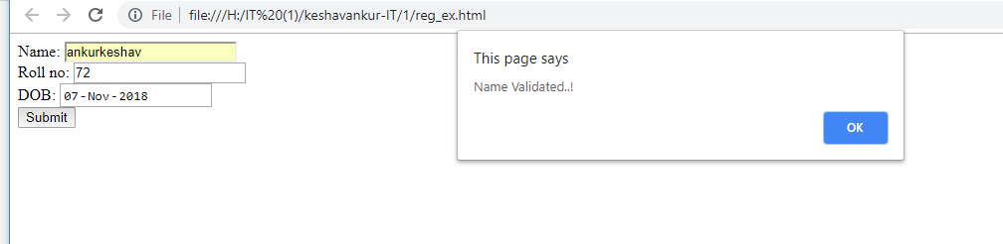

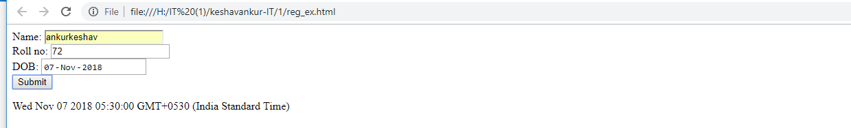

2. Implement a Static Password Protection.

Static_password_protection.html
<!DOCTYPE html>

<html>
<head>
<title>Check Password</title>
</head>
<body>
<form>
Name: <input type="text" id="1"/> </br>
Password: <input type="password" id="2"/> </br>
<input type="button" value="submit " onClick="check()"/>

</form>
<script>
function check()
{
var name="keshav";
var pass="ankur";
var name1=document.getElementById(1).value;
var pass2=document.getElementById(2).value;
if(name==name1 && pass==pass2)
{
alert("login successful");
}
else
alert("wrong credentials");
}
</script>

</body>
</html>

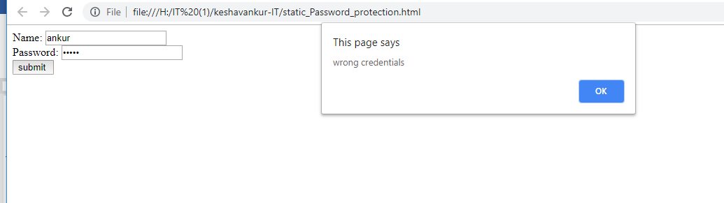

3. Write a java script to sort an array using bubble sort. Take the number of elements and array from user.

Bubblesort.html
<html>
<head>
<title>Bubble Sort</title>
</head>
<body>
<br>
Enter value:
<input type="text" id="enternum" onchange="copyval()" /><br><br><br>
<input type="button" id="push" value="SORT" onclick="sorting()"/>
<br><br>
<input type="text" id="dis" /><br>
<script type="text/javascript">
var arr=new Array();
function copyval(){
var string = document.getElementById("enternum").value;
arr = string.split(",");
document.getElementById("enternum").value="";
for(var i=0; i<arr.length; i++){
arr[i] = parseInt(arr[i] , 10);
}
disp();
}
function sorting(){
for(var i=0; i<arr.length-1; i++){
for(var j=0; j<arr.length-1-i; j++){
if(arr[j]>arr[j+1]){
var t=arr[j];
arr[j]=arr[j+1];
arr[j+1]=t;
}
}
}
disp();
}
function disp(){
var temp="";
for(var i=0; i<arr.length; i++){
temp+= arr[i]+" ";}
document.getElementById("dis").value=temp;
}
</script>
</body>
</html>

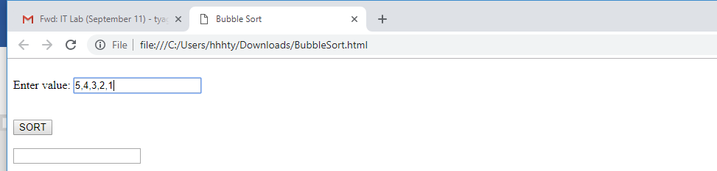
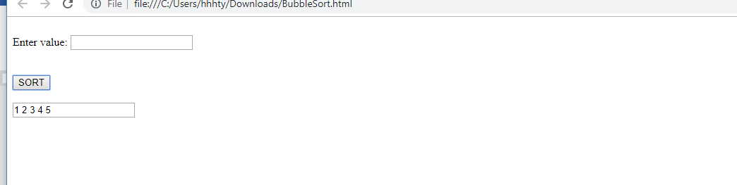
4. Write a JavaScript to implement stack methods (push and pop).

Stackprogm7.html
<html>
<head>
<script>
var arr=[];
function ab(){
var a=document.getElementById('one');
var b=document.getElementById('two');
arr.push(a.value);
b.value=arr;
a.value=" ";

}
function def(){
var len=arr.length;
if(len==0){
alert("no underflow");
}
else{
arr.pop(len);
var c=document.getElementById('two');
c.value=arr;

}
}
</script>
</head>
<body>
<form>
<h2>ENTER NUMBER :<input type="text" name="first" id="one" /></h2>
<h2>STACK: <input type="text" name="second" id="two"/></h2>
<h1><input type="button" value="push" onClick="ab()">
<input type="button" value="pop" onClick="def()"/>
</h1>
</form>
</body>
</html>

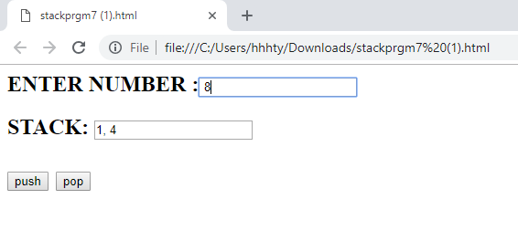
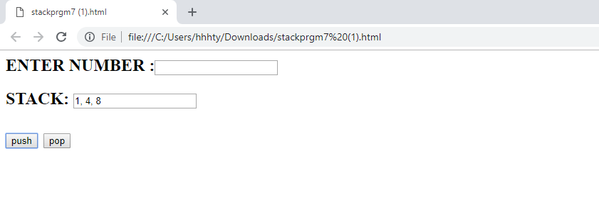

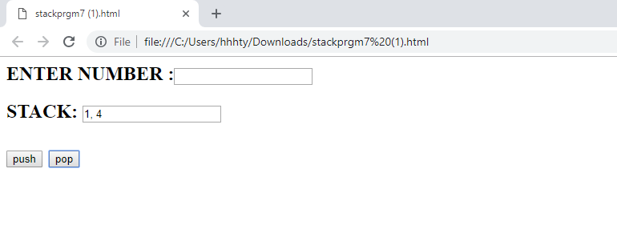
5. Write a JavaScript
a. to change the color of text using setTimeOut()
b. to move an image across screen using setInterval()

timeout.html
<!DOCTYPE html>
<html>
<head>
<title>Timeout</title>
<meta charset="UTF-8">
<meta name="viewport" content="width=device-width, initial-scale=1.0">

</head>
<body onLoad="f()">
<div>
<p id="text">Hello World</p>
</div>
<div>
<img src="H:\wallpapers\me.jpg" id="im" height="150" width="250"><br>
<button onclick="g()" id="b1">Move Image</button>
<button onclick="h()" id="b2">Stop Image</button>
</div>
<script>
var l=0;var w;
function f(){
setTimeout(()=>{
document.getElementById("text").style.color="red";
},3000);
}
function a(){
var img = document.getElementById("im");
img.style.position="relative";
img.style.left=(l)+"px";
l+=10;
//alert(l);
}
function g(){
w=setInterval("a()",500);
}
function h(){
clearInterval(w);
}
</script>
</body>
</html>
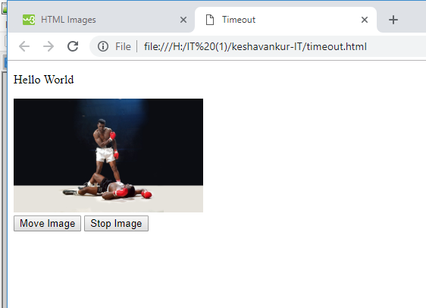
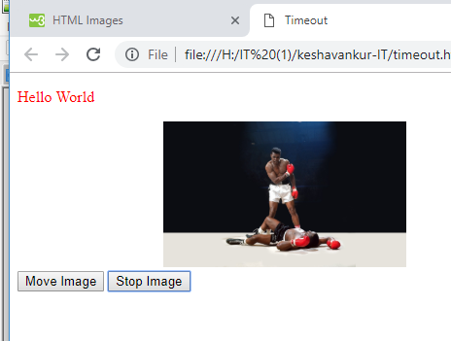

6. Create a form with fields name, mobile no, gender and and interests. No field should be empty
(i.e validate the form)
Form.html
<!DOCTYPE html>
<html>
<head>
<title>Form</title>
<meta charset="UTF-8">
<meta name="viewport" content="width=device-width, initial-scale=1.0">
</head>
<body>
<div>
<form name="form">
Name: <input type="text" id="name" name="Name"/><br><br>
Mobile: <input type="text" id="mob" name="Mobile"/><br><br>
Gender: Male<input type="radio" name="gender" value="male"/> Female<input type="radio" name="gender" value="female"/><br><br>
Interests: Cricket<input type="checkbox" id="crick" name="Interests"/> Football<input type="checkbox" name="Interests" id="foot"/> Tennis<input type="checkbox" name="Interests" id="tennis"/><br><br>
<input type="button" value="Submit" onclick="check()"/>
</form>
</div>
<script>
function validate() {
var a = 0, rdbtn=document.getElementsByName("gender");
for(i=0;i<rdbtn.length;i++) {
if(rdbtn.item(i).checked == false) {
a++;
}
}
if(a == rdbtn.length) {
alert("Gender field is empty");
}}
function validate1() {
var b = 0, chk=document.getElementsByName("Interests")
for(j=0;j<chk.length;j++) {
if(chk.item(j).checked == false) {
b++;
}
}
if(b == chk.length) {
alert("Interests field is empty");
}
}
function check(){
var id,id2,f=0;
for(var i=0;i<2;i++){
if(form.elements[i].value==""){
alert(form.elements[i].name+ " field is empty");
id=form.elements[i].id;
f=1;
break;

}
}
/* if(f==0){
for(var i=2;i<4;i++){
if(!form.elements[i].checked){
alert(form.elements[i].name+ " field is empty");
id2=form.elements[i].id;
break;
}
}
}*/validate();
validate1();
document.getElementById(id).focus();
// document.getElementById(id2).focus();
}
</script>
</body>
</html>

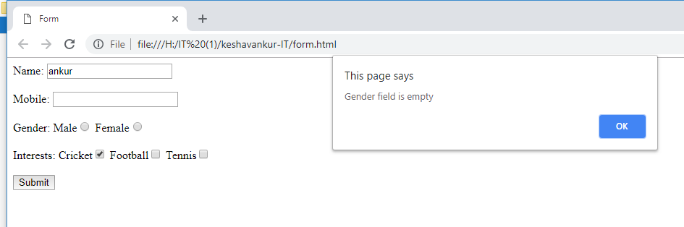

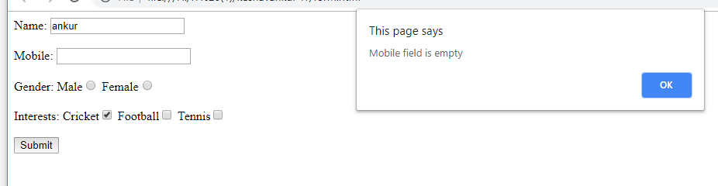

7. Create a program to display system time
Clock.html
<!DOCTYPE html>
<html>
<head>
<title>Clock</title>
<meta charset="UTF-8">
<meta name="viewport" content="width=device-width, initial-scale=1.0">
</head>
<body>
<div>
<p id="text"></p>
</div>
<script>
function f(){
var now=new Date();
var hours=now.getHours();
var min=now.getMinutes();
var sec=now.getSeconds();
document.getElementById('text').innerHTML=""+hours+":"+min+":"+sec;
}
setInterval("f()",1000);
</script>
</body>
</html>

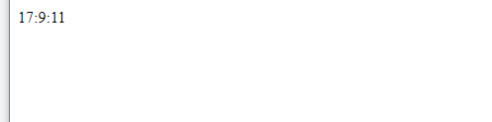

JSP
1. Display the pattern:
1
1 2
1 2 3
Take ‘n’ in a textbox from user. Display this pattern using
• Scriptlets
• <c:forEach> loop

Index.html
<form action="pattern.jsp" method="GET">
Number:<input type="text" name="name" >
<input type="submit" value="print">
</form>

Pattern.jsp
<%@page contentType="text/html" pageEncoding="UTF-8"%>
<!DOCTYPE html>
<html>
<head>
<title>Pattern</title>
</head>
<body>
<% int n=Integer.parseInt((request.getParameter("name")));
int i,j;
for(i=1;i<=n;i++)
{for(j=1;j<=i;j++)
out.print(j);
out.println("<br>");
}
%>
</body>
</html>
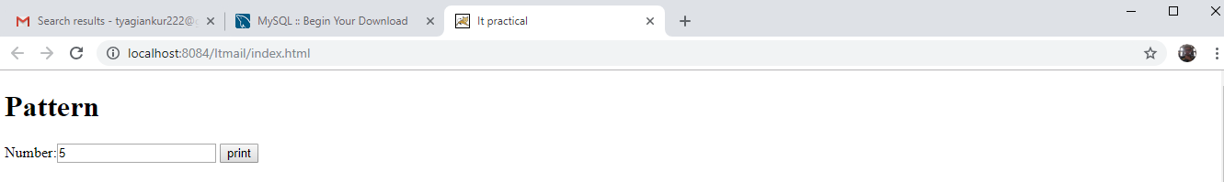

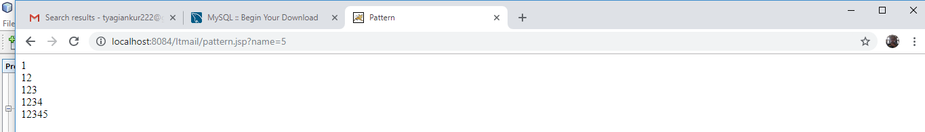

2. Make two files as follows:
a. main.html: shows 2 text boxes and 3 radio buttons with values "addition", "subtraction" and "multiplication"
b. operate.jsp: depending on what the user selects perform the corresponding function (Give two implementations: using request.getParameter() and using expression language)

index.html
<form action="operate2.jsp" method="get">
Number1:<input type="text" name="n1">
Number2:<input type="text" name="n2"><br>
<input type="radio" name="op" value="1">Addition
<input type="radio" name="op" value="2">Subtraction
<input type="radio" name="op" value="3">Multiplication
<input type="radio" name="op" value="4">Division<br>
<input type="submit" value="submit"> <br>
</form>

Operate2.jsp

<%@ taglib prefix="c" uri="http://java.sun.com/jsp/jstl/core" %>
<%@page contentType="text/html" pageEncoding="UTF-8"%>
<!DOCTYPE html>
<html>
<head>
<meta http-equiv="Content-Type" content="text/html; charset=UTF-8">
<title>JSP Page</title>
</head>
<body>
<c:set value="${param.n1}" var="num1"/>
<c:set value="${param.n2}" var="num2"/>
<c:set value="${param.op}" var="x"/>
<c:choose>
<c:when test="${x==1}">
<c:out value="${num1+num2}"/>
</c:when>
<c:when test="${x==2}">
<c:out value="${num1-num2}"/>
</c:when>
<c:when test="${x==3}">
<c:out value="${num1*num2}"/>
</c:when>
<c:when test="${x==4}">

<c:out value="${num1/num2}"/>

</c:when>

<c:otherwise>
<c:out value="Wrong choice"/>
</c:otherwise>

</c:choose>
</body>
</html>
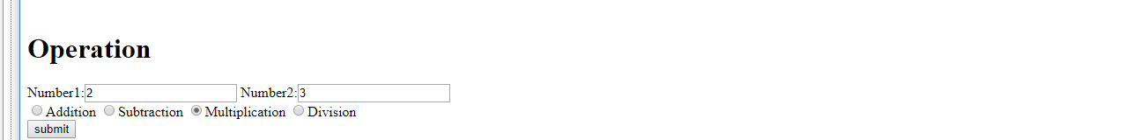

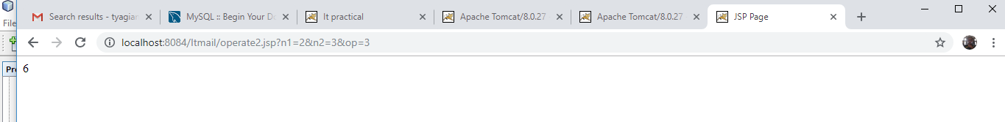

3. Validate User input entered in a form. The input must include Name, DOB, Email ID, Lucky Number, Favorite food etc. (Refer Chapter 8)
Pro3.jsp
<%@page contentType="text/html" pageEncoding="UTF-8"%>
<%@ taglib prefix="c" uri="http://java.sun.com/jsp/jstl/core" %>
<!DOCTYPE html>
<html>
<head>
<meta http-equiv="Content-Type" content="text/html; charset=UTF-8">
<title>pro3</</title>
</head>
<body bgcolor="white">
<form action="pro3.jsp" method="post">
<input type="hidden" name="submitted" value="true">
<table>
<c:if test="${param.submitted && empty param.userName}">
<tr><td></td>
<td colspan="2"><font color="red">
Please enter your Name
</font></td></tr>
</c:if>
<tr>
<td>Name:</td>
<td>
<input type="text" name="userName"
value="<c:out value="${param.userName}" />">
</td>
</tr>

<c:if test="${param.submitted && empty param.birthDate}">
<tr><td></td>
<td colspan="2"><font color="red">
Please enter your Birth Date
</font></td></tr>
</c:if>
<tr>
<td>Birth Date:</td>
<td>
<input type="text" name="birthDate"
value="<c:out value="${param.birthDate}" />">
</td>
<td>(Use format yyyy-mm-dd)</td>
</tr>
<c:if test="${param.submitted && empty param.emailAddr}">
<tr><td></td>
<td colspan="2"><font color="red">
Please enter your Email Address
</font></td></tr>

</c:if>
<tr>
<td>Email Address:</td>
<td>
<input type="text" name="emailAddr"
value="<c:out value="${param.emailAddr}" />">
</td>
<td>(Use format name@company.com)</td>
</tr>

<c:if test="${param.submitted &&
param.gender != 'm' && param.gender != 'f'}">
<tr><td></td>
<td colspan="2"><font color="red">
Please select a valid Gender
</font></td></tr>
</c:if>
<tr>
<td>Gender:</td>
<td>
<c:choose>
<c:when test="${param.gender == 'f'}">
<input type="radio" name="gender" value="m">
Male<br>
<input type="radio" name="gender" value="f" checked>
Female
</c:when>
<c:otherwise>
<input type="radio" name="gender" value="m" checked>
Male<br>
<input type="radio" name="gender" value="f">
Female
</c:otherwise>
</c:choose>
</td>
</tr>

<c:if test="${param.submitted &&
(param.luckyNumber < 1 || param.luckyNumber > 100)}">
<tr><td></td>
<td colspan="2"><font color="red">
Please enter a Lucky Number between 1 and 100
</font></td></tr>
</c:if>
<tr>
<td>Lucky number:</td>
<td>
<input type="text" name="luckyNumber"
value="<c:out value="${param.luckyNumber}" />">
</td>
<td>(A number between 1 and 100)</td>
</tr>

<c:forEach items="${paramValues.food}" var="current">
<c:choose>
<c:when test="${current == 'z'}">
<c:set var="pizzaSelected" value="true" />
</c:when>
<c:when test="${current == 'p'}">
<c:set var="pastaSelected" value="true" />
</c:when>
<c:when test="${current == 'c'}">
<c:set var="chineseSelected" value="true" />
</c:when>
<c:otherwise>
<c:set var="invalidSelection" value="true" />
</c:otherwise>
</c:choose>
</c:forEach>
<c:if test="${invalidSelection}">
<tr><td></td>
<td colspan="2"><font color="red">
Please select only valid Favorite Foods
</font></td></tr>
</c:if>
<tr>
<td>Favorite Foods:</td>
<td>
<input type="checkbox" name="food" value="z"
${pizzaSelected ? 'checked' : ''}>Pizza<br>
<input type="checkbox" name="food" value="p"
${pastaSelected ? 'checked' : ''}>Pasta<br>
<input type="checkbox" name="food" value="c"
${chineseSelected ? 'checked' : ''}>Chinese
</td>
</tr>
<tr>
<td colspan="3">
<input type="submit" value="Send Data">
</td>
</tr>
</table>
</form>
</body>
</html>

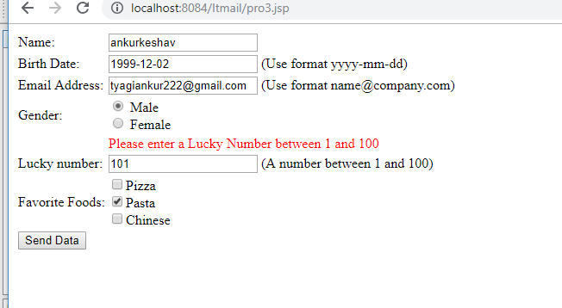

4. Display Good Morning <uname>, Good Afternoon <uname> or Good Evening <uname> based on the current time of the day.
Gret.tld
<?xml version="1.0" encoding="UTF-8"?>
<taglib version="2.1" xmlns="http://java.sun.com/xml/ns/javaee" xmlns:xsi="http://www.w3.org/2001/XMLSchema-instance" xsi:schemaLocation="http://java.sun.com/xml/ns/javaee http://java.sun.com/xml/ns/javaee/web-jsptaglibrary_2_1.xsd">
<tlib-version>1.0</tlib-version>
<short-name>greeta</short-name>
<uri>/WEB-INF/tlds/gret</uri>
<tag>
<name>today</name>
<tag-class>test.pro4</tag-class>
<body-content>scriptless</body-content>
<attribute>
<name>name1</name>
<required>true</required>
<rtexprvalue>true</rtexprvalue>
</attribute>
</tag>
</taglib>

Gr.jsp

<%@page contentType="text/html" pageEncoding="UTF-8"%>
<%@taglib prefix="c" uri="http://java.sun.com/jsp/jstl/core" %>
<%@taglib prefix="k" uri="WEB-INF/tlds/gret.tld"%>
<!DOCTYPE html>
<html>
<k:today name1="${param.name2}"></k:today>
</html>

Pro4.java
package test;
import javax.servlet.jsp.tagext.*;
import javax.servlet.jsp.*;
import java.io.*;
import java.util.*;
public class pro4 extends SimpleTagSupport
{
String name1;
public void setName1(String name1){
this.name1 = name1;
}
int hr, min, sec;
public void doTag() throws JspException, IOException

{
JspWriter out = getJspContext().getOut();

out.print("Time : ");
hr = Calendar.getInstance().get(Calendar.HOUR_OF_DAY);
min = Calendar.getInstance().get(Calendar.MINUTE);
sec = Calendar.getInstance().get(Calendar.SECOND);
out.print(hr+"hr-");
out.print(min+"min-");
out.print(sec+"sec<br>");
if(hr>=5 && hr<= 11 )
{
out.println(name1+"Good Morning ");
}
else if(hr>=12 && hr<= 4)
{
out.println(name1+"Good Afternoon ");
}
else
{
out.println(name1+" Good Evening ");
}
}

}

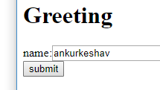

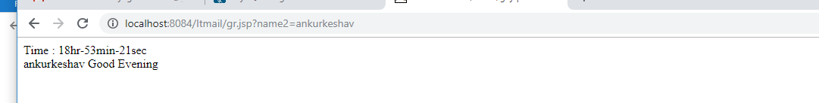

5. Let the user enter a word a in a textbox and let her/him select one of even or odd radio buttons. If she/he selects odd, check the odd positions in the word entered, if they all contain vowels, then display the message ‘You win’, else display ‘You lose’. Similarly, if the user selects even, check for vowels in all even positions in the word entered. Use jstl’s ‘fn’ library.

Index.html
<form action="pro5.jsp" method="post">
Input: <input type="text" name="vowel">S<br>
Choose from:<br>
Odd: <input type="radio" name="evod" value="odd"><br>
Even: <input type="radio" name="evod" value="even"><br>
<input type="submit" value="submit"><br>
</form>

Pro5.jsp
<%@page contentType="text/html" pageEncoding="UTF-8"%>
<%@taglib prefix="c" uri="http://java.sun.com/jsp/jstl/core" %>
<%@taglib prefix="fn" uri="http://java.sun.com/jsp/jstl/functions" %>
<%@taglib prefix="all" uri="/WEB-INF/tlds/custom.tld" %>
<!DOCTYPE html>
<html>
<head>
<meta http-equiv="Content-Type" content="text/html; charset=UTF-8">
<title>Game</title>
</head>
<body>
<c:set var="a" value="${param.vowel}"/>
<c:set var="b" value="${param.evod}"/>
<c:set var="c" value="${fn:split(a , '')}"/>

<c:choose>
<c:when test="${b=='odd'}">
<c:forEach begin="1" end="${c}" var="k" step="2">
<c:if test="${c[k]=='a'|| c[k]=='e'|| c[k]=='i'|| c[k]=='o'|| c[k]=='u'}">

</c:if>

</c:forEach>
<c:otherwise></c:otherwise>
</c:choose>
</body>
</html>
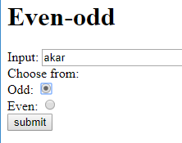

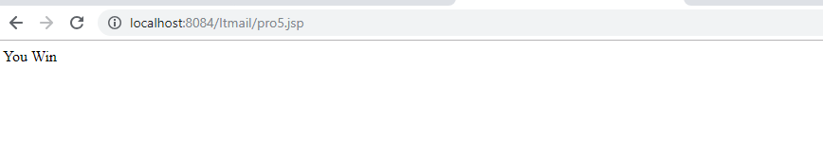
6. Create your custom library which contains two tags: <hello>, <choco>.
Usage of the tags:
• <hello name=”Ajay”>: Output should be Hello Ajay. It contains a mandatory attribute ‘name’ which can accept Dynamic value.
• <choco texture=”Chewy”>: Output should be FiveStar, BarOne.
<choco texture=”Crunchy”>: Output should be Munch. KitKat.
That means the mandatory attribute must accept a value, and based on the attributes value, it should give output. You must use a bean ChocoBean for this purpose.
Index.html
<form action="pro6.jsp" method="post">
Your Name: <input type="text" name="name"/><br><br>
Chocolate Type: <input type="text" name="choc"/><br><br>
<input type="submit" value="Submit"/>
</form>

Pro6.jsp
<%@page contentType="text/html" pageEncoding="UTF-8"%>
<%@taglib prefix="all" uri="/WEB-INF/tlds/custom" %>
<!DOCTYPE html>
<html>
<head>
<meta http-equiv="Content-Type" content="text/html; charset=UTF-8">
<title>JSP Page</title>
</head>
<body>
<all:hello name="${param.name}"/><br><br>
<all:choco texture="${param.choc}"/>

</body>
</html>

Custom.tld

<?xml version="1.0" encoding="UTF-8"?>
<taglib version="2.1" xmlns="http://java.sun.com/xml/ns/javaee" xmlns:xsi="http://www.w3.org/2001/XMLSchema-instance" xsi:schemaLocation="http://java.sun.com/xml/ns/javaee http://java.sun.com/xml/ns/javaee/web-jsptaglibrary_2_1.xsd">
<tlib-version>1.0</tlib-version>
<short-name>custom</short-name>
<uri>/WEB-INF/tlds/custom</uri>
<tag>
<name>choco</name>
<tag-class>test.pro6</tag-class>
<body-content>empty</body-content>
<attribute>
<name>texture</name>
<required>true</required>
<rtexprvalue>true</rtexprvalue>
</attribute>
</tag>
<tag>
<name>hello</name>
<tag-class>test.pro61</tag-class>
<body-content>empty</body-content>
<attribute>
<name>name</name>
<required>true</required>
<rtexprvalue>true</rtexprvalue>
</attribute>
</tag>
</tag-lib>

Pro61.java
package test;
import javax.servlet.jsp.tagext.*;
import javax.servlet.jsp.*;
import java.io.*;
import java.util.*;

public class pro61 extends SimpleTagSupport{
String name;

public void setName(String name){
this.name=name;
}

public void doTag() throws IOException{
JspWriter out = getJspContext().getOut();;
out.println("Hello "+ name);
}
}

Pro6.java
package test;
import javax.servlet.jsp.tagext.*;
import javax.servlet.jsp.*;
import java.io.*;
import java.util.*;

public class pro61 extends SimpleTagSupport{
String name;

public void setName(String name){
this.name=name;
}

public void doTag() throws IOException{
JspWriter out = getJspContext().getOut();;
out.println("Hello "+ name);
}
}

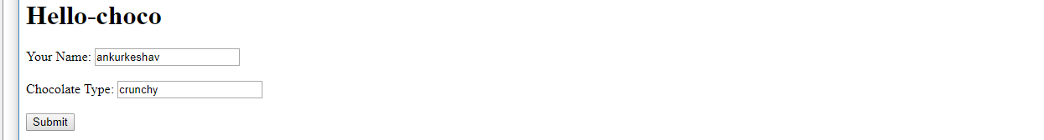

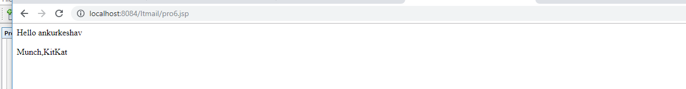

7. Create a custom tag “substring” with 3 mandatory attributes “input”, “start”, “end” which will do substring operation on given input
Index.html
<form action="pro7.jsp" method="post">
Input: <input type="text" name="input"/><br><br>
Start: <input type="text" name="start"/><br><br>
End: <input type="text" name="end"/><br><br>
<input type="submit" value="Submit"/>
</form>

Pro7.jsp

<%@page contentType="text/html" pageEncoding="UTF-8"%>
<%@taglib prefix="all" uri="/WEB-INF/tlds/pr7"%>
<!DOCTYPE html>
<html>
<head>
<meta http-equiv="Content-Type" content="text/html; charset=UTF-8">
<title>SubString Operation</title>
</head>
<body>
<all:substring end="${param.end}" input="${param.input}" start="${param.start}"></all:substring>
</body>
</html>

Pro7.java
package test;
import javax.servlet.jsp.tagext.*;
import javax.servlet.jsp.*;
import java.io.*;
import java.util.*;
public class pro7 extends SimpleTagSupport{
String input;
int start,end;
public void setInput(String input){
this.input=input;
}

public void setStart(int start){
this.start=start;
}

public void setEnd(int end){
this.end=end;
}

public void doTag() throws IOException{
JspWriter out = getJspContext().getOut();
if(start>=0 && end<input.length()){
for(int i=start;i<=end;i++){
out.print(input.charAt(i));
}
}
else out.println("Invalid start or end");
}
}

Pro7.tld
<?xml version="1.0" encoding="UTF-8"?>
<taglib version="2.1" xmlns="http://java.sun.com/xml/ns/javaee" xmlns:xsi="http://www.w3.org/2001/XMLSchema-instance" xsi:schemaLocation="http://java.sun.com/xml/ns/javaee http://java.sun.com/xml/ns/javaee/web-jsptaglibrary_2_1.xsd">
<tlib-version>1.0</tlib-version>
<short-name>pr7</short-name>
<uri>/WEB-INF/tlds/pr7</uri>

<tag>
<name>substring</name>
<tag-class>test.pro7</tag-class>
<body-content>scriptless</body-content>
<attribute>
<name>end</name>
<required>true</required>
<rtexprvalue>true</rtexprvalue>
</attribute>
<attribute>
<name>input</name>
<required>true</required>
<rtexprvalue>true</rtexprvalue>
</attribute>
<attribute>
<name>start</name>
<required>true</required>
<rtexprvalue>true</rtexprvalue>
</attribute>

</tag>
</taglib>
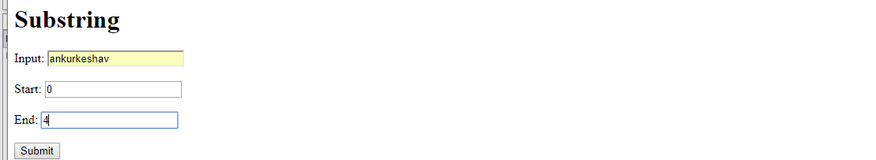

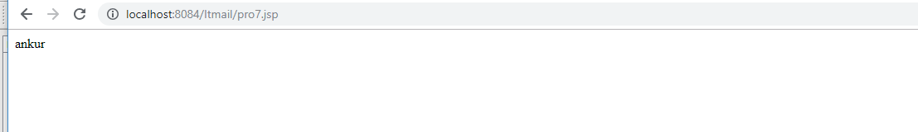

8. Create a custom tag “reverse” with a mandatory attribute “input” to reverse a string.
Index.html
<form action="pro8.jsp" method="post">
Input: <input type="text" name="input"/><br><br>
<input type="submit" value="submit"/>
</form>

Custom.tld
<?xml version="1.0" encoding="UTF-8"?>
<taglib version="2.1" xmlns="http://java.sun.com/xml/ns/javaee" xmlns:xsi="http://www.w3.org/2001/XMLSchema-instance" xsi:schemaLocation="http://java.sun.com/xml/ns/javaee http://java.sun.com/xml/ns/javaee/web-jsptaglibrary_2_1.xsd">
<tlib-version>1.0</tlib-version>
<short-name>custom</short-name>
<uri>/WEB-INF/tlds/custom</uri>
<tag>
<name>reverse</name>
<tag-class>test.pro8</tag-class>
<body-content>empty</body-content>
<attribute>
<name>input</name>
<required>true</required>
<rtexprvalue>true</rtexprvalue>
</attribute>
</tag>
</taglib>

Pro8.jsp
<%@page contentType="text/html" pageEncoding="UTF-8"%>
<%@taglib prefix="all" uri="/WEB-INF/tlds/custom"%>
<!DOCTYPE html>
<html>
<head>
<meta http-equiv="Content-Type" content="text/html; charset=UTF-8">
<title>Reverse</title>
</head>
<body>
<all:reverse input="${param.input}"/>
</body>
</html>

Pro8.java
package test;
import javax.servlet.jsp.tagext.*;
import javax.servlet.jsp.*;
import java.io.*;
import java.util.*;
public class pro8 extends SimpleTagSupport {

String input;

public void setInput(String input){
this.input=input;
}

public void doTag() throws IOException{
JspWriter out = getJspContext().getOut();
for(int i=input.length()-1;i>=0;i--){
out.print(input.charAt(i));
}
}
}

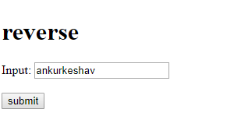
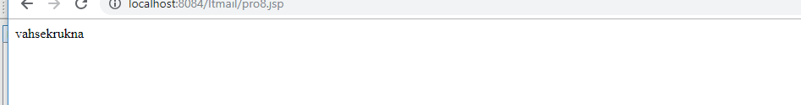

9. Create a custom tag "today" that displays today's date and time
Datetime.jsp
<%@page contentType="text/html" pageEncoding="UTF-8"%>
<%@taglib prefix="x" uri="WEB-INF/tlds/newtag_library.tld" %>
<!DOCTYPE html>

<html>

<x:xyz></x:xyz>
</html>

Newtag_library.tld
<?xml version="1.0" encoding="UTF-8"?>
<taglib version="2.1" xmlns="http://java.sun.com/xml/ns/javaee" xmlns:xsi="http://www.w3.org/2001/XMLSchema-instance" xsi:schemaLocation="http://java.sun.com/xml/ns/javaee http://java.sun.com/xml/ns/javaee/web-jsptaglibrary_2_1.xsd">
<tlib-version>1.0</tlib-version>
<short-name>newtag_library</short-name>
<uri>/WEB-INF/tlds/newtag_library</uri>
<tag>
<name>xyz</name>
<tag-class>test.dtime</tag-class>
<body-content>empty</body-content>
</tag>
</taglib>

Dtime.java
package test;
import javax.servlet.jsp.tagext.*;
import javax.servlet.jsp.*;
import java.io.*;
import java.util.*;
public class dtime extends SimpleTagSupport
{
public void doTag() throws JspException, IOException
{
JspWriter out = getJspContext().getOut();
try{
out.print("Date : ");
out.print(Calendar.getInstance().get(Calendar.DAY_OF_MONTH)+"/");
out.print(Calendar.getInstance().get(Calendar.MONTH)+"/");
out.print(Calendar.getInstance().get(Calendar.YEAR)+"<br>");
out.print("Time : ");
out.print(Calendar.getInstance().get(Calendar.HOUR_OF_DAY)+"hr-");
out.print(Calendar.getInstance().get(Calendar.MINUTE)+"min-");
out.print(Calendar.getInstance().get(Calendar.SECOND)+"sec");
}
catch(Exception e)
{
System.out.println(e);
}
}
}

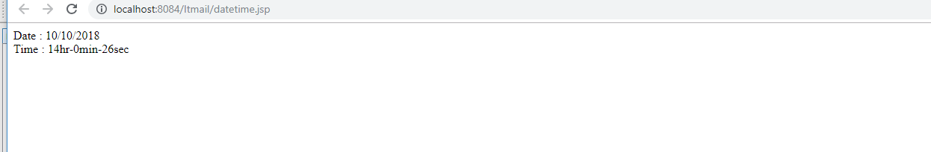

10. Ask a user's name and age on a HTML form. Then display Hello <uname> on a JSP. On the same page ask the product the user would like to buy. Then redirect to another JSP which would display: Hello <uname>, You have ordered <product>. (Use Session Scope Variable using setTag)
Index.html
<form action="pro10.jsp" method="get">
ENTER NAME:<input type="text" name="name"/><br>
ENTER AGE:<input type="text" name="age"/><br>
<input type="submit"/>
</form>
Pro10.jsp

<%@page contentType="text/html" pageEncoding="UTF-8"%>

<%@taglib prefix="c" uri="http://java.sun.com/jsp/jstl/core"%>
<!DOCTYPE html>

<html>
<head>
<meta http-equiv="Content-Type" content="text/html; charset=UTF-8">
<title>JSP Page</title>
</head>
<body>
<c:set var="name" value="${param.name}" scope="session"/>
<c:out value="HELLO ${name}"/>
<form action="pro101.jsp" method="get">
WHAT YOU WANNA BUY: <input type="text" name="prod"/><br>
<input type="submit"/>
</form>
</body>
</html>

Pro101.jsp
<%@page contentType="text/html" pageEncoding="UTF-8"%>
<%@taglib prefix="c" uri="http://java.sun.com/jsp/jstl/core"%>
<!DOCTYPE html>
<html>
<head>
<meta http-equiv="Content-Type" content="text/html; charset=UTF-8">
<title>JSP Page</title>
</head>
<body>
<c:set var="item" value="${param.prod}"/>
<c:out value="HELLO ${name} you have ordered ${item}"/>
</body>
</html>

