1. **Initialize a Local Git Repository**
2. **Stage and Commit File**

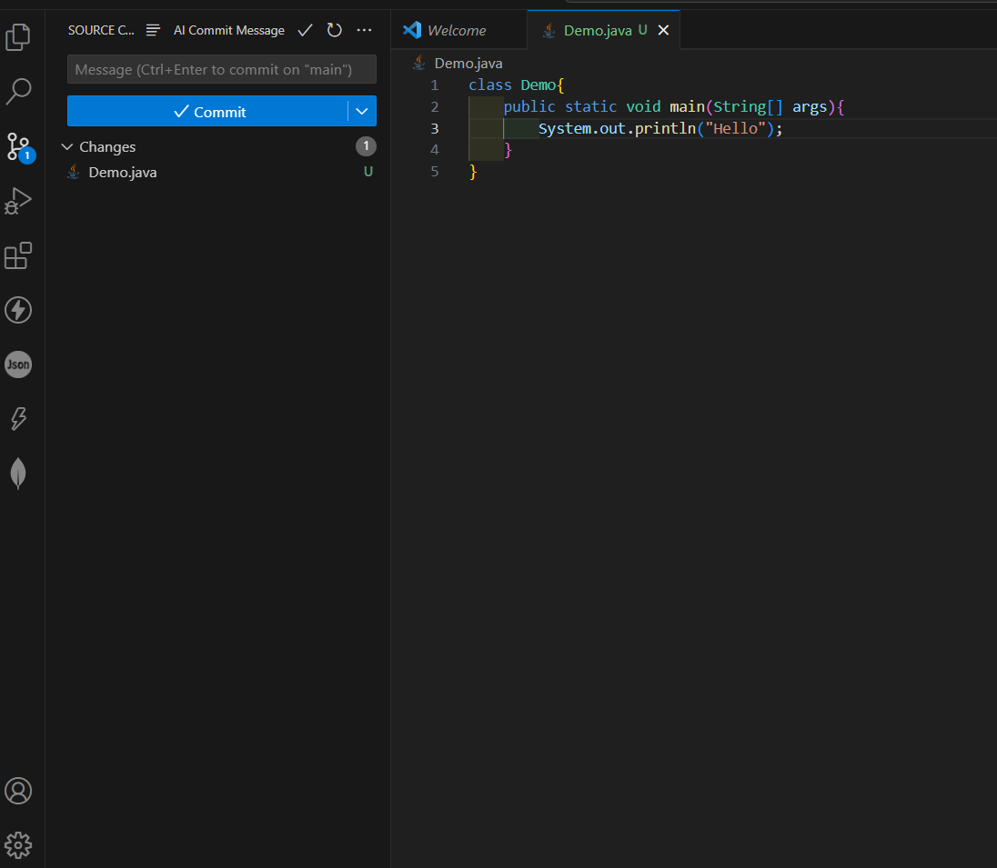

1. **Create Remote Repository on GitHub**



1. **Link local Repo to Github**

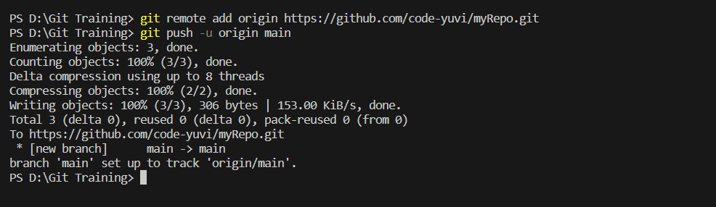

1. **Code Successfully Push to Github**

