1. Create a Simple Spring Project from Spring Initilizer

1. Create a GitHub Repository

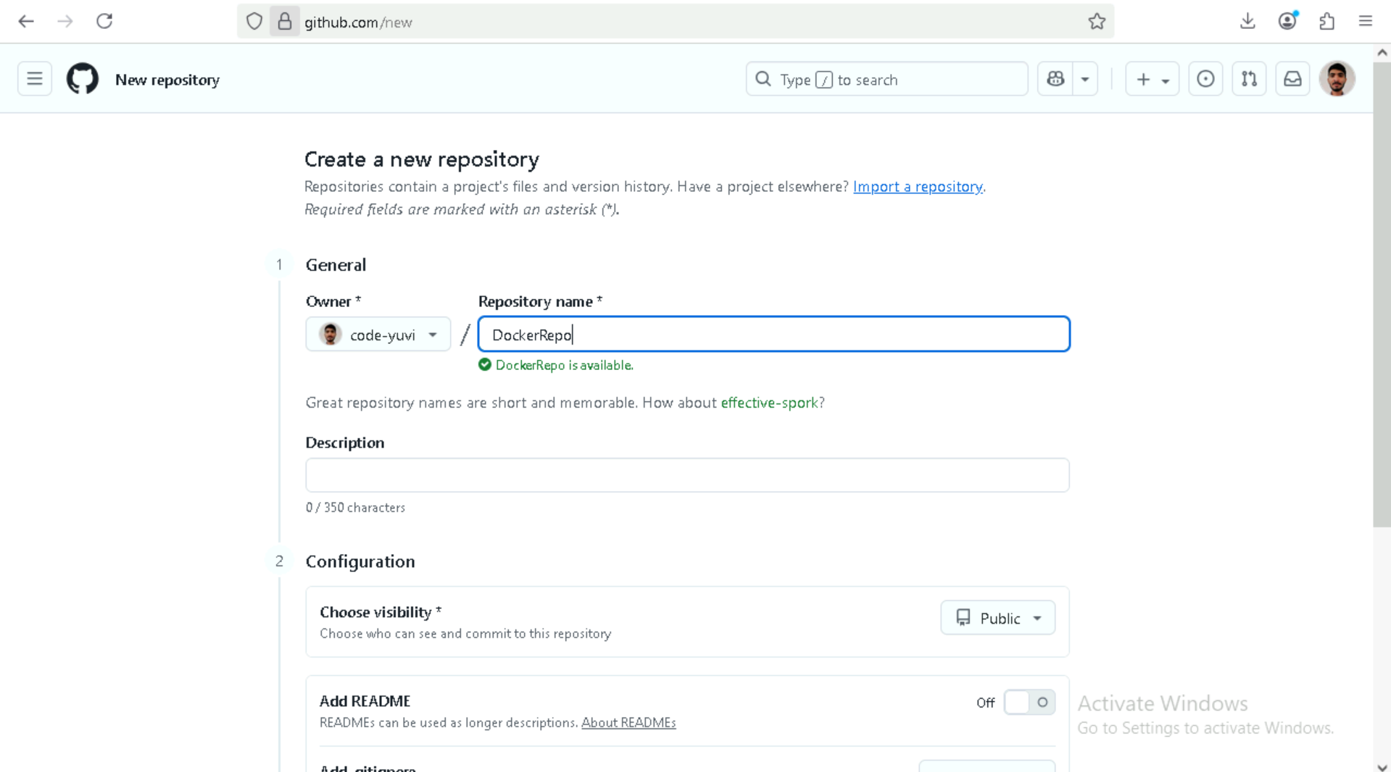

1. Push the project to git repo

1. Project repo

1. Create a Pipeline on Jenkins through git

1. Build the project

1. Create a Dockefile to track the project through docker

1. Do maven install to create jar file in target

1. Build the Dockerfile to create Image

1. Check Image

1. Create a Container from docker Image

1. Image uploaded to docker hub

