**## Insert Documents**

Insert the following documents into a `movies` collection.

**db.movies.insertMany**([{"title ": "Fight Club",

"writer" : "Chuck Palahniuk",

"year" : 1999,

"actors" : [

"Brad Pitt",

"Edward Norton"

]},

{"title":"Pulp Fiction",

"writer" : "Quentin Tarantino",

"year" : 1994,

"actors" : [

"John Travolta",

"Uma Thurman"

]},

{

"title" : "Inglorious Basterds",

"writer" : "Quentin Tarantino",

"year" : 2009,

"actors" : [

"Brad Pitt",

"Diane Kruger",

"Eli Roth"

]

},

{

"title" : "The Hobbit: An Unexpected Journey",

"writer" : "J.R.R. Tolkein",

"year ": 2012,

"franchise" : "The Hobbit"

},

{

"title": "The Hobbit: The Desolation of Smaug",

"writer" : "J.R.R. Tolkein",

"year": 2013,

"franchise" : "The Hobbit"

},

{

"title" : "The Hobbit: The Battle of the Five Armies",

"writer" : "J.R.R. Tolkein",

"year": 2012,

"franchise" : "The Hobbit",

"synopsis ": "Bilbo and Company are forced to engage in a war against an array of combatants and keep the Lonely Mountain from falling into the hands of a rising darkness."

},

{

"title" : "Pee Wee Herman's Big Adventure"

},

{

"title" : "Avatar"

}

])

## Query / Find Documents

query the `movies` collection to

**get all documents:-** db.movies.find().pretty()

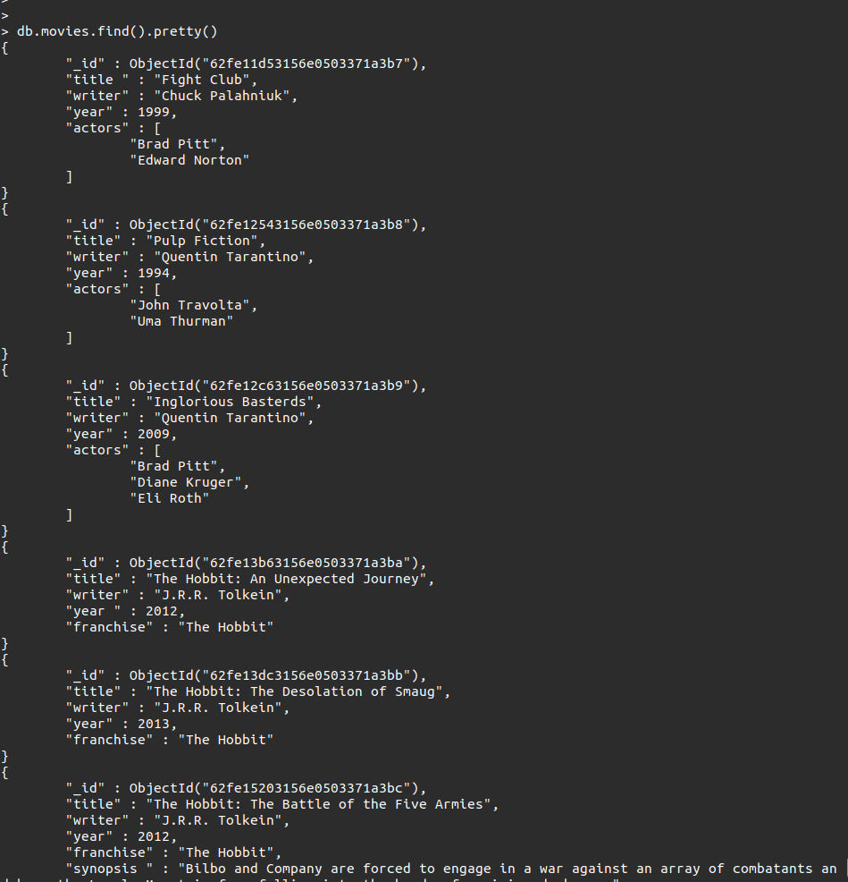

**get all documents with `writer` set to "Quentin Tarantino":-** db.movies.find({“writer”:”Quentin Tarantino”})

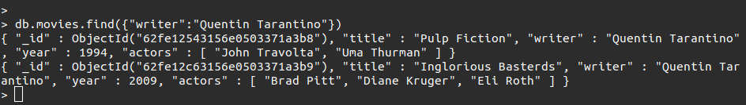

**get all documents where `actors` include "Brad Pitt":-** db.movies.find({“actors”:”Brad Pitt”})

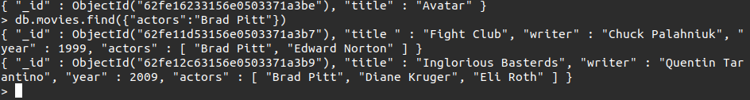

**get all documents with `franchise` set to "The Hobbit:-** db.movies.find({"franchise":"The Hobbit"})



**get all movies released in the 90s:-**

db.movies.find({"year":{$gte:1990}})

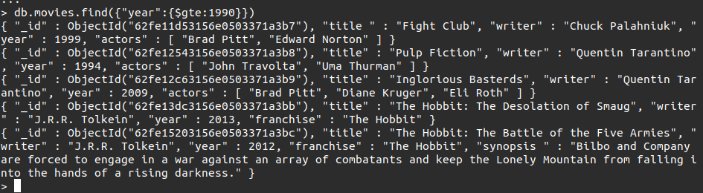

**get all movies released before the year 2000 or after 2010**

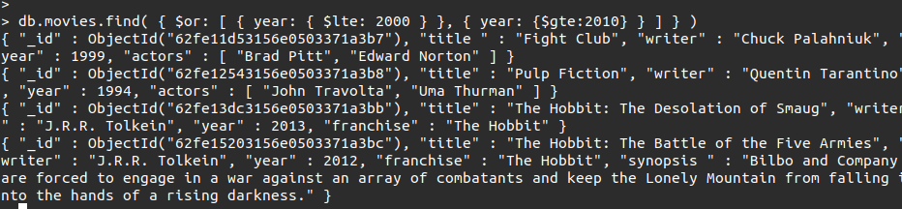

**## Update Documents**

**add a synopsis to "The Hobbit: An Unexpected Journey" : "A reluctant hobbit, Bilbo Baggins, sets out to the Lonely Mountain with a spirited group of dwarves to reclaim their mountain home - and the gold within it - from the dragon Smaug."**

db.movies.update({"title":"The Hobbit: An Unexpected Journey"},{$set:{"synopsis":"A reluctant hobbit, Bilbo Baggins, sets out to the Lonely Mountain with a spirited group of dwarves to reclaim their mountain home - and the gold within it - from the dragon Smaug."}})

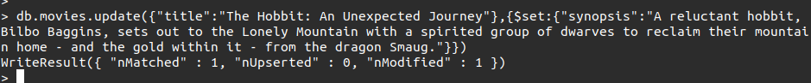

**add a synopsis to "The Hobbit: The Desolation of Smaug" : "The dwarves, along with Bilbo Baggins and Gandalf the Grey, continue their quest to reclaim Erebor, their homeland, from Smaug. Bilbo Baggins is in possession of a mysterious and magical ring."**

db.movies.update({"title":"The Hobbit: The Desolation of Smaug"},{$set:{"synopsis":"The dwarves, along with Bilbo Baggins and Gandalf the Grey, continue their quest to reclaim Erebor, their homeland, from Smaug. Bilbo Baggins is in possession of a mysterious and magical ring."}})



**add an actor named "Samuel L. Jackson" to the movie "Pulp Fiction"**

db.movies.updateOne({"title":"Pulp Fiction"},{$set:{"actors":"Samuel L."}})



**## Text Search**

**To perform text search queries, you must have a text index on your collection.**

**db.movies.createIndex({synopsis:"text"})**

**find all movies that have a synopsis that contains the word "Bilbo"**

db.movies.find({$text:{$search:"Bilbo"}})

Also

db.movies.find({synopsis:{$regex:"Bilbo"}})

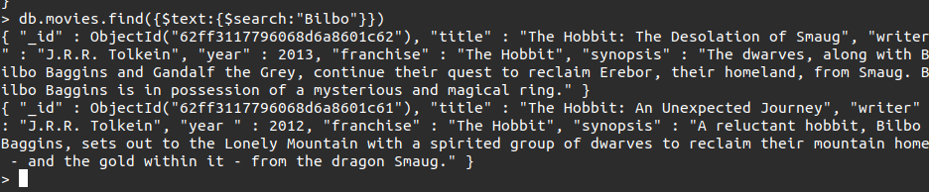

**find all movies that have a synopsis that contains the word "Gandalf"**

db.movies.find({$text:{$search:"Gandalf"}})

Also

db.movies.find({synopsis:{$regex:"Gandalf"}})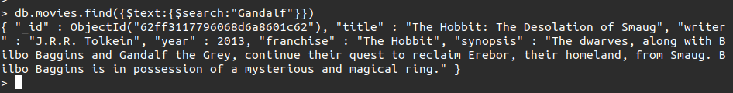

**find all movies that have a synopsis that contains the word "Bilbo" and not the word "Gandalf"**

db.movies.find({$and:[{synopsis:{$regex:"Bilbo"}},{sysnopsis:{$not:/Gandalf/}}]})

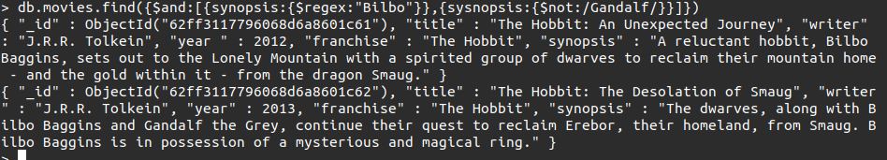

**find all movies that have a synopsis that contains the word "dwarves" or "hobbit"**

db.movies.find({$or:[{"synopsis":{$regex:"dwarves"}},{"synopsis":{$regex:"hobbit"}}]})

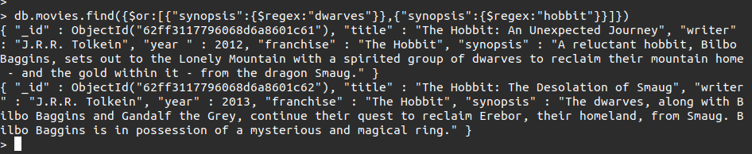

**find all movies that have a synopsis that contains the word "gold" and "dragon"**

db.movies.find({$and:[{"synopsis":{$regex:"gold"}},{"synopsis":{$regex:"hobbit"}}]})

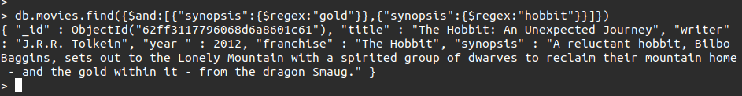

**## Delete Documents**

**delete the movie "Pee Wee Herman's Big Adventure"**

db.movies.deleteOne({"title":"Pee Wee Herman's Big Adventure"})



**1. delete the movie "Avatar"**

db.movies.deleteOne({"title":"Avatar"}

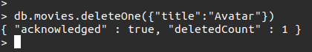

**## Relationships**

### Insert the following documents into a `users` collection

```

username : GoodGuyGreg

first_name : "Good Guy"

last_name : "Greg"

```

```

username : ScumbagSteve

full_name :

first : "Scumbag"

last : "Steve"

```

### Insert the following documents into a `posts` collection

```

username : GoodGuyGreg

title : Passes out at party

body : Wakes up early and cleans house

```

```

username : GoodGuyGreg

title : Steals your identity

body : Raises your credit score

```

```

username : GoodGuyGreg

title : Reports a bug in your code

body : Sends you a Pull Request

```

```

username : ScumbagSteve

title : Borrows something

body : Sells it

```

```

username : ScumbagSteve

title : Borrows everything

body : The end

```

```

username : ScumbagSteve

title : Forks your repo on github

body : Sets to private

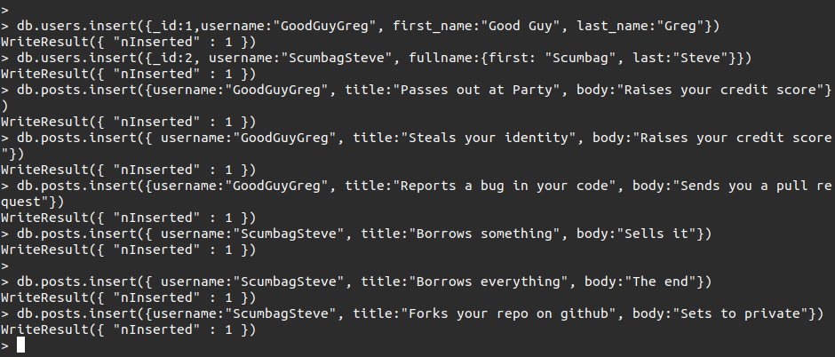

**### Insert the following documents into a `comments` collection**

**db.comments.insert({ username:"GoodGuyGreg", comment:"Hope you got a good deal!", post:ObjectId("5ca0b7e96435f98b5901f463")})**

```

username : GoodGuyGreg

comment : Hope you got a good deal!

post : [post_obj_id]

```

where [post_obj_id] is the ObjectId of the `posts` document: "Borrows something"

```

username : GoodGuyGreg

comment : What's mine is yours!

post : [post_obj_id]

```

where [post_obj_id] is the ObjectId of the `posts` document: "Borrows everything"

```

username : GoodGuyGreg

comment : Don't violate the licensing agreement!

post : [post_obj_id]

```

where [post_obj_id] is the ObjectId of the `posts` document: "Forks your repo on github

```

username : ScumbagSteve

comment : It still isn't clean

post : [post_obj_id]

```

where [post_obj_id] is the ObjectId of the `posts` document: "Passes out at party"

```

username : ScumbagSteve

comment : Denied your PR cause I found a hack

post : [post_obj_id]

```

where [post_obj_id] is the ObjectId of the `posts` document: "Reports a bug in your code"

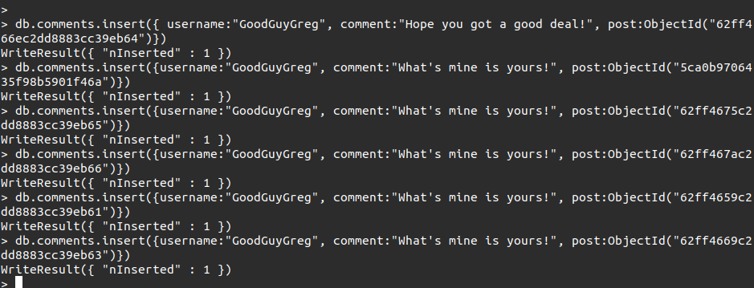

**## Querying related collections**

1. find all users

db.users.find().pretty()

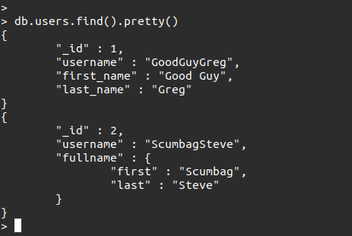

**1. find all posts**

db.posts.find().pretty()

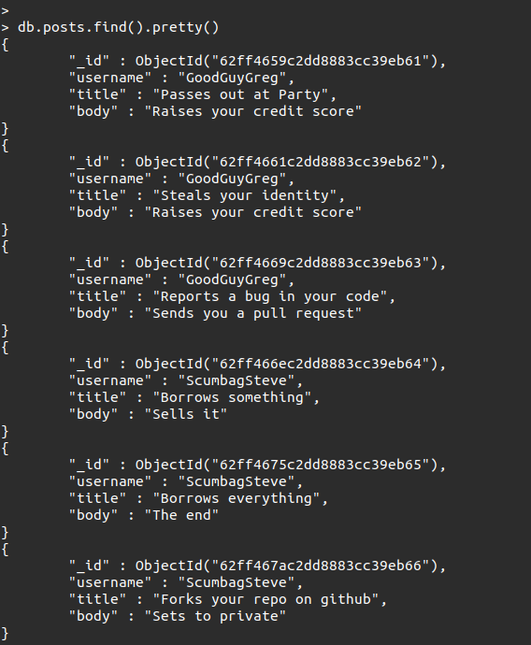

**find all posts that was authored by "GoodGuyGreg"**

db.posts.find({username:"GoodGuyGreg"})

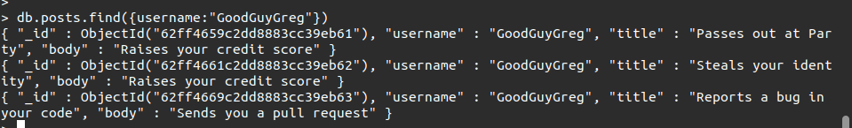

**find all posts that was authored by "ScumbagSteve"**

db.posts.find({username:"ScumbagSteve"})

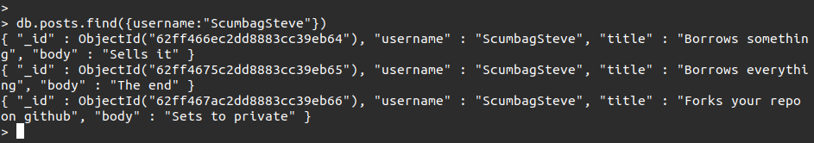

**find all comments**

db.comments.find().pretty()

**find all comments that was authored by "GoodGuyGreg"**

db.comments.find({username:"GoodGuyGreg"})

**find all comments that was authored by "ScumbagSteve"**

db.comments.find({username:"ScumbagSteve"})

**find all comments belonging to the post "Reports a bug in your code"**