AI-Powered Health & Fitness Assistant for Personalized Lifestyle Improvement

Name: Prathamesh Devari
Program: Lenovo Leap Internship

Live Link:
https://health-goal-buddy-88.lovable.app

1. Selected SDG and Reason for Selection
This project is based on Sustainable Development Goal (SDG) 3 – Good Health and Well-being.
SDG 3 focuses on ensuring healthy lives and promoting well-being for people of all ages. In today’s world, many individuals face health issues due to poor lifestyle habits, lack of proper fitness guidance, and unhealthy diets.
This issue is important because it directly affects physical health, mental well-being, and overall quality of life.

2. Problem Statement
Many individuals struggle to maintain a healthy lifestyle due to lack of proper guidance in fitness and nutrition.

Where does this problem exist?
- Among students
- Working individuals
- People with busy lifestyles

Who is affected?
- Young adults
- Fitness beginners
- People trying to improve health

Why is it serious?
- Leads to obesity and health issues
- Causes low energy and poor productivity
- Increases risk of long-term diseases

What happens if not solved?
- Poor physical health
- Lack of discipline
- Decreased quality of life

3. Proposed Solution
The proposed solution is an AI-Powered Health & Fitness Assistant that provides personalized fitness and lifestyle recommendations.
The system works as follows:
- The user enters their fitness goal (e.g., fat loss, muscle gain)
- The AI processes the input
- The system generates:
• A weekly workout plan
• A vegetarian diet plan
• A daily routine
• Discipline and improvement tips
This system uses AI to generate personalized recommendations based on user input.

4. Project Features
- Personalized Workout Plan
- Vegetarian Diet Plan
- Daily Routine Generator
- Discipline & Motivation Tips

5. Technology Stack
- Generative AI (Large Language Model)
- Lovable AI Web App Builder
- Natural Language Processing (NLP)

6. Application Screenshots

HOME PAGE:-
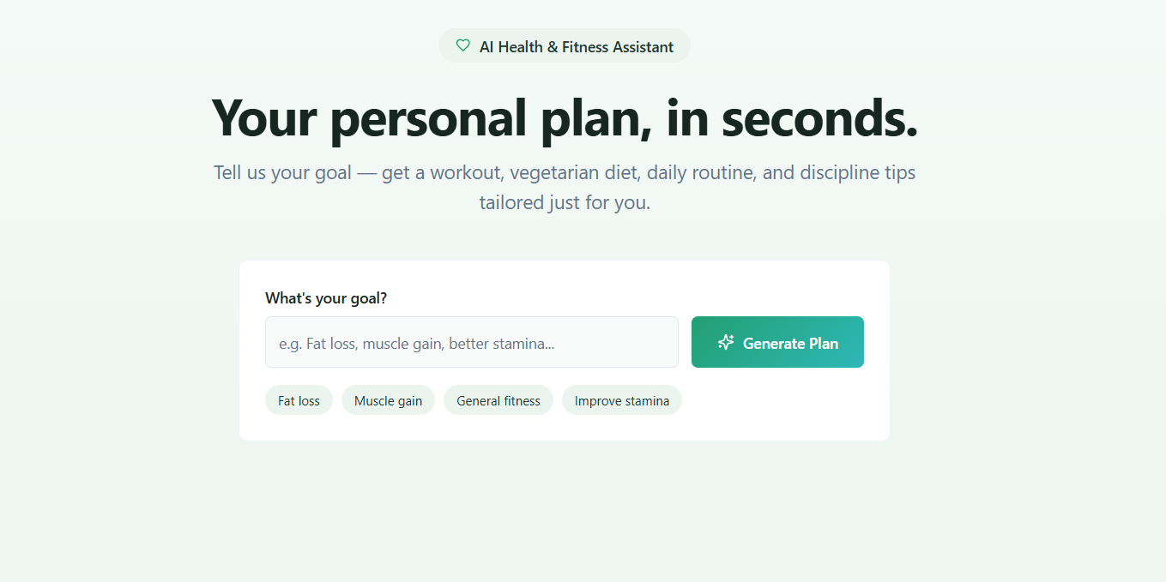

ADD YOUR GOAL:-
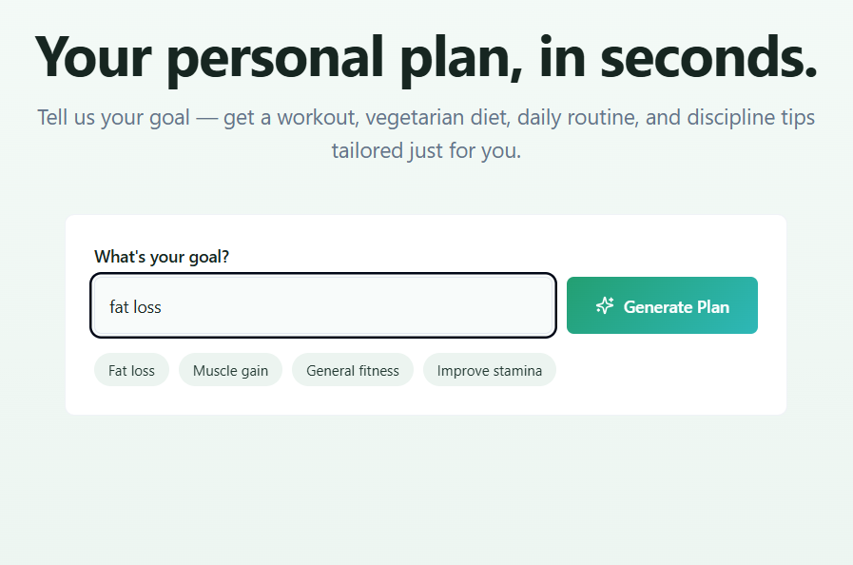

OUTPUT:-
WEEKLY PLAN:-
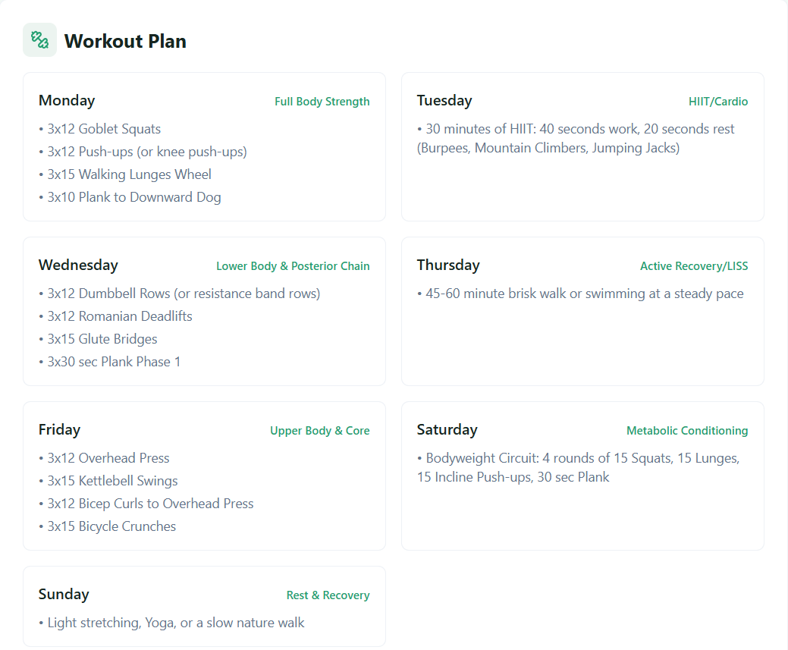
DIET PLAN:-
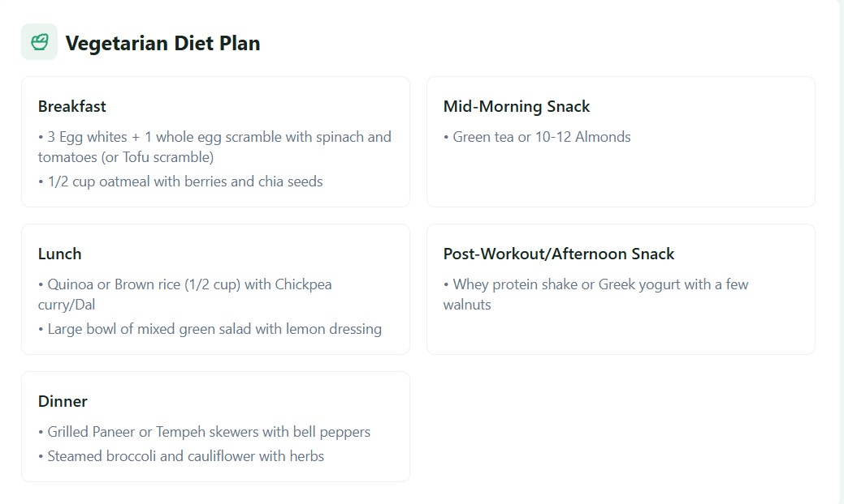
DAILY ROUTINE:-
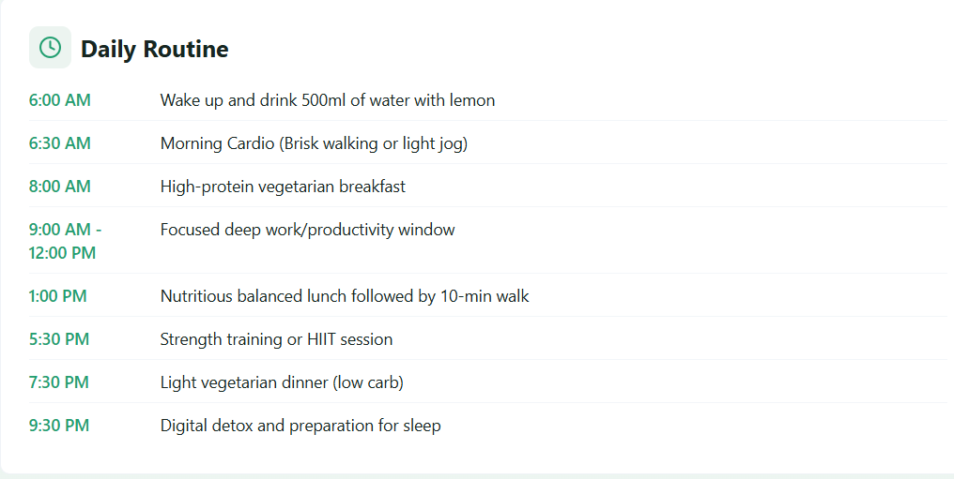
DISCIPLNE TIPS:-
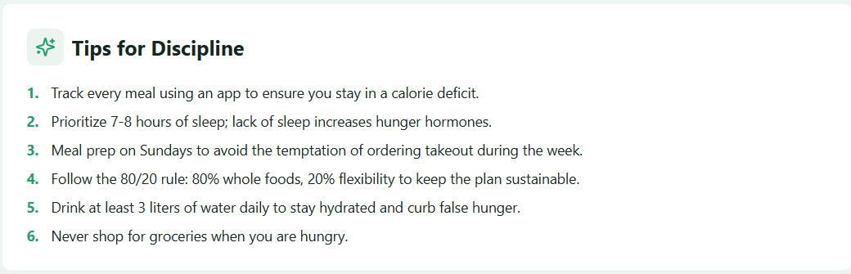

7. Open Source Repository
https://github.com/code101-bot/AI-Health-Fitness-Assistant

8. Future Scope
- Mobile app
- Voice assistant
- Wearable integration
- Real-time tracking

9)Conclusion
This project demonstrates how AI can be used to improve health and lifestyle by providing personalized fitness and diet recommendations. The system helps users make better decisions, stay disciplined, and maintain consistency. This project aligns with SDG 3 by promoting better health and well-being through technology.

