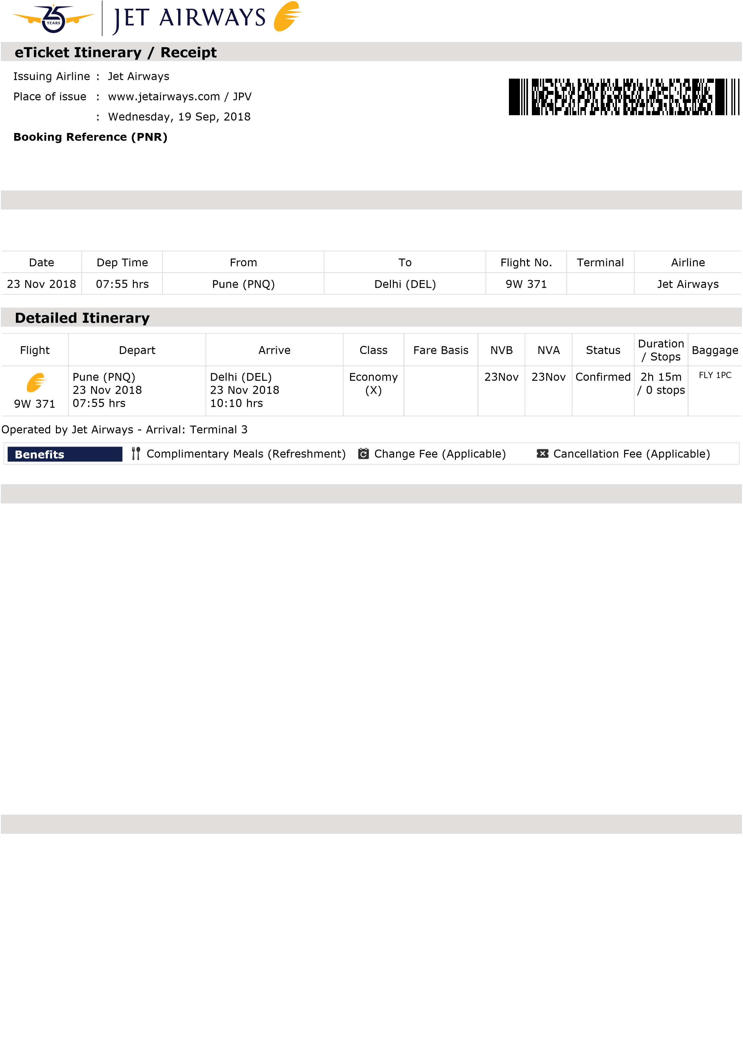Date of issue

# OMZLDM

## Passenger / Itinerary Details

**Passenger Name Frequent Flyer # eTicket #**

Ms Ruchi Gupta 9W150864954 589 21 3529 9605

**Fare**

[Fare(s) include Base Fare + Airline Fuel Charge (YQ)

**Tax** Goods and Services Tax (K3) INR 7

**Fees**

Passenger Service Fee (WO) INR 154

User Development Fee (IN) INR 430 CUTE Fee (YRF) INR 125

Carrier Charge (OC) INR 531

**TOTAL TRIP COST INR 15,247** (including Fare, Tax & Fees)

Total Amount is inclusive of Goods and Services Tax, wherever applicable.

## Payment Details Additional Details

**Name on card:** Ruchi Gupta **Passenger Contact**

(as entered while booking)

**Payment Type:** VISA **Origin Phone:** +91 88267 94547 **Card No.:** XXXX XXXX XXXX 4373 **Dest. Phone:**

**Expiry date:** 0619 **Mobile:**

**Auth Code/Transaction ID:** 878534

**Amount Charged*:** INR 15,247

**Card Holder's Contact IP address used** 223.229.240.67 **Phone:** 1111111111 **to book online:**

**Card holder traveling** NO **Email Address:** ruchi.smile@gmail.com **with this booking:** (as entered while booking)

## Important Notes

This is an eTicket itinerary. To enter the airport and for check-in, you must present the itinerary receipt along with valid photo identification, viz: Official Government issued photo identification, driving license, election photo id, passport (for international passengers) and photo credit card. It is mandatory to carry your photo identification during your entire journey. Guests travelling with infants are requested to carry a valid document as proof indicating the infant’s age.

Guest travelling for business may avail of GST benefits by completing a one-time registration of their company on <http://www.jetairways.com/EN/IN/goods-and-services-tax.aspx>

Certain states and destinations have their own prohibitions and requirements for certain items being carried as baggage. Guest(s) are hereby informed that Bihar, Gujarat, Mizoram and Nagaland are dry states and hence carriage of alcohol/liquor to these destinations is prohibited. In case of any confiscation at the airport, guest(s) will be solely responsible for the same.

For Terms and Conditions, Conditions of Contract, Passenger Rights Policy, Fare Rules, Baggage and Lounge, please refer to <http://www.jetairways.com/EN/GL/TermsAndConditions/General.aspx>

In case of Free Baggage Allowance, Changes, Cancellations, Lounge access, Priority check-in and JPMiles accrual, the most restrictive fare rules will apply.

Lounge facility is available at select ariports only. Visit jetairways.com for further details.

**Reprint of eTicket(s)**

If you require a reprint of your eTicket, we recommend you use our Manage Booking feature on jetairways.com or request our ticketing staff to email the same at no cost. Please note guest(s) will be charged INR 50 for every reprint requested at our City or Airport ticketing offices located in India.

**Check-in**

For all flights within India, our check-in counters will close 45 minutes prior to departure and boarding gate(s) will close 25 minutes prior to departure. Check-in counters for International flights will close 60 minutes prior and boarding gate(s) will close 25 minutes prior to flight departure.

Check-in counters at Dubai airport will close 75 minutes prior to flight departure Check-in counters at Colombo airport will close 90 minutes prior to flight departure.

**Baggage**

Please contact the respective airline(s), or alternatively visit their website(s), to know more about your entitlement on Baggage Allowance, Meal(s) and Special Request(s) on flights operated by our Codeshare / Interline partners.

For select international flights, avail Free Baggage Allowance based on piece concept for each bag weighing 23kgs for travel in Economy and 32kgs in Première/First Class.

For flights within India, avail Free Baggage Allowance based on piece concept for each bag weighing 15kgs for travel in Economy and Premiere.

Cabin Baggage dimensions should not exceed 1.15 mts. Maximum weight allowance including Duty Free purchase for travel in Economy is 7 kgs & 10 kgs in Premiere and First Class.

Guest traveling on flights originating from Srinagar & Leh will not be allowed to carry any cabin baggage.

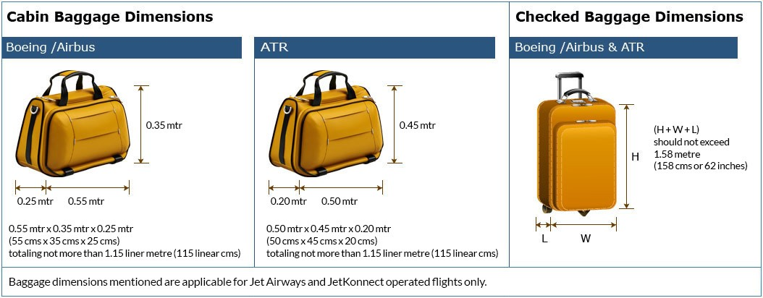

**Security Requirement**

If payment is made via credit and/or debit card(s), you may be required to present the credit and/or debit card(s) used for prior to your departure.

For International travel, please ensure that the validity of the passport is as per the requirements of the destination country.

Due to security reasons, liquids, aerosols and gels (LAGs) in carry-on baggage are restricted to containers of 100ml each. At some airports, duty- free LAGs may be purchased after screening checkpoints. At most airports, including Indian airports, transit guests are not allowed to carry duty-free LAGs purchased on a previous sector in cabin baggage, these will be confiscated at the Security Checkpoint.

For carriage of arms, ammunition, prohibited, restricted articles, please refer to our terms and conditions.

Jet Airways excludes liability for any fragile or perishable items. Further, currency, precious metals, jewellery, negotiable instruments, securities, personal identification documents and other items of value are best carried by the guest in the cabin. If any of these items are in the checked baggage and are lost, damaged or delayed, the guest will not be entitled to claim any reimbursement of its value from Jet Airways unless a special declaration is made regarding its value and a supplementary sum is paid to the airline at the time of check-in.

**JetProtect Travel Insurance**

If you have availed of JetProtect Travel Insurance, you will have to contact ICICI Lombard General Insurance Company Ltd to get a copy of your insurance cover. For any queries related to your insurance cover, please call the 24x7 toll free helpline 1800-209-8888 (accessible even from your mobile phone) for assistance.

**Data Protection Notice**

Your personal data will be processed in accordance with Jet Airways privacy policy at

<https://www.jetairways.com/en/in/policies/privacy-and-security.aspx>and if your passage involves carriage by another carrier, then in accordance with that carrier’s privacy policy. The policies of IATA member carriers are available at

<http://www.iatatravelcenter.com/privacy>or from the carrier directly.

You should read the documentation, which applies to your booking and specifies, for example, how your personal data is collected, stored, used, disclosed and transferred.

**For any assistance you may contact us on the following numbers**

Reservation/Tele check in and JetPrivilege:

. 3989 3333 for Bengaluru, Chennai, Delhi, Hyderabad, Kolkata and Mumbai.

. Other cities: Affix local code of any of these 6 cities and dial 3989 3333

You can also contact us on 08039243333 (India only)

Jet Airways Toll Free Numbers:

. UK toll free number for reservation: 0808 101 1199

. USA toll free number for reservation: 1-877-uflyjet (1-877-835-9538)

For real-time Flight Status

SMS Jet <Flight No.> to 56388

56388 service can be accessed from India only.

For any queries please write to us at info@jetairways.com

### Thank you for choosing Jet Airways. We wish you a pleasant journey