WEEK 2 — EXPLORATORY DATA ANALYSIS AND VISUALIZATION
Adult Income Dataset
Data Science with Python Internship
Submitted by
Keerthi Chandrika Mallela
Dataset Source
UCI Machine Learning Repository
Dataset
Adult / Census Income Dataset

1. Executive Summary
This Week 2 project focuses on Exploratory Data Analysis (EDA) and visualization of the cleaned Adult Income dataset. The objective of the analysis was to examine the structure, distributions, relationships, and patterns present in the dataset using Python-based data analysis and visualization techniques.
The cleaned dataset contains 45,175 records and 15 variables covering demographic, educational, employment, financial, and working-hours information. The analysis began with descriptive statistics and categorical frequency analysis to understand the characteristics and distribution of the dataset.
Multiple visualization techniques were then applied using Matplotlib and Seaborn, including count plots, histograms, box plots, stacked bar charts, and a correlation heatmap. These visualizations were used to examine income distribution, education and workclass distributions, age, working hours, income across education levels, and income proportions across workclass categories.
Correlation analysis was also performed on the numerical variables. The results showed generally weak linear relationships among the numerical variables. Grouped analysis was used to compare income proportions across workclass and education categories, allowing differences between groups to be examined using percentages rather than only raw counts.
The analysis identified several observable patterns in the dataset, including differences in income proportions across education and workclass categories. These findings describe relationships and distributions present in the dataset and should not be interpreted as evidence of causal relationships.
Overall, the project demonstrates the use of Python, Pandas, NumPy, Matplotlib, and Seaborn to perform exploratory data analysis, generate meaningful visualizations, examine relationships between variables, and communicate data-driven observations.

2. Introduction
Exploratory Data Analysis (EDA) is an important step in the data analysis process used to understand the structure, distribution, and relationships present in a dataset. It helps identify patterns and characteristics in the data before further analysis or modelling is performed.
This project focuses on performing exploratory data analysis and visualization on the cleaned Adult Income dataset. The dataset contains demographic, educational, employment, financial, and working-hours information.
In this project, Python and its data analysis and visualization libraries were used to examine the dataset through descriptive statistics, categorical frequency analysis, data visualizations, correlation analysis, and grouped analysis. The analysis was performed using Pandas, NumPy, Matplotlib, Seaborn, and Google Colab.
The purpose of this analysis is to understand the characteristics of the dataset and identify observable patterns and relationships that can be communicated through numerical summaries and visualizations.

3. Project Objectives
The main objectives of this project are:
- To perform exploratory data analysis on the cleaned Adult Income dataset.
- To understand the structure and characteristics of the dataset using descriptive statistics.
- To examine the distribution of categorical and numerical variables.
- To create appropriate visualizations using Matplotlib and Seaborn.
- To identify observable patterns and differences across income, education, workclass, age, and working-hours variables.
- To analyze relationships between numerical variables using correlation analysis.
- To perform grouped analysis using income proportions across workclass and education categories.
- To interpret the results and communicate the findings through numerical summaries and visualizations.

4. Dataset Description
The dataset used for this project is the Adult / Census Income Dataset, obtained from the UCI Machine Learning Repository. The dataset contains demographic, educational, employment, financial, and working-hours information about individuals.
The cleaned dataset used for this analysis contains 45,175 records and 15 variables. The target variable, income, contains two categories: <=50K and >50K.
The variables include numerical attributes such as age, final weight, education number, capital gain, capital loss, and hours worked per week. It also contains categorical attributes such as workclass, education, marital status, occupation, relationship, race, sex, native country, and income.
The dataset used in Week 2 is the cleaned version prepared during Week 1. The cleaned dataset contains no missing values and no duplicate rows, allowing the exploratory analysis to be performed on the prepared data.
Variable Type | Variables
Numerical | age, fnlwgt, education-num, capital-gain, capital-loss, hours-per-week
Categorical | workclass, education, marital-status, occupation, relationship, race, sex, native-country, income

5. Tools and Technologies
The following tools and technologies were used to perform the exploratory data analysis and visualization:
- Python – Used as the primary programming language for data analysis.
- Pandas – Used for loading, examining, grouping, and analyzing the dataset.
- NumPy – Used for numerical operations and data analysis.
- Matplotlib – Used for creating data visualizations.
- Seaborn – Used for statistical visualizations such as count plots, histograms, box plots, and heatmaps.
- Google Colab – Used as the development environment for executing the Python analysis and generating visualizations.

5.1 Analysis Environment
The analysis was performed using a Google Colab notebook. The cleaned dataset prepared during Week 1 was loaded into the notebook and used as the input for the exploratory analysis.

6. Methodology
The exploratory data analysis was performed using a systematic sequence of steps. The cleaned Adult Income dataset prepared during Week 1 was first loaded into the Python environment. The structure and dimensions of the dataset were then examined to understand the available variables.
Descriptive statistics were calculated for the numerical variables to examine measures such as mean, standard deviation, minimum, maximum, and quartiles. Frequency counts were also calculated for categorical variables to understand the distribution of observations across different categories.
Several visualization techniques were then applied to examine important distributions and relationships. Count plots were used for categorical variables, histograms were used for numerical distributions, and box plots were used to compare numerical variables across income categories. Stacked bar charts were used to compare income proportions across workclass and education groups.
Correlation analysis was performed on the numerical variables using a correlation matrix. A heatmap was used to visualize the correlation values and make comparisons between numerical variables easier.
Finally, grouped analysis was performed using income proportions across workclass and education categories. Percentages were used in these comparisons so that groups with different numbers of observations could be examined more directly.

6.1 Analysis Steps
1. Load the cleaned dataset.
2. Examine dataset dimensions and variables.
3. Calculate descriptive statistics.
4. Analyze categorical variable frequencies.
5. Create visualizations for numerical and categorical variables.
6. Compare income distributions across education and workclass groups.
7. Perform correlation analysis on numerical variables.
8. Interpret the observed patterns and relationships.
9. Summarize the findings from the exploratory analysis.

7. Exploratory Data Analysis
Exploratory Data Analysis was performed to understand the distributions, frequencies, and characteristics of the variables in the cleaned Adult Income dataset. Descriptive statistics and categorical frequency counts were used before creating visualizations.
The dataset contains 45,175 records and 15 variables. The numerical variables include age, fnlwgt, education-num, capital-gain, capital-loss, and hours-per-week.
The average age in the dataset is approximately 38.56 years, while the average number of hours worked per week is approximately 40.94 hours. The median number of hours worked per week is 40 hours.
Among the categorical variables, Private is the largest workclass category with 33,262 records, while HS-grad is the most common education category with 14,770 records. The Married-civ-spouse category is the largest marital-status group with 21,042 records.
The income variable contains 33,973 records in the <=50K category and 11,202 records in the >50K category.
These descriptive statistics provide an initial understanding of the dataset and were used as a basis for the visual analysis that follows.

7.1 Descriptive Statistics
Descriptive statistics were calculated for the numerical variables using Pandas. The summary included the count, mean, standard deviation, minimum, maximum, and quartile values.
Statistic | age | fnlwgt | education-num | capital-gain | capital-loss | hours-per-week
count | 45,175.00 | 45,175.00 | 45,175.00 | 45,175.00 | 45,175.00 | 45,175.00
mean | 38.56 | 189,738.80 | 10.12 | 1,102.58 | 88.69 | 40.94
std | 13.22 | 105,652.40 | 2.55 | 7,510.25 | 405.16 | 12.01
min | 17.00 | 13,492.00 | 1.00 | 0.00 | 0.00 | 1.00
25% | 28.00 | 117,392.50 | 9.00 | 0.00 | 0.00 | 40.00
50% | 37.00 | 178,312.00 | 10.00 | 0.00 | 0.00 | 40.00
75% | 47.00 | 237,903.00 | 13.00 | 0.00 | 0.00 | 45.00
max | 90.00 | 1,490,400.00 | 16.00 | 99,999.00 | 4,356.00 | 99.00
Table 1: Descriptive statistics of numerical variables

7.2 Categorical Variable Analysis
Frequency analysis was performed on the categorical variables to understand how observations are distributed across different categories.
The analysis showed that Private is the largest workclass category, while HS-grad is the most frequently occurring education category. The income variable contains two categories, with <=50K containing 33,973 records and >50K containing 11,202 records.
These frequency distributions were used to identify the most common categories and understand the composition of the dataset before performing further visual analysis.

8. Data Visualization and Analysis
Data visualization was performed to make the distributions and relationships within the dataset easier to understand. Different visualization techniques were selected according to the type of variable and the purpose of the analysis.
Count plots were used to examine categorical distributions, histograms were used for numerical variables, box plots were used to compare numerical variables across income categories, and stacked bar charts were used to compare income proportions across groups.

8.1 Income Distribution
The income distribution was visualized using a count plot to compare the number of observations in the two income categories.
The dataset contains 33,973 observations in the <=50K category and 11,202 observations in the >50K category.
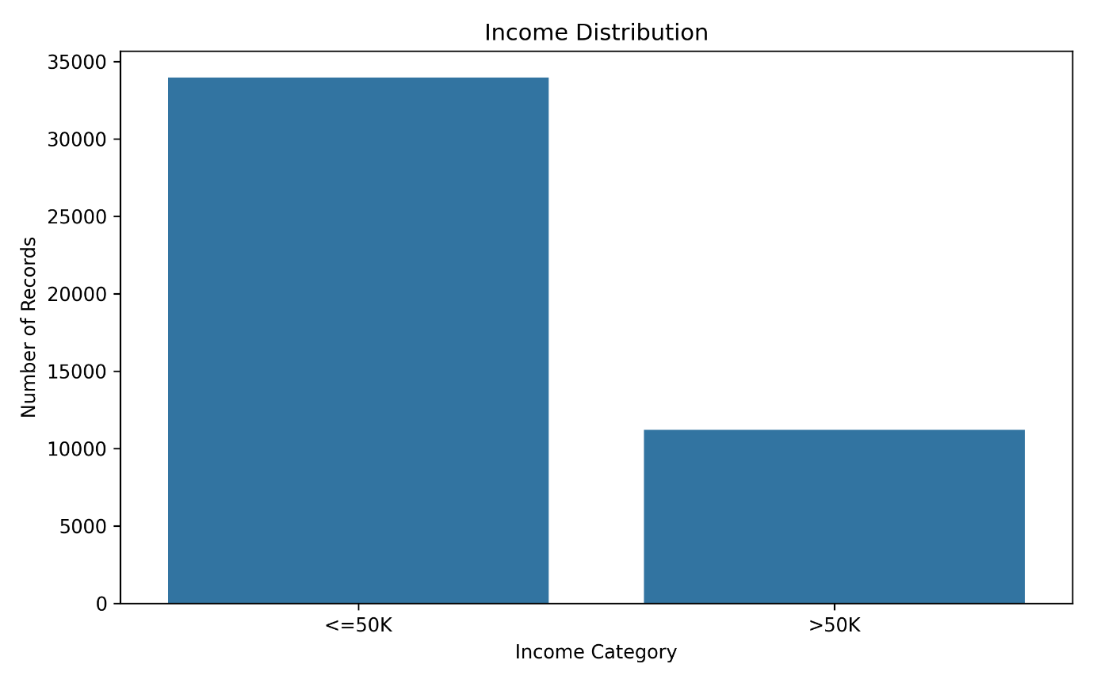
Figure 1: Income distribution

8.2 Education Distribution
The education distribution was examined using a horizontal count plot. The visualization shows the number of observations belonging to each education category.
HS-grad is the most frequently occurring education category with 14,770 records, followed by Some-college with 9,887 records and Bachelors with 7,559 records.
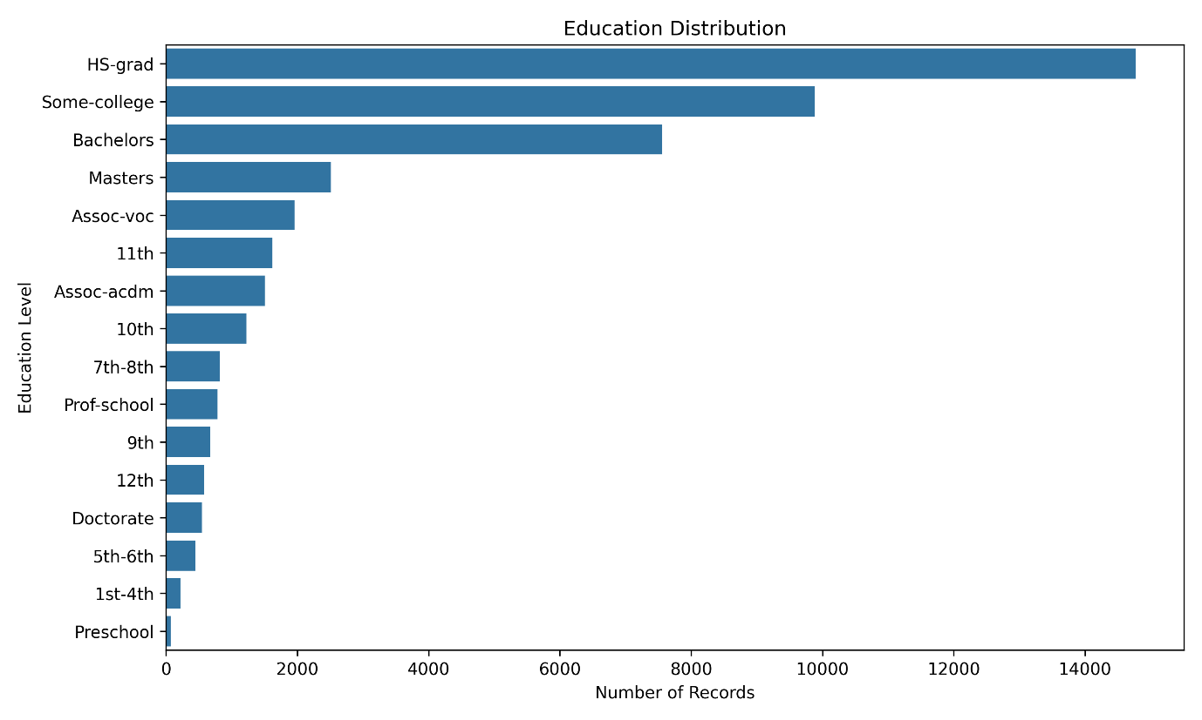
Figure 2: Education distribution

8.3 Workclass Distribution
The workclass distribution was visualized to examine the number of observations across different employment categories.
The Private workclass is the largest category, containing 33,262 records in the cleaned dataset.
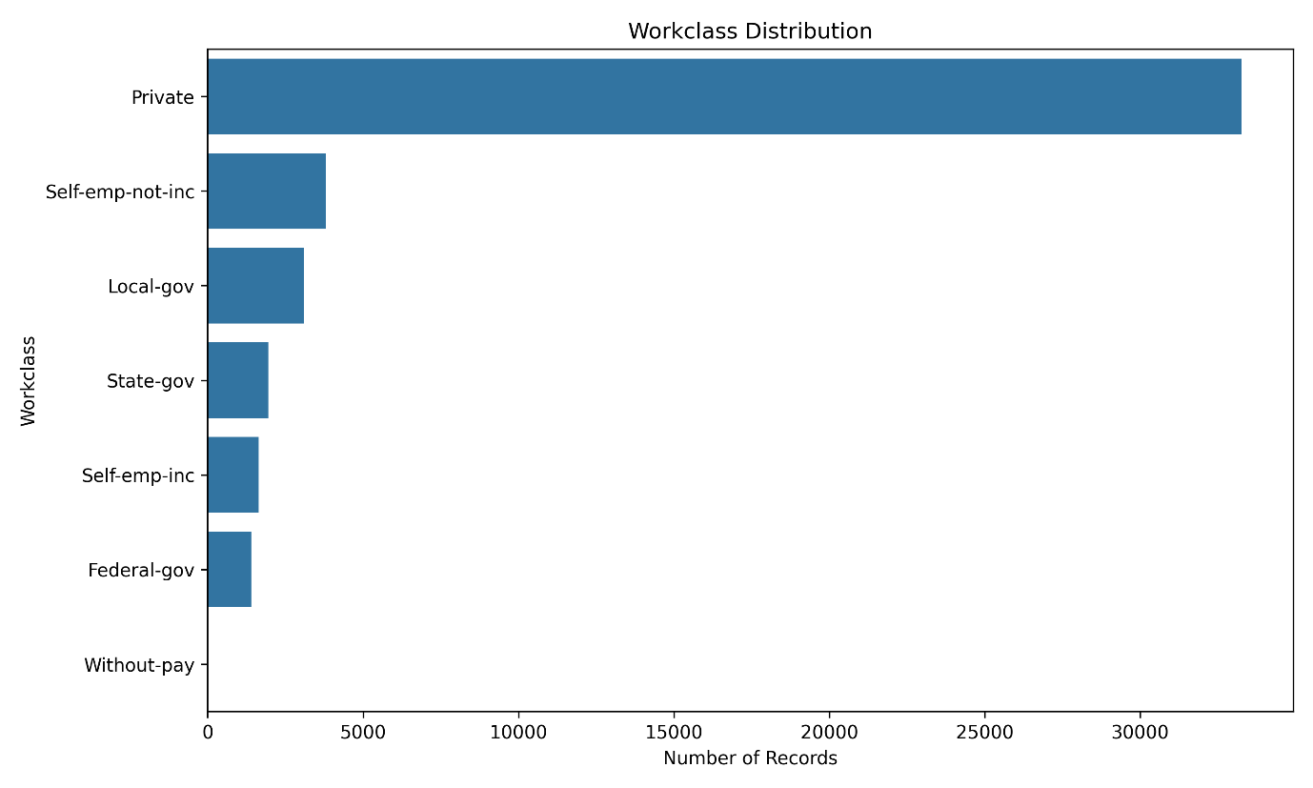
Figure 3: Workclass distribution

8.4 Age Distribution
A histogram was used to examine the distribution of age values in the dataset. The age variable ranges from 17 to 90 years, with a mean age of approximately 38.56 years.
The histogram provides an overview of how observations are distributed across different age values.
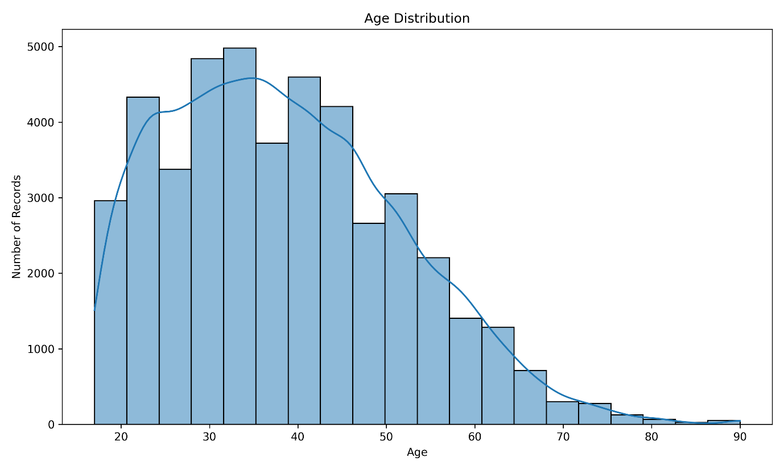
Figure 4: Age distribution

8.5 Hours Worked per Week Distribution
A histogram was used to examine the distribution of weekly working hours. The hours-per-week variable ranges from 1 to 99 hours, with a mean of approximately 40.94 hours and a median of 40 hours.
This visualization helps examine the spread and frequency of different weekly working-hour values.
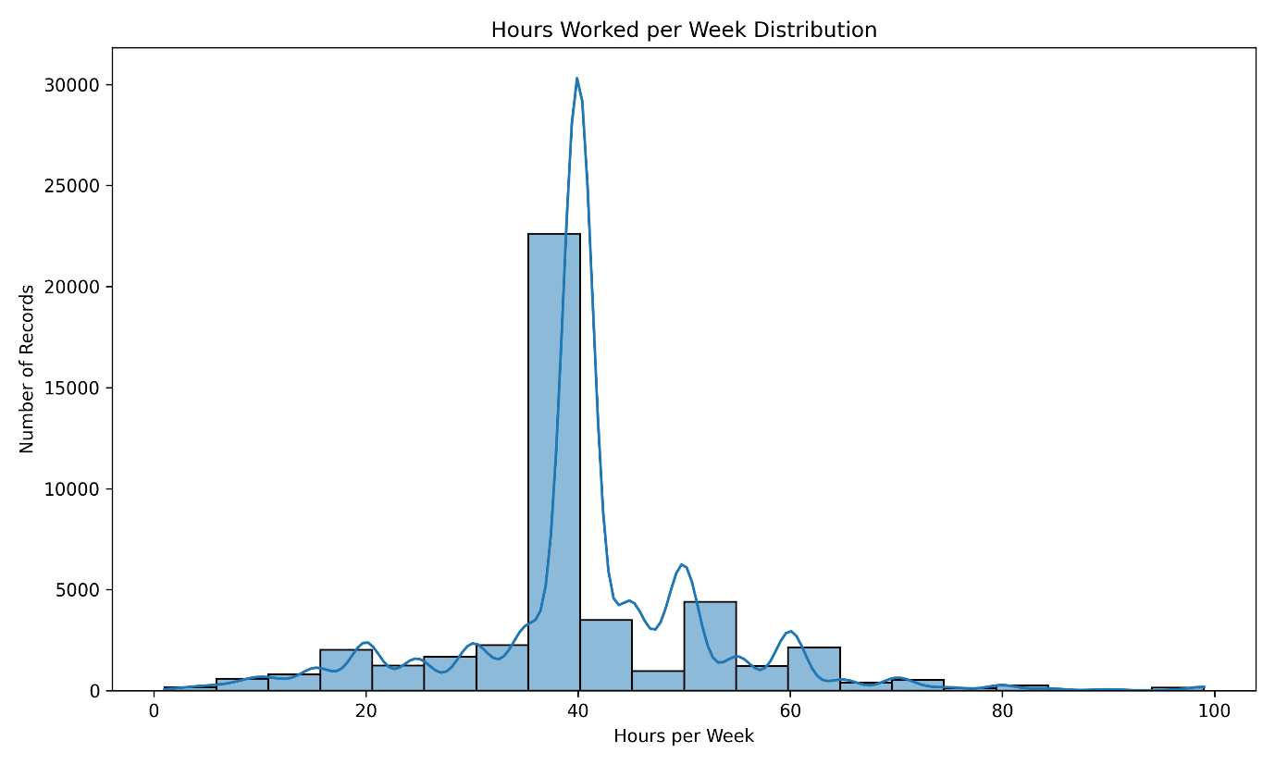
Figure 5: Hours worked per week distribution

9. Relationship Analysis
Relationship analysis was performed to examine how selected variables vary across different income categories and education groups. Box plots and grouped visualizations were used to compare numerical and categorical variables across groups.

9.1 Income Distribution Across Education Levels
The distribution of income categories across education levels was examined using a grouped count plot. The visualization compares the number of <=50K and >50K observations within each education category.
The chart provides a direct comparison of income-category counts across different education levels and helps identify differences in the observed income distribution between education groups.
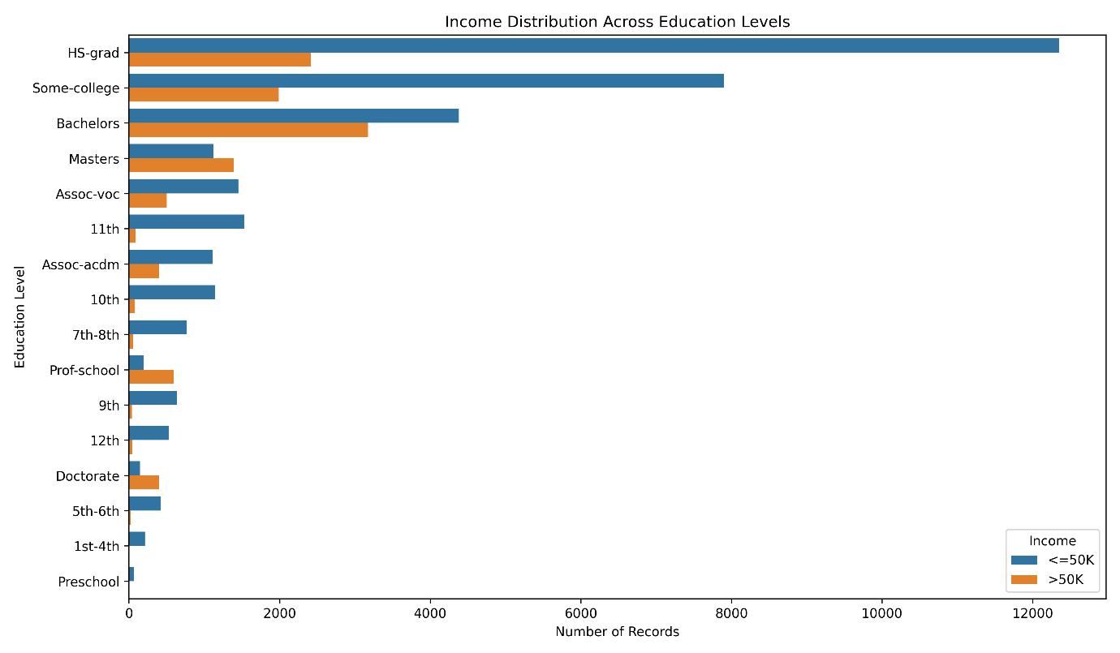
Figure 6: Income distribution across education levels

9.2 Hours Worked per Week by Income Category
A box plot was used to compare the distribution of weekly working hours between the two income categories. The visualization shows the median, spread, and potential extreme values of hours-per-week for each income group.
This comparison helps examine how the distribution of working hours differs between the <=50K and >50K categories.
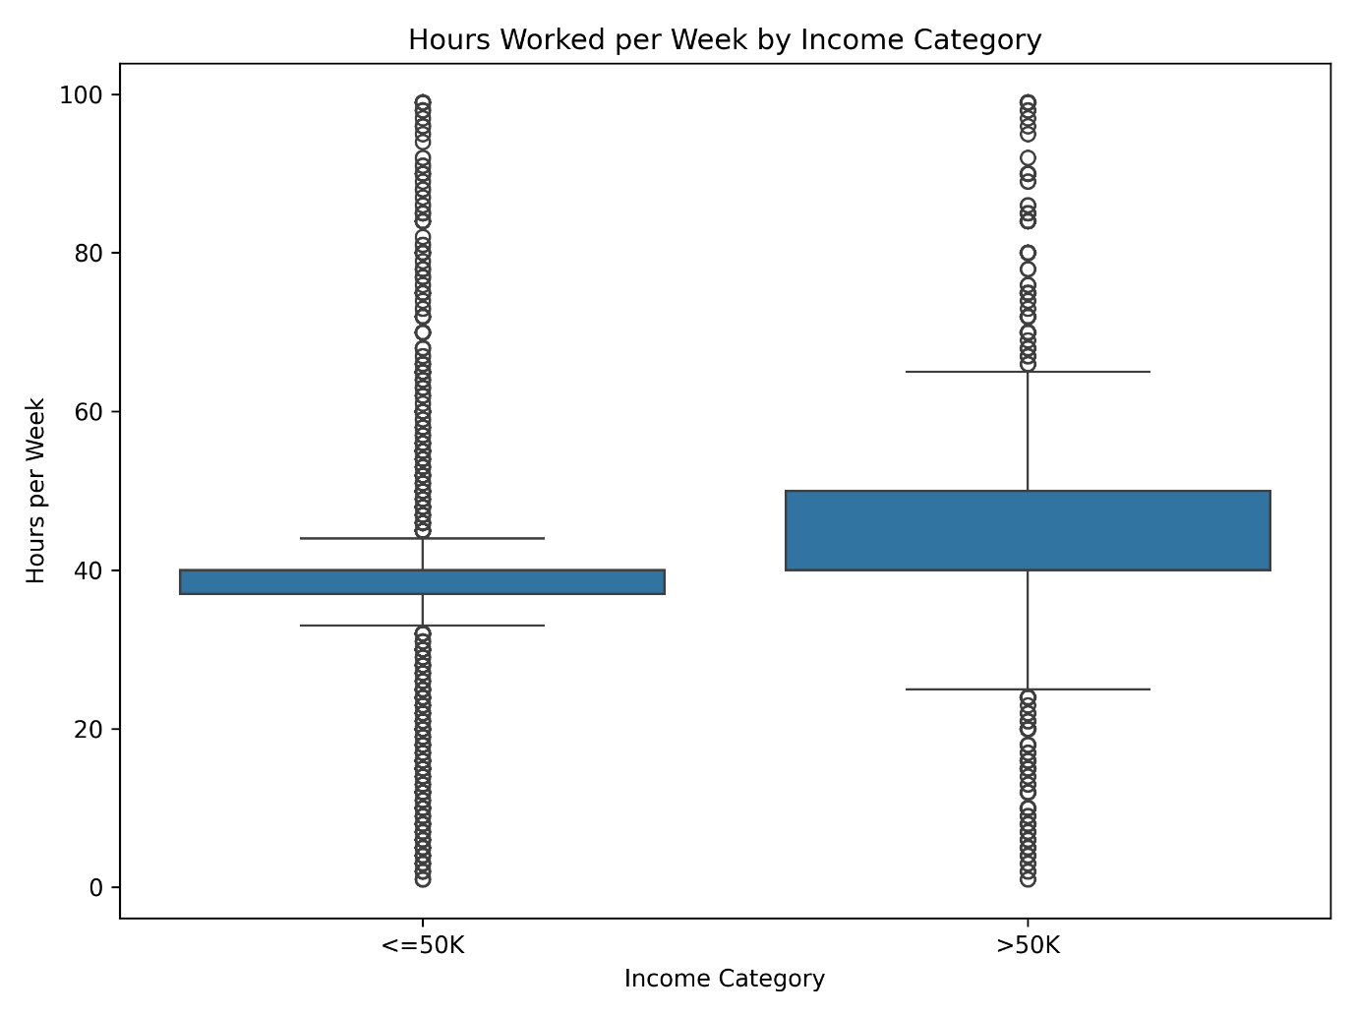
Figure 7: Hours worked per week by income category

9.3 Age Distribution by Income Category
A box plot was used to compare the age distributions of the two income categories. The visualization allows the median, spread, and potential extreme values of age to be compared between the income groups.
This provides a descriptive comparison of age distributions within the two income categories.
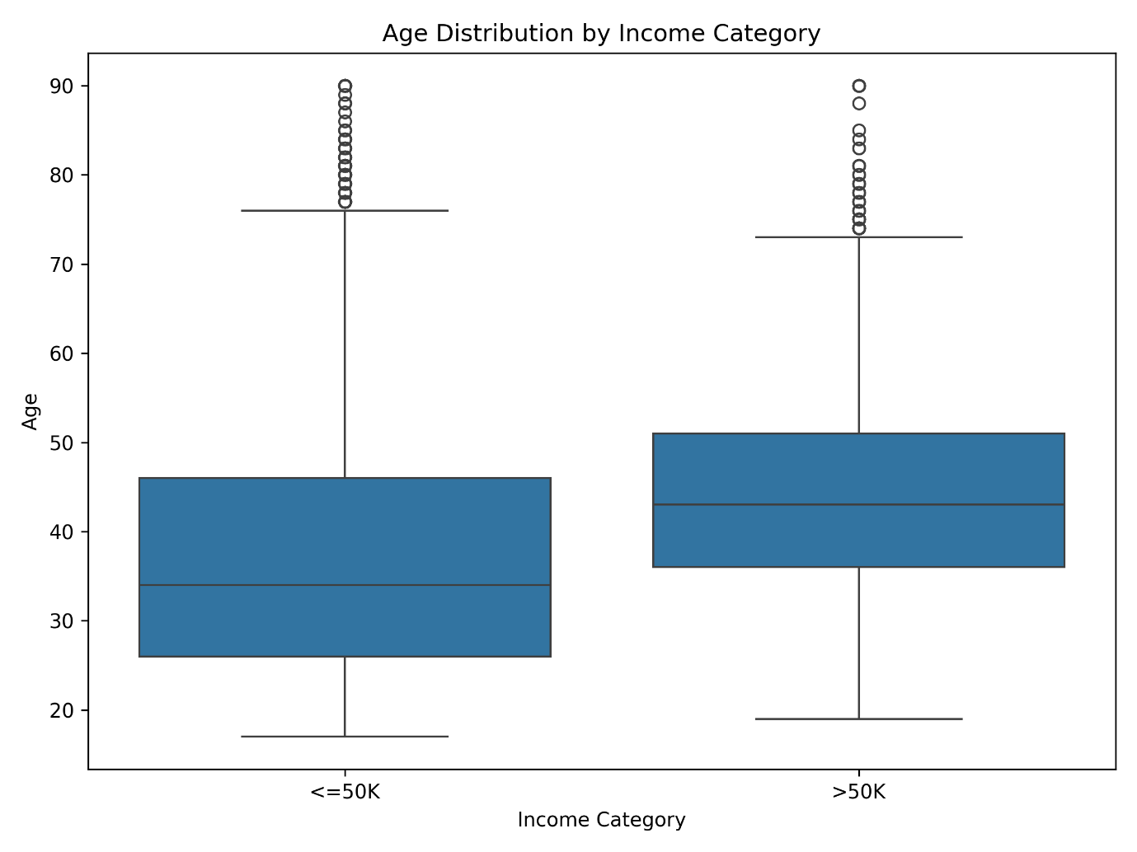
Figure 8: Age distribution by income category

10. Correlation Analysis
Correlation analysis was performed to examine the linear relationships between the numerical variables in the dataset. The analysis included age, fnlwgt, education-num, capital-gain, capital-loss, and hours-per-week.
Correlation coefficients range from -1 to +1. Positive values indicate a positive linear relationship, negative values indicate a negative linear relationship, and values close to zero indicate a weak linear relationship.
A correlation matrix was calculated using Pandas and visualized using a Seaborn heatmap. The heatmap provides a visual representation of the strength and direction of the relationships between the numerical variables.
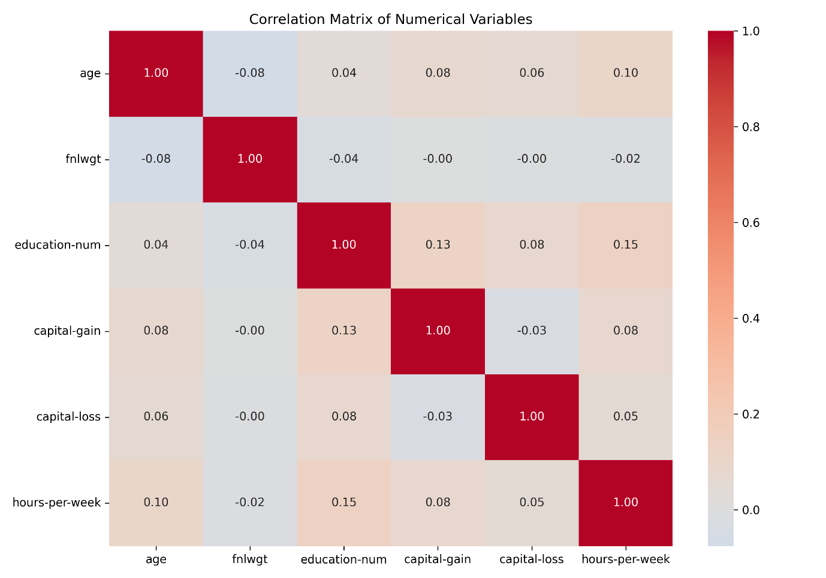
Figure 9: Correlation matrix of numerical variables

10.1 Correlation Findings
The correlation results show generally weak linear relationships among the numerical variables.
The strongest positive correlation observed in the matrix is between education-num and hours-per-week, with a correlation coefficient of approximately 0.146. The correlation between education-num and capital-gain is approximately 0.127, while the correlation between age and hours-per-week is approximately 0.102.
These correlation values are relatively small, indicating that the numerical variables do not show strong linear relationships with one another in this analysis.

11. Grouped Analysis
Grouped analysis was performed to compare the distribution of income categories across different workclass and education groups. Pandas crosstab() was used to aggregate the observations and calculate income proportions within each group.
Percentages were used in addition to raw counts because the categories contain different numbers of observations. Calculating proportions within each group provides a more direct comparison of the income distribution across groups.

11.1 Income Proportions by Workclass
The income distribution was first grouped by workclass. The analysis showed differences in the proportion of <=50K and >50K observations across workclass categories.
For example, Private contains 21.78% >50K observations, while Self-emp-inc contains 55.44% >50K observations. Federal-gov contains 39.05% >50K observations, while State-gov contains 26.72%.
These percentages describe the observed income distribution within each workclass and should not be interpreted as evidence of a causal relationship.
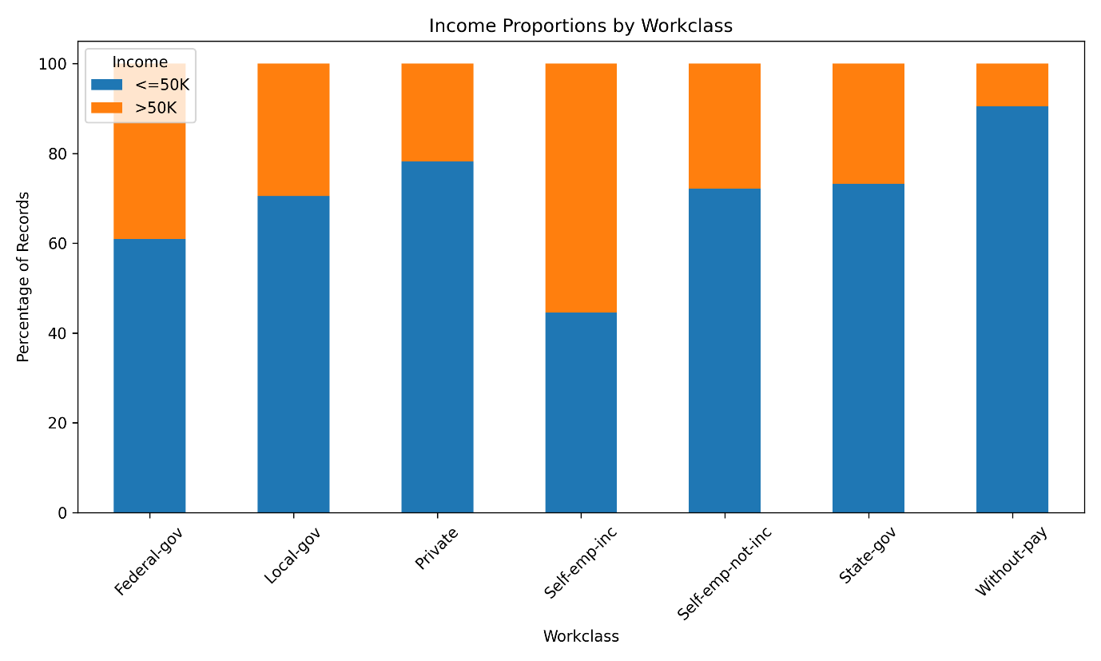
Figure 10: Income proportions by workclass

11.2 Income Proportions by Education Level
Income proportions were also calculated within each education category to compare the income distribution across education levels.
The results show differences between education categories. For example, the Bachelors category contains 42.02% >50K observations, while Masters contains 55.43% and Doctorate contains 73.35%. The Prof-school category contains 75.41% >50K observations, while HS-grad contains 16.34%.
These values represent the observed proportions within each education group. They describe patterns in the dataset and do not establish that education level directly causes differences in income.
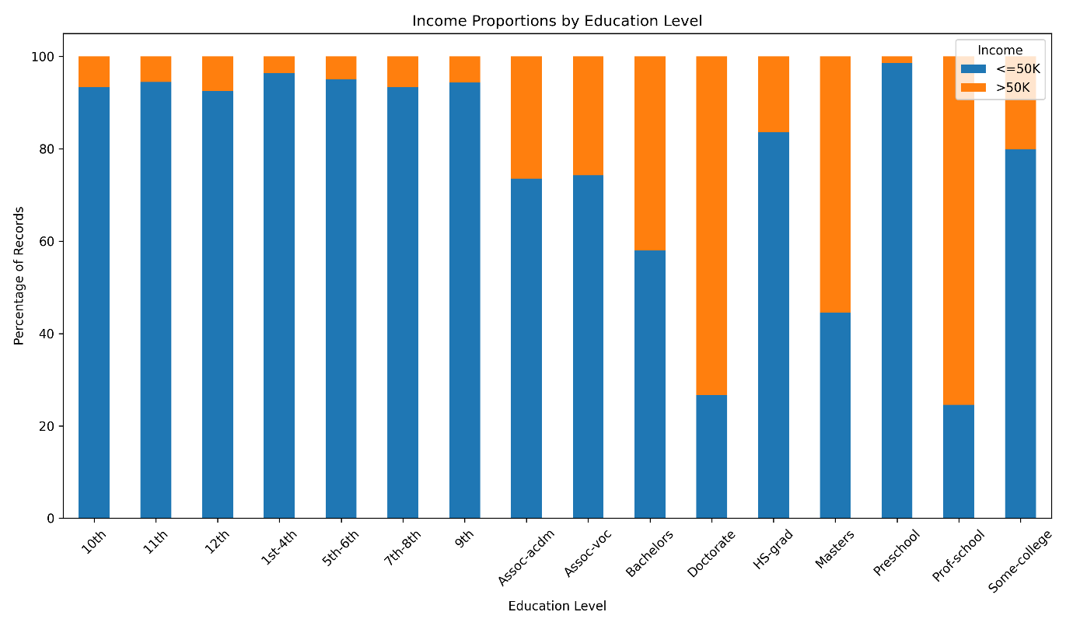
Figure 11: Income proportions by education level

11.3 Transformation and Aggregation
The grouped analysis involved transforming raw category counts into percentages using normalization by group. The pd.crosstab() function was used to aggregate observations by workclass and education, while normalize="index" converted the counts into proportions within each category.
This transformation made groups with different numbers of observations easier to compare. The resulting percentages were then visualized using stacked bar charts.

12. Key Findings
The exploratory analysis produced the following key findings:
- The cleaned dataset contains 45,175 records and 15 variables with no missing values or duplicate rows.
- The <=50K income category contains 33,973 records, while the >50K category contains 11,202 records.
- Private is the largest workclass category with 33,262 records.
- HS-grad is the most common education category with 14,770 records.
- The average age is approximately 38.56 years, and the average number of hours worked per week is approximately 40.94 hours.
- The numerical correlation analysis shows generally weak linear relationships between the numerical variables.
- Income proportions differ across workclass categories and education levels.
- The grouped analysis provides descriptive comparisons of income distributions across different categories without establishing causal relationships.

13. Challenges and Observations
One of the main challenges during the analysis was selecting suitable visualization techniques for different types of variables. Numerical and categorical variables require different approaches to make their distributions and relationships easier to understand.
Another consideration was the difference in the number of observations across categories. Raw counts alone can make comparisons between groups difficult because some categories contain substantially more observations than others. To address this, grouped income analysis was also performed using percentages within each category.
The analysis also required careful interpretation of correlation values. Correlation indicates the strength and direction of a linear relationship between numerical variables, but it does not establish causation.
These considerations helped ensure that the visualizations and findings were presented as descriptive observations of the dataset.

14. Limitations
The analysis is limited to the variables and observations available in the Adult Income dataset. The exploratory analysis identifies distributions and relationships within the data but does not establish causal relationships between variables.
The correlation analysis focuses on linear relationships between numerical variables and therefore may not capture more complex or non-linear relationships.
The findings are also specific to the cleaned dataset used in this project and should not automatically be generalized to populations outside the dataset.

15. Conclusion
This project performed exploratory data analysis and visualization on the cleaned Adult Income dataset using Python. Descriptive statistics and categorical frequency analysis were used to understand the structure and distribution of the data.
Multiple visualization techniques were applied using Matplotlib and Seaborn to examine income, education, workclass, age, and working-hours distributions. Box plots and grouped visualizations were also used to compare income categories across selected variables.
Correlation analysis was performed to examine relationships between numerical variables, while grouped analysis was used to compare income proportions across workclass and education categories.
The analysis provided a clearer understanding of the patterns and distributions present in the dataset. The project also demonstrated how exploratory data analysis and visualization can be used to summarize data and communicate observations effectively.

16. References
1. UCI Machine Learning Repository — Adult Dataset / Census Income Dataset.
2. Pandas Documentation — Python Data Analysis Library.
3. NumPy Documentation — Numerical Computing with Python.
4. Matplotlib Documentation — Python Visualization Library.
5. Seaborn Documentation — Statistical Data Visualization in Python.
6. Google Colab — Cloud-based Python development environment.

