WEEK 3 — CLUSTERING ANALYSIS
Adult Income Dataset
Data Science with Python Internship
Submitted by
Keerthi Chandrika Mallela
Dataset Source
UCI Machine Learning Repository
Dataset
Adult / Census Income Dataset

1. Executive Summary
This report presents the clustering analysis performed during Week 3 of the Data Science with Python internship using the Adult Income dataset. The objective of this analysis was to apply an unsupervised learning technique to identify groups of observations with similar characteristics based on selected numerical features.
The cleaned dataset contained 45,175 observations and 15 variables. Six numerical features — age, fnlwgt, education-num, capital-gain, capital-loss, and hours-per-week — were selected for clustering. Since these features have different numerical scales, StandardScaler was used to standardize them before applying K-Means clustering.
The Elbow Method and Silhouette Score were used to evaluate different numbers of clusters. K values from 2 through 10 were tested. The highest Silhouette Score was approximately 0.5111 for K = 2, while the Elbow Method showed a gradual reduction in inertia with a less pronounced decline around K = 4 to K = 5. Based on the clustering evaluation, K = 2 was selected for the final K-Means model.
The final model was fitted to the complete standardized dataset and divided the observations into two clusters. Cluster 0 contained 2,098 observations, while Cluster 1 contained 43,077 observations. Cluster profiling showed that the clusters differed most noticeably in capital-loss, with additional differences in age, education level, and hours worked per week.
Income was not used as an input feature during clustering. It was examined separately after clustering to understand the composition of the resulting groups. Cluster 0 had approximately 47.76% of observations in the <=50K category and 52.24% in the >50K category, while Cluster 1 contained approximately 76.54% and 23.46%, respectively. These results provide an additional descriptive interpretation of the clusters rather than a classification outcome.

2. Introduction
Data science techniques can be used to identify meaningful patterns and relationships within large datasets. While supervised learning methods rely on predefined target labels, unsupervised learning techniques attempt to discover natural groupings within data without using a target variable during model training.
Clustering is one of the most commonly used unsupervised learning approaches. It groups observations according to similarities in their characteristics. In this project, the K-Means clustering algorithm was applied to the Adult Income dataset to identify groups of observations with similar numerical characteristics.
The analysis builds upon the data cleaning and exploratory analysis completed during the previous weeks of the internship. The cleaned Adult Income dataset was used as the starting point for the clustering process. Numerical features were selected and standardized before applying K-Means. Different values of K were evaluated using the Elbow Method and Silhouette Score to determine a suitable clustering configuration.
The resulting clusters were then examined using cluster profiles and post-clustering income distributions to understand the characteristics of the groups identified by the algorithm.

3. Problem Statement
The Adult Income dataset contains demographic, educational, occupational, and financial attributes for individuals. Although the dataset contains multiple numerical characteristics, it is not immediately clear whether observations can be grouped into distinct segments based on these characteristics.
The problem addressed in this project is to identify groups of observations with similar numerical profiles using an unsupervised clustering technique. Since no target variable is used during clustering, the analysis focuses on the similarity between observations rather than predicting an outcome.
K-Means clustering is applied to the selected numerical features after standardization. Different numbers of clusters are evaluated using the Elbow Method and Silhouette Score, after which a suitable clustering configuration is selected and analyzed.

4. Objectives
- To apply an unsupervised machine learning technique to the cleaned Adult Income dataset.
- To select appropriate numerical features for clustering analysis.
- To standardize the selected features before applying K-Means.
- To evaluate different numbers of clusters using the Elbow Method.
- To evaluate clustering quality using the Silhouette Score.
- To select a suitable number of clusters based on the evaluation results.
- To build a final K-Means clustering model using the complete dataset.
- To analyze and compare the characteristics of the resulting clusters.
- To examine the income distribution across the clusters as a post-clustering interpretation.
- To document the methodology, results, challenges, and limitations of the clustering analysis.

5. Dataset Description
The dataset used for this project is the Adult Income dataset, also known as the Census Income dataset. It contains demographic, educational, occupational, and financial information about individuals and is commonly used for data analysis and machine learning tasks.
The cleaned dataset used in this clustering analysis contains 45,175 observations and 15 variables. The variables include both numerical and categorical attributes such as age, workclass, education, marital status, occupation, relationship, race, sex, capital gain, capital loss, hours worked per week, native country, and income.
For the clustering analysis, only numerical variables were selected. The six features used were:
Feature | Description
age | Age of the individual
fnlwgt | Final sampling weight associated with the observation
education-num | Numerical representation of education level
capital-gain | Capital gain recorded for the observation
capital-loss | Capital loss recorded for the observation
hours-per-week | Number of hours worked per week

The income variable was not included as an input feature for clustering. It was examined only after clustering to help interpret the resulting groups.
The dataset had already undergone data cleaning and preprocessing during Week 1. The cleaned version contained no missing values and no duplicate rows and was subsequently used for the exploratory analysis in Week 2 and the clustering analysis in Week 3.

5.1 Dataset Characteristics
The dataset contains a mixture of numerical and categorical variables. Since K-Means operates on numerical feature values, categorical variables were excluded from the clustering input. The six numerical variables listed above were selected because they provide measurable characteristics that can be compared across observations.
The numerical features have substantially different ranges. For example, age ranges from 17 to 90, while fnlwgt and the capital-related variables have much larger numerical values. Directly applying K-Means to these unscaled variables could cause features with larger numerical magnitudes to have a greater influence on the distance calculations. Therefore, feature standardization was performed before clustering.

6. Tools and Technologies
The following tools and technologies were used to perform the clustering analysis:
- Python – Used as the primary programming language for data processing, analysis, visualization, and machine learning.
- Google Colab – Used as the development environment for writing and executing the Python notebook.
- Pandas – Used for loading, manipulating, grouping, and analyzing the dataset.
- NumPy – Used for numerical operations and reproducible sampling during Silhouette Score evaluation.
- Matplotlib – Used to create the Elbow Method, Silhouette Score, and cluster profile visualizations.
- Seaborn – Imported as part of the data analysis environment for statistical visualization.
- Scikit-learn – Used for feature standardization, K-Means clustering, and Silhouette Score calculation.
- Joblib – Used to save the final trained K-Means model for future reuse.
- Microsoft Word – Used to prepare the internship report.
- GitHub – Used to maintain and submit the project files and documentation.

7. Methodology
The clustering analysis followed a structured workflow beginning with the cleaned Adult Income dataset. The process involved selecting suitable numerical features, standardizing the feature values, evaluating different numbers of clusters, training the final K-Means model, and interpreting the resulting clusters.
The major stages of the methodology were:
1. Load the cleaned dataset — The cleaned Adult Income dataset from the previous week was loaded into the Python environment.
2. Select numerical features — Six numerical variables were selected for clustering: age, fnlwgt, education-num, capital-gain, capital-loss, and hours-per-week.
3. Standardize the features — StandardScaler was used to transform the selected variables to a common scale.
4. Evaluate different values of K — K-Means models with K values from 2 through 10 were tested using the Elbow Method.
5. Calculate Silhouette Scores — Silhouette Scores were calculated for K values from 2 through 10 using a reproducible sample of 10,000 observations to reduce computational time.
6. Select the final number of clusters — The evaluation results were examined, and K = 2 was selected based primarily on the highest Silhouette Score.
7. Train the final model — A K-Means model with two clusters was fitted to the complete standardized dataset.
8. Profile the clusters — Average feature values were calculated for each cluster to understand their characteristics.
9. Perform post-clustering analysis — The income distribution within each cluster was examined separately. The income variable was not used during model training.
10. Visualize the results — The clustering evaluation and cluster characteristics were presented using appropriate visualizations.

7.1 Clustering Workflow
The overall workflow was designed to separate model development from interpretation. The clustering algorithm used only the selected numerical features, while the income variable was kept separate and examined only after the clusters had been created. This approach prevents the income label from directly influencing the formation of the clusters.

7.2 Data Preparation and Feature Scaling
The cleaned Adult Income dataset was used as the input for the clustering analysis. The dataset contained 45,175 observations and 15 variables. Before applying K-Means, the numerical variables suitable for clustering were selected from the dataset.
Six numerical features were selected:
- age
- fnlwgt
- education-num
- capital-gain
- capital-loss
- hours-per-week
The income variable was excluded from the clustering input because it represents the outcome category and should not influence the formation of unsupervised clusters.
The selected features have very different numerical ranges. For example, age has a relatively small numerical range, whereas fnlwgt, capital-gain, and capital-loss can contain much larger values. Since K-Means uses distance calculations to assign observations to clusters, variables with larger numerical magnitudes could otherwise have a disproportionate influence on the clustering process.
To avoid this problem, StandardScaler from Scikit-learn was applied to the six selected features. Standardization transforms the variables so that they are represented on a comparable scale, with each feature centered around zero and scaled according to its standard deviation.
After scaling, the resulting feature matrix contained 45,175 observations and 6 standardized features. This standardized matrix was then used as the input for the K-Means clustering analysis.

7.2.1 Feature Scaling Code
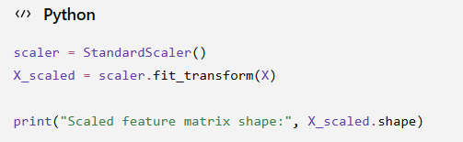
Code 1: Feature standardization using StandardScaler

7.3 Determining the Number of Clusters
Selecting an appropriate number of clusters is an important step in K-Means clustering. In this analysis, two evaluation techniques were used: the Elbow Method and the Silhouette Score.
The Elbow Method evaluates the within-cluster sum of squared distances, represented by inertia. K-Means models were tested for values of K ranging from 2 to 10. As the number of clusters increases, the inertia generally decreases because observations are divided into more groups. The point where the reduction in inertia becomes less pronounced can provide an indication of a suitable number of clusters.
The Silhouette Score was also used to evaluate the quality of the clustering. It measures how similar an observation is to observations within its own cluster compared with observations in other clusters. The score generally ranges from -1 to 1, with higher values indicating better-defined separation between clusters.
The Elbow Method was calculated using the complete standardized dataset. However, calculating the Silhouette Score on all 45,175 observations required substantial computation time. Therefore, a reproducible sample of 10,000 observations was used for Silhouette Score evaluation. A fixed random state of 42 was used so that the same sample could be reproduced.

7.3.1 Elbow Method
K-Means models were evaluated for K values from 2 through 10. The resulting inertia values were plotted to observe how the within-cluster variation changed as the number of clusters increased.
The inertia decreased substantially as K increased. The reduction became less pronounced around K = 4 to K = 5, indicating that this region could be considered from the perspective of the Elbow Method.
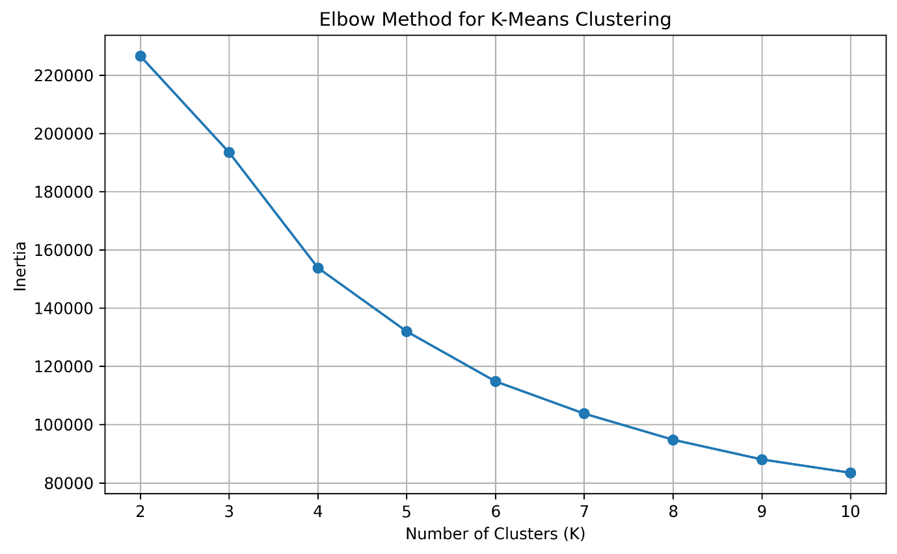
Figure 1: Elbow Method for Selecting the Number of Clusters

7.3.2 Silhouette Score
Silhouette Scores were calculated for K values from 2 through 10 using a reproducible sample of 10,000 observations. The results provided a quantitative measure for comparing the separation and cohesion of the tested cluster configurations.
The highest Silhouette Score was obtained for K = 2, with a score of approximately 0.5111. The scores for the remaining values of K were considerably lower, ranging from approximately 0.1944 to 0.2459.
The Silhouette Score therefore provided stronger evidence for selecting K = 2 than the Elbow Method alone. The Elbow Method results were retained as an additional model-selection diagnostic.
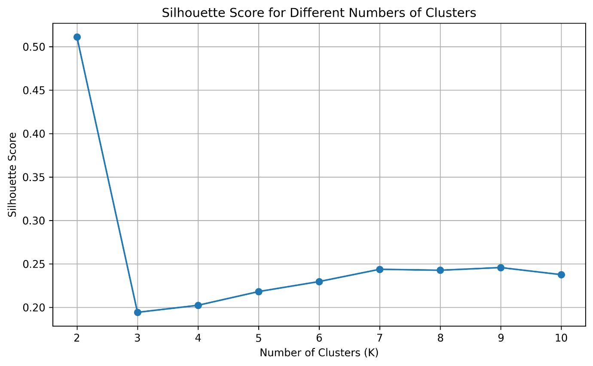
Figure 2: Silhouette Score for Different Numbers of Clusters

7.3.3 Selection of K
Based on the evaluation results, K = 2 was selected for the final K-Means clustering model. The selection was primarily supported by the highest Silhouette Score of approximately 0.5111. Although the Elbow Method showed a less pronounced reduction in inertia around K = 4 to K = 5, the Silhouette Score provided a clearer quantitative separation among the tested configurations.
Therefore, the final clustering model was configured with two clusters and was subsequently fitted to the complete standardized dataset.

7.4 Final K-Means Clustering Model
After evaluating different numbers of clusters, a final K-Means model with K = 2 was created. The model was fitted to the complete standardized dataset containing all 45,175 observations.
The K-Means algorithm was configured with random_state = 42 to make the results reproducible and n_init = 10 to run the clustering initialization multiple times and use the best resulting solution.
The model assigned every observation to one of the two resulting clusters. The cluster labels were then added to the dataset for further analysis and interpretation.

7.4.1 Final Model Code
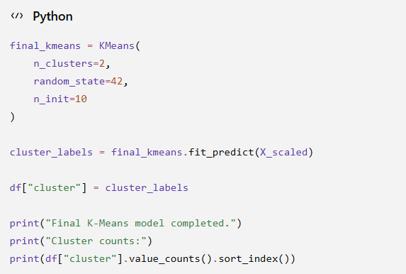
Code 2: Final K-Means model training

7.4.2 Cluster Distribution
The final model divided the 45,175 observations into two clusters. Cluster 0 contained 2,098 observations, while Cluster 1 contained 43,077 observations.
This indicates that the resulting clusters were highly imbalanced in size. Cluster 0 represented approximately 4.64% of the observations, whereas Cluster 1 represented approximately 95.36%.
The imbalance is important when interpreting the clustering results because the two groups do not represent similarly sized segments of the dataset.

7.5 Cluster Profiling
After assigning each observation to a cluster, the characteristics of the resulting groups were examined using the average values of the six numerical features used for clustering.
Cluster profiling helps identify how the groups differ from one another and provides a descriptive understanding of the observations assigned to each cluster. The analysis focused on the numerical features used during model training and did not use the income variable to define the clusters.

7.5.1 Cluster Profile Code
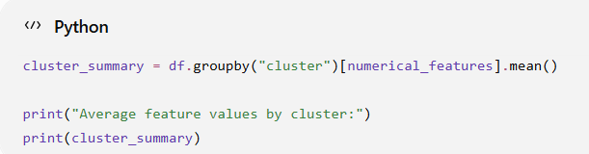
Code 3: Calculating average feature values by cluster

7.5.2 Cluster Profile Results
The average feature values for the two clusters showed several differences.
Cluster 0 contained 2,098 observations. Its average age was approximately 41.78 years, average education-num was 11.03, and average hours-per-week was 43.73. Its average capital-loss was approximately 1,898.04, while its average capital-gain was 0.
Cluster 1 contained 43,077 observations. Its average age was approximately 38.40 years, average education-num was 10.07, and average hours-per-week was 40.81. Its average capital-gain was approximately 1,156.28, while its average capital-loss was close to zero at approximately 0.57.
The most noticeable difference between the two clusters was observed in capital-loss. Cluster 0 had a substantially higher average capital-loss than Cluster 1. Cluster 0 also had somewhat higher average age, education-num, and hours-per-week. The average fnlwgt values were relatively similar between the two clusters.
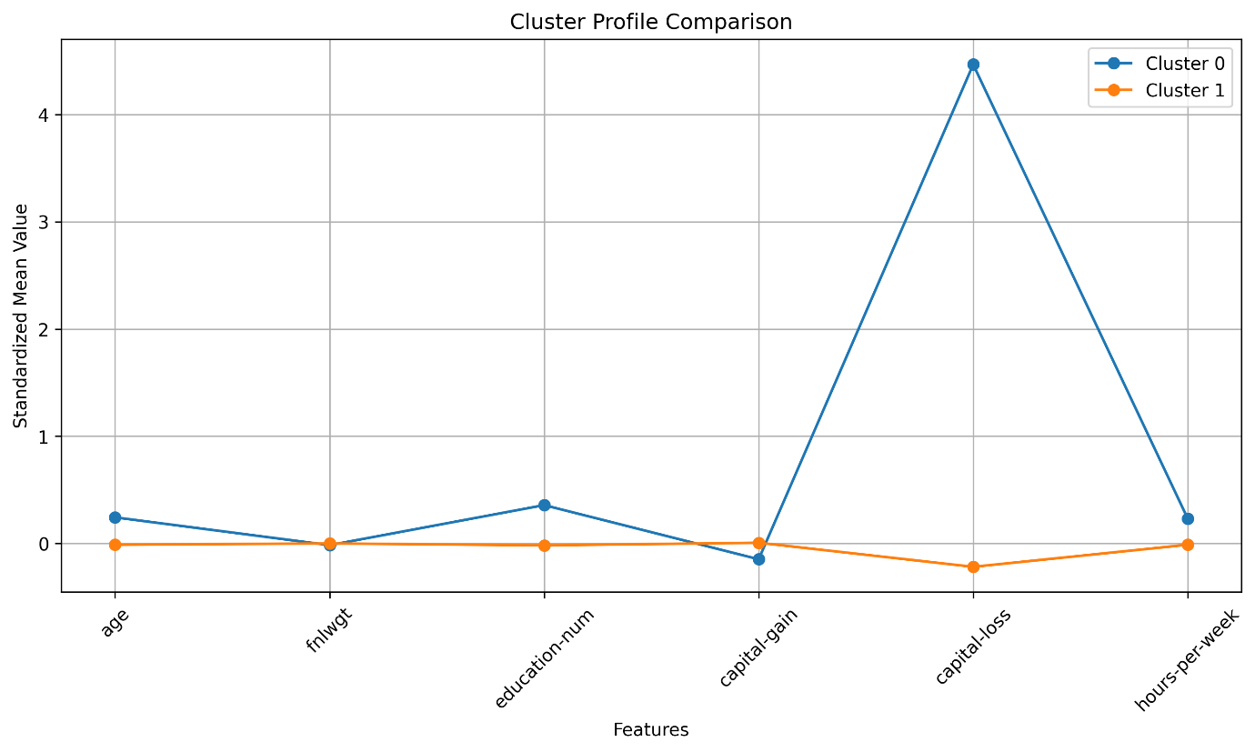
Figure 3: Standardized Cluster Profile Comparison
The standardized cluster profile visualization makes the relative differences between the clusters easier to compare. The largest separation is visible for capital-loss, while the differences in age, education-num, and hours-per-week are comparatively smaller. The similarity in fnlwgt between the two clusters is also visible.

7.6 Post-Clustering Income Analysis
After the clusters were created, the income variable was examined to understand how the existing income categories were distributed across the resulting clusters.
It is important to note that income was not used as an input feature during clustering. Therefore, the income distributions shown in this analysis are a post-clustering descriptive analysis rather than a prediction or classification result.
The percentage distribution of income categories within each cluster was calculated using a cross-tabulation.

7.6.1 Income Distribution Code
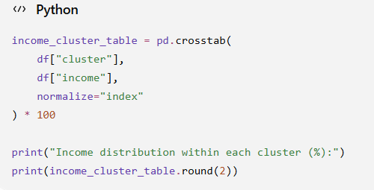
Code 4: Income distribution cross-tabulation by cluster

7.6.2 Income Distribution Results
The income distribution differed between the two clusters.
In Cluster 0, approximately 47.76% of observations belonged to the <=50K category, while 52.24% belonged to the >50K category. The two income categories were therefore relatively balanced within this cluster.
In Cluster 1, approximately 76.54% of observations belonged to the <=50K category, while 23.46% belonged to the >50K category. The <=50K category therefore represented the larger proportion of observations in this cluster.
These percentages describe the composition of the clusters after clustering. They should not be interpreted as evidence that the clustering model predicts income, because income was excluded from the clustering features.
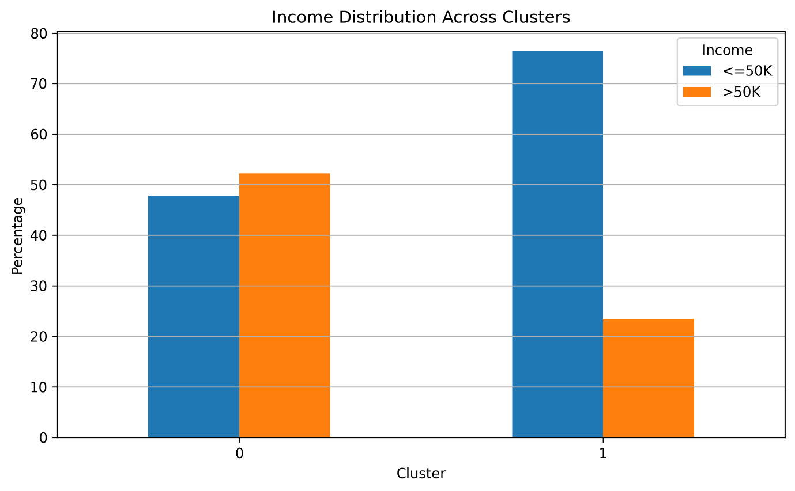
Figure 4: Income Distribution Across Clusters
The visualization provides a direct comparison of the income-category composition of the two clusters. Cluster 0 shows a relatively even distribution between the two income categories, whereas Cluster 1 contains a larger proportion of observations in the <=50K category.

8. Results and Discussion
The K-Means clustering analysis produced two clusters from the 45,175 observations in the cleaned Adult Income dataset. The clustering results were evaluated using the Elbow Method and Silhouette Score, followed by analysis of cluster sizes, feature averages, and post-clustering income distributions.
The results indicate that the selected numerical features can be used to divide the observations into two groups with noticeably different numerical profiles. However, the resulting cluster sizes are highly unequal, with most observations assigned to Cluster 1.
The following subsections summarize the main findings from the clustering analysis.

8.1 Cluster Size Results
The final K-Means model produced the following cluster distribution:
Cluster | Number of Observations | Percentage
Cluster 0 | 2,098 | 4.64%
Cluster 1 | 43,077 | 95.36%
Total | 45,175 | 100%

Cluster 1 contains the large majority of observations, while Cluster 0 represents a much smaller group. This imbalance should be considered when interpreting the characteristics of the clusters.

8.2 Feature-Level Comparison
The cluster profiles showed that the strongest difference between the two groups occurred in capital-loss. Cluster 0 had an average capital-loss of approximately 1,898.04, compared with approximately 0.57 for Cluster 1.
Cluster 0 also had a somewhat higher average age (41.78 compared with 38.40), higher education-num (11.03 compared with 10.07), and higher hours-per-week (43.73 compared with 40.81).
The average fnlwgt values were relatively close between the two clusters, at approximately 188,121.71 for Cluster 0 and 189,817.56 for Cluster 1.
These differences describe the numerical characteristics of the resulting groups. They should not be interpreted as causal relationships.

8.3 Income Distribution Across Clusters
The post-clustering analysis showed different income-category distributions between the two groups. Cluster 0 contained approximately 52.24% observations in the >50K category and 47.76% in the <=50K category. Cluster 1 contained approximately 23.46% in the >50K category and 76.54% in the <=50K category.
This difference provides an additional descriptive perspective on the clusters. However, because income was not included in the clustering features, these results represent an observed association after clustering rather than a classification result.

9. Challenges and How They Were Addressed
Several practical challenges were encountered during the clustering analysis. These challenges were addressed while maintaining reproducibility and ensuring that the final results were based on the complete dataset where appropriate.

9.1 Computational Time for Silhouette Score
The initial attempt to calculate Silhouette Scores using all 45,175 observations required a very long execution time. Since calculating the Silhouette Score involves distance-based computations, applying it directly to the complete dataset was computationally expensive.
To address this issue, a reproducible sample of 10,000 observations was selected using a fixed random state of 42. Silhouette Scores for K values from 2 through 10 were then calculated using this sample. This reduced the computational requirement while maintaining a consistent evaluation process.
The final K-Means model itself was still fitted to the complete dataset of 45,175 observations.

9.2 Different Feature Scales
The selected numerical features had substantially different numerical ranges. Features such as fnlwgt, capital-gain, and capital-loss contained values much larger than features such as age and hours-per-week.
Since K-Means relies on distance calculations, using the raw feature values could allow larger-scale variables to have a greater influence on the clustering process. StandardScaler was therefore applied before clustering so that the selected features were placed on a comparable standardized scale.

9.3 Unequal Cluster Sizes
The final clustering produced highly unequal cluster sizes. Cluster 0 contained 2,098 observations, while Cluster 1 contained 43,077 observations.
This imbalance was retained rather than artificially modifying the clusters because it represents the result produced by the selected K-Means configuration. The imbalance was considered when interpreting the final cluster characteristics and post-clustering income distributions.

9.4 Interpreting the Clusters
Another challenge was interpreting clusters generated without a predefined target variable. The cluster labels themselves do not have inherent meanings such as “high income” or “low income.” Therefore, the clusters were interpreted using their numerical feature profiles and by examining income only as a post-clustering descriptive variable.
This approach avoids assigning unsupported meanings to the clusters and keeps the interpretation based on the observed characteristics of the data.

10. Limitations
Although the clustering analysis successfully identified two groups within the dataset, several limitations should be considered when interpreting the results.
- Dependence on selected features: The clustering model used only six numerical variables. The excluded categorical variables may contain additional information that could influence how observations are grouped.
- Sensitivity to feature representation: K-Means clustering depends on numerical distances. Although the features were standardized, the resulting clusters can still be affected by the choice of features and preprocessing method.
- Unequal cluster sizes: The final clusters were highly imbalanced, with Cluster 0 containing 2,098 observations and Cluster 1 containing 43,077 observations. Therefore, the clusters should not be interpreted as equally sized population segments.
- Silhouette Score sampling: The Silhouette Score was calculated using a reproducible sample of 10,000 observations rather than all 45,175 observations because the full calculation was computationally expensive. Consequently, the reported Silhouette Scores represent the selected sample.
- Choice of K: The Elbow Method and Silhouette Score did not point to exactly the same region. The Elbow Method showed a less pronounced decline around K = 4 to K = 5, while the highest Silhouette Score occurred at K = 2. The final selection therefore relied primarily on the Silhouette Score.
- K-Means assumptions: K-Means is based on distance measurements and cluster centroids. It may not capture all possible types of structure within a dataset, particularly when groups have irregular shapes or substantially different densities.
- Descriptive interpretation: The post-clustering income analysis shows an association between the resulting clusters and income categories. It does not establish causation and should not be interpreted as an income prediction model.

11. Conclusion
This project successfully applied an unsupervised machine learning approach to the cleaned Adult Income dataset using K-Means clustering. The analysis used six numerical features — age, fnlwgt, education-num, capital-gain, capital-loss, and hours-per-week — after standardizing them to a common scale.
The Elbow Method and Silhouette Score were used to evaluate different numbers of clusters. While the Elbow Method showed a less pronounced reduction in inertia around K = 4 to K = 5, the highest Silhouette Score was obtained for K = 2 with a score of approximately 0.5111. Based primarily on the Silhouette Score, K = 2 was selected for the final model.
The final K-Means model was trained on all 45,175 observations and produced two clusters. Cluster 0 contained 2,098 observations, while Cluster 1 contained 43,077 observations. Cluster profiling showed that the largest numerical difference between the groups was observed in capital-loss, with additional differences in age, education-num, and hours-per-week.
Income was excluded from the clustering process and was examined only after the clusters had been created. The resulting income distributions provided additional descriptive information about the composition of the clusters but were not used as a prediction or classification result.
Overall, the project demonstrated the complete workflow of an unsupervised clustering task, including feature selection, standardization, model evaluation, K-Means training, cluster profiling, visualization, and interpretation. The analysis also highlighted the importance of considering computational limitations, cluster imbalance, feature selection, and model assumptions when interpreting clustering results.

12. Future Work
The clustering analysis can be extended in several ways to obtain a broader understanding of the dataset and evaluate alternative approaches.
- Include additional feature representations: Categorical variables could be transformed into suitable numerical representations and incorporated into clustering to capture characteristics that were not included in the current analysis.
- Evaluate additional clustering algorithms: Other unsupervised learning techniques, such as hierarchical clustering or DBSCAN, could be explored and compared with K-Means.
- Experiment with different feature selections: Different combinations of numerical variables could be tested to examine how feature selection affects the resulting clusters.
- Evaluate clustering stability: The consistency of the clusters could be examined using different random samples, initialization settings, or validation approaches.
- Explore alternative dimensionality-reduction techniques: Methods such as Principal Component Analysis (PCA) could be investigated to reduce the dimensionality of the feature space and visualize cluster structure more effectively.
- Perform deeper cluster analysis: Additional statistical comparisons could be conducted to better understand the differences between the identified groups.
These extensions could provide additional perspectives on the structure of the Adult Income dataset and help evaluate whether similar groupings are obtained using alternative features and clustering techniques.

13. References
1. UCI Machine Learning Repository. Adult Dataset. University of California, Irvine.
2. Pedregosa, F., et al. (2011). Scikit-learn: Machine Learning in Python. Journal of Machine Learning Research, 12, 2825–2830.
3. McKinney, W. Python for Data Analysis. O’Reilly Media.
4. Harris, C. R., et al. (2020). Array Programming with NumPy. Nature, 585, 357–362.
5. Hunter, J. D. (2007). Matplotlib: A 2D Graphics Environment. Computing in Science & Engineering, 9(3), 90–95.
6. Lloyd, S. (1982). Least Squares Quantization in PCM. IEEE Transactions on Information Theory, 28(2), 129–137.

