WEEK 1 — DATA CLEANING AND PREPROCESSING
Adult Income Dataset
Data Science with Python Internship
Submitted by
Keerthi Chandrika Mallela
Dataset Source
UCI Machine Learning Repository
Dataset
Adult / Census Income Dataset

1. Executive Summary
This report documents the data acquisition, exploration, quality assessment, cleaning, and preprocessing performed on the Adult Income dataset as part of Week 1 of the Data Science with Python internship.
The objective of this work was to understand the structure and quality of the dataset, identify missing and unknown values, inspect duplicate records and unusual numerical values, and prepare a cleaner dataset for subsequent analysis.
The original dataset contained 48,842 records and 15 columns, including demographic, education, employment, financial, and working-hours information. During the data-quality assessment, missing and unknown values were identified in several categorical columns, duplicate records were investigated, and numerical variables were examined for unusual values.
The cleaning process included converting unknown values represented by “?” into missing values, standardizing the income labels, removing duplicate records, and removing rows containing missing values. The resulting cleaned dataset contained 45,175 records and 15 columns, with no missing values or duplicate rows remaining.
The decisions made during preprocessing were documented based on the observed characteristics of the dataset. Extreme numerical values were investigated but were not automatically removed because there was insufficient evidence to classify them as erroneous.

2. Introduction
The Adult Income dataset was selected for the Week 1 data cleaning and preprocessing task. The dataset contains demographic, education, employment, financial, and working-hours information, along with an income category.
The purpose of this work was not to build a predictive model at this stage, but to understand the quality and structure of the raw data and prepare it for reliable analysis in later stages of the internship.
The dataset was first explored to understand its dimensions, column names, data types, categorical values, numerical ranges, missing values, unknown values, and duplicate records. Data-quality issues were then investigated before applying the cleaning procedures.

2.1 Objectives
The main objectives of this Week 1 task were:
- Acquire a publicly available dataset suitable for data analysis.
- Examine the structure, dimensions, columns, and data types of the dataset.
- Identify missing values and unknown values represented in the dataset.
- Investigate categorical variables for inconsistent or unexpected entries.
- Examine numerical variables for unusual or extreme values.
- Identify and investigate duplicate records.
- Clean and preprocess the dataset using Python and Pandas.
- Document the reasoning behind each major cleaning decision.
- Verify the quality of the cleaned dataset.
- Save the cleaned dataset for use in subsequent analysis and modeling tasks.

3. Dataset Description
The dataset used in this project is the Adult Income dataset, also known as the Census Income dataset. It is a publicly available dataset from the UCI Machine Learning Repository.
The dataset contains demographic, education, employment, financial, and working-hours information. The target variable represents whether an individual's annual income falls into the lower-income or higher-income category.
The dataset was selected because it contains a mixture of numerical and categorical variables and includes real data-quality issues such as missing values, unknown entries, duplicate records, and unusual numerical values. These characteristics make it suitable for demonstrating data exploration and preprocessing techniques.

3.1 Dataset Information
Item | Details
Dataset Name | Adult / Census Income Dataset
Source | UCI Machine Learning Repository
Original Records | 48,842
Number of Columns | 15
Data Types | Numerical and categorical
Task Type | Income classification
Dataset Status | Publicly available

3.2 Dataset Variables
The dataset contains 15 columns. The main variables represent age, employment information, education, marital status, occupation, relationship, race, sex, capital gains, capital losses, hours worked per week, country of origin, and income.
The numerical variables include age, fnlwgt, education-num, capital-gain, capital-loss, and hours-per-week. The remaining variables are primarily categorical.
The “income” column was treated as the target variable for the dataset and contained income labels that required standardization during preprocessing.

4. Tools and Technologies
The following tools and technologies were used to complete the Week 1 data cleaning and preprocessing task:
- Python – Used as the primary programming language for data analysis and preprocessing.
- Pandas – Used to load, inspect, transform, clean, and save the dataset.
- Matplotlib – Used to create visualizations for the data-quality assessment.
- Google Colab – Used as the development environment for executing Python code and analyzing the dataset.
- Jupyter Notebook format – Used to organize the analysis into code, outputs, explanations, and conclusions.
- UCI Machine Learning Repository – Used as the source of the publicly available Adult Income dataset.

5. Methodology
The Week 1 workflow followed a systematic data-cleaning process.
First, the publicly available dataset was acquired and loaded into Python. The dataset was then combined into a single DataFrame containing the input features and target variable.
The initial exploration focused on understanding the dataset dimensions, column names, data types, descriptive statistics, categorical values, and target labels.
Next, data-quality checks were performed to identify missing values, unknown values represented by “?”, duplicate records, and unusual numerical values. Missing-value patterns were also examined to understand how many records were affected.
After the quality assessment, the dataset was cleaned. Unknown values represented by “?” were converted into missing values, duplicate records were removed, income labels were standardized, and records containing missing values were removed.
Finally, the cleaned dataset was verified by checking its dimensions, missing-value count, duplicate count, and standardized income categories. Visualizations were also created to support the data-quality assessment.

6. Initial Dataset Exploration
The dataset was first inspected to understand its overall structure before any cleaning operations were performed.
The original dataset contained 48,842 records and 15 columns. The columns included both numerical and categorical variables covering demographic, education, employment, financial, and working-hours information.
The dataset was loaded into a Pandas DataFrame and inspected using methods such as shape, columns, info(), and describe(). These checks provided an initial understanding of the dataset dimensions, data types, numerical ranges, and categorical information.

6.1 Dataset Dimensions
The initial dimensions of the dataset were:
- Number of records: 48,842
- Number of columns: 15
The feature data contained 14 columns, while the income column represented the target variable.

6.2 Data Types
The dataset contained a combination of integer and categorical/object columns.
The numerical columns were:
- age
- fnlwgt
- education-num
- capital-gain
- capital-loss
- hours-per-week
The categorical columns included workclass, education, marital-status, occupation, relationship, race, sex, native-country, and income.
Understanding the data types was important because numerical and categorical variables require different approaches during data-quality assessment and preprocessing.

6.3 Numerical Data Summary
The numerical variables were examined to understand their ranges before cleaning.
The observed ranges included:
- Age: 17 to 90
- fnlwgt: 12,285 to 1,490,400
- education-num: 1 to 16
- capital-gain: 0 to 99,999
- capital-loss: 0 to 4,356
- hours-per-week: 1 to 99
These ranges were recorded as part of the initial data investigation and were later used when examining unusual numerical values.

7. Data Quality Assessment

7.1 Missing and Unknown Values
The dataset was examined for missing values and unknown entries before cleaning. During the initial inspection, some categorical columns contained the value “?”, which represented unknown information rather than a meaningful category.
The columns containing “?” values included workclass, occupation, and native-country. These values were treated as missing information during preprocessing so that they could be handled consistently.
After replacing “?” with missing values, the number of missing values identified was:
- workclass: 2,799
- occupation: 2,809
- native-country: 857
In total, 3,620 records initially contained at least one missing or unknown value.
Column | Missing / Unknown Values
workclass | 2,799
occupation | 2,809
native-country | 857

7.1.1 Missing-Value Handling Decision
The unknown values were converted from “?” to missing values so that they could be identified and handled consistently.
Rows containing missing values were removed during preprocessing rather than being filled with estimated values. This decision was made because the affected variables were categorical and the missing entries did not provide enough information to confidently determine their correct categories.
The removal of these records reduced the number of observations available for subsequent analysis. This trade-off was accepted in order to produce a dataset with complete values for the variables used in later analysis.

7.2 Categorical Value Inspection
The categorical variables were inspected to identify unexpected, inconsistent, or unknown entries.
The workclass, occupation, and native-country columns contained unknown values represented by “?”. These were addressed as missing values during preprocessing.
The income column also required attention because the same income categories appeared with and without a trailing period. Before standardization, the observed labels were:
- <=50K
- <=50K.
- >50K
- >50K.
The labels with and without the trailing period represented the same two income categories. Therefore, the trailing period was removed so that equivalent categories were represented consistently.
Original Income Label | Number of Records
<=50K | 24,720
<=50K. | 12,435
>50K | 7,841
>50K. | 3,846

7.2.1 Income Label Standardization
The income labels were standardized by removing the trailing period from labels that contained it. This converted the four observed representations into two consistent categories: <=50K and >50K.
After standardization, the income column contained:
- <=50K: 37,128
- >50K: 11,685
Standardizing these labels was necessary because otherwise the same income category would be treated as separate categories during analysis.

7.3 Duplicate Record Investigation
Duplicate records were investigated to determine whether the dataset contained repeated observations.
The initial duplicate check identified 29 duplicate rows. These records were removed during the first stage of duplicate cleaning.
After the income labels were standardized, an additional 19 duplicate rows became identical because records that previously differed only by the trailing period in the income label now had the same standardized values.
These additional duplicates were therefore removed during the final duplicate check.

7.3.1 Duplicate Removal Summary
Cleaning Stage | Duplicate Records Removed
Initial duplicate removal | 29
Duplicate removal after income standardization | 19

A final duplicate check was performed after all major standardization steps. This check was important because standardizing values can cause previously different records to become identical.
After the final duplicate removal, the cleaned dataset contained zero duplicate rows.

7.4 Numerical Data and Unusual Value Investigation
The numerical variables were examined for values that appeared unusually high or low based on their observed ranges.
The following observations were identified during the investigation:
- 244 records had a capital-gain value of 99,999.
- 2,282 records had a capital-loss value greater than 0.
- 700 records had fewer than 10 hours worked per week.
- 318 records had more than 80 hours worked per week.
- 595 records had an age below 18.
- 148 records had an age above 80.

7.4.1 Decision Regarding Unusual Values
The unusual numerical values were investigated but were not automatically removed.
An unusually high or low value is not necessarily an erroneous value. For example, working more than 80 hours per week or having a very high capital-gain value may represent legitimate observations in the source dataset.
Because there was no sufficient evidence from the dataset inspection to conclude that these values were data-entry errors, they were retained. Removing them without evidence could result in unnecessary loss of information and could alter the characteristics of the dataset.
Therefore, the unusual values were documented as part of the data-quality assessment rather than treated as errors.

7.5 Missing-Value Pattern Analysis
The distribution of missing values across records was also examined to understand how widespread the missing-data issue was.
Before cleaning, 3,620 records contained at least one missing or unknown value, while 45,222 records did not contain any missing or unknown values.
After the initial removal of 29 duplicate records, 3,619 records remained affected by missing values. These records were subsequently removed during the cleaning process.

7.5.1 Impact of Missing-Value Removal
Removing records containing missing values reduced the number of observations available for analysis. However, the resulting dataset contained complete values across all columns.
The trade-off was between retaining more observations through imputation and maintaining a dataset based entirely on observed values. For this Week 1 preprocessing task, complete-case cleaning was selected because the affected fields were primarily categorical and their missing values could not be reliably inferred from the available information.

8. Data Cleaning and Preprocessing
The data cleaning process was performed systematically after the initial data-quality assessment. Each cleaning operation was applied based on an issue identified during the exploration stage.
The main preprocessing steps were:
- Converting unknown values represented by “?” into missing values.
- Removing duplicate records.
- Standardizing the income labels.
- Removing records containing missing values.
- Performing a final duplicate check after standardization.
- Resetting the DataFrame index after the final cleaning operations.

8.1 Converting Unknown Values to Missing Values
The dataset used the character “?” to represent unknown values in several categorical columns. These values were replaced with Pandas missing values (NaN / NA) so that they could be consistently identified and handled during preprocessing.
After this conversion, the missing values were identified in the workclass, occupation, and native-country columns.
This step did not remove any records. It only changed the representation of unknown values so they could be properly handled in subsequent cleaning steps.

8.2 Initial Duplicate Removal
An initial duplicate check identified 29 duplicate rows in the original dataset.
These duplicate records were removed before handling the missing values. After this operation, the dataset contained 48,813 records.

8.3 Income Label Standardization
The income column contained four representations of two income categories because some labels included a trailing period.
The trailing period was removed from the income labels so that <=50K and <=50K. became the same category, and >50K and >50K. became the same category.
After standardization, the income column contained two consistent categories:
- <=50K: 37,128 records
- >50K: 11,685 records

8.4 Removing Records with Missing Values
After converting the unknown values into missing values, records containing at least one missing value were removed.
After the initial duplicate removal, 3,619 records contained missing values and were removed.
The dataset was reduced from 48,813 records to 45,194 records after this operation.

8.5 Final Duplicate Check
A final duplicate check was performed after the income labels had been standardized and missing-value records had been removed.
This check identified 19 additional duplicate rows. These duplicates became identical after the income labels were standardized, so they were removed from the dataset.
After removing these 19 records, the final cleaned dataset contained 45,175 records.

8.6 Final Cleaning Result
The final cleaned dataset contained 45,175 records and 15 columns.
The final verification confirmed that:
- Missing values: 0
- Duplicate rows: 0
- Income categories: <=50K and >50K
- <=50K records: 33,973
- >50K records: 11,202
A total of 3,667 records were removed from the original dataset during the complete cleaning process.
Metric | Before Cleaning | After Cleaning
Records | 48,842 | 45,175
Columns | 15 | 15
Missing values | Present | 0
Duplicate rows | Present | 0

9. Data Visualization and Findings
Data visualizations were created to support the data-quality assessment and provide a descriptive overview of the cleaned dataset.
The visualizations included a missing-value bar chart, an income-category bar chart, and histograms for age, education-num, and hours-per-week.

9.1 Missing Values Before Cleaning
The missing-value visualization shows that missing or unknown information was concentrated in the workclass, occupation, and native-country columns.
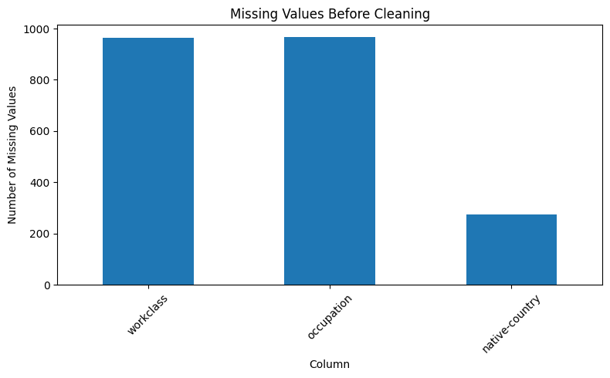
Figure 1: Missing Values Before Cleaning
This visualization supports the earlier data-quality assessment and shows why these fields required preprocessing before further analysis.

9.2 Income Distribution After Cleaning
The income distribution visualization shows the number of records in each standardized income category after cleaning.
The cleaned dataset contained 33,973 records in the <=50K category and 11,202 records in the >50K category.
The visualization confirms that the income labels were successfully standardized into two categories.
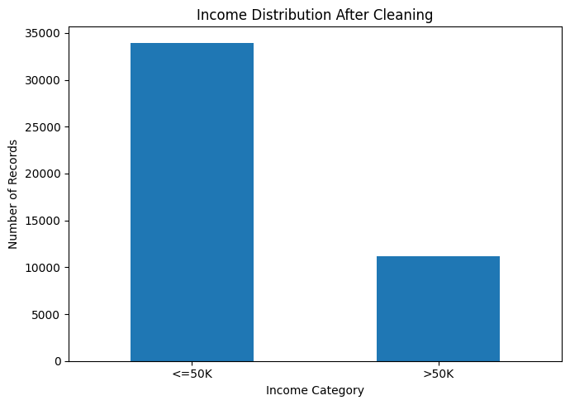
Figure 2: Income Distribution After Cleaning

9.3 Numerical Variable Distributions
Histograms were created for age, education-num, and hours-per-week.
The age histogram provides an overview of the age distribution in the cleaned dataset. The education-num histogram shows the distribution of the numerical representation of education level. The hours-per-week histogram provides an overview of the number of hours worked per week.
These visualizations are descriptive and were used to support understanding of the dataset rather than to make predictive conclusions.
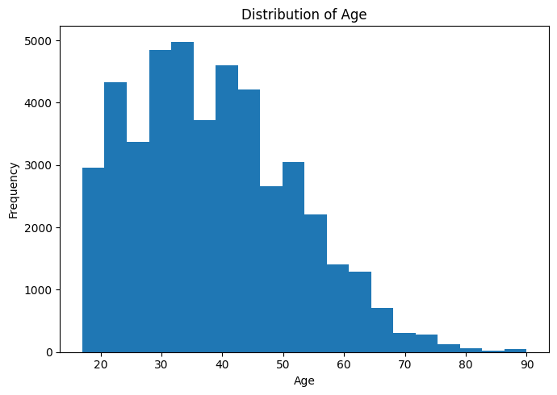
Figure 3: Age Distribution
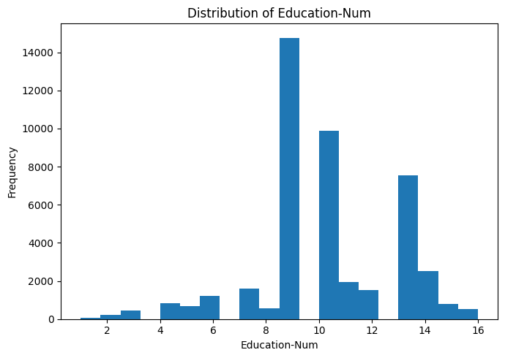
Figure 4: Education Number Distribution
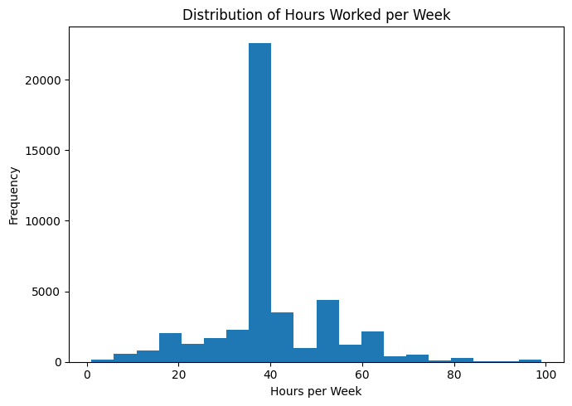
Figure 5: Hours-per-Week Distribution

10. Impact of Data Cleaning
The data cleaning process improved the consistency and usability of the dataset for subsequent analysis.
The original dataset contained 48,842 records. After removing duplicate records, handling missing and unknown values, standardizing the income labels, and performing the final duplicate check, the cleaned dataset contained 45,175 records.
The cleaning process removed a total of 3,667 records. The reduction in dataset size represents a trade-off between retaining observations and ensuring that the final dataset contains complete and consistently formatted records.
Missing and unknown values were removed rather than imputed because the affected variables were primarily categorical and their original values could not be reliably determined from the available information. Income labels were standardized so that equivalent categories were represented consistently.
The numerical values identified during the quality assessment were retained because there was insufficient evidence to classify them as data-entry errors. This prevented potentially valid observations from being removed unnecessarily.
After cleaning, the dataset contained no missing values and no duplicate rows. The resulting dataset is therefore more consistent and suitable for the exploratory analysis and machine learning tasks planned for the following weeks.

11. Challenges and Limitations
During the data cleaning and preprocessing process, several challenges were identified.
One challenge was the presence of unknown values represented by the character “?” in categorical columns. These values had to be identified and converted into missing values before they could be handled consistently.
Another challenge was the presence of duplicate records. An initial duplicate check identified duplicate rows, but additional duplicate records appeared after the income labels were standardized. Therefore, a final duplicate check was necessary after the preprocessing steps.
The dataset also contained numerical values that appeared unusually high or low. However, determining whether these values were genuine observations or data-entry errors was not always possible from the dataset alone. Therefore, these values were retained rather than removed without sufficient evidence.
A limitation of the cleaning approach was the removal of records containing missing values. Although this produced a complete dataset, it also reduced the number of available observations. Alternative approaches such as categorical imputation could be explored in future work.
These challenges highlight the importance of performing data-quality checks before applying statistical analysis or machine learning models.

12. Conclusion
The Week 1 data cleaning and preprocessing task provided a systematic understanding of the Adult Income dataset and its data-quality characteristics.
The dataset was examined for its structure, data types, missing and unknown values, categorical inconsistencies, duplicate records, and unusual numerical values. The identified issues were addressed through a series of preprocessing steps, including converting unknown values into missing values, removing duplicate records, standardizing income labels, and removing records containing missing values.
After preprocessing, the final dataset contained 45,175 records and 15 columns, with no missing values or duplicate rows. The income categories were also standardized into two consistent categories: <=50K and >50K.
The cleaning decisions were made based on the observed characteristics of the dataset, while unusual numerical values were retained when there was insufficient evidence that they represented errors.
The resulting cleaned dataset provides a consistent foundation for the exploratory analysis, clustering, supervised learning, and other data science tasks planned for the subsequent weeks of the internship.

13. References
UCI Machine Learning Repository. Adult Dataset / Census Income Dataset.
Dataset source used for the Week 1 data cleaning and preprocessing task.
Pandas Documentation. Pandas User Guide.
Documentation consulted for data loading, inspection, cleaning, transformation, and analysis.
Matplotlib Documentation. Matplotlib User Guide.
Documentation consulted for creating data visualizations.

