Code4Lib 2010 | 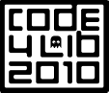 | February 22-25, Asheville, NC

Welcome to Asheville!
Code4Lib 2010 is being hosted by Appalachian State University, Western Carolina University, and the University of North Carolina at Asheville. All conference events are in the Renaissance Asheville Hotel. We hope that you will have fun, learn a lot, and want to come back next year!

If you are lost or have questions in Asheville you can reach Kevin Clarke at 828-278-9478.

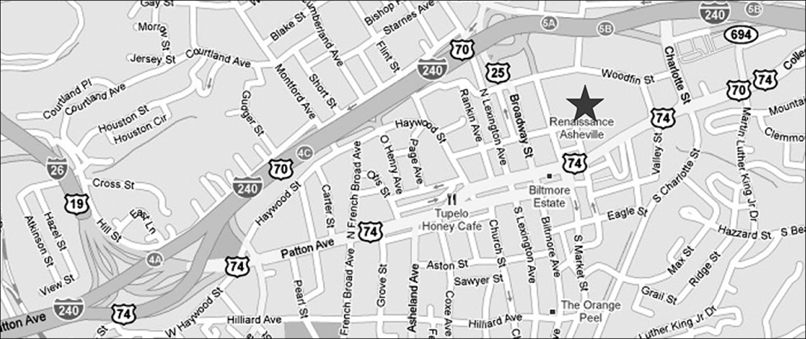

About Code4Lib
Code4Lib is a community of people interested in the intersection of libraries, technology, and the future. Communication takes place in a fluid environment that shifts with technology trends: currently active arenas include email lists, a wiki, blogs, a quarterly journal, and of course IRC.

Code4Lib is a participatory conference. Here are some ways to get involved.

- Sign up to speak, or propose a breakout session! A flip chart will be available to sign up.

- Sign up for a social event! http://wiki.code4lib.org/index.php/C4L2010_social_activities

- Join the IRC chat! http://code4lib.org/irc/ or http://webchat.freenode.net/ Channel:#code4lib

- Check out the Hospitality Suite: 1114 (“open when a warm body is there”)

- When tagging web content use the conference tag c4l10, or the hashtag #c4l10 in Twitter.

Always remember: “If you want to participate, just do it. If you want to lead, just do it. Don't expect anyone to appoint you to anything, because we won't. If you see something that should be done, simply step forward and do it.” —Roy Tennant
Code4Lib 2010 |  | Program (page 1)

Monday, February 22nd (preconferences)

Morning (09:00 - 12:00) | Afternoon (13:30-16:30)
Solr White Belt - Bess Sadler  Salon Ballroom A | Blacklight - Naomi Dushay, Jessie Keck, Bess Sadler  Salon Ballroom A
Hacker 101/102 - Dan Chudnov  Salon Ballroom B | Hacker 201/202 - Dan Chudnov  Salon Ballroom B
Solr Black Belt - Erik Hatcher & Naomi Dushay
Salon Ballroom C2
Web Services & Widgets - Godmar Back & Annette Bailey  Windsor Ballroom B | Evergreen - Bill Erickson  Windsor Ballroom B
Full day - 09:00 - 16:30
Serials Solutions - Andrew Nagy & Harry Kaplanian
Oakland Heights Room - 12th floor
OCLC Web Services and Lightning Talk Demos - Roy Tennant, Karen Coombs & Alice Sneary
Salon Ballroom C1
Koha - Brendan Gallagher and Ian Walls
Swannanoa Room – 2nd floor

Check the conference buzz http://wiki.code4lib.org/index.php/Conference_Buzz

Tuesday, February 23rd

08:00-09:00 | Registration / Breakfast (provided)
09:00-09:15 | Welcome / Orientation /Housekeeping
09:15-10:00 | Keynote #1: Cathy Marshall
10:00-10:20 | Cloud4Lib - Jeremy Frumkin and Terry Reese
10:20-10:40 | Break
10:40-11:00 | The Linked Library Data Cloud: Stop talking and start doing - Ross Singer
11:00-11:20 | Do It Yourself Cloud Computing with Apache and R - Harrison Dekke
11:20-11:40 | Public Datasets in the Cloud - Rosalyn Metz and Michael B. Klein
11:40-12:00 | 7 Ways to Enhance Library Interfaces with OCLC Web Services - Karen A. Coombs
12:00-13:00 | Lunch (provided)
13:00-13:20 | Taking Control of Library Metadata & Websites Using the eXtensible Catalog - Jennifer Bowen
13:20-13:40 | Matching Dirty Data – Yet Another Wheel - Anjanette Young and Jeff Sherwood
13:40-14:00 | HIVE: A New Tool for Working With Vocabularies - Ryan Scherle and Jose Aguera
14:00-14:20 | Metadata Editing – A Truly Extensible Solution - David Kennedy and David Chandek-Stark
14:20-14:40 | Break
14:40-15:45 | Breakout Sessions 1 - see Breakout Sessions & Lightning Talks, p5
15:55-17:00 | Lightning Talks 1- see Breakout Sessions & Lightning Talks, p5
17:00-17:15 | Daily Wrap Up
Check the conference buzz http://wiki.code4lib.org/index.php/Conference_Buzz

Code4Lib 2010 |  | Program (page 2)

Wednesday, February 24th

08:00-09:00 | Breakfast (provided)
09:00-09:15 | Housekeeping, Intros
09:15-09:35 | Iterative Development Done Simply – Emily Lynema
09:35-09:55 | Vampires vs. Werewolves: Ending the War Between Developers & Sysadmins with Puppet – Bess Sadler
09:55-10:15 | I Am Not Your Mother: Write Your Test Code – Naomi Dushay, Willy Mene, and Jessie Keck
10:15-10:35 | Break
10:35-10:55 | Media, Blacklight, and Viewers Like You – Chris Beer
10:55-11:15 | Becoming Truly Innovative: Migrating from Millennium to Koha – Ian Walls
11:15-12:00 | Ask Anything! – Facilitated by Dan Chudnov
12:00-13:00 | Lunch (provided)
13:00-13:20 | A Better Advanced Search – Naomi Dushay and Jessie Keck
13:20-13:40 | Kill the Search Button – Michael Poltorak Nielsen and Jørn Thøgersen
13:40-14:00 | Enhancing Discoverability With Virtual Shelf Browse – Andreas Orphanides, Cory Lown, and Emily Lynema
14:00-14:20 | How to Implement A Virtual Bookshelf With Solr – Naomi Dushay and Jessie Keck
14:20-14:40 | Break
14:40-15:40 | Breakout Sessions 2
15:55-17:00 | Lightning Talks 2
17:00-17:15 | Daily Wrap Up
Check the conference buzz http://wiki.code4lib.org/index.php/Conference_Buzz

Thursday, February 25th

08:00-09:00 | Breakfast (provided)
09:00-09:15 | Housekeeping
09:15-10:00 | Keynote #2: Paul Jones
10:00-10:15 | Break
10:15-11:00 | Lightning Talks 3
11:00-11:20 | You Either Surf or You Fight: Integrating Library Services With Google Wave - Sean Hannan
11:20-11:40 | library/mobile: Developing a Mobile Catalog - Kim Griggs
11:40-12:00 | Mobile Web App Design: Getting Started - Michael Doran
12:00-12:15 | Wrap Up
Check the conference buzz http://wiki.code4lib.org/index.php/Conference_Buzz

Our thanks to our sponsors, and to everyone else who made this conference happen:  - The local organizers  - All speakers & session organizers  - All volunteers  - All attendees  - You! | 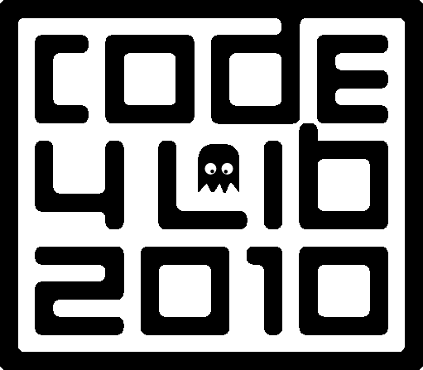  Logo by Patrick Hochstenbach

Code4Lib 2010 |  | How to Hack Code4Lib
by Declan Fleming, Director of IT, UCSD Libraries (BigD in channel)
Budget willing this year will be my third code4lib, one of my favorite conferences ever. I remember what it was like to be new and wondered if I could write a short piece that would help new people get as much out of the conference as I do.
Hop into the #code4lib IRC channel and listen for a while: The conference back channel on IRC is the most invaluable tool available to help you quickly get the feel for the conference and the people attending. Most technical people have the attention span of a gnat at times, and the channel helps keep a conversation flowing when the presentations get slow. Be warned that the level of discourse on the channel is very similar to how a group of friends would be talking around a table full of drinks. The topics range from inside jokes about bacon and sad facial hair to esoteric explorations of the RDF expression of specific pieces of metadata. The channel is also very useful for seeing where groups are going for lunch or dinner. You can find more information about IRC and how to get on it via the IRC page on the main Code4Lib site.
Listen 90% of the time / Talk 10% of the time: code4lib is jammed with characters who are passionate about some aspect of our profession. Ask a question or two then sit back and bask in the output. Don't worry, you'll have the chance to talk about what you're working on when your companion stops to drink beer.
If you don't have a lot to share, at least try to be funny: My dirty little non-secret is that I love code4lib but I'm not a programmer, or even a sysadmin anymore. I manage these type of folks and I love hearing what's new. I don't have much to offer in terms of pythons or rubies, but most people appreciate a sense of humor.
Don't be sexist/racist/*ist: It's great to be funny, maybe even a little blue at times, but be careful about steering into areas that make segments of the world uncomfortable, or even feel attacked. We are in a very interesting niche of the technology world. Our librarian population is primarily female, but our technical aspects of librarianship tend to be more stereotypically white and male. We have a wonderful opportunity to attract and promote equality in our field and there's no reason to make an underrepresented group feel unwanted just to get laughs.
One group that gets beat up on a lot is vendors. There's a healthy debate that comes and goes about whether it's good to have a place to vent, or if making vendors the butt of jokes limits their interaction in the community. One of the great strengths of the channel is that the norms are constantly in flux and openly discussed and debated.
Don't be too sensitive: Of course, political correctness can sway too far to the conservative, and what fun is that? Don't always assume that the jibe you took in the channel is meant personally. It is usually safest to always give the speaker the benefit of the doubt. So many non-verbal cues are missing in this medium, after all.
Be willing to laugh at yourself: I've found that making fun of myself is a safe outlet for being bitingly clever. And once you've shown people that you don't mind being a target, they'll let their hair down and pick on you too. Besides, why not beat everyone to the punch.
Don't be intimidated by what looks like the “in crowd”: There is no in crowd. There are people who jump in and participate - both to the conversation & the ongoing work involved in promoting and supporting code4lib. You'll see them as the center of things until you actually get involved - a little at first to learn the social norms of the group, then more and more until you realize that new people are seeing you as part of the in crowd. Now your job is to make the new people feel included.
Share your passion about any one thing: I never thought I'd stick around in libraries that long. I'm an IT professional, not a librarian. But I tell ya, being in this crowd infects you with the depth & longevity of the problems that need to be addressed. Supporting a profession that has such a long tradition, and helping to bring it into the present and future is more satisfying than I ever thought possible. I have a passion for linked data and making things talk to other things in easy ways. I've shared this a few times in bar conversations and formal talks. Nothing got people talking to me more than this.
Be ready to learn new stuff: Listen to others' passions and see if any of it strikes a chord in you. There are times when I'm listening to a talk, or in channel, and I'll just make word lists of things I've never heard of. Later, I'll start Googling around and end up a little smarter.
Expect 80% of the value of the conference to come from things other than the presentations: I used to feel mightily guilty about spending university money to sit in a presentation and feel like I got nothing from it. Adding the IRC back channel to my stream of awareness either helps me ping the crowd for more depth on the presentation, or helps me see that others are struggling as much as I am. Admittedly, the channel can be quite distracting, but if you let go and get all Zen and let it flow over and through you, you'll be surprised how much you come away with!
Take a sip from the firehose: Code4lib has a blog to stuff in your feed reader. But if you want to see what's going on in code4lib check out the planet aggregator of blogs from code4lib folks. If you have a blog and want it listed there ask jrochkind in irc. You can also follow code4lib on twitter, or consider following code4lib twitter users via code4lib lists from eby or mjgiarlo. There is also a LinkedIn group you can join for more “professional” networking.
Code4Lib 2010 |  | Breakout Sessions & Lightning Talks

Breakout sessions allow folks to discuss issues, follow up on topics from keynotes and other talks, learn more about a project or a standard, or actually work on developing a specification or hacking out useful code. The best part about the breakout sesions is that any attendee can propose and lead a session. Several rooms are available to accommodate crowds of various sizes.
Two 65-minute breakouts are scheduled, Tuesday and Wednesday, from 14:40-15:40. We’ll have flip charts available for listing breakout topics. Before the breakouts start, we’ll take a quick show of hands to divvy up the rooms according to interest. Smaller groups will just spread out in the ballroom.
A Lightning Talk is a fast-paced 5-minute talk on a topic of your choosing. Lightning talks are scheduled for 65 minutes on Tuesday and Wednesday, and 45 minutes on Thursday. Lightning talks from past conferences are linked from the conference schedules. Be sure check out the videos from 2008 and 2009!
If you’d like to give a lightning talk, please add your name and topic to the flipchart. We want to hear as many voices as possible: before giving a second talk, please be sure eveyone has spoken.
Mark Jason Dominus has a nice page about lightning talks: http://perl.plover.com/lt/lightning-talks.html
Code4Lib 2010 |  | Getting Around in Asheville

- Three bus routes travel within 5 minutes' walk of the conference hotel: Route 2, 3, & 54.
- Free fare: Near the hotel, buses are free as part of the downtown “free fare” zone!
- Bus fare outside this zone is $1. Attractions outside it are marked with an asterix (*).

For more information on the bus system, visit http://tinyurl.com/ashevillebus
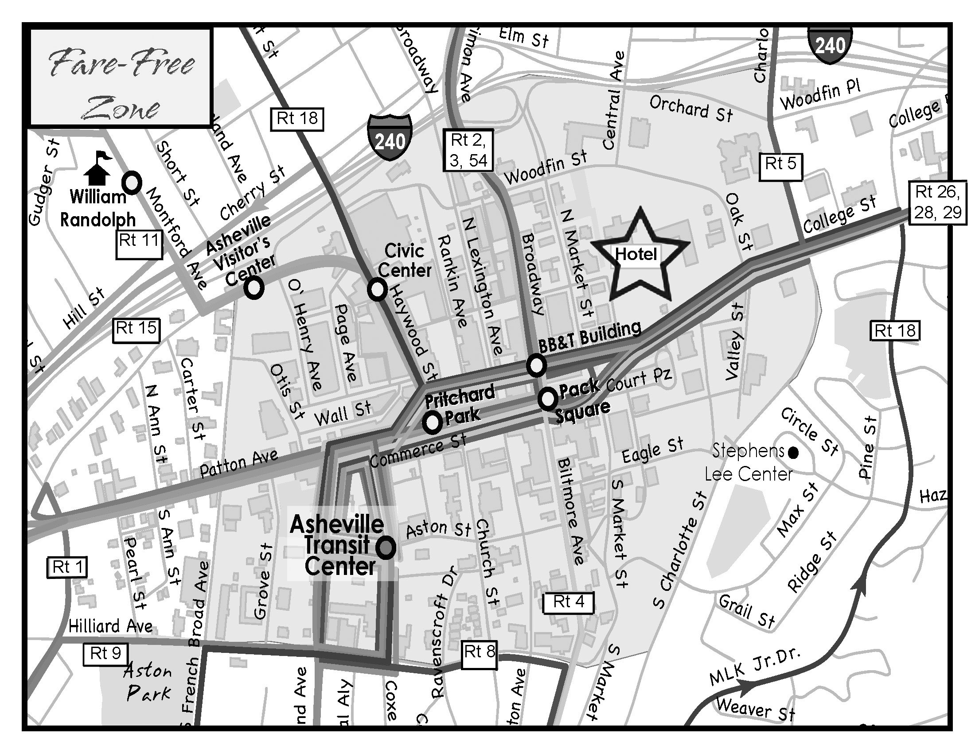
Pubs
0.2 mi Bruisin' Ales: A retail store with over 600 different beers. bruisin-ales.com
0.3 mi Mellow Mushroom Pizza Bakers: Pizza place with over 50 taps. mellowmushroom.com
0.4 mi Lexington Ave Brewery: Newly opened Gastropub in renovated 1916 building. lexavebrew.com
0.4 mi Bier Garden: A selection of over 200 beers of the world. Ashevillebiergarden.com
0.5 mi The Thirsty Monk: Specializes in Belgian and Belgian-style beers. monkpub.com
0.5 mi Barley's Taproom: 24 taps featuring the South's best selection. barleystaproom.com
0.5 mi Hannah Flanagan's Irish Pub: Some of the finest Irish draft and bottled beers.
0.8 mi Jack of the Wood: English style ales are brewed at their brewing facility. Ashevillepizza.com
3.5 mi* Westville Pub: A variety of local and regional craft beers. westvillepub.com

For a Google Map showing these points of interest, visit http://tinyurl.com/ashevillemap

Code4Lib 2010 |  | Food & Fun in Asheville
Restaurants
0.2 mi Rosetta's Kitchen: Eclectic veg*n menu featuring local, organic fare. rosettaskitchen.com
0.3 mi Wasabi Japanese Restaurant: Inventive sushi and Japananese cuisine. ichibanwasabi.com
0.3 mi Bouchon: French Country Food ashevillebouchon.com
0.3 mi Mela Indian Restaurant: Authentic North and South Indian dishes. melaasheville.com
0.4 mi Table: Farm to table New American cuisine. tableasheville.com
0.4 mi Kanpai Sushi Bar & Thai Cuisine: Sister restaurant to Wasabi Sushi.
0.4 mi Zambra Spanish Wine Tapas: The food of Spain and North Africa. zambratapas.com
0.4 mi Bistro 1896: American cuisine with a decidedly chic twist. bistro1896.com
0.5 mi Early Girl Eatery: Diverse southern dishes using local foods. earlygirleatery.com
0.5 mi Limones: Mix of Mexican and Californian cuisine. limonesrestaurant.com
0.5 mi Tupelo Honey Cafe: Southern cuisine with an uptown twist. shop.tupelohoneycafe.com
0.6 mi Laughing Seed Cafe: Veg*an options laughingseed.com
0.6 mi Jerusalem Garden Cafe: Moroccan and Mediterran cuisine at its best. jerusalem-garden.com
0.6 mi Chorizo: Best Latin fare from Spain to Argentina. chorizo-asheville.com
0.6 mi Carmel's Restaurant & Bar: Naturally raised meats, organic produce. carmelsofasheville.com
0.6 mi Thai Basil Restaurant: Thai food cooked in a natural & healthy way.
0.6 mi Modesto: A trattoria with brick wood-fired oven pizza. modesto-asheville.com
0.6 mi Kathmandu Cafe: Nepalese, Himalayan, diverse & less $$ than Mela. kathmanducafeasheville.com
0.6 mi Market Place: Restaurant acclaimed by NYT, Food & Wine, etc. marketplace-restaurant.com
0.6 mi Cats & Dawgs: Vienna Beef hot dogs, catfish sandwiches.
1.9 mi* Grove Park Inn Resort & Spa: Inn, spa, and restaurant (a full service stop). groveparkinn.com

Coffee & Dessert
0.4 mi Malaprop's Bookstore Cafe: Independent bookstore, around for 20+ years. malaprops.com
0.5 mi Double Decker Coffee Co: Gourmet coffee, teas, great hot chocolate. dbldecker.com
0.6 mi City Bakery Cafe: Coffee + European-Style breads and pastries. citybakery.net
0.6 mi True Confections: Coffee + biscuits, cookies, cakes, pies.
0.5 mi World Coffee Cafe: Organic, fair-trade, kosher, shade-grown coffees.
0.5 mi French Broad Chocolate Lounge: Handmade, organic chocolate. frenchbroadchocolates.com

Clubs/Music
0.3 mi Tressa's Downtown Jazz & Blues: Live jazz and blues every night. tressas.com
0.6 mi Orange Peel: Social Aid & Pleasure Club (Live Music). theorangepeel.net
1.4 mi* The Grey Eagle: Listening room-style concert non-smoking venue. thegreyeagle.com

Tourist attractions
4.8 mi Biltmore Estate House: The Historic home of the Vanderbilts. biltmore.com
0.6 mi* Asheville Historic Trolley: 80 minute tour of city's major interests. ashevilletrolleytours.com
0.2 mi Thomas Wolfe Memorial: One of American Lit's most famous landmarks. wolfememorial.com
0.4 mi Asheville Art Museum: Collection of 20th-21st cent. American art. Ashevilleart.org
10.4 mi* The North Carolina Arboretum: A 434 acre public education institution. ncarboretum.org
1.5 mi* Asheville Botanical Gardens: A collection of native plants. ashevillebotanicalgardens.org

Grocery stores
0.3 mi Greenlife Grocery: A full service natural foods store. greenlifegrocery.com
0.6 mi French Broad Food Co-Op: A natural foods co-op. frenchbroadfood.coop
Code4Lib 2010 |  | Supporters

Platinum Sponsor

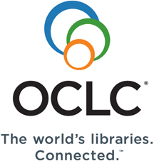

Silver Sponsors
 |  |  | 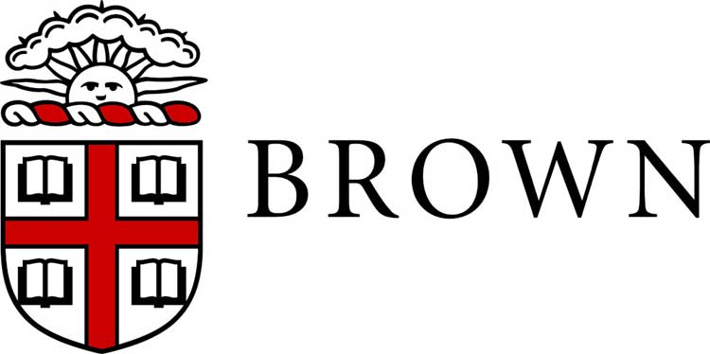

Bronze Sponsors
 | CrossRef | Princeton |  | ProQuest |  | Index Data
 | Serial Solutions |  | Talis |  | Lucid Imagination

Scholarships

Oregon State University

Brown University

Book/Software Donors
<oXygen/> XML editor
O'Reilly
APress
Manning
Pragmatic Programmers
Morgan & Claypool Publishers

