## ONLINE EXAMINATION SYSTEM MINI PROJECT REPORT

**Submitted by NEETHU GANESH**

## MZC21MCA2018

### to

The APJ Abdul Kalam Technological University

in partial fulfillment of the requirements for the award of the Degree of

## MASTER OF COMPUTER APPLICATIONS

Under the guidance of

## ASST.PROF. SARANAYA RAJ S



**DEPARTMENT OF COMPUTER APPLICATIONS MOUNT ZION COLLEGE OF ENGINEERING,KADAMMANITTA,**

## PATHANAMTHITTA

**November 2022**

## DEPARTMENT OF COMPUTER APPLICATIONS

**MOUNT ZION COLLEGE OF ENGINEERING, KADAMMANITTA, PATHANAMTHITTA**



CERTIFICATE

This is to certify that the report entitled, “Online Examination System” submitted by **Neethu Ganesh (MZC21MCA2018)** to the APJ Abdul Kalam Technological University in partial fulfillment of the requirements for the award of the Degree of Master of Computer Application is a bonafide record of the project work carried out by her under our guidance and our supervision. This report in any form has not been submitted to any other University or Institute for any purpose.

Project Supervisor Head of the Department

# DECLARATION

I undersigned hereby declare that the project report “Online Examination system” submitted for partial fulfillment of the requirements for the award of degree of Master of Computer Application of the APJ Abdul Kalam Technological University, Kerala is a bonafide work done by me under supervision of Asst. Prof. Saranaya Raj S of MCA Department. This submission represents my ideas in my own words and where ideas or words of others have been included, I have adequately and accurately cited and referenced the original sources. I also declare that I have adhered to ethics of academic honesty and integrity and have not misrepresented or fabricated any data or idea or fact or source in my submission. I understand that any violation of the above will be a cause for disciplinary action by the University and can also evoke penal action from the sources which have thus not been properly cited or from whom proper permission has not been obtained. This report has not been previously formed the basis for the award of any degree, diploma, or similar title of any other University.

Place: KADAMMANITTA NEETHU GANESH (MZC21MCA2018)

Date:

# ACKNOWLEDGEMENT

Firstly, I would like to thank GOD, Almighty, our supreme guide for bestowing his blessings upon me in my entire endeavor.

I express my deep-felt gratitude to **Dr. A Sivasubramanian**, Principal of Mount Zion College of Engineering, Kadammanitta for his warm support with regard, to the work and to the management for providing the facilities required.

I would like to place my deep sense of gratitude to **Prof. Sindhu Daniel**, HOD- MCA, Mount Zion College of Engineering for her valuable suggestions.

I am profoundly grateful to **Mrs. Saranaya Raj S** Assistant Professor of MCA Department, our class in charge and Project guide for his valuable guidance, help and assessment.

I also thank all the teachers **Mrs. Jogimol Joseph** (Prof), **Mrs. Bevi Mariam Koshy** (Asst Prof), **Mrs. Sreeshma Mohan** (Asst Prof) and all other staff members in other department who helped directly or indirectly.

Further I would like to thank all others especially my parents and numerous friends. This seminar report would not have been a success without their inspiration, valuable suggestions and moral support from them throughout its course.

# ABSTRACT

This Web Application provides the facility to conduct online examinations. It saves time as it allows a number of students to give the exam at a time and displays the result as the tests gets over, so no need to wait for the result .It is automatically generated by the server. Administrator has a privilege to create, modify and delete the questions and its particular questions. User can register, login and give the test with his specific ID, and can see the results as well. Online examination system seek to efficiently evaluate the exam partakers to thoroughly through a fully automated system that not only saves time but also give fast results. The Online examination system helps to completely automate the old manual procedure of conducting exams. It is Usually done through a Web Based Online examination Software or an intranet variant. It also significantly eliminates the need for monitoring while the exam is being taken. All the instructions are displayed to the exam taker before the tests begin. As has been stated before , the security and confidentiality of an exam are critical if the exam is to retain its value. Prepared exams need to be securely kept. Questions can also be randomized so that no participants see the same questions in the same order. Questions can easily be mixed as each new question is added to the systems database. The questions can then be randomly drawn from the database. This is why most examination bodies have gradually adopted the online platform.

#### CONTENTS

**Contents Page No**.

Chapter 1. INTRODUCTION 1

1.1 About The Project 1

Chapter 2. SYSTEM ANALYSIS 2

* 1. Introduction 2
  2. Existing System 2
     1. Drawbacks 2
  3. Proposed System 3
  4. Module Description 3
  5. Feasibility Study 4
     1. Technical Feasibility 4
     2. Economic Feasibility 5
     3. Operational Feasibility 5
     4. Behavioural Feasibility 5
     5. Legal Feasibility 6

Chapter 3. SYSTEM REQUIREMENT SPECIFICATION 7

* 1. Introduction 7
  2. System Requirement 7
     1. Hardwarerequiremts 8
     2. software requirements 8
  3. Language description 9
     1. About python 9
     2. About Django 10
     3. About mysql 11

Chapter 4. SYSTEM DESIGN 11

* 1. Introduction 12
  2. Functional And Non-Functional Requirements 12
     1. Functional Requirements 12
     2. Non-Functional Requirements 13

|  |  |
| --- | --- |
| 4.3 Use Case Diagram | 14 |
| 4.4 Data Flow Diagram | 15 |
| 4.5 Input Design | 20 |
| 4.6 Output Design | 20 |
| 4.7 Database Design | 21 |
| 4.8 Table Design | 21 |
| 4.9 Database Table | 22 |
| Chapter 5. SYSTEM CODING | 25 |
| 5.1Introduction | 25 |
| 5.2 Coding Standards And Guidelines | 22 |
| 5.3 Sample Code | 27 |
| Chapter 6. SYSTEM TESTING | 38 |
| 6.1Introduction | 38 |
| 6.2Test Plan | 38 |
| 6.2.1Unit Testing | 39 |
| 6.2.2Data Validation Testing | 39 |
| 6.2.3Output Testing | 40 |
| 6.2.4Black Box Testing | 40 |
| 6.2.5White Box Testing | 40 |
| 6.3Test Case | 41 |
| Chapter 7. IMPLEMENTATION AND MAINTENANCE | 42 |
| 7.1Implementation Of The Project | 42 |
| 7.2System Maintenance | 42 |
| 7.2.1Maintenance Issues | 43 |
| 7.3Software Maintenance | 43 |

|  |  |
| --- | --- |
| Chapter 8. CONCLUSION AND FUTURE ENHANCEMENT | 44 |
| 8.1Conclusion | 44 |
| 8.2Future Enhancement | 44 |
| REFERENCES | 45 |
| APPENDIX | 46 |
| SCREENSHOTS | 46 |
| **LIST OF TABLES** |  |
| No. Title | Page No. |
| 4.9.1Admin | 22 |
| 4.92. Student | 22 |
| 4.9.3 Staff | 23 |
| 4.9.4.Exam | 23 |
| **LIST OF FIGURES** |  |
| No. Title | Page No. |
| 4.3.1 Use Case Diagram | 15 |
| 4.4.1 Level 0 | 18 |
| 4.4.2 Level 1 | 18 |
| 4.4.3 Level 2 | 19 |

# CHAPTER 1 INTRODUCTION

## 1.1 ABOUT THE PROJECT

This Web Application provides facility to conduct online examinations. It saves time as it allows number of students to give the exam at a time and displays the results as the tests gets over, so no need to wait for the result. It is automatically generated by the server. Administrator has a privilege to create, modify and delete the questions and its particular questions. User can register, login and give the test with his specific ID, and can see the results as well. Online examination systems seek to efficiently evaluate the exam partakers thoroughly through a fully automated system that not only saves time but also give fast results. The Online examination system helps to completely automate the old manual procedure of conducting exams. Usually it is done through a Web Based Online Examination Software or and Intranet variant. It also significantly eliminates the need for monitoring while the exam is being taken. All instructions are displayed to the exam taker before the tests begin. As has been stated before, the security and confidentiality of an exam are critical if the exam is to retain its value. Prepared exams need to be securely kept. Any leakage will definitely compromise the standard of the exam and may result to a cancelation or a retake. All these features are well addressed using an online system because not only is the content of the exam safely locked away in a database, access to the database is only possible with an authorized personnel. A lot of possibilities are also opened up on exam day as it allows you to conveniently make your own test in a secure environment. Questions can easily be randomized so that no participants see the same questions in the same order. Questions can easily be mixed as each new question is added to the system’s database. The questions can then be randomly drawn from the database. This is why most examination bodies have gradually adopted the online platform.

# CHAPTER 2 SYSTEM ANALYSIS

## INTRODUCTION

System Analysis is the process of gathering and interpreting facts, diagnosing the problems and using the information to recommend improvements. System analysis is a problem solving activity that requires intensive co between system user and system developers. System analysis or study is an import phase of any system development process. The system is viewed on a whole and inputs to the system are identified. The output from the organization is travel through various phases of the processing of inputs.

The system is viewed as a whole and inputs to the system are in defined the output from the system are traced through the various data are collected on available files. Description points and transaction held by the present system. Based on analysis, a cost or benefit analysis are considered, cost of the system is calculated on the basis of analysis made on the solution is given as a proposal.

## EXISTING SYSTEM

Existing system is a manual one in which users are maintaining books to store the informationlikeStudent Details, Instructor Details, Schedule Details and feedbacks about students who attempted examas per schedule.. Itisvery difficult to maintain historical data.

##### Drawbacks:

The following drawbacks of existing system emphasize the need for computerization: lot of copies of question papers have to be made

## PROPOSED SYSTEM

This application is used to conduct online examination. The students can sit at individual terminals and login to write the exam in the given duration. The questions have to be

given to the students. This application will perform correction, display the result immediately and also store it in database.This application provides the administrator with a facility to add new exams.This application provides the instructor add questions to the exam, modify questions in the exam in a particular exam.This application takes care of authentication of the administrator, Instructor as well as the student

## MODULE DESCRIPTION

There are only 5 modules are there:

##### Admin Login

Admin panel has the right to create batch, exam series, create questions and students with limited control and permission. Admin has the authority to manage everything inside the application like batch management, student management, exam series and many more

##### Candidate Login

In this module the registration of the candidates is done. The admin adds the students with their department details and provide them with a user name and password. The student can login by providing their user name and password and attend the corresponding exam.

##### Exam conducting module

In this module the conduction of exams take place.The students can attend the exam and provide the correct options. After completing each question, the student have to press the submit key for saving the answer and attending the next question.

##### Manage Exam

This module contains the management of the exams.The admin can create, edit or delete exams. Admin is responsible for all kind of operation in the exams of students he designs the question paper according to the teacher of the subject in the portal

##### Result Generation Module

The result of the corresponding exam can be viewed in this module. We have to select the corresponding exam and click the view button. Details including the test date,

student name, register number, passing score, grade and remarks will be displayed on the screen.

## 5 FEASIBILITY STUDY

A feasibility study is made to see if the project on completion will serve the purpose of the organization for the amount of work, time and effort spent on it. Feasibility study lets the developer to foresee the future of the project and its usefulness. There are three aspects in the feasibility study portion ofthe preliminary investigation:

* Technical Feasibility
* Economic Feasib
* Operational Feasibility

The proposed system must be evaluated from the technical point of view first, and if technically feasible their impact on the organization must be assessed. If compatible,operational system can be devised. Then they must be tested for economic feasibility.

##### TECHNICAL FEASIBILITY

The system must be evaluated from the technical viewpoint first. The assessment of this feasibility must be based on an outline design of the system requirement in the terms of input, output, programs, procedure and staff. Having identified an outline system, the investigation must go to suggest the type of the equipment, required method developing the system, method of running the system once it has been designed. The project should be developed such that the necessary functions and performance are achieved within the constraints. Though the system may become obsolete after some period of time, due to the fact that the newer version software supports the older versio n, this system may still beused

##### ECONOMICAL FEASIBILITY

The developing system must be justified by cost and benefit. Criteria are to ensure that effort taken on the project give the best return at the earliest. One of the factors, whichaffect the development of a new system, is the cost it would require. Since the system Developed is part of a project work, there is no manual cost to spend for the

proposed system. Also all the resources are already available, giving an indication that the system is economically possible for development.

##### OPERATIONAL FEASIBILITY

The proposed project would be beneficial to anyone who would like to send their files securely. One of the main problems faced during development of a new system is getting the acceptance from the user. They were doubtful about the degree of security provided by our software. We have considered all the operational aspects. Thus the project is

operationally feasible.

##### BEHAVIOURAL FEASIBILY

Proposed projects are beneficial only if they can be turned into information systems that will meet the operating requirements ofthe organization. This test of feasibility asks if the system will work when it is developed satisfies all the operational conditions. It was the most difficult task for me, but met efficiently. As this package is found to be feasible technically, economically and functionally, the system is judged feasible. Viewing the collected information, recommendation and justification, conclusions is made of the

proposed system. Hence decision is taken to go on with the project.

##### LEGAL FEASIBILITY

A determination of any infringement, violation, or liability that could result from development of the system. Legal feasibility encompasses a broad range of concerns that include contracts, liability, infringement, and myriad other traps frequently unknown to technical staff. It determines whether the proposed system conflicts with legal requirements, eg., a data processing system must comply with the local data protectionregulations and if the proposed venture is acceptable in accordance to the low ofthe land

# CHAPTER 3

**SYSTEM REQUIRMENTS AND SPECIFICATIONS**

## INTRODUCTION

Requirement analysis involves studying the current system to find out how it works and where improvements could be made. A clear idea about the existing system is a must for making improvements where it is required. Proper planning and collection of data serves the purpose. The popularity of this document is to describe all the requirements for the popularity of the website for intelligent business analysis andplanning software for transport department..

## 2 SYSTEM REQUIREMENTS

System requirements are all of the requirements at the system level that describe the functions which the system as a whole should fulfill to satisfy the stakeholder needs and requirements, and is expressed in an appropriate combination of textual statements, views, and non-functional requirements; the latter expressing the levels of safety, security,, etc., that will be necessary.

System requirements play major roles in systems engineering, as they:

* + - Form the basis of system architecture and design activities.
    - Form the basis of system integration and verification activities.
    - Act as reference for validation and stakeholder acceptance

Provide a means of communication between the various technical staff that interact throughout the project.

##### HARDWARE REQUIREMENTS

The selection of hardware configuration is a very important task related to software development. Insufficient random access memory may affect adversely on speed and efficiency of the entire system. The process should be powerful to handle the entire operations. The hard disk should have sufficient capacity to store the file and application**.** Processor :1.7 GHz i3 Processor or higher

Hard Disk :550 GB or higher RAM :2.00 GB or higher

Input Device : Standard Mouse and Keyboard Output Device :High Resolution Monitor

##### SOFTWARE SPECIFICATIONS

Operating System :Windows 7 or above Front End :Python Django

Back End :MYSQL

Technologies Used : CSS, HTML,Bootstrap

## LANGUAGE DESCRIPTION

##### ABOUT FRONT END-PYTHON

Python is one of those rare languages which can claim to be both simple and powerful. You will find yourself pleasantly surprised to see how easy it is to concentrate on the solution to the problem rather than the syntax and structure of the language you are programming in.Python is an easy to learn, powerful programming language. It has efficient high-level data structures and a simple but effective approach to object-oriented programming. Python's elegant syntax and dynamic typing, together with its interpreted nature, make it an ideal language for scripting and rapid application development in many areas on most platforms.

Guido van Rossum , the creator of the Python language, named the language after the BBC show "Monty Python's Flying Circus". He doesn't particularly like snakes that kill animals for food by winding their long bodies around them and crushing them.

Python is a simple and minimalistic language. Reading a good Python program feels almost like reading English, although very strict English! This pseudo-code nature of Python is one of its greatest strengths. It allows you to concentrate on the solution to the problem rather than the language itself.

Python is an example of a FLOSS (Free/Libré and Open Source Software). In simple terms, you can freely distribute copies of this software, read its source code, make changes to it, and use pieces of it in new free programs. FLOSS is based on the concept of a community which shares knowledge. This is one of the reasons why Python is so good - it has been created and is constantly improved by a community who just want to see a better Python.

Due to its open-source nature, Python has been ported to (i.e. changed to make it work on) many platforms. All your Python programs can work on any of these platforms without requiring any changes at all if you are careful enough to avoid any system-dependent features. A program written in a compiled language like C or C++ is converted from the source language i.e. C orC++ into a language that is spoken by your computer (binary code i.e. 0s and 1s) using a compiler with various flags and options. When you run the

program, the linker/loader software copies the program from hard disk to memory and starts running it.

Python, on the other hand, does not need compilation to binary. You just run the program directly from the source code. Internally, Python converts the source code into an intermediate form called bytecodes and then translates this into the native language of your computer and then runs it. All this, actually, makes using Python much easier since you don't have to worry about compiling the program, making sure that the proper libraries are linked and loaded, etc. This also makes your Python programs much more portable, since you can just copy your Python program onto another computer and it just works!

Python supports procedure-oriented programming as well as object-oriented programming. In procedure-oriented languages, the program is built around procedures or functions which are nothing but reusable pieces of programs. In object-oriented languages, the program is built around objects which combine data and functionality. Python has a very powerful but simplistic way of doing OOP, especially when compared to big languages like C++ or Java.

Python is indeed an exciting and powerful language. It has the right combination of performance and features that make writing programs in Python both fun and easy. 6

##### DJANGO RELATIONSHIP

Django is a high-level Python Web framework that encourages rapid development and clean, pragmatic design. Built by experienced developers, it takes care of much of the hassle of Web development, so you can focus on writing your app without needing to reinvent the wheel. It’s free and open source.

Django takes security seriously and helps developers avoid many common security mistakes, such as SQL injection, cross-site scripting, cross-site request forgery and clickjacking. Its user authentication system provides a secure way to manage user accounts and passwords.

Companies, organizations and governments have used Django to build all sorts of things

— from content management systems to social networks to scientific computing platforms.

##### ABOUT BACKEND – SQLite

SQLite is a C library that provides a lightweight disk-based database that doesn’t require a separate server process and allows accessing the database using a nonstandard variant of the SQL query language. Some applications can use SQLite for internal data storage. It’s also possible to prototype an application using SQLite and then port the code to a larger database such as PostgreSQL or Oracle. SQLite3 can be integrated with Python using sqlite3 module, which was written by Gerhard Haring. It provides an SQL interface compliant with the DB- API 2.0 specification described by PEP 249. You do not need to install this module separately because it is shipped by default along with Python version 2.5.x onwards.To use sqlite3 module, you must first create a connection object that represents the database and then optionally you can create a cursor object, which will help you in executing all the SQL statements

# CHAPTER 4 SYSTEM DESIGN

## INTRODUCTION

The logical design describes structure and characteristics of features, like the outputs, inputs, databases and procedures. The physical construction which follows the logical design produces actual program software files and the working system. System design sits at the technical kernel of the software engineering and is applied regardless of the software process model that is used. Beginning once software requirements have been analyzed and specified software design is the first technical activity that is used to build and verify the software. Each activity (designing, coding and testing) transform information in a manner that ultimately results in validated computer software. System design is the process of developing specifications for a candidate system that meet the criteria established in the system analysis. Major step in system design is the preparation of the input forms and the output reports in a form applicable to the user. The main objective of the system design is to use the package easily by any computer operator. System Design is the creative act of invention, developing new inputs, a database, offline files, method, procedures and output for processing business to meet an organization objective. System design builds information gathered during the system analysis. In design an efficient and effective system is of great importance to consider the human factor and equipment that these will require to use. System analyst must evaluate the capabilities and limitations of the personal and corresponding factors of the equipment itself.

## FUNCTIONAL AND NON-FUNCTIONAL REQUIREMENTS

##### Functional Requirements

Functional requirement explains what has to be done by identifying the necessary task, action or activity that must be accomplished. Functional requirement analysis will be used as the toplevel functions for functional analysis. Some of the requirements that

resembles to our project are listed below.

1. **Interface:** The Graphical User Interface that communicates with the user with ease.
2. **Network Access:** Provide accessibility to application through Wi-Fi or cellular network.
3. **Storage**: MySQL, and Firebase that store the information to be displayed to the user.
4. **Easy integration:** The application should be easy to integrate with the existing system.

##### Non-Functional Requirements

Non-functional requirements are requirements that specify criteria that can be used to judge the operation of a system rather than specific behaviors.

##### Reliability

It is required that the system should be available all the time. This can beachieved by hosting the system in a reliable server. Also the system is built using Java, and this adds

more confidence to the system.

##### Performance

The application would be used by numerous customers throughout the country. So it was required that the system should take minimum time to produce output. The main concern was the time taken to query database system to extract the relevant names and calculate the similarity scores. This time depend upon the type of internet service used. Overall the response time for map loading and data retrieve from database has been

improved to some extends.

##### Accuracy

The application is purposed to be real time, so it is required that the high accuracy is maintained. This is maintained by the in-built Google API's and open source frameworks

of Apache that supplies correct data and classes to give a precise coding option.

## USE CASE DIAGRAM

Use cases help to determine the functionality and features of the software from user‘s perspective. A use case describes how a user interacts with the system by defining the steps required to accomplish a specific goal. Variations in the sequence of steps describe various scenarios. In the diagram the stick figure represents an actor that is associated with one category of user. In the use-case diagram the use cases are displayed as ovals. A use case is a set of scenarios that describing an interaction between a user and a system. A use case diagram displays the relationship among actors and use cases.

The two main components of a use case diagram

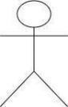

##### Actor use case

The actors are connected by lines to the use cases that they carry out. The use cases are placed in a rectangle but the actors are not .This rectangle is a visual remainder of the system boundaries and that the actors are outside the system. Use case diagrams are used to gather the requirements of a system including internal and external influences. These requirements are mostly design requirements. Hence, when a system isanalyzed to gather

its functionalities, use cases are prepared and actors are identified.

When the initial task is complete, use case diagrams are modelled to present the outside

view. In brief, the purposes ofuse case diagrams can be said to be as follows –

* Used to gather the requirements of a system.
* Used to get an outside view of a system.
* Identify the external and internal factors influencing the system.
* Show the interaction among the requirements is actors.

➢

## Use Case Diagram

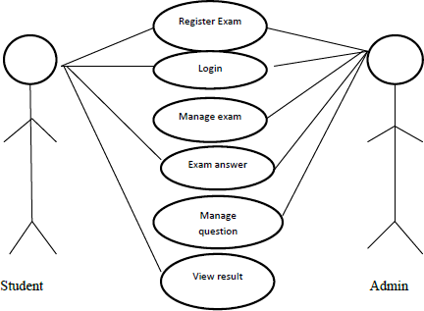

* 1. **4 DATA FLOW DIAGRAM**

Data Flow Diagram (DFD) representing a system at any level of detail with a graphic network of symbols showing data flows, data stores, data processes, and data sources. The purpose of DFD is to provide a semantic bridge between users and system developers. The diagram is the basis of structured system analysis. A level 0 DFD, also called a fundamental system model or a context model represents the entire software elements as a single bubble with input and output indicated by incoming and outgoing arrows respectively. Additional process and information flow parts are represented in the

next level i.e., Level 1 DFD. Each ofthe processes represented at Level 1 are sub functions of overall system depicted in the context model. Any processes, which are complex in Level 1, will be further represented into sub functions in the next level, i.e.,in level 2.Data flow diagrams illustrate how data is processed by a system in terms of inputs, and outputs. Represent major components or functions with Circles. Actions for input by a user or a system go in Rectangular Boxes. Databases are represented by Parallel lines enclosing a

phrase corner.

For each data flow, at least one of the endpoints (source and / or destination) must exist in a process. The refined representation of a process can be done in another data- flow diagram, which subdivides this process into sub-processes. The data-flow diagram is part of the structured-analysis modelling tools. When using UML, the activity diagram typically takes over the role of the data-flow diagram. A special form of data-flow plan is a site-oriented data- flow plan. Data-flow diagrams can be regarded as inverted Petri nets, because places in such networks correspond to the semantics of data memories. Analogously, the semantics of transitions from Petri nets and data flows and functions from data-flow diagrams should be considered equivalent. Rules for Data flow diagrams

are:

 External Entities

External entities are objects outside the system, with which the system communicates. External entities are sources and destinations of the system‗s inputs and

outputs

 Processes

When naming process, avoid glossing over them, without really understanding their role. Indications that this has been done are the use ofvague terms in the descriptive

title area like‘ ‗process ‗or ‗‗update‗.Data Flows

 Data Flows

Double-headed arrows can be used (to show two-way flows) on all but bottom level diagrams. Furthermore, in common with most of the other symbols used, a data flow at a particular level of a diagram may be decomposed to multiple data flows atlower levels. Flow should only transmit one type of information (material). The arrow shows the flow direction (it can also be bi-directional ifthe information to/from the entity is logically

dependent - e.g. question and answer). Flows link processes, warehouses and terminators.

 Data Store

Data store represent stores of data within the systems and are represented by open rectangle. Data Flows represent the movements ofdata between other components and are

shown by arrows.

A circle stands for processes that convert data into information

Data flow



Open Rectangle, which shows a data stores.

##### LEVEL 0

request

Online examinati on system

response

user

user

**LEVEL 1**

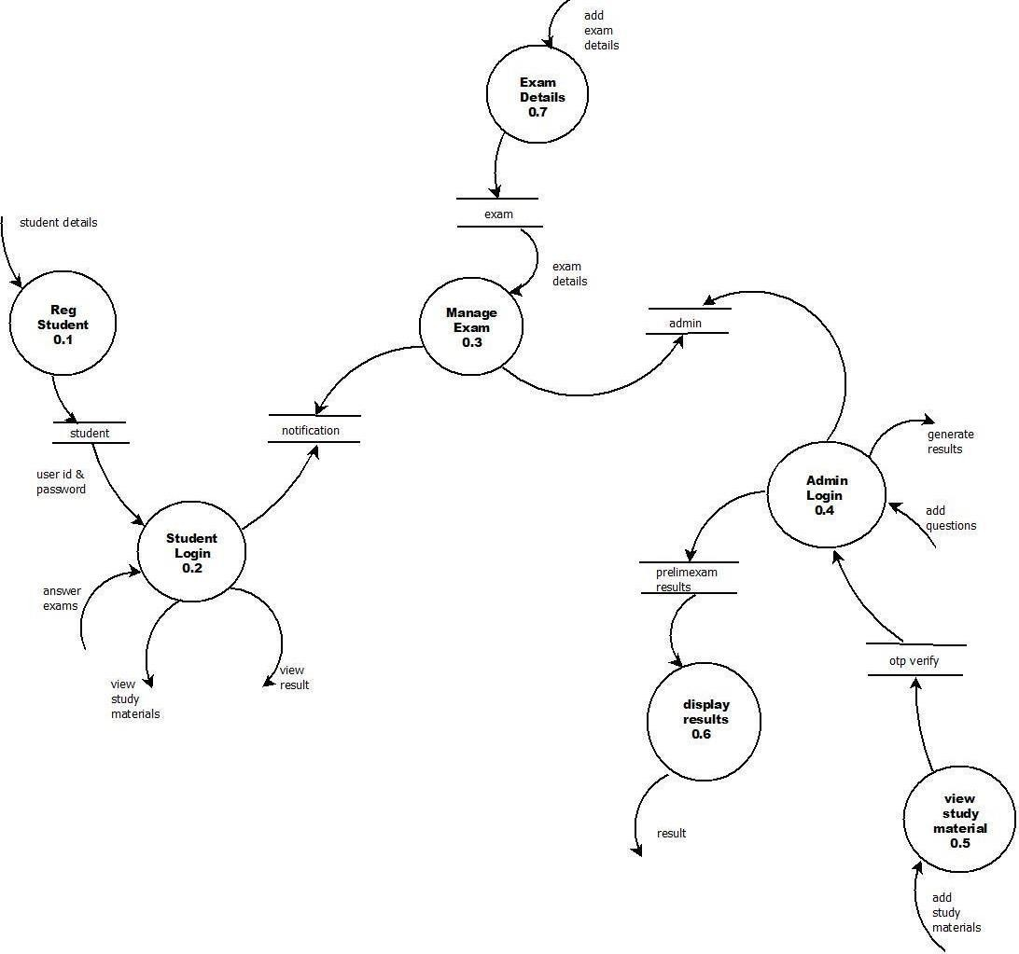

**LEVEL 2**

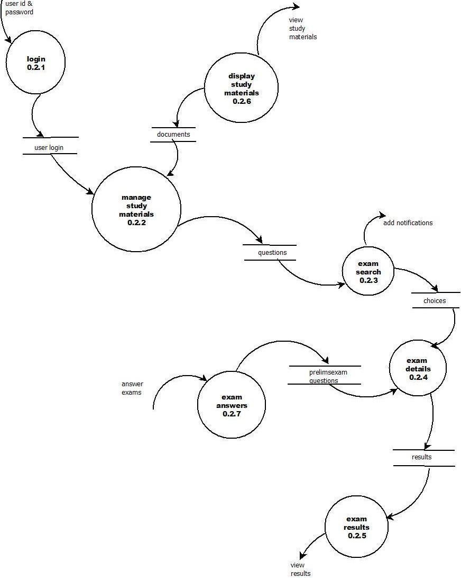

## INPUT DESIGN

Input design is the process of converting the user-originated inputs to a computer- based format. The design for handling input specifies how data are accepted for computer processing. Input design is a part of overall system design that needs careful attention and if includes specifying the means by which actions are taken. A system user interacting through a workstation must be able to tell the system whether to accept input produce a report or end processing. The collection of input data is considered to be the most extensive part of the system design. Since the inputs have tobe planned in such a manner so as to get the relevant information extreme care is takento obtain the information. If the data going into the system is incorrect then the processing and outputs will magnify

these errors. The major activities carried out are,

 Collection ofneeded data from the source

 Conversion of data into computer accepted

 Verification of converted data

## OUTPUT DESIGN

The output design has been done so that the results of processing should be communicated to the user. Effective output design will improve the clarity and performance of outputs. Output is the main reason for developing the system and the basis on which they will evaluate the usefulness of the application. Output design phase of the system is concerned with the convergence of information to the end user-friendly manner. The output design should be efficient, intelligible so that system relationship with the end user is improved and they‘re by enhancing the process ofdecision-making. Because useful output is essential to ensuring the use and acceptance ofthe information system, there are

six objectives that the systems analyst tries to attain when designing output:

 Designing output to serve the intended purpose.

 Designing output to fit the user.

 Delivering the appropriate quantity of output.

## 7 DATABASE DESIGN

The database design is a logical development in the methods used by the computers to access and manipulate data stored in the various parts of the computer systems. Database is defined as an integrated collection of data. The overall objective in the development of database technology has been to treat data as an organizational resource and as an integrated whole. The main objectives of databases are data integrity and data independence. A database is a collection of interrelated data stored with minimum redundancy to serve many users quickly and effectively. The database serves as the repository of data, so a well-designed database can lead to a better program structure and reduce procedural complexity. In a database environment, common data are available and

used by several users. The main objectives covered in database design are:

#####  Controlled redundancy

 **Data independence**

#####  Accuracy and integrity

 **Privacy and security**

 **Performance**

* 1. **TABLE DESIGN**

This is one of the major tasks is designing the database. It is important to realize that the design of the system is totally inter-related and so table design of the system is totally inter-related and so table design cannot really be considered in isolation from inputs, outputs, procedures, codes and security requirements. In this project, the database has to maintain all the information about the username, password, tolerance, picture

sequence, sound clips and click points etc

#### 9 DATABASE TABLE

**Table 1**

##### Tbl_name : EXAM_COURSE Tbl_description: Details of course

|  |  |  |  |  |
| --- | --- | --- | --- | --- |
| **slno** | **Field name** | **Datatype** | **Constraint** | **Description** |
| 1 | Id | Int(15) | Primary key | Id |
| 2 | coursename | Varchar(20) | Null | coursename |
| 3 | Question number | int(15) | Null | Question number |
| 4 | Total marks | Int(15) | Null | Total marks |

**Table 2**

##### Tbl_name:Question

**Tbl_description: Details about question**

|  |  |  |  |  |
| --- | --- | --- | --- | --- |
| **slno** | **Fieldname** | **Datatype** | **Constraint** | **Description** |
| **1** | **id** | **Integer(10)** | **Primary key** | **Id** |
| **2** | **Marks** | **Integer(20)** | **null** | **Marks** |
| **3** | **Question** | **Varchar(20)** | **Null** | **Question** |
| **4** | **Option1** | **Varchar(20)** | **null** | **Option1** |
| **5** | **Option2** | **Varchar(20)** | **null** | **Option2** |
| **6** | **Option3** | **Varchar(20)** | **null** | **Option3** |
| **7** | **Option4** | **Varchar(20)** | **Null** | **Option4** |
| **8** | **Answer** | **Varchar(20)** | **null** | **Answer** |
| **9** | **Course_id** | **Integer(20)** | **null** | **Course id** |

## Table :3 Tbl_name:exam_Result

**Tbl_description :Detailsabout result**

|  |  |  |  |  |
| --- | --- | --- | --- | --- |
| **slno** | **Fieldname** | **Datatype** | **Constraint** | **Description** |
| 1 | Id | Integer(20) | Primarykey | Id |
| 2 | marks | Integer(20) | null | Integer |
| 3 | Exam_id | Integer(10) | Null | Examid |
| 4 | Student_id | Integer(30) | null | Studentid |
| 5 | Date | Integer(20) | null | date |

## Table 4 Tbl_name:Student_student Tbl_description: Details about student

|  |  |  |  |  |
| --- | --- | --- | --- | --- |
| **Sl no** | **Field name** | **Datatype** | **Constraint** | **Description** |
| 1 | id | Int(10) | Primary key | Id |
| 2 | Profile_pic | Varchar(100) | null | ProfilePicture |
| 3 | Address | Varchar(20) | Null | adddress |
| 4 | mobile | Varchar(20) | Null | Mobilenumber |
| 5 | User_id | Integer(20) | Null | userid |

**Table 5**

## Tbl_name: teacher_teacher

**Tbl_description: details about teacher**

|  |  |  |  |  |
| --- | --- | --- | --- | --- |
| **Sl no** | **Field name** | **Data type** | **Constraint** | **Description** |
| 1 | id | Int(10) | Primarykey | id |
| 2 | Profile_pic | Varchar(100) | Null | Profilepicture |
| 3 | Address | varchar(10) | Null | Adddress |
| 4 | Mobile | Varchar(20) | Null | Mobile |
| 5 | Status | bool | null | Status |
| 6 | User_id | Integer(10) | null | Userid |
| 7 | salary | Integer(20) | null | salary |

# CHAPTER 5

**SYSTEM CODING**

## INTRODUCTION

The coding step is a process that transforms design into a programming language. It translates a detail design representation of software into a programming language realization. The translation process continues when a compiler accepts source code as input and produces machine-dependent object code as output. Quality is an important goal during coding. The quality of source code can be improved by the use of structured coding techniques; good coding style and readable, consistent code format. Duringcoding, some coding standards are to be followed. This has two purposes; reducing the chance of making it easier for some time to modify the code later on. Coding phase affects both testing and maintenance profoundly. The ―Budget Planner ‖ uses Python a s the programming language for coding. Coding methodology refers to a set of well- documented procedures and guidelines used in the analysis, design, and implementation of programs. Coding methodology includes a diagrammatic notation for documenting the results of the procedure. It also includes an objective set (ideally quantified) of criteria for determining

whether the results ofthe procedure are ofthe desired quality.

## CODING STANDARDS AND GUIDELINES

Good software development organizations usually develop their own coding standards and guidelines depending on what best suits their organization and the type of products they develop. The following are some representative coding standards:-Rules for limiting the use of global: These rules list what types of data can be declared global and

what cannot. Contents of the headers preceding codes for different modules:

The information contained in the headers of different modules should be standard for the organization. The exact format in which the header information is organized in

the header can also be specified.

The following are some standard header data:

 Name ofthe module.

 Date on which the module was created. Author‘s name.

 Modification history.

 Synopsis of the module.

 Different functions supported, along with their input/output parameters. Global variables accessed/modified by the module.

Naming conventions for global variables, local variables and constant identifiers: A possible naming convention can be that global variable names always capital letter, local variable names are made of small letters, and constant names are always capital letters. Error returns conventions and exception handling mechanisms: The way error conditions are reported by different functions in a program are handled should be standard within an organization. For example, different functions while encountering an error condition should either return a 0 or 1 consistently. The following are somerepresentative coding guidelines recommended by many software development organizations. Do not use a coding style that too clever or too difficult to understand: Code should be easy to understand. Many inexperienced engineers actually take pride in writing cryptic and incomprehensible code. Clever coding can obscure meaning of the code and hamper understanding. It also makes maintenance difficult . Do not use an identifier for multiple purposes: Programmers often use the same identifier to denote several temporary entities. However several things wrong with this approach and hence should be avoided. Some of the problems caused by use of variables for multiplepurposed as follows: Contents of the

headers preceding codes for different modules:

The information contained in the headers of different modules should be standard for the organization. The exact format in which the header information is organized in the header can also be specified. Each variable should be give n a descriptive name indicating its purpose. Use of variable for multiple purposes usually makes future

enhancements more difficult. Avoid obscure side effects: The side effects of a function call include modification ofparameters passed by reference.

#### SAMPLE CODE

##### Admin login

<!DOCTYPE html>

{% load widget_tweaks %}

<html lang="en" dir="ltr">

<head>

<meta charset="utf-8">

<title></title>

<style media="screen"> body {

margin: 0;

padding: 0;

font-family: sans-serif;

background: #304352; /* fallback for old browsers */

background: -webkit-linear-gradient(to bottom, #d7d2cc, #304352); /* Chrome 10-25, Safari 5.1-6 */

background: linear-gradient(to bottom, #d7d2cc, #304352); /* W3C, IE 10+/ Edge, Firefox 16+, Chrome 26+, Opera 12+, Safari 7+ */

}

.box {

width: 500px; padding: 40px; position: absolute; top: 50%;

left: 50%;

background: #212529; border-radius: 15px; text-align: center; transition: 0.25s; margin-top: 100px

}

.box input[type="text"],

.box input[type="password"] { border: 0;

background: none; display: block; margin: 20px auto; text-align: center;

border: 2px solid #838383; padding: 10px 10px; width: 250px;

outline: none; color: white; border-radius: 5px; transition: 0.25s

}

.box h1 { color: white;

font-weight: 500

}

.box input[type="text"]:focus,

.box input[type="password"]:focus { width: 300px;

border-color: #4caf50;

}

.box input[type="submit"] { border: 0;

background: #4caf50; display: block; margin: 20px auto; text-align: center;

padding: 14px 40px; outline: none;

color: white; border-radius: 5px; transition: 0.25s; cursor: pointer

}

.box input[type="submit"]:hover { background: #347736;

}

</style>

</head>

<body>

{% include "exam/navbar.html" %}

<div class="container">

<div class="row">

<div class="col-md-6">

<div class="card">

<form class="box" method="post">

{% csrf_token %}

<h1>Admin Login Panel</h1>

{% render_field form.username class="form-control" autocomplete="off" placeholder="Username" %}

{% render_field form.password class="form-control" autocomplete="off" placeholder="Password" %}

<input type="submit" name="" value="Admin Login">

</form>

</div>

</div>

</div>

</div>

<br><br><br><br><br><br><br><br><br>

<br><br><br><br><br><br><br><br><br>

<br><br><br><br><br>

{% include "exam/footer.html" %}

</body>

</html>

## Student Login

<!DOCTYPE html>

{% load widget_tweaks %}

<html lang="en" dir="ltr">

<head>

<meta charset="utf-8">

<title></title>

<style media="screen"> body {

margin: 0;

padding: 0;

font-family: sans-serif;

background: #304352; /* fallback for old browsers */

background: -webkit-linear-gradient(to right, #d7d2cc, #304352); /* Chrome 10- 25, Safari 5.1-6 */

background: linear-gradient(to right, #d7d2cc, #304352); /* W3C, IE 10+/ Edge, Firefox 16+, Chrome 26+, Opera 12+, Safari 7+ */

}

.box {

width: 500px; padding: 40px; position: absolute; top: 50%;

left: 50%;

background: #212529; border-radius: 15px; text-align: center;

transition: 0.25s; margin-top: 100px

}

**.**box input[type="text"],

.box input[type="password"] { border: 0;

background: none; display: block; margin: 20px auto; text-align: center;

border: 2px solid #838383; padding: 10px 10px; width: 250px;

outline: none; color: white; border-radius: 0px; transition: 0.25s

}

.box h1 { color: white;

font-weight: 500

}

.box input[type="text"]:focus,

.box input[type="password"]:focus { width: 300px;

border-color:#4caf50;

}

.box input[type="submit"] { border: 0;

background: #4caf50; display: block; margin: 20px auto; text-align: center; padding: 14px 40px; outline: none;

color: white; border-radius: 0px; transition: 0.25s; cursor: pointer

}

.box input[type="submit"]:hover { background: #347736;

}

</style>

</head>

<body>

{% include "exam/navbar.html" %}

<div class="container">

<div class="row">

<div class="col-md-6">

<div class="card">

<form class="box" method="post">

{% csrf_token %}

<h1>Student Login Panel</h1>

{% render_field form.username class="form-control" autocomplete="off" placeholder="Username" %}

{% render_field form.password class="form-control" autocomplete="off" placeholder="Password" %}

<input type="submit" name="" value="Login">

</form>

</div>

</div>

</div>

</div>

<br><br><br><br><br><br><br><br><br>

<br><br><br><br><br><br><br><br><br>

<br><br><br><br><br>

{% include "exam/footer.html" %}

</body>

</html>

## View.py

from django import forms

from django.contrib.auth.models import User from . import models

class ContactusForm(forms.Form):

Name = forms.CharField(max_length=30) Email = forms.EmailField()

Message = forms.CharField(max_length=500,widget=forms.Textarea(attrs={'rows': 3, 'cols': 30}))

class TeacherSalaryForm(forms.Form): salary=forms.IntegerField()

class CourseForm(forms.ModelForm): class Meta:

model=models.Course fields=['course_name','question_number','total_marks']

class QuestionForm(forms.ModelForm):

#this will show dropdown str method course model is shown on html so

override it

#to_field_name this will fetch corresponding value user_id present in course model and return it

courseID=forms.ModelChoiceField(queryset=models.Course.objects.all(),empty_label="Cou rse Name", to_field_name="id")

class Meta: model=models.Question

fields=['marks','question','option1','option2','option3','option4','answer'] widgets = {

'question': forms.Textarea(attrs={'rows': 3, 'cols': 50})

}

## Manage.py

#!/usr/bin/env python

"""Django's command-line utility for administrative tasks.""" import os

import sys

def main():

os.environ.setdefault('DJANGO_SETTINGS_MODULE', 'onlinexam.settings') try:

from django.core.management import execute_from_command_line except ImportError as exc:

raise ImportError(

"Couldn't import Django. Are you sure it's installed and "

"available on your PYTHONPATH environment variable? Did you " "forget to activate a virtual environment?"

) from exc execute_from_command_line(sys.argv)

if name == ' main ': main()

# CHAPTER 6 SYSTEM TESTING

## INTRODUCTION

In any software development, testing is a process to show the correctness of the program and it meets the design specifications. Testing is needed to prove correctness, to show completeness, to improve the quality of the software and to provide the maintenance aid. Some testing standards are therefore necessary to ensure completeness of testing, improve the quality of the software, and reduce the testing costs and to reduce study needs and operation time. Testing software extends throughout the coding phase and it represents the ultimate review of configurations, design and coding. A series of test cases are created that are intended to demolish the software that has been built. Testing involves a series of operation of a system of application under controlled conditions and subsequently evaluating the result. The controlled condition should include both normal and abnormal conditions. It is planned and monitor for each testing level (e.g., unit, integration, system and acceptance). The various testing performed are unit testing, integration testing, validation testing, output testing and system testing.

## TEST PLAN

A test plan implies a series of desired course of action to be followed in accomplishing various testing methods. The Test Plan acts as a blue print for the action to be followed. The software engineers create a computer program, its documentation and related data structures. The software developers is always responsible for testing the individual units of the programs, ensuring that each performs the function for which it was designed. There is an independent test group (ITG) which is to remove the inherent problems associated with letting the builder to test the thing that has been built. The specific objectives of testing should be stated in measurable terms. So that the mean time to failure, the cost to find and fix the defects, remaining defect density or frequency of occurrence and test work-hours per regression test all should be tested within the test plan.

The levels of testing include:

##### UNIT TESTING

The primary goal of unit testing is to take the smallest piece of testable software in the application, isolate it from the remainder of the code, and determine whether it behaves exactly as you expect. Each unit is tested separately before integrating them into modules to test the interfaces between the modules. Unit testing has proven its value in that a large percentage of defects are identified during its use. The most common approach to unit testing requires drivers and stubs to be written. The driver simulates a calling unit and the stub simulates a called unit. The investment of developer time in this activity sometimes results in demoting unit testing to a lower level of priority and that is almost always a mistake. Even though the drivers and stubs cost time and money, unit testing provides some undeniable advantages. It allows for automation of the testing process, reduces difficulties of discovering errors contained in more complex pieces of the application, and test coverage is often enhanced because attention is given to each unit. Unit testing focuses first on modules, independently of one another, to locate errors. This testing includes entering data and ascertaining if the value matches to the type and size. The various controls are tested to ensure that each performs its action as required. The main modules of the project such as admin, stand, conductor, checker, virtual bank are tested separately. Also each user is login and tested the sub modules.

##### DATA VALIDATION TESTING

Data validation is the process of testing the accuracy of data. A set of rule we can apply to a control to specify the type and range of data that can enter. It can be used to display error alert when users enter incorrect values in to a form. Now performing validation testing in system Centralized Social Welfare by undergoing validation for each tools and in a manner that can be reasonably accepted, by the user. At the culmination of integration testing, the software was completely assembled as a package, interfacing errors have been uncovered and corrected and a final series of the validation succeeded when the software function in a software validation testing began .In validation testing the entered data validated for correct format, and correct order.

##### OUTPUT TESTING

After performing validation test, the next phase is output test of the system, since no system could be useful if it does not produce desired output in the desired format. The output format was considered in two ways: one is on the screen and the other as a printed form. The main output of the project is that the admin gets the graph of loss and profit of bus extracted from the reviews provided by the stand and the output is successfully tested.

##### BLACK-BOX TESTING

Black box testing is defined as a testing technique in which functionality of the Application Under Test (AUT) is tested without looking at the internal code structure, implementation details and knowledge of internal paths of the software. This type of testing is based entirely on software requirements and specifications. In Black-Box Testing we just focus on inputs and output of the software system without bothering about internal knowledge of the software program. It is a way of software testing in which the internal structure or the program or the code is hidden and nothing is known about it. It is mostly done by software testers. No knowledge of implementation is needed. It can be referred as outer or external software testing. It is functional test of the software. This testing can be initiated on the basis of requirement specifications document. No knowledge of programming is required. It is the behavior testing of the software. It is applicable to the higher levels of testing of software. It is also called closed testing. It is least time consuming. It is not suitable or preferred for algorithm testing. It Can be done by trial and error ways and methods.

##### WHITE-BOX TESTING

White-box testing is a testing technique which evaluates the code and the internal structure of a program. White box testing involves looking at the structure of the code. When you know the internal structure of a product, tests can be conducted to ensure that the internal operations performed according to the specification. And all internal components have been adequately exercised. It is a way of testing the software in which the tester has knowledge about the internal structure r the code or the program of the Software. It is mostly done by software developers. Knowledge ofimplementation is required. It is the inner or the internal software testing. It is structural test of the software. This type of testing of software is started after detail design document. It is mandatory to have knowledge of programming. It is the logic testing of the software. It is generally applicable to the lower levels of software testing.

It is also called as clear box testing. It is most time consuming. It is suitable for algorithm testing. Data domains along with inner or internal boundaries can be better tested.

## TEST CASE

Test case is a set of conditions or variables under which will a tester will determine whether a system under test satisfies requirements correctly. The process of developing test cases can also find problems in the requirements or design of an application. In order to fully test that all the requirements of an application are met, there must be at least two test cases for each requirement: one positive test and one negative test. If a requirement has sub- requirements, each sub-requirement must have at least two test cases. Keeping track of the link between the requirement and the test is frequently done using a traceability matrix. Written test cases should include a description of the functionality to be tested, and the preparation required to ensure that the test can be conducted. A formal written test-case is characterized by a known input and by an expected output, which is worked out before the test is executed. The known input should test a precondition and the expected output should test a post condition. For applications or systems without formal requirements, test cases can be written based on the accepted normal operation of programs of a similar class. In scenario testing, hypothetical stories are used to help the tester think through a complex problem or system. These scenarios are usually not written down in any detail. They can be as simple as a diagram for a testing environment or they could be a description written in prose. The ideal scenario test is a story that is motivating, credible, complex, and easy to evaluate. They are usually different from test cases in that test cases are single steps while scenarios cover a number of steps of the key.

# CHAPTER 7 IMPLEMENTATION AND MAINTENANCE

## IMPLEMENTATION OF THE PROJECT

The implementation is the final stage and it is an important phase. It involves the individual programming; system testing, user training and the operational running of developed proposed system that constitutes the application subsystems. One major task of preparing for implementation is education of users, which should really have been taken place much earlier in the project when they were being involved in the investigation and the design. The implementation phase of the software development is concerned with translating design specifications into source code. The user tests the developed system and changes are made according to their needs. Our system has been successfully implemented. Before implementation several tests have been conducted to ensure that no errors are encounter during the operation. The implementation phase ends with an evaluation of the system after placing it into operation for a period of time. Implementation is the third phase of the system process. In order to achieve the objectives and the expected performance the system has been developed in a highly interactive and user-friendly manner.

## SYSTEM MAINTENANCE

The launching of the system, even though it is fully correct and complete is not the end of the matter. The system should be given proper security and maintenance in order to keep them efficient and up-to-date. The system security is for protection against fraud and disaster. To avoid unauthorized access, password protection is highly recommended while running this new system. The password as to be maintained directly and files have to be kept very confidential. Finally systems and programs that have been successfully implemented are usually subjected to continuous change. The system should made modification and improvement to meet changing conditions. The first class maintenance requires the cooperation of the people served by the system or programs and that Reasonable for maintaining it. An integral part of software is the maintenance One, which requires an accurate maintenance plan to be prepared during the software development

##### MAINTENANCE ISSUES

Maintenance ease with which a program can be corrected if any error is encountered, adapted if its environment changes or enhanced if the customer decides a change in requirements. The software is characterized by the following activities. In this project considerable amount of time is spent in maintenance and monitoring.



Corrective maintenance is to uncover the errors still exist after testing. During this maintenance work the user is asked to work on the system and if any error is reported.

Adaptive Maintenance

The adaptive maintenance is needed if the platform or the environment of the project to be change. For the project the language takes care of all of these things.

Perfective Maintenance

The third maintenance active is the perfective maintenance. The recommendation of new capabilities and modification of existing function and general enhancement are received from the user and proposed future enhancement.

## SOFTWARE MAINTENANCE

Maintenance involves the software industry captive, typing up system resources. It means restoring something to its original condition. Maintenance involves a wide range of activities including correcting, coding, and design errors, updating documentation and test data, and upgrading user support. Maintenance was done after the success implementation. Maintenance is continued till the product is reengineered or deployed to another platform

# CHAPTER 8

**CONCLUSION AND FUTURE ENHANCEMENT**

## CONCLUSION

This system called Online Examination system named as Exam Helper. Students can easily register to the page. There is an admin to Approve, Search, Update, Delete Students, Add Notifications, Create Exams Add Question Paper and Study Materials. This page is easy to handle and it helps Students and the Faculty to conduct and attend exams effectively compared to the existing system. This project is designed to Create and Attend Exams. It is an online system through which students can register, view profile, attend exams, view study materials, and view notifications.

## FUTURE ENHANCEMENT

This application is used to conduct online examination. The students can sit at individual terminals and login to write the exam in the given duration. The questions have to be given to the students. This application will perform correction, display the result immediately and also store it in database.This application provides the administrator with a facility to add new exams.This application provides the instructor add questions to the exam, modify questions in the exam in a particular exam.This application takes care of authentication of the administrator, Instructor as well as the student

# REFERENCES

[**https://docs.djangoproject.com/en/dev/internals/git/**](https://docs.djangoproject.com/en/dev/internals/git/)[**https://docs.djangoproject.com/en/dev/internals/contributing/writing-**](https://docs.djangoproject.com/en/dev/internals/contributing/writing-code/coding-style/)[**code/coding-style/**](https://docs.djangoproject.com/en/dev/internals/contributing/writing-code/coding-style/)[**https://docs.djangoproject.com/en/dev/internals/contributing/writing-**](https://docs.djangoproject.com/en/dev/internals/contributing/writing-code/coding-style/)[**code/coding-style/**](https://docs.djangoproject.com/en/dev/internals/contributing/writing-code/coding-style/)

[**https://code-projects.org/c/python/django-projects/**](https://code-projects.org/c/python/django-projects/)

# APPENDIX

## SCREENSHOT

1. **ADMIN LOGIN**

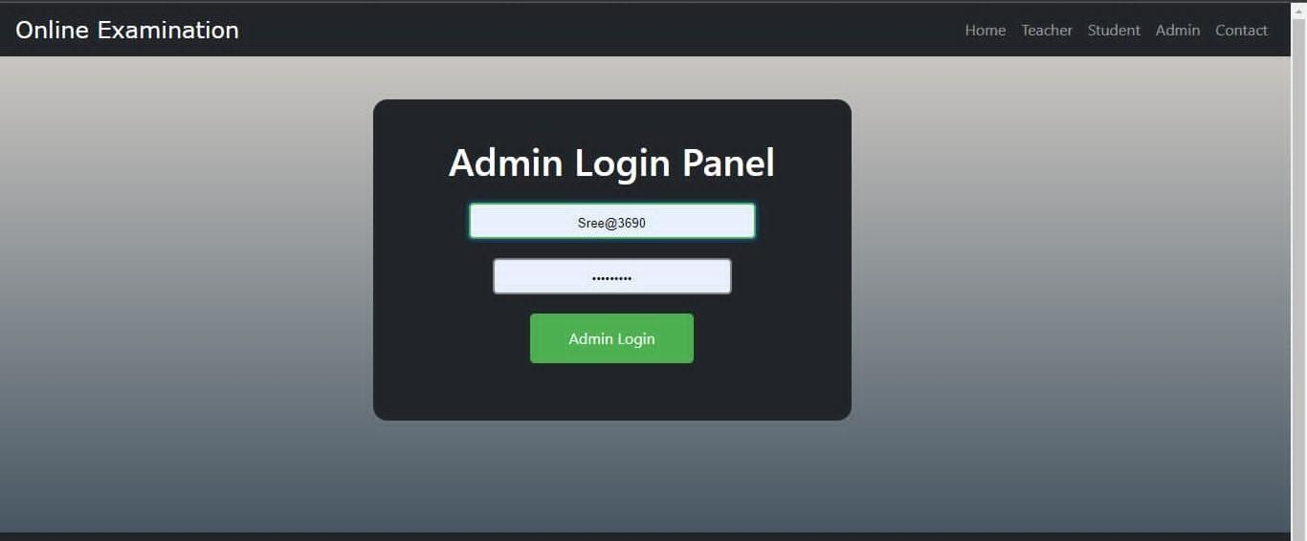

## STUDENT SIGNUP

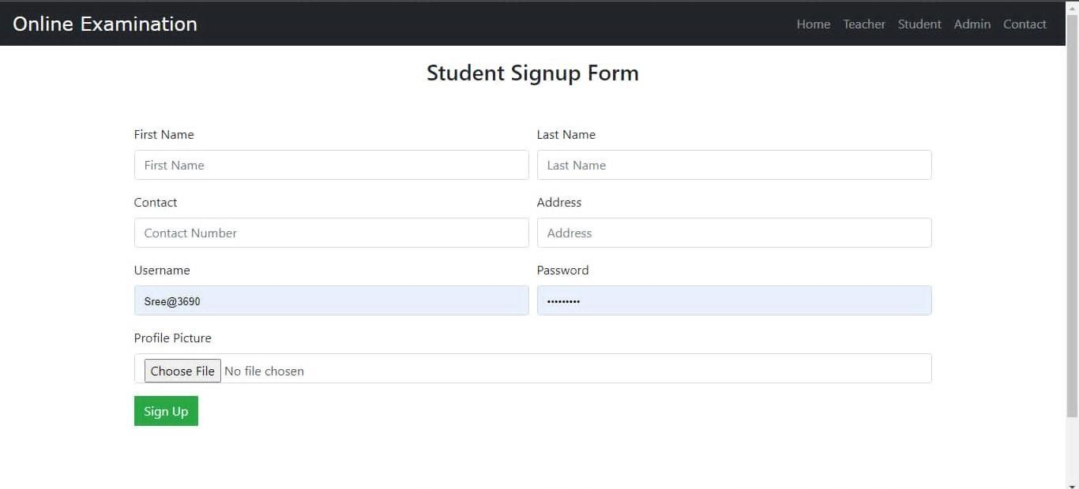

1. **TEACHER SIGNUP**

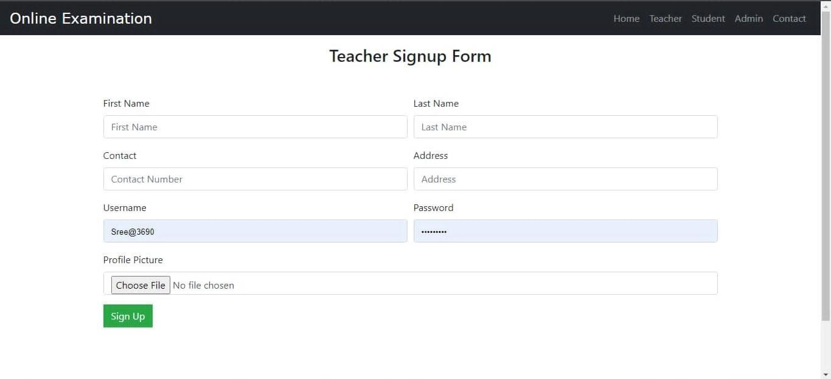

## CONTACT

