**T-Mobile Dev Puzzle**

This dev puzzle tests skills that will be required to contribute to the tos-apps monorepo. It should take around 8 hours to complete all the tasks.

**Getting Started**

Please **DO NOT** clone or fork this repo. Follow the steps below to get started.

1. Download the ZIP file and extract it on your machine.
2. Go into the extracted folder and run:
3. git init
4. git add .
5. git commit -m 'initial commit'
6. Create a *new* repo on GitHub/GitLab/BitBucket and push your new repo there.
7. Install dependencies with npm install.

You should be able to start the app with npm start. The app runs at http://localhost:4200.

**About this app**

The app you will be working on is called *okreads*. This app allows you to search for books and add them to your reading list. It is like goodreads but lighter on features.

Users can search for books.

[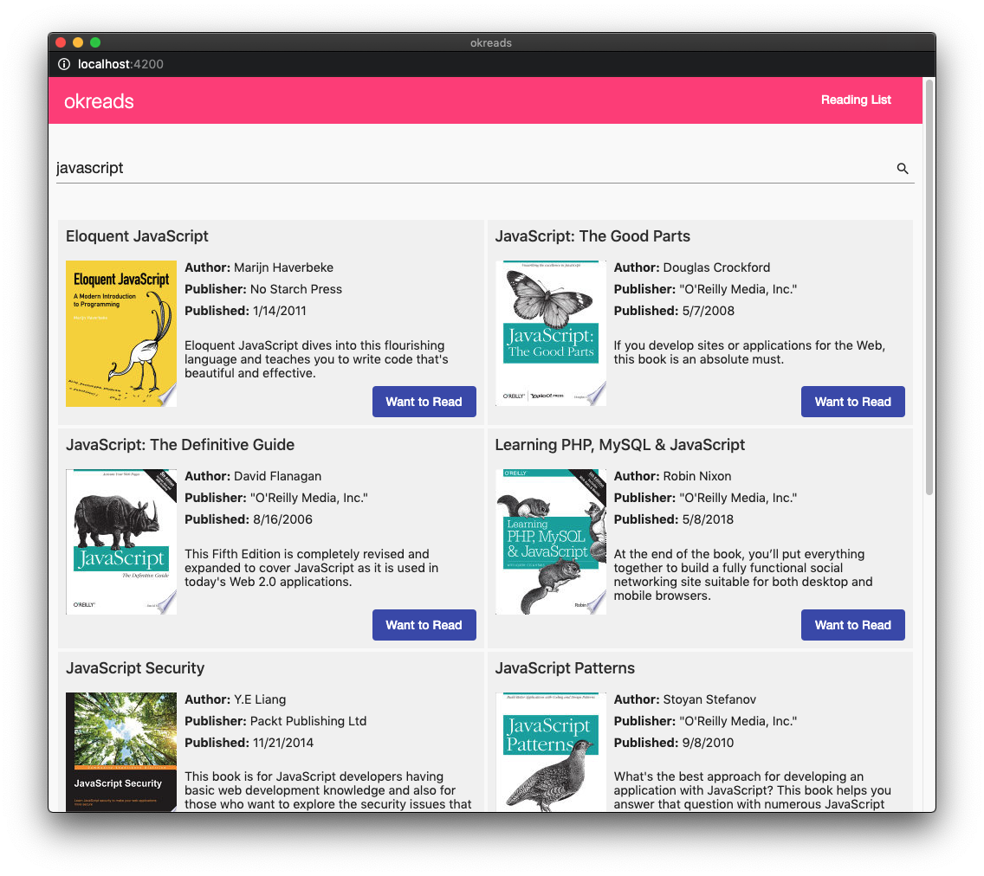](https://github.com/tmo-digital/web-ui-developer-puzzle/blob/master/screencapture-1.png)

Then add them to their reading list.

[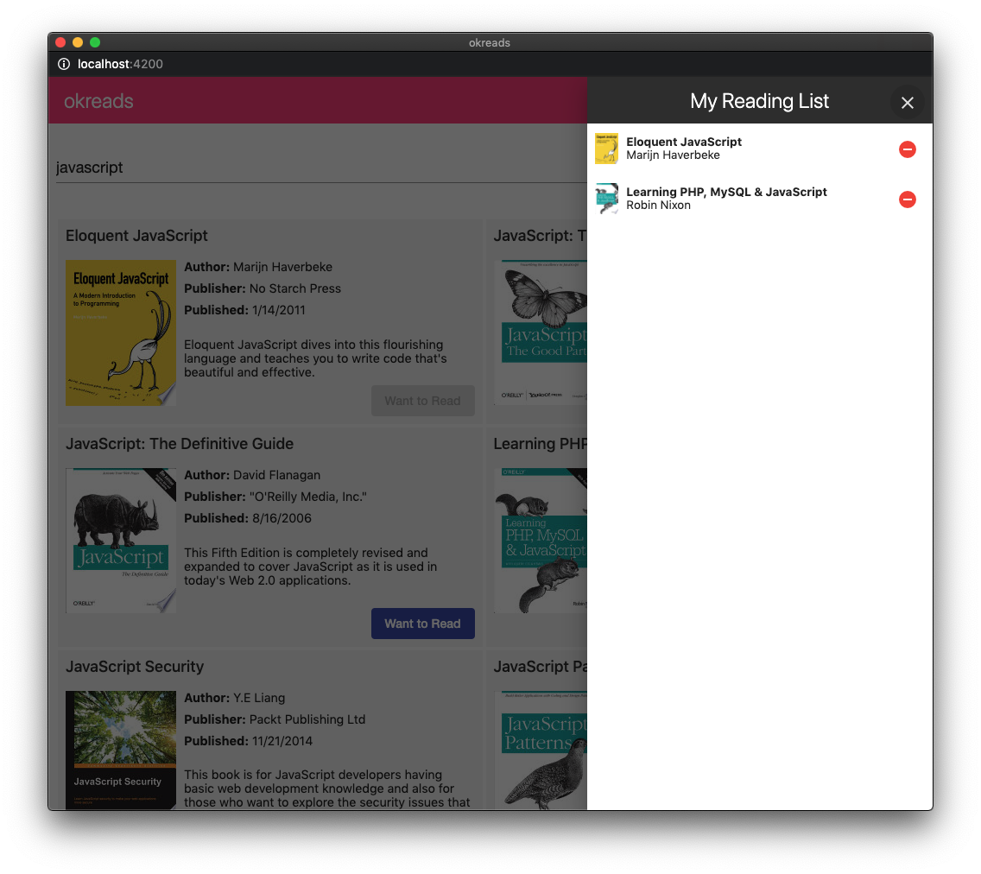](https://github.com/tmo-digital/web-ui-developer-puzzle/blob/master/screencapture-2.png)

**Technologies used**

* Angular - Browser app
* NgRx - State management
* NestJS - API app
* Nx - CLI dev tools

**Helpful Hints**

* You can see an overview of the architecture by running npx nx dep-graph.
* You should not need to modify anything in the apps/okreads folder. The browser and api apps are shells that wrap around projects in the libs folder.
* Make sure lint and tests are passing before submitting your code. Write new tests as necessary.
* You can run individual tests by providing the project name as found in angular.json. For example,
* npx nx test books-data-access
* npx nx test books-feature

**Tasks**

There are five tasks in total. Each task has an estimated time for completion, so use this as a rough guide.

**Task 1: Code fixes and review**

**Estimated time:** 1 hour

1. Starting from the master branch, create a new branch chore/code-review.
2. Create a file named CODE_REVIEW.md at the workspace root write a short code review based on the existing code.

For example,

* + Are there any problems or code smells in the app? (Focus on code in the libs/books folder)
  + Are there other improvements you would make to the app? What are they and why?

Write your review in bullet points. You should list at least three items.

1. Accessibility is an important feature of all public facing websites.
   * In Google Chrome, run an automated scan with the Lighthouse extension. Lighthouse, note these issues.
   * In Chrome again, manually check for accessibility issues. Identify at least 3 issue, not found in the automated scan.
2. Fix *at least one* of the issues noted in step 2 and *all* the issues from step 3.
3. Run lint, unit tests, and e2e tests. Fix anything that fails.
4. npm run lint
5. npm run test
6. npm run e2e

**Note:** For the e2e tests to work the app must be running (npm start).

1. Commit your changes to the feature branch and open a pull-request with master as the target.

**Note:** You should now have two commits on master. For example, you should see something similar to the following in git.

$ git log --oneline

bbbbbbb (HEAD -> master) chore: add code review and fix tests

aaaaaaa initial commit

**Task 2: Adding instant search**

**Estimated time:** 1 hour

**Requirements**

As a user, I want to see book results as I am typing in the search field -- I don't want to have to submit the form.

1. Starting from the chore/code-review branch from Task 1, create a new branch feat/instant-search.
2. Update the code to provide instant search results as the user is typing. Be sure not to spam the API with too many calls -- no more than one request every 500 ms.
3. Open the e2e test file apps/okreads-e2e/src/specs/search-books.spec.ts. Enable the second spec by renaming xit to it, then implement the test to ensure instant search works.
4. Commit your changes to the feature branch and open a pull-request with chore/code-review as the target.

**Task 3: Undo add and remove from reading list**

**Estimated time:** 2-4 hours

**Requirements**

As a user, I want to be able to quickly undo my action when clicking the Want to Read button in the book list, or the remove button in the reading list.

1. Starting from the chore/code-review branch from Task 1, create a new branch feat/undo-actions.
2. Update the code such that a snackbar appears whenever the user adds or removes a book. (Hint: this module is already installed and set up)
   * The snackbar must display the event that occurred (i.e. added/removed), and an Undo action.
   * When the user clicks Undo it should set the reading list state back to the previous state.
3. Write a new e2e test in apps/okreads-e2e/src/specs/reading-list.spec.ts to test the new undo feature.
4. Commit your changes on the feature branch and open a pull-request with chore/code-review as the target.

**Task 4: Ability to mark a book as finished**

**Estimated time:** 2-4 hours

**Requirements**

As a user, I want to be able to mark a book as finished in my reading list.

1. Starting from the chore/code-review branch from Task 1, create a new branch feat/mark-as-read.
2. Update the *api* code to provide a new PUT /api/reading-list/:id/finished endpoint.
   * This endpoint should update the finished flag to true and set finishedDate as an ISO date string (e.g. 2020-01-01T00:00:00.000Z).
3. Update the UI to allow user to mark a book as *finished* from the reading list sidenav. (Bonus points for a thoughtful UI/UX design for this feature)
   * Indicate the book as finished in the sidenav, including the finished date.
   * The user can still remove the book from their reading list. Removing a book will reset the finished status (i.e. if they add the book back it will not be finished).
   * The Want to Read button should change to Finished.
4. Write a new e2e test in apps/okreads-e2e/src/specs/reading-list.spec.ts to test the new mark as finished feature.
5. Commit your changes on the feature branch and open a pull-request with chore/code-review as the target.

**Submission**

Ready to submit? Please review the checklist below.

1. Have you opened four pull-requests for the tasks? Make sure they are opened with the correct target branch.
   * Task 1: chore/code-review -> master
   * Task 2: feat/instant-search -> chore/code-review
   * Task 3: feat/undo-actions -> chore/code-review
   * Task 4: feat/mark-as-read -> chore/code-review
2. Are all your features working as per requirements?
3. Are lint, test, e2e passing?