Computer Networks Homework

Network Layer

1. Consider a datagram network using 32-bit host addresses. Suppose a router has four links, numbered 0 through 3, and packets are to be forwarded to the link interfaces as follows:

|  |  |
| --- | --- |
| Destination Address Range | Link interface |
| 11100000 00000000 00000000 00000000  through  11100000 00111111 11111111 11111111 | 0 |
| 11100000 01000000 00000000 00000000  through  11100000 01000000 11111111 11111111 | 1 |
| 11100000 01000001 00000000 00000000  through  11100001 01111111 11111111 11111111 | 2 |
| Otherwise | 3 |

a. Provide a forwarding table that has five CIDR entries, uses longest prefix matching, and forwards packets to the correct link interfaces.

b. Describe how your forwarding table determines the appropriate link interface for datagrams with destination addresses:

11001000 10010001 01010001 01010101

11100001 01000000 11000011 00111100

11100001 10000000 00010001 01110111

1. Suppose a host send out an IP datagram of a size 3200 bytes (20 bytes header and 3180 bytes of IP payload), suppose that the MTU of the link is 804 bytes, how many fragments are sent out? And what are the values of the Length, flag bit, and Offset fields of each IP fragments?
2. 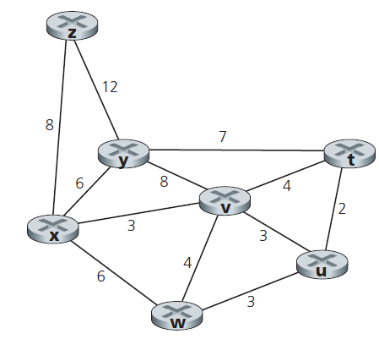Consider the following network. With the indicated link costs, use link-state routing algorithm to compute the shortest path from x to all network nodes. Show how the algorithm works by filling the table as on PPT page 97.
3. Consider the three-node topology, compute the distance tables after the initialization step and after each iteration of a synchronous version of the distance-vector algorithm as in PPT page 109.

