[Add Title Here, up to 12 Words, on One to Two Lines]

[Author Name(s), First M. Last, Omit Titles and Degrees]

[Institutional Affiliation(s)]

Author Note

[Include any grant/funding information and a complete correspondence address.]

Abstract

[The abstract should be one paragraph of between 150 and 250 words. It is not indented. Section titles, such as the word Abstract above, are not considered headings so they don’t use bold heading format. Instead, use the Section Title style. This style automatically starts your section on a new page, so you don’t have to add page breaks. (To see your document with pagination, on the View tab, click Reading View.) Note that all text styles for this template are available on the Home tab of the ribbon, in the Styles gallery.]

Keywords: [Add keywords here. To replace this (or any) tip text with your own, just select it and then start typing. Don’t include space to the right or left of the characters in your selection.]

[Add Title Here, up to 12 Words, on One to Two Lines]

[The body of your paper uses a half-inch first line indent and is double-spaced. APA style provides for up to five heading levels, shown in the paragraphs that follow. Note that the word Introduction should not be used as an initial heading, as it’s assumed that your paper begins with an introduction.]

# [Heading 1]

[The first two heading levels get their own paragraph, as shown here. Headings 3, 4, and 5 are run-in headings used at the beginning of the paragraph.]

## [Heading 2]1

[For APA formatting requirements, it’s easy to just type your own footnote references and notes. To format a footnote reference, select the number and then, on the Home tab, in the Styles gallery, click Footnote Reference.]

[Heading 3]. [Include a period at the end of a run-in heading. Note that you can include consecutive paragraphs with their own headings, where appropriate.]

[Heading 4]. [When using headings, don’t skip levels. If you need a heading 3, 4, or 5 with no text following it before the next heading, just add a period at the end of the heading and then start a new paragraph for the subheading and its text.] (Last Name, Year)

[Heading 5]. [Like all sections of your paper, references start on their own page, as you see on the page that follows. Just type in-text citations as you do any text of your paper, as shown at the end of this paragraph and the preceding paragraph.] (Last Name, Year)

[To see this document with all layout and formatting, such as hanging indents, on the View tab of the ribbon, click Reading View.]

References

Last Name, F. M. (Year). Article Title. *Journal Title*, Pages From - To.

Last Name, F. M. (Year). *Book Title.* City Name: Publisher Name

Footnotes

1[Add footnotes, if any, on their own page following references. The body of a footnote, such as this example, uses the Normal text style. (Note: If you delete this sample footnote, don’t forget to delete its in-text reference as well. That’s at the end of the sample Heading 2 paragraph on the first page of body content in this template.)]

Tables

Table 1

[Table Title]

|  |  |  |  |  |
| --- | --- | --- | --- | --- |
| Column Head | Column Head | Column Head | Column Head | Column Head |
| Row Head | 123 | 123 | 123 | 123 |
| Row Head | 456 | 456 | 456 | 456 |
| Row Head | 789 | 789 | 789 | 789 |
| Row Head | 123 | 123 | 123 | 123 |
| Row Head | 456 | 456 | 456 | 456 |
| Row Head | 789 | 789 | 789 | 789 |

Note: [Place all tables for your paper in a tables section, following references (and, if applicable, footnotes). Start a new page for each table, include a table number and table title for each, as shown on this page. All explanatory text appears in a table note that follows the table, such as this one. Use the Table/Figure style, available on the Home tab, in the Styles gallery, to get the spacing between table and note. Tables in APA format can use single or 1.5 line spacing. Include a heading for every row and column, even if the content seems obvious. A table style has been setup for this template that fits APA guidelines. To insert a table, on the Insert tab, click Table.]

Figures

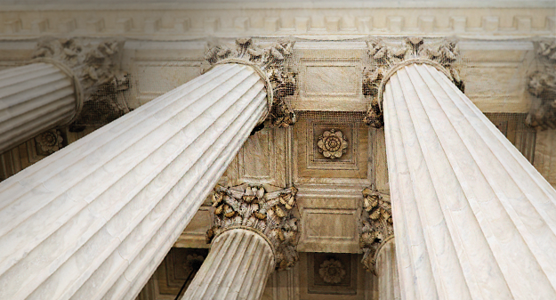

Figure 1. [Include all figures in their own section, following references (and footnotes and tables, if applicable). Include a numbered caption for each figure. Use the Table/Figure style for easy spacing between figure and caption.]

For more information about all elements of APA formatting, please consult the APA Style Manual, 6th Edition.