R version 3.2.2 (2015-08-14) -- "Fire Safety"
Copyright (C) 2015 The R Foundation for Statistical Computing
Platform: x86_64-w64-mingw32/x64 (64-bit)

R is free software and comes with ABSOLUTELY NO WARRANTY.
You are welcome to redistribute it under certain conditions.
Type 'license()' or 'licence()' for distribution details.

Natural language support but running in an English locale

R is a collaborative project with many contributors.
Type 'contributors()' for more information and
'citation()' on how to cite R or R packages in publications.

Type 'demo()' for some demos, 'help()' for on-line help, or
'help.start()' for an HTML browser interface to help.
Type 'q()' to quit R.

> library(plyr)
> setwd("C:/Users/TonyLaptop/Desktop/rowan/DM1/lecture9/lecture9")
> data<-read.csv("censusAdult50k.csv",header = TRUE, sep = ",", stringsAsFactors = TRUE)
> minn = min(data$Age)
> maxx = max(data$Age)
> data$Age2 <- sapply(data$Age,function(b) {
+ return((b-minn)/(maxx-minn))
+ })
> minn = min(data$CapitalGain)
> maxx = max(data$CapitalGain)
> data$Gain2 <- sapply(data$CapitalGain,function(b) {
+ return((b-minn)/(maxx-minn))
+ })
> minn = min(data$CapitalLoss)
> maxx = max(data$CapitalLoss)
> data$Loss2 <- sapply(data$CapitalLoss,function(b) {
+ return((b-minn)/(maxx-minn))
+ })
> minn = min(data$EducationNum)
> maxx = max(data$EducationNum)
> data$Educ2 <- sapply(data$EducationNum,function(b) {
+ return((b-minn)/(maxx-minn))
+ })
> minn = min(data$HoursPerWeek)
> maxx = max(data$HoursPerWeek)
> data$Hours2 <- sapply(data$HoursPerWeek,function(b) {
+ return((b-minn)/(maxx-minn))
+ })
> m <-model.matrix(~ Income + Age2 + Educ2 + MaritalStatus + Relationship + Race + Sex + Hours2 + Job+Gain2 + Loss2, data=data)
> names(m[1,])
[1] "(Intercept)" "Income >50K"
[3] "Age2" "Educ2"
[5] "MaritalStatus Married-AF-spouse" "MaritalStatus Married-civ-spouse"
[7] "MaritalStatus Married-spouse-absent" "MaritalStatus Never-married"
[9] "MaritalStatus Separated" "MaritalStatus Widowed"
[11] "Relationship Not-in-family" "Relationship Other-relative"
[13] "Relationship Own-child" "Relationship Unmarried"
[15] "Relationship Wife" "Race Asian-Pac-Islander"
[17] "Race Black" "Race Other"
[19] "Race White" "Sex Male"
[21] "Hours2" "Job Armed-Forces"
[23] "Job Craft-repair" "Job Exec-managerial"
[25] "Job Farming-fishing" "Job Handlers-cleaners"
[27] "Job Machine-op-inspct" "Job Other"
[29] "Job Other-service" "Job Priv-house-serv"
[31] "Job Prof-specialty" "Job Protective-serv"
[33] "Job Sales" "Job Tech-support"
[35] "Job Transport-moving" "Gain2"
[37] "Loss2"
> colnames(m)= c("dk","Income","Age2","Educ2","MarStat1","MarStat2","MarStat3","Unmarried","Separated","Widowed","Rel1","Rel2","Rel3","Unmarried2","Wife","Race1","Black","RaceOther","White","Male","Hours","Milit","Craft","Executive","Farmer","Cleaner","MachineOp","JobOth","OthServ","HouseServ","ProfSpec","ProtServ","Sales","TechSup","Moving","Gain","Loss")
> v<-as.data.frame(m[,2:37])
> set.seed(2)
> train=sample(1:nrow(v),nrow(v)/2)
> test=-train
> trainingData=v[train,]
> testingData=v[test,]
> formula = Income~Age2+Educ2+MarStat1+MarStat2+MarStat3+Unmarried+Separated+Widowed+Rel1+Rel2+Rel3+Unmarried2+
+ Wife+Race1+Black+RaceOther+White+Male+Hours+Milit+Craft+Executive+Farmer+
+ Cleaner+MachineOp+JobOth+OthServ+HouseServ+ProfSpec+ProtServ+Sales+TechSup+Moving+Gain+Loss
> library("neuralnet")
Loading required package: grid
Loading required package: MASS
> nnet<-neuralnet(formula,trainingData, hidden=5, threshold=0.5)
> results<-compute(nnet,testingData[,2:36])
> testingData$result<- sapply(results$net.result, function(b) {
+ if (b<=.5){
+ return(0)
+ }else{
+ return(1)
+ }})

> count(testingData,c('Income','result'))
Income result freq
1 0 0 11416
2 0 1 921
3 1 0 1498
4 1 1 2446

> #install.packages('SDMTools')
> library('SDMTools')
> confusion.matrix(testingData[,1:1],results$net.result,threshold=0.5)
obs
pred 0 1
0 11416 1498
1 921 2446
attr(,"class")
[1] "confusion.matrix"
> #suppose we’re using model to predict who to give a loan to. Actual 1 is worth $2000, actual 0 is -25, false positive costs -3000 (because the loan doesn’t get paid back) and false negative costs -25 (in paperwork and time that we don’t recover)
> 11416*(-25)+921*(-3000)+1498*(-25)+2446*2000
[1] 1806150
> confusion.matrix(testingData[,1:1],results$net.result,threshold=0.4)
obs
pred 0 1
0 10889 1070
1 1448 2874
attr(,"class")
[1] "confusion.matrix"
> 10889*(-25)+1448*(-3000)+1070*(-25)+2874*(2000)
[1] 1105025
> confusion.matrix(testingData[,1:1],results$net.result,threshold=0.6)
obs
pred 0 1
0 11790 1912
1 547 2032
attr(,"class")
[1] "confusion.matrix"
> 11790*(-25)+547*(-3000)+1912*(-25)+2032*(2000)
[1] 2080450
> (921+1498)/(921+1498+2446+11416)
[1] 0.1485780972
> (547+1912)/(547+1912+11790+2032)
[1] 0.1510349487
> #note the error rate is worse, but the second model is better in this example

> confusion.matrix(testingData[,1:1],results$net.result,threshold=0.7)
obs
pred 0 1
0 12063 2394
1 274 1550
attr(,"class")
[1] "confusion.matrix"
> 12063*(-25)+274*(-3000)+2394*(-25)+1550*(2000)
[1] 1916575
> #too far; let's try .65
> confusion.matrix(testingData[,1:1],results$net.result,threshold=0.65)
obs
pred 0 1
0 11948 2145
1 389 1799
attr(,"class")
[1] "confusion.matrix"
> 11948*(-25)+389*(-3000)+2145*(-25)+1799*(2000)
[1] 2078675
> confusion.matrix(testingData[,1:1],results$net.result,threshold=0.62)
obs
pred 0 1
0 11864 2009
1 473 1935
attr(,"class")
[1] "confusion.matrix"
> 11864*(-25)+473*(-3000)+2009*(-25)+1935*(2000)
[1] 2104175
> confusion.matrix(testingData[,1:1],results$net.result,threshold=0.63)
obs
pred 0 1
0 11891 2048
1 446 1896
attr(,"class")
[1] "confusion.matrix"
> 11891*(-25)+446*(-3000)+2048*(-25)+1896*(2000)
[1] 2105525
> confusion.matrix(testingData[,1:1],results$net.result,threshold=0.64)
obs
pred 0 1
0 11913 2106
1 424 1838
attr(,"class")
[1] "confusion.matrix"
> 11913*(-25)+424*(-3000)+2106*(-25)+1838*(2000)
[1] 2053525

> #.63 threshold is best in this example even though error rate is
> (424+2106)/(424+2106+11913+1838)
[1] 0.1553958602
> testingData$result<- sapply(results$net.result, function(b) {
+ if (b<=.64){
+ return(0)
+ }else{
+ return(1)
+ }})
> count(testingData,c('Income','result'))
Income result freq
1 0 0 11913
2 0 1 424
3 1 0 2106
4 1 1 1838
> #sometimes blending models can improve things as well
> mylogit <- glm(formula, data = trainingData, family = "binomial")
Warning message:
glm.fit: fitted probabilities numerically 0 or 1 occurred

> summary(mylogit)
Call:
glm(formula = formula, family = "binomial", data = trainingData)

Deviance Residuals:
Min 1Q Median 3Q Max
-4.9264625 -0.5106173 -0.1834466 -0.0319894 3.3252902

Coefficients:
Estimate Std. Error z value Pr(>|z|)
(Intercept) -9.073012018 0.535917584 -16.92986 < 0.000000000000000222 ***
Age2 1.685498215 0.166284469 10.13623 < 0.000000000000000222 ***
Educ2 4.194875648 0.193517349 21.67700 < 0.000000000000000222 ***
MarStat1 2.929706509 0.735909676 3.98107 0.0000686062994520529 ***
MarStat2 2.190420975 0.370510698 5.91190 0.0000000033819060940 ***
MarStat3 -0.006577681 0.297875586 -0.02208 0.98238256
Unmarried -0.480663936 0.124962588 -3.84646 0.00011984 ***
Separated -0.160530023 0.238060379 -0.67432 0.50010482
Widowed -0.113253925 0.234309524 -0.48335 0.62884598
Rel1 0.543751626 0.365673924 1.48698 0.13701878
Rel2 -0.701231670 0.350546232 -2.00040 0.04545740 *
Rel3 -0.693571184 0.356846541 -1.94361 0.05194227 .
Unmarried2 0.494061111 0.388729461 1.27096 0.20374149
Wife 1.394560865 0.145532406 9.58248 < 0.000000000000000222 ***
Race1 0.807743103 0.343399756 2.35219 0.01866300 *
Black 0.690465473 0.331244936 2.08446 0.03711871 *
RaceOther -0.089815691 0.490218627 -0.18322 0.85462887
White 0.782254393 0.316853377 2.46882 0.01355589 *
Male 0.883186961 0.112574492 7.84536 0.0000000000000043173 ***
Hours 3.002742039 0.223414645 13.44022 < 0.000000000000000222 ***
Milit -0.241304406 1.626633016 -0.14835 0.88206976
Craft 0.054815247 0.111032729 0.49369 0.62152832
Executive 0.838374963 0.107489271 7.79962 0.0000000000000062096 ***
Farmer -1.607591289 0.211612186 -7.59687 0.0000000000000303368 ***
Cleaner -0.619843032 0.197140079 -3.14418 0.00166555 **
MachineOp -0.179900752 0.141141723 -1.27461 0.20244706
JobOth -0.536478011 0.163291854 -3.28539 0.00101840 **
OthServ -0.731222048 0.160378121 -4.55936 0.0000051309048581704 ***
HouseServ -3.637447374 1.684920547 -2.15882 0.03086380 *
ProfSpec 0.527571262 0.111102065 4.74853 0.0000020490254726066 ***
ProtServ 0.511460496 0.174978714 2.92299 0.00346691 **
Sales 0.292674996 0.114313534 2.56028 0.01045870 *
TechSup 0.705127597 0.156744933 4.49857 0.0000068413004968849 ***
Moving -0.005945010 0.137777191 -0.04315 0.96558240
Gain 30.889856167 1.415821889 21.81761 < 0.000000000000000222 ***
Loss 2.752717446 0.227933151 12.07686 < 0.000000000000000222 ***
---
Signif. codes: 0 ‘***’ 0.001 ‘**’ 0.01 ‘*’ 0.05 ‘.’ 0.1 ‘ ’ 1

(Dispersion parameter for binomial family taken to be 1)

Null deviance: 17919.613 on 16279 degrees of freedom
Residual deviance: 10339.384 on 16244 degrees of freedom
AIC: 10411.384

Number of Fisher Scoring iterations: 7

> testingData$guess<-predict(mylogit,newdata=testingData[,2:37],type="response")
> dim(testingData)
[1] 16281 38
> for (i in 1:16281){
+ testingData$guess[i]=trunc(.5+testingData$guess[i])
+ }
> count(testingData,c('Income','guess','result'))
Income guess result freq
1 0 0 0 11444
2 0 0 1 1
3 0 1 0 469
4 0 1 1 423
5 1 0 0 1602
6 1 0 1 4
7 1 1 0 504
8 1 1 1 1834
> #blend1 count either model 1 as a 1
> 11444*(-25)+(423+469+1)*(-3000)+1602*(-25)+(4+504+1834)*2000
[1] 1678850
> #blend2 count only both models 1 as 1
> (11444+1+469)*(-25)+423*(-3000)+(1602+4+504)*(-25)+1834*2000
[1] 2048400
> testingData$guess<-predict(mylogit,newdata=testingData[,2:37],type="response")
> for (i in 1:16281){
+ testingData$guess[i]=trunc(.4+testingData$guess[i])
+ }
> count(testingData,c('Income','guess','result'))
Income guess result freq
1 0 0 0 11754
2 0 0 1 49
3 0 1 0 159
4 0 1 1 375
5 1 0 0 1895
6 1 0 1 73
7 1 1 0 211
8 1 1 1 1765
> 11754*(-25)+(49+159+375)*(-3000)+1895*(-25)+(73+211+1765)*2000
[1] 2007775

> (11754+49+159)*(-25)+375*(-3000)+(1895+73+211)*(-25)+1765*2000
[1] 2051475
> testingData$guess<-predict(mylogit,newdata=testingData[,2:37],type="response")
> for (i in 1:16281){
+ testingData$guess[i]=trunc(.38+testingData$guess[i])
+ }
>
> count(testingData,c('Income','guess','result'))
Income guess result freq
1 0 0 0 11790
2 0 0 1 84
3 0 1 0 123
4 0 1 1 340
5 1 0 0 1934
6 1 0 1 106
7 1 1 0 172
8 1 1 1 1732
> (11790+84+123)*(-25)+340*(-3000)+(1934+106+172)*(-25)+1732*2000
[1] 2088775
> #in this case we can’t get the blended model to beat the best
> #but still much better than the 1.8 million that we would get
> #by minimizing the overall error rate
> #install.packages('ROCR')
> library('ROCR')
Loading required package: gplots

Attaching package: ‘gplots’

The following object is masked from ‘package:stats’:

lowess

Attaching package: ‘ROCR’

The following object is masked from ‘package:neuralnet’:

prediction

> v <- c(pred = testingData$guess)
> pred <- prediction(v, testingData$Income)
> gain <- performance(pred,"tpr","fpr")
> plot(gain, col="orange", lwd=2)
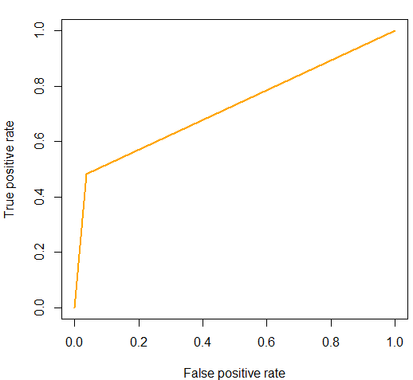
> perf <- performance(pred,"lift","rpp")
> plot(perf, main="lift curve", colorize=T)
>

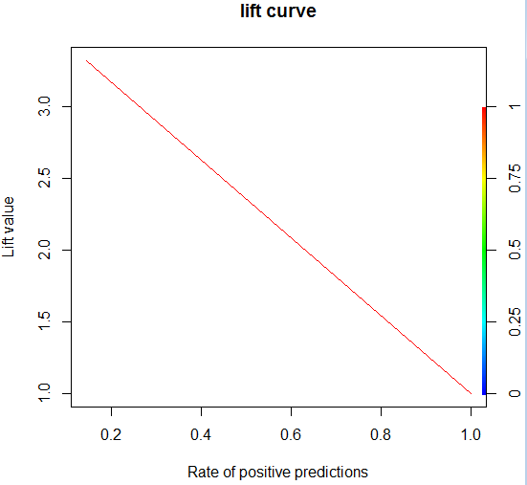

I prefer ROC curves over Lift and Gain charts. We will see them in Data Minin 2 in the fall.

