R version 3.2.2 (2015-08-14) -- "Fire Safety"
Copyright (C) 2015 The R Foundation for Statistical Computing
Platform: x86_64-w64-mingw32/x64 (64-bit)

R is free software and comes with ABSOLUTELY NO WARRANTY.
You are welcome to redistribute it under certain conditions.
Type 'license()' or 'licence()' for distribution details.

Natural language support but running in an English locale

R is a collaborative project with many contributors.
Type 'contributors()' for more information and
'citation()' on how to cite R or R packages in publications.

Type 'demo()' for some demos, 'help()' for on-line help, or
'help.start()' for an HTML browser interface to help.
Type 'q()' to quit R.

> setwd("c:/Users/TonyLaptop/Desktop/Rowan/DM1/Lecture13")
> getwd()
[1] "c:/Users/TonyLaptop/Desktop/Rowan/DM1/Lecture13"
> library(foreign)
> #this is a stata data set from UCLA.
> #stata is a $1000 statistics package. There are a lot of data sets in stata format
> #it can be read into R with the following call
> dat <- read.dta("binary.dta")
> head(dat)
admit gre gpa rank
1 0 380 3.61 3
2 1 660 3.67 3
3 1 800 4.00 1
4 1 640 3.19 4
5 0 520 2.93 4
6 1 760 3.00 2

> dim(dat)
[1] 400 4
> #this data set is related to attributes related to people getting into grad school
> #install.packages("ggplot2")
> library(ggplot2)
> boxplot(dat$gre)
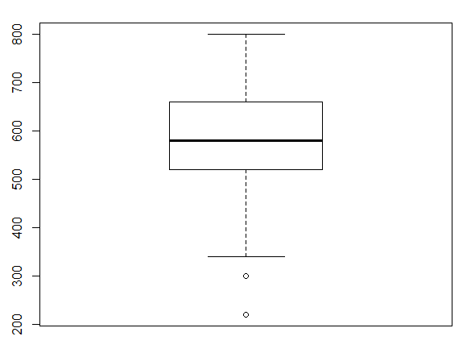
> plot(dat$gre,dat$admit)
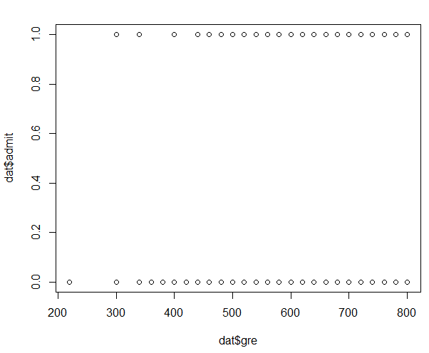
> dat$gre2<-sapply(dat$gre,function(b){
+ if (b<520){
+ return('low')
+ }else{
+ if (b<650){
+ return('med')
+ } else {
+ return('high')
+ }}}
+ )
> head(dat)
admit gre gpa rank gre2
1 0 380 3.61 3 low
2 1 660 3.67 3 high
3 1 800 4.00 1 high
4 1 640 3.19 4 med
5 0 520 2.93 4 med
6 1 760 3.00 2 high

> #In this example we show how to layer multiple plots in a single
> Plot
> ggplot(dat,aes(x=admit,y=gpa)) + geom_boxplot(size = .75) +
+ geom_point() +
+ facet_grid(gre2 ~ rank, margins = TRUE)+
+ theme(axis.text.x = element_text(angle = 45, hjust = 1, vjust = 1))
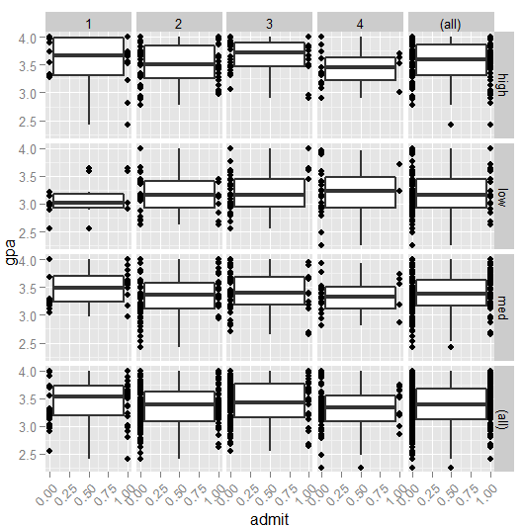

> #the top left corner is a bit surprising. There are people with high GPA, in good schools, with
> #high GRE’s that are not being admitted. This doesn’t bode well for modeling
> aggregate(dat$admit,list(gre=dat$gre),mean)
gre x
1 220 0.0000000
2 300 0.3333333
3 340 0.2500000
4 360 0.0000000
5 380 0.0000000
6 400 0.1818182
7 420 0.0000000
8 440 0.2000000
9 460 0.2857143
10 480 0.3750000
11 500 0.0952381
12 520 0.4166667
13 540 0.3333333
14 560 0.2500000
15 580 0.2068966
16 600 0.3913043
17 620 0.4000000
18 640 0.2380952
19 660 0.5000000
20 680 0.4500000
21 700 0.2272727
22 720 0.2727273
23 740 0.3636364
24 760 0.8000000
25 780 0.8000000
26 800 0.4400000
> aggregate(dat$gre,list(admit=dat$admit),mean)
admit x
1 0 573.1868
2 1 618.8976
> aggregate(dat$rank,list(admit=dat$admit),mean)
admit x
1 0 2.641026
2 1 2.149606
> aggregate(dat$gpa,list(admit=dat$admit),mean)
admit x
1 0 3.343700
2 1 3.489213
> names(dat)
[1] "admit" "gre" "gpa" "rank" "gre2"
> library(plyr)
> count(dat,c('admit','gre2'))
admit gre2 freq
1 0 high 71
2 0 low 81
3 0 med 121
4 1 high 52
5 1 low 18
6 1 med 57
> dat$gpa2<-sapply(dat$gpa,function(b){
+ return(trunc(10*b)/10)
+ })
> dat$gpa3<-sapply(dat$gpa,function(b){
+ if (b >=3.7){
+ return('hi')
+ }else{
+ if (b < 3){
+ return('low')
+ }else{
+ return('mid')
+ }}
+ })
> count(dat,c('admit','gpa3','rank','gre2'))
admit gpa3 rank gre2 freq
1 0 hi 1 high 5
2 0 hi 1 med 1
3 0 hi 2 high 9
4 0 hi 2 low 1
5 0 hi 2 med 6
6 0 hi 3 high 11
7 0 hi 3 low 2
8 0 hi 3 med 10
9 0 hi 4 high 3
10 0 hi 4 low 3
11 0 hi 4 med 3
12 0 low 1 low 4
13 0 low 2 high 4
14 0 low 2 low 5
15 0 low 2 med 11
16 0 low 3 low 11
17 0 low 3 med 5
18 0 low 4 high 1
19 0 low 4 low 8
20 0 low 4 med 3
21 0 mid 1 high 5
22 0 mid 1 low 3
23 0 mid 1 med 10
24 0 mid 2 high 13
25 0 mid 2 low 17
26 0 mid 2 med 31
27 0 mid 3 high 11
28 0 mid 3 low 17
29 0 mid 3 med 26
30 0 mid 4 high 9
31 0 mid 4 low 10
32 0 mid 4 med 15
33 1 hi 1 high 6
34 1 hi 1 med 6
35 1 hi 2 high 7
36 1 hi 2 med 8
37 1 hi 3 high 6
38 1 hi 3 low 1
39 1 hi 3 med 3
40 1 hi 4 high 1
41 1 hi 4 low 1
42 1 hi 4 med 1
43 1 low 1 high 2
44 1 low 1 low 1
45 1 low 1 med 1
46 1 low 2 high 1
47 1 low 2 low 3
48 1 low 2 med 2
49 1 low 3 high 2
50 1 low 3 med 2
51 1 low 4 med 1
52 1 mid 1 high 5
53 1 mid 1 low 3
54 1 mid 1 med 9
55 1 mid 2 high 14
56 1 mid 2 low 5
57 1 mid 2 med 14
58 1 mid 3 high 4
59 1 mid 3 low 3
60 1 mid 3 med 7
61 1 mid 4 high 4
62 1 mid 4 low 1
63 1 mid 4 med 3
> count(dat,c('admit','gpa3','gre2'))
admit gpa3 gre2 freq
1 0 hi high 28
2 0 hi low 6
3 0 hi med 20
4 0 low high 5
5 0 low low 28
6 0 low med 19
7 0 mid high 38
8 0 mid low 47
9 0 mid med 82
10 1 hi high 20
11 1 hi low 2
12 1 hi med 18
13 1 low high 5
14 1 low low 4
15 1 low med 6
16 1 mid high 27
17 1 mid low 12
18 1 mid med 33
> ggplot(dat,aes(x=admit,y=gpa2)) + geom_boxplot() +
+ geom_point(position=position_jitter(w=.2,h=.05)) +
+ facet_grid(gre2 ~ rank, margins = TRUE)+
+ theme(axis.text.x = element_text(angle = 45, hjust = 1, vjust = 1))
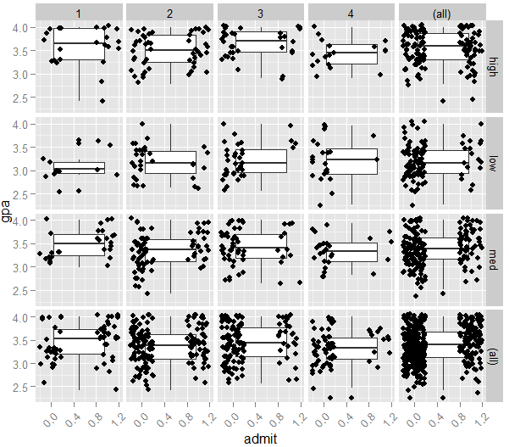
> dim(dat)
[1] 400 7
> train=sample(1:400,300)
> dim(train)
> test=-train
> trainingData=dat[train,]
> testingData=dat[test,]
> dim(trainingData)
[1] 300 7
> dim(testingData)
[1] 100 7
> names(testingData)
[1] "admit" "gre" "gpa" "rank" "gre2" "gpa2" "gpa3"
> regmodel<-lm(trainingData$admit~trainingData$gre+trainingData$gpa+trainingData$rank)
> summary(regmodel)

Call:
lm(formula = trainingData$admit ~ trainingData$gre + trainingData$gpa +
trainingData$rank)

Residuals:
Min 1Q Median 3Q Max
-0.6117 -0.3343 -0.1898 0.4958 0.9778

Coefficients:
Estimate Std. Error t value Pr(>|t|)
(Intercept) -0.1838640 0.2454747 -0.749 0.45444
trainingData$gre 0.0001987 0.0002382 0.834 0.40475
trainingData$gpa 0.1886045 0.0725217 2.601 0.00977 **
trainingData$rank -0.1121541 0.0270865 -4.141 4.52e-05 ***
---
Signif. codes: 0 ‘***’ 0.001 ‘**’ 0.01 ‘*’ 0.05 ‘.’ 0.1 ‘ ’ 1

Residual standard error: 0.4373 on 296 degrees of freedom
Multiple R-squared: 0.09563, Adjusted R-squared: 0.08647
F-statistic: 10.43 on 3 and 296 DF, p-value: 1.517e-06

> #terrible r-sqaured. Let's see how awful the prediction is
> testingData$guess<-0
> for (i in 1:100){
+ testingData$guess[i]<-trunc(.5 -.183864 + .0001987*testingData$gre[i]+.1886045*testingData$gpa[i]-
+ .1121541*testingData$rank[i])
+ }
> head(testingData)
admit gre gpa rank gre2 gpa2 gpa3 guess
1 0 380 3.61 3 low 3.6 mid 0
2 1 660 3.67 3 high 3.6 mid 0
4 1 640 3.19 4 med 3.1 mid 0
10 0 700 3.92 2 high 3.9 hi 0
11 0 800 4.00 4 high 4.0 hi 0
15 1 700 4.00 1 high 4.0 hi 1
> count(testingData,c('admit','guess'))
admit guess freq
1 0 0 61
2 0 1 1
3 1 0 33
4 1 1 5
> #66% correct
> #try logistic model
> mylogit <- glm(admit ~ gre + gpa + rank, data = trainingData, family = "binomial")
> summary(mylogit)

Call:
glm(formula = admit ~ gre + gpa + rank, family = "binomial",
data = trainingData)

Deviance Residuals:
Min 1Q Median 3Q Max
-1.4661999 -0.8446838 -0.6096447 1.1270904 2.1742281

Coefficients:
Estimate Std. Error z value Pr(>|z|)
(Intercept) -3.086631730 1.359531431 -2.27036 0.02318548 *
gre 0.001833189 0.001282269 1.42964 0.15281908
gpa 0.718206907 0.378823370 1.89589 0.05797478 .
rank -0.573880475 0.150509127 -3.81293 0.00013733 ***
---
Signif. codes: 0 ‘***’ 0.001 ‘**’ 0.01 ‘*’ 0.05 ‘.’ 0.1 ‘ ’ 1

(Dispersion parameter for binomial family taken to be 1)

Null deviance: 359.48402 on 299 degrees of freedom
Residual deviance: 331.57689 on 296 degrees of freedom
AIC: 339.57689

Number of Fisher Scoring iterations: 4

> testingData$guess <- predict(mylogit, newdata = testingData[,1:4], type = "response")
> for (i in 1:100){
+ testingData$guess[i]=trunc(testingData$guess[i]+.5)
+ }
>
> count(testingData,c('admit','guess'))
admit guess freq
1 0 0 57
2 0 1 2
3 1 0 35
4 1 1 6
> #63%. Slightly worse

> #perhaps we can do better if we don’t assume rank is continuous, because it probably isn’t
> #treat as factors and see if it makes a difference
> testingData$rank <- factor(testingData$rank)
> trainingData$rank <- factor(trainingData$rank)
> mylogit <- glm(admit ~ gre + gpa + rank, data = trainingData, family = "binomial")
> summary(mylogit)

Call:
glm(formula = admit ~ gre + gpa + rank, family = "binomial",
data = trainingData)

Deviance Residuals:
Min 1Q Median 3Q Max
-1.5145 -0.8435 -0.6012 1.0873 2.1259

Coefficients:
Estimate Std. Error z value Pr(>|z|)
(Intercept) -4.505821 1.364522 -3.302 0.000960 ***
gre 0.001018 0.001290 0.790 0.429749
gpa 1.122350 0.403155 2.784 0.005371 **
rank2 -0.507012 0.361787 -1.401 0.161091
rank3 -1.550176 0.422351 -3.670 0.000242 ***
rank4 -1.444152 0.497346 -2.904 0.003688 **
---
Signif. codes: 0 ‘***’ 0.001 ‘**’ 0.01 ‘*’ 0.05 ‘.’ 0.1 ‘ ’ 1

(Dispersion parameter for binomial family taken to be 1)

Null deviance: 364.81 on 299 degrees of freedom
Residual deviance: 331.77 on 294 degrees of freedom
AIC: 343.77

Number of Fisher Scoring iterations: 4

> names(trainingData)
[1] "admit" "gre" "gpa" "rank" "gre2" "gpa2" "gpa3"
> testingData$guess <- predict(mylogit, newdata = testingData[,1:4], type = "response")
> head(testingData)
admit gre gpa rank gre2 gpa2 gpa3 guess
1 0 380 3.61 3 low 3.6 mid 0.1655715
2 1 660 3.67 3 high 3.6 mid 0.2201373
4 1 640 3.19 4 med 3.1 mid 0.1521371
10 0 700 3.92 2 high 3.9 hi 0.5248843
11 0 800 4.00 4 high 4.0 hi 0.3439145
15 1 700 4.00 1 high 4.0 hi 0.6673934
> for (i in 1:100){
+ testingData$guess[i]=trunc(testingData$guess[i]+.5)
+ }
> head(testingData)
admit gre gpa rank gre2 gpa2 gpa3 guess
1 0 380 3.61 3 low 3.6 mid 0
2 1 660 3.67 3 high 3.6 mid 0
4 1 640 3.19 4 med 3.1 mid 0
10 0 700 3.92 2 high 3.9 hi 1
11 0 800 4.00 4 high 4.0 hi 0
15 1 700 4.00 1 high 4.0 hi 1
> count(testingData,c('admit','guess'))
admit guess freq
1 0 0 58
2 0 1 4
3 1 0 28
4 1 1 10

> #68% correct. Better but still Not great. Probably because the data is goofy as seen before
> #Let’s look at the census data again

> setwd("C:/Users/TonyLaptop/Desktop/rowan/DM1/lecture9/lecture9")
> data<-read.csv("censusAdult50k.csv",header = TRUE, sep = ",", stringsAsFactors = TRUE)
> minn = min(data$Age)
> maxx = max(data$Age)
> data$Age2 <- sapply(data$Age,function(b) {
+ return((b-minn)/(maxx-minn))
+ }
+ )
> minn = min(data$CapitalGain)
> maxx = max(data$CapitalGain)
> data$Gain2 <- sapply(data$CapitalGain,function(b) {
+ return((b-minn)/(maxx-minn))
+ }
+ )
> minn = min(data$CapitalLoss)
> maxx = max(data$CapitalLoss)
> data$Loss2 <- sapply(data$CapitalLoss,function(b) {
+ return((b-minn)/(maxx-minn))
+ }
+ )
>
> minn = min(data$EducationNum)
> maxx = max(data$EducationNum)
> data$Educ2 <- sapply(data$EducationNum,function(b) {
+ return((b-minn)/(maxx-minn))
+ }
+ )
>
> minn = min(data$HoursPerWeek)
> maxx = max(data$HoursPerWeek)
> data$Hours2 <- sapply(data$HoursPerWeek,function(b) {
+ return((b-minn)/(maxx-minn))
+ }
+ )
> m <-model.matrix(~ Income + Age2 + Educ2 + MaritalStatus + Relationship + Race + Sex + Hours2 + Job+Gain2 + Loss2, data=data)
>
> names(m[1,])
[1] "(Intercept)" "Income >50K" "Age2"
[4] "Educ2" "MaritalStatus Married-AF-spouse" "MaritalStatus Married-civ-spouse"
[7] "MaritalStatus Married-spouse-absent" "MaritalStatus Never-married" "MaritalStatus Separated"
[10] "MaritalStatus Widowed" "Relationship Not-in-family" "Relationship Other-relative"
[13] "Relationship Own-child" "Relationship Unmarried" "Relationship Wife"
[16] "Race Asian-Pac-Islander" "Race Black" "Race Other"
[19] "Race White" "Sex Male" "Hours2"
[22] "Job Armed-Forces" "Job Craft-repair" "Job Exec-managerial"
[25] "Job Farming-fishing" "Job Handlers-cleaners" "Job Machine-op-inspct"
[28] "Job Other" "Job Other-service" "Job Priv-house-serv"
[31] "Job Prof-specialty" "Job Protective-serv" "Job Sales"
[34] "Job Tech-support" "Job Transport-moving" "Gain2"
[37] "Loss2"
>colnames(m)=c("dk","Income","Age2","Educ2","MarStat1","MarStat2","MarStat3","Unmarried","Separated","Widowed","Rel1","Rel2","Rel3","Unmarried2","Wife","Race1","Black","RaceOther","White","Male","Hours","Milit","Craft","Executive","Farmer","Cleaner","MachineOp","JobOth","OthServ","HouseServ","ProfSpec","ProtServ","Sales","TechSup","Moving","Gain","Loss")
> v<-as.data.frame(m[,2:37])
> set.seed(2)
> train=sample(1:nrow(v),nrow(v)/2)
> test=-train
>
> trainingData=v[train,]
> testingData=v[test,]
> formula =
+ Income~Age2+Educ2+MarStat1+MarStat2+MarStat3+Unmarried+Separated+Widowed+Rel1+Rel2+Rel3+Unmarried2+
+ Wife+Race1+Black+RaceOther+White+Male+Hours+Milit+Craft+Executive+Farmer+
+ Cleaner+MachineOp+JobOth+OthServ+HouseServ+ProfSpec+ProtServ+Sales+TechSup+Moving+Gain+Loss
> nnet<-neuralnet(formula,trainingData, hidden=5, threshold=0.5)
> results<-compute(nnet,testingData[,2:36])
> testingData$result<- sapply(results$net.result, function(b) {
+ if (b<=.5){
+ return(0)
+ }else{
+ return(1)
+ }})
> count(testingData,c('Income','result'))
Income result freq
1 0 0 11416
2 0 1 921
3 1 0 1498
4 1 1 2446
> (11416+2446)/16281
[1] 0.8514219028
>

> #Now let's try a logistic model
> mylogit <- glm(formula, data = trainingData, family = "binomial")
Warning message:
glm.fit: fitted probabilities numerically 0 or 1 occurred
> summary(mylogit)

Call:
glm(formula = formula, family = "binomial", data = trainingData)

Deviance Residuals:
Min 1Q Median 3Q Max
-4.9264625 -0.5106173 -0.1834466 -0.0319894 3.3252902

Coefficients:
Estimate Std. Error z value Pr(>|z|)
(Intercept) -9.073012018 0.535917584 -16.92986 < 0.000000000000000222 ***
Age2 1.685498215 0.166284469 10.13623 < 0.000000000000000222 ***
Educ2 4.194875648 0.193517349 21.67700 < 0.000000000000000222 ***
MarStat1 2.929706509 0.735909676 3.98107 0.0000686062994520529 ***
MarStat2 2.190420975 0.370510698 5.91190 0.0000000033819060940 ***
MarStat3 -0.006577681 0.297875586 -0.02208 0.98238256
Unmarried -0.480663936 0.124962588 -3.84646 0.00011984 ***
Separated -0.160530023 0.238060379 -0.67432 0.50010482
Widowed -0.113253925 0.234309524 -0.48335 0.62884598
Rel1 0.543751626 0.365673924 1.48698 0.13701878
Rel2 -0.701231670 0.350546232 -2.00040 0.04545740 *
Rel3 -0.693571184 0.356846541 -1.94361 0.05194227 .
Unmarried2 0.494061111 0.388729461 1.27096 0.20374149
Wife 1.394560865 0.145532406 9.58248 < 0.000000000000000222 ***
Race1 0.807743103 0.343399756 2.35219 0.01866300 *
Black 0.690465473 0.331244936 2.08446 0.03711871 *
RaceOther -0.089815691 0.490218627 -0.18322 0.85462887
White 0.782254393 0.316853377 2.46882 0.01355589 *
Male 0.883186961 0.112574492 7.84536 0.0000000000000043173 ***
Hours 3.002742039 0.223414645 13.44022 < 0.000000000000000222 ***
Milit -0.241304406 1.626633016 -0.14835 0.88206976
Craft 0.054815247 0.111032729 0.49369 0.62152832
Executive 0.838374963 0.107489271 7.79962 0.0000000000000062096 ***
Farmer -1.607591289 0.211612186 -7.59687 0.0000000000000303368 ***
Cleaner -0.619843032 0.197140079 -3.14418 0.00166555 **
MachineOp -0.179900752 0.141141723 -1.27461 0.20244706
JobOth -0.536478011 0.163291854 -3.28539 0.00101840 **
OthServ -0.731222048 0.160378121 -4.55936 0.0000051309048581704 ***
HouseServ -3.637447374 1.684920547 -2.15882 0.03086380 *
ProfSpec 0.527571262 0.111102065 4.74853 0.0000020490254726066 ***
ProtServ 0.511460496 0.174978714 2.92299 0.00346691 **
Sales 0.292674996 0.114313534 2.56028 0.01045870 *
TechSup 0.705127597 0.156744933 4.49857 0.0000068413004968849 ***
Moving -0.005945010 0.137777191 -0.04315 0.96558240
Gain 30.889856167 1.415821889 21.81761 < 0.000000000000000222 ***
Loss 2.752717446 0.227933151 12.07686 < 0.000000000000000222 ***
---
Signif. codes: 0 ‘***’ 0.001 ‘**’ 0.01 ‘*’ 0.05 ‘.’ 0.1 ‘ ’ 1

(Dispersion parameter for binomial family taken to be 1)

Null deviance: 17919.613 on 16279 degrees of freedom
Residual deviance: 10339.384 on 16244 degrees of freedom
AIC: 10411.384

Number of Fisher Scoring iterations: 7

> names(testingData)
[1] "Income" "Age2" "Educ2" "MarStat1" "MarStat2" "MarStat3" "Unmarried" "Separated" "Widowed" "Rel1" "Rel2"
[12] "Rel3" "Unmarried2" "Wife" "Race1" "Black" "RaceOther" "White" "Male" "Hours" "Milit" "Craft"
[23] "Executive" "Farmer" "Cleaner" "MachineOp" "JobOth" "OthServ" "HouseServ" "ProfSpec" "ProtServ" "Sales" "TechSup"
[34] "Moving" "Gain" "Loss" "result"
> testingData$guess<-predict(mylogit,newdata=testingData[,2:37],type="response")
>
>
> for (i in 1:16281){
+ testingData$guess[i]=trunc(.5+testingData$guess[i])
+ }
>
>
> count(testingData,c('Income','guess'))
Income guess freq
1 0 0 11445
2 0 1 892
3 1 0 1606
4 1 1 2338
> (11445+2338)/16281
[1] 0.846569621
>
> #85% correct without all of the complications of a neuralnet
> names(testingData)
[1] "Income" "Age2" "Educ2" "MarStat1" "MarStat2" "MarStat3" "Unmarried" "Separated"
[9] "Widowed" "Rel1" "Rel2" "Rel3" "Unmarried2" "Wife" "Race1" "Black"
[17] "RaceOther" "White" "Male" "Hours" "Milit" "Craft" "Executive" "Farmer"
[25] "Cleaner" "MachineOp" "JobOth" "OthServ" "HouseServ" "ProfSpec" "ProtServ" "Sales"
[33] "TechSup" "Moving" "Gain" "Loss" "result" "guess"
> count(testingData,c('Income','guess','result'))
Income guess result freq
1 0 0 0 11255
2 0 0 1 190
3 0 1 0 161
4 0 1 1 731
5 1 0 0 1413
6 1 0 1 193
7 1 1 0 85
8 1 1 1 2253
> (731+1413)/16281
[1] 0.1316872428
> #both models simultaneously wrong only 13% of the time, versus each wrong 15% of the time.
> #so both behave similarly.
> #Let's do a multiple regression, just so we have a comparison.
> regmodel<-lm(trainingData$Income~trainingData$Age2+trainingData$Educ2 + trainingData$MarStat1 + trainingData$MarStat2 + trainingData$MarStat3 +
+ trainingData$Unmarried + trainingData$Separated + trainingData$Widowed + trainingData$Rel1 + trainingData$Rel2 + trainingData$Rel3 +
+ trainingData$Unmarried2 + trainingData$Wife + trainingData$Race1 + trainingData$Black + trainingData$RaceOther + trainingData$White +
+ trainingData$Male + trainingData$Hours + trainingData$Milit + trainingData$Craft + trainingData$Executive + trainingData$Farmer +
+ trainingData$Cleaner + trainingData$MachineOp + trainingData$JobOth + trainingData$OthServ + trainingData$HouseServ + trainingData$ProfSpec +
+ trainingData$ProtServ + trainingData$Sales + trainingData$TechSup + trainingData$Moving + trainingData$Gain + trainingData$Loss)
> summary(regmodel)

Call:
lm(formula = trainingData$Income ~ trainingData$Age2 + trainingData$Educ2 +
trainingData$MarStat1 + trainingData$MarStat2 + trainingData$MarStat3 +
trainingData$Unmarried + trainingData$Separated + trainingData$Widowed +
trainingData$Rel1 + trainingData$Rel2 + trainingData$Rel3 +
trainingData$Unmarried2 + trainingData$Wife + trainingData$Race1 +
trainingData$Black + trainingData$RaceOther + trainingData$White +
trainingData$Male + trainingData$Hours + trainingData$Milit +
trainingData$Craft + trainingData$Executive + trainingData$Farmer +
trainingData$Cleaner + trainingData$MachineOp + trainingData$JobOth +
trainingData$OthServ + trainingData$HouseServ + trainingData$ProfSpec +
trainingData$ProtServ + trainingData$Sales + trainingData$TechSup +
trainingData$Moving + trainingData$Gain + trainingData$Loss)

Residuals:
Min 1Q Median 3Q Max
-0.9132098 -0.2542395 -0.0331964 0.1643714 1.1233477

Coefficients:
Estimate Std. Error t value Pr(>|t|)
(Intercept) -0.336102548 0.046640693 -7.20621 0.0000000000006005898 ***
trainingData$Age2 0.176293359 0.018458682 9.55070 < 0.000000000000000222 ***
trainingData$Educ2 0.474457753 0.019197887 24.71406 < 0.000000000000000222 ***
trainingData$MarStat1 0.206711940 0.093022821 2.22216 0.02628596 *
trainingData$MarStat2 0.115944531 0.032721080 3.54342 0.00039608 ***
trainingData$MarStat3 0.029027945 0.023570234 1.23155 0.21813468
trainingData$Unmarried -0.007841171 0.010029262 -0.78183 0.43432628
trainingData$Separated 0.012627198 0.016794198 0.75188 0.45213499
trainingData$Widowed 0.006470502 0.017899774 0.36149 0.71774154
trainingData$Rel1 -0.166481334 0.032545026 -5.11542 0.0000003166147461074 ***
trainingData$Rel2 -0.148182732 0.032155615 -4.60830 0.0000040906153074929 ***
trainingData$Rel3 -0.139883317 0.032514328 -4.30221 0.0000170094788472772 ***
trainingData$Unmarried2 -0.150089353 0.033804978 -4.43986 0.0000090611070175791 ***
trainingData$Wife 0.112520801 0.015112743 7.44543 0.0000000000001014728 ***
trainingData$Race1 0.064758756 0.030423813 2.12855 0.03330611 *
trainingData$Black 0.059754877 0.028001763 2.13397 0.03286030 *
trainingData$RaceOther 0.003285718 0.038844091 0.08459 0.93259052
trainingData$White 0.067966057 0.026779539 2.53798 0.01115855 *
trainingData$Male 0.059085859 0.007995290 7.39008 0.0000000000001538695 ***
trainingData$Hours 0.291830851 0.023650614 12.33925 < 0.000000000000000222 ***
trainingData$Milit -0.017821903 0.139746273 -0.12753 0.89852216
trainingData$Craft -0.022518368 0.011629422 -1.93633 0.05284494 .
trainingData$Executive 0.150941965 0.011376479 13.26790 < 0.000000000000000222 ***
trainingData$Farmer -0.145013595 0.018056319 -8.03118 0.0000000000000010311 ***
trainingData$Cleaner -0.049475933 0.015883109 -3.11500 0.00184263 **
trainingData$MachineOp -0.035649481 0.013706093 -2.60100 0.00930380 **
trainingData$JobOth -0.020171043 0.013919113 -1.44916 0.14731179
trainingData$OthServ -0.015390166 0.011700525 -1.31534 0.18841432
trainingData$HouseServ 0.047321659 0.038536375 1.22797 0.21947459
trainingData$ProfSpec 0.095705595 0.011557231 8.28101 < 0.000000000000000222 ***
trainingData$ProtServ 0.056883303 0.021303688 2.67012 0.00759007 **
trainingData$Sales 0.047856496 0.011451081 4.17921 0.0000294051087745518 ***
trainingData$TechSup 0.082198788 0.017716333 4.63972 0.0000035160863351457 ***
trainingData$Moving -0.029575154 0.015023045 -1.96865 0.04901000 *
trainingData$Gain 0.854784752 0.037912466 22.54627 < 0.000000000000000222 ***
trainingData$Loss 0.411081140 0.029366169 13.99846 < 0.000000000000000222 ***
---
Signif. codes: 0 ‘***’ 0.001 ‘**’ 0.01 ‘*’ 0.05 ‘.’ 0.1 ‘ ’ 1

Residual standard error: 0.3410493 on 16244 degrees of freedom
Multiple R-squared: 0.3625805, Adjusted R-squared: 0.3612071
F-statistic: 264.0001 on 35 and 16244 DF, p-value: < 0.00000000000000022204

> #.36 R-Squared with a standard error of .34 is terrible.
> dim(testingData)
[1] 16281 38
> names(testingData)
[1] "Income" "Age2" "Educ2" "MarStat1" "MarStat2" "MarStat3" "Unmarried" "Separated" "Widowed" "Rel1" "Rel2"
[12] "Rel3" "Unmarried2" "Wife" "Race1" "Black" "RaceOther" "White" "Male" "Hours" "Milit" "Craft"
[23] "Executive" "Farmer" "Cleaner" "MachineOp" "JobOth" "OthServ" "HouseServ" "ProfSpec" "ProtServ" "Sales" "TechSup"
[34] "Moving" "Gain" "Loss" "result" "guess"
> testingData$guess3<-0
> for (i in 1:16281){
+ testingData$guess3[i] = -0.336102548 +
+ testingData$Age2[i]*0.176293359 +
+ testingData$Educ2[i]*0.474457753 +
+ testingData$MarStat1[i]*0.206711940 +
+ testingData$MarStat2[i]*0.115944531 +
+ testingData$MarStat3[i]*0.029027945 +
+ testingData$Unmarried[i]*(-0.007841171) +
+ testingData$Separated[i]*0.012627198 +
+ testingData$Widowed[i]*0.006470502 +
+ testingData$Rel1[i]*(-0.166481334) +
+ testingData$Rel2[i]*(-0.148182732) +
+ testingData$Rel3[i]*(-0.139883317) +
+ testingData$Unmarried2[i]*(-0.150089353) +
+ testingData$Wife[i]*0.112520801 +
+ testingData$Race1[i]*0.064758756 +
+ testingData$Black[i]*0.059754877 +
+ testingData$RaceOther[i]*0.003285718 +
+ testingData$White[i]*0.067966057 +
+ testingData$Male[i]*0.059085859 +
+ testingData$Hours[i]*0.291830851 +
+ testingData$Milit[i]*(-0.017821903) +
+ testingData$Craft[i]*(-0.022518368) +
+ testingData$Executive[i]*0.150941965 +
+ testingData$Farmer[i]*(-0.145013595) +
+ testingData$Cleaner[i]*(-0.049475933) +
+ testingData$MachineOp[i]*(-0.035649481) +
+ testingData$JobOth[i]*(-0.020171043) +
+ testingData$OthServ[i]*(-0.015390166) +
+ testingData$HouseServ[i]*(0.047321659) +
+ testingData$ProfSpec[i]*0.095705595 +
+ testingData$ProtServ[i]*0.056883303 +
+ testingData$Sales[i]*0.047856496 +
+ testingData$TechSup[i]*0.082198788 +
+ testingData$Moving[i]*(-0.029575154) +
+ testingData$Gain[i]*0.854784752 +
+ testingData$Loss[i]*0.411081140
+ }
> for (i in 1:16281){
+ testingData$guess3[i]<-trunc(.5+testingData$guess3[i])
+ }

> count(testingData,c('Income','guess3'))
Income guess3 freq
1 0 0 11592
2 0 1 745
3 1 0 1916
4 1 1 1991
5 1 2 37
> (11592+1991+37)/16281
[1] 0.836557951
> #surprisingly good

> count(testingData,c('Income','guess','result','guess3'))
Income guess result guess3 freq
1 0 0 0 0 11219
2 0 0 0 1 36
3 0 0 1 0 158
4 0 0 1 1 32
5 0 1 0 0 59
6 0 1 0 1 102
7 0 1 1 0 156
8 0 1 1 1 575
9 1 0 0 0 1388
10 1 0 0 1 25
11 1 0 1 0 158
12 1 0 1 1 35
13 1 1 0 0 26
14 1 1 0 1 59
15 1 1 1 0 344
16 1 1 1 1 1872
17 1 1 1 2 37
> (575+1388)/16281
[1] 0.1205699896
> #Only 12% of cases have all 3 models wrong
> #When we do Data Mining II we will do ensemble models
> #which combine multiple models and do majority voting
> #in this case we would gain accuracy over a single model

