R version 3.2.2 (2015-08-14) -- "Fire Safety"
Copyright (C) 2015 The R Foundation for Statistical Computing
Platform: x86_64-w64-mingw32/x64 (64-bit)

R is free software and comes with ABSOLUTELY NO WARRANTY.
You are welcome to redistribute it under certain conditions.
Type 'license()' or 'licence()' for distribution details.

Natural language support but running in an English locale

R is a collaborative project with many contributors.
Type 'contributors()' for more information and
'citation()' on how to cite R or R packages in publications.

Type 'demo()' for some demos, 'help()' for on-line help, or
'help.start()' for an HTML browser interface to help.
Type 'q()' to quit R.

> setwd("C:/Users/TonyLaptop/Desktop/Rowan/DM1/Lecture21")
> #the apriori function needs a file of transactions
> #install.packages("arules")
> library(arules)
Loading required package: Matrix

Attaching package: ‘arules’

The following objects are masked from ‘package:base’:

%in%, abbreviate, write

> farm=read.csv("farmMarket.csv",header=FALSE,sep=",")
> dim(farm)
[1] 15 4

> farm
V1 V2 V3 V4
1 broccoli peppers corn
2 asparagus squash corn
3 corn tomatoes beans squash
4 peppers corn tomatoes beans
5 beans asparagus broccoli
6 squash asparagus beans tomatoes
7 tomatoes corn
8 broccoli tomatoes peppers
9 squash asparagus beans
10 beans corn
11 peppers broccoli beans squash
12 asparagus beans squash
13 squash corn asparagus beans
14 corn peppers tomatoes beans
15 broccoli
> transactions=read.transactions(file=file("farmMarket.csv"),format="basket",sep=",")
> itemFrequencyPlot(transactions,type="absolute")

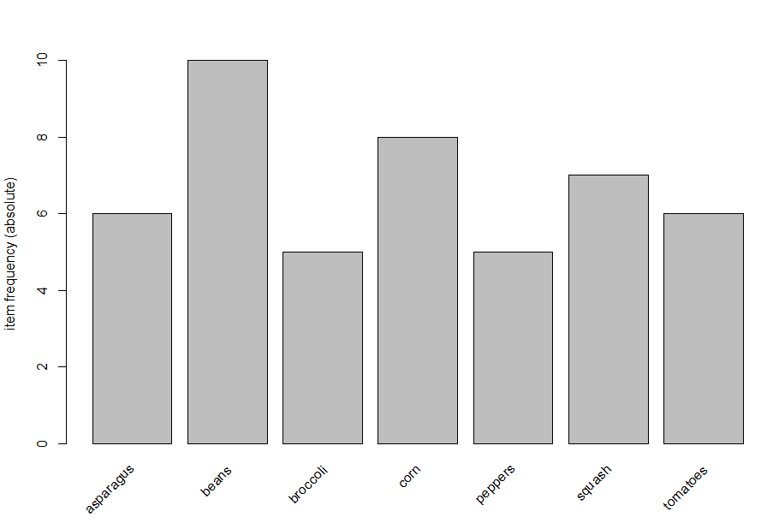

> itemFrequencyPlot(transactions,topN=7,type="absolute")

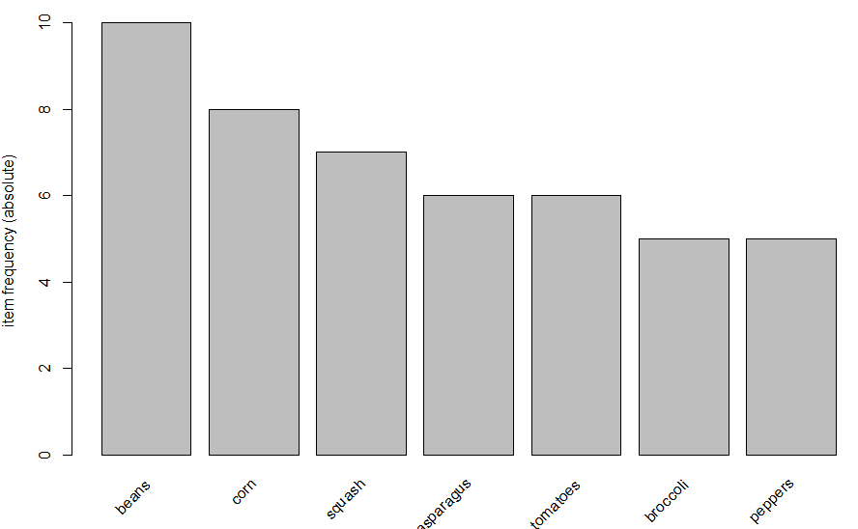

> rules=apriori(transactions,parameter=list(minlen=1,sup=.2,conf=.8))
Apriori

Parameter specification:
confidence minval smax arem aval originalSupport support minlen maxlen target ext
0.8 0.1 1 none FALSE TRUE 0.2 1 10 rules FALSE

Algorithmic control:
filter tree heap memopt load sort verbose
0.1 TRUE TRUE FALSE TRUE 2 TRUE

Absolute minimum support count: 3

set item appearances ...[0 item(s)] done [0.00s].
set transactions ...[7 item(s), 15 transaction(s)] done [0.00s].
sorting and recoding items ... [7 item(s)] done [0.00s].
creating transaction tree ... done [0.00s].
checking subsets of size 1 2 3 done [0.00s].
writing ... [7 rule(s)] done [0.00s].
creating S4 object ... done [0.00s].
> summary(rules)
set of 7 rules

rule length distribution (lhs + rhs):sizes
2 3
5 2

Min. 1st Qu. Median Mean 3rd Qu. Max.
2.000 2.000 2.000 2.286 2.500 3.000

summary of quality measures:
support confidence lift
Min. :0.2667 Min. :0.8000 Min. :1.200
1st Qu.:0.2667 1st Qu.:0.8000 1st Qu.:1.268
Median :0.2667 Median :0.8000 Median :1.714
Mean :0.3048 Mean :0.8177 Mean :1.719
3rd Qu.:0.3333 3rd Qu.:0.8333 3rd Qu.:2.093
Max. :0.4000 Max. :0.8571 Max. :2.400

mining info:
data ntransactions support confidence
transactions 15 0.2 0.8
>

> l<-inspect(rules)
lhs rhs support confidence lift
1 {broccoli} => {peppers} 0.2666667 0.8000000 2.400000
2 {peppers} => {broccoli} 0.2666667 0.8000000 2.400000
3 {asparagus} => {squash} 0.3333333 0.8333333 1.785714
4 {asparagus} => {beans} 0.3333333 0.8333333 1.250000
5 {squash} => {beans} 0.4000000 0.8571429 1.285714
6 {asparagus,squash} => {beans} 0.2666667 0.8000000 1.200000
7 {asparagus,beans} => {squash} 0.2666667 0.8000000 1.714286
> dim(l)
[1] 7 6
> l$rank<-0
> l$rank<-l$support*l$confidence
> l[order(-l$rank),]
lhs rhs support confidence lift rank
5 {squash} => {beans} 0.4000000 0.8571429 1.285714 0.3428571
3 {asparagus} => {squash} 0.3333333 0.8333333 1.785714 0.2777778
4 {asparagus} => {beans} 0.3333333 0.8333333 1.250000 0.2777778
1 {broccoli} => {peppers} 0.2666667 0.8000000 2.400000 0.2133333
2 {peppers} => {broccoli} 0.2666667 0.8000000 2.400000 0.2133333
6 {asparagus,squash} => {beans} 0.2666667 0.8000000 1.200000 0.2133333
7 {asparagus,beans} => {squash} 0.2666667 0.8000000 1.714286 0.2133333

> library(arulesViz)
Loading required package: grid

Attaching package: ‘arulesViz’

The following object is masked from ‘package:arules’:

abbreviate

The following object is masked from ‘package:base’:

Abbreviate

> plot(rules, method="graph", control=list(type="items"),interactive=TRUE)
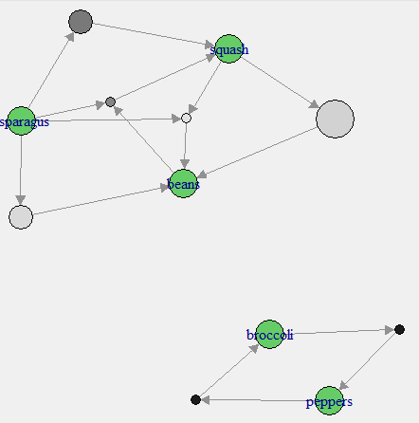
> #go to excel to see creating movies10.csv from movies8.csv
> transactions=read.transactions(file=file("movies10.csv"),format="basket",sep=",")
> itemFrequencyPlot(transactions,topN=20,type="absolute")

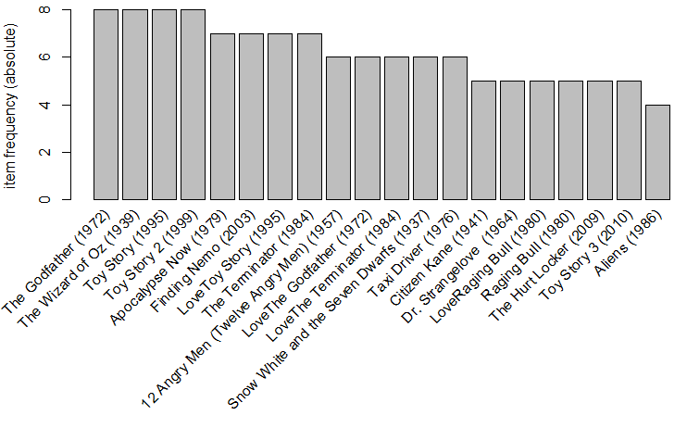

> rules=apriori(transactions,parameter=list(minlen=2,sup=.2,conf=.8,maxlen=2))
Apriori

Parameter specification:
confidence minval smax arem aval originalSupport support minlen maxlen target ext
0.8 0.1 1 none FALSE TRUE 0.2 2 2 rules FALSE

Algorithmic control:
filter tree heap memopt load sort verbose
0.1 TRUE TRUE FALSE TRUE 2 TRUE

Absolute minimum support count: 1

Warning in apriori(transactions, parameter = list(minlen = 2, sup = 0.2, :
You chose a very low absolute support count of 1. You might run out of memory! Increase minimum support.

set item appearances ...[0 item(s)] done [0.00s].
set transactions ...[143 item(s), 8 transaction(s)] done [0.00s].
sorting and recoding items ... [65 item(s)] done [0.00s].
creating transaction tree ... done [0.00s].
checking subsets of size 1 2 done [0.00s].
writing ... [978 rule(s)] done [0.00s].
creating S4 object ... done [0.00s].
> summary(rules)
set of 978 rules

rule length distribution (lhs + rhs):sizes
2
978

Min. 1st Qu. Median Mean 3rd Qu. Max.
2 2 2 2 2 2

summary of quality measures:
support confidence lift
Min. :0.2500 Min. :0.8000 Min. :0.9143
1st Qu.:0.2500 1st Qu.:1.0000 1st Qu.:1.0000
Median :0.3750 Median :1.0000 Median :1.3333
Mean :0.3901 Mean :0.9827 Mean :1.5922
3rd Qu.:0.5000 3rd Qu.:1.0000 3rd Qu.:1.6000
Max. :1.0000 Max. :1.0000 Max. :4.0000

mining info:
data ntransactions support confidence
transactions 8 0.2 0.8
> subset.matrix<-is.subset(rules, rules)
> dim(subset.matrix)
[1] 978 978
> subset.matrix[lower.tri(subset.matrix,diag=T)]<-NA
> redundant<-colSums(subset.matrix,na.rm=T) >= 1
> rules.pruned<-rules[!redundant]
> rules<-rules.pruned
> summary(rules)
set of 880 rules

rule length distribution (lhs + rhs):sizes
2
880

Min. 1st Qu. Median Mean 3rd Qu. Max.
2 2 2 2 2 2

summary of quality measures:
support confidence lift
Min. :0.2500 Min. :0.8000 Min. :0.9143
1st Qu.:0.2500 1st Qu.:1.0000 1st Qu.:1.0000
Median :0.2500 Median :1.0000 Median :1.3333
Mean :0.3726 Mean :0.9894 Mean :1.5198
3rd Qu.:0.5000 3rd Qu.:1.0000 3rd Qu.:1.6000
Max. :1.0000 Max. :1.0000 Max. :4.0000

mining info:
data ntransactions support confidence
transactions 8 0.2 0.8
> l<-inspect(rules[1:880])
> dim(l)
[1] 880 6
> l$rank<-0
> l$rank<-l$support*l$confidence
> l[order(-l$rank),][1:50,]
lhs rhs support confidence lift rank
967 {The Wizard of Oz (1939)} => {The Godfather (1972)} 1.000 1 1.000000 1.000
969 {The Wizard of Oz (1939)} => {Toy Story (1995)} 1.000 1 1.000000 1.000
971 {The Wizard of Oz (1939)} => {Toy Story 2 (1999)} 1.000 1 1.000000 1.000
973 {The Godfather (1972)} => {Toy Story (1995)} 1.000 1 1.000000 1.000
975 {The Godfather (1972)} => {Toy Story 2 (1999)} 1.000 1 1.000000 1.000
977 {Toy Story (1995)} => {Toy Story 2 (1999)} 1.000 1 1.000000 1.000
862 {The Terminator (1984)} => {The Wizard of Oz (1939)} 0.875 1 1.000000 0.875
864 {The Terminator (1984)} => {The Godfather (1972)} 0.875 1 1.000000 0.875
866 {The Terminator (1984)} => {Toy Story (1995)} 0.875 1 1.000000 0.875
868 {The Terminator (1984)} => {Toy Story 2 (1999)} 0.875 1 1.000000 0.875
923 {Finding Nemo (2003)} => {The Wizard of Oz (1939)} 0.875 1 1.000000 0.875
925 {Finding Nemo (2003)} => {The Godfather (1972)} 0.875 1 1.000000 0.875
927 {Finding Nemo (2003)} => {Toy Story (1995)} 0.875 1 1.000000 0.875
929 {Finding Nemo (2003)} => {Toy Story 2 (1999)} 0.875 1 1.000000 0.875
951 {Apocalypse Now (1979)} => {The Wizard of Oz (1939)} 0.875 1 1.000000 0.875
953 {Apocalypse Now (1979)} => {The Godfather (1972)} 0.875 1 1.000000 0.875
955 {Apocalypse Now (1979)} => {Toy Story (1995)} 0.875 1 1.000000 0.875
957 {Apocalypse Now (1979)} => {Toy Story 2 (1999)} 0.875 1 1.000000 0.875
959 {LoveToy Story (1995)} => {The Wizard of Oz (1939)} 0.875 1 1.000000 0.875
961 {LoveToy Story (1995)} => {The Godfather (1972)} 0.875 1 1.000000 0.875
963 {LoveToy Story (1995)} => {Toy Story (1995)} 0.875 1 1.000000 0.875
965 {LoveToy Story (1995)} => {Toy Story 2 (1999)} 0.875 1 1.000000 0.875
763 {LoveThe Terminator (1984)} => {The Terminator (1984)} 0.750 1 1.142857 0.750
765 {LoveThe Terminator (1984)} => {Finding Nemo (2003)} 0.750 1 1.142857 0.750
769 {LoveThe Terminator (1984)} => {The Wizard of Oz (1939)} 0.750 1 1.000000 0.750
770 {LoveThe Terminator (1984)} => {The Godfather (1972)} 0.750 1 1.000000 0.750
771 {LoveThe Terminator (1984)} => {Toy Story (1995)} 0.750 1 1.000000 0.750
772 {LoveThe Terminator (1984)} => {Toy Story 2 (1999)} 0.750 1 1.000000 0.750
874 {Taxi Driver (1976)} => {The Wizard of Oz (1939)} 0.750 1 1.000000 0.750
875 {Taxi Driver (1976)} => {The Godfather (1972)} 0.750 1 1.000000 0.750
876 {Taxi Driver (1976)} => {Toy Story (1995)} 0.750 1 1.000000 0.750
877 {Taxi Driver (1976)} => {Toy Story 2 (1999)} 0.750 1 1.000000 0.750
910 {LoveThe Godfather (1972)} => {Apocalypse Now (1979)} 0.750 1 1.142857 0.750
913 {LoveThe Godfather (1972)} => {The Wizard of Oz (1939)} 0.750 1 1.000000 0.750
914 {LoveThe Godfather (1972)} => {The Godfather (1972)} 0.750 1 1.000000 0.750
915 {LoveThe Godfather (1972)} => {Toy Story (1995)} 0.750 1 1.000000 0.750
916 {LoveThe Godfather (1972)} => {Toy Story 2 (1999)} 0.750 1 1.000000 0.750
931 {Snow White and the Seven Dwarfs (1937)} => {12 Angry Men (Twelve Angry Men) (1957)} 0.750 1 1.333333 0.750
933 {Snow White and the Seven Dwarfs (1937)} => {Apocalypse Now (1979)} 0.750 1 1.142857 0.750
935 {Snow White and the Seven Dwarfs (1937)} => {LoveToy Story (1995)} 0.750 1 1.142857 0.750
937 {Snow White and the Seven Dwarfs (1937)} => {The Wizard of Oz (1939)} 0.750 1 1.000000 0.750
938 {Snow White and the Seven Dwarfs (1937)} => {The Godfather (1972)} 0.750 1 1.000000 0.750
939 {Snow White and the Seven Dwarfs (1937)} => {Toy Story (1995)} 0.750 1 1.000000 0.750
940 {Snow White and the Seven Dwarfs (1937)} => {Toy Story 2 (1999)} 0.750 1 1.000000 0.750
941 {12 Angry Men (Twelve Angry Men) (1957)} => {Apocalypse Now (1979)} 0.750 1 1.142857 0.750
943 {12 Angry Men (Twelve Angry Men) (1957)} => {LoveToy Story (1995)} 0.750 1 1.142857 0.750
945 {12 Angry Men (Twelve Angry Men) (1957)} => {The Wizard of Oz (1939)} 0.750 1 1.000000 0.750
946 {12 Angry Men (Twelve Angry Men) (1957)} => {The Godfather (1972)} 0.750 1 1.000000 0.750
947 {12 Angry Men (Twelve Angry Men) (1957)} => {Toy Story (1995)} 0.750 1 1.000000 0.750
948 {12 Angry Men (Twelve Angry Men) (1957)} => {Toy Story 2 (1999)} 0.750 1 1.000000 0.750
>
> transactions=read.transactions(file=file("groceries.csv"),format="basket",sep=",")
> itemFrequencyPlot(transactions,topN=20,type="absolute")
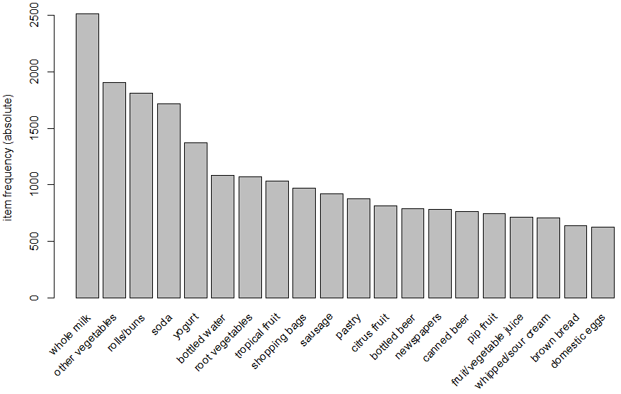
> dim(transactions)
[1] 9835 169
> rules=apriori(transactions,parameter=list(sup=.001,conf=.8,maxlen=3))
Apriori

Parameter specification:
confidence minval smax arem aval originalSupport support minlen maxlen target ext
0.8 0.1 1 none FALSE TRUE 0.001 1 3 rules FALSE

Algorithmic control:
filter tree heap memopt load sort verbose
0.1 TRUE TRUE FALSE TRUE 2 TRUE

Absolute minimum support count: 9

set item appearances ...[0 item(s)] done [0.00s].
set transactions ...[169 item(s), 9835 transaction(s)] done [0.01s].
sorting and recoding items ... [157 item(s)] done [0.00s].
creating transaction tree ... done [0.00s].
checking subsets of size 1 2 3 done [0.06s].
writing ... [29 rule(s)] done [0.00s].
creating S4 object ... done [0.01s].
> summary(rules)
set of 29 rules

rule length distribution (lhs + rhs):sizes
3
29

Min. 1st Qu. Median Mean 3rd Qu. Max.
3 3 3 3 3 3

summary of quality measures:
support confidence lift
Min. :0.001017 Min. :0.8000 Min. : 3.131
1st Qu.:0.001118 1st Qu.:0.8125 1st Qu.: 3.261
Median :0.001220 Median :0.8462 Median : 3.613
Mean :0.001473 Mean :0.8613 Mean : 4.000
3rd Qu.:0.001729 3rd Qu.:0.9091 3rd Qu.: 4.199
Max. :0.002542 Max. :1.0000 Max. :11.235

mining info:
data ntransactions support confidence
transactions 9835 0.001 0.8

> inspect(rules)
lhs rhs support confidence lift
1 {liquor,red/blush wine} => {bottled beer} 0.001931876 0.9047619 11.235269
2 {cereals,curd} => {whole milk} 0.001016777 0.9090909 3.557863
3 {cereals,yogurt} => {whole milk} 0.001728521 0.8095238 3.168192
4 {butter,jam} => {whole milk} 0.001016777 0.8333333 3.261374
5 {bottled beer,soups} => {whole milk} 0.001118454 0.9166667 3.587512
6 {house keeping products,napkins} => {whole milk} 0.001321810 0.8125000 3.179840
7 {house keeping products,whipped/sour cream} => {whole milk} 0.001220132 0.9230769 3.612599
8 {pastry,sweet spreads} => {whole milk} 0.001016777 0.9090909 3.557863
9 {curd,turkey} => {other vegetables} 0.001220132 0.8000000 4.134524
10 {rice,sugar} => {whole milk} 0.001220132 1.0000000 3.913649
11 {butter,rice} => {whole milk} 0.001525165 0.8333333 3.261374
12 {domestic eggs,rice} => {whole milk} 0.001118454 0.8461538 3.311549
13 {bottled water,rice} => {whole milk} 0.001220132 0.9230769 3.612599
14 {rice,yogurt} => {other vegetables} 0.001931876 0.8260870 4.269346
15 {mustard,oil} => {whole milk} 0.001220132 0.8571429 3.354556
16 {canned fish,hygiene articles} => {whole milk} 0.001118454 1.0000000 3.913649
17 {fruit/vegetable juice,herbs} => {other vegetables} 0.001220132 0.8000000 4.134524
18 {herbs,shopping bags} => {other vegetables} 0.001931876 0.8260870 4.269346
19 {herbs,tropical fruit} => {whole milk} 0.002338587 0.8214286 3.214783
20 {herbs,rolls/buns} => {whole milk} 0.002440264 0.8000000 3.130919
21 {chocolate,pickled vegetables} => {whole milk} 0.001220132 0.8571429 3.354556
22 {grapes,onions} => {other vegetables} 0.001118454 0.9166667 4.737476
23 {margarine,meat} => {other vegetables} 0.001728521 0.8500000 4.392932
24 {hard cheese,oil} => {other vegetables} 0.001118454 0.9166667 4.737476
25 {butter milk,onions} => {other vegetables} 0.001321810 0.8125000 4.199126
26 {butter milk,pork} => {other vegetables} 0.001830198 0.8571429 4.429848
27 {onions,waffles} => {other vegetables} 0.001220132 0.8000000 4.134524
28 {curd,hamburger meat} => {whole milk} 0.002541942 0.8064516 3.156169
29 {bottled beer,hamburger meat} => {whole milk} 0.001728521 0.8095238 3.168192
> l<-inspect(rules)
> dim(l)
[1] 29 6
> l$rank<-0
> l$rank<-l$support*l$confidence

> l[order(-l$rank),]
lhs rhs support confidence lift rank
28 {curd,hamburger meat} => {whole milk} 0.002541942 0.8064516 3.156169 0.0020499533
20 {herbs,rolls/buns} => {whole milk} 0.002440264 0.8000000 3.130919 0.0019522115
19 {herbs,tropical fruit} => {whole milk} 0.002338587 0.8214286 3.214783 0.0019209819
1 {liquor,red/blush wine} => {bottled beer} 0.001931876 0.9047619 11.235269 0.0017478878
14 {rice,yogurt} => {other vegetables} 0.001931876 0.8260870 4.269346 0.0015958975
18 {herbs,shopping bags} => {other vegetables} 0.001931876 0.8260870 4.269346 0.0015958975
26 {butter milk,pork} => {other vegetables} 0.001830198 0.8571429 4.429848 0.0015687414
23 {margarine,meat} => {other vegetables} 0.001728521 0.8500000 4.392932 0.0014692425
3 {cereals,yogurt} => {whole milk} 0.001728521 0.8095238 3.168192 0.0013992786
29 {bottled beer,hamburger meat} => {whole milk} 0.001728521 0.8095238 3.168192 0.0013992786
11 {butter,rice} => {whole milk} 0.001525165 0.8333333 3.261374 0.0012709710
10 {rice,sugar} => {whole milk} 0.001220132 1.0000000 3.913649 0.0012201322
7 {house keeping products,whipped/sour cream} => {whole milk} 0.001220132 0.9230769 3.612599 0.0011262759
13 {bottled water,rice} => {whole milk} 0.001220132 0.9230769 3.612599 0.0011262759
16 {canned fish,hygiene articles} => {whole milk} 0.001118454 1.0000000 3.913649 0.0011184545
6 {house keeping products,napkins} => {whole milk} 0.001321810 0.8125000 3.179840 0.0010739705
25 {butter milk,onions} => {other vegetables} 0.001321810 0.8125000 4.199126 0.0010739705
15 {mustard,oil} => {whole milk} 0.001220132 0.8571429 3.354556 0.0010458276
21 {chocolate,pickled vegetables} => {whole milk} 0.001220132 0.8571429 3.354556 0.0010458276
5 {bottled beer,soups} => {whole milk} 0.001118454 0.9166667 3.587512 0.0010252500
22 {grapes,onions} => {other vegetables} 0.001118454 0.9166667 4.737476 0.0010252500
24 {hard cheese,oil} => {other vegetables} 0.001118454 0.9166667 4.737476 0.0010252500
9 {curd,turkey} => {other vegetables} 0.001220132 0.8000000 4.134524 0.0009761057
17 {fruit/vegetable juice,herbs} => {other vegetables} 0.001220132 0.8000000 4.134524 0.0009761057
27 {onions,waffles} => {other vegetables} 0.001220132 0.8000000 4.134524 0.0009761057
12 {domestic eggs,rice} => {whole milk} 0.001118454 0.8461538 3.311549 0.0009463846
2 {cereals,curd} => {whole milk} 0.001016777 0.9090909 3.557863 0.0009243426
8 {pastry,sweet spreads} => {whole milk} 0.001016777 0.9090909 3.557863 0.0009243426
4 {butter,jam} => {whole milk} 0.001016777 0.8333333 3.261374 0.0008473140

> rules=apriori(transactions,parameter=list(sup=.0001,conf=.8,maxlen=3))
Apriori

Parameter specification:
confidence minval smax arem aval originalSupport support minlen maxlen target ext
0.8 0.1 1 none FALSE TRUE 1e-04 1 3 rules FALSE

Algorithmic control:
filter tree heap memopt load sort verbose
0.1 TRUE TRUE FALSE TRUE 2 TRUE

Absolute minimum support count: 0

Warning in apriori(transactions, parameter = list(sup = 1e-04, conf = 0.8, :
You chose a very low absolute support count of 0. You might run out of memory! Increase minimum support.

set item appearances ...[0 item(s)] done [0.00s].
set transactions ...[169 item(s), 9835 transaction(s)] done [0.02s].
sorting and recoding items ... [169 item(s)] done [0.00s].
creating transaction tree ... done [0.00s].
checking subsets of size 1 2 3 done [0.05s].
writing ... [25533 rule(s)] done [0.02s].
creating S4 object ... done [0.00s].
> summary(rules)
set of 25533 rules

rule length distribution (lhs + rhs):sizes
2 3
36 25497

Min. 1st Qu. Median Mean 3rd Qu. Max.
2.000 3.000 3.000 2.999 3.000 3.000

summary of quality measures:
support confidence lift
Min. :0.0001017 Min. :0.8000 Min. : 3.131
1st Qu.:0.0001017 1st Qu.:1.0000 1st Qu.: 9.530
Median :0.0001017 Median :1.0000 Median : 18.046
Mean :0.0001241 Mean :0.9969 Mean : 45.749
3rd Qu.:0.0001017 3rd Qu.:1.0000 3rd Qu.: 36.561
Max. :0.0025419 Max. :1.0000 Max. :9835.000

mining info:
data ntransactions support confidence
transactions 9835 1e-04 0.8

> inspect(rules[1:10])
lhs rhs support confidence lift
1 {sound storage medium} => {frozen potato products} 0.0001016777 1 118.493976
2 {sound storage medium} => {cat food} 0.0001016777 1 42.947598
3 {sound storage medium} => {candy} 0.0001016777 1 33.452381
4 {sound storage medium} => {ham} 0.0001016777 1 38.417969
5 {sound storage medium} => {white bread} 0.0001016777 1 23.756039
6 {sound storage medium} => {pastry} 0.0001016777 1 11.240000
7 {sound storage medium} => {shopping bags} 0.0001016777 1 10.149639
8 {sound storage medium} => {bottled water} 0.0001016777 1 9.047838
9 {sound storage medium} => {soda} 0.0001016777 1 5.734694
10 {baby food} => {finished products} 0.0001016777 1 153.671875
> rules.sorted <- sort(rules, by="support")
> inspect(rules.sorted[1:20])
lhs rhs support confidence lift
25532 {curd,hamburger meat} => {whole milk} 0.002541942 0.8064516 3.156169
25448 {herbs,rolls/buns} => {whole milk} 0.002440264 0.8000000 3.130919
25447 {herbs,tropical fruit} => {whole milk} 0.002338587 0.8214286 3.214783
20874 {liquor,red/blush wine} => {bottled beer} 0.001931876 0.9047619 11.235269
24439 {rice,yogurt} => {other vegetables} 0.001931876 0.8260870 4.269346
25446 {herbs,shopping bags} => {other vegetables} 0.001931876 0.8260870 4.269346
25530 {butter milk,pork} => {other vegetables} 0.001830198 0.8571429 4.429848
21213 {cereals,yogurt} => {whole milk} 0.001728521 0.8095238 3.168192
25524 {margarine,meat} => {other vegetables} 0.001728521 0.8500000 4.392932
25533 {bottled beer,hamburger meat} => {whole milk} 0.001728521 0.8095238 3.168192
24434 {butter,rice} => {whole milk} 0.001525165 0.8333333 3.261374
24092 {house keeping products,napkins} => {whole milk} 0.001321810 0.8125000 3.179840
25529 {butter milk,onions} => {other vegetables} 0.001321810 0.8125000 4.199126
24094 {house keeping products,whipped/sour cream} => {whole milk} 0.001220132 0.9230769 3.612599
24308 {curd,turkey} => {other vegetables} 0.001220132 0.8000000 4.134524
24423 {rice,sugar} => {whole milk} 0.001220132 1.0000000 3.913649
24438 {bottled water,rice} => {whole milk} 0.001220132 0.9230769 3.612599
25299 {mustard,oil} => {whole milk} 0.001220132 0.8571429 3.354556
25444 {fruit/vegetable juice,herbs} => {other vegetables} 0.001220132 0.8000000 4.134524
25490 {chocolate,pickled vegetables} => {whole milk} 0.001220132 0.8571429 3.354556

> #everything is associated with milk. Who cares. Let’s look at some specific examples
> #not necessarily related to milk.
> rules<-apriori(transactions, parameter=list(supp=0.001,conf = 0.15,minlen=2),
+ appearance = list(default="rhs",lhs="soda"),
+ control = list(verbose=F))

> summary(rules)
set of 5 rules

rule length distribution (lhs + rhs):sizes
2
5

Min. 1st Qu. Median Mean 3rd Qu. Max.
2 2 2 2 2 2

summary of quality measures:
support confidence lift
Min. :0.02735 Min. :0.1569 Min. :0.8991
1st Qu.:0.02898 1st Qu.:0.1662 1st Qu.:0.9703
Median :0.03274 Median :0.1878 Median :1.1244
Mean :0.03349 Mean :0.1921 Mean :1.1385
3rd Qu.:0.03833 3rd Qu.:0.2198 3rd Qu.:1.1951
Max. :0.04006 Max. :0.2297 Max. :1.5036

mining info:
data ntransactions support confidence
transactions 9835 0.001 0.15
> inspect(rules)
lhs rhs support confidence lift
1 {soda} => {bottled water} 0.02897814 0.1661808 1.5035766
2 {soda} => {yogurt} 0.02735130 0.1568513 1.1243678
3 {soda} => {rolls/buns} 0.03833249 0.2198251 1.1951242
4 {soda} => {other vegetables} 0.03274021 0.1877551 0.9703476
5 {soda} => {whole milk} 0.04006101 0.2297376 0.8991124
> #terrible confidence
> #try another one
> rules<-apriori(transactions, parameter=list(supp=0.001,conf = 0.15,minlen=2),
+ appearance = list(default="rhs",lhs="rolls/buns"),
+ control = list(verbose=F))
> inspect(rules)
lhs rhs support confidence lift
1 {rolls/buns} => {sausage} 0.03060498 0.1663903 1.771048
2 {rolls/buns} => {soda} 0.03833249 0.2084024 1.195124
3 {rolls/buns} => {yogurt} 0.03436706 0.1868436 1.339363
4 {rolls/buns} => {other vegetables} 0.04260295 0.2316197 1.197047
5 {rolls/buns} => {whole milk} 0.05663447 0.3079049 1.205032
> rules<-apriori(transactions, parameter=list(supp=0.001,conf = 0.15,minlen=2),
+ appearance = list(default="rhs",lhs="sausage"),
+ control = list(verbose=F))

> inspect(rules)
lhs rhs support confidence lift
1 {sausage} => {shopping bags} 0.01565836 0.1666667 1.691606
2 {sausage} => {root vegetables} 0.01494662 0.1590909 1.459570
3 {sausage} => {soda} 0.02430097 0.2586580 1.483324
4 {sausage} => {yogurt} 0.01962379 0.2088745 1.497289
5 {sausage} => {rolls/buns} 0.03060498 0.3257576 1.771048
6 {sausage} => {other vegetables} 0.02694459 0.2867965 1.482209
7 {sausage} => {whole milk} 0.02989324 0.3181818 1.245252
> rules<-apriori(transactions, parameter=list(supp=0.001,conf = 0.15,minlen=2),
+ appearance = list(default="rhs",lhs="frankfurter"),
+ control = list(verbose=F))
> inspect(rules)
lhs rhs support confidence lift
1 {frankfurter} => {sausage} 0.010066090 0.1706897 1.816810
2 {frankfurter} => {tropical fruit} 0.009456024 0.1603448 1.528092
3 {frankfurter} => {root vegetables} 0.010167768 0.1724138 1.581800
4 {frankfurter} => {soda} 0.011286223 0.1913793 1.097502
5 {frankfurter} => {yogurt} 0.011184545 0.1896552 1.359518
6 {frankfurter} => {rolls/buns} 0.019217082 0.3258621 1.771616
7 {frankfurter} => {other vegetables} 0.016471784 0.2793103 1.443519
8 {frankfurter} => {whole milk} 0.020538892 0.3482759 1.363029

