DM 1 Summer 2018 – Exam 2 Version u Name ___________________________

==========================Each Question worth 3 points. ============================
Directions: You may use Excel, R, Python, Mathematica, or other tools. You may also access any notes, power points, web sites etc. The only restriction is you should work on this alone and hand in prior to class on Monday August 20.

- You have data clustered into the following groups (hearts, triangles, hexagons, stars) and you wish to cluster the smiley face. You also know the circled points are clustroids. Describe (briefly) an algorithm that places the smiley face in the correct cluster without needing to compute all the distances between the smiley and each of the 25 points. (Be careful here there is an obvious but wrong answer).
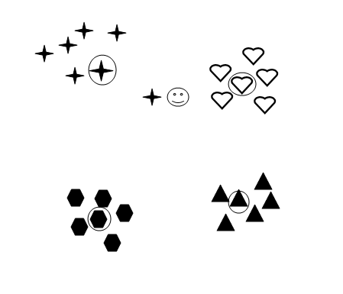

- Suppose we have run a linear regression to find a relationship between weight and height. A large sample of students between 60 and 75 inches were weighed and the resulting regression equation is (-180 lbs) + (5 lbs x Height in inches).

- If one student is 3 inches taller than another, what is the expected difference in weight?

- How much should a 5 foot 5 inch student weigh?

- What should a 4 foot student weigh?

- Is there anything about the above estimates that give you pause? Explain.

- Consider the following data table.
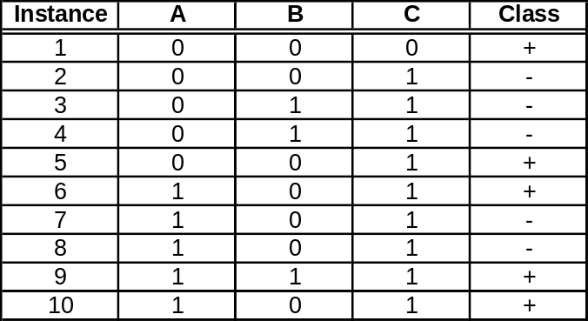
  - Estimate the conditional probabilities P(A|+), P(B|+), P(C|+), P(A|-), P(B|-), P(C|-)

  - Use the estimates above to predict the class for a test sample A=0, B=1, C=0, using the Naïve Bayes approach.

- Consider the following data table.
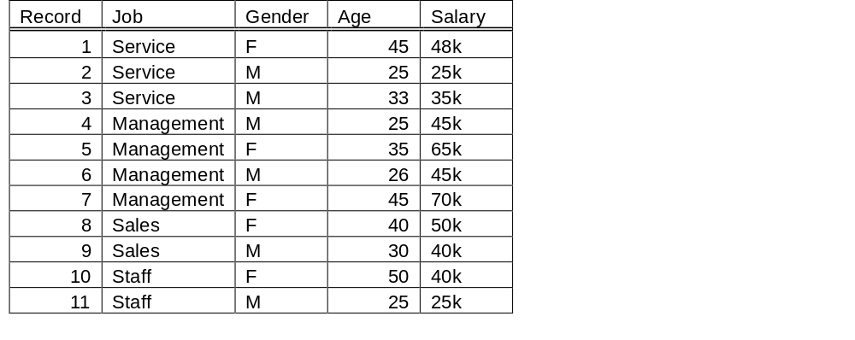
You wish to make a decision tree that will predict salary levels. Recall that decision trees need categorical data in place of numerical data. So we recreate the table using the following concordance: Level 1: < 35k, Level 2: 35k to <45k, Level 3:45k to <55k, Level 4: Above 55k. Similarly entry level: age 20-29, Early Mid: 30-39, Mid 40-49, Late Mid 50-59, Late career 60+.

- Create a CART table that makes the best decision for the initial left subtree and right subtree. You can do by hand or with excel or some other tool, but be sure to show the various probabilities.

- Do the second iteration for the left subtree above

- Do the second iteration on the right subtree above

- You wish to make a neural net from the table from ploblem 4, but the data first needs to be normalized. Create a new table where all of the attributes are normalized. Hint, you will need to use the min-max normalization for the numeric data. The job data will require dummy variables of course. You can do this by hand or use excel or use R. Whatever you like.

