DM 1 Summer 2018 – Exam 2 Version u Name ____Ronald Neely______________

==========================Each Question worth 3 points. ============================
Directions: You may use Excel, R, Python, Mathematica, or other tools. You may also access any notes, power points, web sites etc. The only restriction is you should work on this alone and hand in prior to class on Monday August 20.

- You have data clustered into the following groups (hearts, triangles, hexagons, stars) and you wish to cluster the smiley face. You also know the circled points are clustroids. Describe (briefly) an algorithm that places the smiley face in the correct cluster without needing to compute all the distances between the smiley and each of the 25 points. (Be careful here there is an obvious but wrong answer).
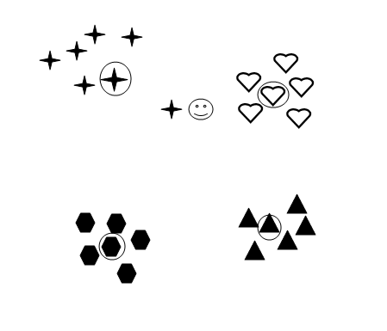
  - Compute the distance between the smiley face and each cluster centroid.
  - Assign the smiley face to the cluster from which it has the minimum distance from its cluster centroid.

If there is more data and you wish to continue in preparation for the next new point:
  - Recompute the clustroid center only for the clustroid to which the smiley face was assigned.
  - Repeat at (a) for the next new point.

- Suppose we have run a linear regression to find a relationship between weight and height. A large sample of students between 60 and 75 inches were weighed and the resulting regression equation is
(-180 lbs) + (5 lbs x Height in inches).
- If one student is 3 inches taller than another, what is the expected difference in weight?
The slope of the line is 5 lbs/inch, therefore if one student is 3 inches taller than another that student would be predicted to weigh 15 lbs more.
- How much should a 5 foot 5 inch student weigh?
weight = -180 lbs + 5 lbs/in x (5ft x 12 in/ft + 5 in) = -180 + 5 x 65 lbs = -180 + 325 lbs = 145 lbs
- What should a 4 foot student weigh?
weight = -180 lbs + 5 lbs/in x (4ft x 12 in/f t+ 0 in) = -180 + 5 x 48 lbs = -180 + 240 lbs = 60 lbs
- Is there anything about the above estimates that give you pause? Explain.
Question (c) asks to predict an extrapolated weight outside the range of the data upon which the regression was formed even though linear regression is good at interpolation and not good at extrapolation. Still, the expected weight for the 5’5” student is on the high side whereas the expected weight for the 4’ student is normal per www.weightchart.com/height-weight-adult-chart.aspx which takes its data from the CDC. This suggests that the slope of the model is much more positive than expected for the normal U.S. population. The intercept of -180lbs is also suspicious. While way outside the interpolation range of our model, our model would predict a 2’ tall would weigh -48 lbs. Clearly wrong. Perhaps an exponential or quadratic linear regression model could be fitted to the data. Such a model would approach zero as height approaches zero and have a steeper slope for taller students.

- Consider the following data table.
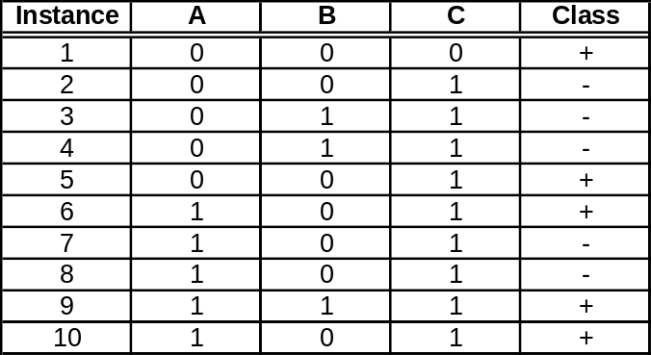
  - Estimate the conditional probabilities P(A|+), P(B|+), P(C|+), P(A|-), P(B|-), P(C|-)
P(A=1|+)=3/5=0.6 P(B=1|+)=1/5=0.2 P(C=1|+)=4/5=0.8
P(A=1|-)=2/5=0.4 P(B=1|-)=2/5=0.4 P(C=1|-)=5/5=1.0
P(A=0|+)=2/5=0.4 P(B=0|+)=4/5=0.8 P(C=0|+)=1/5=0.2
P(A=0|-)=3/5=0.6 P(B=0|-)=3/5=0.6 P(C=0|-)=0/5=0
There is a zero. Let’s prepare to use Laplace smoothing in the next step.

  - Use the estimates above to predict the class for a test sample A=0, B=1, C=0, using the Naïve Bayes approach. Given Bayes Theorem P(H|X) = P(X|H)P(H)/P(X)
Priors P(H): P(+) = 5/10 = 0.5, P(-) = 5/10 = 0.5
Normalization evidence P(X): hold constant as denominator is same in both cases P(A,B,C) = k
Laplace: add 1 to numerator and denominator to smooth conditional probabilities so none are 0
ΔP(A=0|+) = (1+2)/(1+5) = 0.5, ΔP(B=1|+) = (1+1)/(1+5) = 0.333, ΔP(C=0|+) = (1+1)/(1+5) = 0.333
numP(+|A=0, B=1, C=0) = ΔP(A=0|+) ΔP(B=1|+) ΔP(C=0|+)P(+) = 0.5(0.333)0.333(0.5) = 0.02778
ΔP(A=0|-) = (1+3)/(1+5) = 0.667, ΔP(B=1|-) = (1+2)/(1+5) = 0.5, ΔP(C=0|-) = (1+0)/(1+5) = 0.167
numP(-|A=0, B=1, C=0) = ΔP(A=0|-) ΔP(B=1|-) ΔP(C=0|-)P(-) = 0.667(0.5)0.167(0.5) = 0.02778
P(+|0,1,0) = 0.02778/(0.02778+0.02778) = 0.5
P(-|0,1,0) = 0.02778/(0.02778+0.02778) = 0.5
H(0,1,0) = “+”: 50%, Laplace smoothing = 1

Hmm. These are the same. Same chance it could be “-”. Back off on the smoothing. Use Lambda = 0.1

ΔP(A=0|+) = (.1+2)/(.1+5), ΔP(B=1|+) = (.1+1)/(.1+5), ΔP(C=0|+) = (.1+1)/(.1+5)
numP(+|0,1,0) = 0.411764706(0.215686275)0.215686275(0.5) = 0.009577764
ΔP(A=0|-) = (.1+3)/(.1+5), ΔP(B=1|-) = (.1+2)/(.1+5), ΔP(C=0|-) = (.1+0)/(.1+5)
numP(-|0,1,0) = 0.607843137(0.411764706)0.019607843(0.5) = 0.002453807
P(+|0,1,0) = 0.009577764/(0.009577764+0.002453807) = 0.796052632
P(-|0,1,0) = 0.002453807/(0.009577764+0.002453807) = 0.203947368
H(0,1,0) = “+”: 80%, Laplace smoothing = 0.1

- Consider the following data table.

You wish to make a decision tree that will predict salary levels. Recall that decision trees need categorical data in place of numerical data. So we recreate the table using the following concordance: Level 1: < 35k, Level 2: 35k to <45k, Level 3:45k to <55k, Level 4: Above 55k. Similarly, entry level: age 20-29, Early Mid: 30-39, Mid 40-49, Late Mid 50-59, Late career 60+.

- Create a CART table that makes the best decision for the initial left subtree and right subtree. You can do by hand or with excel or some other tool, but be sure to show the various probabilities.
Pictures below via enclosed exam2cart.xlsx: cart worksheet:
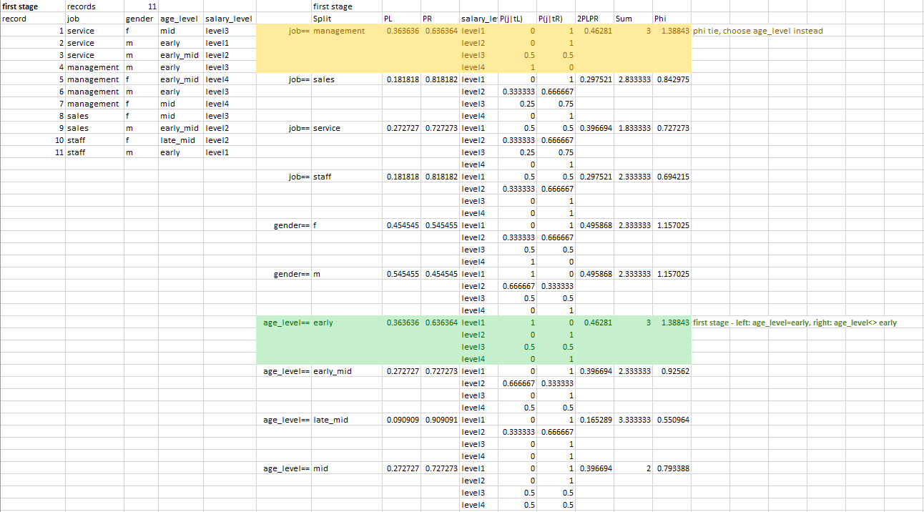
- Do the second iteration for the left subtree above


- Do the second iteration on the right subtree above
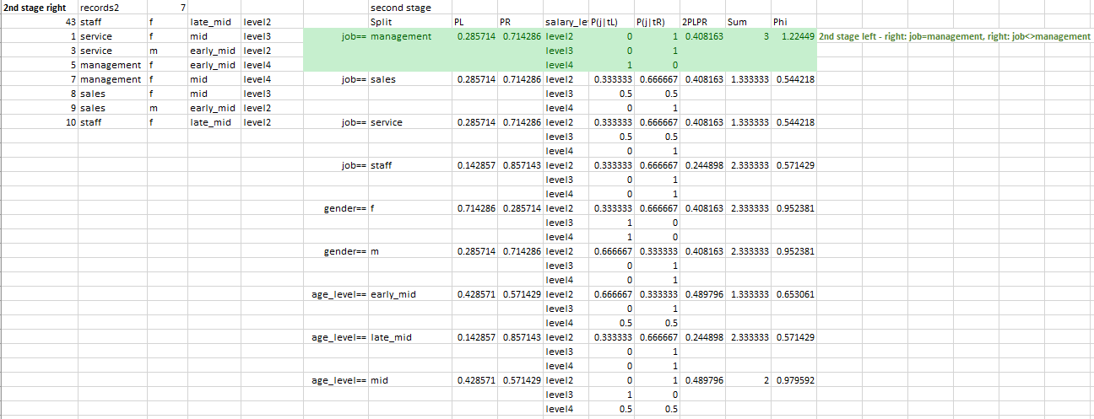

- You wish to make a neural net from the table from problem 4, but the data first needs to be normalized. Create a new table where all of the attributes are normalized. Hint, you will need to use the min-max normalization for the numeric data. The job data will require dummy variables of course. You can do this by hand or use excel or use R. Whatever you like.

Picture below via enclosed exam2clean.ipynb:

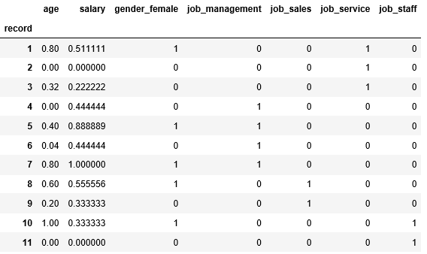

Note: the above cleaning is good enough. A next step could be to remove job_staff as it is redundant with !(job_management | job_sales | job_service). Without doing so “job” may get weighed slightly more than needed.

