**Scott Summerill (LM Employee – Former Student Notes on Neural Networks)**

We did some research on neural nets for the extra point.

MIT has a very nice OCW (open courseware) program offering full semester video recorded classes. One of these is course 6.034 – Artificial Intelligence taught by Professor Patrick Winston in fall of 2010. The lectures cover goal trees, optimal branch and bound, genetic algorithms, nearest neighbor methods, support vector machines, boosting. Lectures 12a and 12b are neural nets and deep neural nets.

Link to lectures: <https://ocw.mit.edu/courses/electrical-engineering-and-computer-science/6-034-artificial-intelligence-fall-2010/lecture-videos/>

In lecture 12a, Professor Winston started the class by saying how the faculty almost eliminated neural nets because, and paraphrasing here, “no one had ever done anything worth a darn with a neural net but we decided to include them because otherwise the students would feel deprived and then go off and waste a lot of time inventing them.” He then qualified the statement saying that all changed when in 2012 Jeff Hinton of the University of Toronto stunned the world when he created a neural net having 60 million parameters and 650,000 neurons. Hinton’s work was from an entry to the Large Scale Visual Recognition Challenge (ILSVRC2012) where the challenge was to recognize 1000 different types of objects. His team’s entry blew away the competition.

Link to team information and abstracts: <http://www.image-net.org/challenges/LSVRC/2012/results.html>

Professor Hinton’s team is SuperVision.

Below are some of the images that his model got correct and some that were incorrect. **2**

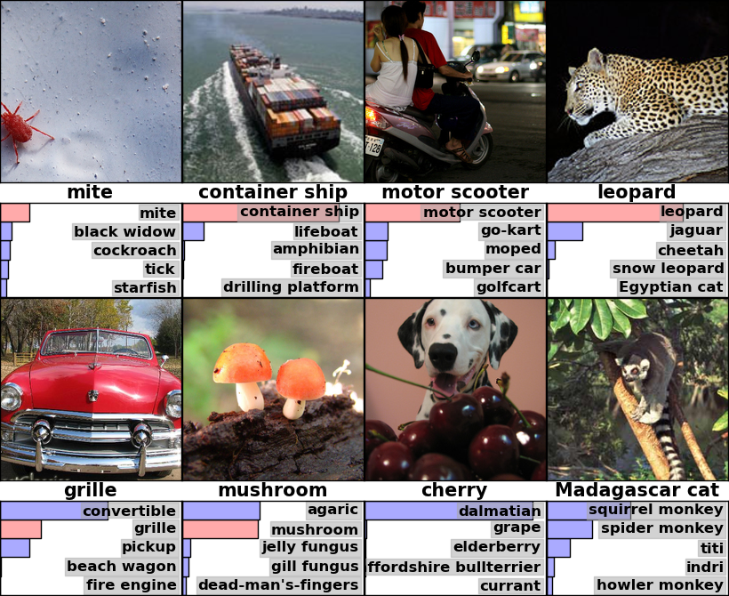

In the top row are some of the models correct guesses.

* In the top left the model correctly guessed that the image was a mite even though the mite is somewhat hidden.
* Next we have a container ship. The second guess was a lifeboat, which in fact is similar to enclosed life rafts found on commercial vessels.
* Next the model correctly guessed that the image was a scooter.
* And finally the leopard was guessed correctly and all of the secondary guesses were in fact cats.

In the bottom row are some incorrect guesses.

* The bottom left image was a convertible and the model guessed a grill, which is actually not entirely an incorrect guess. And grill was the second guess.
* Next we have a mushroom and the model guessed an agaric, which is a type of mushroom. The second guess was mushroom.
* Next was a Dalmatian and the model selected cherry. Again this is not exactly a wrong guess. Most people would be confused by the question.
* And in the final image the model guessed squirrel monkey and the image was a Madagascar cat. Looking at a squirrel monkey, the guess is again not exactly incorrect.

So Professor Hinton’s 60 million parameter, 650,000-neuron model did an amazing job.

Professor Hinton recently become the chief AI guy at Google which divides his time between teaching at the University of Toronto, research and paper generation (he is prolific) mostly on various topics involving neural nets, and working for Google both at their Toronto offices and in Mountain View, California during summer break.

Most of Hinton’s papers involve training of restrictive Boltzmann machines (RBM). From Wikipedia, a restricted Boltzmann machine is a “generative stochastic artificial neural net that can learn a probability distribution over its set of inputs.” Beyond our understanding at this moment but Hinton provides an introduction on his personal website.

Link to RBM paper: <http://www.cs.toronto.edu/~hinton/absps/guideTR.pdf>

Link to Hinton’s university webpage: <http://www.cs.toronto.edu/~hinton/>

Professor Hinton’s site includes sections on basic papers on deep learning, papers on deep learning without much math, and recent published papers (all with links to the pdfs). Video talks and tutorials are available as his extensive publications by year. One area of interest for me are the 2012 papers on acoustic modeling. My current work involves antisubmarine warfare so his work could find a practical application.

**Sources**

1. "Google Adds Another Big Name In Artificial Intelligence To Its Employee Roster." 33rd Square. March 22, 2013. Accessed February 1, 2017. <http://www.33rdsquare.com/2013/03/google-ads-another-big-name-in.html>