seriationLouvre.r

Sun Apr 23 23:34:41 2017

#####################################################  
## Breitzman   
## 4/23/17  
## Piping and seriation images  
#####################################################  
  
  
s1 <- "this is a string. "  
s2 <- "this is another string. "  
  
toupper(s1)

## [1] "THIS IS A STRING. "

paste(s1,s2)

## [1] "this is a string. this is another string. "

#install.packages("magrittr")  
library(magrittr)

## Warning: package 'magrittr' was built under R version 3.3.3

## fun with pipes. If you've used a unix shell you may have used pipes before  
## this is equivalent to paste(s1,s2)  
s1 %>% paste(s2)

## [1] "this is a string. this is another string. "

## this is equivalent to toupper(paste(s1,s2))  
s1 %>% paste(s2) %>% toupper()

## [1] "THIS IS A STRING. THIS IS ANOTHER STRING. "

toupper(paste(s1,s2))

## [1] "THIS IS A STRING. THIS IS ANOTHER STRING. "

## this is silly but it works  
## it's obviously equal to tolower(toupper(paste(s1,s2)))  
toupper(paste(s1,s2)) %>% tolower()

## [1] "this is a string. this is another string. "

## use it if you want.  
## some people like it  
## sometimes it's less readable  
(1 + 8) %>% sqrt

## [1] 3

sqrt(1+8)

## [1] 3

## doesn't always work  
(sqrt(1+8))^3

## [1] 27

##(1+8) %>% sqrt %>% ^3  
  
  
##install.packages("imager")  
library(imager)

## Warning: package 'imager' was built under R version 3.3.3

## Loading required package: plyr

## Warning: package 'plyr' was built under R version 3.3.3

##   
## Attaching package: 'imager'

## The following object is masked from 'package:plyr':  
##   
## liply

## The following object is masked from 'package:magrittr':  
##   
## add

## The following objects are masked from 'package:stats':  
##   
## convolve, spectrum

## The following object is masked from 'package:graphics':  
##   
## frame

## The following object is masked from 'package:base':  
##   
## save.image

im <- load.image("C:\\Users\\Tony\\Dropbox\\Rowan\\ProgWorkshop-R\\Lectures\\lecture24louvre.jpg")  
  
  
plot(im)

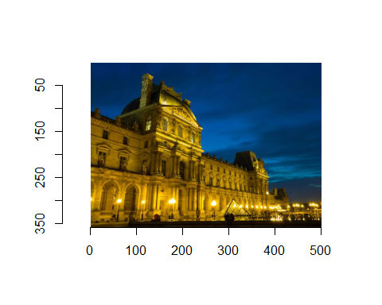

dim(im)

## [1] 501 358 1 3

## 501 pixels wide by 358 pixels tall  
  
t <- imsplit(im,"x")  
length(t)

## [1] 501

## we essentially get 501 vectors containing a 1 pixel by 358 tall slice  
  
## if we do   
plot(imappend(t[1:250],"x"))

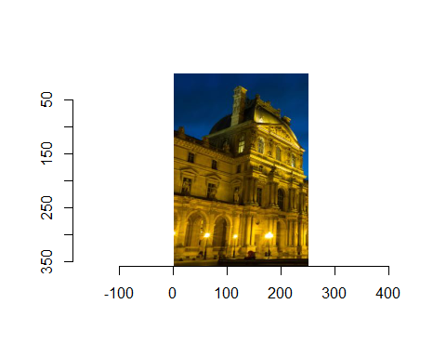

## we obviously get half the picture  
  
## we can grab a chunk of blue sky for example by doing the following  
chunk <- imsplit(im,"x")  
chunk2 <- imsplit(imappend(chunk[1:50],"x"),"y")  
plot(imappend(chunk2[1:50],"y"),"y")

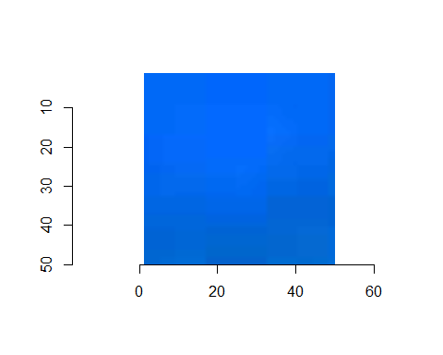

## how did that work? We grabbed the first 50 vertical vectors  
## and then grabbed the 50 horizontal vectors from that subset  
  
## we can write a function to plot any subset of the picture  
## as follows  
plotSubset <- function(image,xRange,yRange){  
 chunk <- imsplit(im,"x")  
 chunk2 <- imsplit(imappend(chunk[xRange],"x"),"y")  
 plot(imappend(chunk2[yRange],"y"),"y")  
}  
   
  
plot(im)



## get a chunk of the sky  
plotSubset(im,1:50,1:50)



plot(im)



## zoom in on the street lights at the bottom right  
plotSubset(im,450:501,300:350)

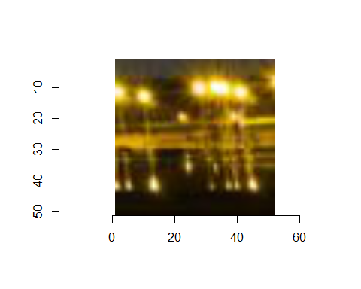

## Note we can rewrite that function with pipes  
## i'm not claiming it's more readable  
## but it does have the advantage of not using  
## the temp variables chunk and chunk2  
plotSubset2 <- function(image,xRange,yRange){  
 imsplit((imsplit(image,"x")[xRange] %>% imappend("x")),"y")[yRange] %>%   
 imappend("y") %>% plot  
}  
  
  
plot(im)



plotSubset2(im,450:501,300:350)



## look at this  
## recall that sample randomly rearranges  
## things so this essentially chops up the image  
## and puts it back together randomly  
scramble <- function(im,axis="x")  
{  
 imsplit(im,axis) %>% { .[sample(length(.))] } %>% imappend(axis)   
}  
  
  
plot(im)



scrambledIm <- scramble(im)  
  
plot(scrambledIm)  
  
## does anybody have any idea how we can unscramble this picture?  
## believe it or not it can be done.

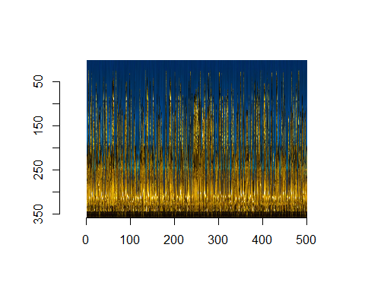

## It turns out that any 2  
## adjacent vectors are very similar to each other  
## since each pixel is just a number we can compare 2 vectors  
## and sort the vectors by similarity using seriate.

##install.packages("seriation")  
library(seriation)

## Warning: package 'seriation' was built under R version 3.3.3

##install.packages("purrr")  
library(purrr)

## Warning: package 'purrr' was built under R version 3.3.3

##   
## Attaching package: 'purrr'

## The following object is masked from 'package:plyr':  
##   
## compact

## The following object is masked from 'package:magrittr':  
##   
## set_names

unscramble <- function(im.s,axis="x",method="TSP",...)  
{  
 cols <- imsplit(im.s,axis)  
 #Compute a distance matrix (using L1 - Manhattan - distance)  
 #Each entry D_ij compares column i to column j   
 D <- map(cols,as.vector) %>% do.call(rbind,.) %>% dist(method="manhattan")  
 out <- seriate(D,method=method,...)  
 cols[get_order(out)] %>% imappend(axis)   
}  
  
## note sometimes it will reverse the picture  
## because it orders the vectors by closeness  
## doesn't know which is first  
plot(unscramble(scrambledIm))



## the surprising thing is it will work with a picture  
## that is vertically and horizontally scrambled  
  
scrambledIm2 <- scramble(scramble(im,"x"),"y")  
plot(scrambledIm2)

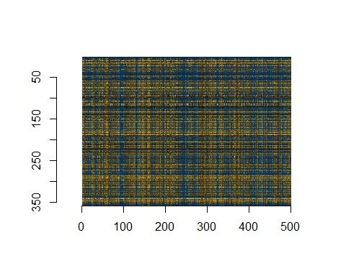

## It would be a miracle if we could fix this right?  
plot(unscramble(scrambledIm2,"y"))

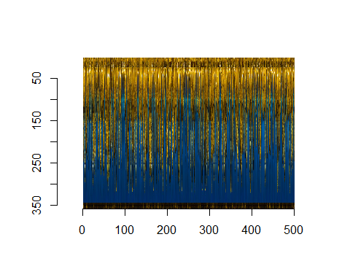

## It looks like we just have to run unscramble twice  
  
plot(unscramble(unscramble(scrambledIm2,"y"),"x"))

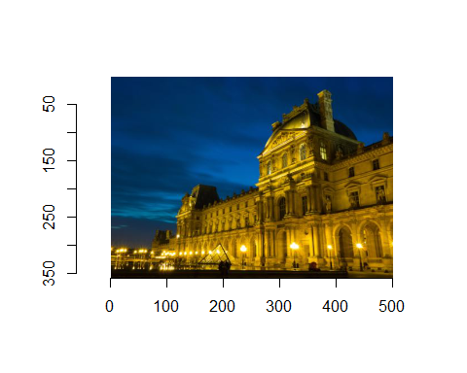

## or if you prefer  
  
unscramble(scrambledIm2,"y") %>% unscramble("x") %>% plot

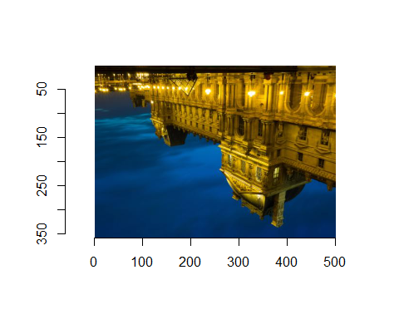

## Sometimes we get a picture that’s upside down or backwards

## Note if we have a picture with a lot of symmetry (mirror images)  
## this method won't really work  
  
## consider  
doubleIm <- imappend(list(im,im),"x")  
plot(doubleIm)

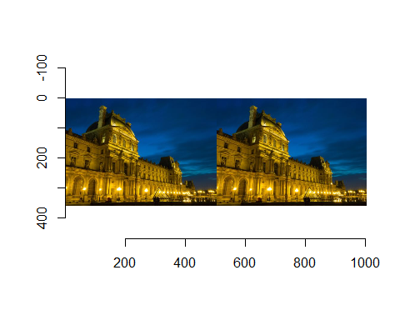

plot(scramble(doubleIm))

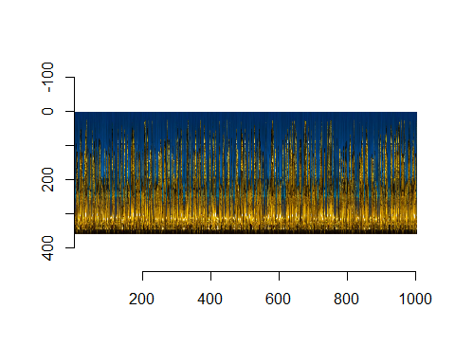

## any guesses on what unscramble will do?

plot(unscramble(scramble(doubleIm)))

