
Technical Proposal
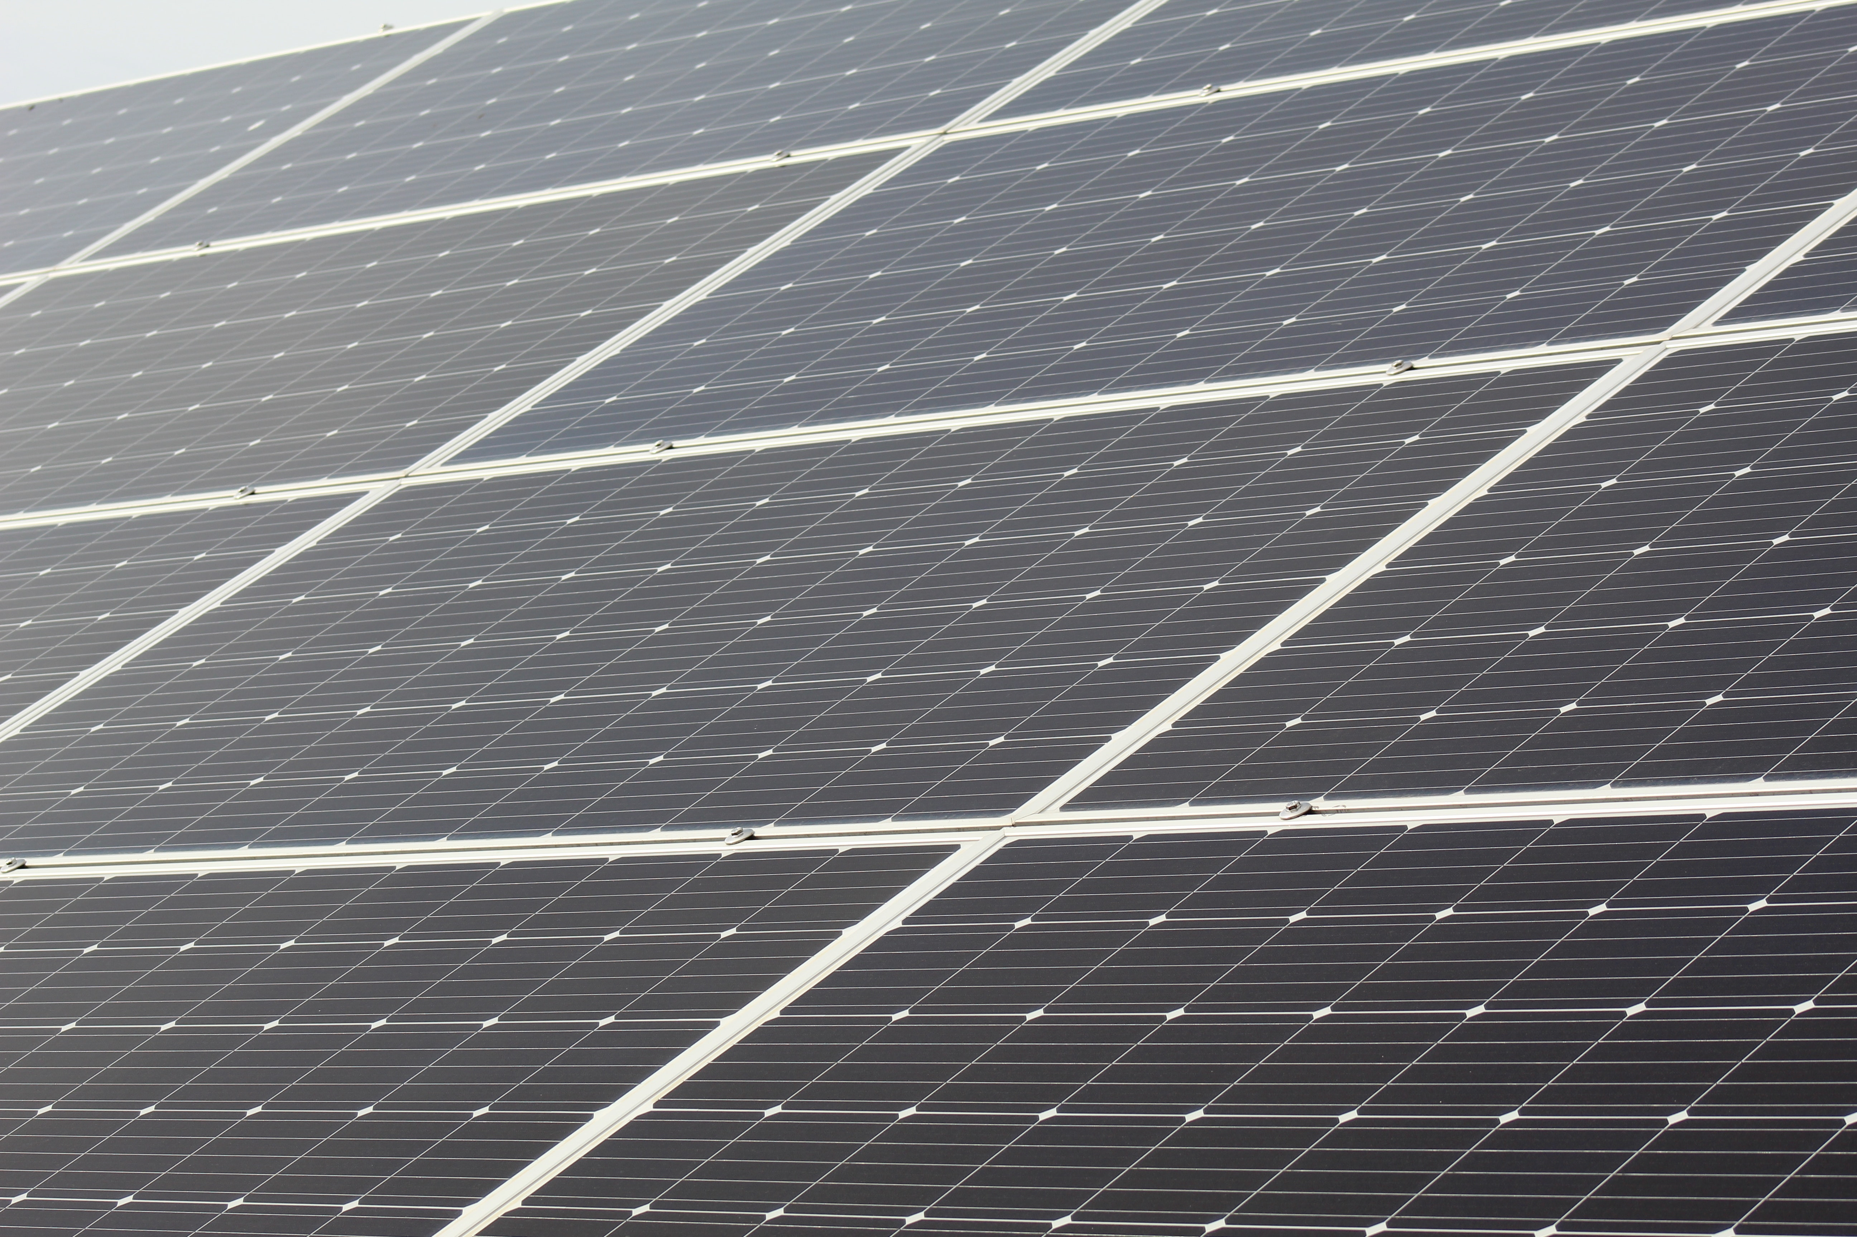

Solar Wattage: ~4.5KWhamza
Wattage: 5000 Watts
Net-Metering Enabled Solar System

Sir,
Thank you for giving SolarFlare the opportunity to promote clean energy and a safer environment for our future generation. It’s a noble thing to care for nature and offset the adverse effects on our environment by our carbon emissions.

The cost of electricity from NEPRA is rising everyday, and the importance of maintaining a healthy environment grows every day. Installing a solar energy system is a cost-effective, green, and clean way to reduce your environmental footprint. This comes with an added advantage of decreasing or even eliminating your monthly energy expenditure.

SolarFlare promotes solar energy as it is in-expensive, simple, clean, eco-friendly and the smartest choice of energy. Your rooftop will be harnessing the energy of the abundant nature’s gift to man – Sun. Solar energy is non-polluting and renewable. The average life of a solar system installed by SolarFlare will be 25 years, your new system will offset your carbon footprint by more than 25 tonnes of carbon dioxide which is equal to planting 45 Acres of trees. We want to save electricity bills and manage your energy resources so you always have the highest availability of energy at the lowest possible cost.

Our Integrated Monitoring System for the inverters will be available to you 24/7 for monitoring and reporting of the solar system installed at your premises. In the event of any technical problem, SolarFlare can monitor your systems remotely and diagnose the problem and send a member of our technical team to help you fix any issue you can face with your solar energy system.
We hope to help you get more energy independence by providing a good investment for the coming years and helping you
make a more positive impact on the environment.
Thanks & Regards,
SolarFlare Team

System Details

System Details
System Watts | ~4.5KW
Panels | 8 Tier-1 Panels Longi/Jinko/JA– 25 Years Workmanship Warranty
hamza | Growatt/Goodwe/Knox/Sofar 10 KW On Grid hamza – 98.1% Efficiency – 5 Yrs Warranty
Structure | GI Structure – 14 Gauge OR Aluminum Rust Free
Roof Angle | 10-15 Degrees
Property Type | Residential
Notes | On-Grid System With Net Metering
Meter Phase: | 3-Phase Meter Required

Technical Details
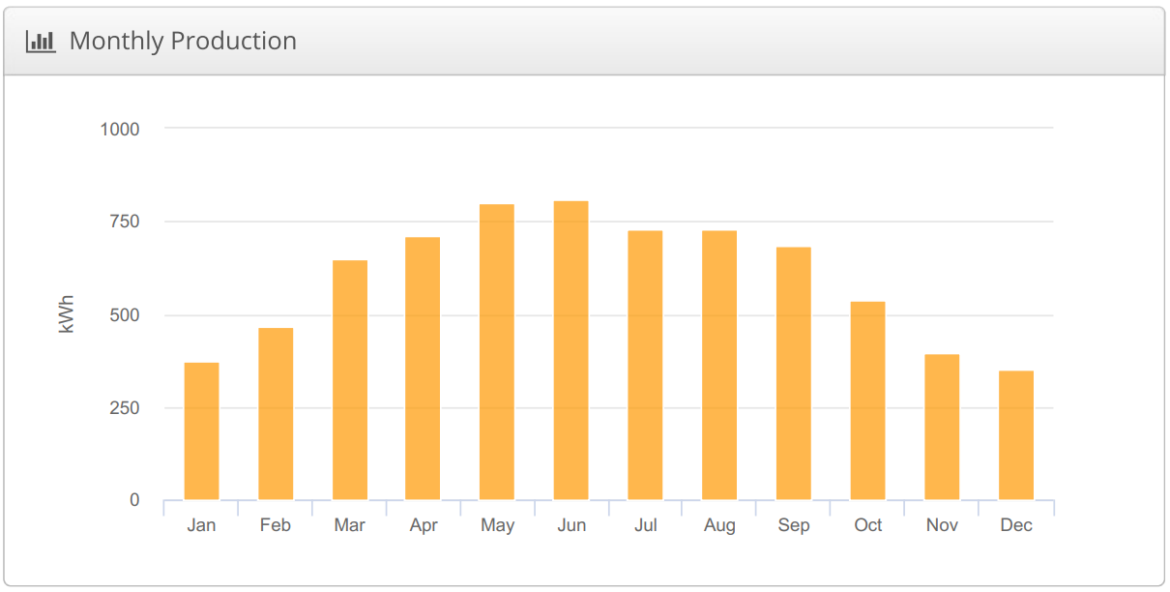
Electricity Units Generation Per Month – Estimated with Optimal Conditions

The proposed system will produce the following energy according to SolarFlare estimates based on optimal conditions.

Energy Details
Annual Production | ~ 7.01 MWh
Average Monthly | ~ 590 kWh
Performance Efficiency | ~ 81%
Yearly Savings | Rs. 200,000
Payback Period | 3.9 Years
NOTE: This calculation uses optimal conditions for the solar generations and the price of electricity is calculated to be 22 Rs/kWh.
Equipment Details

Item | Description
Solar Panels | 8 x Mono Crystalline—Tier 1 Panels—540W- 25 Years International  Warranty
hamza | 1 x On-Grid hamza 10KW—5 Years Warranty
Equipment | All Imported/Genuine Equipment  1 x DC Breakers [CLBE/CNC/Tomzn/Suntree/Schneider/ABB]  1 x DC SPDs [CLBE/CNC/Tomzn/Suntree/Schneider/ABB]  1 x AC SPD [Tomzn/Suntree/Schneider/ABB]  1 x AC Breaker [Tomzn/Suntree/Schneider/ABB]  1 x External Disconnector Switch – 4Pole [CLBE/CNC/Suntree]  4 x MC4 Connectors Imported  1 x Customized Internal DB Box of High Quality  1 x External DB Box with Canopy  1 x Lightning Arrestor  DC Cable For Installation – Minimum 4mm [LAPP Germany, Fast, Pakistan Cables]  AC Cable For Installation – Minimum 6mm/16mm/25mm [Fast Cables]  UPVC Pipes, Lugs, Channels, Conduits, Ducts – Only Top Quality  All Equipment for Ground Bores
Structure | GI Structure 14 Gauge
Net Metering | Net Metering Complete  Application Process  Documentation  All Sub-Division Related Tasks  Inspection Tasks  NEPRA Fees  Demand Notice Submission
Misc. | System Design and Simulations  Structure Installation  Electrical Installation  3rd Party Quality Inspection  Transportation of Equipment  AC and DC NEPRA Approvable Bores  Labour Charges

SolarFlare VS. Other Installers

Item | SolarFlare | Other Installers
Solar Panels | Mono PERC Technology—Tier 1 Panels – Jinko/Longi/JA/Trina-25 Years  International Warranty 530+ Watts | Poly/Mono – Tier 1 – 400+ Watts
hamza | Goodwe/Huawei On-Grid hamza—5 Years Warranty | Goodwe/Huawei/Local
Equipment | Imported and Genuine Equipment.  No Lot Purchased Or Copy  3ft Pure Copper Lightning Arrestor | Lot Purchased and Counterfeit Products. Some use original.  1ft Lightning Arrestor of lesser purity.
Structure | Aluminum Alloy Structure  GI Structure 14 Gauge With Civil Work | GI Structure no Gauge Warranty.  No Civil Work.  Reluctance to install Aluminum Structure.
Cables | DC Dual PVC or XLPE Low Smoke >= 4mm Genuine Cables Only.  German LAPP/Fast/Nafees DC Cable for Solar System Connections  Genuine DC >= 6mm For Earthing  Fast Cables AC >= 6mm | 4mm Genuine DC Cables  4mm AC Cables  6mm AC Cable for Earthing
Earthing | Two Bores with NEPRA Approvable Depth Bores both for AC and DC.  16mm Pure Copper Rope Wire  Pure Copper Strip | One Bore of 15ft Depth  16mm Copper Wire  Copper Strip
Net Metering | Net Metering Application Complete Process. | Only Net-Metering Process
Values | Professional Installation  Absolutely no Compromise on Quality  Neat, Symmetrical, and Tidy Workmanship  Quality Civil Work Included without any charges.  Generation Reports  Technical Analysis for PV Output and Structural Integrity before Installation. | Professional Installation  Civil Work Charged Separately  Generation Reports are shared rarely

Payment Details

Commercial Details
Total Price | Rs. 695,000
Initial Payment | Rs. 450,000
On Material Delivery | Rs. 150,000
After Installation | Rs. 95,000
System Price contains ALL expense related to Solar System Installation and Net-Metering.

Payment Plan:
The payment plan of the complete system is as follows:

Advance Payment – ~75% - After confirmation of the Client Installation.
After Goods Delivery – ~15% - After Equipment delivery at Client’s Premises.
After Installation – ~10% - After complete installation and commissioning of the system.

Payment Breakdown

Item | Description | Unit Price | Qty | Subtotal
Solar Panels | Mono Crystalline—Tier 1 Panels—540W- 25 Years International  Warranty | 37,877 | 8 | 303,020
hamza | Goodwe On-Grid hamza 10KW—5 Years Warranty | 190,000 | 1 | 190,000
Equipment | All Imported/Genuine Equipment  1 x DC Breakers – (2000)  1 x DC SPDs – (3000)  1 x AC SPD – (4500)  1 x AC Breaker – (4000)  1 x External Disconnector Switch – (5500)  10 x MC4 Connectors Imported (1000)  1 x Internal DB Box – (2000)  1 x External DB Box – (4000)  1 x Lightning Arrestor Set – (8000)  DC Cable For Installation – (10000)  Earthing Cable – (15000)  AC Cable For Installation – (5000)  UPVC Pipes, Lugs, Channels, Conduits (5000)  All Equipment for Ground Bores – (21000) | 90,000 | 1 | 90,000
Structure | GI Structure of 14 Gauge Material with Nuts and Bolts | 30,000 | 1 | 30,000
Net Metering | Net Metering File | 20,000 | 1 | 20,000
Misc. | System Design and Simulations  Structure Installation  Electrical Installation  3rd Party Quality Inspection  Transportation of Equipment  Bores Commissioning | 60,000 | 1 | 60,000

Terms and Conditions

- Quotation is valid for Dollar at 200 Rs.
- Net-Metering is LESCO and NEPRA dependent, normal installation time for bi-directional energy meter is 3-4 working months.
- We will try our best to expedite the Net-Metering process from each and every resource available.
- All charges mentioned are inclusive of all taxes.
- Complete System Design and Simulation reports will be shared after confirmation and initial payment from client.
- This offer is subject to standard force majeure conditions.
- Delivery and installation time is 14 Working Days after initial payment.
- The cable wire prices may vary depending on AC/DC Wiring Length.
- Our scope of work does not include load balancing and inter meter connections.
- Sanctioned Load Increase if required, is at customer’s end.

