# Data Curation & Management

**Aruna (Aaron) Tillekeratne**  
S27345483 *Monash University*

## Introduction

The benefits of data management have been widely recognised by government, industry, and research sectors as an important practice in their operations (Denison, Introduction – The Benefits of Managing Data, 2015). Particularly in the last decade, where an explosion of data and data products have surfaced, subsequently the amount of data generated and stored have exponentially increased. With the onset of the utilisation of data mining and data science practices, the interest of managing this data in a consistent manner has become a focal point.

Data management can cover a large range of tasks and responsibilities, from obvious tasks such as storage and migration to more complex and abstract responsibilities such as regulatory requirements and privacy (Denison, Introduction – The Benefits of Managing Data, 2015), with the latter being largely the focus of data curation and more or less data governance. It is to be noted, data curation and data governance is often used interchangeably. However, although related, each emphasizes a different practice towards data management (Denison, Data Curation and Management, 2015).

## Data Curation Roles

As defined in Alexandria, the data curation is aimed at enabling or improving the usability and usefulness of data throughout its lifecycle. Consequently, data curation and its scope of works includes, but not limited to, representation, archiving, authentication, management, preservation, retrieval and use (DHCuration, 2015).

Although the data curation process and somewhat the interpretation can vary within industries (Denison, Data Management Associations and Approaches to Data Management, 2015), a general number of core skills have been identified by the Data Curation Centre.

It is highlighted that the skills required reach far beyond just technical expertise and multiple roles play an interrelating and interdependent part in enabling successful data management (Digital Curation Centre, 2004-2017). Figure 1 highlights two important roles that are specific to data curation, namely Data Manager and Data Librarian.

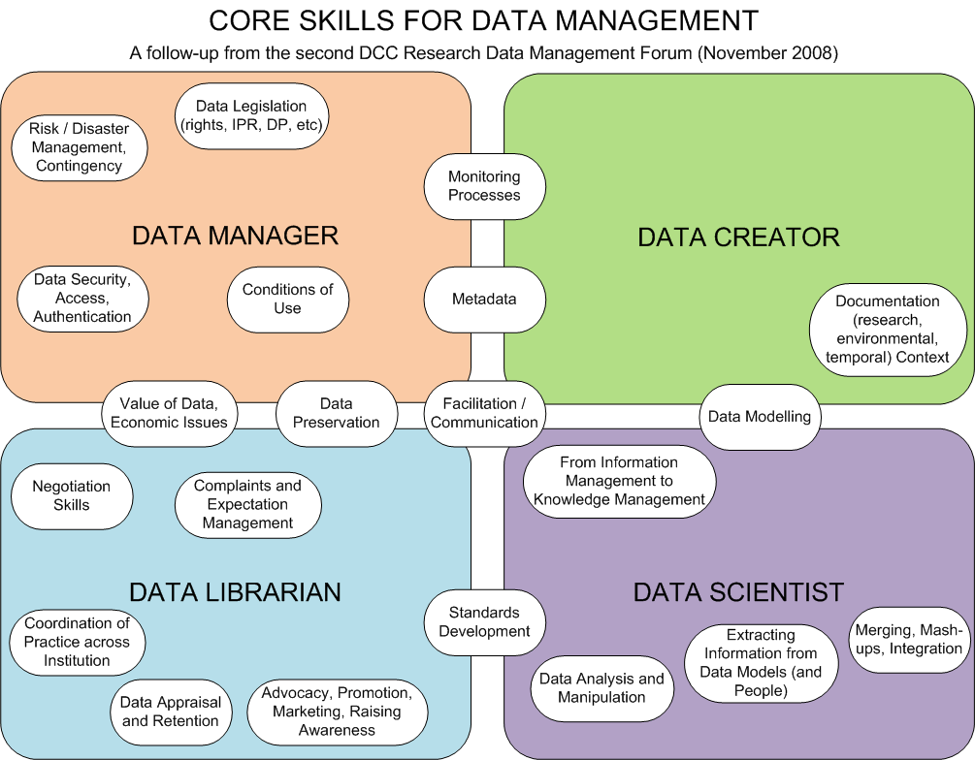

Figure 1: Data Curation Roles (Digital Curation Center)

Data Managers can be identified as the “back-end” of the whole process, whose responsibility is to ensure the development of engineering of the data curation process. Tasks such as data legislation require the ability to implement current data curation and governance principles in the relevant industry into practice. It is also identified that a good technical knowledge is essential to this role, particularly in data security, access and authentication.

Data Librarians on the other hand may be seen as the “front-end” of the process, where the responsibilities lie in the implementation of the data curation process in day to day operations. They have been identified to be responsible for expectation management and negotiation to ensure that data curation processes have been adequately followed. A notable responsibility includes the coordination of practice across institution, which is imperative to data homogeneity. This is essential in reducing inconsistencies not only in the data itself, but the value of the information that is contained within it, such as the semantic meaning of a symbol or code (Rudra & Yeo, 1999).

Although the number of roles identified for Data Creators is reduced, adequate documentation is key for data re-use across institutions and preservation. A corollary to documentation is the completeness of the data captured, since context is also considered. This is a key in reducing data pollution given that it was identified that the lack of completeness in the data was one of the leading causes of data pollution (Rudra & Yeo, 1999).

Data Scientists also have an important role in the data curation process. Adequate data curation enables the validity of extracted information and helps in the transformation of information to knowledge. This is particularly highlighted in big data, where Data Scientists mash up data from various different sources to develop data products which make decisions on individuals (Marcus R. Wigan, 2013). This is highlighted in the case of granting loans where a model may be developed using a large number of data that is gathered from various sources. Should the integrity of the data be polluted, then it is the consumer that is impacted from the lack of data curation.

Figure 1 also highlights some critical and overlapping responsibilities in the data curation process. Central to all role types is the facilitation and communication between each other. This is an obvious and crucial task to ensure that the “back-end” engineering is correctly followed, implemented and any changes are communicated to all stakeholders in the data curation process.

The overlapping responsibilities also show a two distinct groups, divisible by a vertical line between the groups. Responsibilities that overlap between Data Manager and Data Creators as well as Data Librarian and Data Scientists seem to be implementation of standards and processes which can broadly be said to be part of data governance. In contrast, the overlap between Data Creators and Data Librarians are predominantly responsibilities of data curation, ensuring data preservation and valued.

## Skills in Data Management

From the roles that have been identified above, a generalised set of skills can already be identified. These include, but are not limited to, stakeholder management, communication, process management and technical skills. Given that the roles differ from industry to industry (Denison, Data Management Associations and Approaches to Data Management, 2015), it is necessary to identify the unique traits of three major sectors that implement data curation.

### Skills in Governmental Data Management

There are a number of challenges in governmental data curation with the obvious being the handling of large number of public data sources. Strategic data governance in this context is very challenging, since standards, abbreviations, context, semantics change widely from individual government organisations. Governmental sector also issues unique challenges in privacy, particularly relating to national security.

The nature of the roles seems to be oriented towards developing frameworks for data quality management. Particularly aimed at increasing the data consistency and data quality of the organisation, very closely at a level of a data manager (Horizon Recruitment Specialists , 2017) (Total Resource Solutions, 2017).

The roles seem to be contract levels with short time frames in the 6-month window, primarily the data curator seems to be operating as a consultant, the seniority being similar among the government positions advertised (Horizon Recruitment Specialists , 2017) (Total Resource Solutions, 2017).

Specific roles that were present at the time of the development of this article showed that government focused on data quality management. Some of the key skills identified for the roles of Data Quality manger included, data quality policy development, ability to develop data quality standards and processes, stakeholder engagement to implement and evaluate the data quality framework, develop methodologies to monitor and manage data quality, and contribute do addressing data quality issues once identified (Total Resource Solutions, 2017) (Horizon Recruitment Specialists , 2017).

The operational environment seems to be defined vaguely at a high level where the curator is to advice the relevant stakeholders encouraging strategic data governance. A key importance is the identification of on-going data management roadmap (Horizon Recruitment Specialists , 2017) (Total Resource Solutions, 2017).

This highlights the interest in government sector in developing good data governance and curation policy. The main interest is shown to be that development of procedure and concepts to enable better data management practice to take place across the wide range of governmental sectors. Less emphasis is shown to be put on technical skills with focus primarily shifted towards stakeholder engagement and training. This approach to data curation and subsequently data quality management can be shown to be a combination of people and process based approaches (Denison, Approaches to achieving data quality, 2015).

### Skills in Corporate Data Management

Data curation in the corporate sector can be identified to be more or less a combination of governmental and research data curation. Business problems in the modern world vary widely, yet the validity and integrity of data have always played a central role in business continuity and information security (Teeling, 2012).

Much of the roles offered in this sector seems to be a mix of data managers and data librarians, with responsibilities ranging from policy and structural design to monitoring, management and system design (Site Minder, 2017) (Morgan McKinley, 2017) (Clicks IT Recruitment, 2017).

The levels of positions in the organisational structure seems to be very high, salary up to $140,000 (Morgan McKinley, 2017). Most of the rules seem to be at the managerial level, although technical savvy is required including familiarity with business intelligence and statistical tools.

Specific roles in the enterprise/corporate sector seem to have focuses both on stakeholder management and technical ability. Some common skills required by Master Data Manager and Data Quality Manager roles include proficiency in SQL, T-SQL, SAS, etc. (The Network, 2017) (Morgan McKinley, 2017). The ability to develop data management plans and successfully implement them is absolutely required (Site Minder, 2017). Data curators are expected to operate closely with data architects, various business departments and establish leadership and direction with senior management (Site Minder, 2017) (Morgan McKinley, 2017).

Whilst the supporting infrastructure did vary from the available roles, most business entities provided some high level control around enforcing data governance and authority for implementing data standards, valuation and management (Clicks IT Recruitment, 2017) (Morgan McKinley, 2017) (Site Minder, 2017).

Primarily the concern of data management in the corporate environment is to strengthen the data integrity, quality and availability across the organisation (Site Minder, 2017). Particularly of note was managing the integrity and quality of data during migration (Paxus, 2017).

These position descriptions show that data curators in business need to undertake a number of key roles overarching a wide area of data curation. The expectation is set at implementing data management plans in real day to day operations. Ability to work with data architects to ensure that common ETL tasks adhere by the processes that have been developed by the data curator is also held in high regard. Data curation skills seem to be blended with statistical competencies which in many cases are traditionally being labelled as data science rather than data curation (Palmer, Weber, Muñoz, & Renear, 2017).

### Skills in Research Data Management

In contrast to corporate data management, research data management require a largely an involvement with the research team and subsequently the enabling of the data to the public for use (Palmer, Weber, Muñoz, & Renear, 2017). This requires a permeation on the entire workflow at an unprecedented level, from the initial planning stages of the research project followed by the on-going long term data management in both archiving, securing, and facilitating access to the public.

The roles present in research data management highlight the ability work in a multidisciplinary environment ensuring that publication and copyright policies are well implemented, primarily focused towards data librarians (Australian Library and Information Association, 2016).

In the research area, the data curator’s role can be primarily found lower down in the organisational structure, with more process management and enforcement as a focus (Rowan University, 2017). This is highlighted by mostly hands on practices of encouraging faculty members to adhere to data governance policies and procedures.

Supporting infrastructure is provided mainly via the process driven and technology driven methods, although some control is available in enforcing correct usage and practice to the end users (Australian Library and Information Association, 2016).

Primary focus of the research data management is to liaise and guide the student and research staff to ensure proper governance around copyright and publication is followed (Rowan University, 2017). That being said, the involvement of data curators throughout the research process can be seen, aimed at ensuring that adequate data governance is achieved (Australian Library and Information Association, 2016).

## Conclusion

It can be identified that although very much overlapping, there are some unique traits to each of the sectors in which data curation is carried out. Some obvious, such as roles presented in the government sector are very much geared towards policy and methodology implementation; aimed at beginning to standardise the data acquisition, merging and storage practices across a large number of different individual organisations.

Business sector seems to be more technical minded with less emphasis on policy development and more emphasis on implementation and data governance planning. As identified, they tend to bundle the data curation responsibilities with traditional technical skills.

In the research sector, data curators perhaps have the most expansive and permissive scope being embedded in from the very start of project or series of projects to the management of public access portals. However, many roles seem to be focusing on following data governance practice than developing new methodologies in data governance.

# References

Australian Library and Information Association. (2016, November 13). *Research Data Librarian.* Retrieved from Alia: https://www.alia.org.au/employment-and-careers/jobs/14790/research-data-librarian

Clicks IT Recruitment. (2017, January 23). *Data Architect - Sydney CBD.* Retrieved from Seek: https://www.seek.com.au/job/32652096?type=standard&tier=no_tier&pos=3&whereid=3000&userqueryid=600874a3ec718a0514162f1272591d62-3681600&ref=beta

Denison, T. (2015, December 22). *Approaches to achieving data quality.* Retrieved from Introduction to Data Curation: https://www.alexandriarepository.org/syllabus/1-introduction-to-data-curation/79138

Denison, T. (2015). *Data Curation and Management.* Retrieved from Introduction to Data Curation: https://www.alexandriarepository.org/syllabus/1-introduction-to-data-curation/79137

Denison, T. (2015). *Data Management Associations and Approaches to Data Management.* Retrieved from Introduction to Data Curation: https://www.alexandriarepository.org/syllabus/1-introduction-to-data-curation/79137

Denison, T. (2015, December 22). *Introduction – The Benefits of Managing Data.* Retrieved from Introduction to data curation: https://www.alexandriarepository.org/syllabus/1-introduction-to-data-curation/

DHCuration. (2015). *Frequently asked questions about data curation.* Retrieved from https://guide.dhcuration.org/faq/

Digital Curation Centre. (2004-2017). *Digital Curation Roles.* Retrieved from Digital Curation Centre: http://www.dcc.ac.uk/resources/roles

Horizon Recruitment Specialists . (2017, January 22). *Data Quality Information Manager.* Retrieved from Seek: https://www.seek.com.au/job/32649828?type=standout&tier=no_tier&pos=2&whereid=3000&userqueryid=6c329df7879e3074215f441bb78f5e11-6192637&ref=beta

Marcus R. Wigan, R. C. (2013). Big Data’s Big Unintended Consequences. *Computer*, 46-53.

Morgan McKinley. (2017, January 11). *Master Data Manager - Governance.* Retrieved from Seek: https://www.seek.com.au/job/32565968?type=standout&tier=no_tier&pos=5&whereid=3000&userqueryid=600874a3ec718a0514162f1272591d62-6089552&ref=beta

Palmer, C. L., Weber, N. M., Muñoz, T., & Renear, A. H. (2017). *Foundations of Data Curation: The Pedagogy and Practice of “Purposeful Work” with Research Data.* Retrieved from Archive Journal: http://www.archivejournal.net/issue/3/archives-remixed/foundations-of-data-curation-the-pedagogy-and-practice-of-purposeful-work-with-research-data/

Paxus. (2017, 01 23). *Data Architect.* Retrieved from Seek: https://www.seek.com.au/job/32654819?type=standard&tier=no_tier&pos=1&whereid=3000&userqueryid=600874a3ec718a0514162f1272591d62-3681600&ref=beta

Rowan University. (2017, January 13). *Scholarly Communication & Data Curation Librarian.* Retrieved from Rowan University: Scholarly Communication & Data Curation Librarian

Rudra, A., & Yeo, E. (1999). Key Issues in Achieving Data Quality and Consistency in Data Warehousing. *Proceedings of the 32nd Hawaii International Conference on System Sciences.* Monash University.

Site Minder. (2017, Jan 10). *Senior Data Governance Manager.* Retrieved from Seek: https://www.seek.com.au/job/32563431?type=standard&tier=no_tier&pos=4&whereid=3000&userqueryid=600874a3ec718a0514162f1272591d62-6089552&ref=beta

TechTarget. (2005-2017). *A must to avoid: Worst practices in enterprise data governance.* Retrieved from Search Data Management: http://searchdatamanagement.techtarget.com/feature/A-must-to-avoid-Worst-practices-in-enterprise-data-governance

TechTarget. (2005-2017). *Building an effective data governance framework.* Retrieved from Search Data Management: http://searchdatamanagement.techtarget.com/essentialguide/Building-an-effective-data-governance-framework

Teeling, M. (2012, May 14). *What is Data Integrity? Learn How to Ensure Database Data Integrity via Checks, Tests, & Best Practices.* Retrieved from Veracode: https://www.veracode.com/blog/2012/05/what-is-data-integrity

The Network. (2017, January 19). *Data Quality Manager.* Retrieved from Seek: https://www.seek.com.au/job/32631225?type=standard&tier=no_tier&pos=5&whereid=3000&userqueryid=6c329df7879e3074215f441bb78f5e11-6192637&ref=beta

Total Resource Solutions. (2017, January 20). *Data Quality Manager (Maestro Profisee).* Retrieved from Seek: https://www.seek.com.au/job/32645147?type=standard&tier=no_tier&pos=3&whereid=3000&userqueryid=6c329df7879e3074215f441bb78f5e11-6192637&ref=beta

Wood, C. (2014, April 29). *Data Governance: The Public Sector’s Next Big Frontier.* Retrieved from Government Technology: http://www.govtech.com/data/Data-Governance.html