SRC SPORTS ACADEMY WEB PLATFORM

PROJECT DEVELOPMENT AND TESTING REPORT

Prepared By
Emmanuel Appiah – PUIT/24210144
Level 200 Web Development Student Faculty of Engineering, Science and Computing Pentecost University

Project Title
SRC Sports Academy Web Platform

Submission Date
14th May 2026

TABLE OF CONTENTS
- Introduction
- Project Objectives
- Project Planning and Analysis
- Website Structure
- Technologies and Tools Used
- Codex-Assisted Development Process
- Frontend Design and User Interface
- HTML5 Implementation
- CSS3 Implementation
- JavaScript and Interactivity
- Responsive Design Implementation
- Accessibility Features
- Forms and Validation
- Media Integration
- Testing and Validation
- Cross-Browser Testing
- Accessibility Evaluation
- Web Development Tools Analysis
- Web Services Analysis
- Challenges Encountered
- Recommendations and Future Improvements
- Conclusion
- References

1. INTRODUCTION
The SRC Sports Academy Web Platform project was developed as a modern responsive website solution for the Student Representative Council Sports Academy. The purpose of the platform is to provide students, athletes, parents, coaches, and community members with a centralized digital system where they can explore sports activities, register for programs, book training sessions, access sports news, and engage with the academy online.
The project was developed using modern frontend development technologies including HTML5, CSS3, and JavaScript. The development process also involved the use of Codex-assisted coding techniques to improve productivity, code structure, and rapid frontend development.
The platform was designed to support both desktop and mobile devices while following modern UI/UX standards and accessibility principles.

2. PROJECT OBJECTIVES
The main objectives of the SRC Sports Academy website were:
- To create a modern and responsive sports academy website.
- To showcase all sports activities offered by the academy.
- To provide online registration and booking capabilities.
- To improve communication between students, coaches, and parents.
- To create a scalable web platform that can support future upgrades.
- To ensure accessibility and responsive usability.
- To implement professional frontend development practices.
The platform also aimed to strengthen the digital presence of the SRC Sports Academy and improve community engagement.

3. PROJECT PLANNING AND ANALYSIS
Before development started, the system requirements were analyzed carefully. The website requirements included multiple interconnected pages, responsive layouts, booking forms, accessibility support, media integration, and clean navigation systems.
The planning stage involved:
- Requirement gathering
- User interface planning
- Site structure design
- Folder organization
- Navigation flow analysis
- Responsive layout planning
- Testing strategy planning
A modular folder structure was created to improve maintainability and scalability.

4. WEBSITE STRUCTURE
The website was developed using a multi-page structure.

Pages Developed
- Home Page
- HTML Learning Page
- CSS Learning Page
- Forms Page
- Responsive Design Page
- Resources Page
- Additional supporting sections

Folder Structure
WebDev-Basics/
│
├── index.html
├── html.html
├── css.html
├── forms.html
├── responsive.html
├── resources.html
│
├── css/
│ └── style.css
│
├── js/
│ └── script.js
│
├── images/
│
└── assets/
This structure improved project organization and allowed reusable CSS and JavaScript files.

5. TECHNOLOGIES AND TOOLS USED
The following technologies were used during development:

HTML5
HTML5 was used to create the semantic structure of the website. Semantic tags such as:
- header
- nav
- section
- article
- footer
- form
were used to improve accessibility and maintainability.

CSS3
CSS3 was used for:
- Layout styling
- Responsive design
- Animations
- Hover effects
- Typography
- Media queries
- Box shadows
- Border radius styling

JavaScript
JavaScript was used to implement:
- Interactive effects
- Hover animations
- Dynamic behavior
- User interaction improvements

Codex AI Assistance
Codex-assisted development was used to:
- Generate reusable frontend code
- Improve coding efficiency
- Accelerate UI development
- Assist with responsive layouts
- Improve code organization
- Generate navigation structures and responsive components

6. CODEX-ASSISTED DEVELOPMENT PROCESS
The website was developed using a Codex-assisted frontend workflow. Codex was used as an intelligent development assistant throughout the project.

Areas Where Codex Was Used

UI Generation
Codex assisted in generating responsive navigation bars, hero sections, card layouts, forms, and footer structures.

CSS Styling
Codex helped generate reusable CSS rules for:
- Navigation menus
- Responsive cards
- Buttons
- Hover effects
- Mobile layouts
- Flexbox and Grid systems

JavaScript Features
Codex was used to assist with interactive frontend behavior including:
- Hover animations
- Card scaling effects
- Dynamic event listeners
- User interaction enhancements

Responsive Design
Codex-generated media queries improved responsiveness across:
- Mobile devices
- Tablets
- Desktop screens

File Organization
Codex also assisted in structuring the website into separate folders including:
- HTML files
- CSS files
- JavaScript files
- Image assets
This development approach improved development speed and code consistency.

7. FRONTEND DESIGN AND USER INTERFACE
The user interface was designed using modern frontend principles.

Design Goals

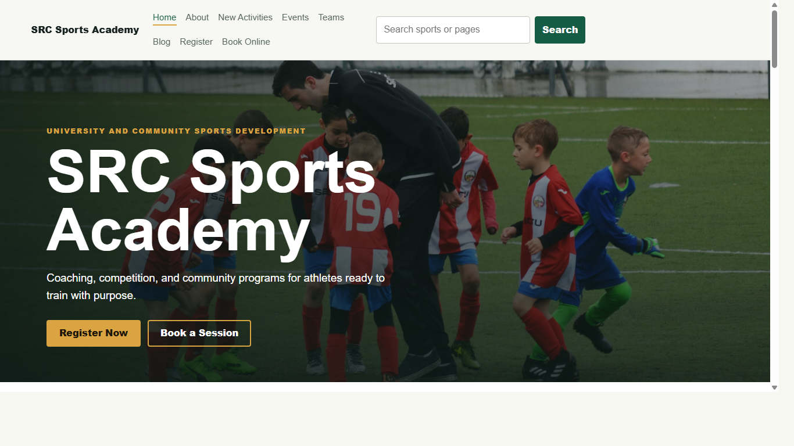
- Clean appearance
- Easy navigation
- Mobile responsiveness
- Professional layout
- Visual consistency
- User-friendly interaction

User Interface Features

Navigation Bar
The navigation bar provides links to all major sections of the website.

Hero Section
The homepage contains a large hero section introducing the SRC Sports Academy.

Cards Layout
Cards were used to organize content and improve readability.

Buttons
Call-to-action buttons were included to improve user engagement.

Footer
The footer contains branding and navigation support.

8. HTML5 IMPLEMENTATION
HTML5 semantic structure was used throughout the website.

Semantic Tags Used
- header
- nav
- main
- section
- article
- footer
- form

Advantages of Semantic HTML
- Improved accessibility
- Better SEO support
- Cleaner structure
- Easier maintenance
- Better screen reader compatibility

Form Elements Used
- Input fields
- Labels
- Buttons
- Checkboxes
- Email fields
- Password fields
Proper form labeling was implemented for accessibility.

9. CSS3 IMPLEMENTATION
External CSS styling was used throughout the entire project.

CSS Features Implemented

Layout Systems
- Flexbox
- CSS Grid

Visual Styling
- Box shadows
- Rounded corners
- Gradient backgrounds
- Typography styling
- Hover animations

Responsive Design
Media queries were used to adjust layouts on smaller screens.

Mobile Navigation
The desktop navigation switches to a vertical layout on mobile devices.

Animation Effects
Smooth hover transitions and scaling effects improved user experience.

10. JAVASCRIPT AND INTERACTIVITY
JavaScript was used to improve frontend interactivity.

Features Implemented

Card Hover Effects
Cards scale slightly when users hover over them.

Dynamic Event Handling
Event listeners were attached to interactive components.

Console Feedback
JavaScript console messages were used for development testing.

Benefits
- Improved user experience
- Better visual feedback
- Increased frontend interactivity
- Modern UI behavior

11. RESPONSIVE DESIGN IMPLEMENTATION
The website was designed using responsive web design principles.

Responsive Techniques Used

Media Queries
Media queries adjusted layouts based on screen size.

Flexible Grids
CSS Grid and Flexbox improved layout responsiveness.

Mobile-First Considerations
The design was optimized for smaller screens.

Devices Tested
- Desktop computers
- Tablets
- Mobile phones
The website maintained usability across all devices.

12. ACCESSIBILITY FEATURES
Accessibility was considered during development.

Accessibility Features Implemented

Proper Form Labels
All forms included descriptive labels.

Semantic HTML
Semantic tags improved screen reader support.

Keyboard Navigation
Users could navigate forms and links using keyboard controls.

Color Contrast
Readable color combinations improved visibility.

Accessibility Benefits
- Improved usability
- Better support for disabled users
- Enhanced navigation
- WCAG awareness compliance

13. FORMS AND VALIDATION
Forms were developed for registration and booking functionality.

Forms Included

Registration Form
Users can register by entering:
- Full name
- Email
- Password

Booking Form
The booking section allows users to request training sessions.

Validation Features
- Required fields
- Email validation
- Structured input controls
These validations improved data quality and user experience.

14. MEDIA INTEGRATION
Media integration improved the visual appeal of the website.

Media Elements Included

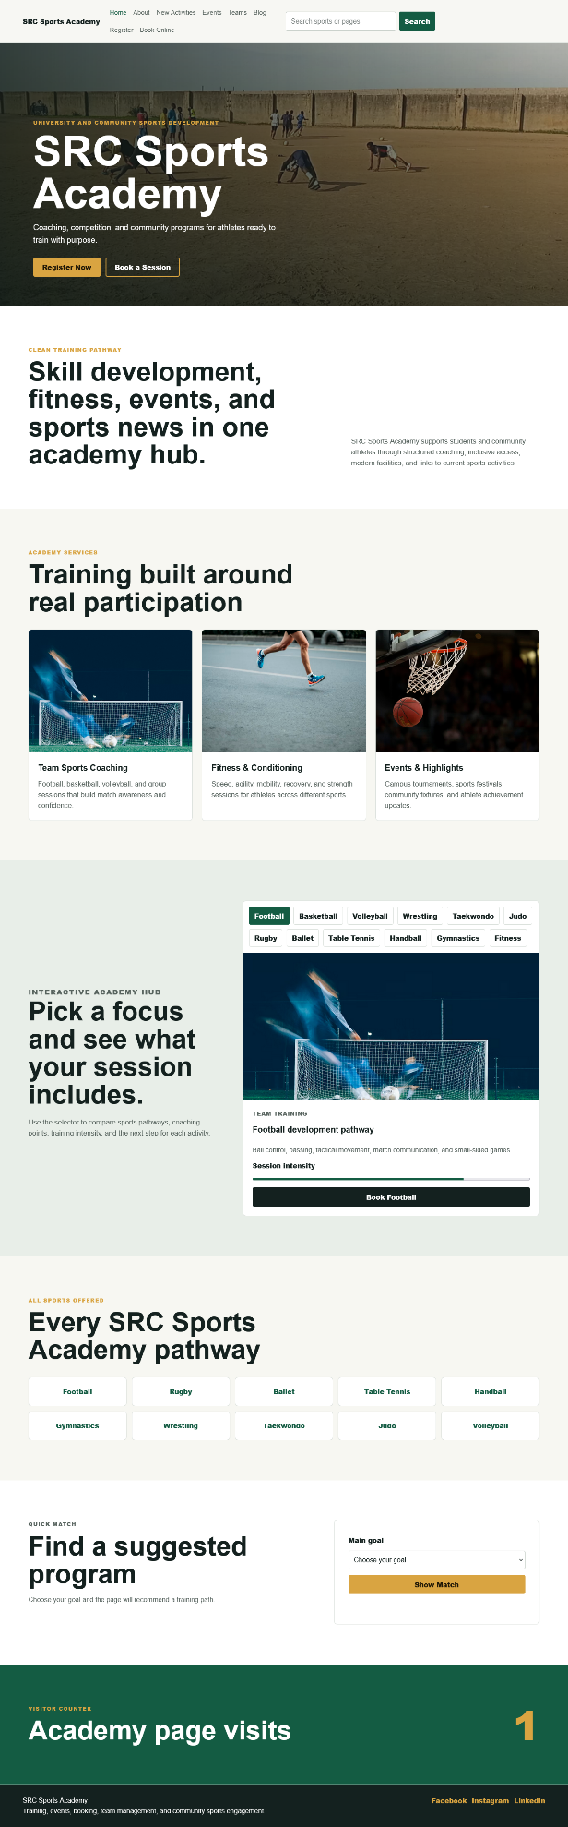
- Sports images
- Hero backgrounds
- Visual cards
- Interactive layouts

Social Media Integration
The website structure supports social media linking and future media embedding.

15. TESTING AND VALIDATION
Testing was performed to ensure the website met project requirements.

HTML Validation
HTML pages were checked using W3C validation principles.

Issues Found
- Missing alt attributes
- Minor nesting issues
- Missing labels in early form versions

Corrections Made
- Added alt attributes
- Corrected semantic nesting
- Improved form accessibility

CSS Validation
CSS was reviewed for:
- Syntax errors
- Responsive behavior
- Layout consistency
No major CSS errors were found after corrections.

16. CROSS-BROWSER TESTING
The website was tested across multiple browsers.

Browsers Tested
- Google Chrome
- Mozilla Firefox
- Microsoft Edge

Results

Google Chrome

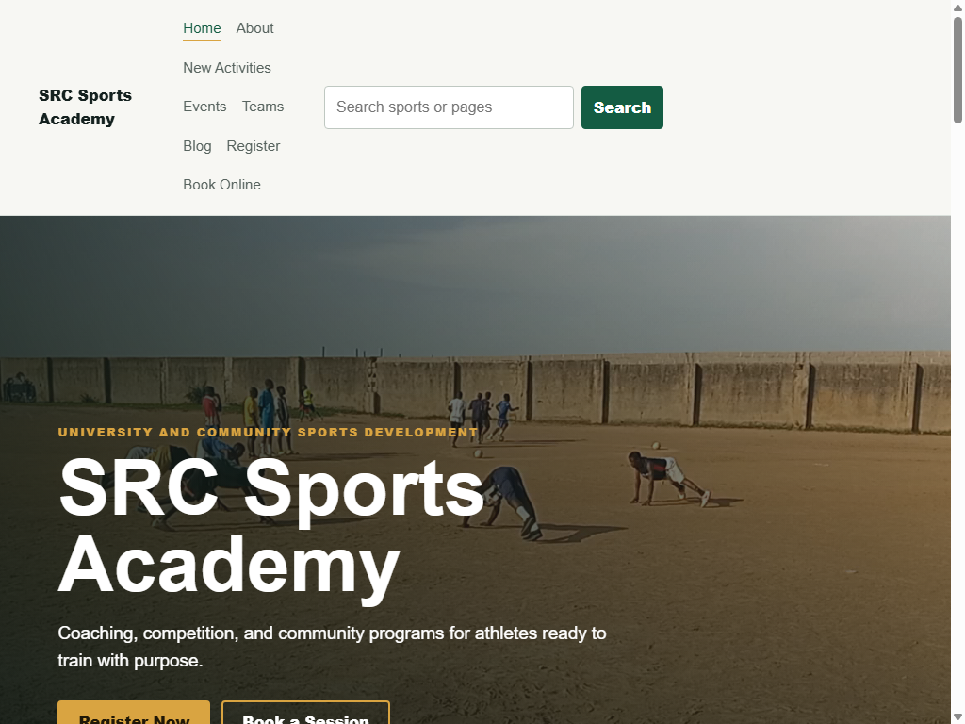
The website functioned correctly with no major issues.

Mozilla Firefox


Minor spacing inconsistencies were observed but corrected.

Microsoft Edge


Responsive behavior worked successfully.

Conclusion
The website maintained comp

