**1. Implementing the Singleton Pattern**

**CODE:**

class Logger

{

private static Logger instance;

private Logger()

{

System.out.println("Logger instance created");

}

public static Logger getInstance()

{

if(instance==null)

{

instance=new Logger();

}

return instance;

}

public void log(String msg)

{

System.out.println(msg);

}

}

public class Main

{

public static void main(String[] args)

{

Logger log1=Logger.getInstance();

log1.log("Application started");

Logger log2=Logger.getInstance();

log2.log("Another message logged successfully!");

if(log1==log2)

{

System.out.println("Only one instance is used!");

}

else

{

System.out.println("Different instances are used!");

}

}

}

**OUTPUT:**

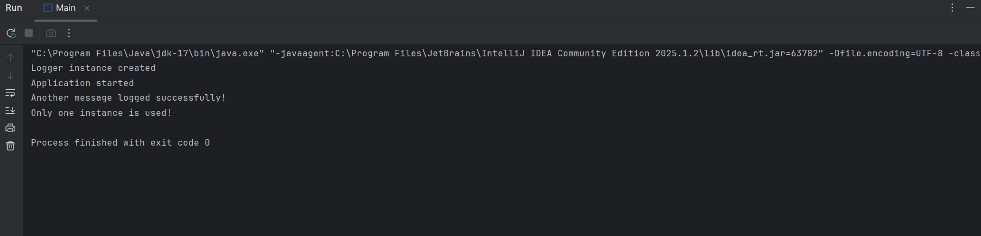

**2. Implementing the Factory Method Pattern**

**CODE:**

interface Document

{

void open();

void save();

void print();

}

class WordDocument implements Document

{

public void open()

{

System.out.println("Opening the word document....");

}

public void save()

{

System.out.println("Saving the word document....");

}

public void print()

{

System.out.println("Printing the word document....");

}

}

class PdfDocument implements Document

{

public void open()

{

System.out.println("Opening the Pdf document....");

}

public void save()

{

System.out.println("Saving the pdf document....");

}

public void print()

{

System.out.println("Printing the pdf document....");

}

}

class ExcelDocument implements Document

{

public void open()

{

System.out.println("Opening the excel document....");

}

public void save()

{

System.out.println("Saving the excel document....");

}

public void print()

{

System.out.println("Printing the excel document....");

}

}

class Factory

{

public Document createDocument(String type)

{

if(type.equalsIgnoreCase("WORD"))

{

return new WordDocument();

}

else if(type.equalsIgnoreCase("PDF"))

{

return new PdfDocument();

}

else if(type.equalsIgnoreCase("EXCEL"))

{

return new ExcelDocument();

}

return null;

}

}

public class Main {

public static void main(String[] args) {

Factory factory=new Factory();

Document word=factory.createDocument("word");

word.open();

word.save();

word.print();

Document pdf=factory.createDocument("pdf");

pdf.open();

pdf.save();

pdf.print();

Document excel=factory.createDocument("excel");

excel.open();

excel.save();

excel.print();

}

}

**OUTPUT:**

