**1. Static**

This is the default value for elements. The element is positioned according to the normal flow of the document.

The left, right, top, bottom and z-index properties do not affect an element with position: static.

### 2. Relative

Elements with position: relative remain in the normal flow of the document. But it is offset relative/ based on the previous element.

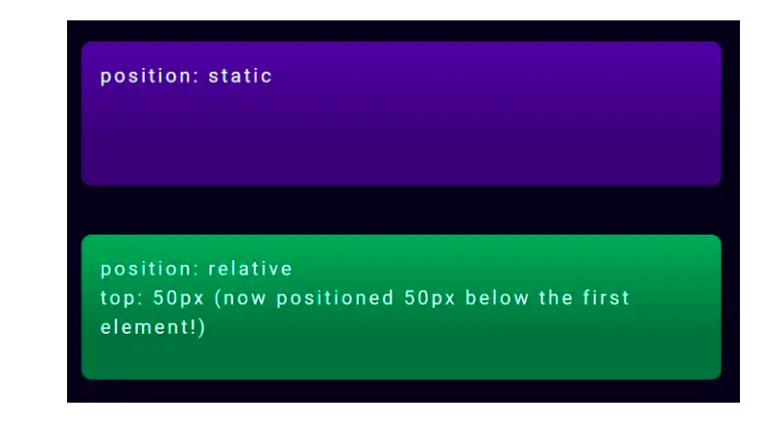

## 3. Absolute positioning

Absolute positioned element is removed from the normal document flow, and no space is created for the element in the page layout.

It is positioned relative to its closest positioned ancestor, if there is any. Else, it is placed relative to the initial containing block.

# An absolutely positioned element needs to position itself in relation to a positioned ancestor.

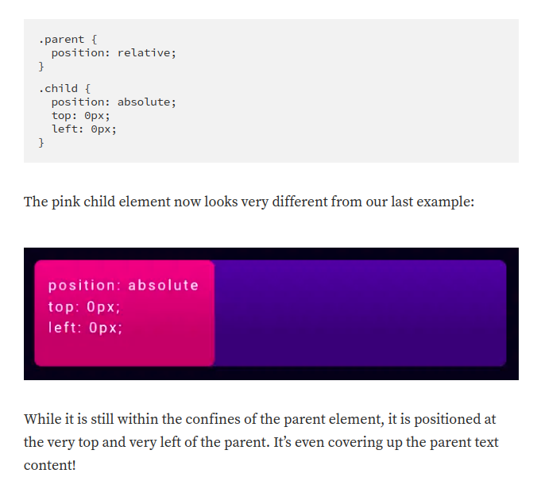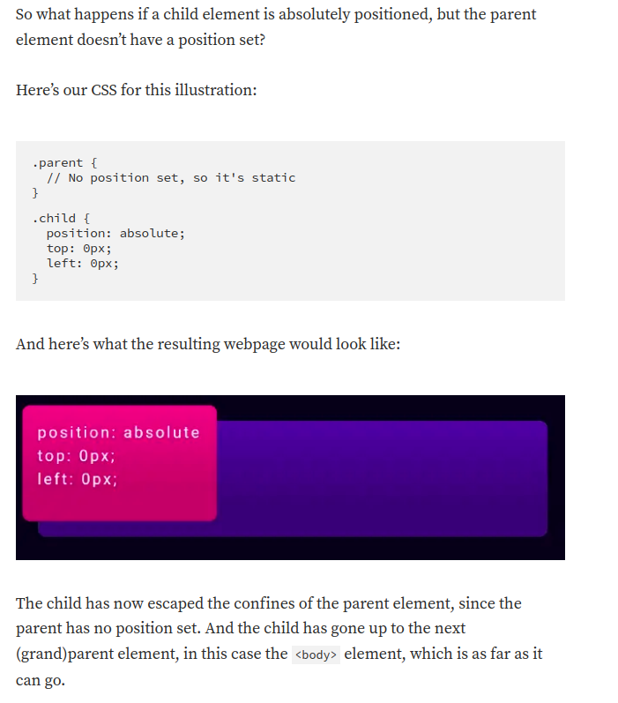4. **Fixed**

position: fixed will take the element out of the normal flow, and also position it in the same place in the viewport (what's visible on screen). This means that scrolling will not affect its position at all.

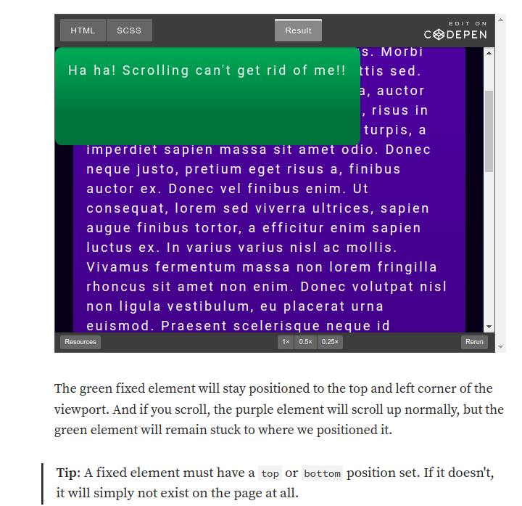

# 5. **Sticky**

Position: sticky elements will initially behave like position: relative elements, but if you keep scrolling, they will get taken out of the normal flow and behave like position: fixed wherever you have positioned them.

This can be really useful if you want to stick an element that’s initially farther down the page to the top of the screen.

