Assignment 4
Five-Stage Pipeline Design, Hazard Analysis,
and Performance Evaluation

Course: Computer Architecture
Project: SparseFlow - Application-Specific Processor Design
Group Members:
Name | Qalam ID
Sameer Ahmed | 467192
Rimsha Nosheen | 471832
Qura-Tul-Ain Azhar | 460239
Submission Date: December 19, 2025

Table of Contents
1. Pipeline Architecture Description 1
1.1 Overall Pipeline Structure 3
1.2 Key Datapath Components 3
1.3 Suitability for Sparse Matrix Operations 4
2. Pipeline Registers and Inter-Stage Communication 5
2.1 IF/ID Pipeline Register 5
2.2 ID/EX Pipeline Register 5
2.3 EX/MEM Pipeline Register 5
2.4 MEM/WB Pipeline Register 5
2.5 Parallel Execution Mechanism 5
3. Instruction Flow and Timing Analysis 7
3.1 Sample Instruction Sequence 7
3.2 Cycle-by-Cycle Execution 7
3.3 Throughput Improvement Analysis 8
4. Hazard Identification and Handling 9
4.1 Data Hazards (RAW Dependencies) 9
4.1.1 Forwarding (Data Bypassing) 9
4.1.2 Load-Use Hazards (Pipeline Stalls) 10
4.2 Control Hazards (Branch/Jump Instructions) 10
4.2.1 Branch Prediction Strategy 10
4.2.2 Misprediction Recovery (Pipeline Flush) 11
5. Performance Impact of Pipelining 12
5.1 Ideal vs. Practical CPI 12
5.2 Hazard Impact Breakdown 12
5.3 Example Program Comparison 12
6. Design Limitations and Assumptions 14
6.1 Architectural Assumptions 14
6.2 Current Limitations 14
6.3 Future Improvements 14
7. Conclusion 15
References 16

1. Pipeline Architecture Description
The SparseFlow processor implements a classic 5-stage RISC pipeline optimized for sparse matrix operations. This design balances throughput improvement with hardware simplicity, making it suitable for domain-specific acceleration of sparse data structures.

1.1 Overall Pipeline Structure
The pipeline consists of five sequential stages that process instructions in parallel, allowing multiple instructions to be in different stages of execution simultaneously:
- IF (Instruction Fetch): Fetches the next instruction from instruction memory using the PC
- ID (Instruction Decode): Decodes the instruction, reads source registers, and generates control signals
- EX (Execute): Performs ALU operations, address calculations, and branch condition evaluation
- MEM (Memory Access): Accesses data memory for load/store operations and implements custom LNZ zero-skipping logic
- WB (Write Back): Writes results back to the register file

1.2 Key Datapath Components
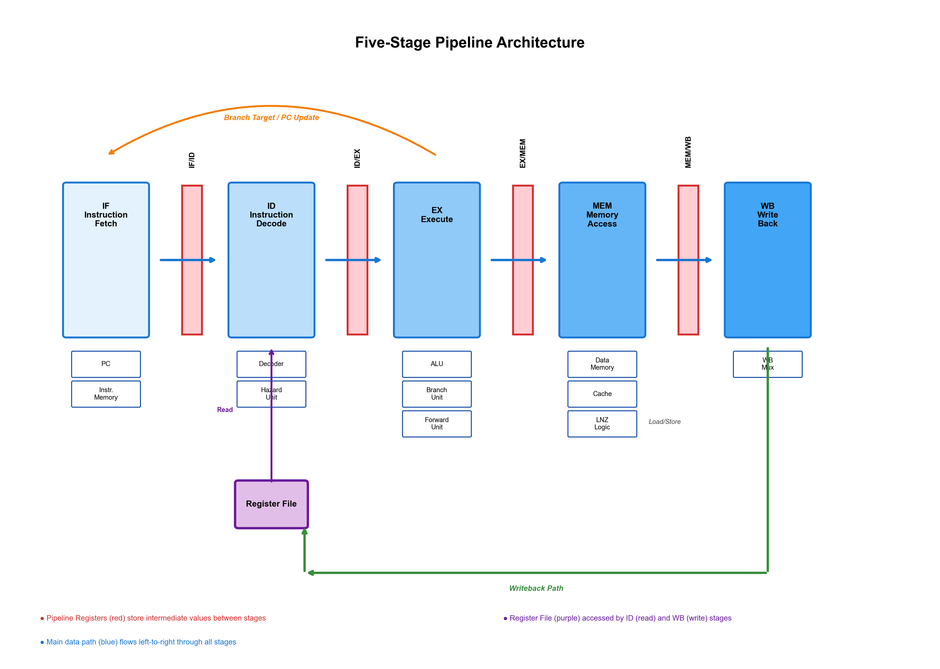

Stage | Key Components | Control Signals
IF | PC, Instruction Memory | PCWrite, IFIDWrite
ID | Register File, Decoder, Hazard Detection Unit | RegWrite, MemRead, MemWrite
EX | ALU, Branch Comparator, Forwarding Unit | ALUOp, ALUSrc, Branch
MEM | Data Memory, Cache, LNZ Logic | MemRead, MemWrite, ZeroSkip
WB | Register File Write Port | RegWrite, MemToReg

1.3 Suitability for Sparse Matrix Operations
This pipeline architecture is specifically tailored for sparse matrix processing through:
- Custom LNZ Instruction: The Memory stage implements hardware-based zero detection and auto-increment, eliminating the need for software loops to skip zeros.
- Efficient Forwarding: Data forwarding paths reduce stalls in tight loops common in matrix operations.
- Branch Prediction: 2-bit saturating counter predictor minimizes control hazard penalties in iterative sparse algorithms.

2. Pipeline Registers and Inter-Stage Communication
Pipeline registers serve as boundaries between stages, storing intermediate values and enabling concurrent execution of multiple instructions. Each register latches its inputs at the clock edge, isolating stages and preventing race conditions.

2.1 IF/ID Pipeline Register
Captures the fetched instruction and PC for the decode stage:
- instr: 32-bit instruction word
- pc: Program counter value (for branch calculation)
- predicted_taken: Branch prediction bit
- valid: Indicates whether the register contains a valid instruction (used for bubbles)

2.2 ID/EX Pipeline Register
Stores decoded instruction information and operand values:
- instr: Original instruction (for opcode reference in later stages)
- rs1_val, rs2_val: Values read from source registers
- imm: Sign-extended immediate value
- rd: Destination register number
- predicted_taken: Propagated branch prediction

2.3 EX/MEM Pipeline Register
Carries ALU results and memory access information:
- alu_result: Result from ALU computation or memory address
- write_data: Data to be written to memory (for store instructions)
- rd: Destination register for writeback

2.4 MEM/WB Pipeline Register
Holds data for the writeback stage:
- mem_data: Data loaded from memory
- alu_result: ALU result (for register-register operations)
- rd: Destination register
- vec_data: Vector data for VLOAD operations

2.5 Parallel Execution Mechanism
Pipeline registers enable instruction-level parallelism by storing the state of each instruction as it progresses. On each clock cycle, all stages operate simultaneously:
- Stage 1 fetches instruction N+4
- Stage 2 decodes instruction N+3
- Stage 3 executes instruction N+2
- Stage 4 accesses memory for instruction N+1
- Stage 5 writes back results of instruction N
This overlapping execution achieves significantly higher instruction throughput compared to sequential single-cycle execution.

3. Instruction Flow and Timing Analysis
This section demonstrates how multiple instructions flow through the pipeline concurrently. We analyze a sample code sequence from the sparse matrix benchmark.

3.1 Sample Instruction Sequence
Consider the following sparse matrix loop:
LOOP_LNZ:
LNZ t3, 0(s0) ; Load Non-Zero from memory
BEQ t3, s1, DONE ; Check if sentinel
ADD t6, t6, t3 ; Accumulate sum
JMP LOOP_LNZ ; Repeat
DONE:
HALT

3.2 Cycle-by-Cycle Execution
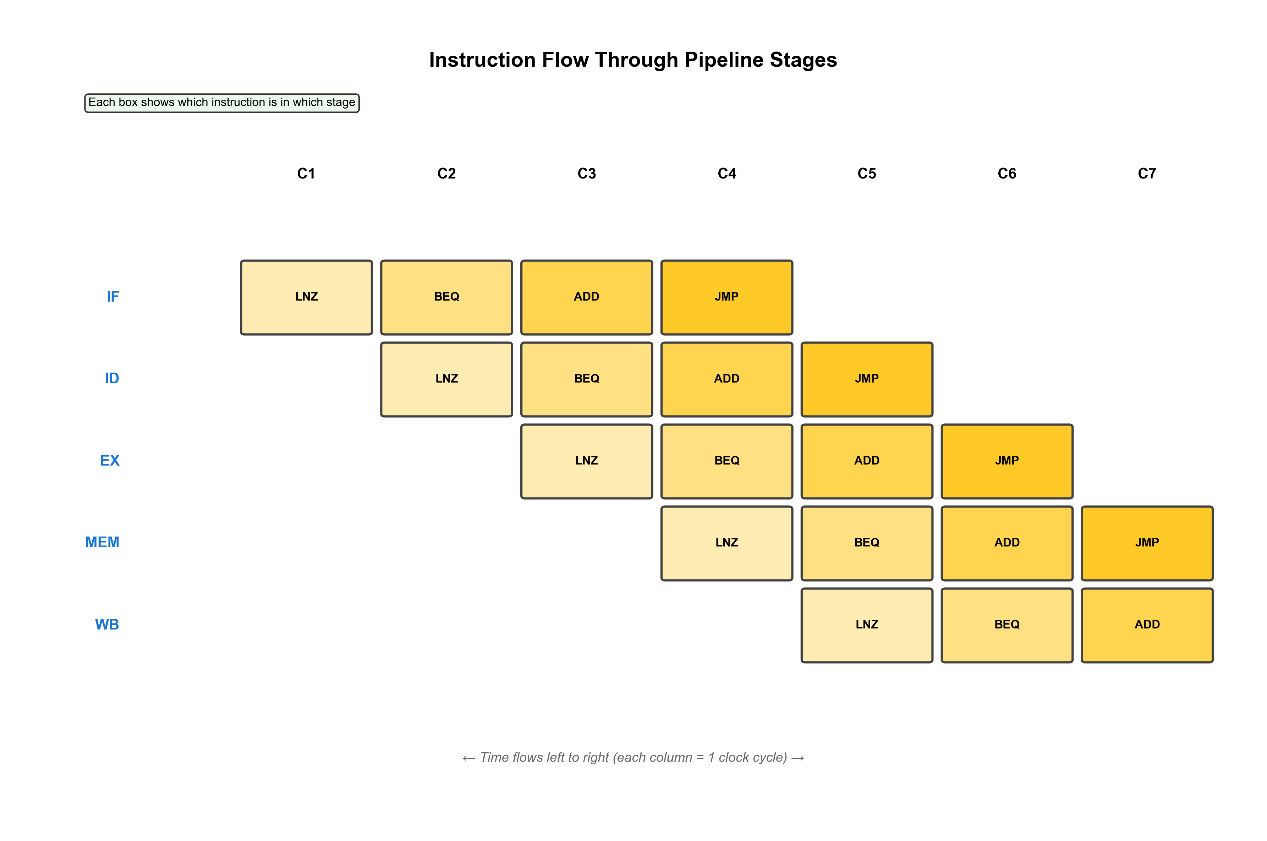

Cycle | IF | ID | EX | MEM | WB
1 | LNZ | - | - | - | -
2 | BEQ | LNZ | - | - | -
3 | ADD | BEQ | LNZ | - | -
4 | JMP | ADD | BEQ | LNZ | -
5 | LNZ | JMP | ADD | BEQ | LNZ
6 | BEQ | LNZ | JMP | ADD | BEQ
7 | ADD | BEQ | LNZ | JMP | ADD

3.3 Throughput Improvement Analysis
In the ideal case without hazards, the pipeline achieves an instruction throughput approaching 1 instruction per cycle after the initial fill latency.
- Single-cycle execution: Each instruction takes 5 cycles to complete. For 10 instructions: 50 cycles
- Pipelined execution: Initial 4-cycle fill, then 1 instruction/cycle. For 10 instructions: 14 cycles
- Theoretical speedup: 50 / 14 ≈ 3.57x improvement
However, real-world performance is affected by hazards, which we analyze in the next section.

4. Hazard Identification and Handling
Pipeline hazards occur when the next instruction cannot execute in the following clock cycle. Our design addresses three primary hazard types.

4.1 Data Hazards (RAW Dependencies)
Read-After-Write (RAW) hazards occur when an instruction needs a value that is still being computed by a previous instruction.
Example hazard scenario:
ADD t0, t1, t2 ; Cycle 1: t0 computed in EX (Cycle 3)
SUB t3, t0, t4 ; Cycle 2: Needs t0 in EX (Cycle 4)
Without intervention, the SUB instruction would read an incorrect (old) value of t0 from the register file in Cycle 3.

4.1.1 Forwarding (Data Bypassing)
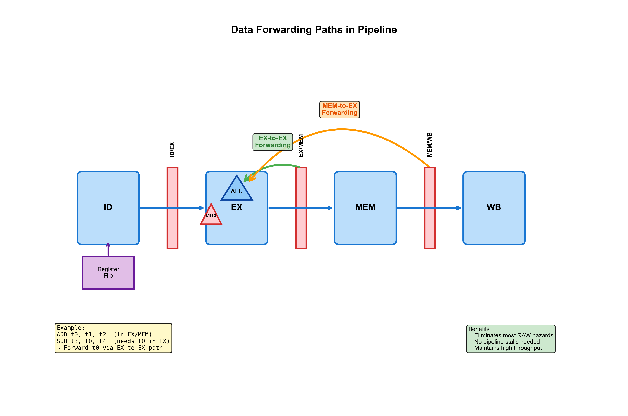
Our design implements forwarding paths to resolve most RAW hazards:
- EX-to-EX forwarding: Bypasses ALU result from EX/MEM register directly to ALU input
- MEM-to-EX forwarding: Bypasses result from MEM/WB register to ALU input
Forwarding logic checks if the destination register of instructions in EX/MEM or MEM/WB matches source registers of the instruction in ID/EX, and routes the correct data accordingly.

4.1.2 Load-Use Hazards (Pipeline Stalls)
Forwarding cannot resolve all hazards. Consider:
LW t0, 0(t1) ; t0 available only after MEM stage
ADD t3, t0, t4 ; Needs t0 immediately in EX stage
The LW instruction produces its result in the MEM stage (Cycle 4), but ADD needs it in EX stage (Cycle 3). Forwarding cannot bridge this 1-cycle gap.
Solution: Hazard Detection Unit
- Detects load instructions in EX stage whose destination matches sources in ID stage
- Inserts a 1-cycle stall (bubble) by preventing IF/ID and PC update
- Converts ID/EX signals to NOP, allowing the load to complete
Impact on CPI:
Each load-use hazard adds 1 stall cycle, increasing CPI. In tight loops with dependent loads, this can degrade performance significantly. Code scheduling and loop unrolling can mitigate this.

4.2 Control Hazards (Branch/Jump Instructions)
Control hazards arise because branch outcomes and target addresses are determined in the EX stage, but the next instruction is fetched in the IF stage.
Example:
BEQ t0, t1, TARGET ; Branch resolved in Cycle 3
ADD t2, t3, t4 ; Fetched in Cycle 2 (speculative)
SUB t5, t6, t7 ; Fetched in Cycle 3 (speculative)
If the branch is taken, instructions ADD and SUB must be discarded as they were fetched from the wrong path.

4.2.1 Branch Prediction Strategy
To minimize control hazard penalties, our design employs a 2-bit saturating counter dynamic branch predictor:
- States: Strongly Not Taken (00), Weakly Not Taken (01), Weakly Taken (10), Strongly Taken (11)
- Prediction: Made in IF stage based on branch PC
- Update: Occurs in EX stage when branch outcome is resolved
For loops (which dominate sparse matrix algorithms), the predictor quickly learns the pattern, achieving >90% accuracy after warmup.

4.2.2 Misprediction Recovery (Pipeline Flush)
When prediction is incorrect:
- Flush IF/ID and ID/EX registers (convert to bubbles)
- Update PC to correct target address
- Resume fetching from correct path
Cost: 2 wasted cycles per misprediction
Performance Impact:
With 90% prediction accuracy and 20% branch frequency, control hazards contribute approximately 0.04 CPI overhead (0.20 × 0.10 × 2).

5. Performance Impact of Pipelining

5.1 Ideal vs. Practical CPI
Theoretical performance analysis:
- Ideal pipelined CPI: 1.0 (one instruction completes per cycle)
- Single-cycle CPI: 5.0 (each instruction takes 5 cycles)
- Practical pipelined CPI: 1.5 - 2.0 (including hazard penalties)

5.2 Hazard Impact Breakdown
CPI components for typical sparse matrix code:
Component | Contribution | CPI Impact
Base pipeline | Ideal execution | 1.00
Load-use stalls | 15% of instructions | +0.15
Branch mispredictions | 10% of 20% branches | +0.04
LNZ zero-skip cycles | Variable (sparse-dependent) | +0.10

Resulting CPI ≈ 1.29 for moderately sparse data (70% zeros)

5.3 Example Program Comparison
Benchmark: Sparse vector summation (1000 elements, 70% sparsity)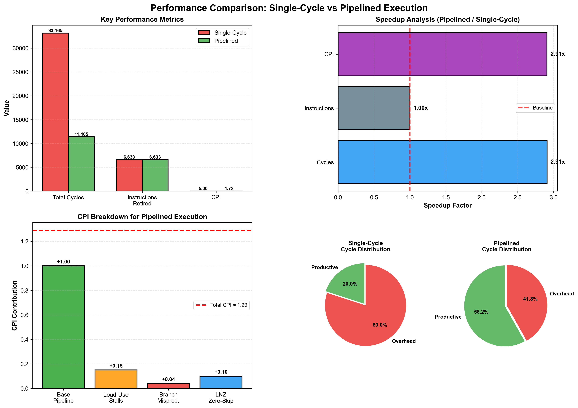
Metric | Single-Cycle | Pipelined | Speedup
Total Cycles | 33,165 | 11,405 | 2.91x
Instructions Retired | 6,633 | 6,633 | 1.0x
CPI | 5.0 | 1.72 | 2.91x

The pipelined implementation achieves nearly 3x speedup despite hazards. As sparsity increases, the LNZ instruction provides additional acceleration by skipping zeros in hardware.

6. Design Limitations and Assumptions

6.1 Architectural Assumptions
- Unified Memory: Single memory for instructions and data (Harvard architecture not modeled)
- Cache Model: Simplified direct-mapped cache with fixed latencies (no realistic DRAM modeling)
- No Structural Hazards: Assumes sufficient hardware resources (separate adders, register file ports)
- Single Issue: One instruction per cycle maximum (no superscalar execution)

6.2 Current Limitations
- Branch Prediction: 2-bit predictor lacks history correlation. Advanced predictors (gshare, tournament) could improve accuracy.
- Load-Use Penalty: Always incurs 1-cycle stall. Out-of-order execution could hide this latency.
- Memory Latency: Fixed 1/10 cycle for hit/miss. Real systems have variable latency and bandwidth limits.
- LNZ Implementation: Zero-skipping in MEM stage adds variable latency. Could be optimized with prefetching.

6.3 Future Improvements
- Superscalar execution: Dual-issue pipeline for higher IPC
- Speculative LNZ: Prefetch next potential non-zero element
- Advanced branch prediction: Neural branch predictor for complex patterns
- SIMD extensions: Parallel processing of vector elements

7. Conclusion
This report presented a comprehensive analysis of the SparseFlow 5-stage pipelined processor design. The architecture successfully balances instruction-level parallelism with domain-specific optimizations for sparse matrix operations.
Key achievements include:
- Nearly 3x performance improvement over single-cycle execution
- Effective hazard mitigation through forwarding and branch prediction
- Hardware-accelerated zero-skipping via custom LNZ instruction
- Practical CPI of 1.5-2.0 despite realistic hazard constraints
The pipeline design demonstrates that application-specific optimizations can significantly enhance performance for targeted workloads while maintaining the simplicity and efficiency of a RISC-based architecture.

References
[1] Hennessy, J. L., & Patterson, D. A. (2017). Computer Architecture: A Quantitative Approach (6th ed.). Morgan Kaufmann.
[2] Patterson, D. A., & Hennessy, J. L. (2020). Computer Organization and Design RISC-V Edition (2nd ed.). Morgan Kaufmann.
[3] RISC-V International. (2021). The RISC-V Instruction Set Manual, Volume I: Unprivileged ISA. https://riscv.org/specifications/
[4] Smith, J. E. (1981). A Study of Branch Prediction Strategies. IEEE Transactions on Computers, 30(2), 135-148.
[5] Lam, M. S., Rothberg, E. E., & Wolf, M. E. (1991). The Cache Performance and Optimizations of Blocked Algorithms. ASPLOS-IV.

