SparseFlow Simulator

A Cycle-Accurate RISC-V Processor with Sparse Matrix Extensions
Documentation & Source Code Reference
Language: C++17

Submitted by:
Name | Qalam ID
Rimsha Nosheen | 471832
Sameer Ahmed | 467192
Qura-Tul-Ain Azhar | 460239

Table of Contents
1. Architecture Overview
2. Directory Structure
3. Core Module (src/core/)
3.1 SparseFlowCore.h/.cpp
3.2 PipelineRegisters.h
4. ISA Module (src/isa/)
4.1 Instruction.h
4.2 ISA.h
5. Hardware Module (src/hardware/)
5.1 Memory.h/.cpp
5.2 RegisterFile.h/.cpp
5.3 Cache.h/.cpp
5.4 BranchPredictor.h/.cpp
6. Utilities Module (src/utils/)
6.1 Loader.h/.cpp
6.2 Stats.h/.cpp
6.3 TraceLogger.h/.cpp
7. Main Entry Point
8. Class Diagrams
9. Data Flow
10. API Reference

1. Architecture Overview
The SparseFlow Simulator is a cycle-accurate processor simulator implementing a 5-stage pipeline based on the RISC-V instruction set with custom extensions for sparse matrix operations.

1.1 System Components
Component | Description
SparseFlowCore | Main pipeline controller managing the 5-stage execution
Memory | Instruction and data memory with cache simulation
RegisterFile | 32 scalar registers + 8 vector registers
BranchPredictor | 1-bit dynamic branch predictor
Cache | Direct-mapped L1 cache with configurable size
Loader | Assembly file parser with label resolution
Stats | Performance metrics collector and reporter
TraceLogger | CSV-based pipeline trace generator

1.2 Pipeline Stages
Stage | Function
IF (Fetch) | Fetches instruction from instruction memory using PC. Applies branch prediction.
ID (Decode) | Decodes opcode, reads register file. Detects load-use hazards and inserts stalls.
EX (Execute) | Performs ALU operations. Implements data forwarding. Resolves branches.
MEM (Memory) | Accesses data memory for load/store. Simulates cache latency.
WB (Writeback) | Writes results back to register file. Updates forwarding shadow register.

2. Directory Structure
src/
├── main.cpp # Program entry point
├── core/ # Pipeline core logic
│ ├── SparseFlowCore.h # Core class declaration
│ ├── SparseFlowCore.cpp # Pipeline implementation
│ └── PipelineRegisters.h # Pipeline register structs
├── isa/ # Instruction Set Architecture
│ ├── Instruction.h # Opcode enum and Instruction struct
│ └── ISA.h # Register ABI mappings
├── hardware/ # Hardware component models
│ ├── Memory.h/.cpp # RAM and instruction memory
│ ├── RegisterFile.h/.cpp # Scalar and vector registers
│ ├── Cache.h/.cpp # Direct-mapped cache
│ └── BranchPredictor.h/.cpp # 1-bit dynamic predictor
└── utils/ # Utility classes
├── Loader.h/.cpp # Assembly file parser
├── Stats.h/.cpp # Performance statistics
└── TraceLogger.h/.cpp # Pipeline trace output

3. Core Module (src/core/)
The core module contains the main pipeline controller and pipeline register definitions.

3.1 SparseFlowCore.h
The main class that orchestrates the 5-stage pipeline simulation.

Class Declaration
class SparseFlowCore {
private:
int pc; // Program Counter
long long cycle_count; // Total cycles executed
bool halted; // Simulation stop flag
// Hardware Units
RegisterFile reg_file; // 32 scalar + 8 vector registers
Memory memory; // Instruction and data memory
BranchPredictor branch_predictor;// 1-bit dynamic predictor
Stats stats; // Performance metrics
TraceLogger trace_logger; // CSV trace output
// Pipeline Registers
IF_ID_Reg if_id; // Fetch → Decode
ID_EX_Reg id_ex; // Decode → Execute
EX_MEM_Reg ex_mem; // Execute → Memory
MEM_WB_Reg mem_wb; // Memory → Writeback
MEM_WB_Reg wb_shadow; // Shadow register for WB forwarding
// Pipeline Control
int zero_skips; // LNZ zero-skip counter
bool stall_pipeline; // Stall flag for hazards
int mem_stall_cycles; // Memory latency counter
bool single_cycle_mode; // Single-cycle execution flag
// Pipeline Stage Methods
void stageFetch();
void stageDecode();
void stageExecute();
void stageMemory();
void stageWriteback();
public:
SparseFlowCore();
void loadProgram(const std::vector<Instruction>& prog);
void writeDataMemory(int addr, int val);
void run();
void setSingleCycleMode(bool enable);
private:
bool isPipelineEmpty() const;
};

Key Methods
Method | Description
SparseFlowCore() | Constructor. Initializes PC to 0, cycle count to 0, halted to false.
loadProgram(prog) | Loads a vector of Instructions into instruction memory.
writeDataMemory(addr, val) | Pre-initializes data memory before simulation.
run() | Main simulation loop. Executes stages in reverse order until HALT.
setSingleCycleMode(enable) | Enables single-cycle mode (drains pipeline after each instruction).
stageFetch() | Fetches instruction at PC. Applies branch prediction for BEQ/JMP.
stageDecode() | Decodes instruction, reads registers. Detects load-use hazards.
stageExecute() | Performs ALU ops. Implements forwarding from MEM and WB stages.
stageMemory() | Accesses data memory for LW/SW. Handles cache hit/miss latency.
stageWriteback() | Writes result to register file. Updates wb_shadow for forwarding.

3.2 PipelineRegisters.h
Defines the structures for inter-stage pipeline registers that hold instruction state as it flows through the pipeline.

IF/ID Register
Holds state between Fetch and Decode stages.
struct IF_ID_Reg {
Instruction instr; // Fetched instruction
int pc; // PC of this instruction
bool predicted_taken; // Branch prediction result
bool valid; // Is this register holding valid data?
};

ID/EX Register
Holds state between Decode and Execute stages.
struct ID_EX_Reg {
Instruction instr; // Decoded instruction
int pc; // PC of this instruction
int rs1_val; // Value read from rs1
int rs2_val; // Value read from rs2
int imm; // Sign-extended immediate
int rd; // Destination register number
bool predicted_taken; // Propagated branch prediction
bool valid; // Is this register holding valid data?
};

EX/MEM Register
Holds state between Execute and Memory stages.
struct EX_MEM_Reg {
Instruction instr; // Instruction in MEM stage
int alu_result; // Result from ALU
int write_data; // Data to write (for SW)
int rd; // Destination register number
bool valid; // Is this register holding valid data?
};

MEM/WB Register
Holds state between Memory and Writeback stages.
struct MEM_WB_Reg {
Instruction instr; // Instruction in WB stage
int mem_data; // Data loaded from memory
std::vector<int> vec_data; // Vector data for VLOAD
int alu_result; // ALU result (for non-memory ops)
int rd; // Destination register number
bool valid; // Is this register holding valid data?
};

4. ISA Module (src/isa/)
The ISA module defines the instruction set architecture including opcodes and instruction format.

4.1 Instruction.h

Opcode Enumeration
Defines all supported opcodes including custom sparse extensions.
enum Opcode {
// Base RISC-V Subset
ADD, // rd = rs1 + rs2
SUB, // rd = rs1 - rs2
JMP, // PC = PC + imm (unconditional jump)
LW, // rd = Mem[rs1 + imm]
SW, // Mem[rs1 + imm] = rs2
BEQ, // if (rs1 == rs2) PC += imm
SLT, // rd = (rs1 < rs2) ? 1 : 0
ADDI, // rd = rs1 + imm
JR, // PC = rs1 (return)
// Custom Sparse Extensions
LNZ, // Load Non-Zero (skips zeros in hardware)
ZMUL, // Zero-Skip Multiply (1 cycle if operand is 0)
ZMAC, // Zero-Skip Multiply-Accumulate
VLOAD, // Vector Load (loads 4 words)
BZERO, // Branch if Zero
MOV, // Move (pseudo-instruction → ADDI)
HALT // Stop simulation
};

Instruction Structure
struct Instruction {
Opcode op; // Operation code
int rd; // Destination register (0-31)
int rs1; // Source register 1 (0-31)
int rs2; // Source register 2 (0-31)
int imm; // Immediate value (signed)
std::string raw_asm;// Original assembly text (for debugging)
// Default constructor creates a NOP (HALT with rd=rs1=rs2=imm=0)
Instruction() : op(HALT), rd(0), rs1(0), rs2(0), imm(0), raw_asm("NOP") {}
};

Opcode Reference Table
Opcode | Format | Description
ADD | R-Type | rd = rs1 + rs2
SUB | R-Type | rd = rs1 - rs2
ADDI | I-Type | rd = rs1 + imm
SLT | R-Type | rd = (rs1 < rs2) ? 1 : 0
LW | I-Type | rd = Mem[rs1 + imm]
SW | S-Type | Mem[rs1 + imm] = rs2
BEQ | B-Type | if (rs1 == rs2) PC += imm
JMP | J-Type | PC = PC + imm
JR | I-Type | PC = rs1
LNZ | I-Type | Load Non-Zero. Skip if zero.
ZMUL | R-Type | Zero-Skip Multiply. 1 cycle if 0.
VLOAD | I-Type | Vector Load. 4 words → vD.
BZERO | B-Type | Branch if rs1 == 0
HALT | X-Type | Stop simulation

4.2 ISA.h
Defines register ABI name mappings for debugging output.
const std::map<int, std::string> REG_ABI = {
{0, "zero"}, // Hardwired zero
{1, "ra"}, // Return address
{2, "sp"}, // Stack pointer
{5, "t0"}, // Temporary 0
{6, "t1"}, // Temporary 1
{7, "t2"}, // Temporary 2
{10, "a0"}, // Argument 0
{11, "a1"} // Argument 1
};

5. Hardware Module (src/hardware/)
The hardware module contains models of processor hardware components including memory, registers, cache, and branch predictor.

5.1 Memory.h/.cpp
Models both instruction memory and data memory with cache simulation.

Class Declaration
class Memory {
private:
std::vector<int> data_mem; // Data memory (4KB)
std::vector<Instruction> instr_mem; // Instruction memory
Cache cache; // L1 cache model
const int HIT_LATENCY = 1; // Cache hit: 1 cycle
const int MISS_LATENCY = 10; // Cache miss: 10 cycles
public:
Memory();
// Program loading
void loadProgram(const std::vector<Instruction>& program);
// Instruction fetch
Instruction fetch(int pc);
// Data access with latency
int requestAccess(int addr); // Returns latency in cycles
int readData(int addr);
void writeData(int addr, int value);
// Cache statistics
Cache& getCache();
long long getCacheHits() const;
long long getCacheMisses() const;
};

Method Details
Method | Description
Memory() | Constructor. Initializes 1024-word data memory to zero.
loadProgram(program) | Copies instruction vector to instruction memory.
fetch(pc) | Returns instruction at given PC. Returns NOP if out of bounds.
requestAccess(addr) | Queries cache. Returns HIT_LATENCY or MISS_LATENCY.
readData(addr) | Returns data at address. Returns 0 if out of bounds.
writeData(addr, value) | Writes value to address if within bounds.

5.2 RegisterFile.h/.cpp
Implements the register file with 32 scalar registers (x0-x31) and 8 vector registers (v0-v7).

Class Declaration
class RegisterFile {
private:
int regs[32]; // 32 scalar registers (x0-x31)
int vregs[8][4]; // 8 vector registers, 4 elements each
public:
RegisterFile();
// Scalar access
int read(int reg_num); // Read register (x0 always returns 0)
void write(int reg_num, int value); // Write register (x0 writes ignored)
// Vector access
std::vector<int> readVector(int reg_num);
void writeVector(int reg_num, const std::vector<int>& values);
// Debug output
void dump(); // Prints all non-zero registers
};

Implementation Notes
x0 Hardwired to Zero: Reading x0 always returns 0. Writing to x0 is ignored (no-op).
Vector Registers: Each vector register holds 4 integers (128 bits total). Used by VLOAD instruction.

5.3 Cache.h/.cpp
Implements a direct-mapped cache with configurable size and block size.

Class Declaration
class Cache {
private:
struct CacheLine {
bool valid; // Line contains valid data
int tag; // Address tag
};
std::vector<CacheLine> lines;
int size_bytes; // Total cache size (default: 1024 bytes)
int block_size; // Block size (default: 64 bytes)
int num_lines; // Number of cache lines
// Statistics
long long hits;
long long misses;
public:
Cache(int size_bytes = 1024, int block_size = 64);
// Access cache, returns true if hit, false if miss
bool access(int addr);
// Statistics getters
long long getHits() const;
long long getMisses() const;
};

Cache Access Algorithm
bool Cache::access(int addr) {
// Calculate index and tag
int index = (addr / block_size) % num_lines;
int tag = addr / (block_size * num_lines);
// Check for hit
if (lines[index].valid && lines[index].tag == tag) {
hits++;
return true; // Cache hit
} else {
misses++;
// Allocate line (write-allocate policy)
lines[index].valid = true;
lines[index].tag = tag;
return false; // Cache miss
}
}

5.4 BranchPredictor.h/.cpp
Implements a 1-bit dynamic branch predictor with direct-mapped table.

Class Declaration
class BranchPredictor {
private:
std::vector<bool> prediction_table; // 1-bit per entry
int size; // Table size (default: 1024)
public:
BranchPredictor(int table_size = 1024);
// Predict branch outcome (true = taken, false = not taken)
bool predict(int pc);
// Update predictor after branch resolution
void update(int pc, bool actually_taken);
};

Prediction Algorithm
bool BranchPredictor::predict(int pc) {
int index = pc % size;
return prediction_table[index]; // Return last outcome for this PC
}
void BranchPredictor::update(int pc, bool actually_taken) {
int index = pc % size;
prediction_table[index] = actually_taken; // Update to actual outcome
}

6. Utilities Module (src/utils/)

6.1 Loader.h/.cpp
Parses assembly files and converts them to Instruction vectors.

Class Declaration
class Loader {
private:
std::map<std::string, int> label_map; // Label → PC mapping
// Helper methods
int parseRegister(std::string reg_str);
Opcode parseOpcode(std::string op_str);
void parseOperands(Instruction& instr, const std::string& op_part, int current_pc);
std::string trim(const std::string& str);
public:
std::vector<Instruction> loadFromFile(const std::string& filename);
};

Two-Pass Assembly
The loader uses a two-pass algorithm:
- Pass 1: Scan for labels and record their PC addresses.
- Pass 2: Parse instructions and resolve label references to offsets.

Register Parsing
Supports both numeric (x0-x31) and ABI names:
ABI Name | Register Number
Zero | 0
Ra | 1
Sp | 2
t0 | 5
t1 | 6
t2 | 7
s0 | 8
s1 | 9
a0 | 10
a1 | 11
t3 | 28
t4 | 29
t5 | 30
t6 | 31

6.2 Stats.h/.cpp
Collects and reports performance statistics.

Class Declaration
class Stats {
private:
long long total_cycles;
long long instructions_retired;
long long stall_cycles;
long long branch_flushes;
long long zero_skips;
// Instruction Mix
long long alu_ops;
long long memory_ops;
long long branch_ops;
// Cache Stats
long long cache_hits;
long long cache_misses;
// Branch Prediction
long long branch_predictions;
long long branch_correct;
public:
Stats();
// Increment methods
void addCycle();
void addInstructionRetired();
void addStall();
void addBranchFlush();
void addZeroSkip();
void addAluOp();
void addMemoryOp();
void addBranchOp();
// Setters
void setCacheStats(long long hits, long long misses);
void addBranchPrediction(bool correct);
// Output
void printReport();
};

Performance Report Output
================================================================================
SPARSEFLOW PERFORMANCE REPORT
================================================================================
Total Cycles: 349
Instructions Retired: 80
CPI (Cycles Per Instr): 4.36
IPC (Instr Per Cycle): 0.23
[Pipeline Events]
Stall Cycles (Hazards/Mem): 16 cycles lost
Branch Mispredict Flushes: 4 times
Zero-Skipping Savings: 5 ops skipped
[Instruction Mix]
ALU / Compute: 45
Memory (Load/Store): 25
Control Flow: 14
[Cache Performance]
Cache Hits: 28
Cache Misses: 1
Cache Hit Rate: 96.6%
[Branch Prediction]
Predictions Made: 14
Correct Predictions: 10
Prediction Accuracy: 71.4%
================================================================================

6.3 TraceLogger.h/.cpp
Generates CSV trace files for pipeline visualization.

Class Declaration
class TraceLogger {
private:
std::ofstream file;
bool enabled;
public:
TraceLogger(const std::string& filename);
~TraceLogger();
void logCycle(int cycle,
const std::string& fetch_instr,
const std::string& decode_instr,
const std::string& execute_instr,
const std::string& memory_instr,
const std::string& writeback_instr,
const std::string& event);
};

CSV Output Format
Cycle,IF,ID,EX,MEM,WB,Event
1,ADDI t0 x0 5,-,-,-,-,
2,ADD t1 t0 t0,ADDI t0 x0 5,-,-,-,
3,SW t1 0(t0),ADD t1 t0 t0,ADDI t0 x0 5,-,-,
4,LW t2 0(t0),SW t1 0(t0),ADD t1 t0 t0,ADDI,-,Forwarding
5,BEQ t1 t2 LOOP,LW t2 0(t0),SW t1 0(t0),ADD,ADDI,Stall (Load-Use)

7. Main Entry Point (main.cpp)
The entry point that initializes the simulator and runs the program.
int main(int argc, char* argv[]) {
SparseFlowCore core;
Loader loader;
// Parse command-line arguments
string filename = "test_program.asm";
bool single_cycle = false;
for (int i = 1; i < argc; ++i) {
string arg = argv[i];
if (arg == "--single-cycle") {
single_cycle = true;
} else {
filename = arg;
}
}
// Configure execution mode
if (single_cycle) {
cout << "Mode: Single-Cycle (Serialized Pipeline)" << endl;
core.setSingleCycleMode(true);
} else {
cout << "Mode: Pipelined" << endl;
}
// Load and run program
cout << "Loading program from: " << filename << endl;
vector<Instruction> program = loader.loadFromFile(filename);
if (program.empty()) {
cout << "Error: Program is empty or file not found." << endl;
return 1;
}
core.loadProgram(program);
core.run();
return 0;
}

Command-Line Usage
# Run in pipelined mode (default)
./simulator program.asm
# Run in single-cycle mode
./simulator program.asm --single-cycle

8. Class Diagrams

8.1 Class Relationships

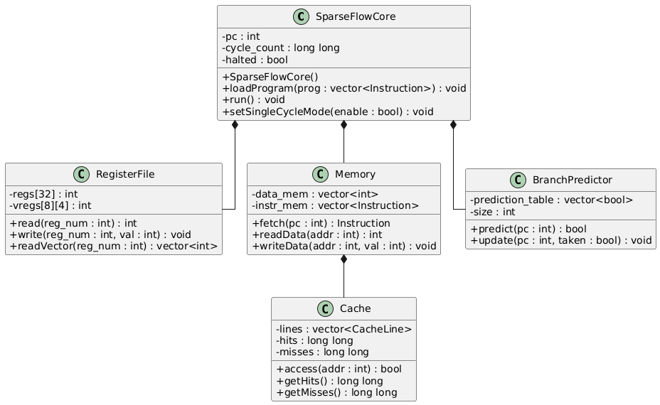

9. Data Flow

9.1 Pipeline Data Flow

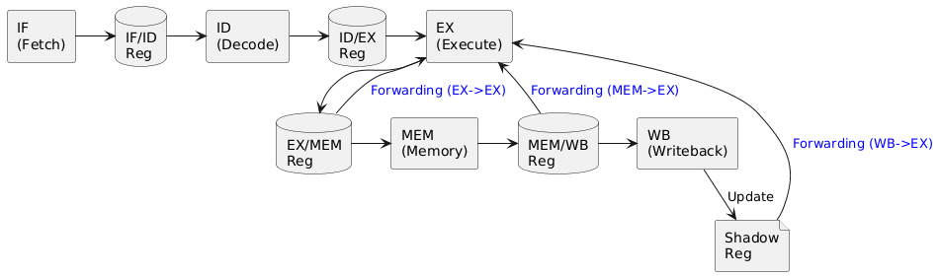

9.2 Hazard Detection Flow
Load-Use Hazard Detection (in Decode stage):
═══════════════════════════════════════════════════════════════════
if (id_ex.instr.op == LW || id_ex.instr.op == LNZ) {
if (id_ex.rd == if_id.instr.rs1 || id_ex.rd == if_id.instr.rs2) {
// Insert bubble: stall IF/ID, insert NOP in ID/EX
stall_pipeline = true;
}
}
Control Hazard Detection (in Execute stage):
═══════════════════════════════════════════════════════════════════
if (branch_taken != predicted_taken) {
// Misprediction: flush IF/ID, correct PC
if_id.valid = false;
pc = correct_target;
branch_predictor.update(pc, branch_taken);
}

10. API Reference

10.1 SparseFlowCore Public API
Method | Returns | Description
SparseFlowCore() | void | Default constructor
loadProgram(prog) | void | Load instruction vector into memory
writeDataMemory(addr, val) | void | Pre-initialize data memory
run() | void | Execute simulation until HALT
setSingleCycleMode(enable) | void | Enable/disable single-cycle mode

10.2 Memory Public API
Method | Returns | Description
loadProgram(program) | void | Load instruction vector
fetch(pc) | Instruction | Fetch instruction at PC
requestAccess(addr) | int | Get cache latency (1 or 10)
readData(addr) | int | Read from data memory
writeData(addr, value) | void | Write to data memory
getCacheHits() | long long | Get cache hit count
getCacheMisses() | long long | Get cache miss count

10.3 Loader Public API
Method | Returns | Description
loadFromFile(filename) | vector<Instruction> | Parse assembly file and return instructions

Appendix: Build Instructions

Requirements
- C++17 compiler (GCC 7+, Clang 5+, MSVC 2017+)
- CMake 3.10+ (optional)

Manual Compilation (g++)
g++ -std=c++17 -O2 \
-I src/core -I src/utils -I src/hardware -I src/isa \
src/main.cpp \
src/core/SparseFlowCore.cpp \
src/utils/Loader.cpp \
src/utils/Stats.cpp \
src/utils/TraceLogger.cpp \
src/hardware/Memory.cpp \
src/hardware/RegisterFile.cpp \
src/hardware/BranchPredictor.cpp \
src/hardware/Cache.cpp \
-o simulator

CMake Build
mkdir build
cd build
cmake ..
make

Running the Simulator
# Pipelined mode (default)
./simulator test_program.asm
# Single-cycle mode
./simulator test_program.asm --single-cycle
# With benchmark
./simulator benchmarks/sparse_90pct.asm

