Remote Sensing of Environment

Lab 7: Data Fusion

Due on Oct 28, 2010

Please zip all your files and upload them to folder “lab7” in your drop box

Data fusion is the process of combining multiple image layers into a single composite image. It is commonly used to enhance the spatial resolution of multispectral datasets using higher spatial resolution panchromatic data or single-band SAR data.

To perform data fusion in ENVI, the files must either be georeferenced (in which case spatial resampling is performed on the fly), or, if not georeferenced, cover the same geographic area, have the same pixel size, have the same image size, and have the same orientation. The files used in this exercise are not georeferenced. Therefore, the low spatial resolution images must be resampled to have the same pixel size as the high spatial resolution image (using nearest-neighbor resampling).

Exercise 1

The London data consist of TM and SPOT data binary files with ER Mapper header files. ENVI has ER Mapper routines to automatically read the data.
1. From the ENVI main menu bar, select File > Open External File > IP Software > ER Mapper. A file selection dialog appears.
2. Navigate to \TM_SPOT and use the Shift key to select lon_tm.ers and lon_
spot.ers. Click Open.
3. In the Available Bands List, select the RGB Color radio button, then click Load RGB to display the true-color Landsat TM image (lon_tm).
4. In the Available Bands List, click Display #1 and select New Display.
5. Select the Gray Scale radio button. Under lon_spot, select the Pseudo Layer band and click Load Band to display the gray scale SPOT image.

Resize Images to the Same Pixel Size
The Dims field of the Available Bands List shows that the spatial dimensions of the SPOT image are 2820 x 1569, and those of the Landsat TM are 1007 x 560. The Landsat data have 28 m spatial resolution, while the SPOT data have 10 m spatial resolution. You will need to resize the Landsat image by a factor of 2.8 to create 10 m data that match the SPOT data.
1. From the ENVI main menu bar, select Basic Tools > Resize Data (Spatial/Spectral). A Resize Data Input File dialog appears.
2. Select lon_tm and click OK. A Resize Data Parameters dialog appears.
3. In the xfac field, enter 2.8. In the yfac field, enter 2.8009. You must use a value of 2.8009 rather than 2.8 to add an extra pixel to the y dimension, so the images will exactly match. This difference is insignificant for the purposes of this exercise.
4. In the Enter Output Filename field, enter resize_lon_tm and click OK.
5. In the Available Bands List, click Display #2 and select Display #1.
6. Select the RGB Color radio button. Load resize_lon_tm as an RGB composite into Display #1.
7. From a Display group menu bar, select Tools > Link > Link Displays. A Link Displays dialog appears. Click OK to link the resized image (Display #1) to the SPOT panchromatic image (Display #2). Compare the two images.
8. When you are finished, select Tools > Link > Unlink Displays from a Display group menu bar.

Manual HSV Data Fusion
Manually performing data fusion may help you better understand the data fusion process. First, transform the color TM image into hue-saturation-value (HSV) color space. Replace the value band with the higher resolution SPOT data and stretch the value band from 0 to 1 to fill the correct data range. Then transform the TM hue and saturation data and SPOT data values back to RGB color space. This produces an output image that contains the colors from the TM data with the spatial resolution of the SPOT data.

Forward HSV Transform
1. From the ENVI main menu bar, select Transform > Color Transforms > RGB to HSV. An RGB to HSV Input dialog appears.
2. Select Display #1 (which contains resize_lon_tm) and click OK. An RGB to HSV Parameters dialog appears.
3. In the Enter Output Filename field, enter out_hsv and click OK to perform the transform.
4. In the Available Bands List, under out_hsv, display the resulting Hue, Sat, and Val bands as individual gray scale images or as an RGB composite in Display #1.

Create a Stretched SPOT Image to Replace TM "Value" Band
1. From the ENVI main menu bar, select Basic Tools > Stretch Data. A Data Stretch Input File dialog appears.
2. Select lon_spot and click OK. A Data Stretching dialog appears.
3. In the Output Data section of the Data Stretching dialog, enter 0 in the Min field and 1.0 in the Max field.
4. In the Enter Output Filename field, enter stretch_lon_spot and click OK to stretch the SPOT data to floating-point data with a range of 0 to 1.0.

Inverse HSV Transform
1. From the ENVI main menu bar, select Transform > Color Transforms > HSV to RGB. An HSV to RGB Input Bands dialog appears.
2. Select the Hue and Sat bands under out_hsv as the H and S bands for the transform. Select the Stretch band under stretch_lon_spot as the V band. Click OK. An HSV to RGB Parameters dialog appears.
3. In the Enter Output Filename field, enter fused_london.img and click OK to perform the inverse transform.

Display Results
1. In the Available Bands List, load fused_london as an RGB composite into Display #1.
2. In the Available Bands List, click Display #1 and select New Display.
3. Load resize_lon_tm as an RGB composite into Display #3. Following is a summary of what each display group contains at this point:
Display #1: Fused TM/SPOT image (fused_london)
Display #2: SPOT panchromatic image (lon_spot)
Display #3: Resized TM image (resize_lon_tm)
4. From a Display group menu bar, select Tools > Link > Link Displays. A Link Displays dialog appears.
5. Click OK to link all three display groups. Click in the Image window to use dynamic overlay to compare the images.

Upload fused_london.img to your drop box.

Automated HSV Data Fusion
1. From the ENVI main menu bar, select Transform > Image Sharpening > HSV. A Select Input RGB dialog appears.
2. Select Display #3 (the resized TM image) and click OK. A High Resolution Input File dialog appears.
3. Select the Pseudo Layer band under lon_spot and click OK. An HSV Sharpening Parameters dialog appears.
4. In the Enter Output Filename field, enter lontmsp.img and click OK.
5. In the Available Bands List, click Display #3 and select New Display.
6. Load lontmsp.img as an RGB composite into Display #4.
7. From a Display group menu bar, select Tools > Link > Link Displays. A Link Displays dialog appears. Click OK to link all four display groups.

Upload lontmsp.img to your drop box.

Exercise 2

1. From the ENVI main menu bar, select File > Open Image File. Navigate to Data \TM_SPOT and select s_0417_2.bil. Click Open. This is a SPOT-XS multispectral data file.
2. In the Available Bands List, select the RGB Color radio button. Click Load RGB to display s_0417_2.bil as a false-color infrared composite.
3. From the ENVI main menu bar, select File > Open Image File. Select s_0417_1.bil. Click Open. This is a SPOT panchromatic data file.
4. In the Available Bands List, select the Gray Scale radio button. Select Band 1 under s_0417_1.bil, and click Load Band to display the SPOT panchromatic data.

Resize Images to Same Pixel Size
1. The Dims field of the Available Bands List shows that the spatial dimensions of the panchromatic image are 2835 x 2227, and those of the SPOT-XS image are 1418 x 1114. The SPOT-XS data have 20 m spatial resolution, while the SPOT panchromatic data have 10 m spatial resolution. You will need to resize the SPOT-XS image by a factor of 2.0 to create 10 m data that match the SPOT data.
2. From the ENVI main menu bar, select Basic Tools > Resize Data (Spatial/Spectral). A Resize Data Input File dialog appears.
3. Select s_0417_2.bil (the SPOT-XS image) and click OK. A Resize Data Parameters dialog appears.
4. In the xfac and yfac fields, enter 1.999. You must use a value of 1.999 rather than 2.0 to add an extra pixel to the x and y dimensions, so the images will exactly match. This difference is insignificant for the purposes of this exercise.
5. In the Enter Output Filename field, enter resize_spotxs and click OK.
6. In the Available Bands List, click Display #1 and select New Display.
7. Display the resized image as an RGB composite in Display #2.
8. From a Display group menu bar, select Tools > Link > Link Displays to link the resized SPOTXS image (Display #2) with the SPOT panchromatic image (Display #1). Click in an Image window to use the dynamic overlay to compare the two images.

Fuse the SPOT Panchromatic Image
1. From the ENVI main menu bar, select Transform > Image Sharpening > HSV. A Select Input RGB dialog appears.
2. Select Display #2 (which contains the resized SPOT-XS image) and click OK. A High Resolution Input File dialog appears.
3. Select Band 1 under s_0417_1.bil and click OK. An HSV Sharpening Parameters dialog appears.
4. In the Enter Output Filename field, enter brest_fused.img and click OK.

Display and Compare Results
1. In the Available Bands List, click Display #2 and select New Display.
2. Load the fused image (brest_fused.img) as an RGB composite into Display #3.
3. From a Display group menu bar, select Tools > Link > Link Displays. A Link Displays dialog appears. Click OK to link the fused image to the two original SPOT images.
4. When you are finished comparing the images, exit ENVI.

Upload brest_fused.img to your drop box.

Exercise 3

In this exercise you will co-register Landsat Thematic Mapper (TM) data and ERS-2 synthetic aperture radar (SAR) data of Rome, Italy using image-to-image registration. You will fuse the two datasets using a hue-saturation-intensity (HSI) color transform, and you will compare the fused data to the individual datasets.

1. From the ENVI main menu bar, select File > Open Image File. Navigate to \TM_SAR and select rome_ers2. Click Open. This file contains ERS-2 SAR data.
2. In the Available Bands List, select the Gray Scale radio button. Select Band 1 under rome_ers2 and click Load Band.
3. From the ENVI main menu bar, select File > Open Image File. Select rome_tm. Click Open. This file contains Landsat TM data.
4. In the Available Bands List, click Display #1 and select New Display.
5. Select the RGB Color radio button. Select Band 4, Band 3, and Band 2 in sequential order. Click Load RGB to display rome_tm as a false-color composite into Display #2.
Following is a comparison of the Landsat TM false-color composite (left) and the ERS-2 SAR gray scale image (right):

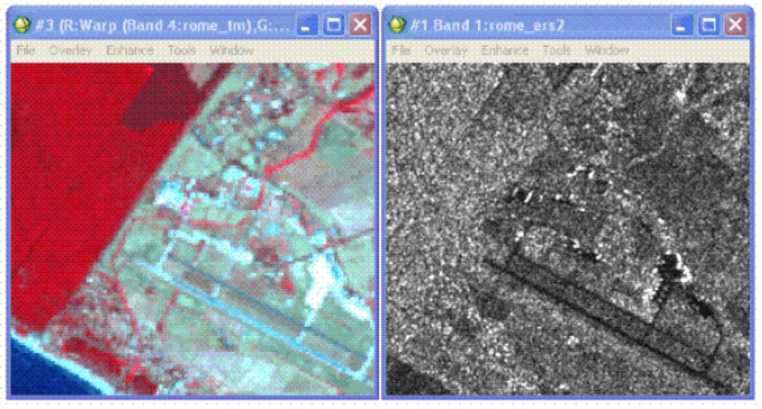

Register the TM image to the ERS-2 image
1. From the ENVI main menu bar, select Map > Registration > Select GCPs: Image-to-Image. An Image to Image Registration dialog appears.
2. Under Base Image, select Display #1 (ERS-2 data). Under Warp Image, select Display #2 (TM data). Click OK. A Ground Control Points Selection dialog appears.
3. From the Ground Control Points Selection dialog menu bar, select File > Restore GCPs from ASCII. A file selection dialog appears.
4. Select rome_tm.pts and click Open.
5. Pre-selected GCPs are loaded into both the TM and ERS-2 display groups. Review the positions of these points in both images for accuracy, and observe the total RMS error listed at the bottom of the Ground Control Points Selection dialog.
6. Click Show List. In the Image to Image GCP List that appears, scroll to the right and review the RMS values for each GCP. These GCPs are sufficient for a quick registration and for this exercise; however, adding more GCPs will improve the match between images.
7. From the Ground Control Points Selection dialog menu bar, select Options > Warp File. A file selection dialog appears. Select rome_tm and click OK to warp all seven TM bands to match the ERS-2 data. A Registration Parameters dialog appears.
8. Enter the following values for Output Image Extent:
Upper Left X: 1
Upper Left Y: 1
Output Samples: 5134
Output Lines: 5549
9. Accept the default values for the remaining fields. In the Enter Output Filename field, enter register_tm. Click OK to perform the image-to-image registration.
10. In the Available Bands List, click Display #2 and select New Display.
11. In the Available Bands List, select the RGB Color radio button. Select Warp bands 4, 3, and 2 under register_tm and click Load RGB to display the registered TM image as a false-color composite in Display #3.

Perform HSI Transform to Fuse Data
1. From the ENVI main menu bar, select Transform > Image Sharpening > HSV. A Select Input RGB dialog appears.
2. Select Display #3 (which contains register_tm) and click OK. A High Resolution Input File appears.
3. Select Band 1 under rome_ers2 and click OK. An HSV Sharpening Parameters dialog appears.
4. In the Enter Output Filename field, enter rome_fused.img and click OK.

Display and Compare Results
1. In the Available Bands List, select the RGB Color radio button. Click Display #2.
2. Select the HSV Sharp R, G, and B bands under rome_fused.img in sequential order. Click Load RGB to load the HSV-sharpened, fused, color image into Display #2, replacing the original TM image.
3. From a Display group menu bar, select Tools > Link > Link Displays. A Link Displays dialog appears.
4. Click OK to link Display #1 (original ERS-2 image), Display #2 (fused image), and Display #3 (registered TM image). Compare these three images.
5. Try fusing other color composites with the ERS-2 data as above and compare the results.
6. When you are finished, exit ENVI.

Upload rome_fused.img to your drop box.

