TATYASAHEB KORE INSTITUTE OF ENGINEERING AND TECHNOLOGY, WARANANAGAR
DEPARTMENT OF COMPUTER SCIENCE & ENGINEERING


A Mini Project Report
On
“LINE CODING SCHEMES”
Submitted By,
Mr. REDEKAR PANKAJ G.
Mr. SHINDE DNYANESHWAR S.
Mr. ZIRANGE ABHISHEK B.
Mr. JADHAV SUDARSHAN V.

Under The Valuable Guidance Of

Prof. C.A. KURI
TATYASAHEB KORE INSTITUTE OF ENGINEERING AND TECHNOLOGY, WARANANAGAR
DEPARTMENT OF COMPUTER SCIENCE & ENGINEERING

ACADAMIC YEAR
2015-16
CERTIFICATE
This is to certify that Mr. Pankaj G. Redekar, Mr. Dnyaneshwar S. Shinde, Mr. Abhishek B. Zirange, Mr. Sudarshan V. Jadhav is studying in SE CSE course in semester II and they have successfully completed the mini project report, entitled “LINE CODING SCHEMES” in partial fulfillment of the award of Bachelor of computer science and engineering as laid down by Shivaji University, Kolhapur during academic year 2015-16
Date: Place: Warananagar

(Prof. C.A. Kuri) (Prof. A. G. Patil)
(Mini Project Guide) (HOD CSE Department)

(Dr. S. V. Anekar )
External Examiner (Principal)

ACKNOWLEDGEMENT

It is our foremost duty to express our deep sense of gratitude and respect to the guide, Prof. C.A. Kuri and HOD of computer science and Engineering, Prof. A.G. Patil and Principal Dr. S.V. Anekar for their valuable advises and inspirations for us which made us complete the project work successfully.
We are indebted to professors of department who always guided us whenever needed. Last but not least, we are thankful to our colleagues and those who helped us directly or indirectly throughout this project work.

Mr. Redekar Pankaj G. [51]
Mr. Shinde Dnyaneshwar S. [54]
Mr. Zirange Abhishek B. [59]
Mr. Jadhav Sudarshan V. [46]

Sr. No. | Content | Page No.
1. | Introduction  1.1 Objectives  - Problem Statement
2. | Proposed system  2.1 System Architecture  2.2 Flow Chart
3. | System requirement specification  3.1 Software Requirement  3.2 Hardware Requirement
4. | Advantages & Future Development  4.1 Advantages  4.2 Future Development
5. | Screenshots
6. | Conclusion
7. | Reference  7.1 Books  7.2 Web Sites
INDEX

ABSTRACT
This document is meant for describing all the features and procedures that followed while developing the system.
This document specially mentioned the details of the project, how it was developed, the primary requirements, as well as various features and functionalities of the project and the procedure followed in achieving these objectives.
The project “Line coding schemes” is a desktop based system which helps the technical and non-technical user to understand the different types of line coding schemes with user interaction with generating diagrammatically.
In a present system it is difficult to new or a non-technical user to familiar with different types of line coding schemes. In this system user can interact with the concept of line coding user can input any text and it will convert into binary. On the basis of user choice the actual line coding technique will display graphically. At the end of the system operation user will familiar with the line coding schemes and how data will transfer using signal.

- Automation
The “Line coding scheme” automates each and every activity of the manual system and increases its throughput. Thus the response time of the system is very less and it works very fast.

- Accuracy
The “Line coding schemes” provides the user a quick response with very accurate information regarding the data entered by user.
- User friendly
The software “Line coding schemes” has a very user friendly interface. Thus the users will feel very easy to work on it. This software provides accuracy along with a pleasant interface. Make the present manual system more iterative, speedy and user friendly.

Chapter 1
Introduction
The C/CPP project on “Line coding schemes”, which provides a lot of facilities to their users.
The objective and scope of this project is to help the every computer user to get familiar with digital data and different types of line coding schemes which is used to transmit data in electric signals. It will simplifies the task.
Due to this software it will become efficient and reliable for users to perform various line coding techniques on there data. As already told above that this project helps users to display digital data in graphical manner.
The software is more efficient because user can easily track there total record after completing their operation. In this software the facilities are can be stated as,
- User can read there track record from start to end of the program.
- User can freely enter the data which user want.
- At the time of graphical representation user can get valuable information about current line coding technique.
- Any technical or Non-technical user can be familiar with line coding scheme using this software
- User can access the log files to track the use of software.

  - Objective:
- In “Line coding scheme”, user can easily understand the coding techniques used to represent digital data.
- This is CPP project on, which provides different coding techniques to their user.
- The objective and scope of this “Line coding scheme” project is to help the user to better understand digital data transmission.
- It will help to user to generate binary code of data entered by user.

1.2 Problem Statement:
To develop software which will help the user to understand the how line coding schemes used to generate digital signal.

Chapter 2
PROPOSED SYSTEM
2.1 SYSTEM ARCHITECTURE:

In this system user interact with no. of characters entered by user to performing various types of line coding scheme operation. On that basis user can get desired output from software user can track record using log files. We can exit from the main menu directly.
The different operation performed is as follows:
a) Convert string into binary.
b) Select option from user.
c) Give proper output.
d) Store record into log.
e) Display log file.

2.3 Flow Chart:
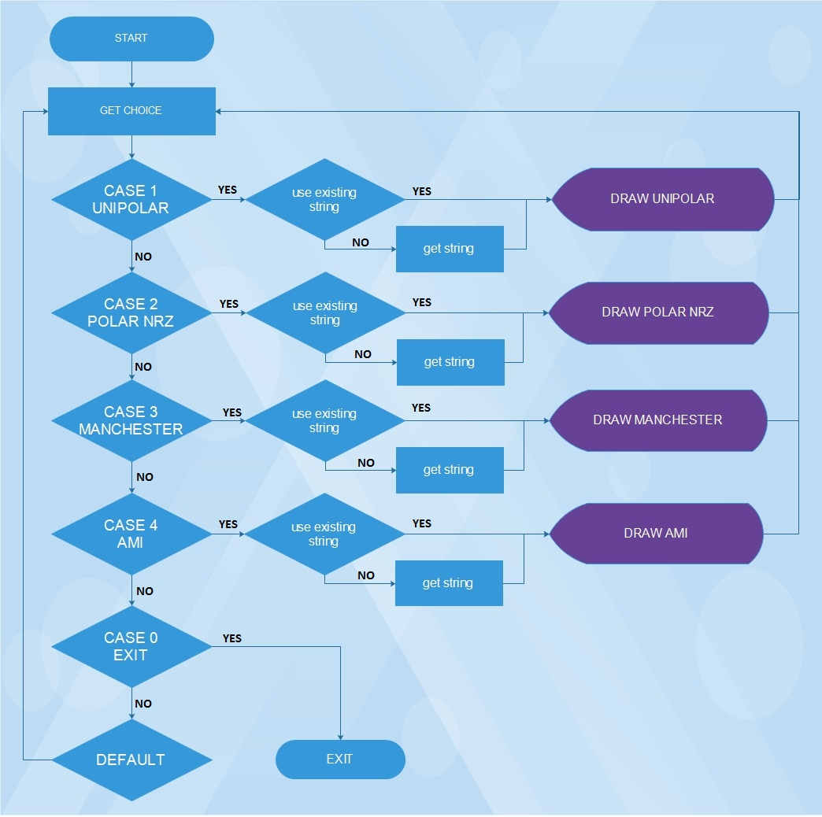

Chapter 3
SYSTEM REQUIREMENT SPECIFICATION

  - Software Requirements :
Operating System: Windows XP / Vista / 7 / 8 / 8.1/ 10, Android (with Turbo c)
Front-end: C, CPP
Back-end: Turbo C++,notepad

  - Hardware Requirements :
The minimum hardware requirement for this project is as follows:
- Intel Pentium Processor (Min. 550 MHz)
- 256 MB RAM
- 40 GB HDD
- Internet facility is not required.

Chapter 4
ADVANTAGES &FURUTURE DEVELOPMENT
4.1 Advantages:
- Our project is useful for errorless & speedy services.

- This project will help in learning different types of line coding schemes.

- It will graphically display how the signal will generated.

- User can see the log file for tracking the use of the project

4.2 Future Development:
It is not possible to develop a system that fulfill all the requirement of the user. Users requirement are keep changing as the system is being used.
Some of the future enhancement that can be done to this system are:
- In future actual transmission of digital data can be seen graphically on monitor.
- Provide some more features like reading digital signal from scanning graphical line coding images.

Chapter 5
SCREENSHOTS
- Welcome
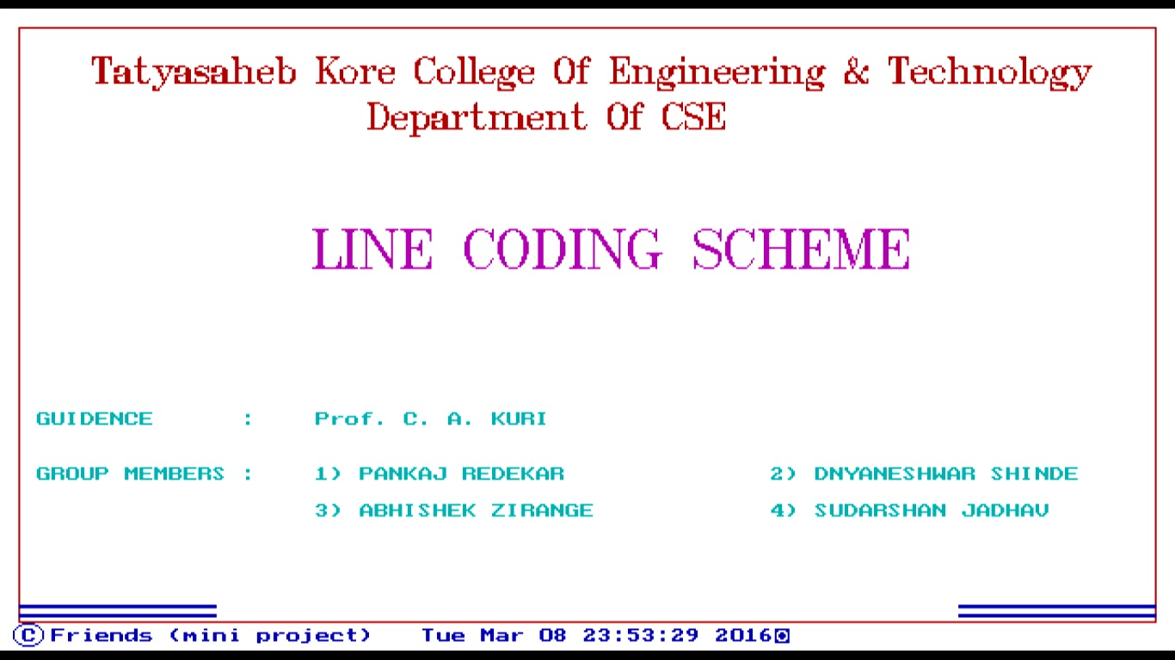
- Main Menu
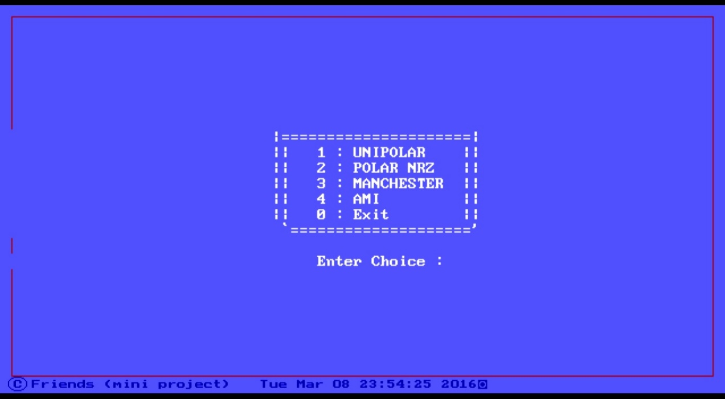

- Get String
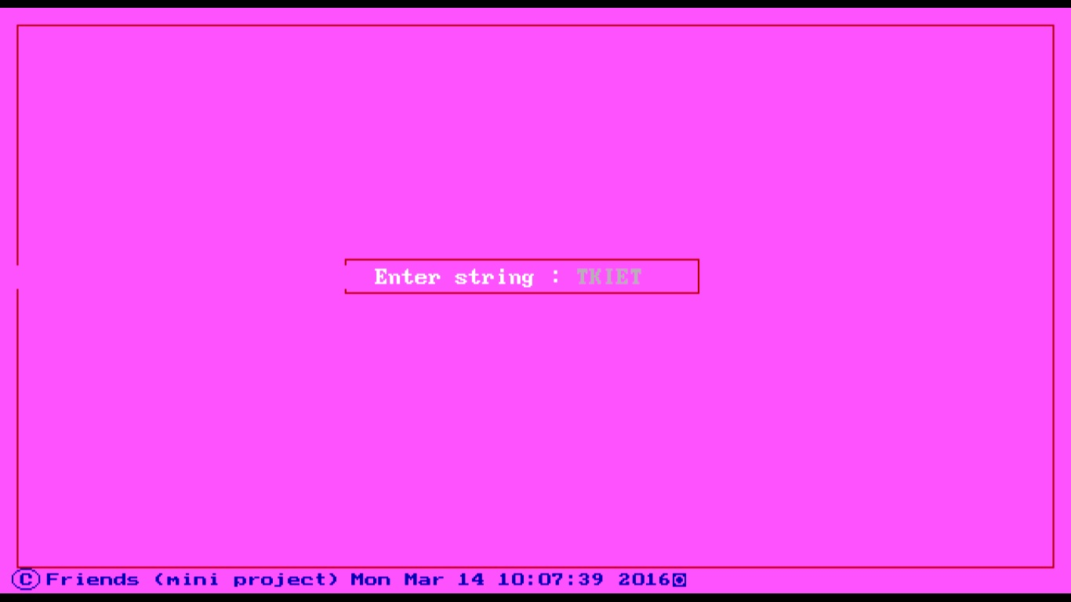
- Unipolar
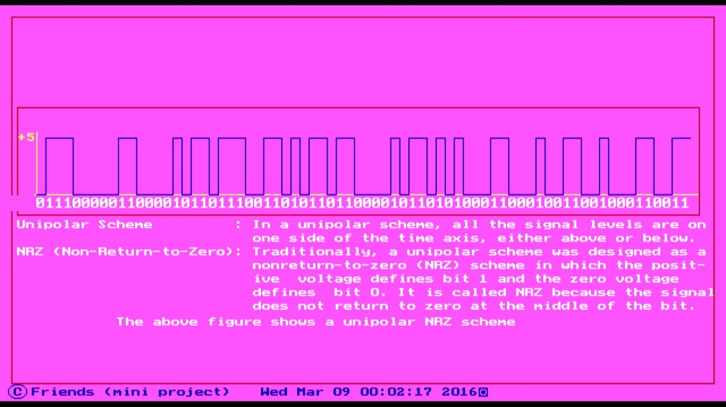

- Check string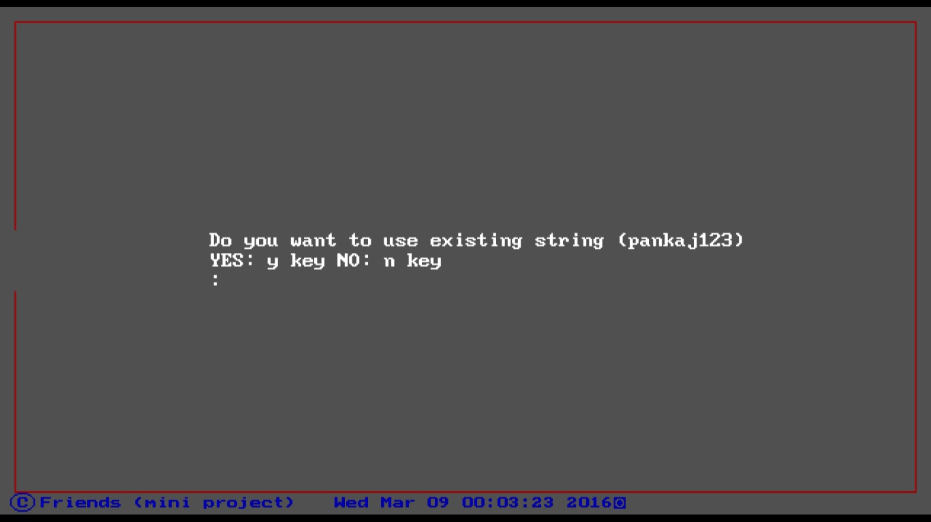
- Polar NRZ
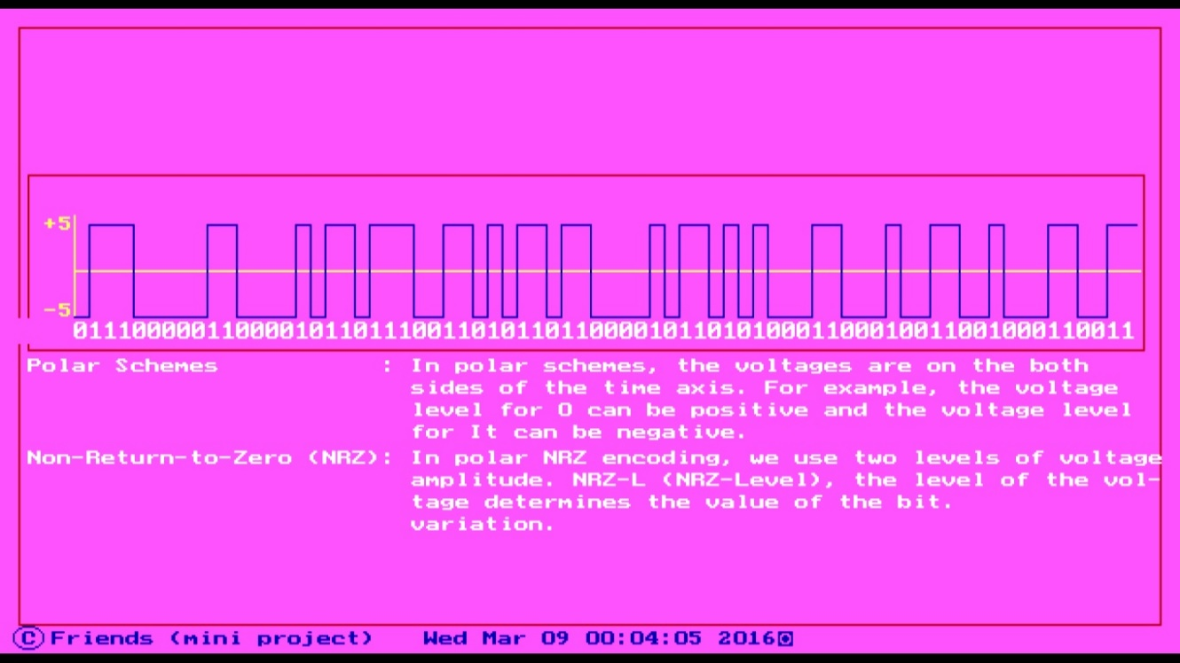

- Manchester
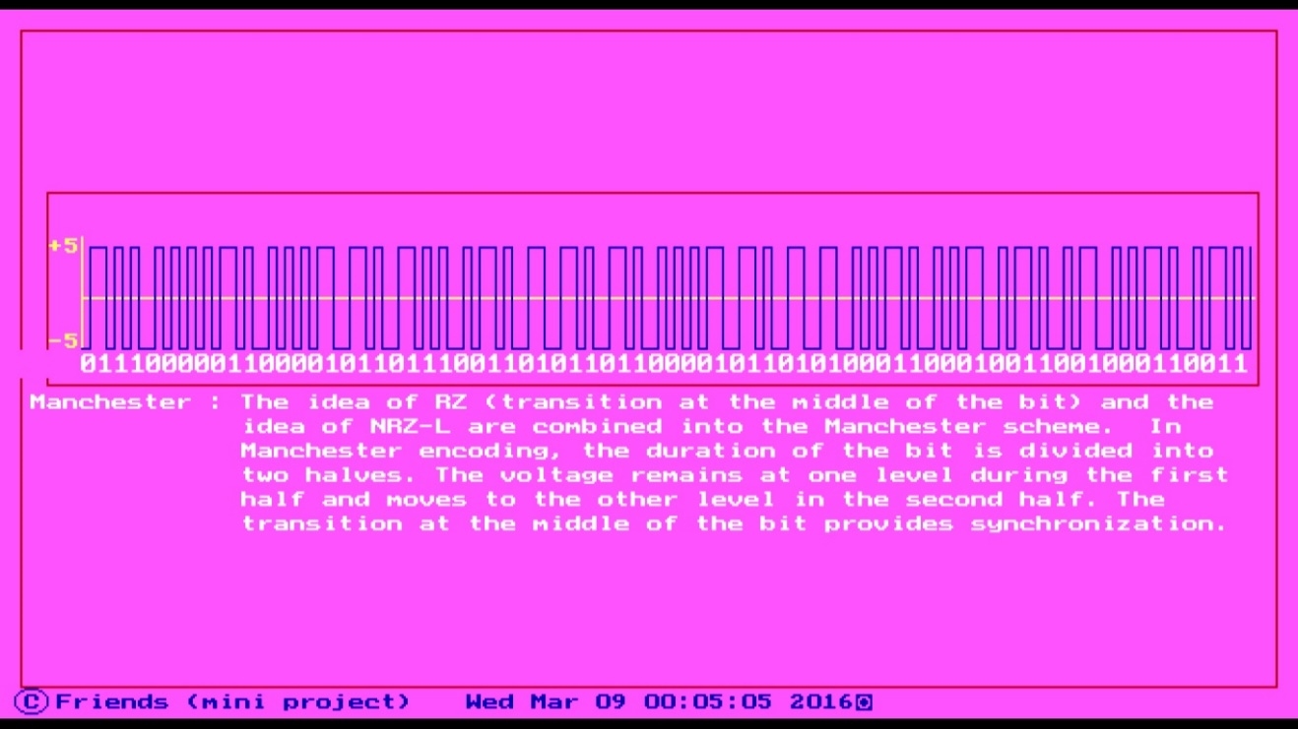
- AMI
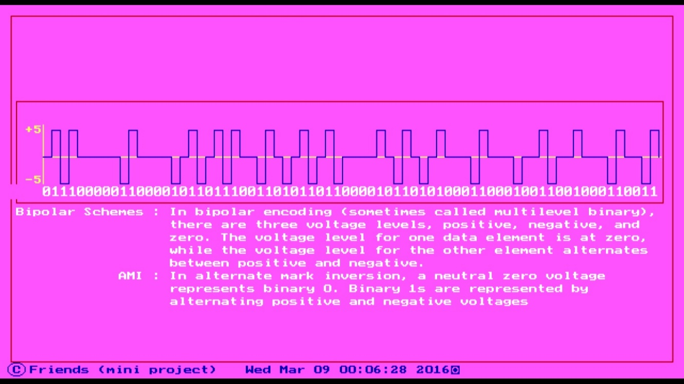

- End (Thank You)
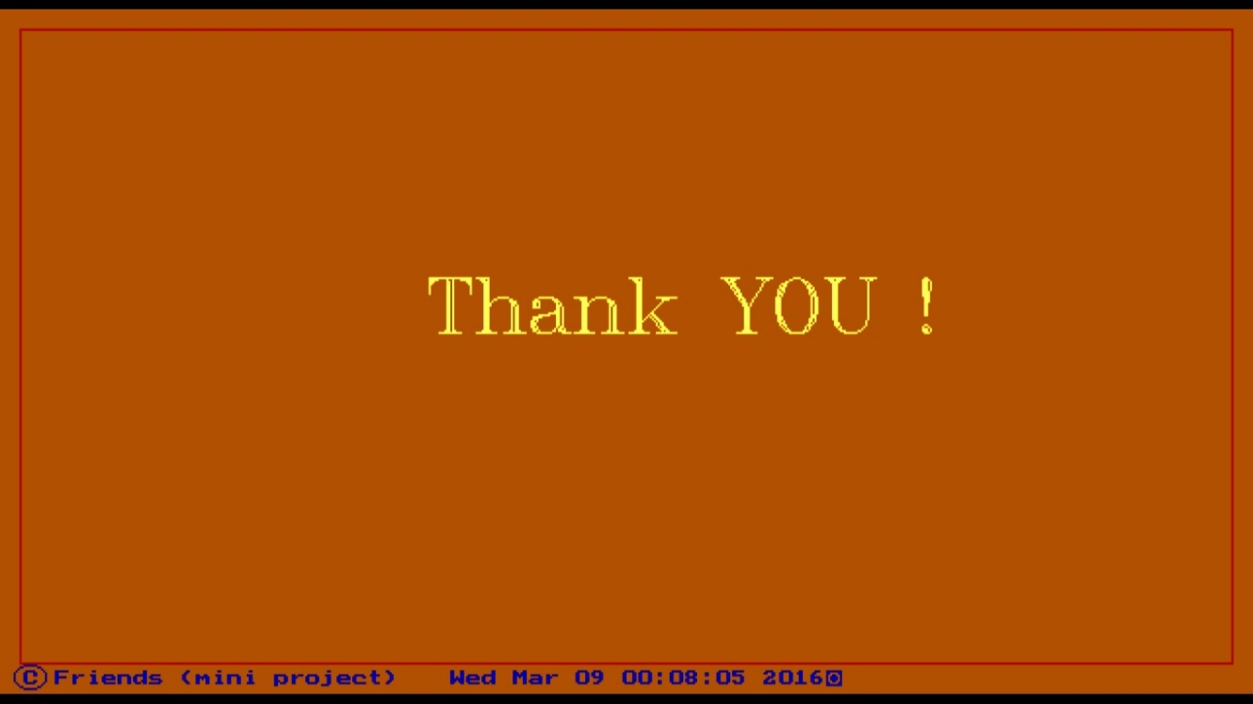
- Log File
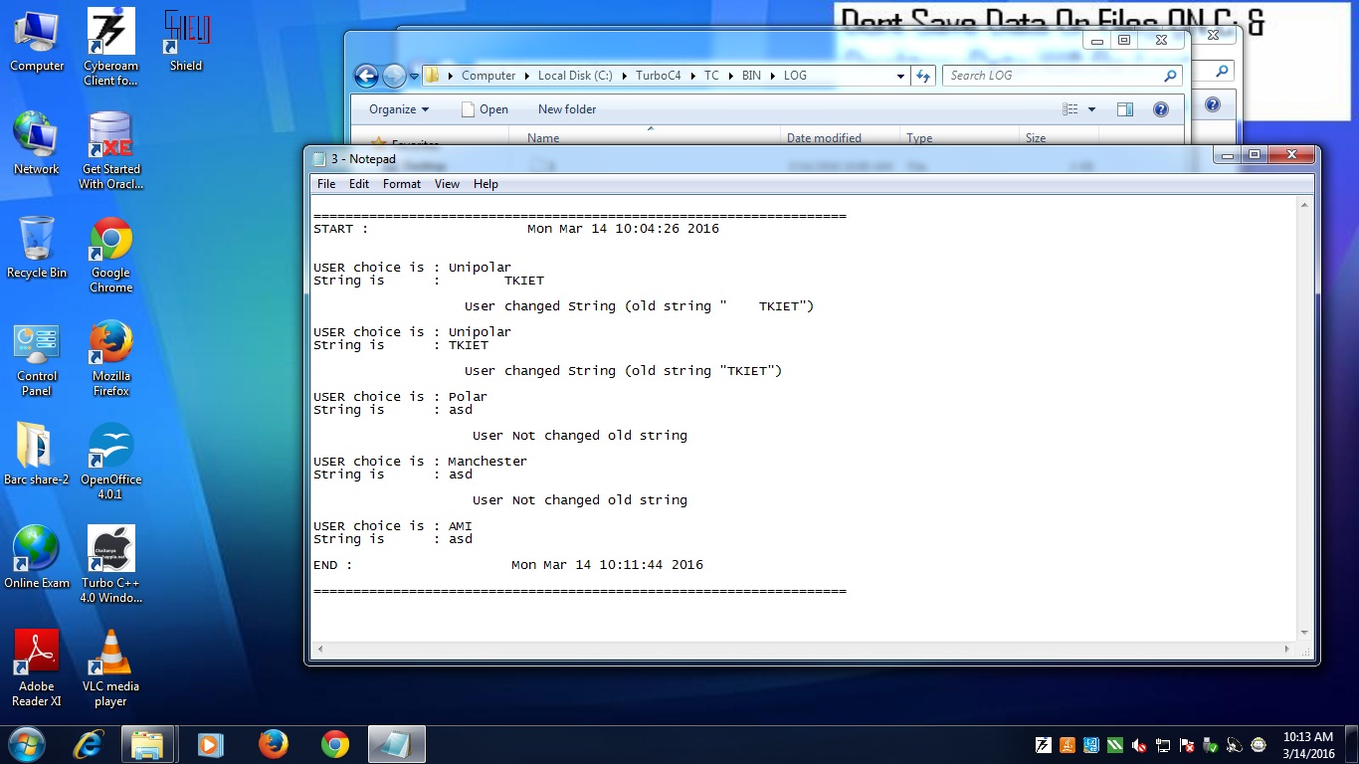

Chapter 6
CONCLUSION:
The project “Line Coding Scheme” is a desktop based system which helps the technical and non-technical user to getting familiar with different types of coding techniques used to represent digital signal.
In a present system it is easy to new or a non-technical user to draw different line codesusing this system, see the contents of that present in log folder after complrting the process of system. In menu user can get different choice for different line coding techniques. On the basis user choice system will display different line coding technique. At every time of new run of this system will create new file for storing user activity from starting time to the end of the run it will keep all record in file.
Hence, using this system any technical or non-technical person get familiar with different Line coding Techniques.

Chapter 7
REFERENCES:

8.1Books:
- Turbo c/c++ help documentation
- The Complete Reference C++ - Herb Schild

8.2 Links
- http://codetkiet.github.io/line-coding-scheme (Poject Site)
- http://github.com/PankajRedekar
- http://github.com/Dnyaneshwarshinde
- http://github.com/abhishekzirange
- http://github.com/jadhavsudarshan

