Project 10: System Resource Monitoring & Alert Script
Screenshots — Running System
Screenshot 1: Live Monitoring View with CPU Alert & Desktop Notification
The script is actively monitoring system resources in real-time. CPU crossed 90.6% which triggered the [ALERT] message and a Windows desktop notification popup.
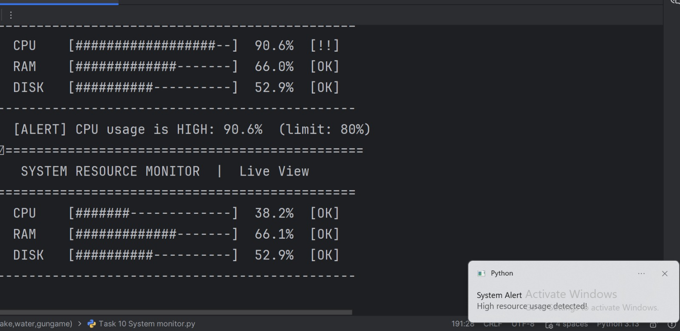
Screenshot 2: Main Menu System
The CLI menu provides four options: Start Monitoring, Set Thresholds, View Logs, and Exit. Email alert option is also shown at startup.
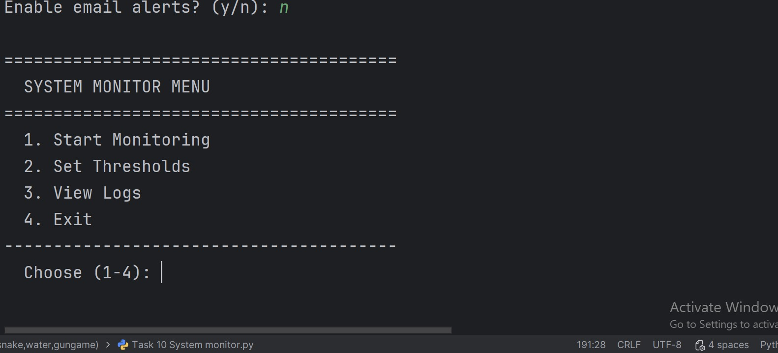
Screenshot 3: System Log File (CSV) Opened in Excel
All monitoring data is automatically saved to system_log.csv with Timestamp, CPU(%), RAM(%), and Disk(%) columns for every captured interval.
